Supplementary material
for „Birds of prey exert pressure on root vole populations in winter and spring”

Additional figures
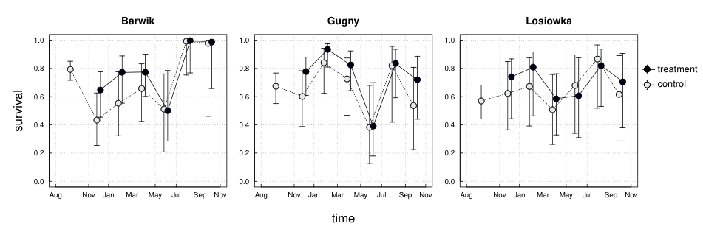
Figure S1. a) Survival of root voles at each site during the study, in treatment (no bird predation) and control plots, for intervals between sessions and scaled to a one-month period. Points show expected values, whiskers represent 95% confidence intervals. Estimates are averaged over a set of highest-ranked models (see see Table 1 in the main text). For better readability, consecutive points from the same plot are connected by a line, and points from the same session are slightly shifted apart along the horizontal axis.
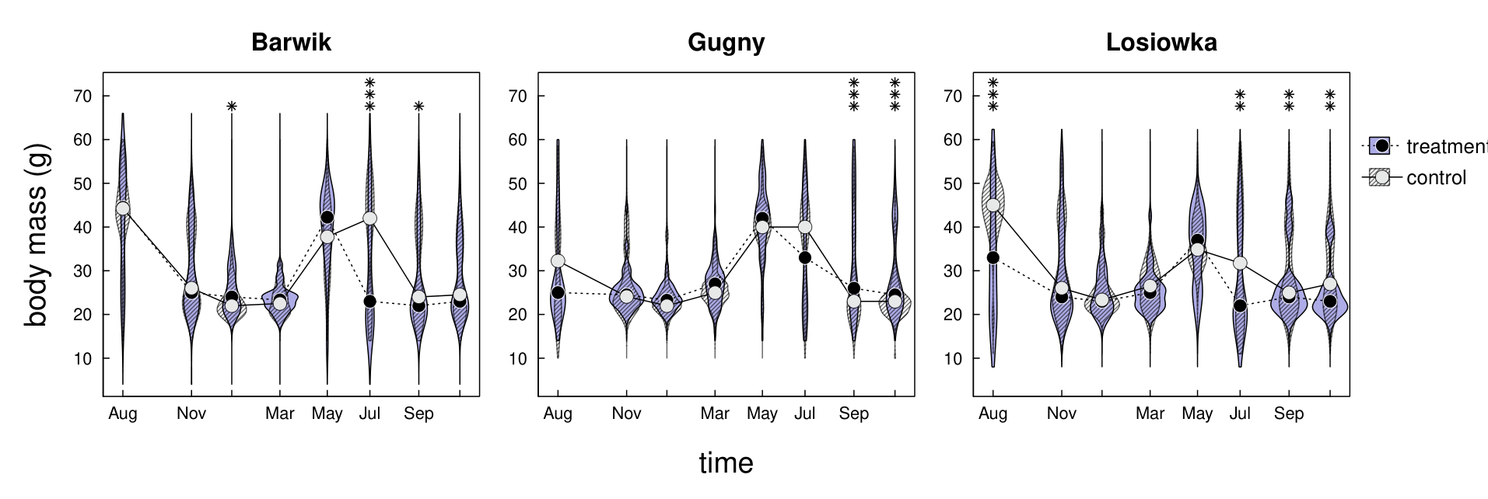
Figure S2. Body mass of voles captured in control and treatment plots, in each session and separately for each site. Violin graphs show the density distribution of body mass of individuals captured in each session, with dots indicating the median for control and treatment plots. or better readability, consecutive points from the same plot are connected by a line. Asterisks at top indicate significant difference (p ≤ 0.001, 0.01, 0.05 indicated by three, two and one symbols, respectively).

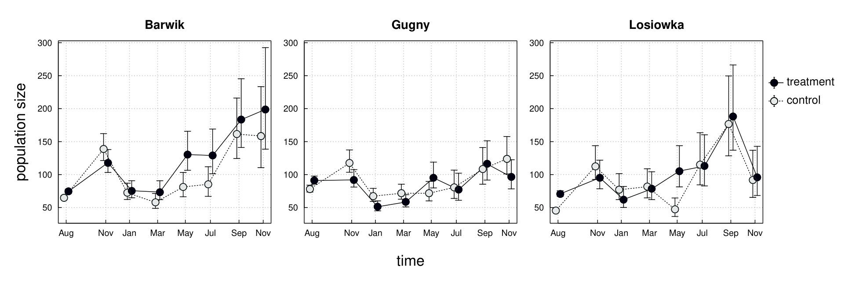
Figure S3. Population size of root vole at each site during the study in treatment and control plots. Points show expected values, whiskers represent 95% confidence intervals. Estimates are averaged over a set of highest-ranked models (see Table 1 in the main text). For readability, consecutive points from the same plot are connected by a line, and points from the same session are slightly shifted apart along the horizontal axis.
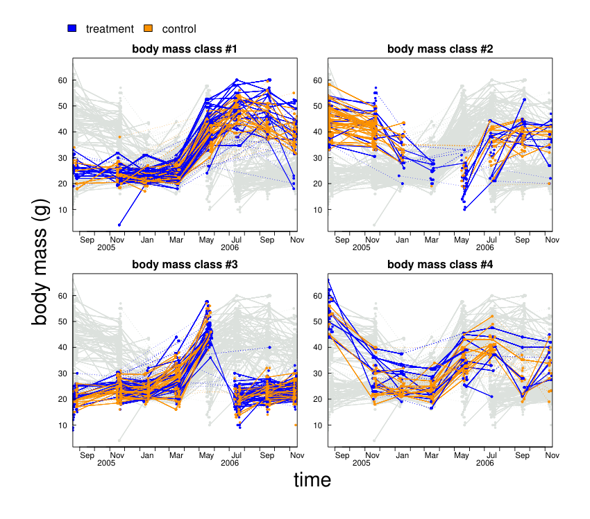
Figure S4. Changes in body mass of captured voles. The recorded body mass of individuals is shown as points connected by a line along the time axis. The colours indicate the individuals seen in the treatment and control plots. If an individual was captured in consecutive sessions, the points are connected by a solid line, whereas if the captures were discontinuous (the individual appeared in the preceding and subsequent sessions), the points are connected by a dashed line. Each panel highlights one group as determined by the latent class linear mixed model. To allow for comparison, the remaining groups are shown in the background in light gray.

Additional tables
Table S1. Number of individuals caught in each plot in each trapping session.
Location | Type | Session date
Location | Type | 18 Aug 2005 | 16 Nov 2005 | 9 Jan 2006 | 14 Mar 2006 | 16 May 2006 | 12 Jul 2006 | 15 Sep 2006 | 9 Nov 2006
Barwik | treatment | 55 | 80 | 50 | 47 | 77 | 68 | 84 | 84
Gugny | treatment | 64 | 65 | 38 | 44 | 65 | 44 | 59 | 59
Losiowka | treatment | 56 | 61 | 38 | 47 | 58 | 53 | 80 | 47
Barwik | control | 48 | 94 | 48 | 37 | 48 | 45 | 74 | 67
Gugny | control | 55 | 83 | 50 | 54 | 49 | 46 | 55 | 76
Losiowka | control | 36 | 72 | 47 | 49 | 26 | 54 | 75 | 45

Table S2. Number of captures (i.e. individuals seen for the first time) and re-captures (second or subsequent record) in each session, broken down into treatment and control plots, locations and as an overall total.
session | treatment |  | control |  | Barwik |  | Gugny |  | Losiowka |  | total
session | captures | recaptures | captures | recaptures | captures | recaptures | captures | recaptures | captures | recaptures | captures | recaptures
18 Aug 2005 | 175 |  | 139 |  | 103 |  | 119 |  | 92 |  | 314
16 Nov 2005 | 160 | 46 | 193 | 56 | 130 | 44 | 108 | 40 | 115 | 18 | 353 | 102
9 Jan 2006 | 35 | 91 | 71 | 74 | 44 | 54 | 23 | 65 | 39 | 46 | 106 | 165
14 Mar 2006 | 39 | 99 | 68 | 72 | 36 | 48 | 23 | 75 | 48 | 48 | 107 | 171
16 May 2006 | 122 | 78 | 74 | 49 | 84 | 41 | 55 | 59 | 57 | 27 | 196 | 127
12 Jul 2006 | 123 | 42 | 98 | 47 | 75 | 38 | 61 | 29 | 85 | 22 | 221 | 89
15 Sep 2006 | 128 | 95 | 139 | 65 | 99 | 59 | 69 | 45 | 99 | 56 | 267 | 160
9 Nov 2006 | 68 | 122 | 99 | 89 | 103 | 0 | 119 | 0 | 92 | 0 | 167 | 211
total | 850 | 573 | 881 | 452 | 626 | 380 | 539 | 367 | 566 | 278 | 1731 | 1025

Table S3. A cohort as used in the capture-mark-recapture model context are individuals first observed during each session.
session date | 2005-08-18 | 2005-11-16 | 2006-01-09 | 2006-03-14 | 2006-05-16 | 2006-07-12 | 2006-09-15 | 2006-11-09
number of captures of each cohort
cohort 1 | 314 | 102 | 54 | 32 | 24 | 8 | 7 | 9
cohort 2 |  | 353 | 111 | 106 | 55 | 22 | 19 | 15
cohort 3 |  |  | 106 | 33 | 14 | 7 | 7 | 4
cohort 4 |  |  |  | 107 | 34 | 11 | 8 | 7
cohort 5 |  |  |  |  | 196 | 41 | 32 | 25
cohort 6 |  |  |  |  |  | 221 | 87 | 69
cohort 7 |  |  |  |  |  |  | 267 | 82
cohort 8 |  |  |  |  |  |  |  | 167
Table S4. Body mass of captured individuals in each session, and sex.
session | body mass [mean (s.d.)]
session | total | females | males
August | 37.1 (13.0) | 34.3 (11.8) | 41.2 (13.7)
November | 28.3 (8.7) | 27.6 (8.0) | 29.3 (9.4)
January | 24.5 (4.7) | 24.6 (4.9) | 24.3 (4.5)
March | 25.3 (4.4) | 23.8 (3.7) | 27.1 (4.4)
May | 38.6 (8.8) | 36.0 (8.1) | 41.6 (8.5)
July | 33.1 (13.1) | 33.5 (11.9) | 32.4 (15.0)
September | 28.9 (10.5) | 28.8 (9.9) | 29.1 (11.3)
November | 27.1 (8.1) | 27.2 (7.8) | 27.0 (8.5)

Table S5. Initial population size estimates at the beginning of the study (i.e. before netting), in control and treatment plots. Percentage difference refers to the mean population size of the pair of plots.
Location | median (95% CI) |  | difference of medians (n) | percentage difference
Location | control | treatment | difference of medians (n) | percentage difference
Barwik | 64.7 (61.8 - 68.1) | 74.2 (70.9 - 78.0) | 9.4 | 14%
Gugny | 78.3 (73.3 - 84.3) | 91.1 (85.3 - 98.1) | 12.8 | 15%
Losiowka | 45.2 (42.8 - 48.4) | 70.3 (66.6 - 75.3) | 25.1 | 43%
(total) | 64.8 (43.3 - 82.4) | 74.5 (67.4 - 95.9) | 9.7 | 14%

