Supplementary Information

Strong Metal–Base Interaction (SMBI): a fresh angle to understand the alkali metal promotion in hydrogenation catalysis

Munam Jungª, Maxim Park Dickiesonª, Pinzhang Chenª, Clemen Jia Gen Gohª, Peijie Hanª, Bingqing Yao^{b}, Xing-Chi Li^{c}, Qian He^{b} , Ya-Wen Zhang^{c}, Kyungho Lee^{d,*}, Ning Yan^{a,*}

ª Department of Chemical and Biomolecular Engineering, National University of Singapore, 4 Engineering Drive 4, Singapore 117585, Singapore
^{b} Department of Materials Science and Engineering, National University of Singapore, 9 Engineering, Drive 1, Singapore 117575, Singapore
^{c} School of Chemical and Molecular Engineering, Peking University, 202 Chengfu Road, Yanyuan Street, Haidian District, Beijing, China, 100871
^{d} Clean Fuel Research Laboratory, Korea Institute of Energy Research, 152 Gajeong-ro, Yuseong-gu, Daejeon 34129, Republic of Korea
*Corresponding Authors (K. Lee and N. Yan)

Experimental details
Materials
LiNO₃ (99.99% trace metals basis), KNO₃ (≥99.0%), Ni(NO₃)₂⋅6H₂O, and SiO₂(high purity grade, pore size 60 Å, 200–425 mesh) were purchased from Sigma Aldrich. WO₃ (99.8% 10–20 micron power) was purchased from Alfa Aesar. Deuterium Oxide (D, 99.9%) was purchased from Cambridge Isotope Laboratories. These chemicals were used without further treatment.

Catalyst preparation
Additional Rh- and Ni-based catalysts
AM (AM denotes alkali metal Li and K) doped RhAM_{n}/TiO₂ (2.5 wt% Rh) catalysts were prepared by incipient wetness impregnation method with a Rh:AM molar ratio of 1:n. Typically, the desired mass of Rh(NO₃)₃⋅xH₂O and AMNO₃ were dissolved in 2 cm³ of deionized (DI) water at room temperature by sonication for 30 min. The precursor solution was then added to 1 g of dried TiO₂ support and mixed for 15–20 min. Subsequently, the sample was dried at room temperature overnight and then at 343 K for 10 h. Finally, the sample was calcined in air at 673 K for 4 h and was reduced at 673 K for 2 h.
RhAM_{n}/SiO₂ (2.5 wt% Rh) catalysts were prepared similarly to RhAM_{n}/TiO₂ while using SiO₂ as the support.
NiAM_{n}/TiO₂ (2.5 wt% Ni) catalysts were prepared similarly to RhAM_{n}/TiO₂ while using Ni(NO₃)₂⋅6H₂O as the transition metal precursor instead of Rh(NO₃)₃⋅xH₂O.

Catalyst characterization
High-angle annular dark-field imaging scanning transmission electron microscopy (HAADF-STEM) and energy-dispersive X-ray spectroscopy (EDS) were performed using an aberration-corrected JEOL ARM 200CF operating at 200 kV. The microscope was equipped with an Oxford Instruments X-ray energy-dispersive spectrometer. The samples sparsely scattered on copper grids and the size distribution of supported Rh nanoparticles (d_{Rh}) was analysed based on statistics of over 100 deposits.
N₂ physisorption at 77 K was measured using a porosity analyser (Quantachrome, NOVAtouch). Prior to measurement, the samples were degassed at 673 K for 3 h under a high vacuum. The Brunauer–Emmett–Teller surface area (S_{BET}) was determined in the P/P₀ range of 0.10–0.30 of the adsorption branches of the isotherm, average pore size was determined by Barrett–Joyner–Halenda (BJH) method, and total pore volume (V_{tot}) was determined at the P/P₀ = 0.99.
CO chemisorption was performed using an Autosorb IQ-C-AG (1 Stat.) EPDM instrument with thermal conductivity detector. Each sample was treated at 673 K for 2 h in hydrogen to ensure reduction and cooled down to 298 K under He flow. After a further purging step for 60 minutes, pulsed titration acquisitions were performed with 277 μL of 5%CO/N₂ mixture for 10 injections.
Powder X-ray diffraction (XRD) patterns were recorded using a Bruker D2-Phaser (Bruker) equipped with a Cu Kα radiation source (40 kV, 30 mA) and an LYNXEYE detector. The data were collected at a resolution of 0.02 degrees and a count time of 0.2 s at each point.
Near Ambient Pressure X-ray photoelectron spectroscopy (NAP-XPS) were conducted using Axis Ultra XPS spectrometer (Kratos, U.K.) with an Al Kα X-ray radiation source (h$v$ = 1486.6 eV) operated at 225 W. The binding energy calibration was conducted using the typical C 1s signal of adventitious carbon peak at 284.8 eV. First measurement was taken with pristine samples at room temperature. The samples were then treated with H₂ gas at 673 K for 2 h and followed by cooling to room temperature. The samples were then transferred to the NAP chamber where the next measurement is taken at 673 K under H₂ atmosphere (0.2 kPa). The surface elemental analysis was conducted using CasaXPS software.
In-situ Diffuse reflectance infrared Fourier transform spectroscopy (DRIFTS) was performed using iS50 FT-IR spectrometer with a mercury-cadmium-telluride (MCT) detector and a Praying MantisTM high temperature reaction chamber with Zinc Selenide windows. For all spectra, 32 scans with a resolution of 4 cm⁻¹ were recorded.
H₂-DRIFTS was measured at 298 K after H₂ adsorption. Prior to the experiment, the samples were treated with a H₂ flow at 673 K and then purged with an Ar flow at the same temperature for 2 h. After cooling to 298 K, the background spectra were recorded. Then, H₂ was dosed to the sample, followed by Ar purging. The DRIFT spectrum was recorded once the signal was stabilized. During DRIFTS analyses, a flow rate of 20 cm³ min⁻¹ was chosen for all the gas flows. CO-DRIFTS and D₂-DRIFTS were conducted similarly while using CO and D2 as the probe gas, respectively. During the D₂-DRIFTS, D₂ flow was maintained to obtain the time-dependent spectra.
Temperature programmed desorption (TPD) experiments were performed using an Autosorb IQ-C-AG (1 Stat.) EPDM instrument with thermal conductivity detector. Each sample was pretreated at 673 K for 2 h in He or H₂ flow, cooled down to 323 K, and then the probe gas (i.e. H₂, NH₃ or CO₂) was adsorbed for 30 min. After a He purging step of 60 min, the TPD profile were collected at a heating rate of 10 K min⁻¹ under He as the carrier gas.
Temperature programmed reduction (TPR) was conducted using the same equipment as TPD. The calcined sample was treated at 673 K for 2 h under N₂ gas flow to remove impurities and cooled down to 323 K. Once the signal was stabilized, the TPR profile was collected from 323 to 673 K at a heating rate of 10 K min⁻¹ under 5% H₂/N₂ flow.
H₂–D₂ isotope exchange was carried out using a plug flow quartz reactor with the mass spectrometer (MS, Hidden Analytical, HPR-20 R&D), using a 7 mm inner and 12 mm outer diameter corundum tube at ambient pressure. Typically, 20 mg of catalyst was pre-reduced under H₂ flow at 673 K for 2 h and purged with Ar flow for 2 h at the same temperature. After cooling down to 298 K, a mixture of H₂ (10 kPa) and D₂ (10 kPa) was injected into the reactor. Final data was collected from 298–423 K with a temperature ramping rate at 10 K min⁻¹.
The WO₃ colorization followed Khoobiar’s method¹. Typically, 10 mg of the catalyst pre-reduced under H₂ flow at 673 K for 2 h and 1.0 g of WO₃ were mixed to obtain uniform light-yellow sample². The sample was heated to 423 K under Ar purging, and then gas flow was switched to H₂ in a fixed-bed quartz reactor. The hydrogen spillover effect of the sample was illustrated by taking photos of each sample after 30 min of H₂ treatment.

Catalytic tests
High Performance Liquid Chromatography (HPLC) was used for analyzing hydrogenation of vinyl acetate, acetophenone and nitrobenzene. Shimadzu Nexera X2 instrument was equipped with SB-C18 Column (Poroshell 120 SB-C18, 4.6×150 mm, 2.7 micron); Mobile phase: 55% A (5 mmol L⁻¹ sulfuric acid solution) and 45% B (acetonitrile); Flow rate: 0.4 cm³ min⁻¹; Oven temperature: 303 K. Detector: Diode array detector (195, 230, 269 nm).
CO₂ hydrogenation were analyzed by an online gas chromatography (GC) (Agilent 8890) equipped with a thermal conductivity detector (TCD), a flame ionization detector (FID), Agilent HP-PoraplotQ, and Restek ShinCarbon columns.
The detailed calculation procedure is presented elsewhere³.
First, the volume-change-factor (V.C.F.) was calculated with Ar as the internal standard.
V.C.F. = $\frac{Area_{Ar,in}}{{Area}_{Ar,out}}$ , (1)
where $Area_{Ar,in}$ and ${Area}_{Ar,out}$ are the peak area of Ar in inlet and outlet in the data.
The molar flow rate of CO₂ in inlet (n_{CO2,in}) was calculated as below.
$n_{CO2,in }(mmol \min^{-1}) = {CO}_{2}\% in inlet × molar reactant flow rate$, (2)
where molar reactant flow rate is determined by flow rate (cm³ min⁻¹, STP) and universal gas constant (R).
The molar flow rate of species i in outlet (n_{i,out}) was calculated as below:
$n_{i,out}(mmol \min^{-1}) = mol\% of species i in outlet × molar reactant flow rate × V.C.F$, (3)
where the mol% of species i in outlet is obtained with GC area of species i with prepared calibration curve. Thermal conductivity detector (TCD) was used for CO₂ and CO, flame ionization detector (FID) was used to detect CH₄ and other products.
CO₂ conversion and product selectivity were calculated with the following equations:
${CO}_{2} conversion\% = \frac{n_{CO2,in}-n_{co2,out}}{n_{CO2,in}}×100\%$, (4)
$Product selectivity\% = \frac{n_{i,out}}{\sum{n_{i,out}-n_{CO2,out}}} ×100\%$, (5)
Deuterium isotope labelling during vinyl acetate and acetophenone hydrogenation reactions. For this experiment, 20 mg of pre-reduced Rh/TiO₂, 2 cm³ of D₂O (Cambridge Isotope Labs, 99.8% D labelling), and 10mM of substrate were mixed. H₂ (40 cm³ min⁻¹) was applied under stirring at 1500 rpm. In addition to GC-FID analysis, a GC (Agilent 7890A) equipped with an HP-5 capillary column and an Agilent 5975C inert MSD with Triple Axis Detector was used for product quantification.

Supplementary figures and tables
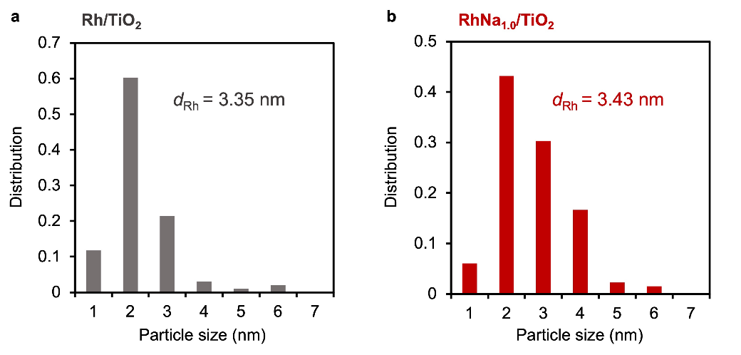
Supplementary Figure 1. Rh particle size distribution of (a) Rh/TiO₂ and (b) RhNa_{1.0}/TiO₂.

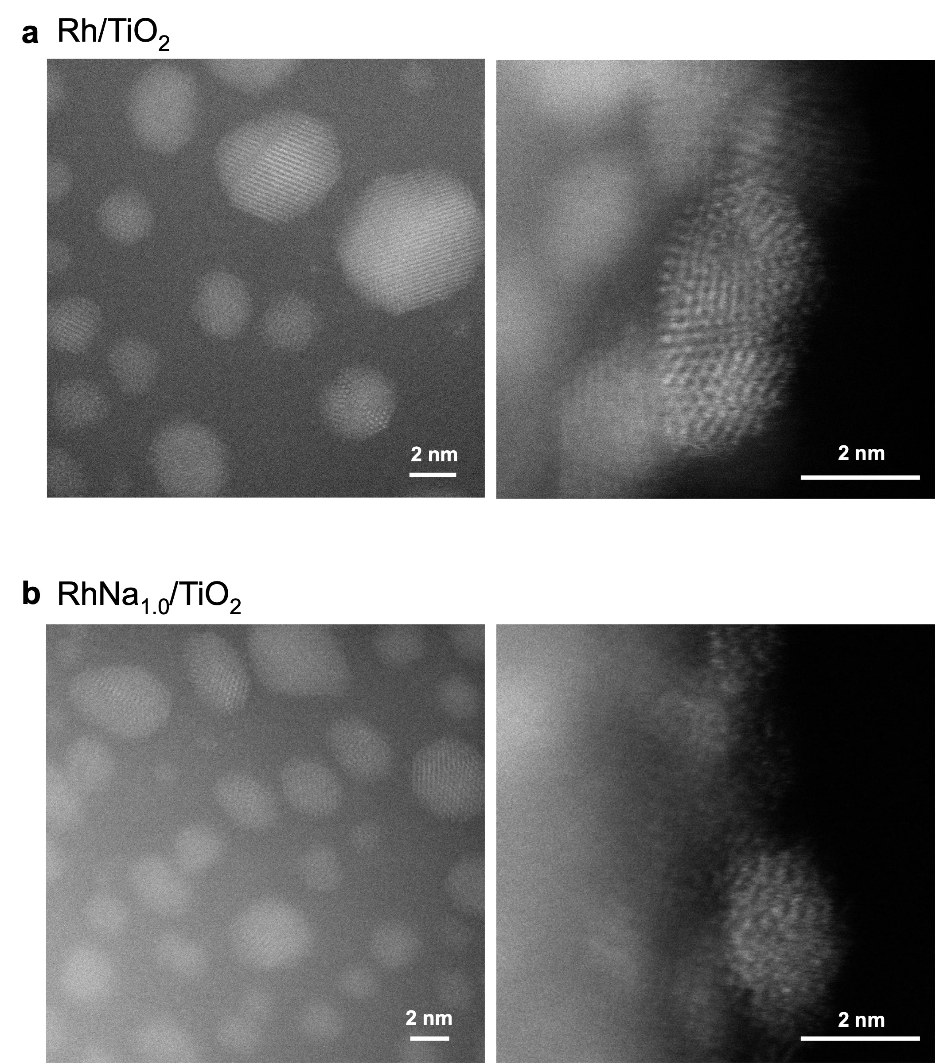
Supplementary Figure 2. HAADF-STEM images of (a) Rh/TiO₂ and (b) RhNa_{1.0}/TiO₂ at various positions and magnifications.

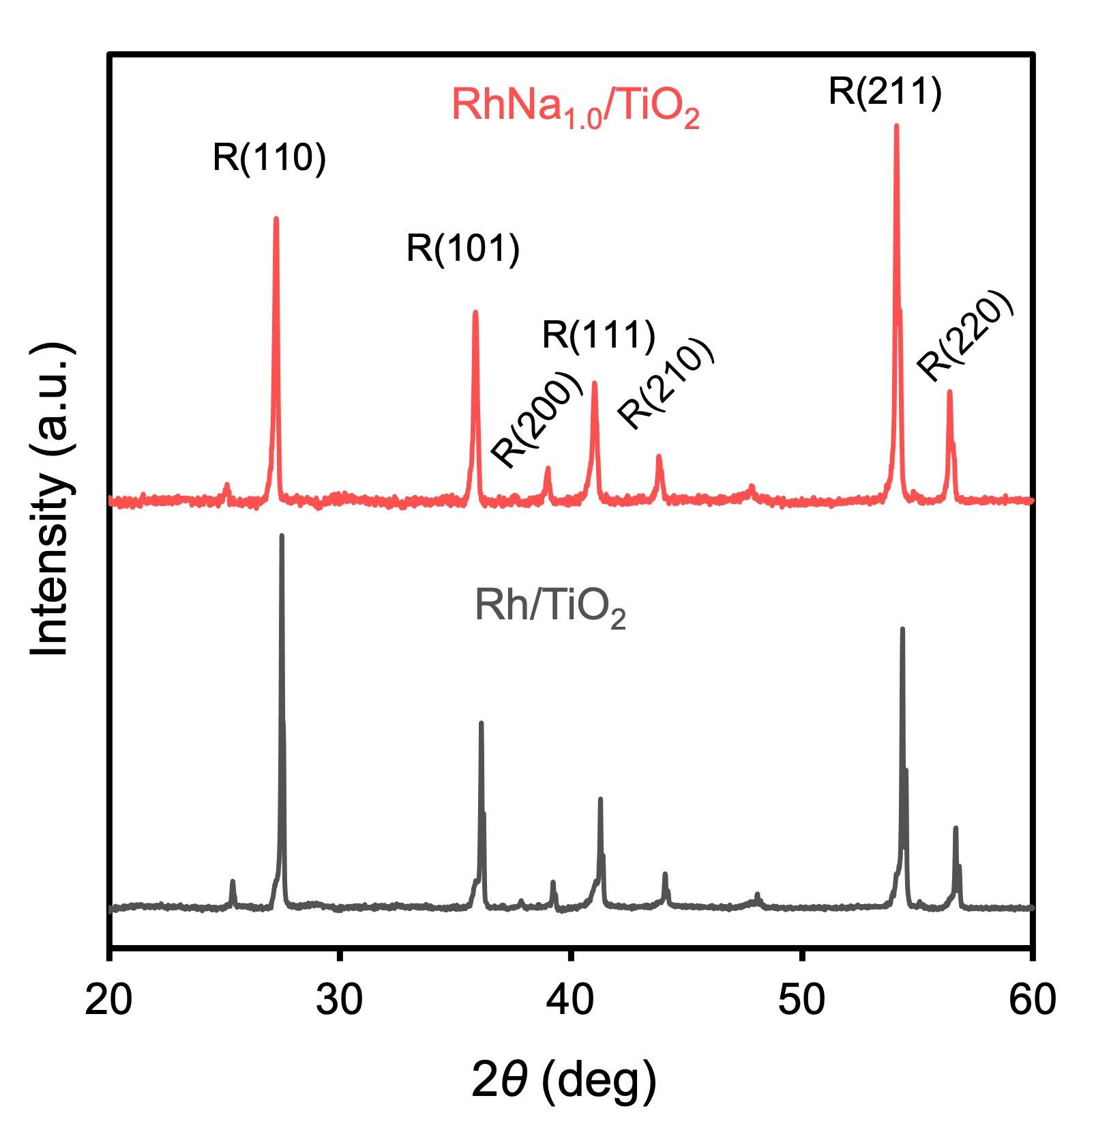
Supplementary Figure 3. Powder XRD pattern of Rh/TiO₂ and RhNa_{1.0}/TiO₂ catalysts. A small amount of anatase phase is an impurity in rutile TiO₂.

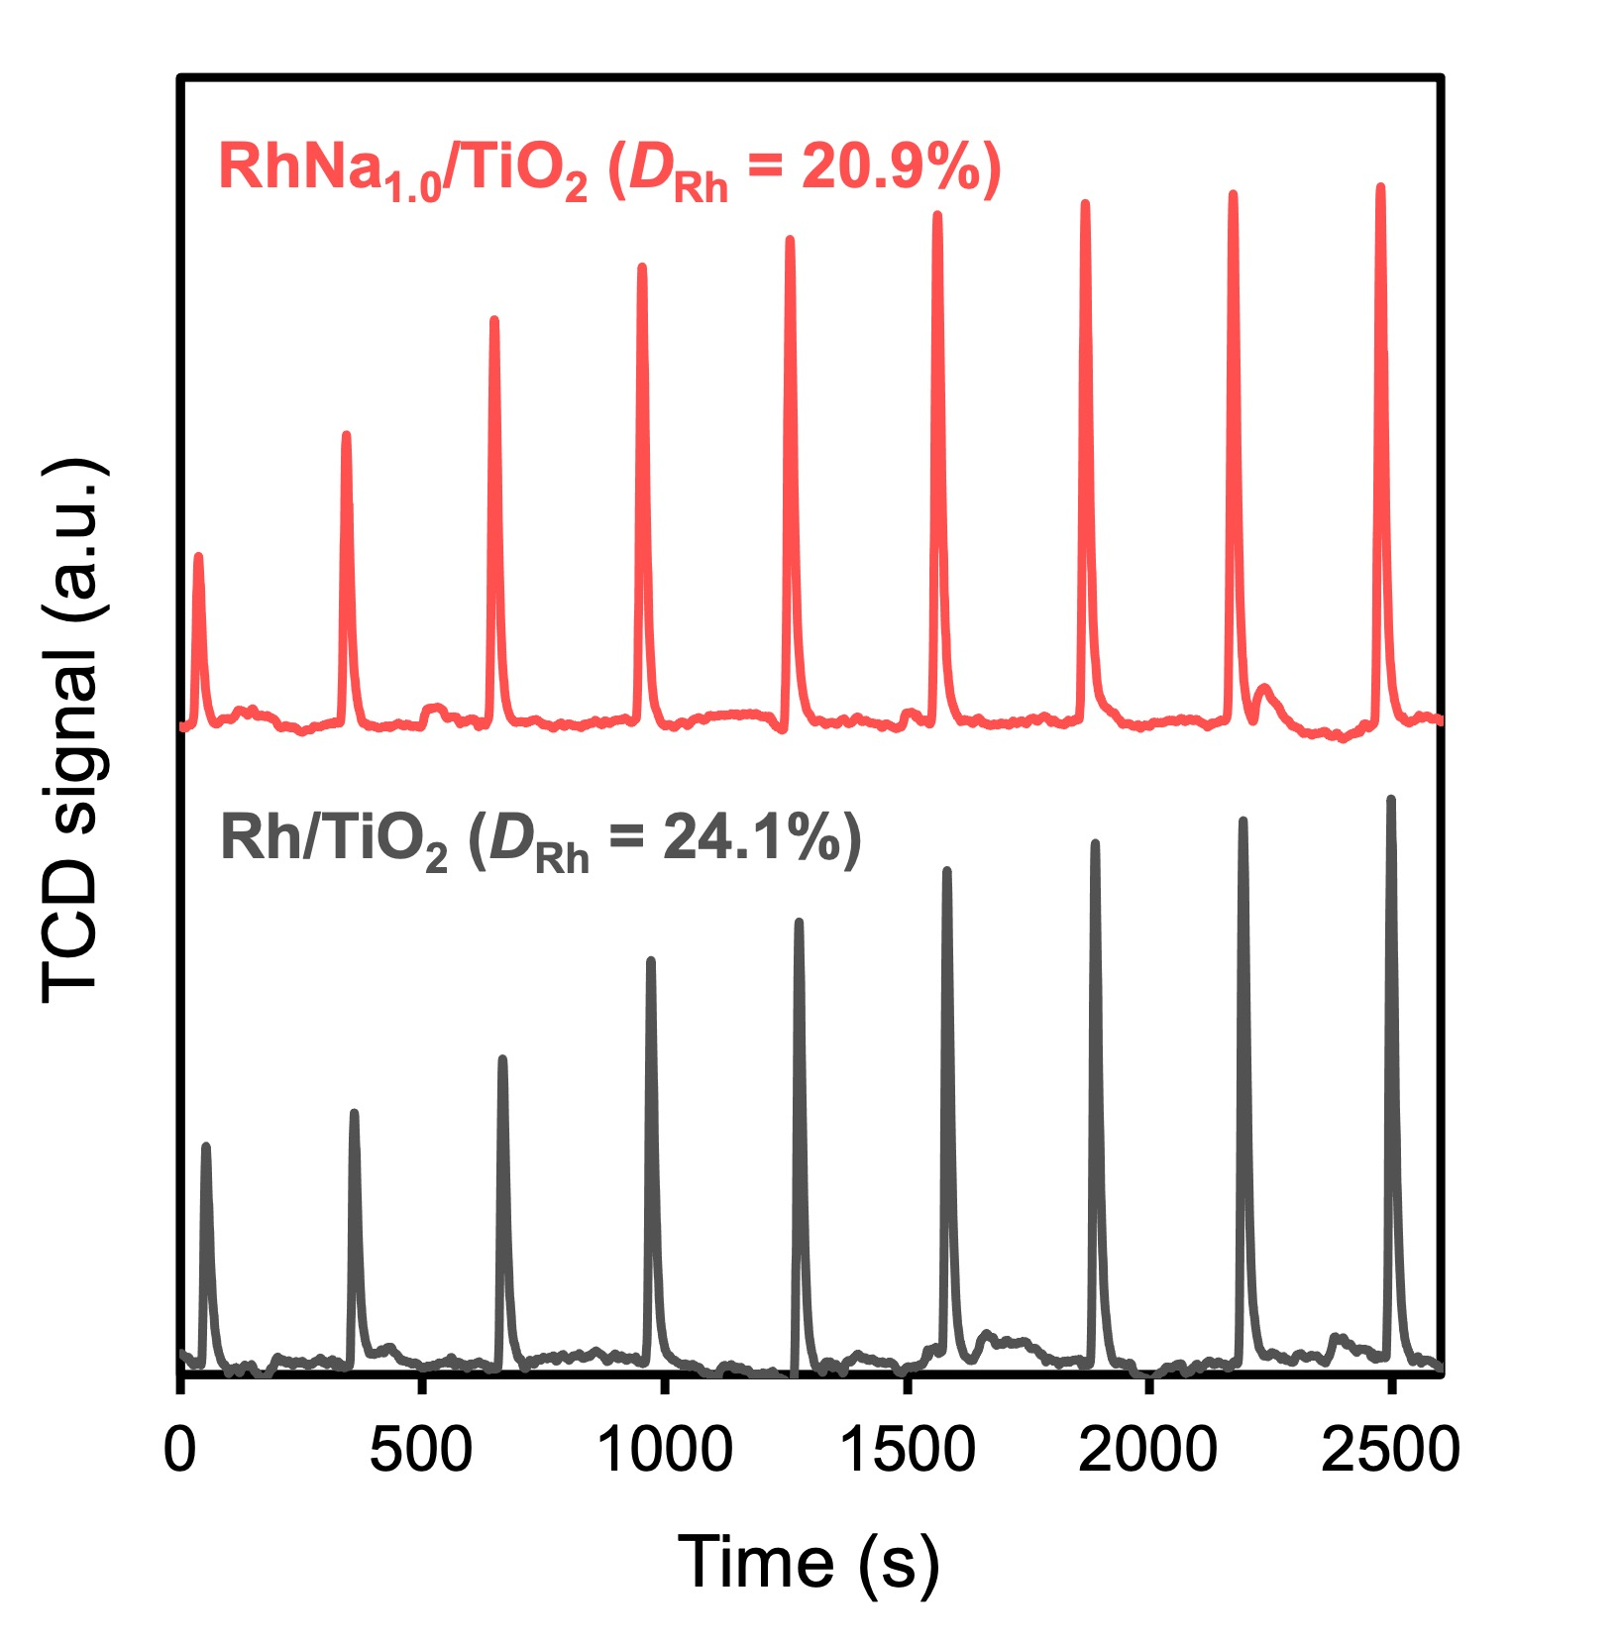
Supplementary Figure 4. CO pulse chemisorption of Rh/TiO₂ and RhNa_{1.0}/TiO₂ catalysts.

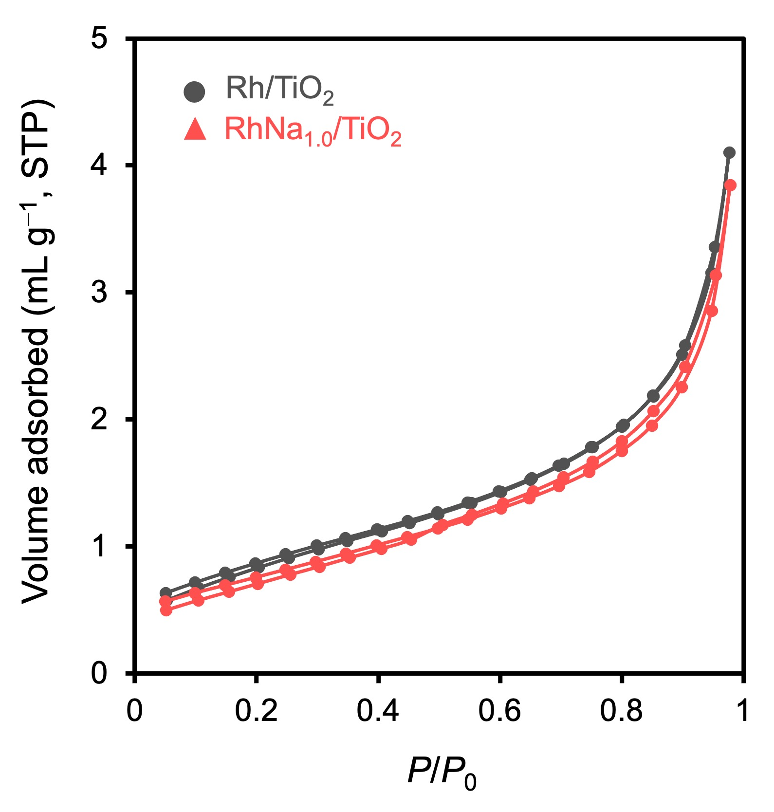
Supplementary Figure 5. N₂ adsorption-desorption isotherm at 77 K of Rh/TiO₂ and RhNa_{1.0}/TiO₂ catalysts.

Supplementary Table 1. Pore structural properties of Rh/TiO₂ and RhNa_{1.0}/TiO₂ catalysts.
Property | Rh/TiO₂ | RhNa_{1.0}/TiO₂
S_{BET} (m² g⁻¹)ª | 3.2 | 2.8
Average pore size (nm)^{b} | 4.28 | 3.96
V_{tot} (cm³ g⁻¹)^{c} | 6.1 $×$ 10⁻³ | 5.2 $×$ 10⁻³
a BET surface area
b Measured by analyzing the adsorption isotherm using the BJH method
c Total pore volume measured at P/P₀ = 0.977

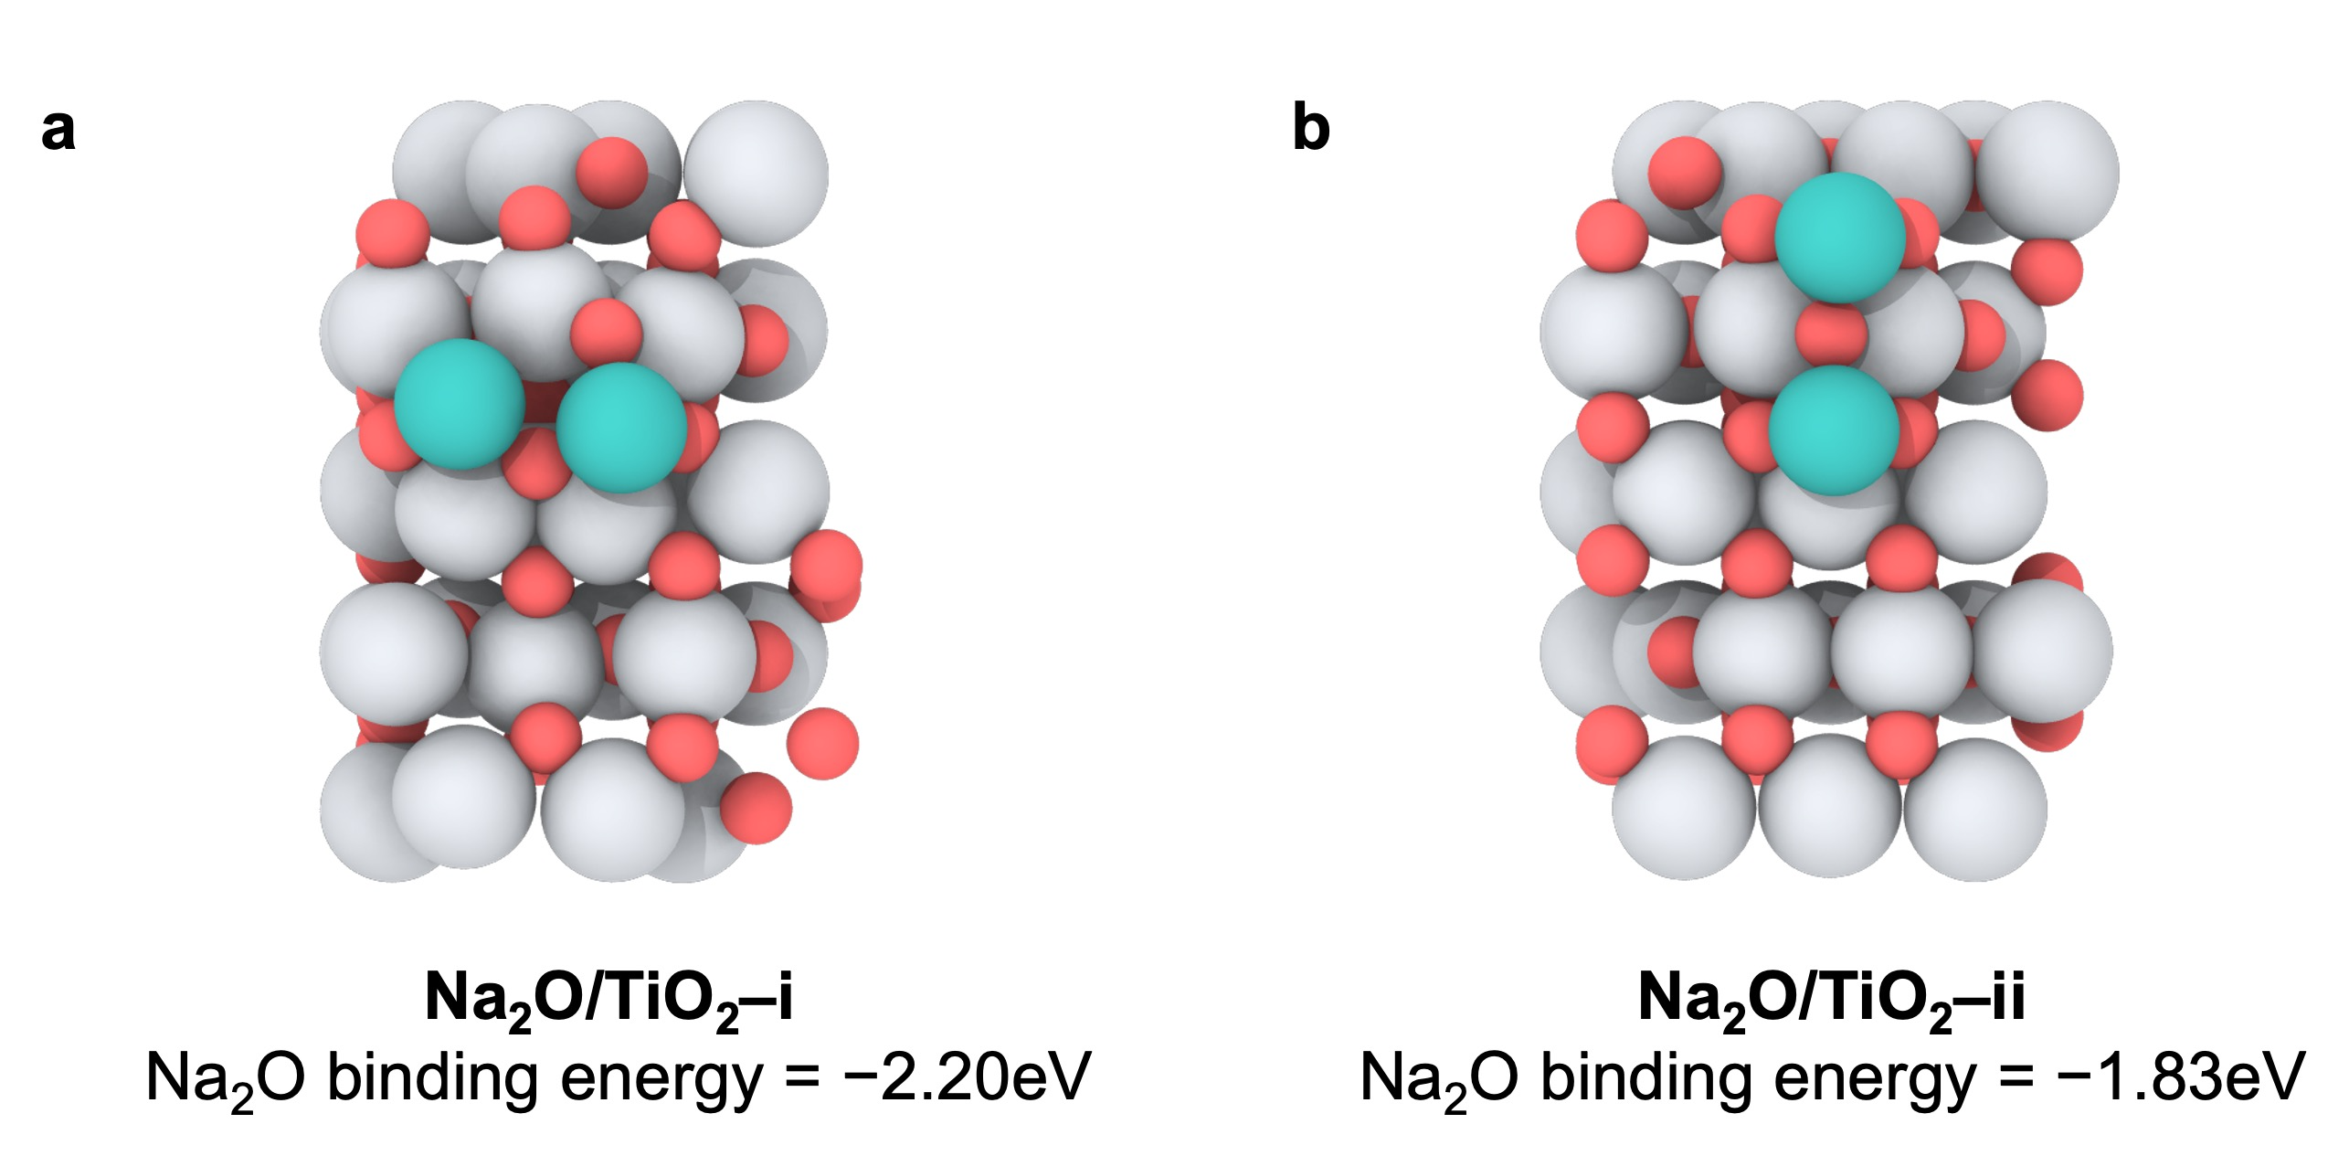
Supplementary Figure 6. Binding energy calculation of Na₂O using DFT. (a) Na₂O binding energy to TiO₂ for position i. (b) Na₂O binding energy to TiO₂ for position ii. The energy for Na⁰ on TiO₂ exceeds 6 eV (not shown here), presenting improbable structure.

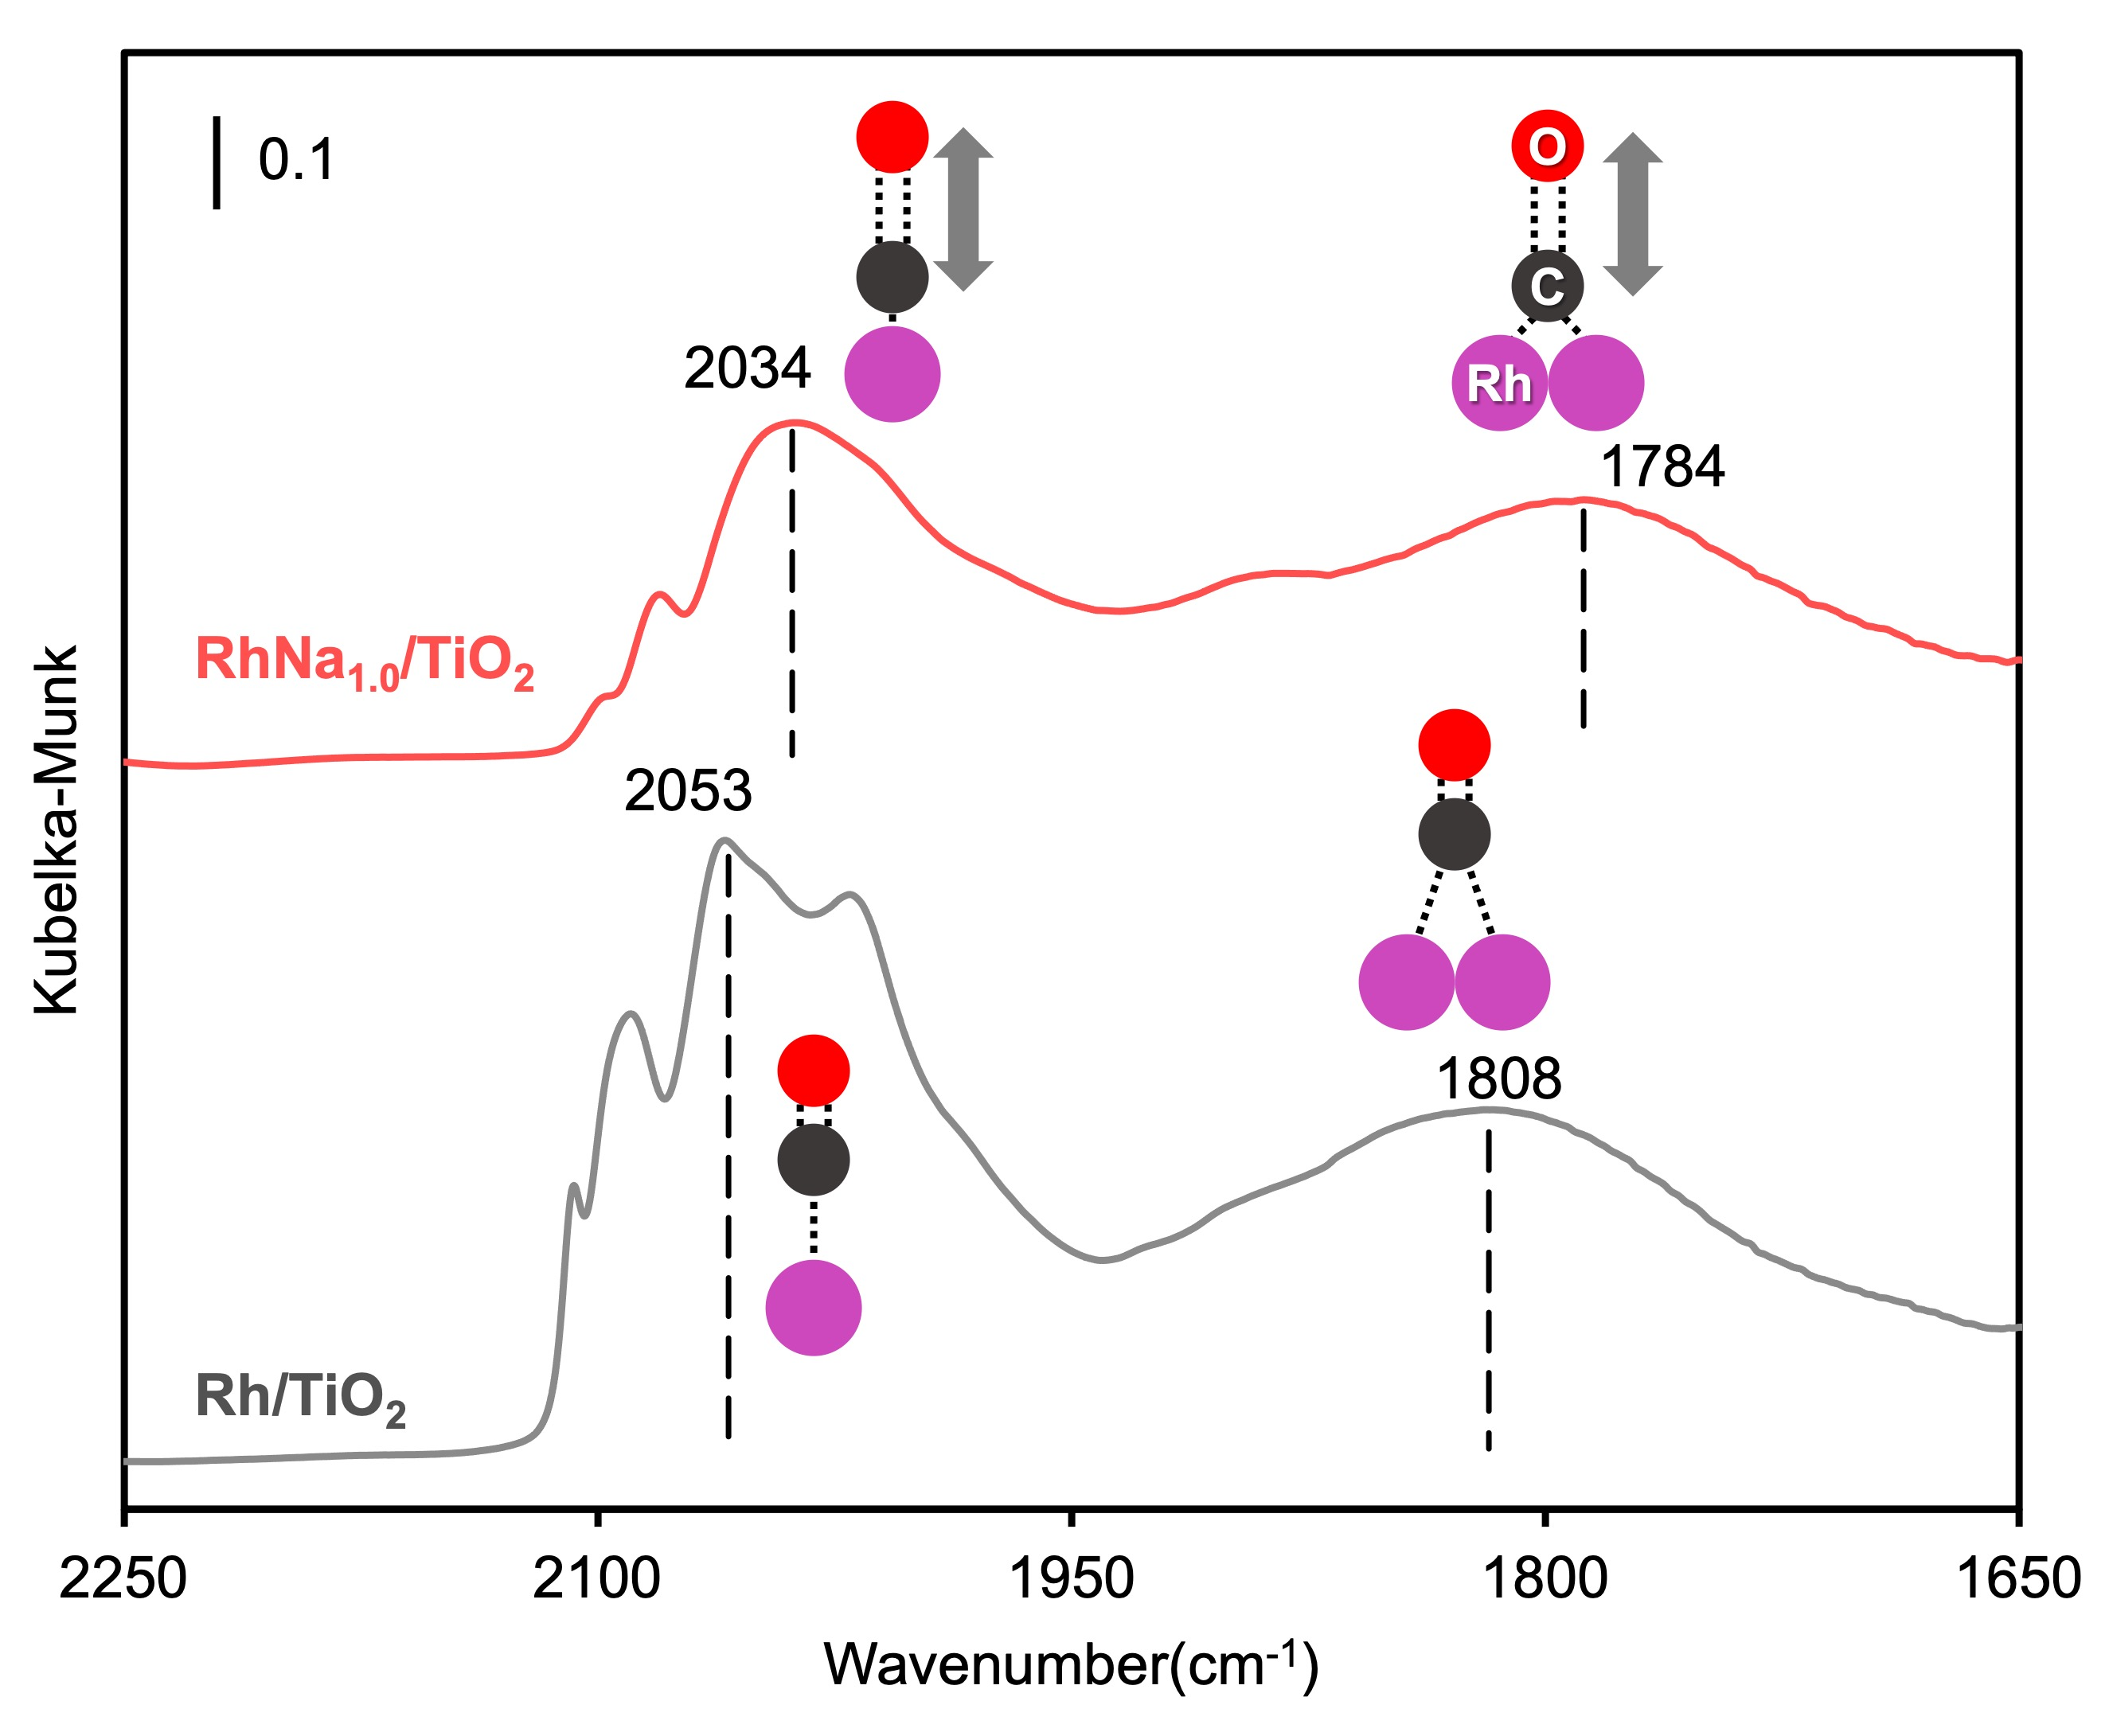
Supplementary Figure 7. In-situ CO-DRIFTS of Rh/TiO₂ and RhNa_{1.0}/TiO₂ catalysts.

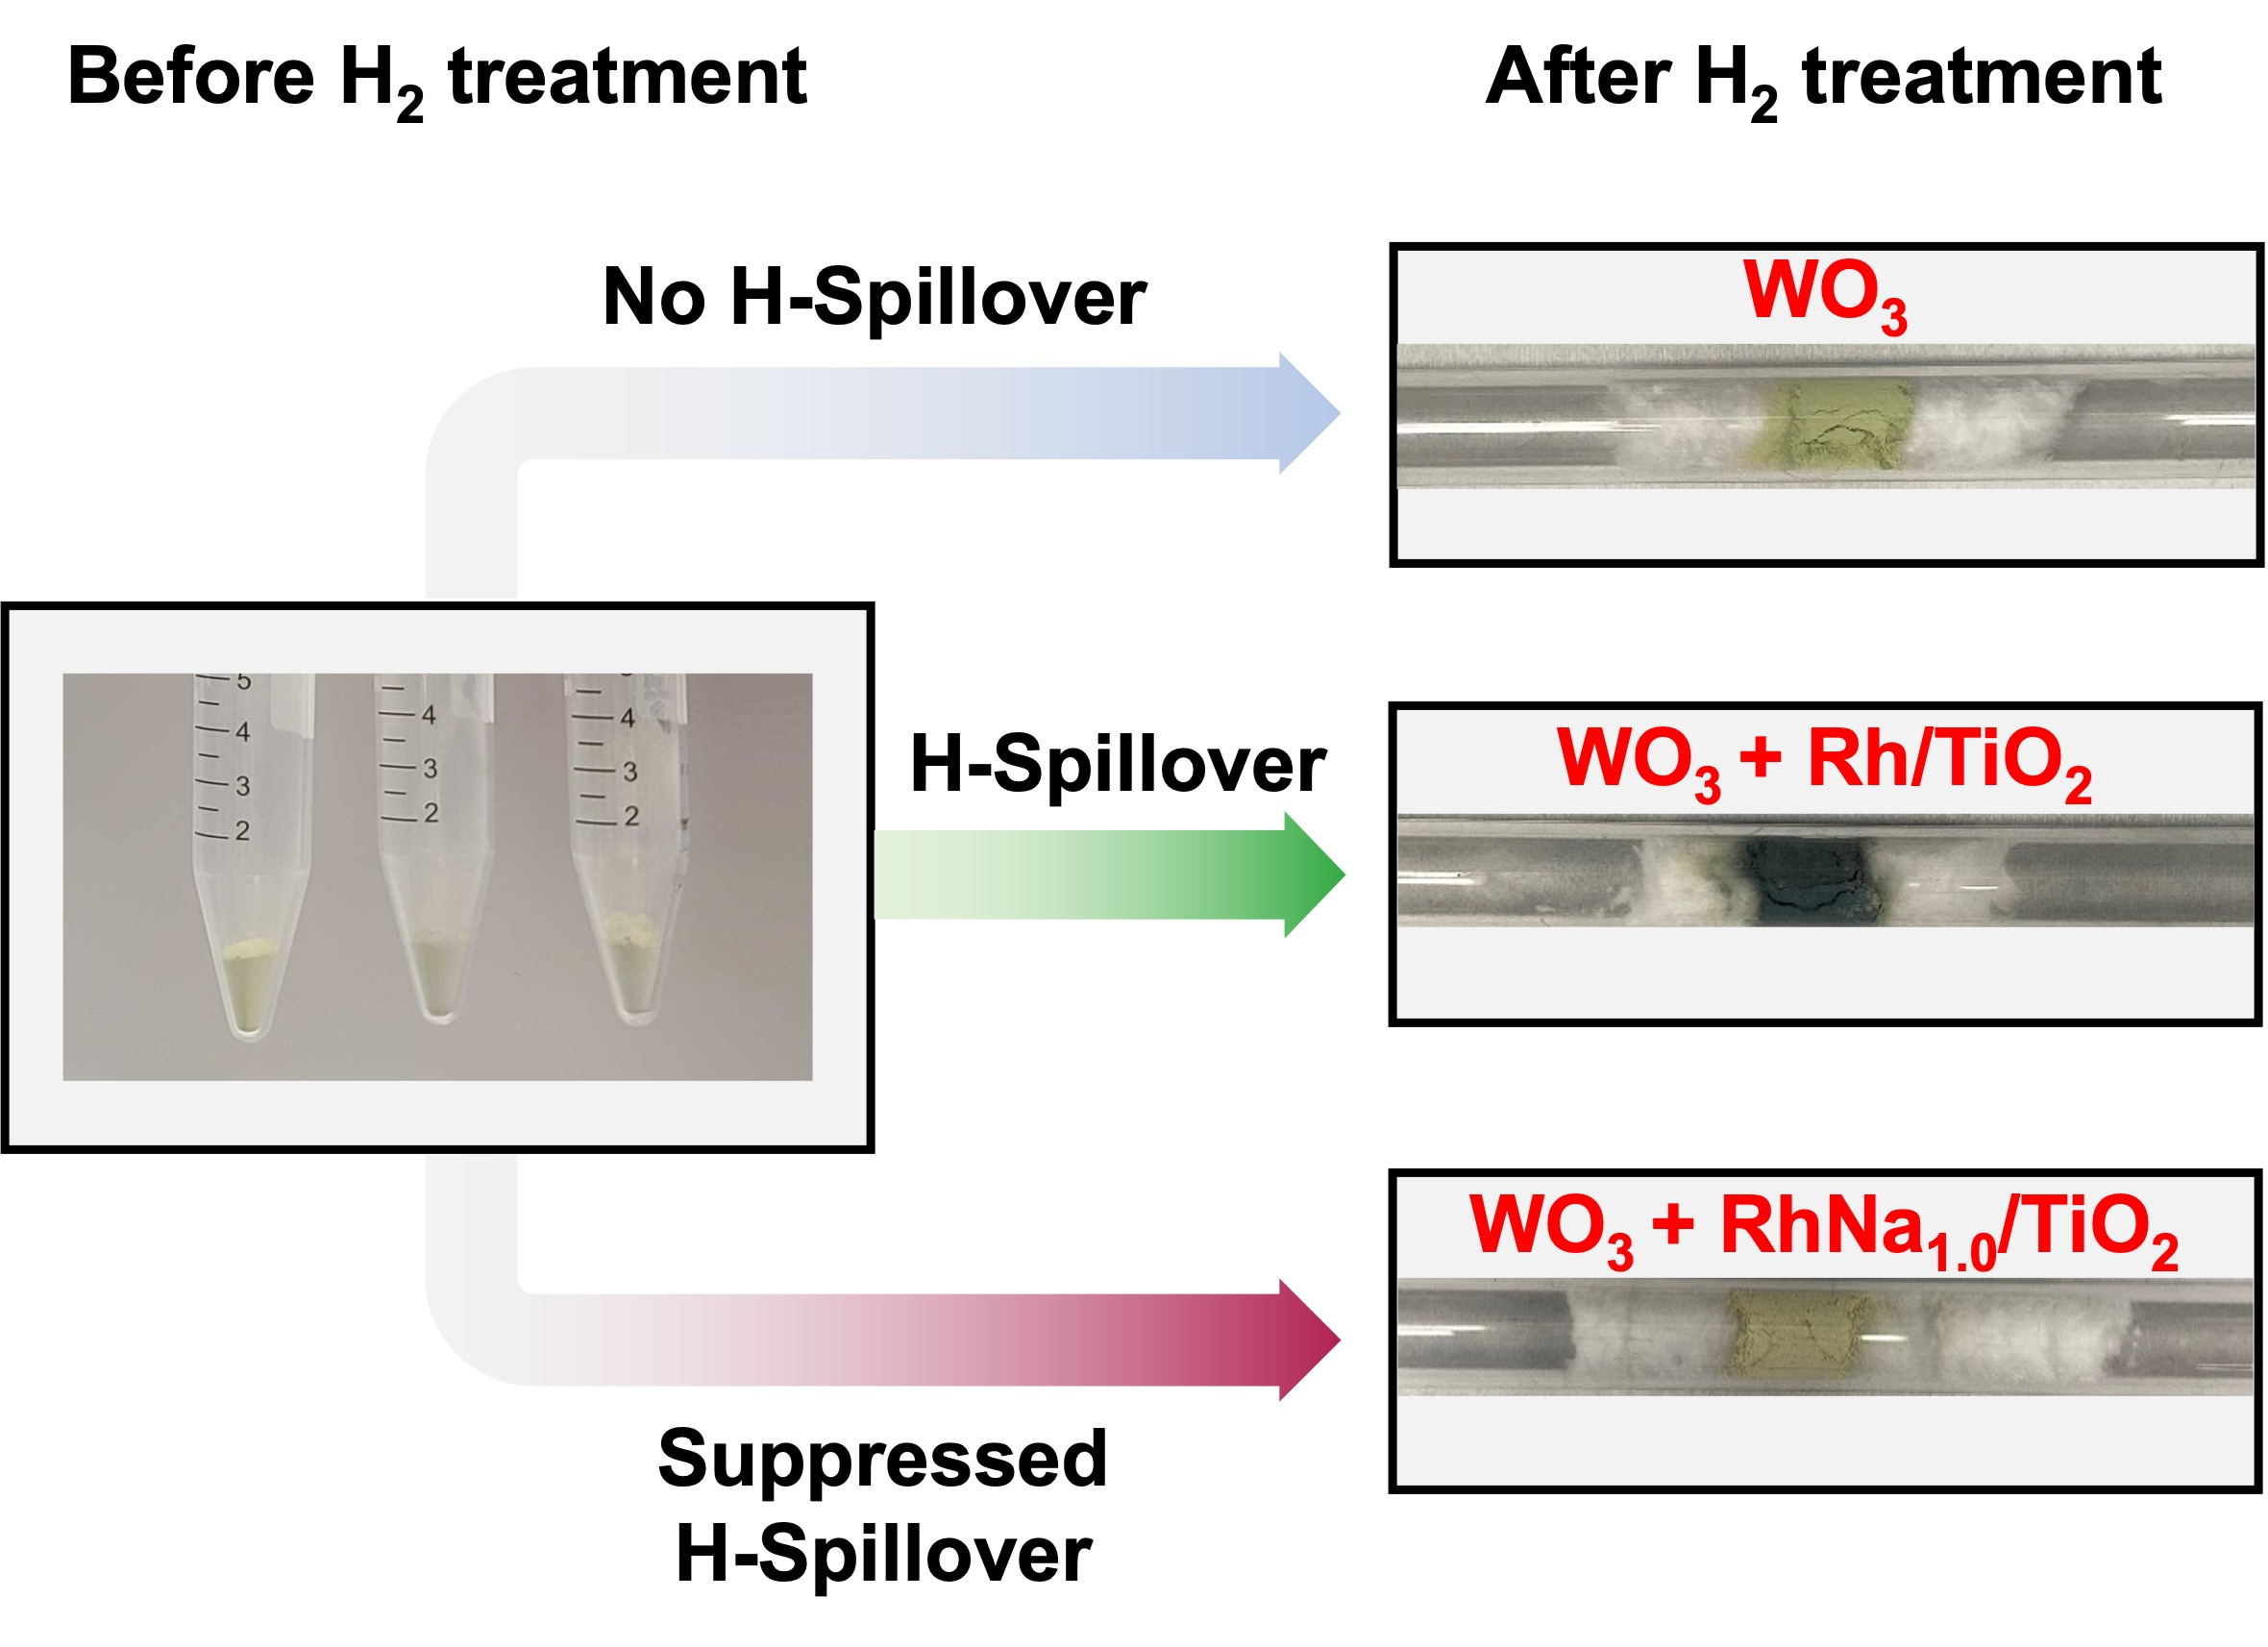
Supplementary Figure 8. WO₃ colorization experiment of Rh/TiO₂ and RhNa_{1.0}/TiO₂ after H₂ flow at 423 K for 30 min. The blue color originates from the formation of reduced WO₃ (e.g. WO_{2.9}).

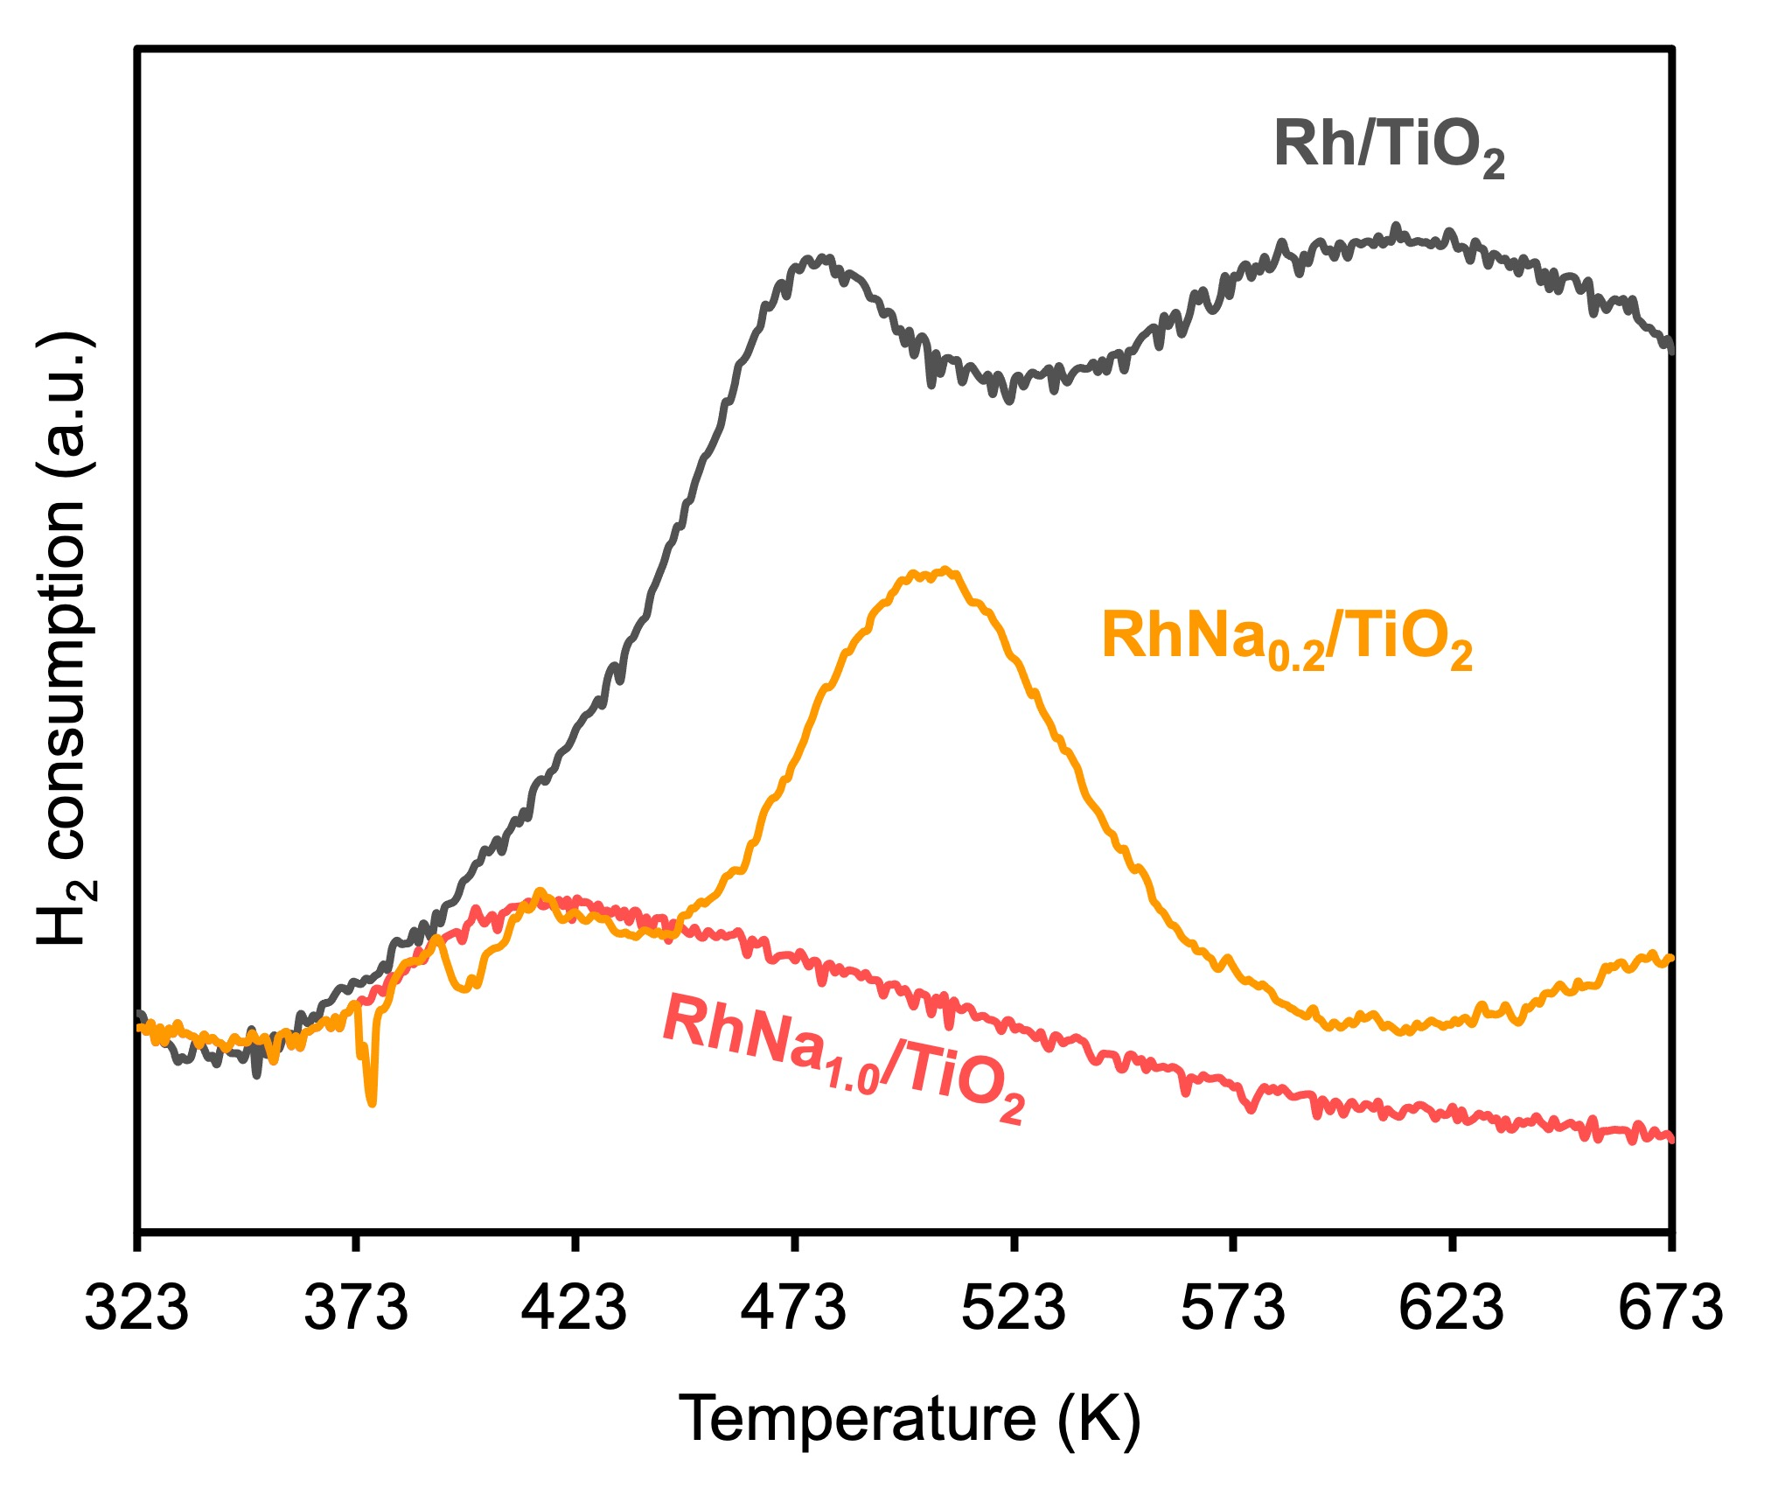
Supplementary Figure 9. TPR profile of Rh/TiO_{2,} RhNa_{0.2}TiO₂ and RhNa_{1.0}TiO₂ (calcined catalysts). The RhNa_{1.0}/TiO₂ shows significantly less reduction behavior compared to Rh/TiO₂, indicating the suppressed hydrogen spillover. The RhNa_{0.2}/TiO₂ shows an intermediate reduction trend, revealing the reduction behavior is determined by the Na content.
Supplementary Table 2. Conversion and product selectivity during CO₂ hydrogenation over various TM-AM/support catalysts (Condition: 3 MPa, 523K, CO₂/H₂/Ar = 24/72/4, WHSV of 6,000 cm³ g_{cat.}⁻¹ h⁻¹)
Product | Conversion% | Selectivity%
Product | Conversion% | CO | CH₄ | MeOH | Others
Rh/TiO₂ | 24.03 | 3.68 | 93.65 | 1.81 | 0.86
RhLi_{1.0}/TiO₂ | 10.76 | 79.44 | 14.19 | 1.50 | 4.87
RhNa_{1.0}/TiO₂ | 10.76 | 90.80 | 6.06 | 1.16 | 1.97
RhK_{1.0}/TiO₂ | 8.32 | 97.89 | 1.51 | 0.30 | 0.29
Ni/TiO₂ | 3.90 | n.d.ª | 100 | n.d. | n.d.
NiLi_{1.0}/TiO₂ | 5.46 | 81.23 | 13.16 | n.d. | 5.61
NiNa_{1.0}/TiO₂ | 6.28 | 73.77 | 18.24 | n.d. | 7.99
NiK_{1.0}/TiO₂ | 4.40 | 88.32 | 7.43 | n.d. | 4.25
Rh/SiO₂ | 7.35 | 99.07 | 0.22 | 0.70 | n.d.
RhNa_{1.0}/SiO₂ | 2.08 | 86.64 | 9.87 | 2.90 | 0.58
ª not detected

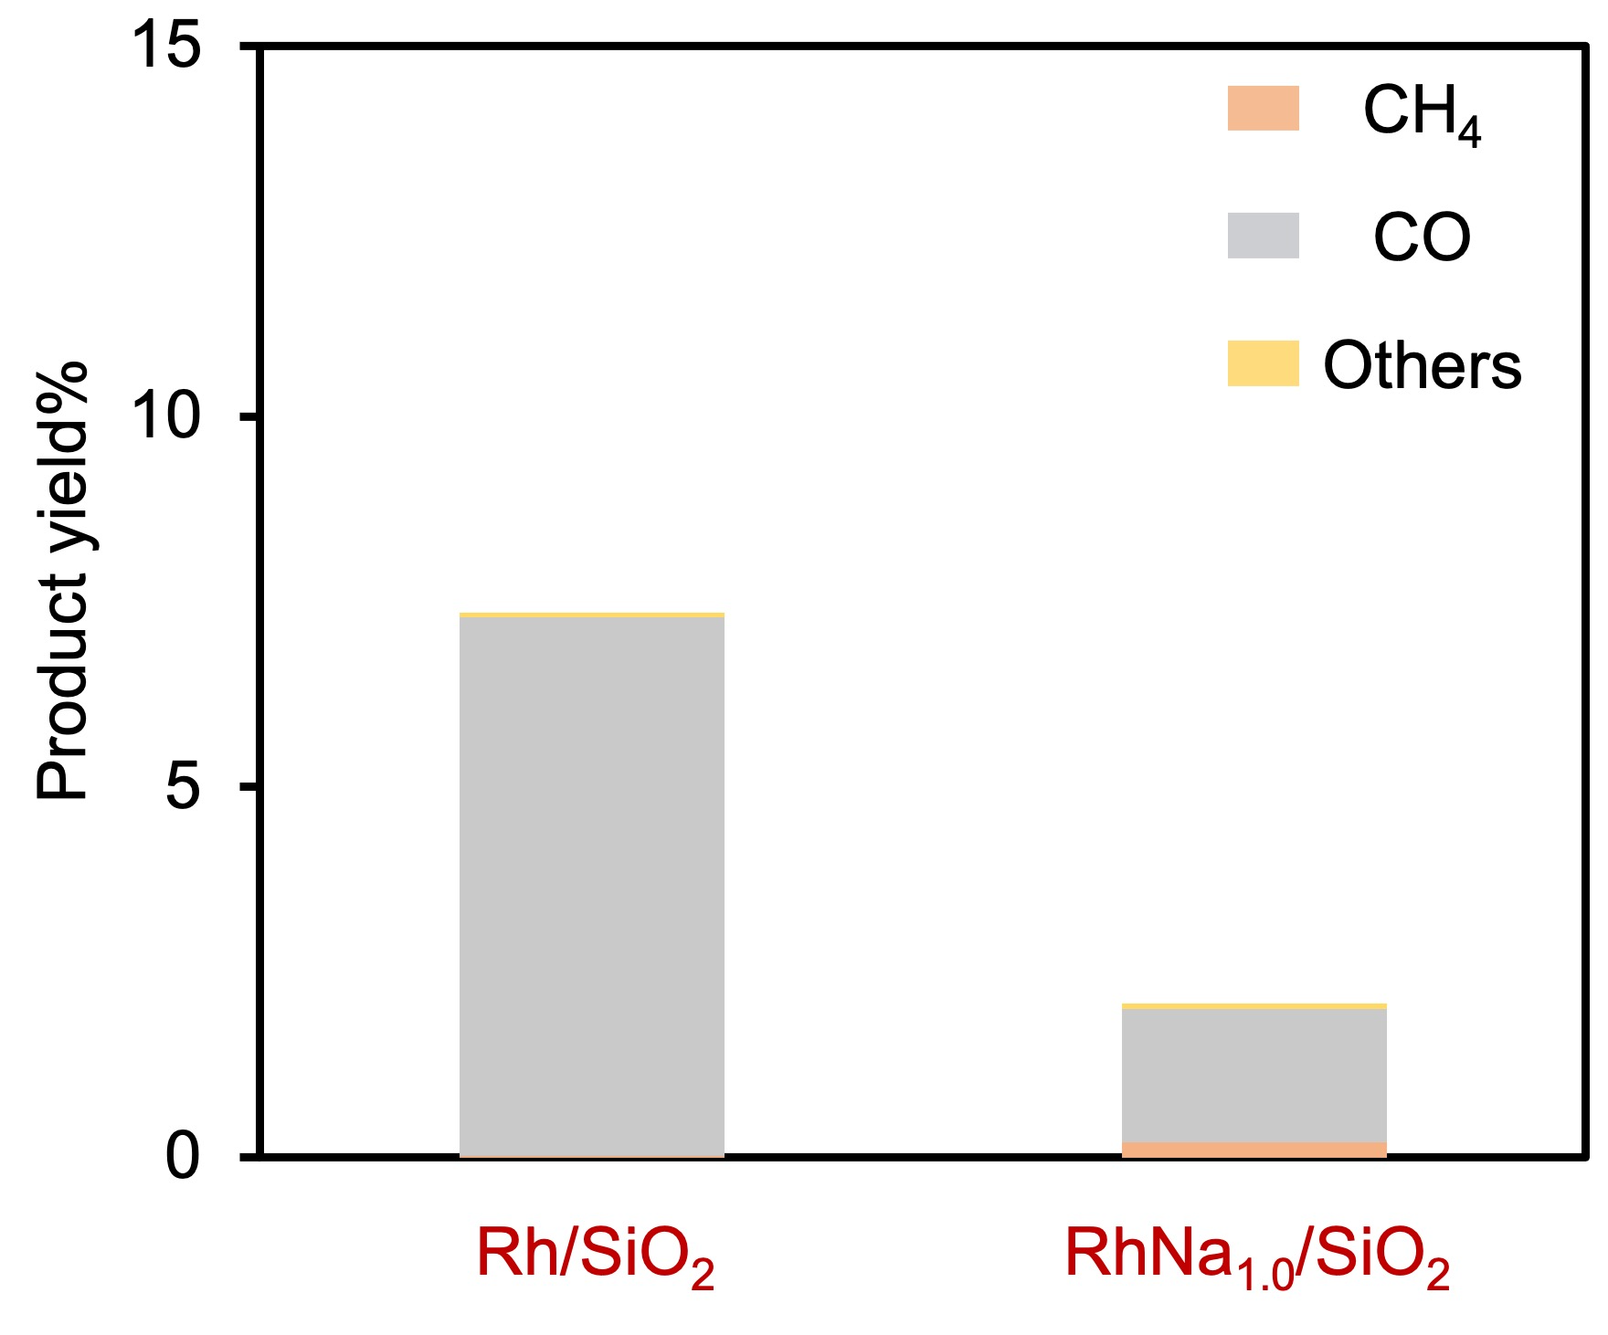
Supplementary Figure 10. Product yield of Rh/SiO₂, RhNa_{1.0}/SiO₂. Reaction condition: 3 MPa, 523 K, CO₂/H₂/Ar = 24/72/4, WHSV of 6,000 cm³ g_{cat.}⁻¹ h⁻¹.

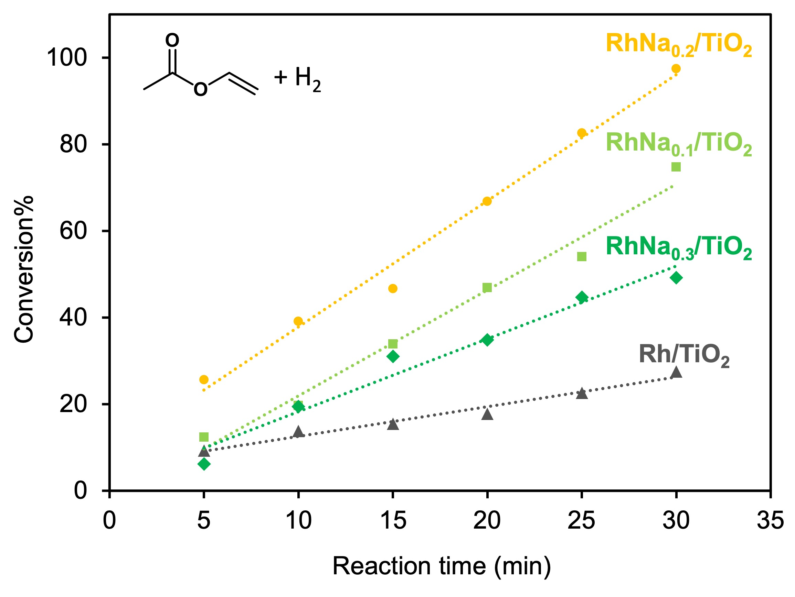
Supplementary Figure 11. Activity of vinyl acetate hydrogenation for various RhNa_{n}/TiO₂ catalysts (n = 0, 0.1, 0.2, and 0.3). Reaction condition: 298K, 40 cm³ min⁻¹ H₂ flow, 10 mM substrate, 20 mg of catalyst, 40 cm³ EtOH.

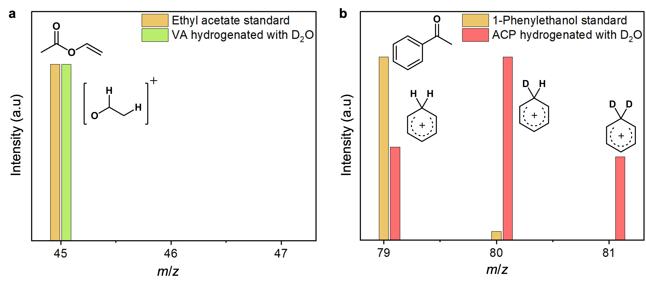
Supplementary Figure 12. Deuterium isotope-labelling during the hydrogenation of a) Vinyl acetate and b) Acetophenone in D₂O as solvent after pretreatment with H₂ for 120 min. The MS spectra of standard samples of the reaction products are shown for comparison.

References
(1) Khoobiar, S. Particle to Particle Migration of Hydrogen Atoms on Platinum—Alumina Catalysts from Particle to Neighboring Particles. The Journal of Physical Chemistry 1964, 68 (2), 411-412. DOI: https://doi.org/10.1021/j100784a503.
(2) Scarfiello, C.; Soulantica, K.; Cayez, S.; Durupt, A.; Viau, G.; Le Breton, N.; Boudalis, A. K.; Meunier, F.; Clet, G.; Barreau, M.; Salusso, D.; Zafeiratos, S.; Minh, D. P.; Serp, P. Modified Co/TiO2 catalysts for CO2 hydrogenation to fuels. Journal of Catalysis 2023, 428, 115202. DOI: https://doi.org/10.1016/j.jcat.2023.115202.
(3) Lee, K.; Mendes, P. C. D.; Jeon, H.; Song, Y.; Dickieson, M. P.; Anjum, U.; Chen, L.; Yang, T.-C.; Yang, C.-M.; Choi, M.; Kozlov, S. M.; Yan, N. Engineering nanoscale H supply chain to accelerate methanol synthesis on ZnZrOx. Nature Communications 2023, 14 (1), 819. DOI: https://doi.org/10.1038/s41467-023-36407-1.

