Extended Data Table 1. EUNIS habitat names and samples sizes (number of vegetation surveys). Vegetation surveys that could be assigned to multiple EUNIS habitat types were assigned to the finest matching level. Sample sizes for broader classes of habitat types (i.e., level 1 and level 2) only include those surveys that could not be classified into more narrowly-defined habitat types.

EUNIS level | EUNIS code | Sample size | name
- | - | 288,401 | - unassigned
1 | MA | 17 | Marine habitats
2 | MA2 | 358 | Littoral biogenic habitats
1 | N | 385 | Coastal habitats
2 | N1 | 2 | Coastal dunes and sandy shores
3 | N11 | 11 | Atlantic, Baltic and Arctic sand beach
3 | N12 | 93 | Mediterranean and Black Sea sand beach
3 | N13 | 581 | Atlantic and Baltic shifting coastal dune
3 | N14 | 513 | Mediterranean, Macaronesian, and Black Sea shifting coastal dune
3 | N15 | 282 | Atlantic and Baltic coastal dune grassland (grey dune)
3 | N16 | 322 | Mediterranean and Macaronesian coastal dune grassland (grey dune)
3 | N18 | 22 | Atlantic and Baltic coastal Empetrum heath
3 | N19 | 16 | Atlantic coastal Calluna and Ulex heath
3 | N1A | 85 | Atlantic and Baltic coastal dune scrub
3 | N1B | 62 | Mediterranean and Black Sea coastal dune scrub
3 | N1D | 9 | Atlantic and Baltic broad-leaved coastal dune forest
3 | N1G | 1 | Mediterranean coniferous coastal dune forest
3 | N1H | 377 | Atlantic and Baltic moist and wet dune slack
3 | N21 | 9 | Atlantic, Baltic and Arctic coastal shingle beach
3 | N31 | 3 | Atlantic and Baltic rocky sea cliff and shore
3 | N32 | 10 | Mediterranean and Black Sea rocky sea cliff and shore
1 | P | 48 | Inland waters
3 | P2N | 120 | Spring
2 | Pa | 9 | Brackish-water vegetation
2 | Pb | 45 | Fresh-water small pleustophyte vegetation
2 | Pc | 46 | Fresh-water large pleustophyte vegetation
2 | Pd | 558 | Fresh-water submerged vegetation
2 | Pe | 176 | Fresh-water nymphaeid vegetation
2 | Pf | 54 | Oligotrophic-water vegetation
2 | Pg | 4 | Dystrophic-water vegetation
2 | Ph | 46 | Stonewort vegetation
1 | Q | 1,005 | Mires and wetlands
3 | Q11 | 205 | Raised bog
3 | Q12 | 20 | Blanket bog
3 | Q21 | 84 | Oceanic valley mire
3 | Q22 | 312 | Poor fen
3 | Q24 | 221 | Intermediate fen and soft-water spring mire
3 | Q25 | 154 | Non-calcareous quaking mire
3 | Q41 | 142 | Alkaline, calcareous, carbonate-rich small-sedge spring fen
3 | Q42 | 71 | Extremely rich moss-sedge fen
3 | Q43 | 46 | Tall-sedge base-rich fen
3 | Q44 | 5 | Calcareous quaking mire
3 | Q45 | 2 | Arctic-alpine rich fen
3 | Q51 | 964 | Tall-helophyte bed
3 | Q52 | 624 | Small-helophyte bed
3 | Q53 | 636 | Tall-sedge bed
3 | Q54 | 179 | Inland saline or brackish helophyte bed
3 | Q61 | 35 | Periodically exposed shore with stable, eutrophic sediments with pioneer or ephemeral vegetation
3 | Q62 | 107 | Periodically exposed shore with stable, mesotrophic sediments with pioneer or ephemeral vegetation
1 | R | 32,887 | Grasslands
2 | R1 | 4 | Dry grasslands
3 | R11 | 3,383 | Pannonian and Pontic sandy steppe
3 | R12 | 19 | Cryptogam- and annual-dominated vegetation on siliceous rock outcrops
3 | R13 | 159 | Cryptogam- and annual-dominated vegetation on calcareous and ultramafic rock outcrops
3 | R14 | 104 | Perennial rocky grassland of the Italian Peninsula
3 | R16 | 525 | Perennial rocky grassland of Central and South-Eastern Europe
3 | R19 | 16 | Dry steppic submediterranean pasture of the Amphi-Adriatic region
3 | R1A | 6,834 | Semi-dry perennial calcareous grassland (meadow steppe)
3 | R1B | 1,141 | Continental dry grassland (true steppe)
3 | R1D | 4 | Mediterranean closely grazed dry grassland
3 | R1E | 83 | Mediterranean tall perennial dry grassland
3 | R1G | 154 | Iberian oromediterranean siliceous dry grassland
3 | R1H | 93 | Iberian oromediterranean basiphilous dry grassland
3 | R1J | 5 | Cyrno-Sardean oromediterranean siliceous dry grassland
3 | R1M | 891 | Lowland to montane, dry to mesic grassland usually dominated by Nardus stricta
3 | R1N | 10 | Open Iberian supramediterranean dry acid and neutral grassland
3 | R1P | 650 | Oceanic to subcontinental inland sand grassland on dry acid and neutral soils
3 | R1Q | 63 | Inland sanddrift and dune with siliceous grassland
3 | R1R | 158 | Mediterranean to Atlantic open, dry, acid and neutral grassland
3 | R21 | 5,261 | Mesic permanent pasture of lowlands and mountains
3 | R22 | 16,123 | Low and medium altitude hay meadow
3 | R23 | 1,065 | Mountain hay meadow
3 | R31 | 8 | Mediterranean tall humid inland grassland
3 | R33 | 7 | Mediterranean short moist grassland of mountains
3 | R34 | 1 | Submediterranean moist meadow
3 | R35 | 4,884 | Moist or wet mesotrophic to eutrophic hay meadow
3 | R36 | 1,023 | Moist or wet mesotrophic to eutrophic pasture
3 | R37 | 1,727 | Temperate and boreal moist or wet oligotrophic grassland
2 | R4 | 13 | Alpine and subalpine grasslands
3 | R41 | 410 | Snow-bed vegetation
3 | R42 | 99 | Boreal and Arctic acidophilous alpine grassland
3 | R43 | 1,866 | Temperate acidophilous alpine grassland
3 | R44 | 1,095 | Arctic-alpine calcareous grassland
3 | R45 | 125 | Alpine and subalpine calcareous grassland of the Balkans and Apennines
3 | R51 | 78 | Thermophilous forest fringe of base-rich soils
3 | R52 | 9 | Forest fringe of acidic nutrient-poor soils
3 | R54 | 803 | Pteridium aquilinum vegetation
3 | R55 | 1,746 | Lowland moist or wet tall-herb and fern fringe
3 | R56 | 151 | Montane to subalpine moist or wet tall-herb and fern fringe
3 | R57 | 459 | Herbaceous forest clearing vegetation
3 | R62 | 11 | Continental inland salt steppe
3 | R63 | 49 | Temperate inland salt marsh
1 | S | 1,759 | Heathlands, scrub and tundra
2 | S2 | 33 | Arctic, alpine and subalpine scrub
3 | S21 | 328 | Subarctic and alpine dwarf Salix scrub
3 | S22 | 1,180 | Alpine and subalpine ericoid heath
3 | S23 | 335 | Alpine and subalpine Juniperus scrub
3 | S24 | 2 | Subalpine genistoid scrub of the Amphi-Adriatic region
3 | S25 | 66 | Subalpine and subarctic deciduous scrub
3 | S26 | 223 | Subalpine Pinus mugo scrub
2 | S3 | 14 | Temperate and mediterranean-montane scrub
3 | S31 | 84 | Lowland to montane temperate and submediterranean Juniperus scrub
3 | S32 | 351 | Temperate Rubus scrub
3 | S33 | 63 | Lowland to montane temperate and submediterranean genistoid scrub
3 | S35 | 868 | Temperate and submediterranean thorn scrub
3 | S36 | 28 | Low steppic scrub
3 | S37 | 78 | Corylus avellana scrub
3 | S38 | 271 | Temperate forest clearing scrub
3 | S41 | 361 | Wet heath
3 | S42 | 262 | Dry heath
3 | S43 | 2,242 | Macaronesian heath
2 | S5 | 3 | Maquis, arborescent matorral and thermo-Mediterranean scrub
3 | S51 | 104 | Mediterranean maquis and arborescent matorral
3 | S52 | 1 | Submediterranean pseudomaquis
3 | S53 | 1 | Spartium junceum scrub
3 | S54 | 7 | Thermomediterranean arid scrub
3 | S61 | 8 | Western basiphilous garrigue
3 | S63 | 3 | Eastern garrigue
2 | S7 | 36 | Spiny Mediterranean heaths (phrygana, hedgehog-heaths and related coastal cliff vegetation)
3 | S75 | 2 | Eastern Mediterranean mountain hedgehog-heath
3 | S91 | 85 | Temperate riparian scrub
3 | S92 | 170 | Salix fen scrub
1 | T | 8,523 | Forest
2 | T1 | 227 | Deciduous broadleaved forest
3 | T11 | 193 | Temperate Salix and Populus riparian forest
3 | T12 | 705 | Alnus glutinosa-Alnus incana forest on riparian and mineral soils
3 | T13 | 996 | Temperate hardwood riparian forest
3 | T14 | 8 | Mediterranean and Macaronesian riparian forest
3 | T15 | 216 | Broadleaved swamp forest on non-acid peat
3 | T16 | 226 | Broadleaved mire forest on acid peat
3 | T17 | 5,369 | Fagus forest on non-acid soils
3 | T18 | 1332 | Fagus forest on acid soils
3 | T19 | 361 | Temperate and submediterranean thermophilous deciduous forest
3 | T1B | 648 | Acidophilous Quercus forest
3 | T1C | 45 | Temperate and boreal mountain Betula and Populus tremula forest on mineral soils
3 | T1E | 2,773 | Carpinus and Quercus mesic deciduous forest
3 | T1F | 625 | Ravine forest
3 | T1H | 330 | Broadleaved deciduous plantation of non site-native trees
2 | T2 | 2 | Broadleaved evergreen forest
3 | T21 | 107 | Mediterranean evergreen Quercus forest
3 | T22 | 4 | Mainland laurophyllous forest
3 | T24 | 49 | Olea europaea-Ceratonia siliqua forest
3 | T27 | 20 | Ilex aquifolium forest
3 | T28 | 6 | Macaronesian heathy forest
3 | T29 | 27 | Broadleaved evergreen plantation of non site-native trees
2 | T3 | 21 | Coniferous forest
3 | T32 | 672 | Temperate mountain Abies forest
3 | T33 | 8 | Mediterranean mountain Abies forest
3 | T34 | 96 | Temperate subalpine Larix, Pinus cembra and Pinus uncinata forest
3 | T35 | 1,403 | Temperate continental Pinus sylvestris forest
3 | T36 | 93 | Temperate and submediterranean montane Pinus sylvestris-Pinus nigra forest
3 | T38 | 1 | Mediterranean montane Cedrus forest
3 | T3A | 61 | Mediterranean lowland to submontane Pinus forest
3 | T3C | 6 | Taxus baccata forest
3 | T3D | 5 | Mediterranean Cupressaceae forest
3 | T3F | 142 | Dark taiga
3 | T3G | 18 | Pinus sylvestris light taiga
3 | T3J | 99 | Pinus and Larix mire forest
3 | T3K | 65 | Picea mire forest
3 | T3M | 395 | Coniferous plantation of non site-native trees
1 | U | 268 | Inland sparsely vegetated habitats
3 | U22 | 1,742 | Temperate high-mountain siliceous scree
3 | U23 | 9 | Temperate, lowland to montane siliceous scree
3 | U24 | 60 | Mediterranean siliceous scree
3 | U26 | 664 | Temperate high-mountain base-rich scree and moraine
3 | U27 | 1,655 | Temperate, lowland to montane base-rich scree
3 | U28 | 44 | Western Mediterranean base-rich scree
3 | U29 | 39 | Eastern Mediterranean base-rich scree
3 | U32 | 18 | Temperate high-mountain siliceous inland cliff
3 | U33 | 31 | Temperate, lowland to montane siliceous inland cliff
3 | U34 | 4 | Mediterranean siliceous inland cliff
3 | U36 | 189 | Temperate high-mountain base-rich inland cliff
3 | U37 | 118 | Temperate, lowland to montane base-rich inland cliff
3 | U38 | 21 | Mediterranean base-rich inland cliff
3 | U3A | 35 | Temperate ultramafic inland cliff
3 | U3D | 7 | Wet inland cliff
3 | U52 | 2 | Polar desert
3 | U71 | 7 | Unvegetated or sparsely vegetated gravel bar in montane and alpine regions
1 | V | 1,802 | Vegetated man-made habitats
3 | V11 | 678 | Intensive unmixed crops
3 | V12 | 17 | Mixed crops of market gardens and horticulture
3 | V13 | 117 | Arable land with unmixed crops grown by low-intensity agricultural methods
3 | V15 | 2387 | Bare tilled, fallow or recently abandoned arable land
3 | V32 | 219 | Mediterranean subnitrophilous annual grassland
3 | V33 | 9 | Dry Mediterranean land with unpalatable non-vernal herbaceous vegetation
3 | V34 | 19 | Trampled xeric grassland with annuals
3 | V35 | 12 | Trampled mesophilous grassland with annuals
3 | V37 | 1,360 | Annual anthropogenic herbaceous vegetation
3 | V38 | 1,627 | Dry perennial anthropogenic herbaceous vegetation
3 | V39 | 239 | Mesic perennial anthropogenic herbaceous vegetation

Extended Data Fig. 1. Number of time series within level 1 and level 2 of the EUNIS hierarchy of habitat types. Colouring indicates number of time series (assignment on the classification at the first survey date): =1■ <10■ <100■ <1,000■ ≥1,000■.
“-“ shows the number of plots that could not be assigned to a habitat type.

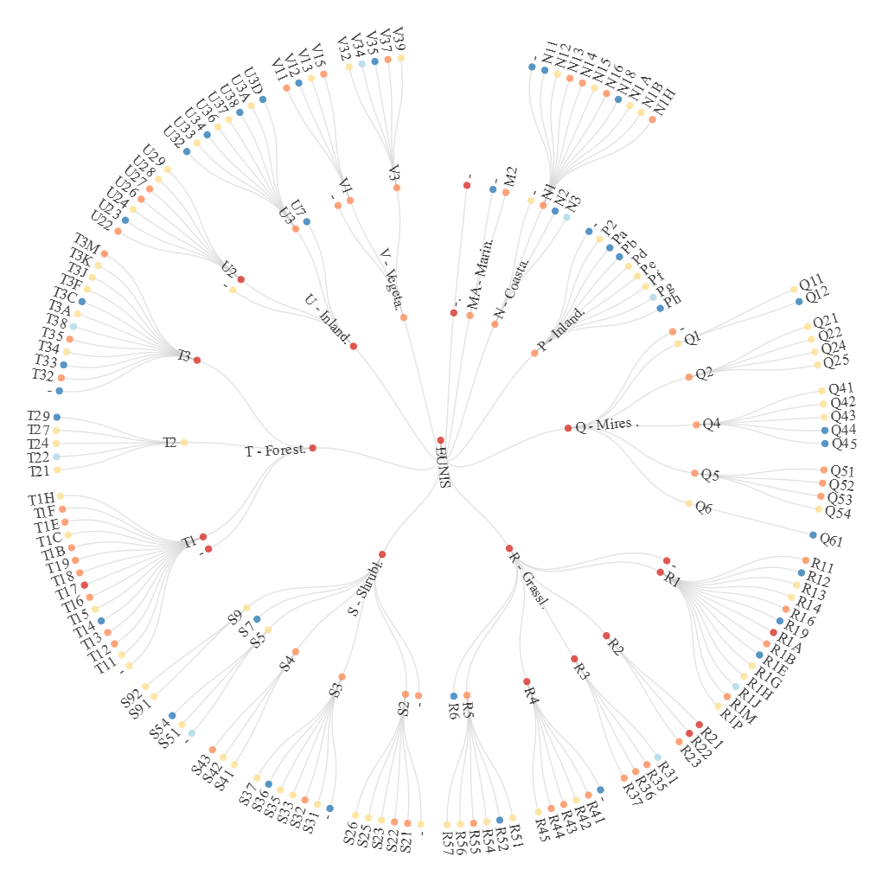

Extended Fig. 2a. Time span and number of time series per EUNIS level 1 habitat types (aggregated into bins of 5-year intervals).

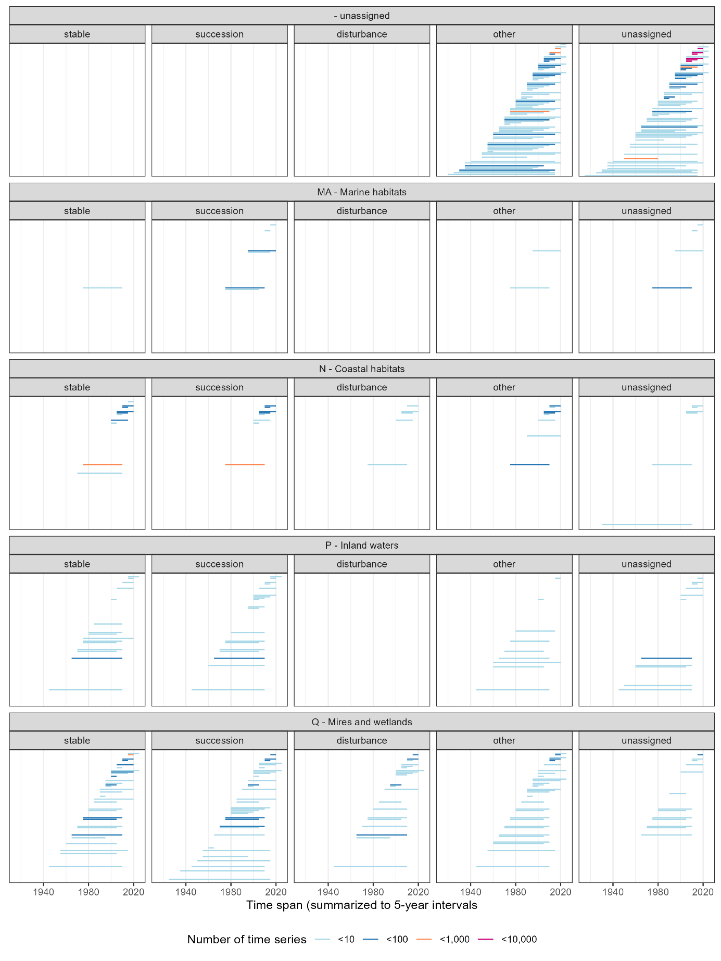

Extended Data Fig. 2b. Time span and number of time series per EUNIS level 1 habitat types (aggregated into bins of 5-year intervals).

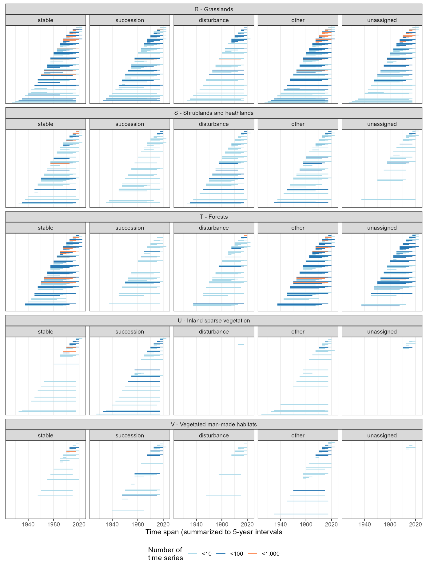

Extended Data Fig. 3. Habitat shifts among EUNIS level 1 habitat types in the ReSurvey Europe time series, including time series that could not be assigned to a habitat type and time series with stable level 1 habitat types.

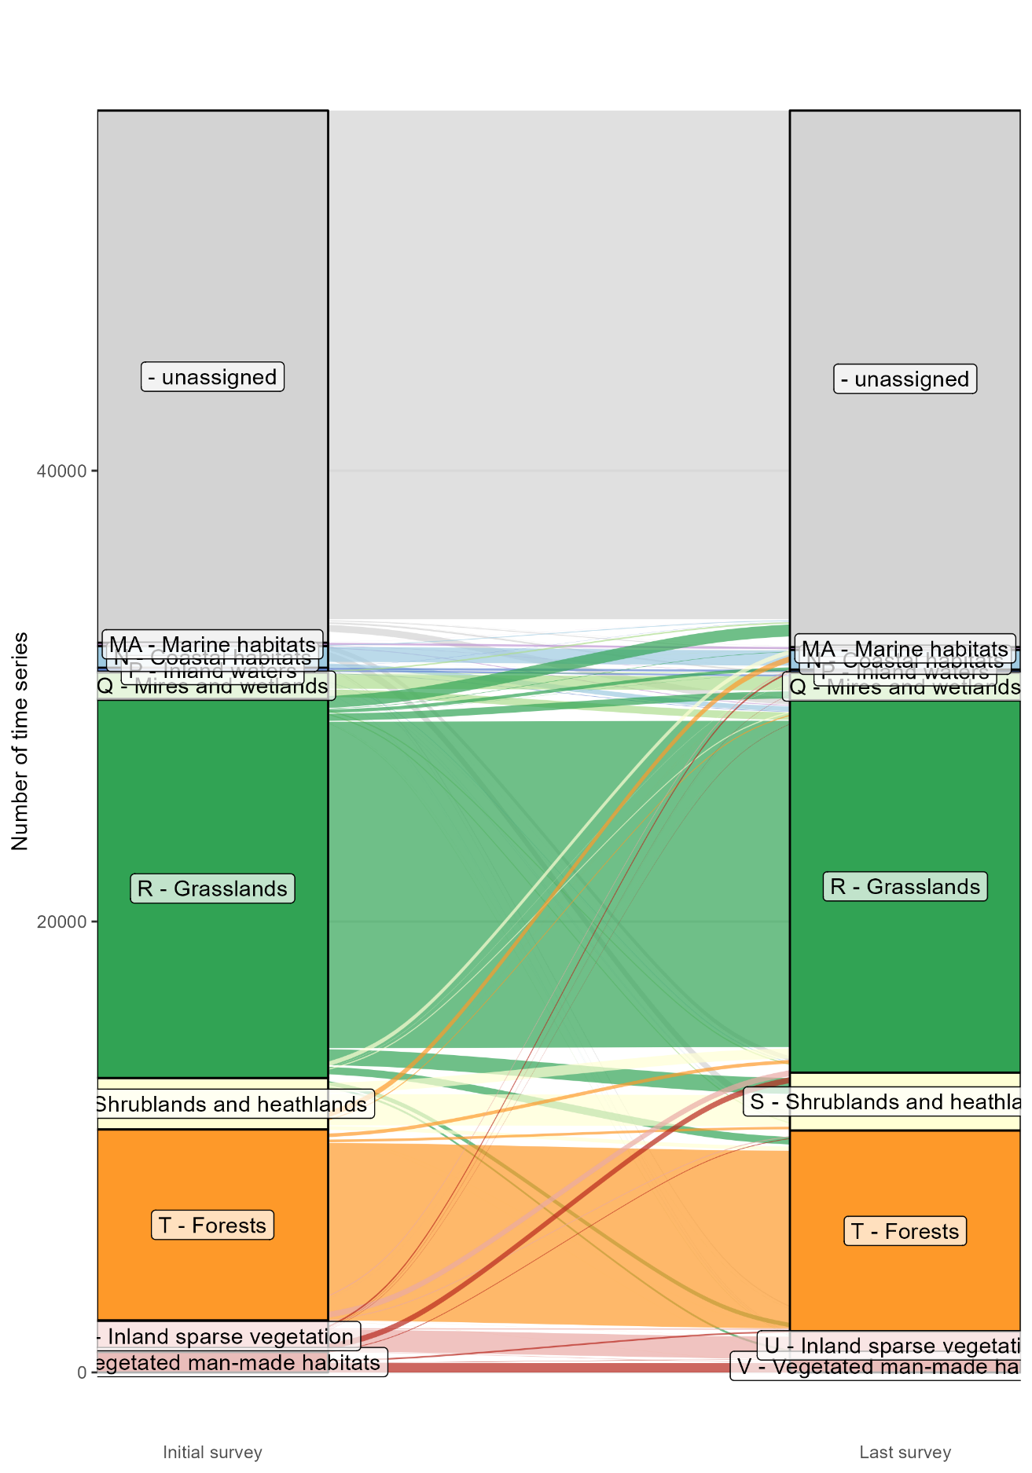

Extended Data Fig. 4. Number and direction of EUNIS level 1 habitat shifts within time series (i.e., differences between vegetation surveys at the first versus the last survey date. Numbers refer to the number of time series (further illustrated by the size and colour of circles). Time series in the diagonal (marked with boxes) showed no shift in EUNIS level 1 habitat types.
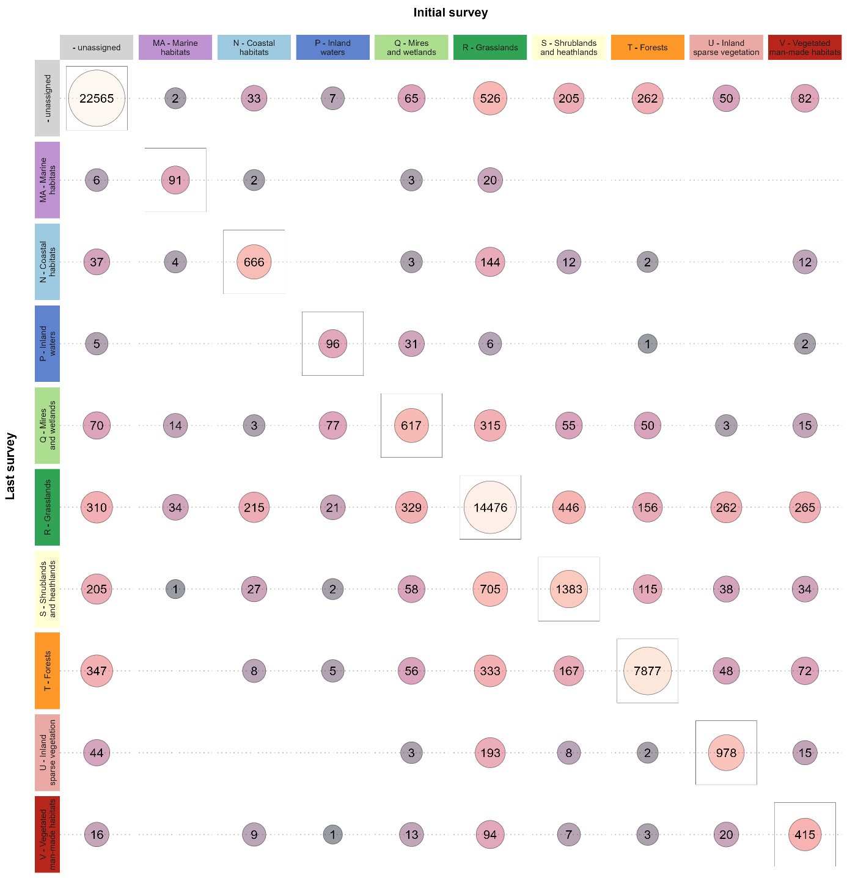

Extended Data Fig. 5. Average annual trends in absolute values of plant diversity within EUNIS level 1 habitat types (estimated with weighted linear models in which each time series contributed according to the logarithm of the number of vegetation surveys).

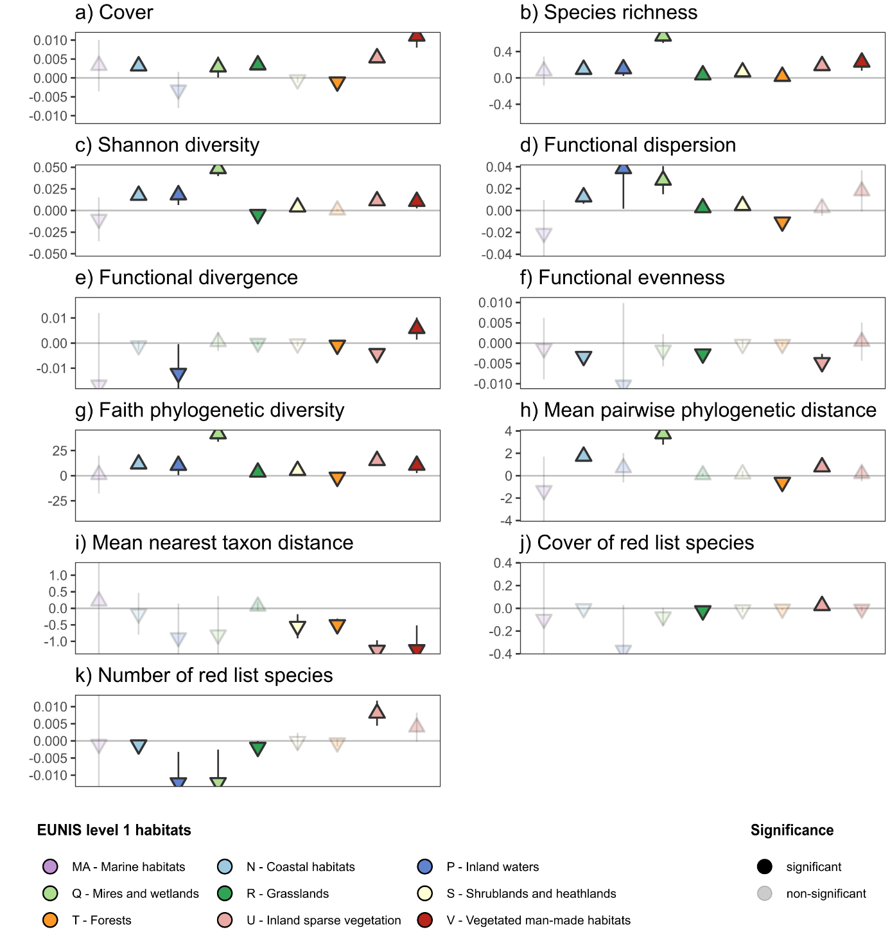

Extended Data Fig. 6a. Average annual trends in absolute values of plant diversity within habitat-change trajectories of EUNIS level 1 habitat types (estimated with weighted linear models in which each time series contributed according to the logarithm of the number of vegetation surveys). Habitat-change trajectories were assigned based on shifts in EUNIS level 3 habitat types between the initial versus the last vegetation survey.

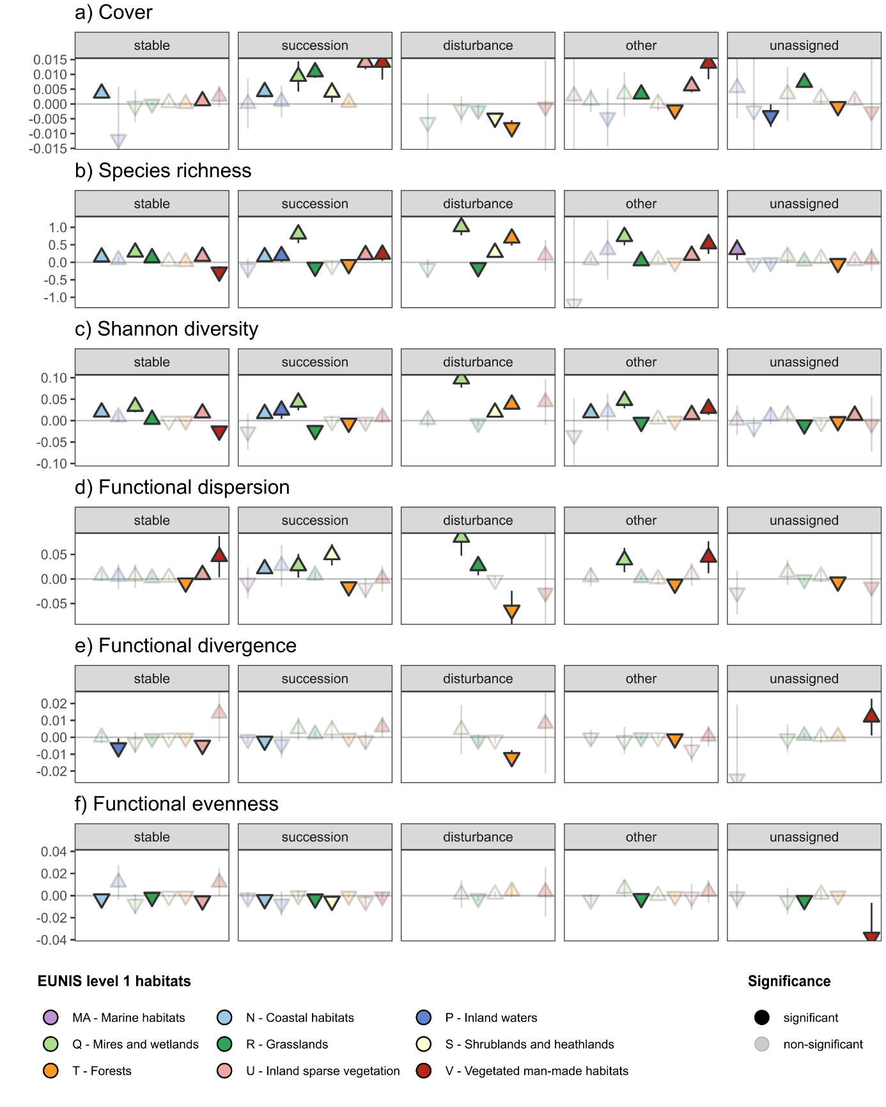

Extended Data Fig. 6b. Average annual trends in absolute values of plant diversity within habitat-change trajectories of EUNIS level 1 habitat types (estimated with weighted linear models in which each time series contributed according to the logarithm of the number of vegetation surveys). Habitat-change trajectories were assigned based on shifts in EUNIS level 3 habitat types between the initial versus the last vegetation survey.

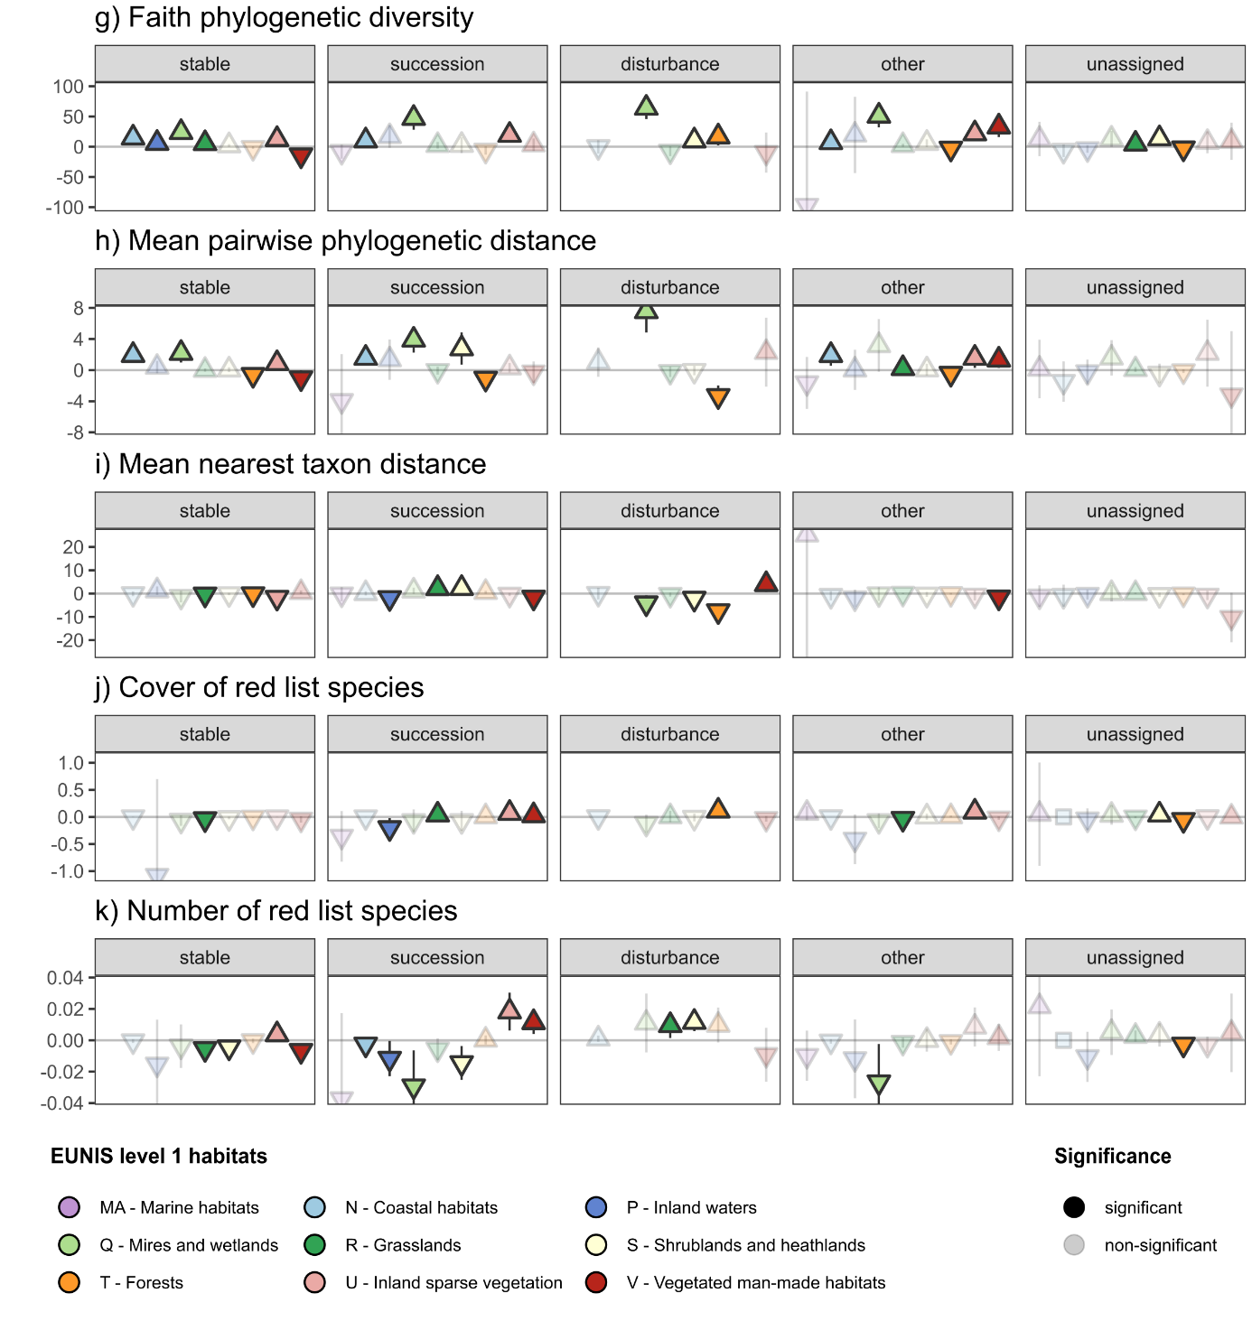

Extended Data Fig. 7. Decadal trends in species pool richness across all the vegetation-plot time series. To account for temporal trends in sample sizes, each trend lines includes only pairs of observations from vegetation plots that were that were surveyed in the focal pair of decades. In the boxes, the first number shows the average decadal trend in species pool richness (with asterisks indicating significance according to t-tests at p < 0.05). The second number shows the proportion of positive versus negative decadal trends (with asterisks indicating significance according to binomial tests at p < 0.05).

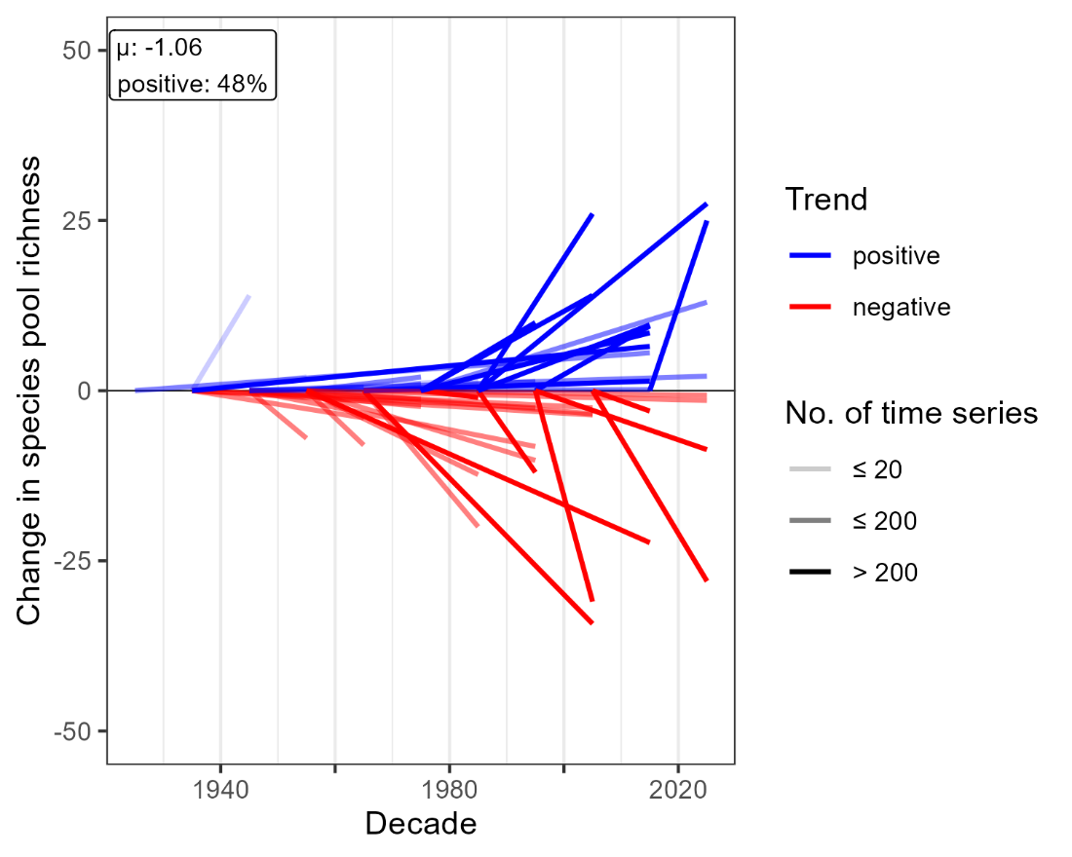

Extended Data Fig. 8a. Impact of vegetation-plot size (in m²) on the annual trends in absolute values of plant diversity (estimated with weighted linear models in which each time series contributed according to the logarithm of the number of vegetation surveys). Habitat-change trajectories were assigned based on shifts in EUNIS level 3 habitat types between the initial versus the last vegetation survey.

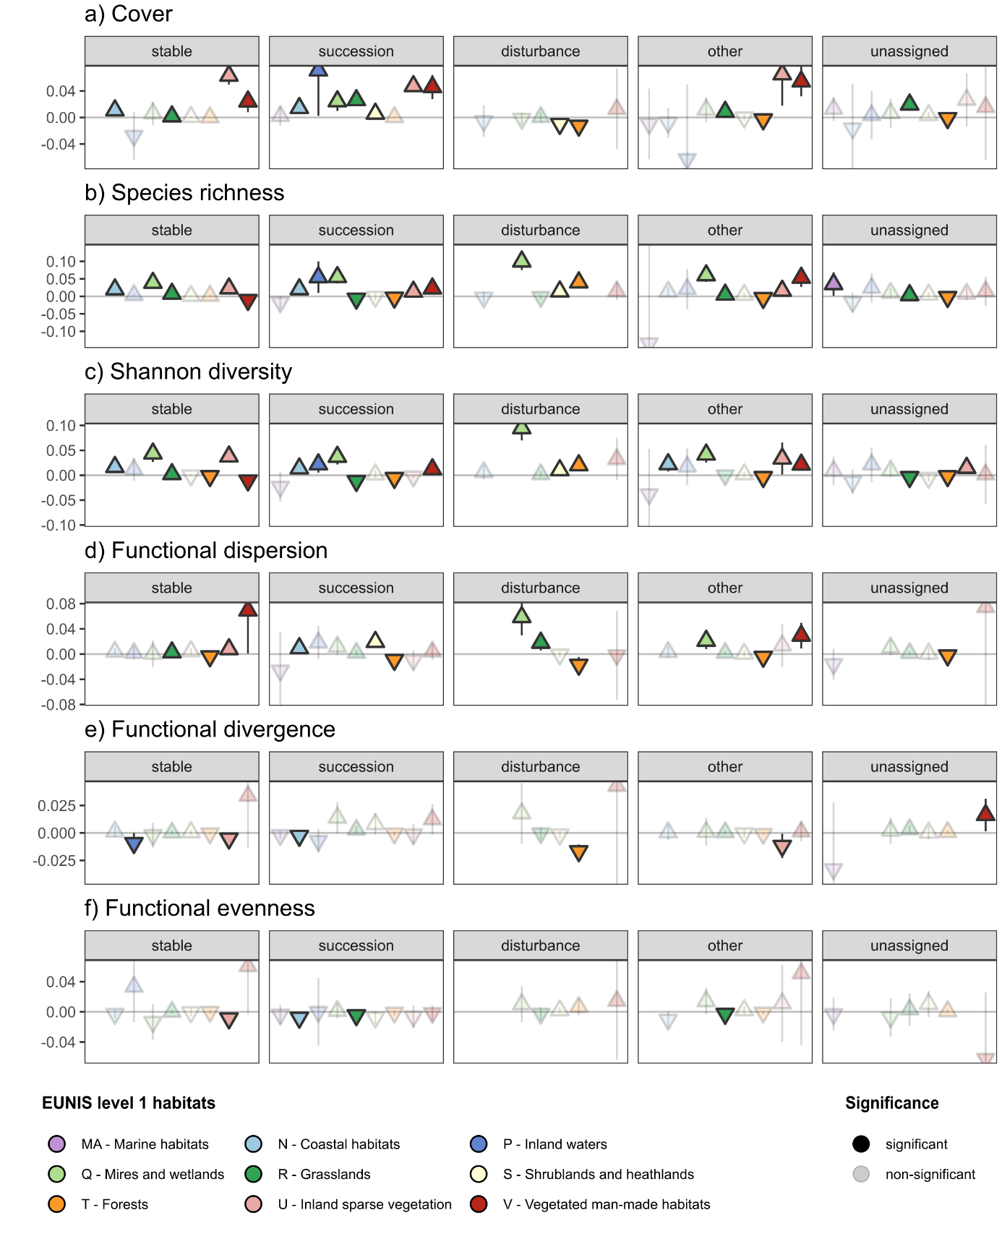

Extended Data Fig. 8b. Impact of vegetation-plot size (in m²) on the annual trends in absolute values of plant diversity (estimated with weighted linear models in which each time series contributed according to the logarithm of the number of vegetation surveys). Habitat-change trajectories were assigned based on shifts in EUNIS level 3 habitat types between the initial versus the last vegetation survey.

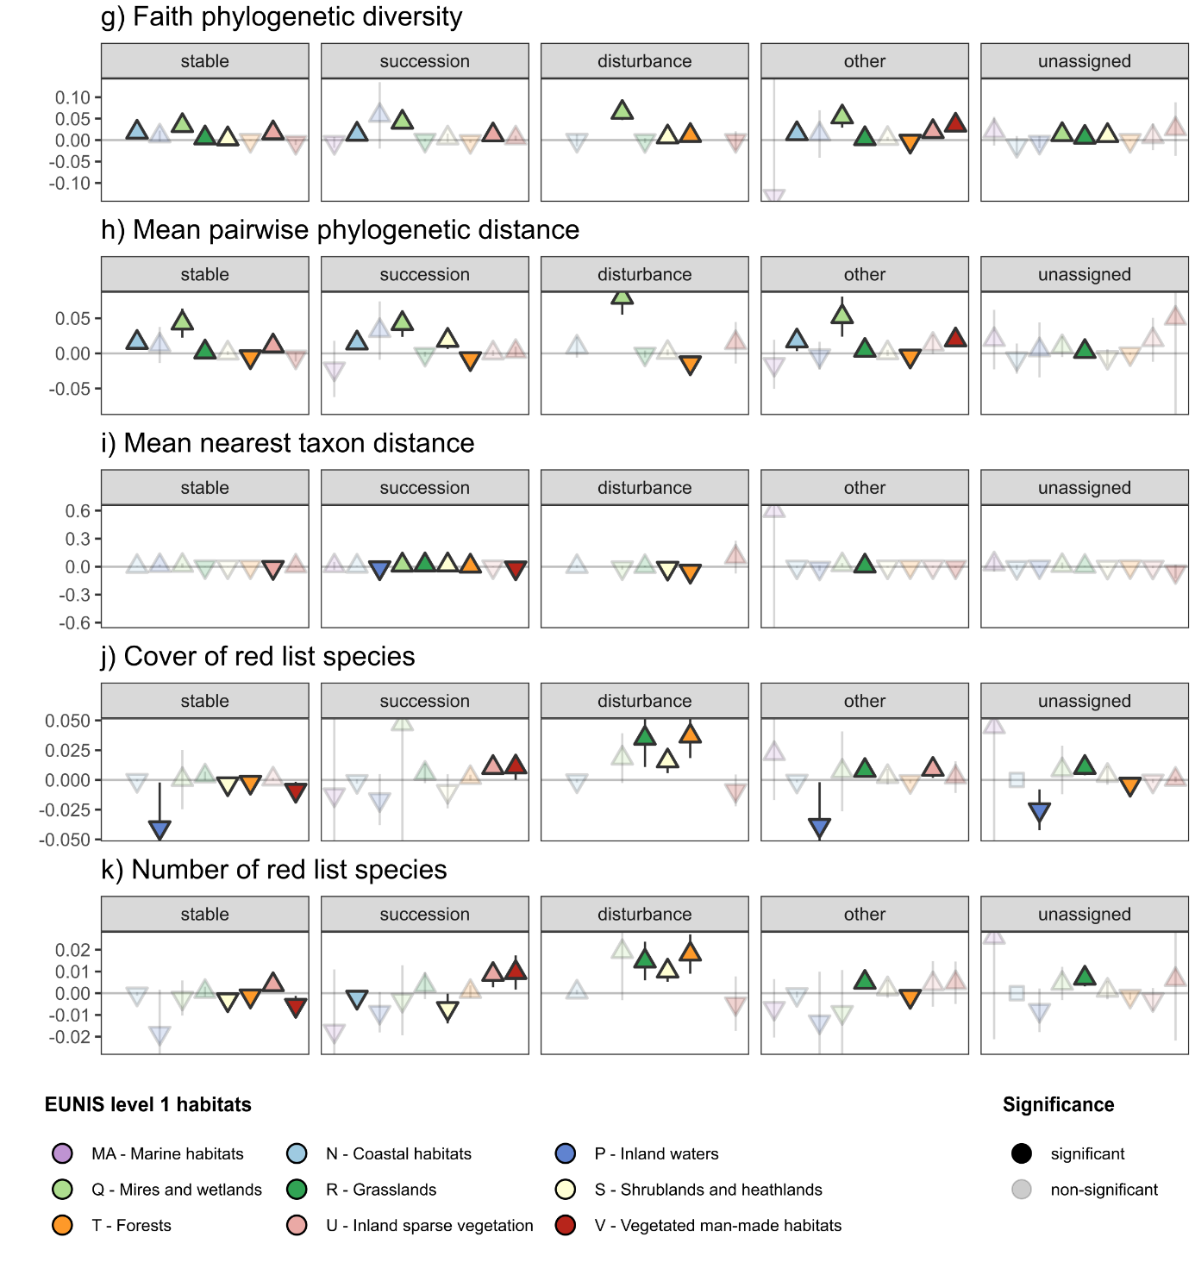

Extended Data Fig. 9. Grand mean trends in annual percentage change of plant diversity indices across all time series. Dotted zero lines indicate no trend. Numbers in boxes show grand mean trends. Horizontal lines show the corresponding approximated 95% confidence intervals that indicate significance of a trend when they do not cross the dotted line zero (at p < 0.05).

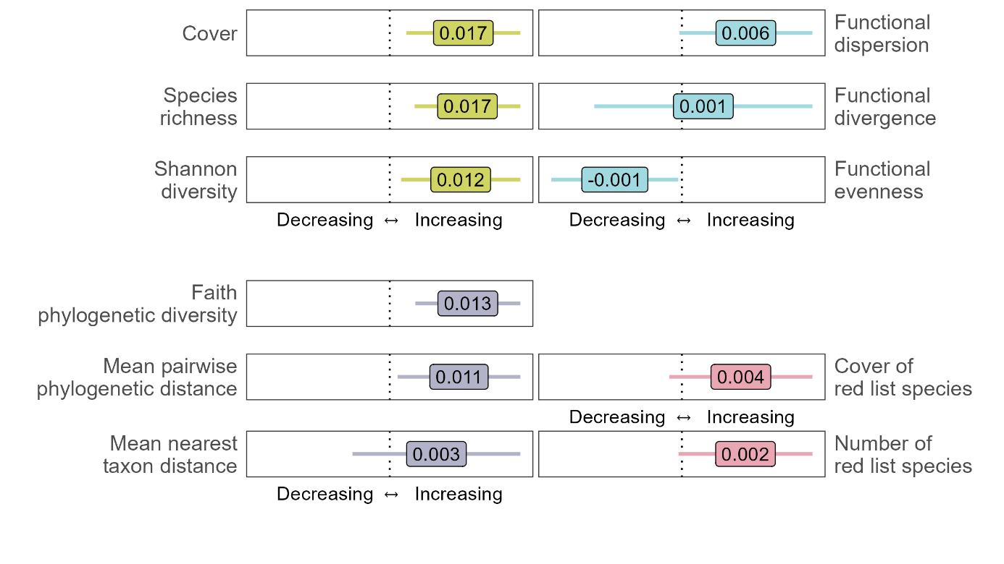

Extended Data Fig. 10. Proportion of explained variation in the annual percentage change in different diversity indices, separated by EUNIS level 1 habitat type. Bar lengths show the amount of independently explained variation by the EUNIS level 3 habitat type, the habitat-change trajectory (stable, succession, or disturbance), and the year of the last vegetation survey. Asterisks indicate significance of joint models that included all three predictors (estimated with analyses of variances p < 0.05). MA - Marine habitats and P – Inland waters were excluded due to low samples sizes.

