Supplementary Data Table 1. Hand-corrected occurrences of potential name mismatches, i.e., taxa with different names in subsequent vegetation surveys that belong to the same taxon.

Resurvey project | Resurvey site | “Doppelgaenger taxon” | Changed to | # of changed occurrences
Active Conservation of Dry Grasslands in CE Poland | Rm, Rb | Galium verum | Galium album | 18
DISEQALP |  | Anthoxanthum alpinum | Anthoxanthum aggr. | 387
 |  | Anthoxanthum odoratum | Anthoxanthum aggr. | 351
 |  | Anthoxanthum odoratum aggr. | Anthoxanthum aggr. | 20
 |  | Empetrum hermaphroditum | Empetrum aggr. | 176
 |  | Empetrum nigrum | Empetrum aggr. | 55
 |  | Empetrum nigrum aggr. | Empetrum aggr. | 6
 |  | Sesleria varia aggr. | Sesleria aggr. | 59
 |  | Sesleria albicans | Sesleria aggr. | 1,022
forestREplot_EU_023a |  | Tilia platyphyllos | Tilia cordata | 6
GLORIA_NO-DOV |  | Empetrum nigrum subsp. hermaphroditum | Empetrum nigrum | 53
 |  | Juncus trifidus subsp. trifidus | Juncus trifidus | 40
jaidhaus_2020_hschwaiger |  | Leucanthemum vulgare | Leucanthemum vulgare aggr. | 19
 |  | Leucanthemum ircutianum | Leucanthemum vulgare aggr. | 50
 |  | Leucanthemum vulgare aggr. | Leucanthemum vulgare aggr. | 64
Milovice_grazing |  | Rubus caesius | Rubus sp. | 6
PonorMts | Ponor | Agrostis stolonifera | Agrostis capillaris | 8
 |  | Cirsium vulgare | Cirsium ligulare | 13
 |  | Euphrasia species | Euphrasia pectinata | 34
Valdemaqueda_Madrid |  | Vicia angustifolia | Vicia lathyroides | 151
WS11 NWR Rotenberghang | StrictNR | Dryopteris dilatata | Dryopteris carthusiana aggr. | 5
 |  | Dryopteris carthusiana | Dryopteris carthusiana aggr. | 29
WS26 Hunstollen-Brache |  | Dactylis glomerata | Dactylis glomerata aggr. | 509
 |  | Dactylis glomerata subsp. aschersoniana | Dactylis glomerata aggr. | 16

Supplementary Data Table 2. Traits from the gap-filled dataset from the TRY Plant Trait Database. Those traits that are used for this study are marked in bold.

Abbreviation | Trait description
Chromosome.cDNAcont | Species genotype: chromosome cDNA content_pg
Chromosome.n | Species genotype: chromosome number_dimensionless
Disp.unit.leng | Dispersal unit length_mm
LDMC | Leaf dry mass per leaf fresh mass (leaf dry matter content, LDMC)_g g-1
Leaf.delta.15N | Leaf nitrogen (N) isotope signature (delta 15N)_per mill
LeafArea.leaf.noPet | Leaf area (in case of compound leaves: leaf, petiole excluded)_mm2
LeafArea.leaf.undef | Leaf area (in case of compound leaves: leaf, undefined if petiole in- or excluded)_mm2
LeafArea.leaf.wPet | Leaf area (in case of compound leaves: leaf, petiole included)_mm2
LeafArea.leaflet.noPet | Leaf area (in case of compound leaves: leaflet, petiole excluded)_mm2
LeafArea.leaflet.undef | Leaf area (in case of compound leaves: leaflet, undefined if petiole is in- or excluded)_mm2
LeafArea.leaflet.wPet | Leaf area (in case of compound leaves: leaflet, petiole included)_mm2
LeafArea.undef.undef | Leaf area (in case of compound leaves undefined if leaf or leaflet, undefined if petiole is in- or excluded)_mm2
LeafC.perdrymass | Leaf carbon (C) content per leaf dry mass_mg/g
LeafCN.ratio | Leaf carbon/nitrogen (C/N) ratio_g/cm3
LeafDryMass.single | Leaf dry mass (single leaf)_mg
Leaffreshmass | Leaf fresh mass_g
LeafLength | Leaf length_mm
LeafN | Leaf nitrogen (N) content per leaf dry mass_mg/g
LeafNperArea | Leaf nitrogen (N) content per leaf area_g m-2
LeafP | Leaf phosphorus (P) content per leaf dry mass_mg/g
LeafThickness | Leaf thickness_mm
LeafWaterCont | Leaf water content per leaf dry mass (not saturated)_g(W)/g(DM)
LeafWidth | Leaf width_cm
PlantHeight | Plant height (vegetative + generative)
PlantHeight.generative | Plant height generative_m
PlantHeight.veg | Plant height vegetative_m
RootingDepth | Root rooting depth_m
Seed.length | Seed length_mm
Seed.num.disp.unit | Seed number per dispersal unit_number
Seed.num.rep.unit | Seed number per reproducton unit_number
SeedGerminationRate | Seed germination rate (germination efficiency)_%
SeedMass | Seed dry mass_mg
SLA | Leaf area per leaf dry mass (specific leaf area, SLA or 1/LMA)
SLA.noPet | Leaf area per leaf dry mass (specific leaf area, SLA or 1/LMA): petiole excluded_mm2 mg-1
SLA.photosinthetic.tissues | Leaf area per leaf dry mass (specific leaf area, SLA or 1/LMA) petiole, rhachis and midrib excluded
SLA.undef | Leaf area per leaf dry mass (specific leaf area, SLA or 1/LMA): undefined if petiole is in- or excluded_mm2 mg-1
SLA.wPet | Leaf area per leaf dry mass (specific leaf area, SLA or 1/LMA): petiole included_mm2 mg-1
SpecificRootLength | Root length per root dry mass (specific root length, SRL)_cm/g
SpecificRootLength.fine | Fine root length per fine root dry mass (specific fine root length, SRL)_cm/g
Stem.cond.dens | Stem conduit density (vessels and tracheids)_mm-2
StemConduitDiameter | Stem conduit diameter (vessels, tracheids)_micro m
StemDens | Stem specific density (SSD) or wood density (stem dry mass per stem fresh volume)_g/cm3
StemDiam | Stem diameter_m
Wood.vessel.length | Wood vessel element length; stem conduit (vessel and tracheids) element length_micro m
WoodFiberLength | Wood fiber lengths_micro m
WoodRay.millimetre | Wood rays per millimetre_number

Supplementary Data Fig. 1. Bivariate correlations among the 46 traits of the gap-filled TRY plant trait database, calculated for the subset of 3,834 taxa that occurred in our vegetation-plot time series data. Trait names and descriptions are noted in Supplementary Data Table 2. Correlations are quantified as Pearson’s r.
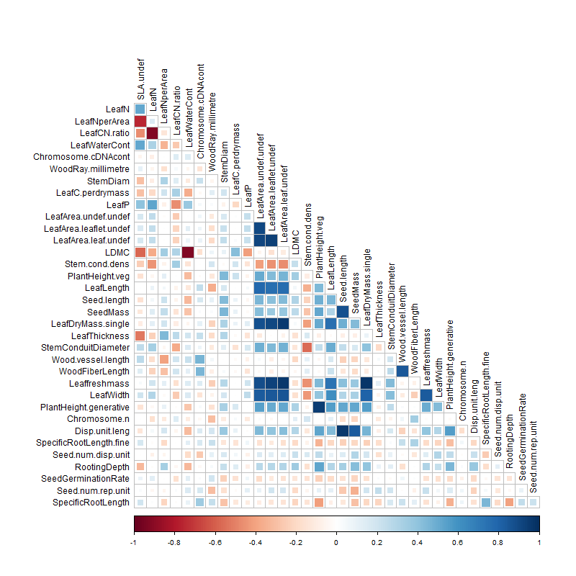

Supplementary Data Fig. 2. The first eight principal components in the joint relationships among the 46 traits of the gap-filled TRY plant trait database, calculated for the subset of 3,834 taxa that occurred in our vegetation-plot time series data. Trait names and descriptions are noted in Supplementary Data Table 2. For each pair of principal components, the 10 traits with the strongest relationships are shown in black; the less weakly related traits are only indicated with grey arrows.

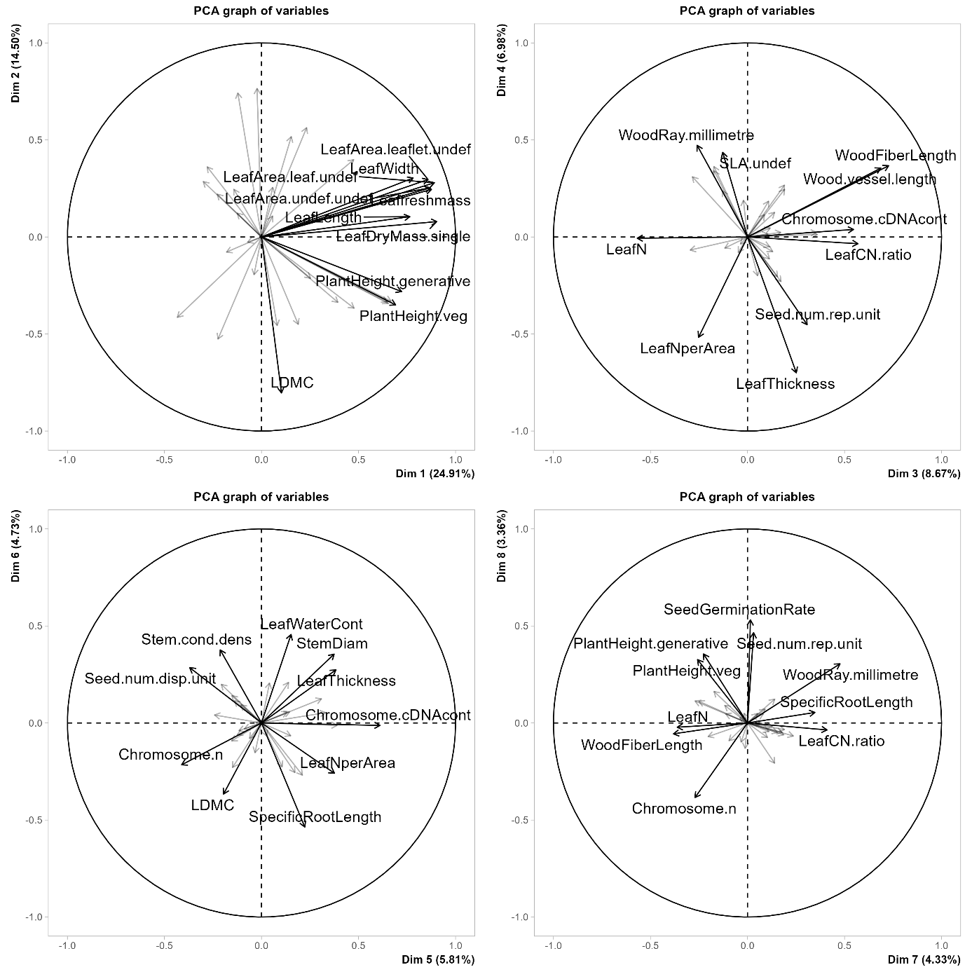

Supplementary Data Fig. 3. Sample sizes of diversity and composition indices, separately for the number of vegetation surveys and the number of time series data (consisting of multiple vegetation surveys) within each of the EUNIS level 1 habitat types.

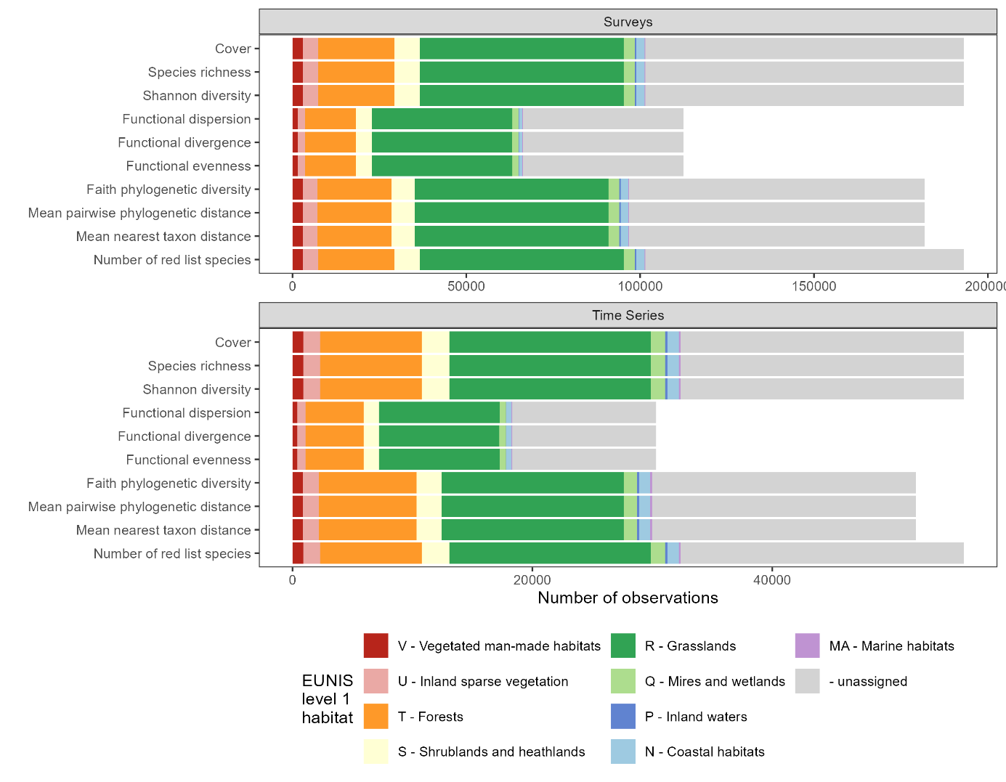

Supplementary Data Fig. 4. Average annual percentage changes in different indices of plant diversity, separated by EUNIS level 1 habitat types (estimated with weighted linear models in which each time series contributed according to the logarithm of the number of vegetation surveys).

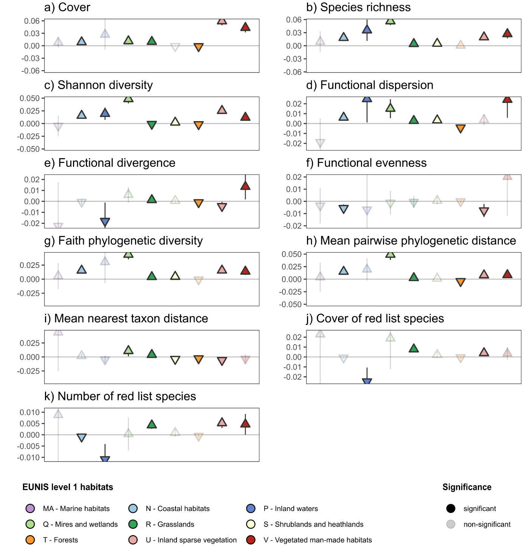

Supplementary Data Fig. 5a. Average annual percentage changes in different indices of plant diversity, separated by the different combinations of EUNIS level 1 habitat type and habitat-change trajectories (estimated with weighted linear models in which each time series contributed according to the logarithm of the number of vegetation surveys). Habitat-change trajectories were assigned based on shifts in EUNIS level 3 habitat types between the initial versus the last vegetation survey.

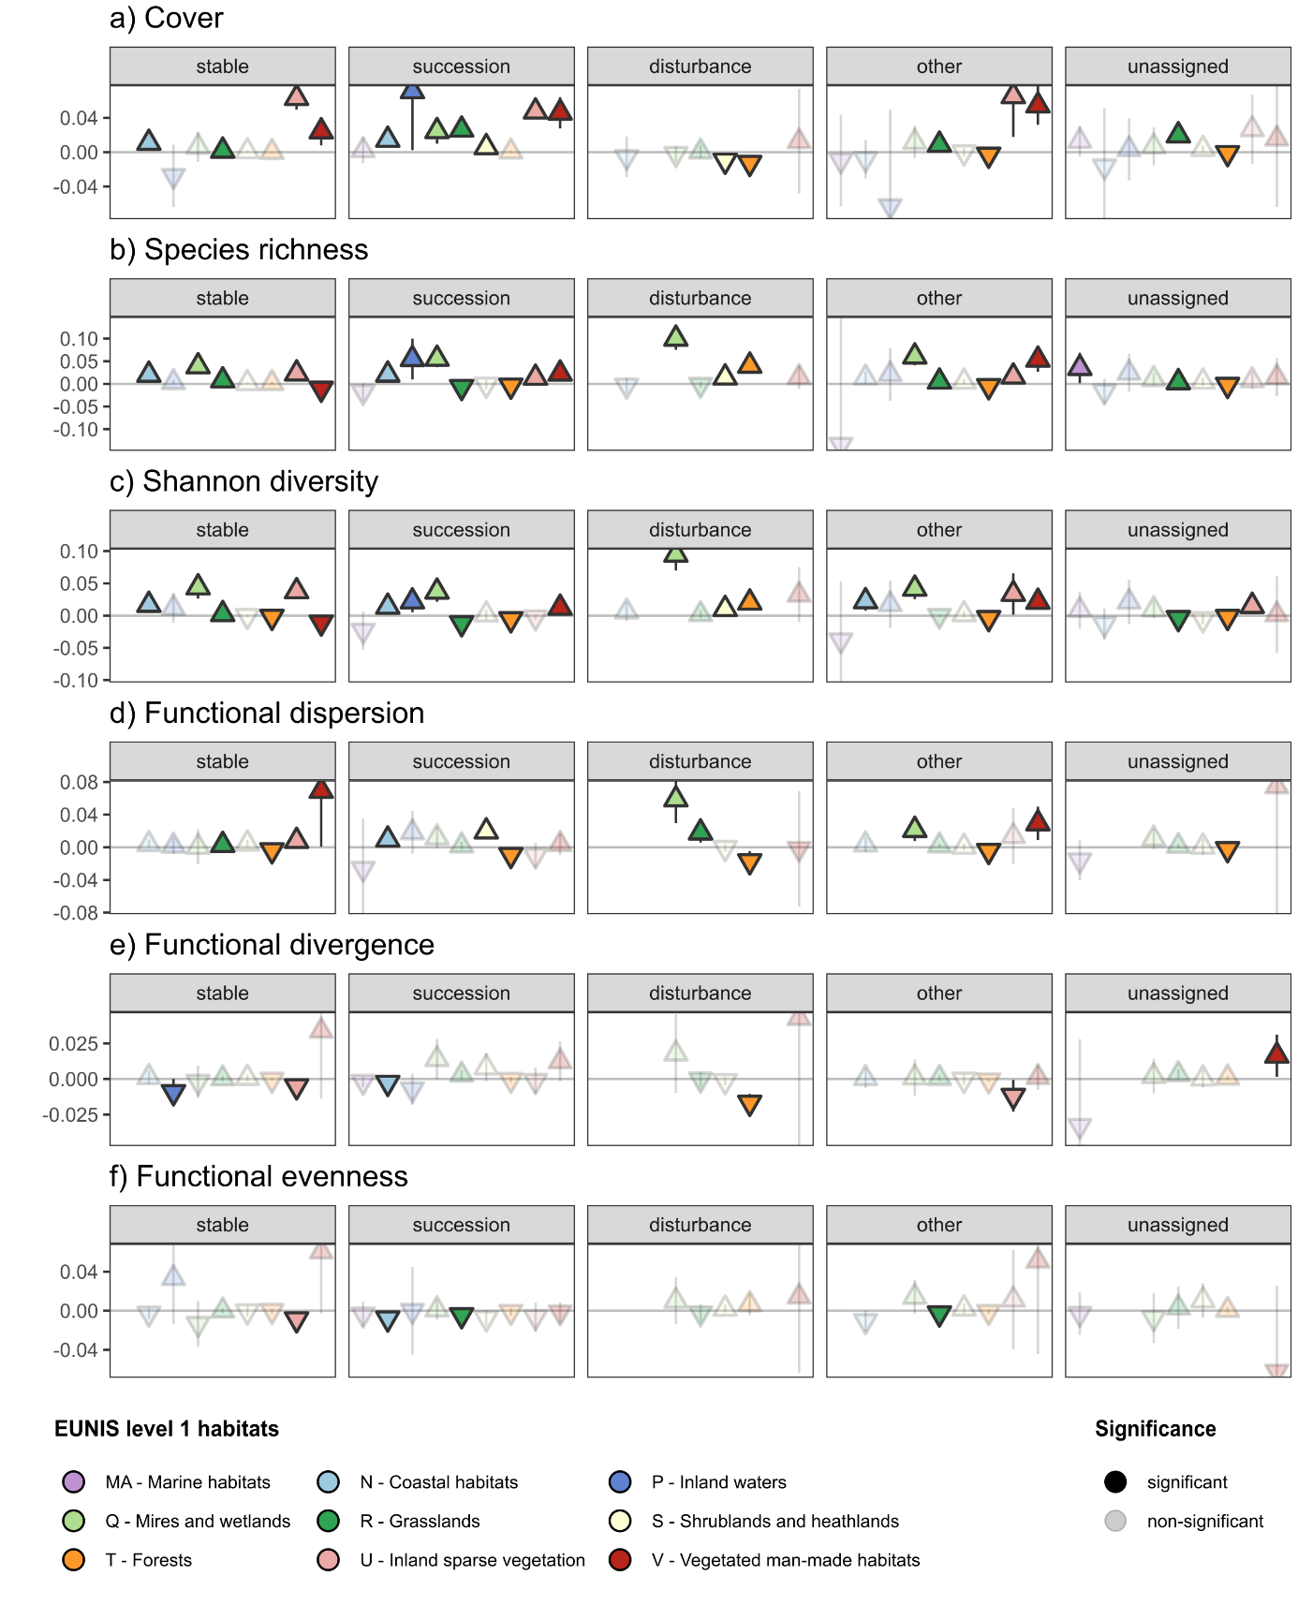

Supplementary Data Fig. 5b. Average annual percentage changes in different indices of plant diversity, separated by the different combinations of EUNIS level 1 habitat type and habitat-change trajectories (estimated with weighted linear models in which each time series contributed according to the logarithm of the number of vegetation surveys). Habitat-change trajectories were assigned based on shifts in EUNIS level 3 habitat types between the initial versus the last vegetation survey.

