Supplementary Materials

Table S1 Specific calculation of the indicators

Supplementary Figure S1 Brief intervention for smoking cessation consultation process

Supplementary Figure S2 Clinical scenario: a typical middle-aged undiagnosed type 2 diabetes Unannounced Standardized Patient (USP)

Supplementary Table S2 Implementation of BISC for hypertensive USPs

Supplementary Table S3 Implementation of BISC for angina USPs

Supplementary Table S4 Implementation of BISC for Asthma USPs

Supplementary Table S5 The score of implementation degree of physician

Supplementary Table S6 Descriptive analysis of the score of implementation degree of physician

Table S1 specific calculation of the indicators
Indicator name | Basis of measurement | Definition | Calculation formula / Operational definition
Implementation rate | Based on the "China Clinical Smoking Cessation Guidelines (2015 Edition)" (asking about tobacco use, assessing smoking severity, informing the patient of health risks, evaluating readiness to quit, and offering cessation support, see Supplementary Figure S1 for details) | The implementation rate refers to the proportion of USP visits where the physician performed at least one step of a brief smoking cessation intervention among all scheduled visits. | Formula: The number of USP visits in which physicians implemented BISC / total number of USP visits.  Assigned value: If the physician performs any one of the five steps during a visit, that visit is assigned a value of 1, indicating "intervention implemented." If none of the steps are performed, it is assigned a value of 0, indicating "intervention not implemented.
The degree of implementation |  | The degree of implementation refers to the number of intervention steps completed by the physician during a single visit. | Assigned Values:  Smoking patients: Each completed intervention step is assigned 1 point, with a total score ranging from 0 to 5 points.  Non-smoking patients: Completing the "Ask" step is assigned 1 point, while failure to perform this step is assigned 0 points.
The number of smokers that could be reduced | Based on the population of China1, the annual number of outpatient visits to secondary and lower-level facilities2, the adult smoking rate in China3, and the effectiveness of BISC4,5 | The number of smokers who, through physician intervention, successfully develop the willingness to quit, take action, and achieve smoking cessation across varying BISC implementation rates. | The number of smokers that could be reduced = implementation rate of BISC * an annual resident visit rate * the number of smokers nationwide * increased self-help quit rates
The direct economic burden of diseases that could be decreased | Considering the per capita economic burden of smoking-related diseases, incidence rates, population attributable fraction, per capita treatment costs^{6,} and the number of smokers that could be reduced at different implementation rates of BISC | The direct medical costs saved for the healthcare system and society by preventing smoking-related diseases through the reduction of smokers, under varying BISC implementation rates. | The direct economic burden of diseases that could be decreased= implementation rate of BISC * an annual resident visit rate * the number of smokers nationwide * increased self-help quit rates * the per capita economic burden of smoking-related diseases * incidence rates * population attributable fraction

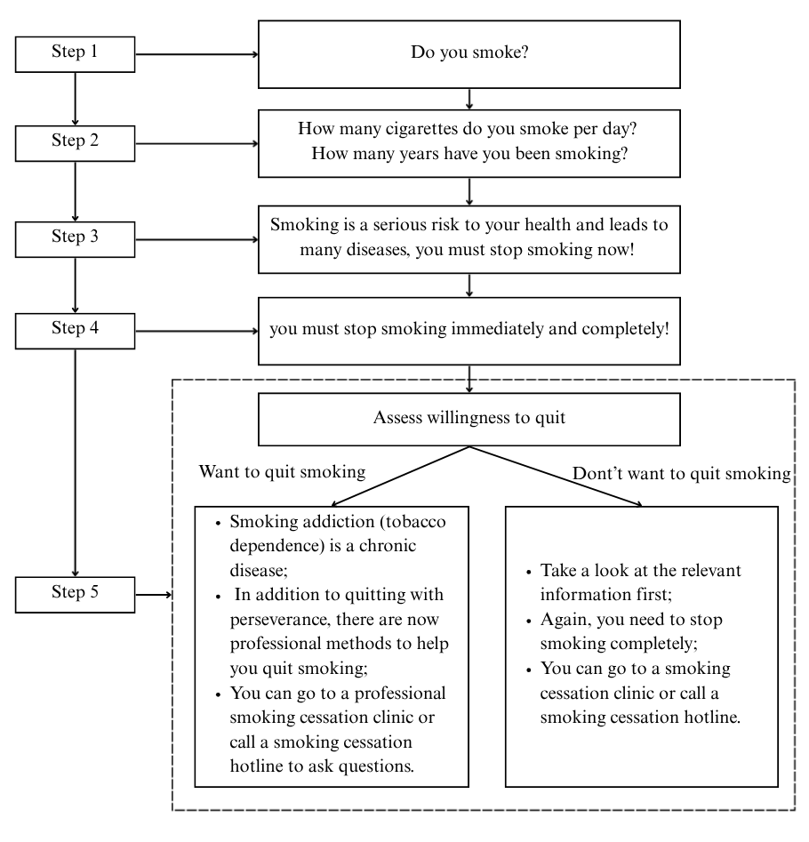
Supplementary Figure S1 Figure 1 Brief intervention for smoking cessation consultation process

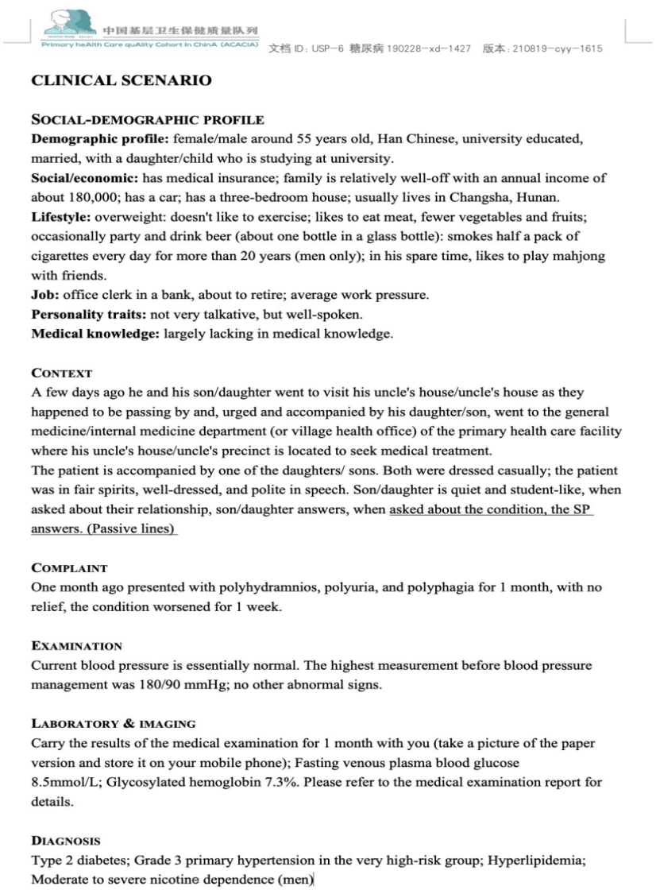

Supplementary Figure S1 Clinical scenario: a typical middle-aged undiagnosed type 2 diabetes Unannounced Standardized Patient (USP)

Supplementary Table S2 Implementation of BISC for hypertensive USPs [N (%)]

Variable | Total visits | Implementation of BISC for hypertensive USPs |  | P
Variable | Total visits | No | Yes | P
Total | 211(100.0) | 210(99.53) | 1(0.47)
Gender |  |  |  | 0.65
Male | 35(100.00) | 35(100.00) | 0(0.00)
Female | 176(100.00) | 175(99.43) | 1(0.57)
Ownership |  |  |  | 0.13
Public | 147(100.00) | 147(100.00) | 0(0.00)
Private | 64(100.00) | 63(98.44) | 1(1.56)
Type of facility |  |  |  | 0.82
Hospital | 57(100.00) | 57(100.00) | 0(0.00)
Community health Service center /station | 11(100.00) | 11(100.00) | 0(0.00)
Township health service centers/Stations | 38(100.00) | 38(100.00) | 0(0.00)
Outpatient department and clinic | 21(100.00) | 21(100.00) | 0(0.00)
Village health clinics | 84(100.00) | 83(98.81) | 1(1.19)
Management |  |  |  | 0.67
Non-profit organization | 178(100.00) | 177(99.44) | 1(0.56)
For-profit organization | 33(100.00) | 33(100.00) | 0(0.00)
Province |  |  |  | 0.80
Inner Mongolia | 11(100.00) | 11(100.00) | 0(0.00)
Hunan province | 45(100.00) | 45(100.00) | 0(0.00)
Guangdong province | 47(100.00) | 47(100.00) | 0(0.00)
Sichuan province | 52(100.00) | 51(98.08) | 1(1.92)
Guizhou province | 23(100.00) | 23(100.00) | 0(0.00)
Shaanxi province | 21(100.00) | 21(100.00) | 0(0.00)
Gansu province | 12(100.00) | 12(100.00） | 0(0.00)
Physician gender |  |  |  | 0.49
Male | 134(100.00) | 133(99.25) | 1(0.75)
Female | 65(100.00) | 65(100.00) | 0(0.00)
Physician age |  |  |  | 0.78
<30 | 5(100.00) | 5(100.00) | 0(0.00)
30-50 | 133(100.00) | 132(99.25) | 1(0.75)
≥50 | 61(100.00) | 61(100.00) | 0(0.00)
Physician title |  |  |  | 0.99
No title | 16(100.00) | 16(100.00) | 0(0.00)
Medical residency | 4(100.00) | 4(100.00) | 0(0.00)
Attending Physician | 23(100.00) | 23(100.00) | 0(0.00)
Deputy Chief Physician | 23(100.00) | 23(100.00) | 0(0.00)
Chief Physician | 3(100.00) | 3(100.00) | 0(0.00)
Unavailable | 130(100.00) | 129(99.23) | 1(0.77)
Physician department |  |  |  | 0.47
Internal medicine | 80(100.00) | 79(98.75) | 1(1.25)
Surgical/Surgery | 84(100.00) | 84(100.00) | 0(0.00)
Other | 35(100.00) | 35(100.00) | 0(0.00)
Physician ethnicity |  |  |  | <0.05
Han | 164(100.00) | 164(100.00) | 0(0.00)
Other | 8(100.00) | 8(100.00) | 0(0.00)
Unavailable | 27(100.00) | 26(96.30) | 1(3.70)

Supplementary Table S3 Implementation of BISC for Asthma USPs [N (%)]
Variable | Total) | Implementation of BISC for Asthma USPs |  | P
Variable | Total) | No | Yes | P
Total | 211(100.0) | 175(82.98) | 36(17.06)
Ownership |  |  |  | 0.77
Public | 154(100.00) | 127(82.47) | 27(17.53)
Private | 57(100.00) | 48(84.21) | 9(15.79)
Type of facility |  |  |  | 0.24
Hospital | 64(100.00) | 53(82.81) | 11(17.19)
Community health Service center /station | 9(100.00) | 5(55.56) | 4(44.44)
Township health service centers/Stations | 37(100.00) | 32(86.49) | 5(13.51)
Outpatient department clinics | 18(100.00) | 16(88.89) | 2(11.11)
Village health clinics | 83(100.00) | 69(83.13) | 14(16.87)
Management |  |  |  | 0.46
Non-profit organization | 179(100.00) | 147(82.12) | 32(17.88)
For-profit organization | 32(100.00) | 28(87.50) | 4(12.50)
Province |  |  |  | <0.05
Inner Mongolia | 13(100.00) | 12(92.31) | 1(7.69)
Hunan province | 42(100.00) | 35(83.33) | 7(16.67)
Guangdong province | 47(100.00) | 43(91.49) | 4(8.51)
Sichuan province | 53(100.00) | 46(86.79) | 7(13.21)
Guizhou province | 22(100.00) | 18(81.82) | 4(18.18)
Shaanxi province | 19(100.00) | 11(57.89) | 8(42.11)
Gansu province | 15(100.00) | 10(66.67） | 5(33.33)
Physician gender |  |  |  | 0.23
Male | 133(100.00) | 112(84.21) | 21(15.79)
Female | 61(100.00) | 47(77.05) | 14(22.95)
Physician age |  |  |  | 0.79
<30 | 10(100.00) | 9(90.00) | 1(10.00)
30-50 | 142(100.00) | 116(81.69) | 26(18.31)
≥50 | 42(100.00) | 34(80.95) | 8(19.05)
Physician title |  |  |  | 0.88
No title | 2(100.00) | 2(100.00) | 0(0.00)
Medical residency | 11(100.00) | 8(72.73) | 3(27.27)
Attending Physician | 17(100.00) | 14(82.35) | 3(17.65)
Deputy Chief Physician | 17(100.00) | 13(76.47) | 4(23.53)
Chief Physician | 9(100.00) | 8(88.89) | 1(11.11)
Unavailable | 138(100.00) | 114(82.61) | 24(17.39)
Physician department |  |  |  | 0.62
Internal medicine | 102(100.00) | 81(79.41) | 21(20.59)
Surgical/Surgery | 79(100.00) | 67(84.81) | 12(15.19)
Other | 13(100.00) | 11(84.62) | 2(15.38)
Physician ethnicity |  |  |  | 0.78
Han | 115(100.00) | 96(83.48) | 19(16.52)
Other | 4(100.00) | 3(75.00) | 1(25.00)
Unavailable | 75(100.00) | 60(80.00) | 15(20.00)

Supplementary Table S4 Implementation of BISC for Angina USPs [N (%)]
Variable | Total | Implementation of BISC for Angina USPs |  | P
Variable | Total | No | Yes | P
Total | 216(100.0) | 183(84.72) | 33(15.28)
Age of visit |  |  |  | 0.67
<43 | 1(100.00) | 1(100.00) | 0(0.00)
>43 | 215(100.00) | 182(84.65) | 33(15.35)
Ownership |  |  |  | 0.16
Public | 155(100.00) | 128(82.58) | 27(17.42)
Private | 61(100.00) | 55(90.16) | 6(9.84)
Type of facility |  |  |  | <0.05
Hospital | 65(100.00) | 46(70.77) | 19(29.23)
Community health Service center /station | 13(100.00) | 11(84.62) | 2(15.38)
Township health service centers/Stations | 37(100.00) | 31(83.78) | 6(16.22)
Outpatient department clinics | 16(100.00) | 16(100.00) | 0(0.00)
Village health clinics | 85(100.00) | 79(92.94) | 6(7.06)
Management |  |  |  | 0.22
Non-profit organization | 189(100.00) | 158(83.60) | 31(16.40)
For-profit organization | 27(100.00) | 25(92.59) | 2(7.41)
Province |  |  |  | 0.30
Inner Mongolia | 13(100.00) | 13(100.00) | 0(0.00)
Hunan province | 43(100.00) | 38(88.37) | 5(11.63)
Guangdong province | 46(100.00) | 35(76.09) | 11(23.91)
Sichuan province | 54(100.00) | 45(83.33) | 9(16.67)
Guizhou province | 25(100.00) | 22(88.00) | 3(12.00)
Shaanxi province | 19(100.00) | 15(78.95) | 4(21.05)
Gansu province | 16(100.00) | 15(93.75） | 1(6.25)
Physician gender |  |  |  | 0.22
Male | 154(100.00) | 131(85.06) | 23(14.94)
Female | 44(100.00) | 34(77.27) | 10(22.73)
Physician age |  |  |  | 0.52
<30 | 4(100.00) | 3(75.00) | 1(25.00)
30-50 | 156(100.00) | 128(82.05) | 28(17.95)
≥50 | 37(100.00) | 33(89.19) | 4(10.81)
Physician title |  |  |  | 0.07
No title | 2(100.00) | 2(100.00) | 0(0.00)
Medical residency | 9(100.00) | 7(77.78) | 2(22.22)
Attending Physician | 21(100.00) | 13(61.90) | 8(38.10)
Deputy Chief Physician | 18(100.00) | 15(83.33) | 3(16.67)
Chief Physician | 6(100.00) | 4(66.67) | 2(33.33)
Unavailable | 142(100.00) | 124(87.32) | 18(12.68)
Physician department |  |  |  | <0.05
Internal medicine | 99(100.00) | 90(90.91) | 9(9.09)
Surgical/Surgery | 78(100.00) | 59(75.64) | 19(24.36)
Other | 21(100.00) | 16(76.19) | 5(23.81)
Physician ethnicity |  |  |  | 0.50
Han | 117(100.00) | 99(84.62) | 18(15.38)
Minority | 4(100.00) | 4(100.00) | 0(0.00)
Unavailable | 77(100.00) | 62(80.52) | 15(19.48)

 | N (%)
Score
0 | 2218 (96.35)
1 | 67 (2.91)
2 | 12 (0.52)
3 | 2 (0.09)
4 | 3 (0.13)
Supplementary Table S5 The score of implementation degree of physician

Supplementary Table S6 Descriptive analysis of the score of implementation degree of physician [N (%)]

Score | 0 | 1 | 2 | 3 | 4 | P
Visit case |  |  |  |  |  | <0.05
Gastritis | 195 (8.79) | 4 (5.97) | 0 (0.00) | 1 (50.00) | 1 (33.33)
Postpartum depression | 207 (9.33) | 0 (0.00) | 0 (0.00) | 0 (0.00) | 0 (0.00)
Pediatric diarrhea | 206 (9.29) | 0 (0.00) | 0 (0.00) | 0 (0.00) | 0 (0.00)
Common cold | 210 (9.47) | 4 (5.97) | 0 (0.00) | 0 (0.00) | 0 (0.00)
Migraines | 202 (9.11) | 3 (4.48) | 0 (0.00) | 0 (0.00) | 0 (0.00)
Asthma | 175 (7.89) | 36 (53.73) | 0 (0.00) | 0 (0.00) | 0 (0.00)
Angina | 183 (8.25) | 18 (26.87) | 12 (100.00) | 1 (50.00) | 2 (66.67)
Low back pain | 212 (9.56) | 0 (0.00) | 0 (0.00) | 0 (0.00) | 0 (0.00)
Stress urinary incontinence | 209 (9.42) | 1 (1.49) | 0 (0.00) | 0 (0.00) | 0 (0.00)
Hypertension | 210 (9.47) | 1 (1.49) | 0 (0.00) | 0 (0.00) | 0 (0.00)
Diabetes | 209 (9.42) | 0 (0.00) | 0 (0.00) | 0 (0.00) | 0 (0.00)
Age of visiting USP |  |  |  |  |  | <0.05
<43 | 1021(46.03) | 11 (16.42) | 0 (0.00) | 1 (50.00) | 1 (33.33)
>43 | 1197(53.97) | 56 (83.58) | 12 (100.00) | 1 (50.00) | 2 (66.67)
Ownership |  |  |  |  |  | 0.489
Public | 1569(70.74) | 50 (74.63) | 10 (83.33) | 2 (100.00) | 3 (100.00)
Private | 649 (29.26) | 17 (25.37) | 2 (16.67) | 0 (0.00) | 0 (0.00)
Institution type |  |  |  |  |  | 0.202
Hospital | 622 (28.04) | 23 (34.33) | 7 (58.33) | 1 (50.00) | 2 (66.67)
Community health service centre/Station | 102 (4.60) | 7 (10.45) | 1 (8.33) | 0 (0.00) | 0 (0.00)
Township health service centre/Stations | 412 (18.58) | 12 (17.91) | 1 (8.33) | 1 (50.00) | 0 (0.00)
Outpatient department and clinic | 207 (9.33) | 2 (2.99) | 0 (0.00) | 0 (0.00) | 0 (0.00)
Village health office | 875 (39.45) | 23 (34.33) | 3 (25.00) | 0 (0.00) | 1 (33.33)
Management |  |  |  |  |  | 0.270
Non-profit organization | 1884(84.94) | 63 (94.03) | 10 (83.33) | 2 (100.00) | 3 (100.00)
For-profit organization | 334 (15.06) | 4 (5.97) | 2 (16.67) | 0 (0.00) | 0 (0.00)
Province |  |  |  |  |  | 0.397
Inner Mongolia | 124 (5.59) | 2 (2.99) | 0 (0.00) | 0 (0.00) | 0 (0.00)
Hunan province | 453 (20.42) | 11 (16.42) | 1 (8.33) | 1 (50.00) | 1 (33.33)
Guangdong province | 491 (22.14) | 12 (17.91) | 4 (33.33) | 0 (0.00) | 1 (33.33)
Sichuan province | 562 (25.34) | 18 (26.87) | 5 (41.67) | 0 (0.00) | 0 (0.00)
Guizhou province | 249 (11.23) | 6 (8.96) | 1 (8.33) | 0 (0.00) | 1 (33.33)
Shaanxi province | 187 (8.43) | 13 (19.40) | 0 (0.00) | 1 (50.00) | 0 (0.00)
Gansu province | 152 (6.85) | 5 (7.46) | 1 (8.33) | 0 (0.00) | 0 (0.00)
Physician gender |  |  |  |  |  | 0.724
Male | 1368(67.19) | 42 (63.64) | 10 (83.33) | 1 (50.00) | 2 (66.67)
Female | 668 (32.81) | 24 (36.36) | 2 (16.67) | 1 (50.00) | 1 (33.33)
Physician age |  |  |  |  |  | 0.648
<30 | 64 (3.15) | 1 (1.52) | 1 (8.33) | 0 (0.00) | 0 (0.00)
30-50 | 1448(71.19) | 53 (80.30) | 9 (75.00) | 1 (50.00) | 3 (100.00)
≥50 | 522 (25.66) | 12 (18.18) | 2 (16.67) | 1 (50.00) | 0 (0.00)
Physician education |  |  |  |  |  | 0.715
Graduate | 22 (1.08) | 2 (3.03) | 0 (0.00) | 0 (0.00) | 0 (0.00)
Bachelor | 201 (9.88) | 4 (6.06) | 1 (8.33) | 0 (0.00) | 2 (66.67)
Junior college | 25 (1.23) | 0 (0.00) | 0 (0.00) | 0 (0.00) | 0 (0.00)
Secondary technical | 8 (0.39) | 0 (0.00) | 0 (0.00) | 0 (0.00) | 0 (0.00)
High school and below | 3 (0.15) | 0 (0.00) | 0 (0.00) | 0 (0.00) | 0 (0.00)
Unavailable | 1776(87.27) | 60 (90.91) | 11 (91.67) | 2 (100.00) | 1 (33.33)
Physician certification |  |  |  |  |  | 0.992
Practitioner | 459 (22.56) | 16 (24.24) | 1 (8.33) | 0 (0.00) | 1 (33.33)
Physician assistant | 25 (1.23) | 1 (1.52) | 0 (0.00) | 0 (0.00) | 0 (0.00)
Village physicians | 98 (4.82) | 3 (4.55) | 1 (8.33) | 0 (0.00) | 0 (0.00)
No certificate | 4 (0.20) | 1 (1.52) | 0 (0.00) | 0 (0.00) | 0 (0.00)
Others | 3 (0.15) | 0 (0.00) | 0 (0.00) | 0 (0.00) | 0 (0.00)
Unavailable | 1446(71.06) | 45 (68.18) | 10 (83.33) | 2 (100.00) | 2 (66.67)
Physician title |  |  |  |  |  | 0.014
No title | 87 (4.27) | 1 (1.52) | 0 (0.00) | 0 (0.00) | 1 (33.33)
Medical residency | 38 (1.87) | 4 (6.06) | 0 (0.00) | 0 (0.00) | 1 (33.33)
Attending physician | 244 (11.98) | 8 (12.12) | 2 (16.67) | 1 (50.00) | 1 (33.33)
Deputy chief physician | 214 (10.51) | 8 (12.12) | 1 (8.33) | 0 (0.00) | 0 (0.00)
Chief physician | 82 (4.03) | 4 (6.06) | 0 (0.00) | 0 (0.00) | 0 (0.00)
Unavailable | 1371(67.34) | 41 (62.12) | 9 (75.00) | 1 (50.00) | 0 (0.00)
Physician department |  |  |  |  |  | 0.187
Internal medicine | 1043(51.30) | 33 (50.00) | 5 (41.67) | 0 (0.00) | 1 (33.33)
Surgical/Surgery | 582 (28.63) | 25 (37.88) | 6 (50.00) | 1 (50.00) | 2 (66.67)
Others | 408 (20.07) | 8 (12.12) | 1 (8.33) | 1 (50.00) | 0 (0.00)
Physician ethnicity |  |  |  |  |  | 0.056
Han | 1518(74.59) | 40 (60.61) | 5 (41.67) | 2 (100.00) | 2 (66.67)
Other | 31 (1.52) | 1 (1.52) | 0 (0.00) | 0 (0.00) | 0 (0.00)
Unavailable | 486 (23.88) | 25 (37.88) | 7 (58.33) | 0 (0.00) | 1 (33.33)

1. census Ootlgotscftsnp. China population census yearbook 2020. 2022;
2. China SICotNHCo. National Health Service, January-November 2022. 2023;
3. China NHCo. China Smoking Hazardous to Health Report 2020. Accessed 20 November, 2023. https://www.gov.cn/fuwu/2021-05/30/content_5613994.htm
4. Stead LF, Buitrago D, Preciado N, Sanchez G, Hartmann-Boyce J, Lancaster T. Physician advice for smoking cessation. Cochrane Database Syst Rev. May 31 2013;2013(5):Cd000165. doi:10.1002/14651858.CD000165.pub4
5. Lei W, bin J, Jing Z, Yao H. Minimal-Intervention on smoking cessation：a Meta-analysis. Chinese Journal of Epidemiology. 2015;36(6):658-662. doi:10.3760/cma.j.issn.0254-6450.2015.06.026
6. Ling L, Qiuling C, Ruixue J, Xuan C. The Smoking Pattern and Disease Burden of Tobacco Use in China. Chinese Health Economics. 2008;27(1):26-30. doi:10.3969/j.issn.1003-0743.2008.01.010

