Supplementary Materials

Table S1 Specific calculation of the indicators

Supplementary Figure S1 Brief intervention for smoking cessation consultation process

Supplementary Figure S2 Clinical scenario: a typical middle-aged undiagnosed type 2 diabetes Unannounced Standardized Patient (USP)

Supplementary Table S2 Implementation of BISC for hypertensive USPs

Supplementary Table S3 Implementation of BISC for angina USPs

Supplementary Table S4 Implementation of BISC for Asthma USPs

Supplementary Table S5 The score of implementation degree of physician

Supplementary Table S6 Descriptive analysis of the score of implementation degree of physician

Table S1 specific calculation of the indicators
Indicator name | Basis of measurement | Calculation formula
We developed a simple estimation model to visualize the number of smokers that could be reduced and the direct economic burden of diseases that could be decreased at different rates of implementation of brief cessation interventions
The number of smokers that could be reduced | Based on the population of China¹, the annual number of outpatient visits to secondary and lower-level facilities², the adult smoking rate in China³, and the effectiveness of BISC^{4,5}, we calculated the number of smokers that could be reduced for different implementation rates of BISC. | The number of smokers that could be reduced=implementation rate of BISC* an annual resident visit rate* the number of smokers nationwide* increased self-help quit rates
The direct economic burden of diseases that could be decreased | Considering the per capita economic burden of smoking-related diseases, incidence rates, population attributable fraction, per capita treatment costs^{6,} and the number of smokers that could be reduced at different implementation rates of BISC, we estimated the direct economic burden of diseases that could be reduced at different BISC implementation rates. | The direct economic burden of diseases that could be decreased= implementation rate of BISC* an annual resident visit rate* the number of smokers nationwide* increased self-help quit rates* the per capita economic burden of smoking-related diseases* incidence rates*population attributable fraction
Based on the "China Clinical Smoking Cessation Guidelines (2015 Edition)" (Ask if they smoke, inquire about the number of cigarettes smoked, and inform them about the benefits/hazards of smoking, advise them to quit, refer them or provide the quit smoking hotline number, see Supplementary Figure S1 for details), this study constructed two indicators to assess the implementation of the intervention by physicians:
Implementation rate | Based on the brief intervention for smoking cessation process in the "China Clinical Smoking Cessation Guidelines (2015 Edition)" was used as the basis. Because Chinese physicians currently lack the time and skills for tobacco control and may have difficulty performing a complete brief intervention for smoking cessation, the current study usually only reported whether physicians asked or advised patients to quit smoking⁷. Therefore, in this study, physicians were judged to have implemented the intervention as long as they performed any of these steps, and only when none of the steps were performed was it judged to have not been implemented. | Implementation rate = the number of USP visits in which physicians implemented BISC/total number of USP visits.
The degree of implementation | It was determined according to the five steps of the brief smoking cessation intervention consultation process in the China Clinical Tobacco Control Guidelines (2015 version). | The allocation of points is as follows: 1 point is awarded for the performance of a single step, 2 point for the performance of two steps, and so on. Therefore, physician scores for smoking patient visits ranged from 0 to 5. Considering that for non-smoking patients, the physician may be able to terminate the cessation intervention after learning that the patient does not smoke, the non-smoking patients were assigned a score ranging from 0 to 1 for the degree of cessation. A higher score indicates better implementation of brief cessation interventions

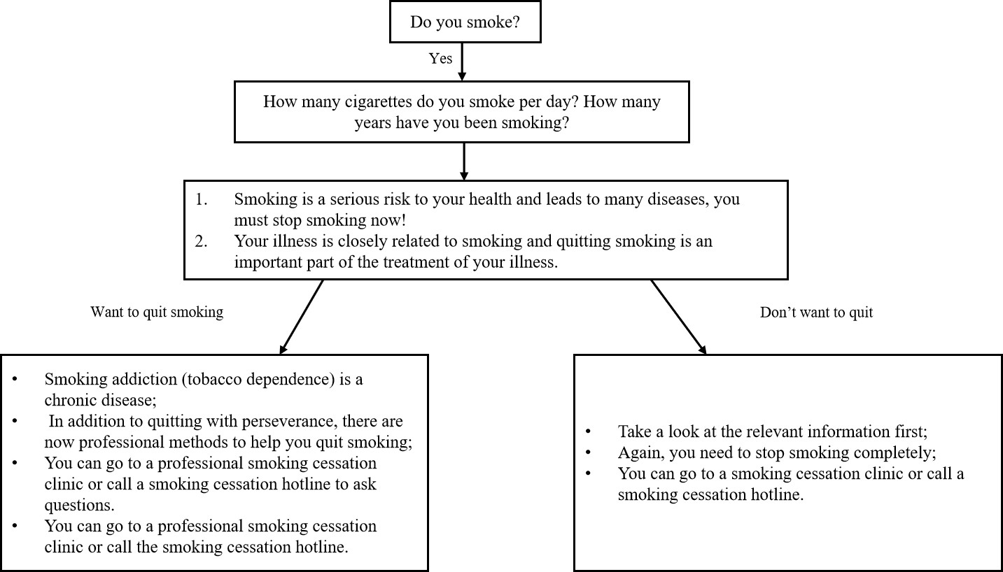Supplementary Figure S1 Figure 1 Brief intervention for smoking cessation consultation process

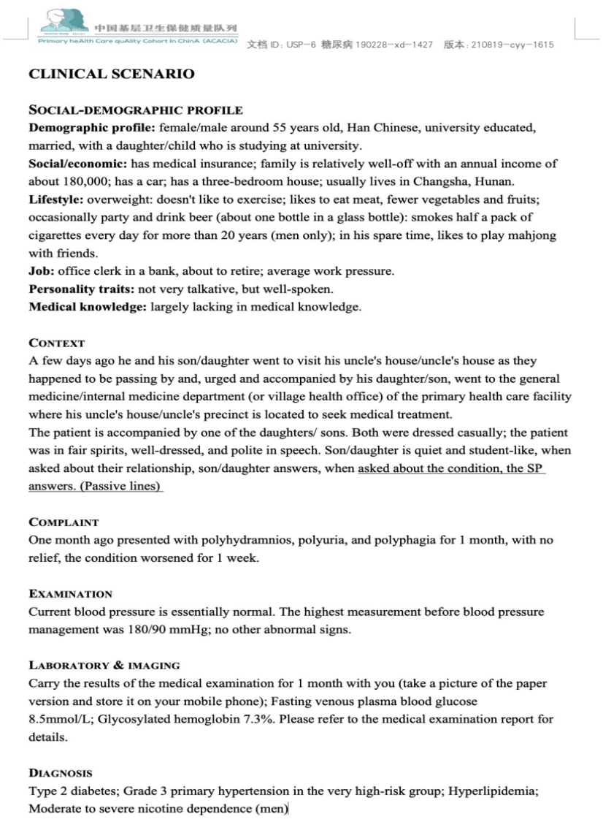

Supplementary Figure S1 Clinical scenario: a typical middle-aged undiagnosed type 2 diabetes Unannounced Standardized Patient (USP)

Supplementary Table S2 Implementation of BISC for hypertensive USPs [N (%)]

Variable | Total | Implementation of BISC for hypertensive USPs |  | P
Variable | Total | No | Yes | P
Total | 211(100.0) | 210(99.53) | 1(0.47)
Gender |  |  |  | 0.65
Male | 35(100.00) | 35(100.00) | 0(0.00)
Female | 176(100.00) | 175(99.43) | 1(0.57)
Ownership |  |  |  | 0.13
Public | 147(100.00) | 147(100.00) | 0(0.00)
Private | 64(100.00) | 63(98.44) | 1(1.56)
Type of facility |  |  |  | 0.82
Hospital | 57(100.00) | 57(100.00) | 0(0.00)
Community health Service center /station | 11(100.00) | 11(100.00) | 0(0.00)
Township health service centers/Stations | 38(100.00) | 38(100.00) | 0(0.00)
Outpatient department and clinic | 21(100.00) | 21(100.00) | 0(0.00)
Village health clinics | 84(100.00) | 83(98.81) | 1(1.19)
Management |  |  |  | 0.67
Non-profit organization | 178(100.00) | 177(99.44) | 1(0.56)
For-profit organization | 33(100.00) | 33(100.00) | 0(0.00)
Province |  |  |  | 0.80
Inner Mongolia | 11(100.00) | 11(100.00) | 0(0.00)
Hunan province | 45(100.00) | 45(100.00) | 0(0.00)
Guangdong province | 47(100.00) | 47(100.00) | 0(0.00)
Sichuan province | 52(100.00) | 51(98.08) | 1(1.92)
Guizhou province | 23(100.00) | 23(100.00) | 0(0.00)
Shaanxi province | 21(100.00) | 21(100.00) | 0(0.00)
Gansu province | 12(100.00) | 12(100.00） | 0(0.00)
Physician gender |  |  |  | 0.49
Male | 134(100.00) | 133(99.25) | 1(0.75)
Female | 65(100.00) | 65(100.00) | 0(0.00)
Physician age |  |  |  | 0.78
<30 | 5(100.00) | 5(100.00) | 0(0.00)
30-50 | 133(100.00) | 132(99.25) | 1(0.75)
≥50 | 61(100.00) | 61(100.00) | 0(0.00)
Physician title |  |  |  | 0.99
No title | 16(100.00) | 16(100.00) | 0(0.00)
Medical residency | 4(100.00) | 4(100.00) | 0(0.00)
Attending Physician | 23(100.00) | 23(100.00) | 0(0.00)
Deputy Chief Physician | 23(100.00) | 23(100.00) | 0(0.00)
Chief Physician | 3(100.00) | 3(100.00) | 0(0.00)
Unavailable | 130(100.00) | 129(99.23) | 1(0.77)
Physician department |  |  |  | 0.47
Internal medicine | 80(100.00) | 79(98.75) | 1(1.25)
Surgical/Surgery | 84(100.00) | 84(100.00) | 0(0.00)
Other | 35(100.00) | 35(100.00) | 0(0.00)
Physician ethnic |  |  |  | <0.05
Han | 164(100.00) | 164(100.00) | 0(0.00)
Other | 8(100.00) | 8(100.00) | 0(0.00)
Unavailable | 27(100.00) | 26(96.30) | 1(3.70)

Supplementary Table S3 Implementation of BISC for angina USPs [N (%)]
Variable | Total) | Implementation of BISC for Asthma USPs |  | P
Variable | Total) | No | Yes | P
Total | 211(100.0) | 175(82.98) | 36(17.06)
Ownership |  |  |  | 0.77
Public | 154(100.00) | 127(82.47) | 27(17.53)
Private | 57(100.00) | 48(84.21) | 9(15.79)
Type of facility |  |  |  | 0.24
Hospital | 64(100.00) | 53(82.81) | 11(17.19)
Community health Service center /station | 9(100.00) | 5(55.56) | 4(44.44)
Township health service centers/Stations | 37(100.00) | 32(86.49) | 5(13.51)
Outpatient department clinics | 18(100.00) | 16(88.89) | 2(11.11)
Village health clinics | 83(100.00) | 69(83.13) | 14(16.87)
Management |  |  |  | 0.46
Non-profit organization | 179(100.00) | 147(82.12) | 32(17.88)
For-profit organization | 32(100.00) | 28(87.50) | 4(12.50)
Province |  |  |  | <0.05
Inner Mongolia | 13(100.00) | 12(92.31) | 1(7.69)
Hunan province | 42(100.00) | 35(83.33) | 7(16.67)
Guangdong province | 47(100.00) | 43(91.49) | 4(8.51)
Sichuan province | 53(100.00) | 46(86.79) | 7(13.21)
Guizhou province | 22(100.00) | 18(81.82) | 4(18.18)
Shaanxi province | 19(100.00) | 11(57.89) | 8(42.11)
Gansu province | 15(100.00) | 10(66.67） | 5(33.33)
Physician gender |  |  |  | 0.23
Male | 133(100.00) | 112(84.21) | 21(15.79)
Female | 61(100.00) | 47(77.05) | 14(22.95)
Physician age |  |  |  | 0.79
<30 | 10(100.00) | 9(90.00) | 1(10.00)
30-50 | 142(100.00) | 116(81.69) | 26(18.31)
≥50 | 42(100.00) | 34(80.95) | 8(19.05)
Physician title |  |  |  | 0.88
No title | 2(100.00) | 2(100.00) | 0(0.00)
Medical residency | 11(100.00) | 8(72.73) | 3(27.27)
Attending Physician | 17(100.00) | 14(82.35) | 3(17.65)
Deputy Chief Physician | 17(100.00) | 13(76.47) | 4(23.53)
Chief Physician | 9(100.00) | 8(88.89) | 1(11.11)
Unavailable | 138(100.00) | 114(82.61) | 24(17.39)
Physician department |  |  |  | 0.62
Internal medicine | 102(100.00) | 81(79.41) | 21(20.59)
Surgical/Surgery | 79(100.00) | 67(84.81) | 12(15.19)
Other | 13(100.00) | 11(84.62) | 2(15.38)
Physician ethnic |  |  |  | 0.78
Han | 115(100.00) | 96(83.48) | 19(16.52)
Other | 4(100.00) | 3(75.00) | 1(25.00)
Unavailable | 75(100.00) | 60(80.00) | 15(20.00)

Supplementary Table S4 Implementation of BISC for Asthma USPs [N (%)]

Variable | Total | Implementation of BISC for Asthma USPs |  | P
Variable | Total | No | Yes | P
Total | 216(100.0) | 183(84.72) | 33(15.28)
Age of visit |  |  |  | 0.67
<43 | 1(100.00) | 1(100.00) | 0(0.00)
>43 | 215(100.00) | 182(84.65) | 33(15.35)
Ownership |  |  |  | 0.16
Public | 155(100.00) | 128(82.58) | 27(17.42)
Private | 61(100.00) | 55(90.16) | 6(9.84)
Type of facility |  |  |  | <0.05
Hospital | 65(100.00) | 46(70.77) | 19(29.23)
Community health Service center /station | 13(100.00) | 11(84.62) | 2(15.38)
Township health service centers/Stations | 37(100.00) | 31(83.78) | 6(16.22)
Outpatient department clinics | 16(100.00) | 16(100.00) | 0(0.00)
Village health clinics | 85(100.00) | 79(92.94) | 6(7.06)
Management |  |  |  | 0.22
Non-profit organization | 189(100.00) | 158(83.60) | 31(16.40)
For-profit organization | 27(100.00) | 25(92.59) | 2(7.41)
Province |  |  |  | 0.30
Inner Mongolia | 13(100.00) | 13(100.00) | 0(0.00)
Hunan province | 43(100.00) | 38(88.37) | 5(11.63)
Guangdong province | 46(100.00) | 35(76.09) | 11(23.91)
Sichuan province | 54(100.00) | 45(83.33) | 9(16.67)
Guizhou province | 25(100.00) | 22(88.00) | 3(12.00)
Shaanxi province | 19(100.00) | 15(78.95) | 4(21.05)
Gansu province | 16(100.00) | 15(93.75） | 1(6.25)
Physician gender |  |  |  | 0.22
Male | 154(100.00) | 131(85.06) | 23(14.94)
Female | 44(100.00) | 34(77.27) | 10(22.73)
Physician age |  |  |  | 0.52
<30 | 4(100.00) | 3(75.00) | 1(25.00)
30-50 | 156(100.00) | 128(82.05) | 28(17.95)
≥50 | 37(100.00) | 33(89.19) | 4(10.81)
Physician title |  |  |  | 0.07
No title | 2(100.00) | 2(100.00) | 0(0.00)
Medical residency | 9(100.00) | 7(77.78) | 2(22.22)
Attending Physician | 21(100.00) | 13(61.90) | 8(38.10)
Deputy Chief Physician | 18(100.00) | 15(83.33) | 3(16.67)
Chief Physician | 6(100.00) | 4(66.67) | 2(33.33)
Unavailable | 142(100.00) | 124(87.32) | 18(12.68)
Physician department |  |  |  | <0.05
Internal medicine | 99(100.00) | 90(90.91) | 9(9.09)
Surgical/Surgery | 78(100.00) | 59(75.64) | 19(24.36)
Other | 21(100.00) | 16(76.19) | 5(23.81)
Physician ethnic |  |  |  | 0.50
Han | 117(100.00) | 99(84.62) | 18(15.38)
Minority | 4(100.00) | 4(100.00) | 0(0.00)
Unavailable | 77(100.00) | 62(80.52) | 15(19.48)

 | N (%)
Score
0 | 2218 (96.35)
1 | 67 (2.91)
2 | 12 (0.52)
3 | 2 (0.09)
4 | 3 (0.13)
Supplementary Table S5 The score of implementation degree of physician

Supplementary Table S6 Descriptive analysis of the score of implementation degree of physician [N (%)]

Score | 0 | 1 | 2 | 3 | 4 | P
Visit case |  |  |  |  |  | <0.05
Gastritis | 195 (8.79) | 4 (5.97) | 0 (0.00) | 1 (50.00) | 1 (33.33)
Postpartum depression | 207 (9.33) | 0 (0.00) | 0 (0.00) | 0 (0.00) | 0 (0.00)
Pediatric diarrhea | 206 (9.29) | 0 (0.00) | 0 (0.00) | 0 (0.00) | 0 (0.00)
Common cold | 210 (9.47) | 4 (5.97) | 0 (0.00) | 0 (0.00) | 0 (0.00)
Migraines | 202 (9.11) | 3 (4.48) | 0 (0.00) | 0 (0.00) | 0 (0.00)
Asthma | 175 (7.89) | 36 (53.73) | 0 (0.00) | 0 (0.00) | 0 (0.00)
Angina | 183 (8.25) | 18 (26.87) | 12 (100.00) | 1 (50.00) | 2 (66.67)
Low back pain | 212 (9.56) | 0 (0.00) | 0 (0.00) | 0 (0.00) | 0 (0.00)
Stress urinary incontinence | 209 (9.42) | 1 (1.49) | 0 (0.00) | 0 (0.00) | 0 (0.00)
Hypertension | 210 (9.47) | 1 (1.49) | 0 (0.00) | 0 (0.00) | 0 (0.00)
Diabetes | 209 (9.42) | 0 (0.00) | 0 (0.00) | 0 (0.00) | 0 (0.00)
Age of visiting USP |  |  |  |  |  | <0.05
<43 | 1021(46.03) | 11 (16.42) | 0 (0.00) | 1 (50.00) | 1 (33.33)
>43 | 1197(53.97) | 56 (83.58) | 12 (100.00) | 1 (50.00) | 2 (66.67)
Ownership |  |  |  |  |  | 0.489
Public | 1569(70.74) | 50 (74.63) | 10 (83.33) | 2 (100.00) | 3 (100.00)
Private | 649 (29.26) | 17 (25.37) | 2 (16.67) | 0 (0.00) | 0 (0.00)
Institution type |  |  |  |  |  | 0.202
Hospital | 622 (28.04) | 23 (34.33) | 7 (58.33) | 1 (50.00) | 2 (66.67)
Community health service centre/Station | 102 (4.60) | 7 (10.45) | 1 (8.33) | 0 (0.00) | 0 (0.00)
Township health service centre/Stations | 412 (18.58) | 12 (17.91) | 1 (8.33) | 1 (50.00) | 0 (0.00)
Outpatient department and clinic | 207 (9.33) | 2 (2.99) | 0 (0.00) | 0 (0.00) | 0 (0.00)
Village health office | 875 (39.45) | 23 (34.33) | 3 (25.00) | 0 (0.00) | 1 (33.33)
Management |  |  |  |  |  | 0.270
Non-profit organization | 1884(84.94) | 63 (94.03) | 10 (83.33) | 2 (100.00) | 3 (100.00)
For-profit organization | 334 (15.06) | 4 (5.97) | 2 (16.67) | 0 (0.00) | 0 (0.00)
Province |  |  |  |  |  | 0.397
Inner Mongolia | 124 (5.59) | 2 (2.99) | 0 (0.00) | 0 (0.00) | 0 (0.00)
Hunan province | 453 (20.42) | 11 (16.42) | 1 (8.33) | 1 (50.00) | 1 (33.33)
Guangdong province | 491 (22.14) | 12 (17.91) | 4 (33.33) | 0 (0.00) | 1 (33.33)
Sichuan province | 562 (25.34) | 18 (26.87) | 5 (41.67) | 0 (0.00) | 0 (0.00)
Guizhou province | 249 (11.23) | 6 (8.96) | 1 (8.33) | 0 (0.00) | 1 (33.33)
Shaanxi province | 187 (8.43) | 13 (19.40) | 0 (0.00) | 1 (50.00) | 0 (0.00)
Gansu province | 152 (6.85) | 5 (7.46) | 1 (8.33) | 0 (0.00) | 0 (0.00)
Physician gender |  |  |  |  |  | 0.724
Male | 1368(67.19) | 42 (63.64) | 10 (83.33) | 1 (50.00) | 2 (66.67)
Female | 668 (32.81) | 24 (36.36) | 2 (16.67) | 1 (50.00) | 1 (33.33)
Physician age |  |  |  |  |  | 0.648
<30 | 64 (3.15) | 1 (1.52) | 1 (8.33) | 0 (0.00) | 0 (0.00)
30-50 | 1448(71.19) | 53 (80.30) | 9 (75.00) | 1 (50.00) | 3 (100.00)
≥50 | 522 (25.66) | 12 (18.18) | 2 (16.67) | 1 (50.00) | 0 (0.00)
Physician education |  |  |  |  |  | 0.715
Graduate | 22 (1.08) | 2 (3.03) | 0 (0.00) | 0 (0.00) | 0 (0.00)
Bachelor | 201 (9.88) | 4 (6.06) | 1 (8.33) | 0 (0.00) | 2 (66.67)
Junior college | 25 (1.23) | 0 (0.00) | 0 (0.00) | 0 (0.00) | 0 (0.00)
Secondary technical | 8 (0.39) | 0 (0.00) | 0 (0.00) | 0 (0.00) | 0 (0.00)
High school and below | 3 (0.15) | 0 (0.00) | 0 (0.00) | 0 (0.00) | 0 (0.00)
Unavailable | 1776(87.27) | 60 (90.91) | 11 (91.67) | 2 (100.00) | 1 (33.33)
Physician certification |  |  |  |  |  | 0.992
Practitioner | 459 (22.56) | 16 (24.24) | 1 (8.33) | 0 (0.00) | 1 (33.33)
Physician assistant | 25 (1.23) | 1 (1.52) | 0 (0.00) | 0 (0.00) | 0 (0.00)
Village physicians | 98 (4.82) | 3 (4.55) | 1 (8.33) | 0 (0.00) | 0 (0.00)
No certificate | 4 (0.20) | 1 (1.52) | 0 (0.00) | 0 (0.00) | 0 (0.00)
Others | 3 (0.15) | 0 (0.00) | 0 (0.00) | 0 (0.00) | 0 (0.00)
Unavailable | 1446(71.06) | 45 (68.18) | 10 (83.33) | 2 (100.00) | 2 (66.67)
Physician title |  |  |  |  |  | 0.014
No title | 87 (4.27) | 1 (1.52) | 0 (0.00) | 0 (0.00) | 1 (33.33)
Medical residency | 38 (1.87) | 4 (6.06) | 0 (0.00) | 0 (0.00) | 1 (33.33)
Attending physician | 244 (11.98) | 8 (12.12) | 2 (16.67) | 1 (50.00) | 1 (33.33)
Deputy chief physician | 214 (10.51) | 8 (12.12) | 1 (8.33) | 0 (0.00) | 0 (0.00)
Chief physician | 82 (4.03) | 4 (6.06) | 0 (0.00) | 0 (0.00) | 0 (0.00)
Unavailable | 1371(67.34) | 41 (62.12) | 9 (75.00) | 1 (50.00) | 0 (0.00)
Physician department |  |  |  |  |  | 0.187
Internal medicine | 1043(51.30) | 33 (50.00) | 5 (41.67) | 0 (0.00) | 1 (33.33)
Surgical/Surgery | 582 (28.63) | 25 (37.88) | 6 (50.00) | 1 (50.00) | 2 (66.67)
Others | 408 (20.07) | 8 (12.12) | 1 (8.33) | 1 (50.00) | 0 (0.00)
Physician ethnic |  |  |  |  |  | 0.056
Han | 1518(74.59) | 40 (60.61) | 5 (41.67) | 2 (100.00) | 2 (66.67)
Other | 31 (1.52) | 1 (1.52) | 0 (0.00) | 0 (0.00) | 0 (0.00)
Unavailable | 486 (23.88) | 25 (37.88) | 7 (58.33) | 0 (0.00) | 1 (33.33)

1. census Ootlgotscftsnp. China population census yearbook 2020. 2022;
2. China SICotNHCo. National Health Service, January-November 2022. 2023;
3. China NHCo. China Smoking Hazardous to Health Report 2020. Accessed 20 November, 2023. https://www.gov.cn/fuwu/2021-05/30/content_5613994.htm
4. Stead LF, Buitrago D, Preciado N, Sanchez G, Hartmann-Boyce J, Lancaster T. Physician advice for smoking cessation. Cochrane Database Syst Rev. May 31 2013;2013(5):Cd000165. doi:10.1002/14651858.CD000165.pub4
5. Lei W, bin J, Jing Z, Yao H. Minimal-Intervention on smoking cessation：a Meta-analysis. Chinese Journal of Epidemiology. 2015;36(6):658-662. doi:10.3760/cma.j.issn.0254-6450.2015.06.026
6. Ling L, Qiuling C, Ruixue J, Xuan C. The Smoking Pattern and Disease Burden of Tobacco Use in China. Chinese Health Economics. 2008;27(1):26-30. doi:10.3969/j.issn.1003-0743.2008.01.010
7. Hang; J, Tong; Z, Li-rong L, et al. Smoking prevalence,attitude towards tobacco control and brief intervention on smoking cessation among medical professionals in a tertiary hospital in Beijing. Chinese Journal of Public Health. 2021;37(1):44-47. doi:10.11847/zgggws1125588

