Supplementary data

Table S1
Information for 69 flax accessions used for InDel genotyping
S. No | Accession | Type | Oil content | Source | S. No | Accession | Type | Oil content | Source
1 | Male (87-3) | Fiber | 35.94 | China | 36 | Tianya9 | Oil | 42.30 | China
2 | Female (84-3) | Oil | 45.77 | China | 37 | Dingya5 | Oil | 36.07 | China
3 | Baxuan3 | Oil | 45.08 | China | 38 | Xihelao | Oil | 36.49 | China
4 | Dingya23 | Oil | 42.60 | China | 39 | Heiya13 | Fiber | 36.77 | China
5 | Longyaza3 | Oil | 42.20 | China | 40 | Diane | Fiber | 36.72 | France
6 | Longya10 | Oil | 40.89 | China | 41 | Zhongya5 | Fiber | 32.66 | China
7 | Omega | Oil | 38.54 | China | 42 | Heya16 | Fiber | 38.95 | China
8 | Huachihuma | Oil | 38.18 | China | 43 | Yuan 2010-37 | Fiber | 38.57 | China
9 | Heshuihonghuma | Oil | 39.25 | China | 44 | Heiya15 | Fiber | 36.98 | China
10 | Zhangya2 | Oil | 42.32 | China | 45 | New1 | Fiber | 37.49 | Netherland
11 | Jinya8 | Oil | 40.85 | China | 46 | Heiya23 | Fiber | 38.36 | China
12 | Ningya19 | Oil | 41.26 | China | 47 | Baihua | Fiber | 38.51 | China
13 | Longya14 | Oil | 41.68 | China | 48 | Tyy13-1 | Fiber | 37.62 | China
14 | Baya7 | Oil | 43.64 | China | 49 | BISON×REDWING | Fiber | 35.32 | American
15 | Baya9 | Oil | 41.02 | China | 50 | P1 | Fiber | 38.52 | China
16 | Tongya12 | Oil | 41.98 | China | 51 | P2 | Fiber | 37.50 | China
17 | Jinya10 | Oil | 39.82 | China | 52 | P3 | Fiber | 39.09 | China
18 | Neiya9 | Oil | 44.15 | China | 53 | P4 | Fiber | 37.70 | China
19 | Baya13 | Oil | 39.40 | China | 54 | P5 | Fiber | 37.36 | China
20 | Jinya12 | Oil | 40.50 | China | 55 | P6 | Fiber | 37.63 | China
21 | Baya4 | Oil | 40.29 | China | 56 | P7 | Fiber | 38.91 | China
22 | Bethune | Oil | 40.12 | Canada | 57 | P8 | Fiber | 37.52 | China
23 | Dingya21 | Oil | 40.70 | China | 58 | P9 | Fiber | 37.81 | China
24 | Baya12 | Oil | 38.95 | China | 59 | P10 | Fiber | 37.17 | China
25 | Longya7 | Oil | 41.60 | China | 60 | P11 | Fiber | 37.74 | China
26 | Longya8 | Oil | 40.62 | China | 61 | P12 | Fiber | 36.98 | China
27 | Longya12 | Oil | 39.80 | China | 62 | P13 | Fiber | 38.87 | China
28 | Baxuan10 | Oil | 40.51 | China | 63 | P14 | Fiber | 38.53 | China
29 | Baya6 | Oil | 39.29 | China | 64 | P15 | Fiber | 39.22 | China
30 | Hongmu65 | Oil | 41.50 | China | 65 | P16 | Fiber | 39.00 | China
31 | Zhangxianhong | Oil | 36.29 | China | 66 | P17 | Fiber | 38.72 | China
32 | Linxiabai | Oil | 36.78 | China | 67 | P18 | Fiber | 38.73 | China
33 | Kuerle | Oil | 35.50 | China | 68 | P19 | Fiber | 37.42 | China
34 | Zhangbeidali | Oil | 36.32 | China | 69 | P20 | Fiber | 37.16 | China
35 | Neiya6 | Oil | 43.20 | China

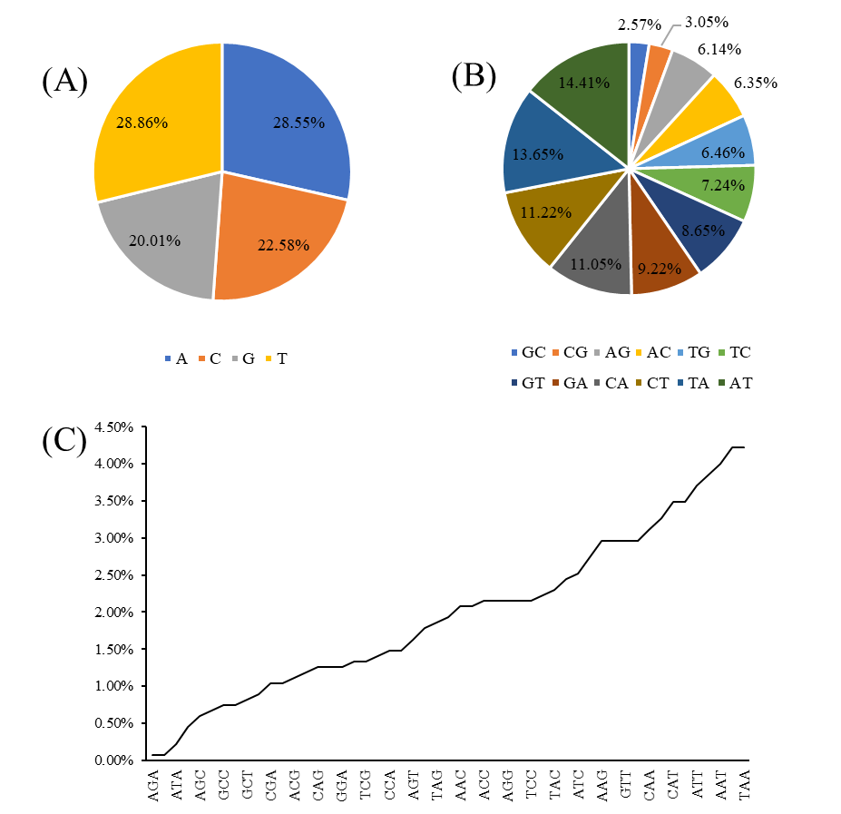
Fig. S1 Distribution of InDel repeats of (A) single nucleotide, (B) dinucleotide and (C) trinucleotide

Table S3
Characteristics of 90 InDel markers used for genetic diversity analysis
Marker | Forward (5'-3') | Reverse (5'-3') | Tm (℃) | Product size (bp)
InDel-1 | TGTGTGCAAGTTCTATGGGGAATA | GAGGAGAAGACAGAGCTAATTCGA | 59.663 | 244
InDel-2 | GATGTGAATTCTCTGCCTCGAAAG | TCCTTTACAGCAGCAGTACATGTA | 59.778 | 242
InDel-3 | TAACGGATCGATACCTGAACTTGG | GGTGGGAATTTGGGTATGTTTACG | 60.142 | 176
InDel-4 | AGGCGGAATGAGTAAATGagatga | CTTCTCCCCAAGTCACCTAATCAA | 60.019 | 194
InDel-5 | ctttagtgtcagtccctagcttca | tcgacaagcttccttattcatgga | 60.081 | 133
InDel-6 | GTTCACGATACCATTACACTGCAG | AGCTAAAGAACAGTAGGGTGAGTG | 60.021 | 162
InDel-7 | GATGGGAAATTCATTATGGCTGCA | GGTATTTGTTGTTGATCCACTGCT | 59.782 | 246
InDel-8 | agaaaactgcCGAACTTCAAGATG | CGGGTTAAATAGTTGATGCTGTCG | 60.26 | 180
InDel-9 | TCTGTTTTCCTCATCTCCATGGTT | TTACAGTAACACAAGCAGGCAAAG | 59.964 | 137
InDel-10 | TTTCTGTTTTACGGTGGGAATGTC | GAATCCTGCAAGCCGAATTACAAT | 60.202 | 228
InDel-11 | cgagtggtctatcatgCGTCAT | tcatcaactaccAGACGCCTTTAA | 60.021 | 149
InDel-12 | TAACTGTTGAATCCTCATGGCTGA | GAGCTACCCTAGTTTAGAAGAGGc | 59.962 | 115
InDel-13 | TGTCAATGGCGTATACTGTAGGAA | ACCACATGTACTAGAGTCTCTACCT | 59.808 | 137
InDel-14 | CCATGACCGGTAAAATTATGACCC | CTGAAGATGTGAGACGAACGAGTA | 60.143 | 159
InDel-15 | GAATGTTAGGTGTTGGGGCATAAG | CGTCAAAATTAAGCCGGTAatcca | 59.905 | 226
InDel-16 | GGTTGATAGTTGGCATTGCATCTT | AACAATCAAGCAAATCTCTCGAGC | 60.143 | 133
InDel-17 | GCGTTATTTAGCTGATCATGTCCC | AGAAGCAATGGTTGAGGAATTTGG | 60.021 | 240
InDel-18 | GGAGAGTGTGAGTGAGATGAATGT | CGCAACTCCTAACCAATTTCAGAC | 60.378 | 141
InDel-19 | AGAAGTTACGAAGATTCACCGACA | AAGCCTTCATCAAACTCAGGAGAT | 60.019 | 239
InDel-20 | GCAACGGAATAAAGCTATCACCTT | ATCTGTGTGGATTGATCAGGGTTT | 60.264 | 116
InDel-21 | CTCCTAAACCAACCACCAATTGTC | TAGAATAGGGAGGTGCGATTTgag | 59.961 | 210
InDel-22 | ATTCATGGCCCAGGTTAGTGATAG | TAATATGCCGTCTCTACCCAGTTG | 59.961 | 171
InDel-23 | gtgtTCAAACTACcccacatcaac | aatgaTGTGGAGGGTGAACTAACA | 59.957 | 223
InDel-24 | ATTCAATGCTAGTCCTCCCAACAT | GGGAGCCATGACAAACAATATGAG | 59.963 | 184
InDel-25 | CCCATCTCGTCTTCAATCACTACA | attgcactaataaaccacacaccg | 60.083 | 117
InDel-26 | AGTACTTTGTGTGATCTGCATTGC | CGTCACGAAACCAAGAAGAATCAA | 60.025 | 181
InDel-27 | TCCCATAACTCTTCTTGCTGGAAA | TTGGCTAACATGGAGAGTGTAGAC | 60.082 | 233
InDel-28 | GAAGAGAATGACGAGTTTAGGGGT | ATGCCCAATTTCATGTCCGAATTC | 60.442 | 180
InDel-29 | GATACCTATGTTTGCGGGAAAAGG | TTTGAACCTCTTCTCCATCTCGTT | 59.96 | 196
InDel-30 | CCAGCACAAAACCTCTCCTaaaag | aaccctaaccatcatcttgtcgaa | 60.02 | 145
InDel-31 | CCCGCTCCTAGTAACATCTacatc | atTTCGGGCAGTGTATTTCAAGTC | 59.844 | 243
InDel-32 | aTTTATGACTTTCCATGCGTGCTC | AGAAAGGCTACGTACGTACAGTTT | 60.023 | 136
InDel-33 | TTTCTTACATTTTGCCGGTAGTCC | GCTTGAAACTGGGGATAATGTCAC | 60.142 | 228
InDel-34 | TCAACCCATAGCCTCAATTAACCA | TAACCAAAGAATTCCCTGcaaagg | 59.717 | 226
InDel-35 | TCTTCGTAAAAGGTGACATCTCGT | TACACACATTTACGCGCATCTTAC | 59.968 | 209
InDel-36 | TGGAATGATGAGAAGAGACGTGTT | GGGCTTTGACTCCAGAATCTTTTC | 60.083 | 238
InDel-37 | CTTATCCAGAGAGTTTCAGACCGT | AATTGGATAAGGGATGGGGACTTG | 60.388 | 232
InDel-38 | GCCCTCTGTCTCTGTGTTTTCAAA | CATCTCTGGCGATCAATCAAGAAC | 60.025 | 171
InDel-39 | GGCTCAACAACTCCCTTATATGTA | CCGACTGTGACTTTATTCTCAAGG | 59.373 | 154
InDel-40 | CTTGTTGTCGTTAAGGGTTTTCGA | TGACGGTGAAGAAAACTGGAAATG | 59.964 | 154
InDel-41 | GGAGGAAAGTACTACTGGTCTCAC | CATGGTTTGGAAAGTATGCCTGAA | 59.78 | 122
InDel-42 | AGATGTGACACTAGAATCCTGCTC | TCAACCAGGAAGCATTTACCCTAA | 59.956 | 220
InDel-43 | TATGGGCAGATTTACACGGACTAG | TTGCGACGGTACAAATGTCTACTA | 60.083 | 195
InDel-44 | GGACAAAATCGTTGCccatttcaa | CAATTCGGACATGAAATTGGGCAT | 60.681 | 241
InDel-45 | CTCGTTGATGAGTAAGCGAATTCC | tatctaaatggtccgcatgatgga | 59.714 | 210
InDel-46 | TGGACATGACTAGCAGTATCAAGG | ATTCAAGAGATCAAATCAGCAGCG | 59.965 | 228
InDel-47 | GGCAAATAACGCTGGATGTCAATT | ACCCTGCATAGTGAACACAAAATG | 60.022 | 127
InDel-48 | AATTGCCCAAGTTTCCTTCTGATG | CTTCCAAGCCTTGTCTTCATCATC | 59.904 | 218
InDel-49 | CGTGCAAAGTGACATACGGATTTA | CCCAATCGTTCTGAATTTGTCGTT | 60.32 | 136
InDel-50 | ACTGGGAGTTCTATATTGGGTTGG | TCTACGACAGTCCTTGCCAATTAA | 60.021 | 201
InDel-51 | CAGCTTTTGAATTCAGAGTGTCGT | TTGAGGTTGATTGCTCTGATCTCA | 60.02 | 218
InDel-52 | TTCATCGTCTTTCTCGTCTTCCTT | TTAAAATCTCCAATTCCGAGCGAC | 59.668 | 143
InDel-53 | aacttCTAAACTTCTTCACGCTGC | TACGGTATAGATAACACAGCTGCC | 60.023 | 188
InDel-54 | CGTGAGGTAGCGTCTAGATTGTAA | CGGACCCATGTTACAACctctaaa | 60.564 | 151
InDel-55 | CACATATATCACTCCCAGTCCCAG | TGGTGATAACATAAGGCCTCCAAA | 60.018 | 135
InDel-56 | GAGACCGAATACTAATAGCGAGCA | TCTGCATATTTGTCGGACTACCTT | 59.838 | 180
InDel-57 | cgtcgtcgtcatttTGAAaggtaa | AGACGTGTTTCcatctttctccat | 60.263 | 211
InDel-58 | ACTTTAAGCATCTGAACAACGACG | tttggaattgaacGAGGGATTGTC | 59.782 | 229
InDel-59 | tgtacctgcgtatacactttgtca | gacacccaattcccctctaataca | 59.835 | 181
InDel-60 | GATTTCCCATTTTCTTGACCGTGT | AAAACGAATTCTGGGAATTGGGAC | 60.021 | 197
InDel-61 | AGTTATTCTCCCAAGGCTCTCAC | CCTCATTCCAAATGCAAGCAATGT | 60.862 | 153
InDel-62 | CACCAACTCTTCGCATCATATGTC | GAGCGAGACGAACTTAAATCACTG | 59.969 | 185
InDel-63 | TACACATTTCAAATGGCCAAGACC | ATGACGTCTTTATTGTTGGTTGGG | 59.782 | 245
InDel-64 | CATGGGAGGATATGAATTCTGGGT | ATTACAGTCCATCGTCATAGTCGG | 60.023 | 145
InDel-65 | TGCGATCCATTTAACTGATGATGC | TTAACGAACCAATCCCtagaacgg | 60.621 | 159
InDel-66 | AGACCTATTACGCATTTGACTCGA | CACACAACACACACACTACACTAC | 59.968 | 168
InDel-67 | GGTTGTTGATTCGCTTCTAGTTCA | TTTCCGTTTACTTCCTTCCTGACT | 59.898 | 148
InDel-68 | CAATTTCAAAGTTTAGAGATCCGCC | ATATGAGGGCACGACAGTAACAAT | 60.142 | 230
InDel-69 | GAGTGAAGAGAGCAGAGTTGAGTC | GCTGCCGGAAACTcatttattctt | 60.142 | 178
InDel-70 | TTTGTAACAACTTCATTCCTCGGC | ACAACAGTTCGACTATGGATTGGA | 60.021 | 178
InDel-71 | TTCTGTTAACTTGCGACGAAGATG | CAACTgcttcaaatcaaaaccagC | 60.025 | 202
InDel-72 | TACAGACAGGCCACCAATTTATGA | TATAAAAGGATGCCGAGACCAACA | 60.081 | 182
InDel-73 | CtcaatcttcatctcctcctcgaG | GCGGAGAAATCATGGTGTTAACAA | 60.083 | 159
InDel-74 | GGGATAAAATACTTGTGCAGCTCG | tctttattcgGCCCAAGGTTCATA | 60.08 | 97
InDel-75 | ATACTCATAGTGCTTGGTCTGACG | CCGAGCTCCACACCATTATTTAAG | 59.727 | 220
InDel-76 | ATGGATTAACGAGATTCCCACTGT | AGCTCCCACTTATACTACACCTCT | 60.079 | 159
InDel-77 | CTCCAACGATTACTTTCTAACGGC | TTCAATGTTTCAGGCTGCACTTAG | 60.023 | 219
InDel-78 | CCGCTGGGTAATCTATCGAATTCC | ttaaaaggTAAGAGCTCCCGAACA | 59.959 | 179
InDel-79 | CTCTTGATTTGGCATTCTTTTCGC | ACAAAAGACTAGGATGATGTGGCT | 60.019 | 179
InDel-80 | GGGGAGAGAGTTATTTGGGAGTTT | tgCTTCAGTCCAGATTTTAATGCC | 59.842 | 212
InDel-81 | ATTGTGGAGGATGGTCATTActga | TAAGCTCAACCATAACCGTACACT | 59.779 | 130
InDel-82 | TCAAACTCTTACCTTCGAGCTCAA | ACGAGCCTTAAAGAGTTTGAGCTA | 60.021 | 180
InDel-83 | acattttcccCTGTTTCTGTGATG | GGGCAGTGGTAAGTGAGTTTAGAT | 60.324 | 150
InDel-84 | CATTCATGGAGCCTTTACTTtgca | AAGTCTGGTTTAGCTGAATTCCCT | 59.957 | 162
InDel-85 | GCAGGGGTCCATGTTCAAAATTAT | CTACTTTATGCATCACCTCTCCGA | 59.962 | 223
InDel-86 | AAAGGAGGATGAAGTTGCCAATTG | GATCAAAATGACCACCGGAAAAGT | 60.022 | 180
InDel-87 | TGTTCATGTCATTGTATCCTGGGA | TGAAGTTATGATCAGAGGAGGCAG | 59.899 | 246
InDel-88 | TTCTTCTATCTTGACTTCCCTGCC | TCCCCAAACTGATCTTGATCCATT | 60.017 | 164
InDel-89 | GTAATTCGCATCTTCTCCAGCTTC | CTCCGATTCTCTCATCCAATTTGC | 60.024 | 204
InDel-90 | GTGTTTGCAAGGATGTCATGAAGA | AAACGAGACCCATGTTACTGAGAA | 59.96 | 205

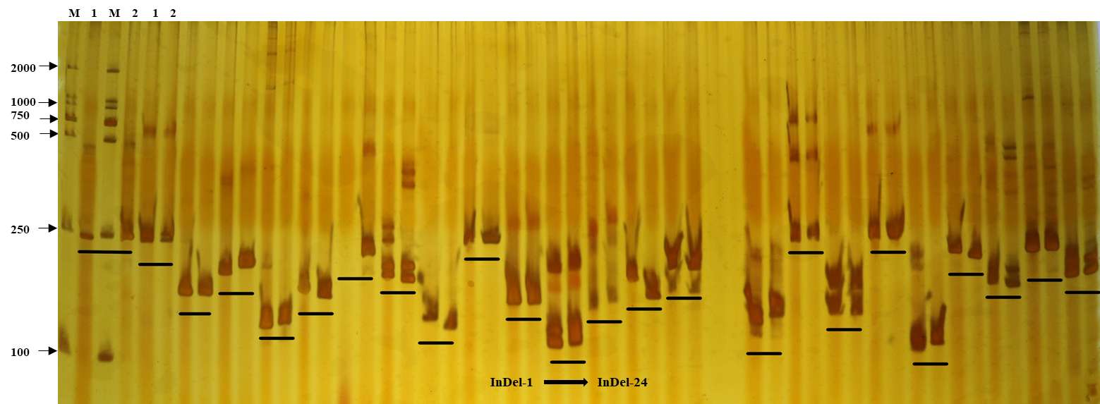
(A)
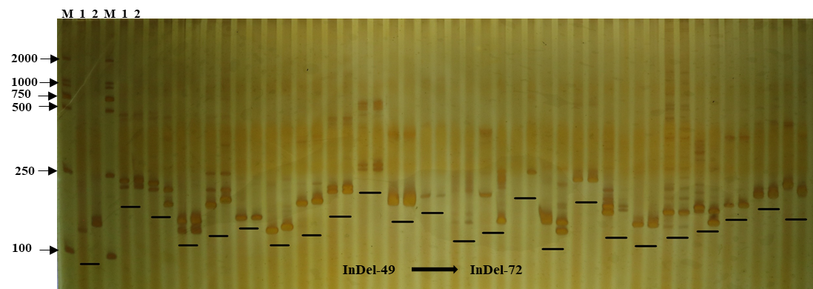
(B)
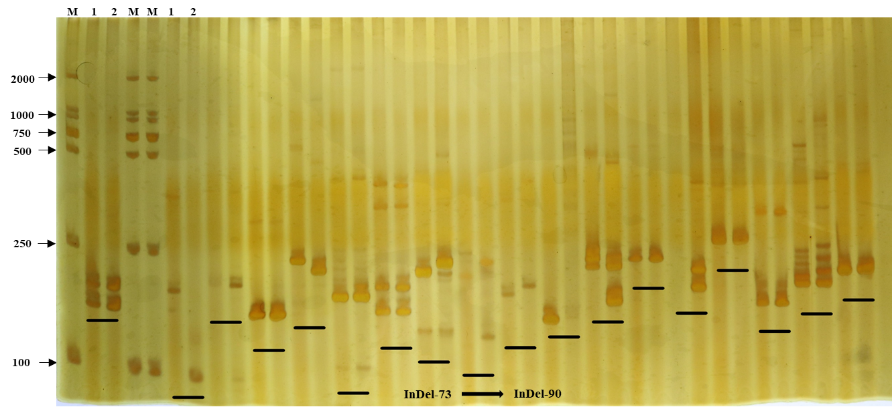
(C)
Fig. S2 Amplification products in 87-3 and 84-3 with (A) InDel-1—InDel-24, (B) InDel-49—InDel-72 and (C) InDel-73—InDel-90;
M, 2000bp marker; 1, 87-3; 2, 84-3

Table S4
Statistics of bands amplified by InDel primers
Marker | Major Allele Frquency | Allele No | Gene Diversity | PIC
InDel-4 | 0.7681 | 3.0000 | 0.3625 | 0.3065
InDel-6 | 0.5652 | 2.0000 | 0.4915 | 0.3707
InDel-8 | 0.5217 | 2.0000 | 0.4991 | 0.3745
InDel-9 | 0.8913 | 2.0000 | 0.1938 | 0.1750
InDel-13 | 0.9638 | 2.0000 | 0.0698 | 0.0674
InDel-14 | 0.7319 | 2.0000 | 0.3925 | 0.3154
InDel-16 | 0.5942 | 2.0000 | 0.4823 | 0.3660
InDel-20 | 0.7971 | 3.0000 | 0.3289 | 0.2835
InDel-21 | 0.7754 | 2.0000 | 0.3484 | 0.2877
InDel-26 | 0.5797 | 2.0000 | 0.4873 | 0.3686
InDel-30 | 0.6957 | 3.0000 | 0.4318 | 0.3503
InDel-31 | 0.5290 | 2.0000 | 0.4983 | 0.3742
InDel-34 | 0.6812 | 3.0000 | 0.4432 | 0.3570
InDel-40 | 0.5725 | 2.0000 | 0.4895 | 0.3697
InDel-41 | 0.7101 | 2.0000 | 0.4117 | 0.3269
InDel-47 | 0.6667 | 2.0000 | 0.4444 | 0.3457
InDel-49 | 0.7174 | 3.0000 | 0.4133 | 0.3390
InDel-51 | 0.5072 | 3.0000 | 0.5138 | 0.3958
InDel-53 | 0.7971 | 3.0000 | 0.3373 | 0.3025
InDel-55 | 0.7391 | 2.0000 | 0.3856 | 0.3113
InDel-56 | 0.5000 | 2.0000 | 0.5000 | 0.3750
InDel-62 | 0.8043 | 2.0000 | 0.3147 | 0.2652
InDel-64 | 0.9420 | 2.0000 | 0.1092 | 0.1033
InDel-66 | 0.5145 | 2.0000 | 0.4996 | 0.3748
InDel-69 | 0.7899 | 2.0000 | 0.3320 | 0.2769
InDel-72 | 0.6667 | 3.0000 | 0.4537 | 0.3631
InDel-74 | 0.7174 | 2.0000 | 0.4055 | 0.3233
InDel-77 | 0.5870 | 2.0000 | 0.4849 | 0.3673
InDel-80 | 0.9130 | 2.0000 | 0.1588 | 0.1462
InDel-81 | 0.5072 | 2.0000 | 0.4999 | 0.3749
InDel-84 | 0.5797 | 2.0000 | 0.4873 | 0.3686
InDel-89 | 0.8841 | 2.0000 | 0.2050 | 0.1840
Mean | 0.6941 | 2.2500 | 0.3899 | 0.3097

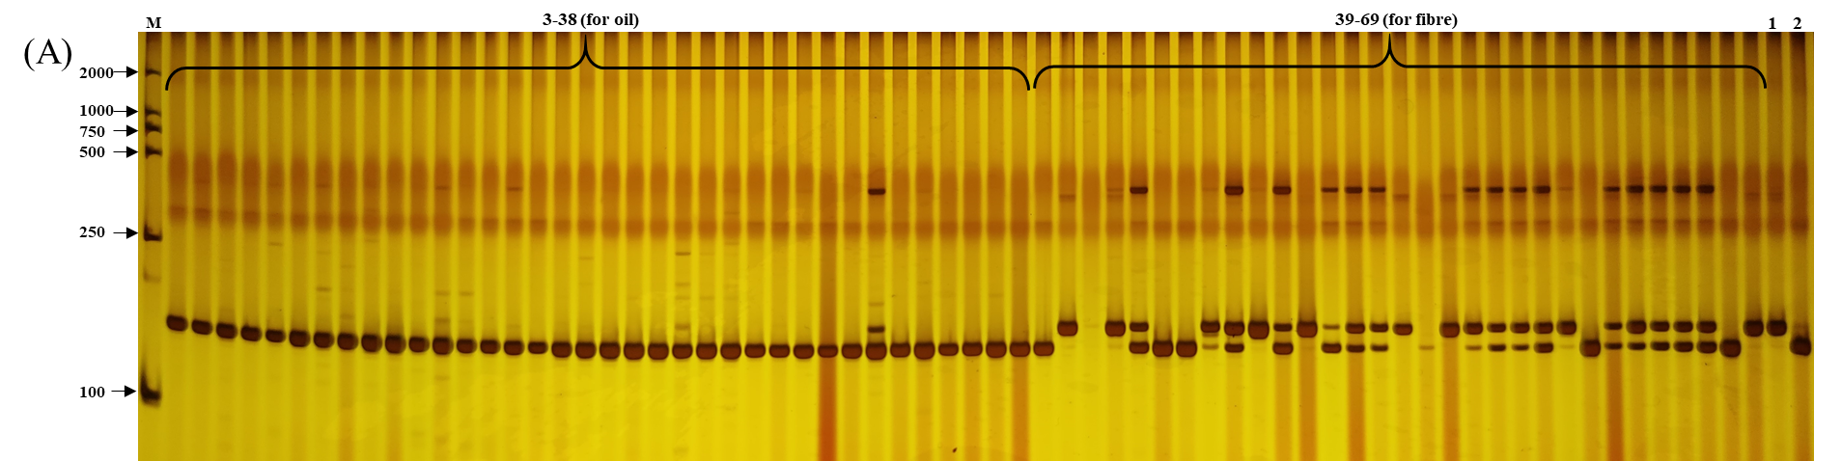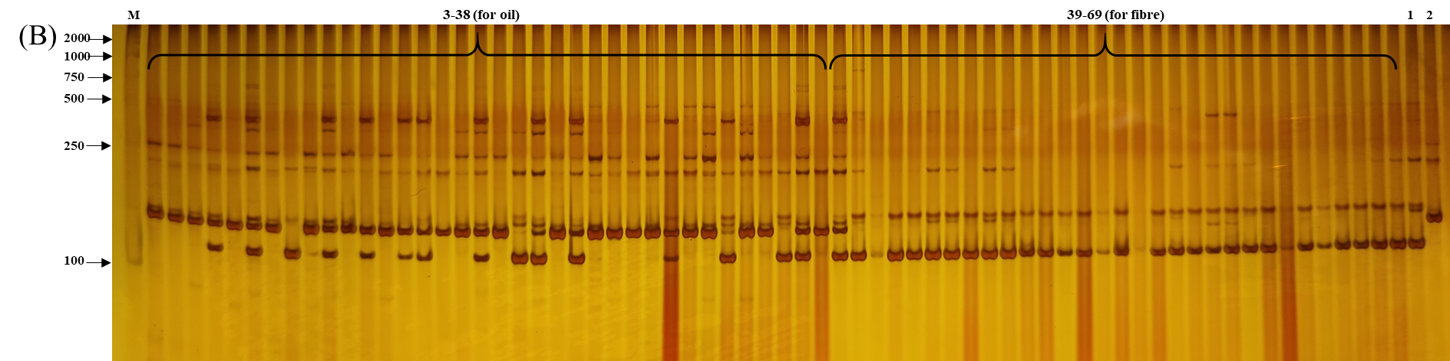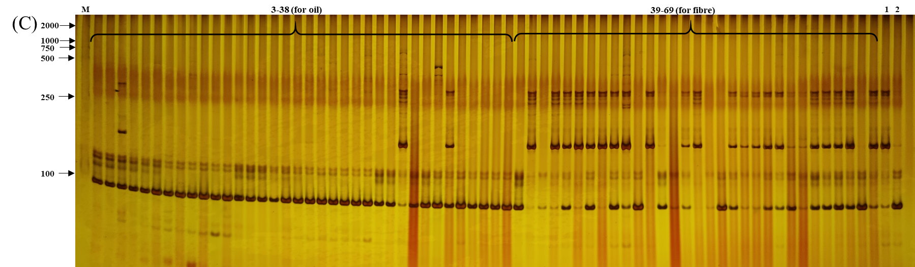
Fig. S3 Amplification products of 69 flax accessions using (A) InDel-14, (B) InDel-40 and (C) InDel-74. M, 2000bp marker; 1 and 2 represent 87-3 and 84-3 respectively; 3-38, flax accessions for oil; 39-69, flax accessions for fibre.

