Visualisations for Young Adults going to college:
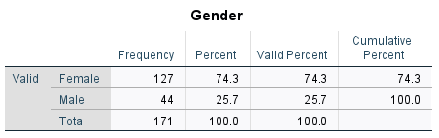
Table 1a: Gender Distribution among young adults going to college. (Figure 1 shows the gender distribution among college-going participants.)
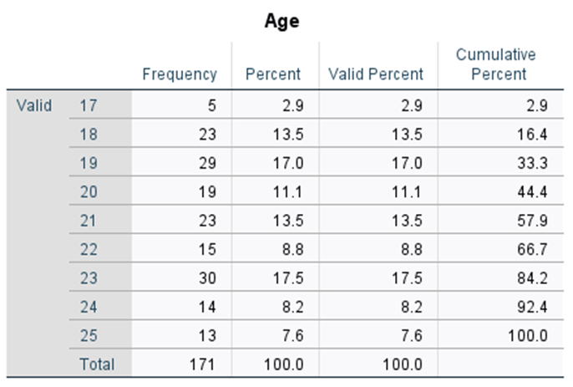
Table 1b: Frequency Distribution according to age in young adults aged 17 to 25
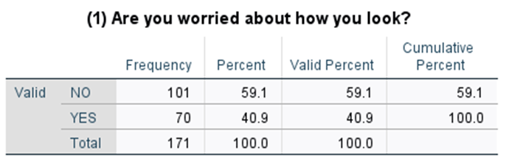
Table 1c: Frequency and Percentage according to whether they are worried about their look.
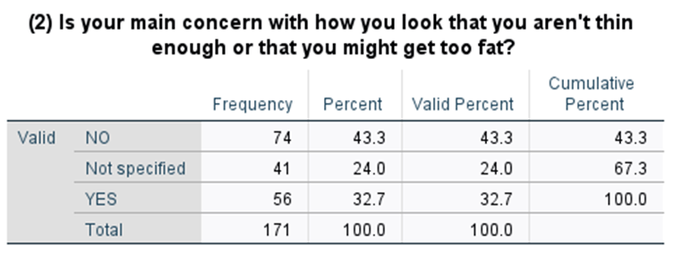
Table 1d: Frequency and Percentage concerning their body shape.
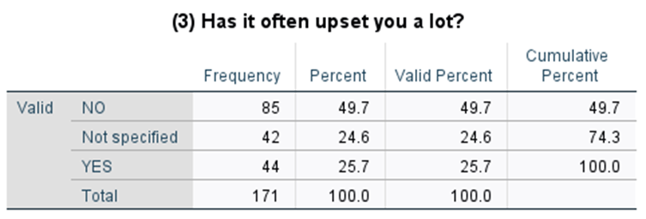
Table 1e: Frequency and Percentage on whether they are upset or not
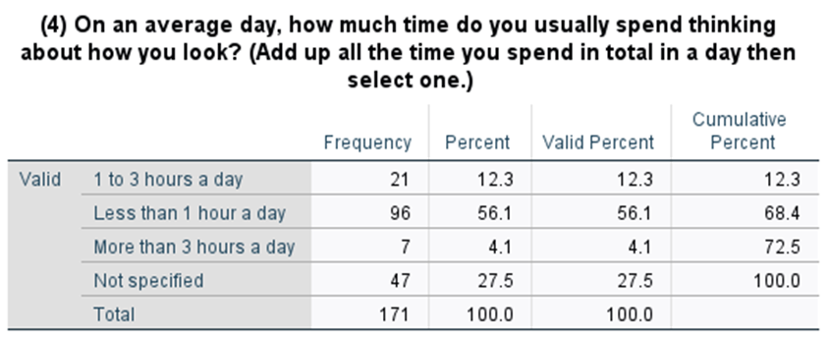
Table 1f: Frequency and Percentage according to average time spent thinking about their look
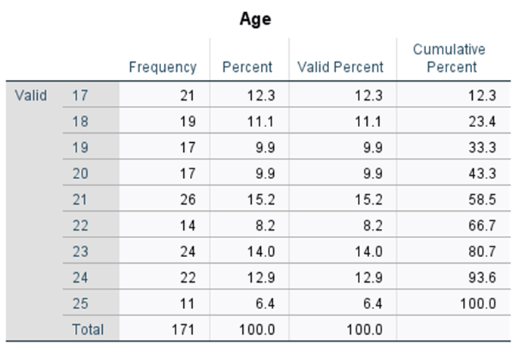
Table 2a: Frequency and Percentage according to age of young adults not going to college aged 17 to 25.
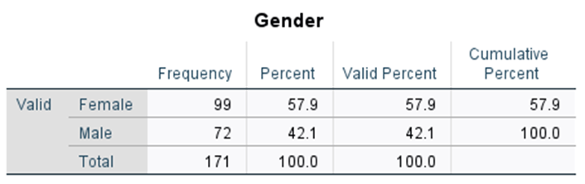
Table 2b: Frequency and Percentage according to gender of young adults not going to college aged 17 to 25.

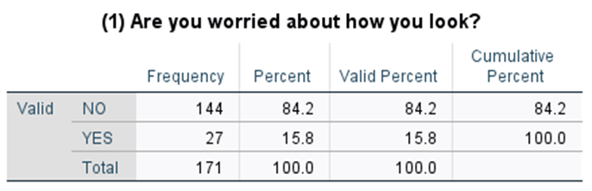
Table 2c: Frequency and Percentage according to whether they are worried about their look
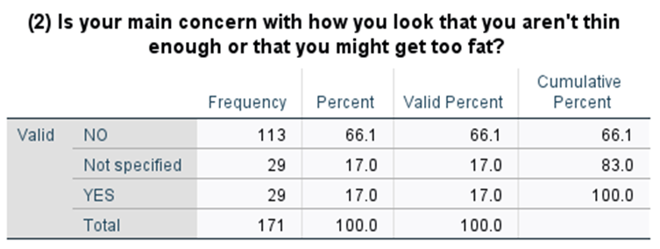
Table 2d: Frequency and Percentage concerning their body shape
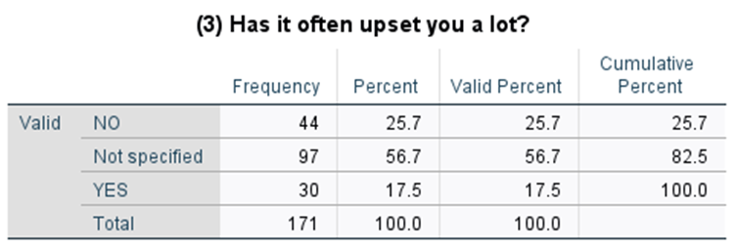
Table 2e: Frequency and Percentage on whether they are upset or not
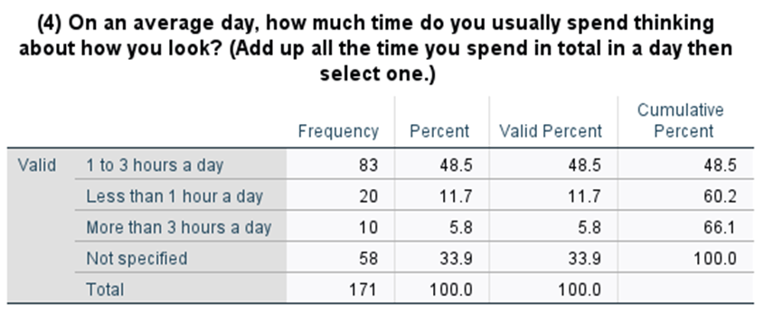
Table 2f: Frequency and Percentage according to average time spent thinking about their look

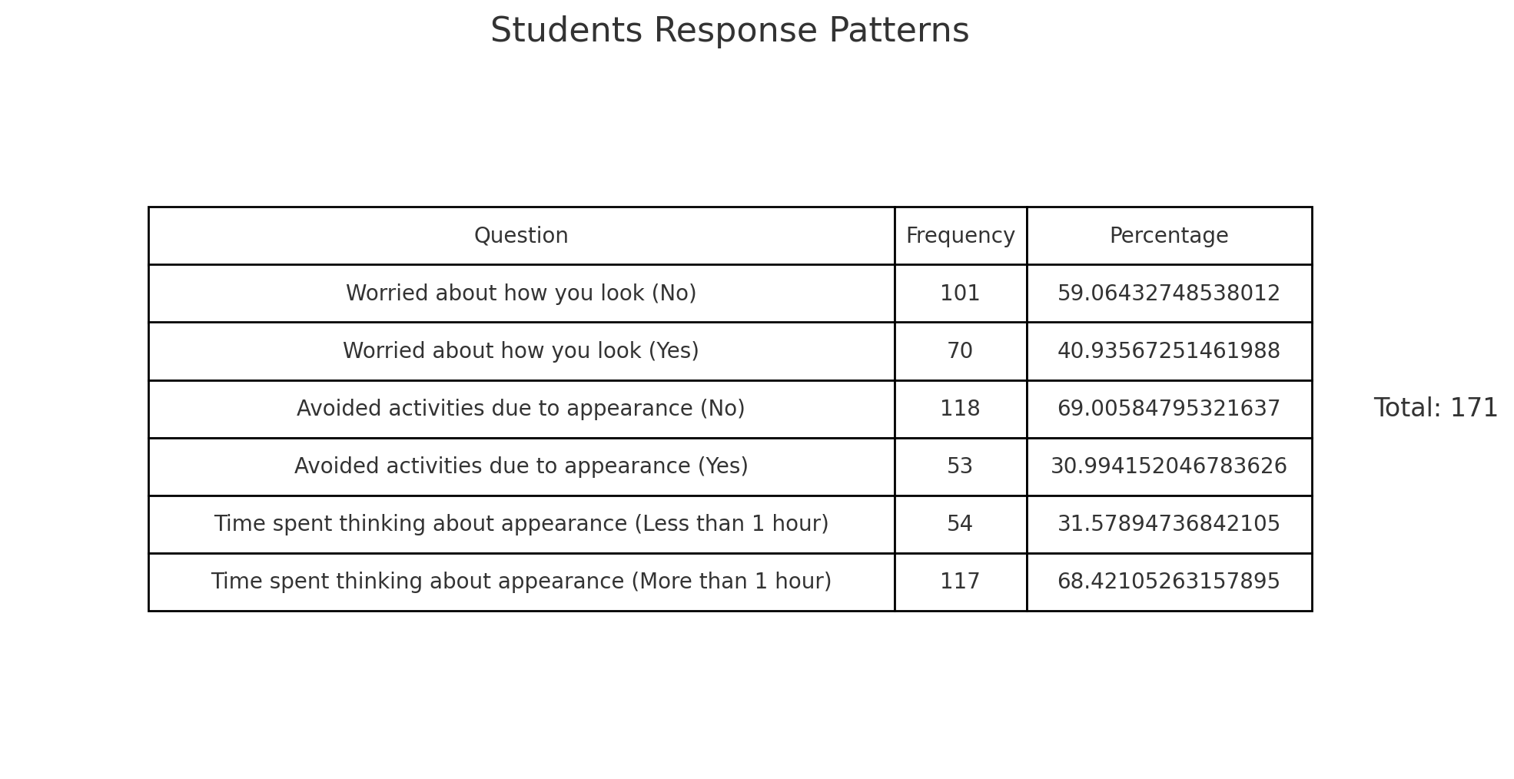
Table 3a: Patterns of responses from Young Adults going to college aged 17 to 25 years

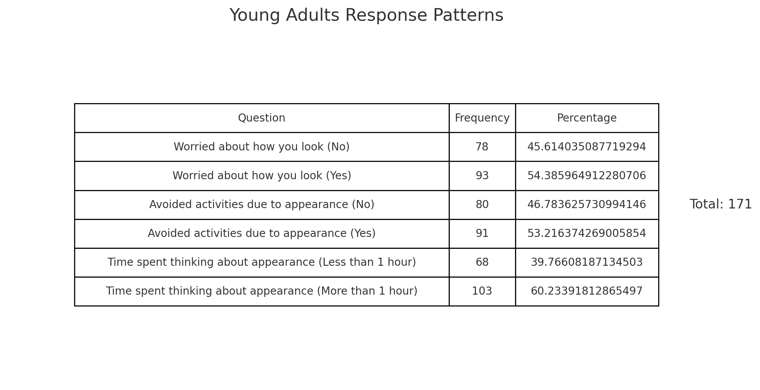
Table 3b: Patterns of responses from Young Adults going to college aged 17 to 25 years

