Tropical seagrass under range extension provides similar range of ecosystem services compared to established meadows: A case study from the east coast of India
Amrit Kumar Mishra, Biswajit Mahari, Anjalis Mishra, Sandip Kumar Mohakud, Syed Hilal Farooq, Prasant Mohanty

Supplementary

Figure I. The seagrass a) H. ovalis, b) H. uninervis and c) R. maritima meadows from our study sites of the coast of Odisha, India.
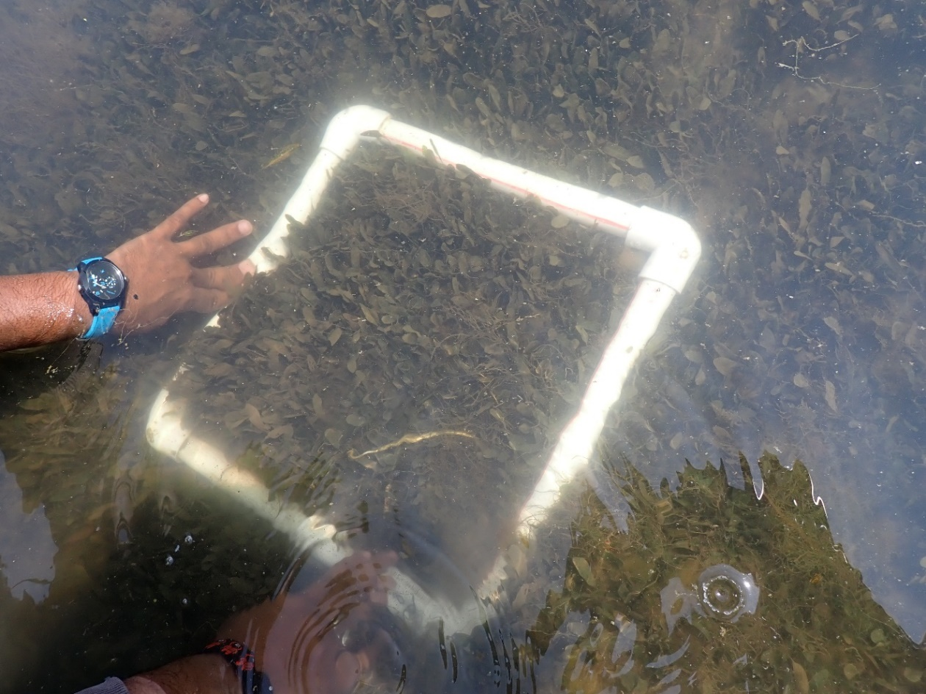
- H. ovalis meadows
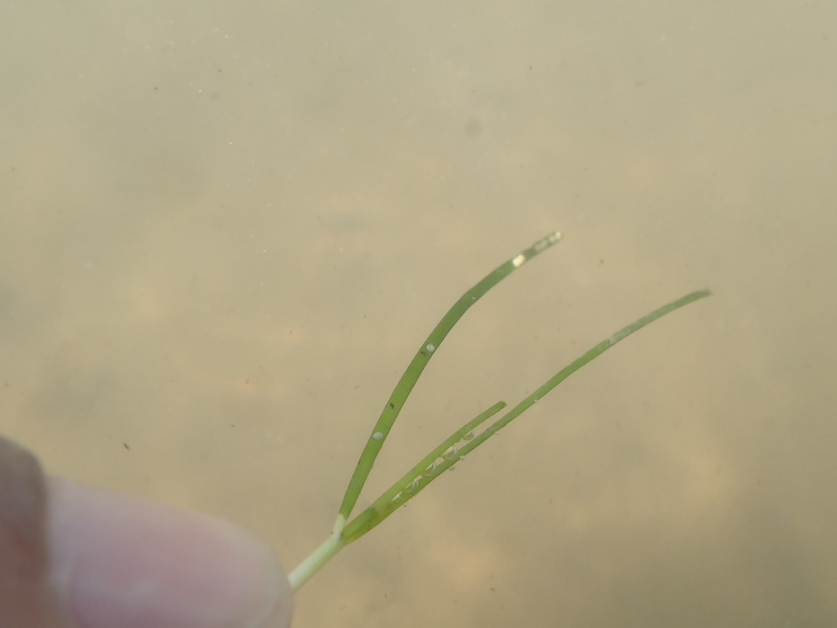
- H. uninervis
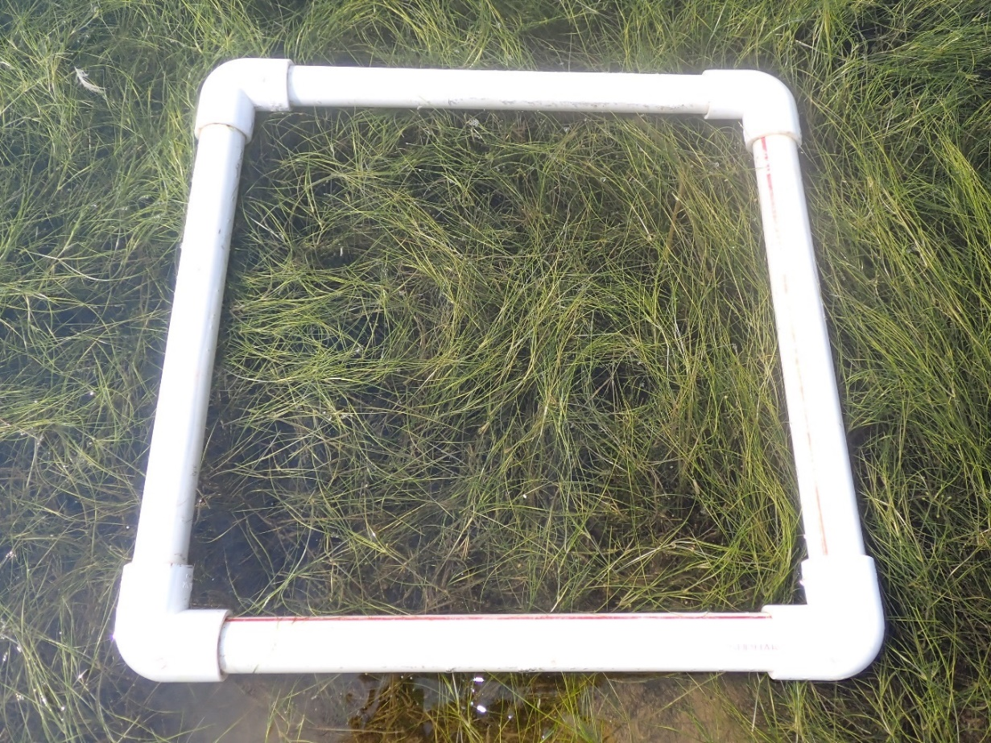
- R. maritima meadows

Figure II. Mean ± SD of surface water salinity (psu) and sediment total carbon (C%), nitrogen (N%) and sulfur (S%) in the newly discovered meadows of our study sites compared with meadows of the same seagrass species from the Chilika lagoon from the coast of Odisha, India. Statistical significance (p<0.05) was derived from one-way ANOVA analysis using species as fixed factors. (p<0.001***, not significant ^{ns}).
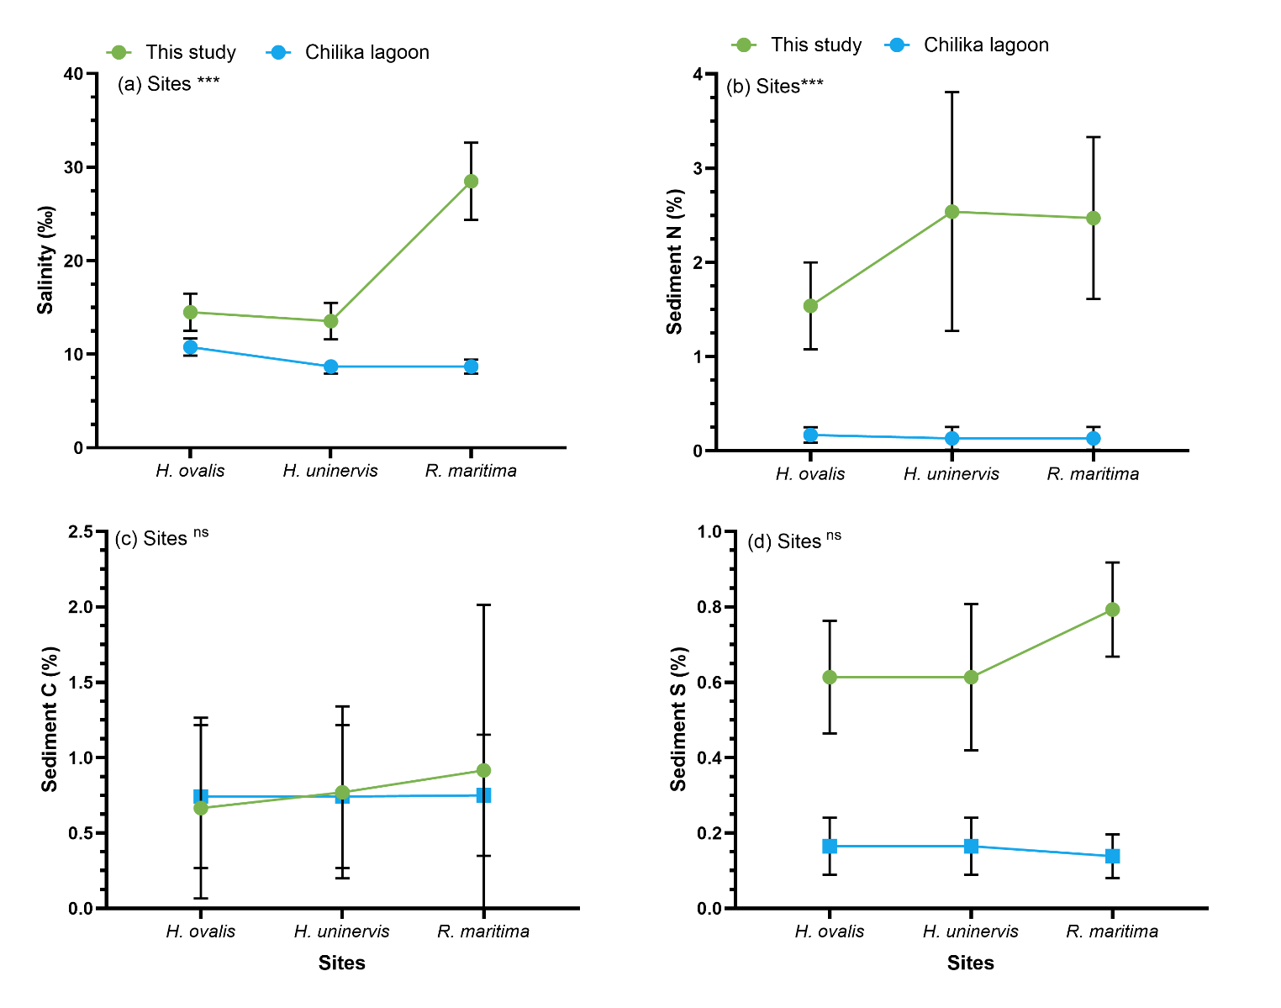

Table III. Mean ± SD of seagrass species-specific sediment C, and CO₂ stocks and their economic value in US$ from our study sites of the coast of Odisha, and compared with other studies from India where sediment C stocks (top 10-30 cm) of H. ovalis or H. uninervis or R. maritima was included.
 | This study |  |  | Other studies from India
Seagrass Species | C stocks  (Mg C ha⁻¹) | CO₂ stocks  (Mg CO₂ ha⁻¹) | Price in US$ millions | C stocks (Mg C ha⁻¹) | Reference
H. ovalis | 1.73 ± 0.97 | 6.37 ± 3.56 | 0.00054± 0.0003 | 0.99 to 11.9 | Kaladharan et al., 2020, 2021, Murugan et al., 2024
H. uninervis | 1.48 ± 0.26 | 5.43 ± 0.98 | 0.00046 ± 0.0008 | 0.99 to 11.9 | Kaladharan et al., 2020, 2021, Murugan et al., 2024
R. maritima | 6.93 ± 2.28 | 25.44 ± 8.39 | 0.0021 ± 0.0007 | NA | NA

Table IV. Principal component contributions for the PCA results presented in Figure 3.
 | PC summary | PC1 | PC2 | PC3 | PC4 | PC5
C stocks | Eigenvalue | 8.454 | 4.598 | 4.106 | 2.164 | 1.676
 | Proportion of variance | 40.26% | 21.90% | 19.55% | 10.31% | 7.98%
 | Cumulative proportion of variance | 40.26% | 62.16% | 81.71% | 92.02% | 100.00%
N stocks | Eigenvalue | 7.952 | 4.862 | 4.257 | 2.331 | 1.598
 | Proportion of variance | 37.87% | 23.15% | 20.27% | 11.10% | 7.61%
 | Cumulative proportion of variance | 37.87% | 61.02% | 81.29% | 92.39% | 100.00%

Figure V. Nonlinear relationship with 95% confidence interval, between biomass nitrogen (N) and C:N ratios of the three seagrass species; H. ovalis, H. uninervis and R. maritima from the coast of Odisha, India showcasing high external N input at our study sites. Dashed lines indicate the threshold values for N and C:N ratios in global seagrasses related to the balance between external N supply and internal utilization by the plants (Duarte, 1990).
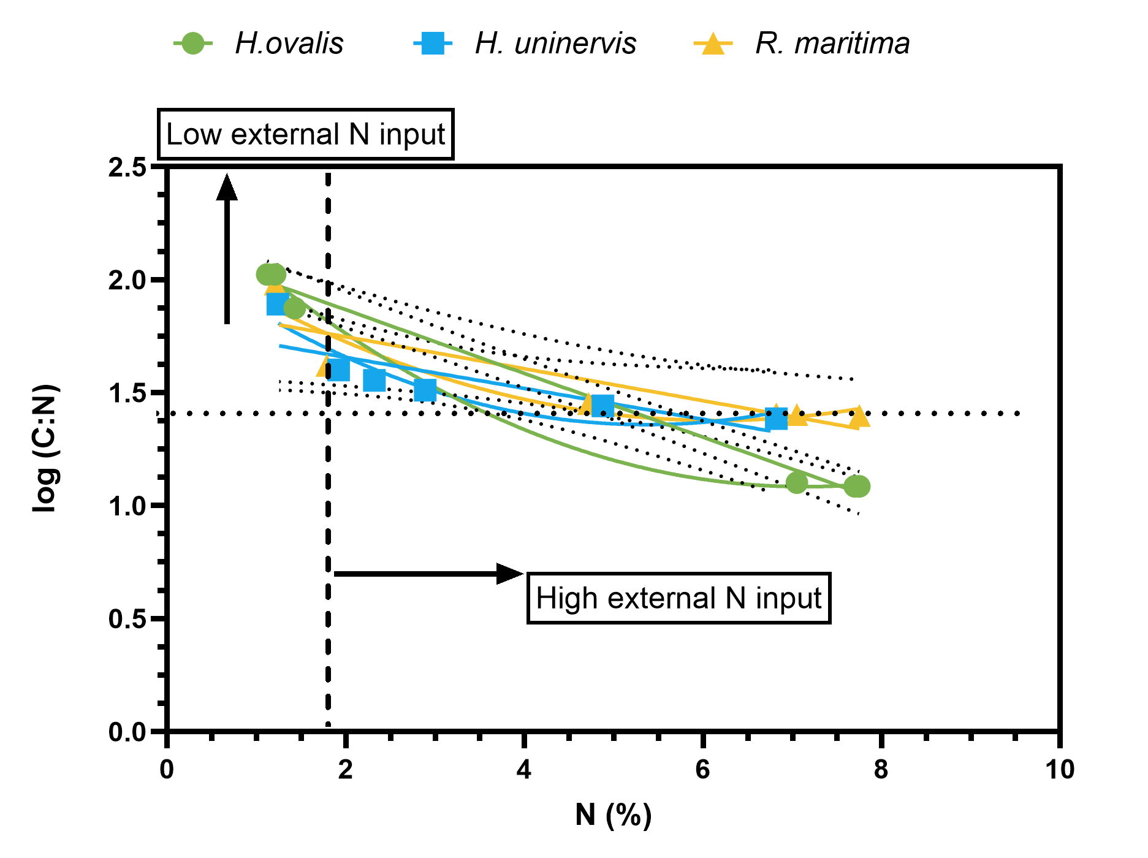

Figure VI. Mean ± SD of seagrass morphometrics, i.e., leaf length (cm), leaf width (cm), horizontal internode (cm) and petiole length (cm) of the three seagrass species from the newly discovered seagrass meadows of our study sites compared with meadows of the same seagrass species from the Chilika lagoon from the coast of Odisha, India. Statistical significance (p<0.05) was derived from one-way ANOVA analysis using species as fixed factors. (p<0.0001****, not significant ^{ns}). An unpaired t-test was used for the leaf width analysis due to R. maritima having cylindrical leaves.
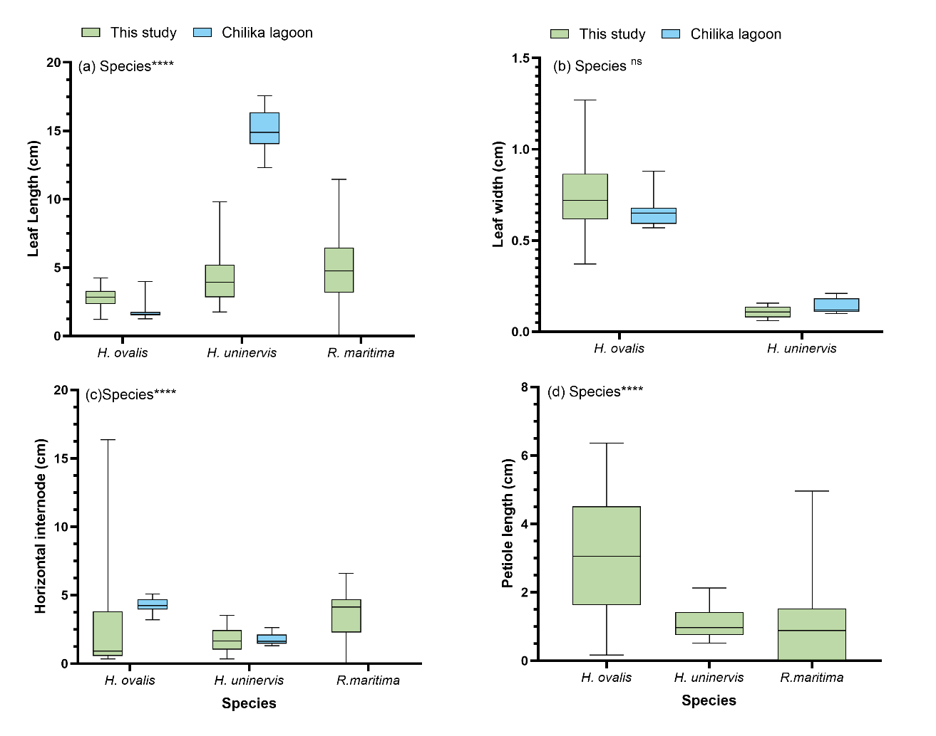

Figure VII. Range of seagrass a) shoot density, b) total biomass and c) C and N stocks of all three species from the coast of Odisha, India. Statistical significance (p<0.05) was derived from one-way ANOVA analysis using species as fixed factors, (p<0.0001****, p<0.001***). The data from Chilika lagoon is presented for comparison and derived from literature review.
