Supplementary Material
Acoustic Amplified Transmission and Emission through k-Gap
Ziling Liu^{1, 2†}, Xinghong Zhu^{3†}, Zhi-Guo Zhang¹, Wei-Min Zhang¹, Xue Chen^{1, 2}, Yong-Qiang Yang^{1, 2}, Ruwen Peng^{4∗}, Mu Wang^{4∗}, Jensen Li^{5∗}, and Hong-Wei Wu^{1, 2∗}
¹School of Mechanics and Photoelectric Physics, Anhui University of Science and Technology, Huainan 232001, China
²Center for Fundamental Physics, Anhui University of Science and Technology, Huainan 232001, China
³Department of Physics, The Hong Kong University of Science and Technology, Clear Water Bay, Hong Kong, China
⁴National Laboratory of Solid State Microstructures, School of Physics, and Collaborative Innovation Center of Advanced Microstructures, Nanjing University, Nanjing 210093, China
⁵ Centre for Metamaterial Research and Innovation, Department of Engineering, University of Exeter, Exeter EX4 4QF, United Kingdom

Band structure for time-varying dispersive media with a Lorentzian-type resonance
When considering the dispersion of the medium, we can write the acoustic wave equation as:
$$∂_{x}p(x,t)+ρ_{0}∂_{t}v\left(x,t\right)=0,$$ | (S1)
$$∂_{x}v(x,t)+β_{0}∂_{t}\left(p(x,t)+M(x,t)\right)=0,$$ | (S2)
with $M(x,t)$ being the monopolar polarization and governed by a Lorentzian-type model
$$∂_{t}^{2}M(x,t)+2Γ∂_{t}M(x,t)+ω_{0}^{2}M(x,t)=a(t)ω_{0}^{2}p(x,t),$$ | (S3)
where$ω_{0}=2f_{0}$is the resonating (radial) frequency, $Γ=2π γ$ is the resonating linewidth. Combining (S1)-(S3) and replacing $∂_{x}$ with $ik$, we can construct a 4 by 4 eigenvalue problem as
$$i∂_{t}ψ=\hat{ω}ψ, \hat{ω}=\left(\begin{matrix}0 & \frac{k}{β_{0}} & 0 & i \\ \frac{k}{ρ_{0}} & 0 & 0 & 0 \\ 0 & 0 & 0 & -i \\ -ia\left(t\right)ω_{0}^{2} & 0 & iω_{0}^{2} & -i2Γ\end{matrix}\right),$$ | (S4)
where the state vector is $ψ={\left(p,v,M,-∂_{t}M\right)}^{T}$. The propagation matrix $\hat{ω}$, switches between the two phases ${\hat{ω}}_{A}$ and ${\hat{ω}}_{B}$, corresponding to the resonant strengths $a_{A}$ and $a_{B}$ in the two phases. Then, using the Floquet mode theory, we can solve the band structure plotted in Fig.1 (e) in the main text by solving the secular equation
$$\det\left[e^{-iΩT_{m}}I_{4}-e^{-i{\hat{ω}}_{B}T_{mB}}e^{-i{\hat{ω}}_{A}T_{mA}}\right]=0,$$ | (S5)
where I₄ is the 4 by 4 identity matrix.

Band structure for quasi-periodic dispersive media with two Lorentzian-type resonances
Following the same spirit of route, when we have two monopolar resonances in each phase, we only need to add another response function into the wave equation by rewriting (S2) and (S3) as
$$∂_{x}v(x,t)+β_{0}∂_{t}\left(p(x,t)+M_{i}(x,t)\right)=0,$$ | (S6)
$$∂_{t}^{2}M_{i}(x,t)+2Γ_{i}∂_{t}M_{i}(x,t)+ω_{0i}^{2}M(x,t)=a_{i}(t)ω_{0i}^{2}p(x,t),$$ | (S7)
with i = 1, 2, representing the first and second resonance mode. Combined with S1, we can construct a 6 by 6 eigenvalue problem as
$$i∂_{t}ψ=\hat{ω}ψ, \hat{ω}=\left(\begin{matrix}0 & k/β_{0} & 0 & ⅈ & 0 & ⅈ \\ k/ρ_{0} & 0 & 0 & 0 & 0 & 0 \\ 0 & 0 & 0 & -ⅈ & 0 & 0 \\ -ⅈa_{1}(t)ω_{01}^{2} & 0 & ⅈω_{01}^{2} & -2ⅈΓ_{1} & 0 & 0 \\ 0 & 0 & 0 & 0 & 0 & -ⅈ \\ -ⅈa_{2}(t)ω_{02}^{2} & 0 & 0 & 0 & ⅈω_{02}^{2} & -2ⅈΓ_{2}\end{matrix}\right),$$ | (S8)
with $ψ={\left(p,v,M_{1},-∂_{t}M_{1},M_{2},-∂_{t}M_{2}\right)}^{T}$. Since now the modulation period becomes $2T_{m}$, and there are 3 different phases in one modulation period: A, B and C, corresponding to resonant strength pairs $(a_{1A},a_{2A})$,$(a_{1B},a_{2B})$ and $(a_{1C},a_{2C})$. The modulation cycle follows the ABAC sequence, with each phase occupying $T_{m}/2$ giving rise to the Floquet modes: $ψ\left(t+2T_{m}\right)=e^{-i{\hat{ω}}_{C}T_{m}/2}e^{-i{\hat{ω}}_{A}T_{m}/2}e^{-i{\hat{ω}}_{B}T_{m}/2}e^{-i{\hat{ω}}_{A}T_{m}/2} ψ\left(t\right)$. The band structure can be obtained by solving the secular equation:
$$\det\left[e^{-iΩT_{m}}I_{6}-e^{-i{\hat{ω}}_{C}T_{m}/2}e^{-i{\hat{ω}}_{A}T_{m}/2}e^{-i{\hat{ω}}_{B}T_{m}/2}e^{-i{\hat{ω}}_{A}T_{m}/2}\right]=0.$$ | (S9)
Fig 4(d) in the main text plotted the band structure of phononic time crystal according to (S9) with modulation cycle following the ABAC sequence.
- Temporal effective medium for nondispersive and dispersive phononic time crystal
In main text, the nondispersive phononic time crystal is experimentally realized by dispersive time-varying metamaterial with discrete resonating meta-atoms. However, their k-gaps matching each other is limited by the low modulating depth. In fact, the temporal effective medium of nondispersive and dispersive phononic time crystal has to abide by different average methods [1]. For dispersive case, the effective compressibility can be expressed as:
$β_{eff}(f)=ξβ_{A}(f)+\left(1-ξ\right)β_{B}(f)$, (S10)
while the nondispersive case has the effective compressibility by
$1/β_{eff}=ξ/β_{A}+\left(1-ξ\right)/β_{B}$, (S11)
where $β_{A}$ and $β_{B}$ are the static compressibilities of material A and B, $ξ$ is the duty cycle. Thus, the k-gap center $k_{c}$of phononic time crystal vary with different temporal effective medium, which can be expressed as:
$k_{c}=\frac{k_{m}}{2}\sqrt{β_{eff}}$, (S12)
where wave number $k_{m}$correspond to the time modulation defined as: $k_{m}=2π/(c_{0}T_{m})$, where $c_{0}$ is the speed of sound in air. It means that the k-gap center will move with changing the effective compressibility. Thus, the k-gap center of the phononic time crystal separates for nondispersive and dispersive case due to different temporal average rules. For the dispersive phononic time crystal, balancing gain and loss through time domain, the effective compressibility always $β_{eff}=$1, then $k_{c}=\frac{k_{m}}{2}$ in Fig. 1(e) and $k_{c}=\frac{k_{m}}{2}$ and $\frac{k_{m}}{4}$ in Fig. 4(d). Furthermore, the effective acoustic impedance of the phononic time crystal can be engineered to approach that of air, thereby eliminating reflections at the spatial boundaries between air and the phononic time crystal. However, for the nondispersive case, modulating between $β_{A}=0.88$ and $β_{B}=1.12$ with duty cycle $ξ=0.5$, then the $k_{c}=\frac{k_{m}}{2}*0.993$, thus the k-gap center slightly left shift in Fig. 1(b), this effect is more obvious for greater modulating depth in Fig. 4(c).

Stability analysis for phononic time crystals in the experiment
Since our meta-atoms involves feedback and time-varying resonant strength, the whole system (including all the atoms) is time dependent and frequency conversion occurs, we need stability analysis to make sure that the system is working in the stable regime. In this section, we develop a multiband harmonic model to determine the eigenmode (stability) of the time-dependent system. As the modulation strength and resonating frequency is modulated periodically, all the signals (from the detector and speaker) can be written in the Fourier series expansion with a set of harmonics $f_{n}=f+n/T_{m}$, where $n$ is an integer and 1/$T_{m}$ is the modulation frequency. The detector and speaker signal can be expanded as $p\left(x_{i},t\right)=\sum_{n}{p_{in}e^{-if_{n}t}},$ $s_{i}\left(t\right)=\sum_{n}{s_{in}e^{-if_{n}t}}$ where $i$ represents the $i$-th atom. The modulation of resonating strength and resonating frequency can be written as $g\left(t\right)=\sum_{n}{g_{n}e^{-int/T_{m}}}$,where $f_{0}=4.7$kHz. Then, the response function Y can be written in terms of Fourier component (labeled by n harmonics): $Y_{nn'}^{i}=\frac{if_{n}g_{n-n'}}{f_{0}^{2}-f_{n}^{2}-2iγf_{n}}$ and it connects the detector and speaker signal by $s_{in}=Y_{nn'}^{i}p_{in'}$. Since the convolution generates the secondary radiation and propagates in waveguide and then is detected again, there is a loop transfer function from detector $D_{i}$ to $D_{j}$ by $T_{\left\{jn\right\},\{in^{'}\}}\left(ω\right)=e^{ik_{0}\left(f_{n}\right)|x_{j}-x_{i}|}Y_{nn'}^{i}=e^{ik_{0}\left(f_{n}\right)|x_{j}-x_{i}|}\frac{if_{n}g_{n-n'}}{f_{0}^{2}-f_{n}^{2}-2iγf_{n}}$ where $|x_{j}-x_{i}|$ is the distance from speaker $i$ to detector $j$ (assuming $D_{i}$ and $S_{i}$ are in the same position since they are collocated). The $T_{\left\{jn\right\},\{in^{'}\}}$ is a square matrix and a stable system means all the poles the of the system response matrix, i.e. zeros of $Det(I-T_{\left\{jn\right\},\{in^{'}\}})$ have to lie in the lower complex plane. The number of harmonics (a total of 7 in the following analysis) is taken to be enough to have converging numerical results. For the time-varying acoustic system in Fig. 2 (modulating resonant strength $g$ between $g_{A}$ = 100Hz and $g_{B}$ = -100Hz, $Δg=200Hz$), we plot the $Det(I-T_{\left\{jn\right\},\{in^{'}\}})$ in the complex frequency plane, as shown in Fig. S1(a). The minimum value of $Det(I-T_{\left\{jn\right\},\{in^{'}\}})$ in the blue dot indicates the pole of the system, around the frequency of (4690-$i$140)Hz, in the lower half plane. This means the system is working in the stable regime. When we increase the modulation depth, the system poles will gradually touch the real frequency axes and make the system become unstable. Fig S1 (b) plots the pole diagram where one of the poles just touch the real frequency axes, corresponding to the maximum modulation depth $Δg=14.56*200Hz$ (Δa =31.05×10⁻²). However, in the experiment, we only obtain the threshold at Δa =10.79×10⁻² due to the intrinsic response of speaker and time delay of microcontroller making the system easier to become unstable.
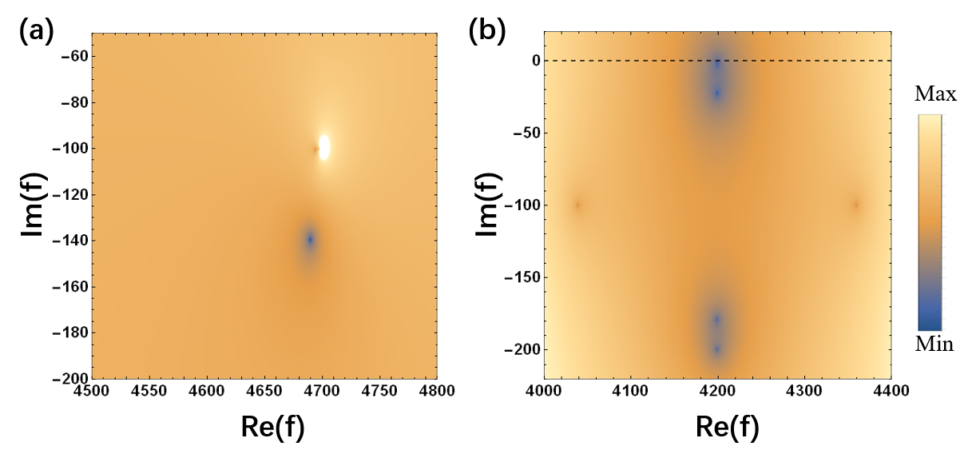
Fig S1 (a) Pole diagram of time-varying meta-atoms in Fig.2, (b) Pole diagram of time-varying meta-atoms with threshold touching the real axes.

