Supplementary Materials

SOX17 Regulates Nestin–p16^{INK4a} Axis to Mitigate Endothelial Senescence in Pulmonary Arterial Hypertension

Ting Wu, Zijing Zhou, Danli Jiang, Tong-you Wei, So Yun Han, John Y-J. Shyy, Gang Li, Ruizheng Shi, Wei Sun

Corresponding authors:

Wei Sun, MD
Department of Medicine, University of California, San Diego
9500 Gilman Drive, La Jolla, CA 92093, USA
Phone: +1 858-534-3736
E-mail: WES001@ucsd.edu

Ruizheng Shi, MD
Department of Cardiovascular Medicine, Xiangya Hospital, Central South University, Changsha, China
Phone: +86 137-5508-2530
E-mail: ruizhengshivip@sina.com

Gang Li, PhD
Aging Institute, University of Pittsburgh
100 Technology Drive Pittsburgh, PA 15219, USA
Phone: +1 412-383-4416
E-mail: LIG@pitt.edu

Supplementary Figure 1. Nestin regulates p14^{ARF}, p15^{INK4b}, p16^{INK4a}, and ANRIL expression in PAECs.
Scrambled, Nestin-downregulated PAECs: A. qPCR analysis of Nestin, p14^{ARF}, p15^{INK4b}, p16^{INK4a} and ANRIL expression; Scrambled, Nestin-overexpression PAECs: B. Western blot assay and C. qPCR analysis of Nestin, p14^{ARF}, p15^{INK4b}, p16^{INK4a} and ANRIL expression. n=3 or 6; *: p<0.05; **: p<0.01; ***: p<0.001; ****: p<0.0001.

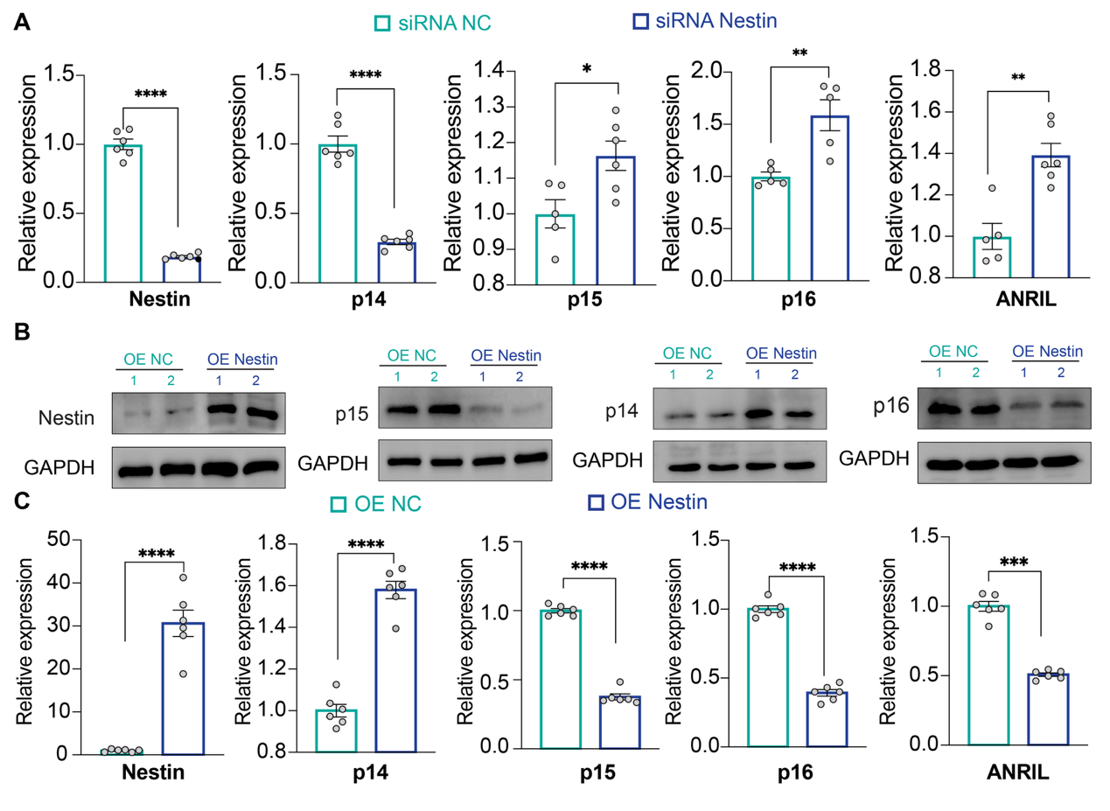

Supplementary Figure 2. Cell cycle analysis in scrambled, Nestin- and/or p16^{INK4a} knockdown PAECs. n=4; *: p<0.05; ns: not significance.

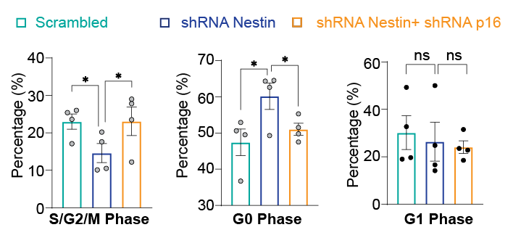

Supplementary Figure 3. ChIP experiment showing the lack of SOX17 binding to the candidate sequences within the Nestin promoter.
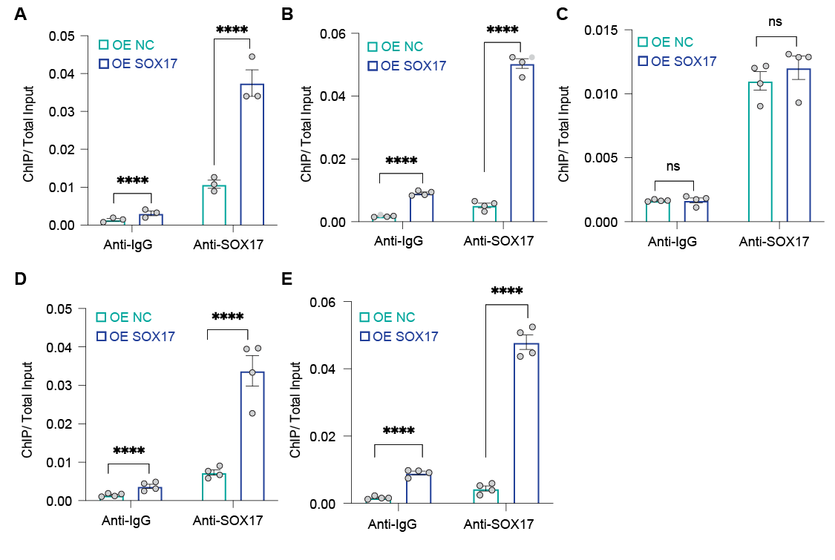
A. S1 sequence; B. S2 sequence; C. S3 sequence; D. S5 sequence; E. S6 sequence.

Supplementary Figure 4. SOX17 inhibits cellular senescence by inducing Nestin expression.
Scrambled, SOX17-downregulated and/or Nestin-overexpressed PAECs: qPCR analysis of A. SOX17, B. Nestin and C. p16^{INK4a} expression; Scrambled, SOX17-overexpression and/or Nestin-downregulated PAECs: qPCR analysis of D. SOX17, E. Nestin and F. p16^{INK4a} expression. n=6; *: p<0.05; **: p<0.01; ***: p<0.001; ****: p<0.0001; ns: not significance.
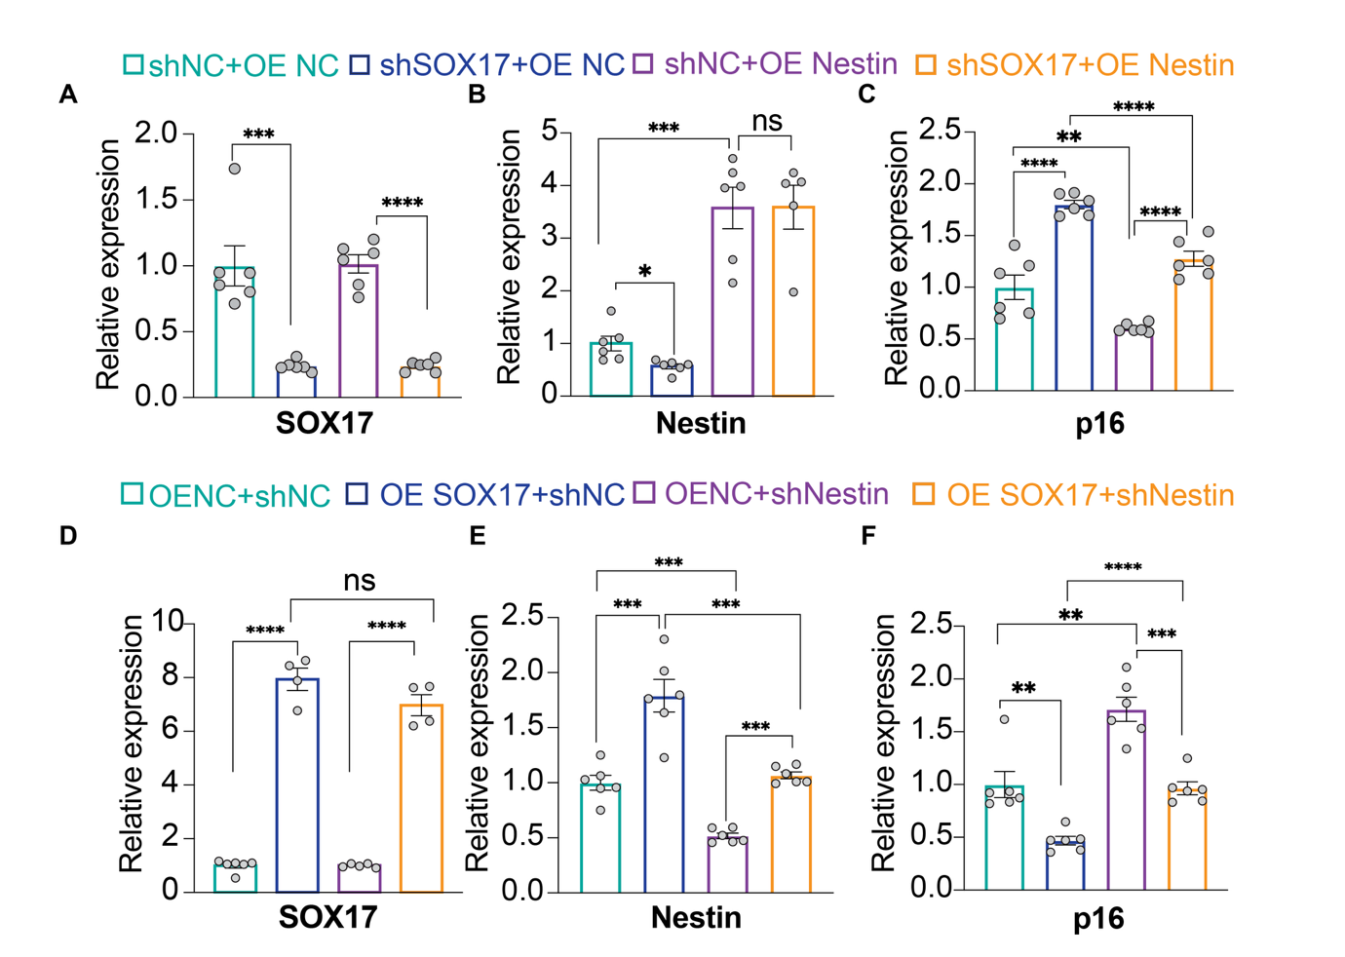

Supplementary Figure 5. SOX17/Nestin is responsible for IL-1β-induced endothelial dysfunction. Control PAECs and PAECs that were treated with IL-1β or treated with IL-1β and overexpressed SOX17 and/or downregulated Nestin: Tube formation assay demonstrating tube forming capacity of PAECs. n=3; *: p<0.05; **: p<0.01.
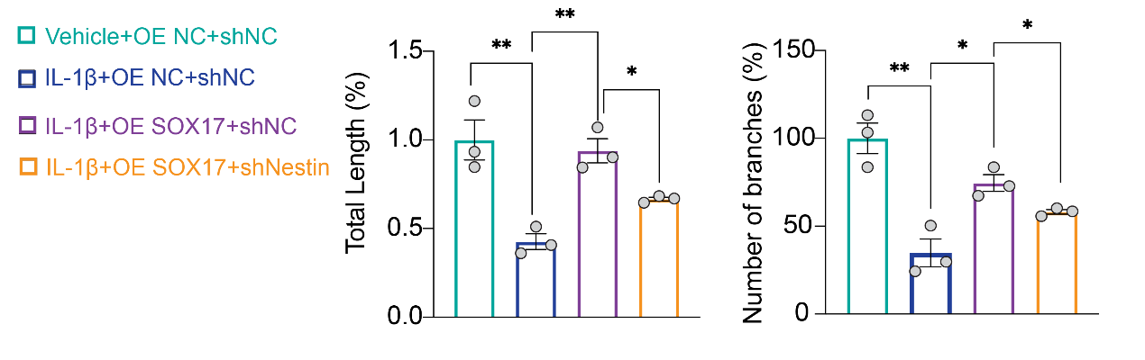

Supplementary Figure 6. SOX17/Nestin regulates endothelial senescence in PAH pathological stimuli.
Pulmonary ECs isolated from mice exposed to normoxia or hypoxia and treated with overexpressed SOX17 and/or downregulated Nestin: A. Western blot assay and B. qPCR analysis of SOX17, Nestin and p16^{INK4a} expression; C. SA-β-gal, D. γ-H2AX staining and E. expression of SASP genes. n=3 or 6; *: p<0.05; **: p<0.01; ***: p<0.001; ****: p<0.0001; ns: not significance; scale bar: 100μm.
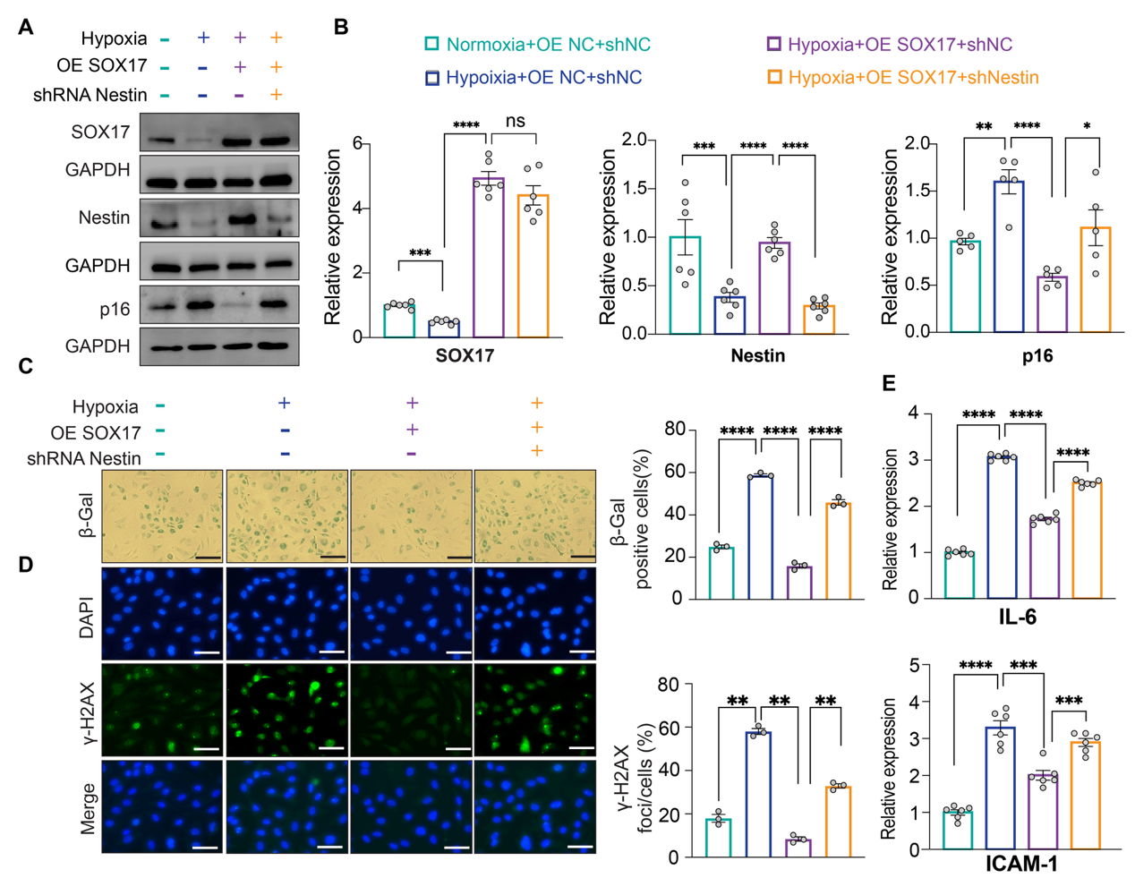

Supplementary Table 1. Primers used in this paper
Usage | Primer name | Sequence
qRT-PCR | IL6-F | GCAGAAAACAACCTGAACCTT
qRT-PCR | IL6-R | ACCTCAAACTCCAAAAGACCA
qRT-PCR | ICAM1-F | AGCGGCTGACGTGTGCAGTAAT
qRT-PCR | ICAM1-R | TCTGAGACCTCTGGCTTCGTCA
qRT-PCR | GAPDH-F | CGACCACTTTGTCAAGCTCA
qRT-PCR | GAPDH-R | AGGGGTCTACATGGCAACTG
qRT-PCR | Nestin-F | CTGCTACCCTTGAGACACCTG
qRT-PCR | Nestin-R | GGGCTCTGATCTCTGCATCTAC
qRT-PCR | SOX17-F | GCCAAGGGCGAGTCCCGTA
qRT-PCR | SOX17-R | GCATCTTGCTCAACTCGGCGTTGTGCA
shRNA knockdown | Nestin shRNA | GCAGACATCATTGGTGTTAAT
shRNA knockdown | SOX17 shRNA | GCGGTATATTACTGCAACTAT
DNA pulldown Western blot | S1606 | Biotin-GGAAATGTGATCTTAAAATTATAGGACCTCAAATT
DNA pulldown Western blot | WT | Biotin-TTCTTGTTTTCCAGGCAGCGTCTC
DNA pulldown Western blot | Mut | Biotin-TTCTTGTTCGTACTATAGCGTCTC
Luciferase reporter assay | S1606 | GGAAATGTGATCTTAAAATTATAGGACCTCAAATT
Luciferase reporter assay | Binding sequence | TTCTTGTTTTCCAGGCAGCGTCTC
Luciferase reporter assay | Mutated | TTCTTGTTCGTACTATAGCGTCTC
ChIP | S1606/Nestin-F | AGTTGCTCATTGTCCATGC
ChIP | S1606/Nestin-R | TGTGCTTGGCACCTAGAGGATTTC
ChIP | SOX17/Nestin-F | AACCTGGTCGCTCCCTTTTC
ChIP | SOX17/Nestin-R | AAGCTAGAGAGACGCTGCC
FREP-MS | BioS1606-F | GCTGTGTTCCGTTGTCCGTGCTGAATGGATCCGGATCCGGAAATGTGATCTTAAAATTATAGGACCTCAAATTGAATTCGAATTC
FREP-MS | S1606-R | GAATTCGAATTCAATTTGAGGTCCTATAATTTTAAGATCACATTTCCGGATCCGGATCCA
FREP-MS | BioNegative-F | GTCTGTGTTCCGTTGTCCGTGCTGAATGGATCCGGATCCACCCGGAGGAACCACGGGGAAAGTGCGCTTCTGAGGAATTCGAATTC
FREP-MS | Negative-R | GAATTCGAATTCCTCAGAAGCGCACTTTCCCCGTGGTTCCTCCGGGTGGATCCGGATCCA

Supplementary Table 2. Antibodies used in this paper
Antibody | Manufacturer | Cat# | Usage
SOX17 | Proteintech | 24903-1-AP | WB
SOX17 | R&D Systems | AF1924-SP | ChIP
SOX17 | Abcam | ab224637 | IF
Nestin | Proteintech | 19483-1-AP | WB/IF
Nestin | Santa Cruz | sc-33677 | ChIP
Rabbit IgG | Cell signaling | 2729S | ChIP
p14^{ARF} | Invitrogen | MA5-14260 | WB
p15^{INK4b} | Invitrogen | PA5-49749 | WB
p16^{INK4a} | Proteintech | 10883-1-AP | WB
GAPDH | Proteintech | 60004-1-Ig | WB
PCNA | Proteintech | 60097-1-Ig | WB
γ-H2AX | Santa Cruz | sc-517348 | IF
Alexa Fluor 488-conjugated antibodies | Invitrogen | A28175 | IF

Supplementary Table 3. Patient information (5 PAH and 5 controls) for Figure. 3C-E
Patients | Age | Gender | Diagnosis | mPAP  (mmHg) | Clinical description | Tissue
1 | 34 | Female | Idiopathic PAH | 50 | Cardiopulmonary arrest | Lung
2 | 64 | Female | Idiopathic PAH | 55 | Cardiopulmonary arrest | Lung
3 | 68 | Female | Scleroderma PAH | 44 | Bilateral lung transplant | Lung
4 | 16 | Male | Idiopathic PAH | 62 | Bilateral lung transplant | Lung
5 | 19 | Male | Idiopathic PAH | 48 | Lung resection | Lung
6 | 36 | Female | Non-PAH | / | Bilateral lung transplant | Lung
7 | 56 | Male | Non-PAH | / | Bilateral lung transplant | Lung
8 | 55 | Male | Non-PAH | / | Bilateral lung transplant | Lung
9 | 23 | Female | Non-PAH | / | Bilateral lung transplant | Lung
10 | 18 | Male | Non-PAH | / | Bilateral lung transplant | Lung

