Supplementary material: The climate implications of failing to manage carbon

Candelaria Bergero^{1*}, Elina Brutschin², Matthew J. Gidden^{2,3}, Zebedee Nicholls^{2,4}, Emily Grubert⁵, Steven J. Davis^{6,7*}

¹ Department of Earth System Science, University of California, Irvine, Irvine, CA, USA
² Energy, Climate, and Environment Program, International Institute for Applied Systems Analysis, Laxenburg, Austria
³Center for Global Sustainability, School of Public Policy, University of Maryland, College Park, MD, USA
⁴ School of Geography, Earth and Atmospheric Sciences, The University of Melbourne, Melbourne, Australia
⁵ Keough School of Global Affairs, University of Notre Dame, Notre Dame, IN, USA
⁶ Department of Earth System Science, Stanford University, Stanford, CA, USA
⁷ Department of Energy Science & Engineering, Stanford University, Stanford, CA, USA

*corresponding authors: candelaria.bergero@uci.edu, sjdavis@stanford.edu

Supplementary Table 1 | AR6 scenarios analyzed in this study
Category | Classification rules | AR6  Scenarios | Scenarios  analyzed *
C1: Limit warming to 1.5°C (>50%) with no or limited overshoot⁺ | < 1.5°C peak warming with ≥ 33% chance and < 1.5°C end-of-century warming with > 50% chance | 97 | 70
C2: return warming to 1.5°C (>50%) after a high overshoot⁺⁺ | < 1.5°C peak warming with < 33% chance and < 1.5°C end-of-century warming with > 50% chance | 133 | 106
C3: limit warming to 2°C (>67%) | <2°C peak warming with > 67% chance | 310 | 231
* Not all scenarios had sufficient data to be reanalyzed in Gidden et al.¹ Since we want to use land data, and thus use Gidden et al.¹, we have reduced the number of scenarios in our analysis.
⁺ Limited overshoot refers to exceeding 1.5°C by up to about 0.1°C and for up to several decades.
⁺⁺ High overshoot refers to temporarily exceeding 1.5°C global warming by 0.1°C–0.3°C for up to several decades.

Supplementary Table 2 | Compounded annual growth rates (CAGR) in percentages (%) for carbon management technologies in AR6 scenarios based on median values per scenario category for determined periods
Technology | Cat. | 2022-2050 | 2020–2029 | 2030–2039 | 2040–2049 | 2050–2059
Fossil CCS | C1 | 26.4 |  | 11.4 | 2.4 | 1.6
Fossil CCS | C2 | 26.6 |  | 17.0 | 5.1 | 2.8
Fossil CCS | C3 | 26.4 |  | 28.5 | 5.7 | 2.7
Land CDR | C1 | 3.7 | 4.4 | 1.8 | 1.0 | 0.1
Land CDR | C2 | 3.5 | 2.0 | 3.7 | 1.2 | 0.4
Land CDR | C3 | 2.4 | 2.3 | 2.3 | -0.4 | 0.2
Engineered CDR | C1 | 31.0 |  | 17.7 | 7.3 | 3.7
Engineered CDR | C2 | 30.6 |  | 30.1 | 13.9 | 6.7
Engineered CDR | C3 | 28.1 |  | 29.1 | 12.7 | 7.6

Supplementary Table 3 | Mitigation rates in percentages (%) calculated as CAGR for GHG emissions based on median values for each path category (C1, C2, C3)
 | 0% underdelivering |  |  |  | 50% underdelivering |  |  |  | 100% underdelivering
 | 2020s | 2030s | 2040s | 2050s | 2020s | 2030s | 2040s | 2050s | 2020s | 2030s | 2040s | 2050s
C1 | 5.9 | 5.8 | 7.3 | 3.5 | 5.3 | 4.4 | 3.9 | 1.7 | 4.6 | 3.2 | 2.8 | 0.5
C2 | 2.5 | 5.5 | 5.7 | 6.5 | 2.1 | 4.6 | 3.9 | 3.2 | 1.9 | 3.7 | 2.8 | 1.5
C3 | 2.2 | 4.4 | 3.8 | 4.1 | 2.0 | 3.8 | 2.9 | 2.0 | 1.8 | 3.1 | 2.3 | 1.2

Supplementary Table 4 | Mitigation rates in percentages (%) calculated as CAGR for CO₂ emissions based on median values for each path category (C1, C2, C3)
 | 0% underdelivering |  |  |  | 50% underdelivering |  |  |  | 100% underdelivering
 | 2020s | 2030s | 2040s | 2050s | 2020s | 2030s | 2040s | 2050s | 2020s | 2030s | 2040s | 2050s
C1 | 6.4 | 9.1 | 23.9 | – | 5.5 | 5.8 | 6.9 | 3.5 | 4.5 | 4.0 | 4.0 | 1.3
C2 | 2.7 | 6.6 | 10.3 | – | 2.2 | 5.3 | 5.3 | 5.5 | 1.8 | 4.1 | 2.9 | 2.0
C3 | 2.2 | 5.1 | 5.9 | 9.4 | 1.8 | 4.4 | 3.5 | 3.4 | 1.5 | 3.7 | 2.4 | 1.3

Supplementary Table 5 | Median net-zero CO₂ emissions year (includes land and energy CO₂)
 | Percent underdelivered carbon management
 | 0% | 10% | 20% | 30% | 40% | 50% | 60% | 79% | 80% | 90% | 100%
C1 | 2050 | 2053 | 2059 | 2092 | ≥2100 | ≥2100 | ≥2100 | ≥2100 | ≥2100 | ≥2100 | ≥2100
C2 | 2058 | 2060 | 2064 | 2069 | 2076 | 2088 | ≥2100 | ≥2100 | ≥2100 | ≥2100 | ≥2100
C3 | 2071 | 2081 | ≥2100 | ≥2100 | ≥2100 | ≥2100 | ≥2100 | ≥2100 | ≥2100 | ≥2100 | ≥2100
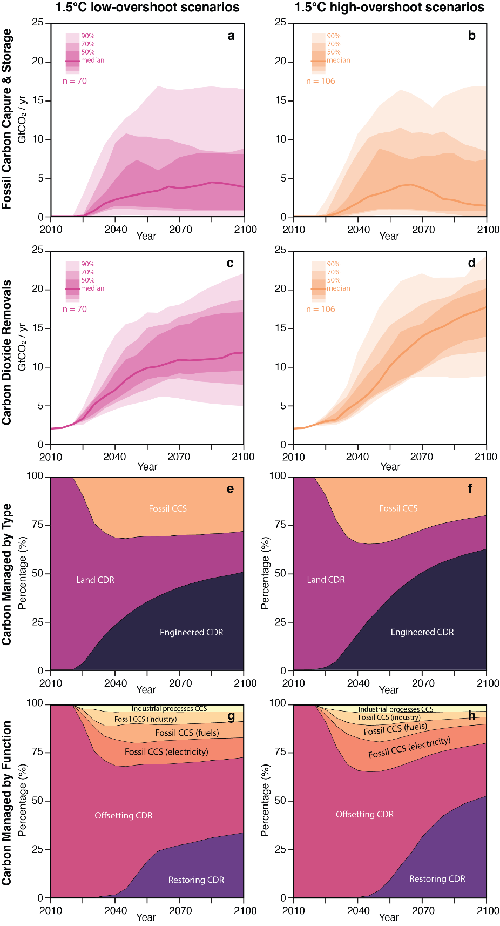
Supplementary Figure 1 | Carbon management in AR6 1.5°C scenarios. Panels a–b show fossil CCS (including CCS for industrial processes) across 1.5°C (categories C1 and C2). Panels c–d show carbon dioxide removals for the same scenarios, including land- and engineered CDR. Panels e–f show carbon managed by type, including fossil CCS, land CDR, and engineered CDR. Panels g–h show carbon managed by function, including where fossil CCS is used, and whether CDR is used of offset emissions or to restore temperature by achieving net-negative emissions.
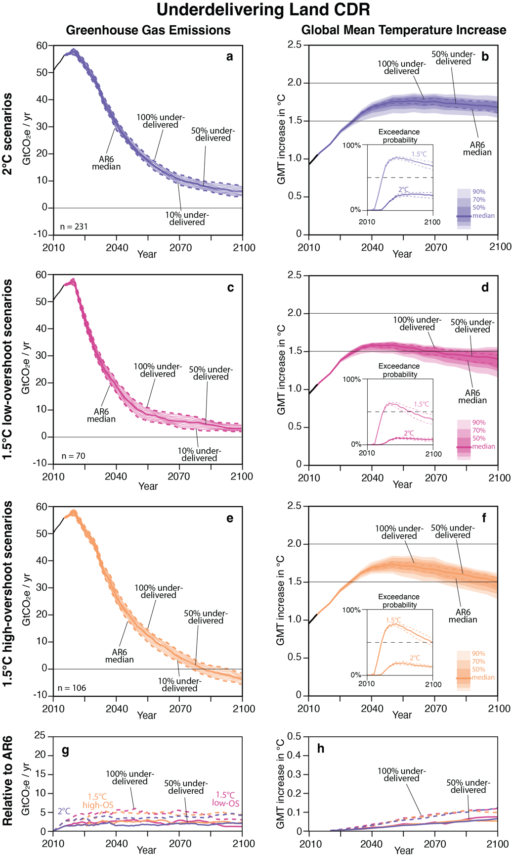
Supplementary Figure 2 | Underdelivering land CDR alone – Greenhouse gas emissions and global mean temperature increase compared to 1850–1900 for original and underdelivering land CDR. Panels a–b show results for 2°C scenarios, c–d for 1.5°C with low-overshoot, e–f for 1.5°C with high-overshoot, and g–h show the difference in the scenarios compared to the original 0% underdelivering runs. Insets show the probability of exceeding a temperature threshold in each year from 2010–2100.
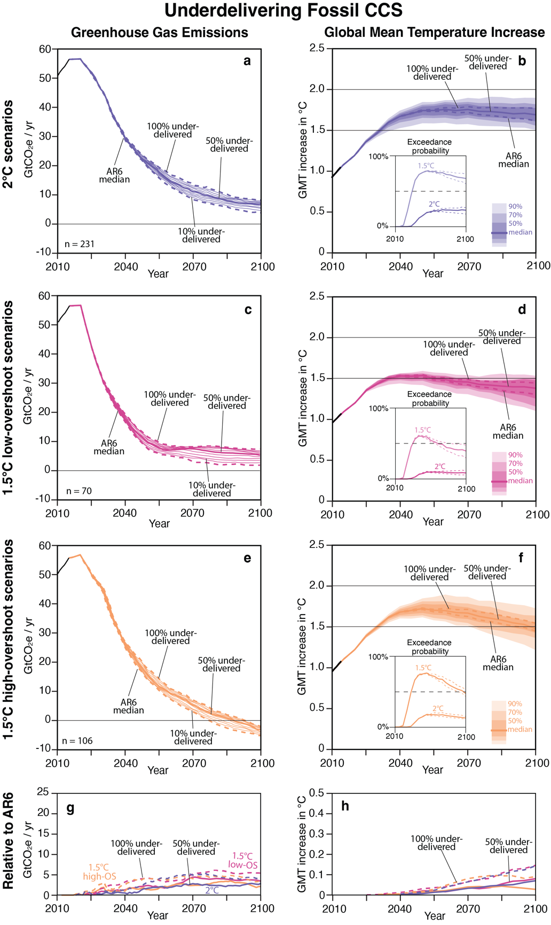
Supplementary Figure 3 | Underdelivering fossil CCS alone – Greenhouse gas emissions and global mean temperature increase compared to 1850–1900 for original and underdelivering fossil CCS. Panels a–b show results for 2°C scenarios, c–d for 1.5°C with low-overshoot, e–f for 1.5°C with high-overshoot, and g–h show the difference in the scenarios compared to the original 0% underdelivering runs. Insets show the probability of exceeding a temperature threshold in each year from 2010–2100.
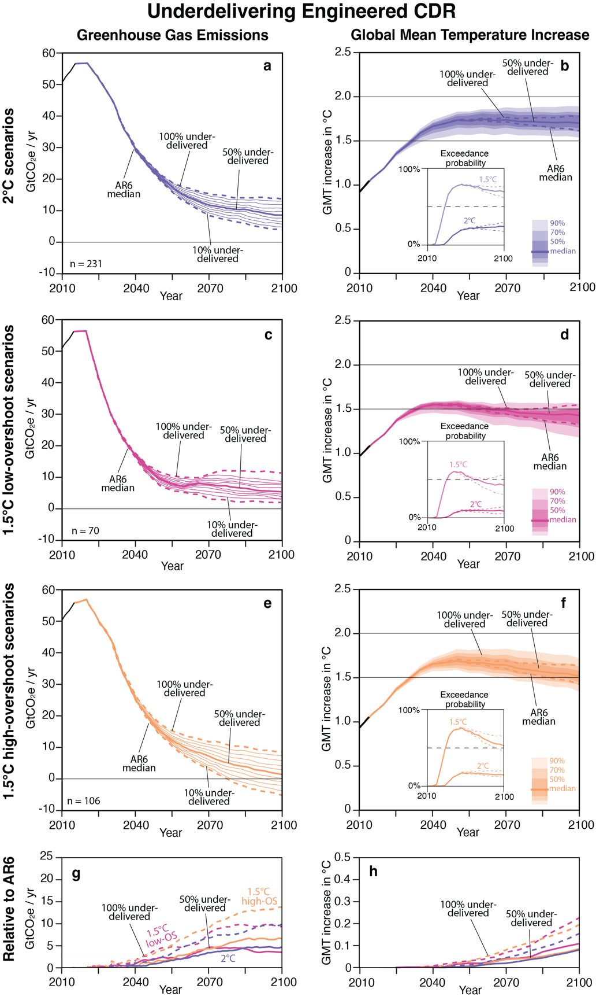
Supplementary Figure 4 | Underdelivering engineered CDR alone – Greenhouse gas emissions and global mean temperature increase compared to 1850–1900 for original and underdelivering engineered CDR. Panels a–b show results for 2°C scenarios, c–d for 1.5°C with low-overshoot, e–f for 1.5°C with high-overshoot, and g–h show the difference in the scenarios compared to the original 0% underdelivering runs. Insets show the probability of exceeding a temperature threshold in each year from 2010–2100.
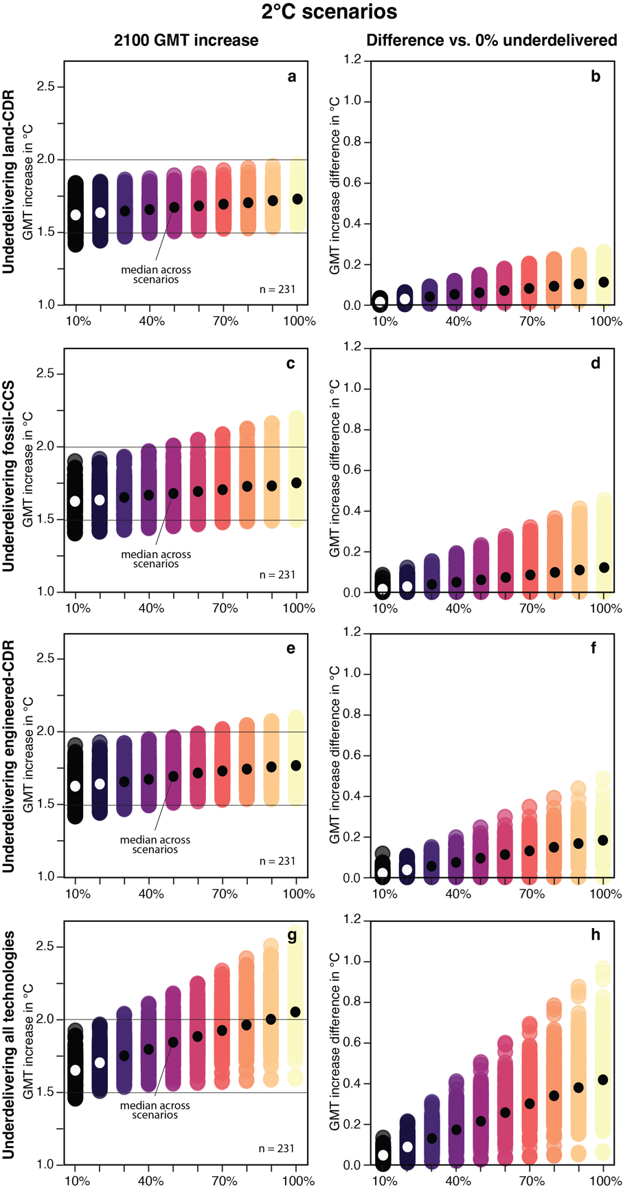
Supplementary Figure 5 | Global mean temperature increases for 231 scenarios compatible with 2°C (or C3 category). Each dot represents one scenario. Panels a, c, e, g show GMT increase in 2100 compared to the mean between 1850–1900 based on percent underdelivered by technologies (i.e. land CDR, fossil CCS, engineered CDR, and all three combined). Panels b, d, f, h show the 2100 GMT increase difference in each scenario compared to its original run (i.e. 0% underdelivered).
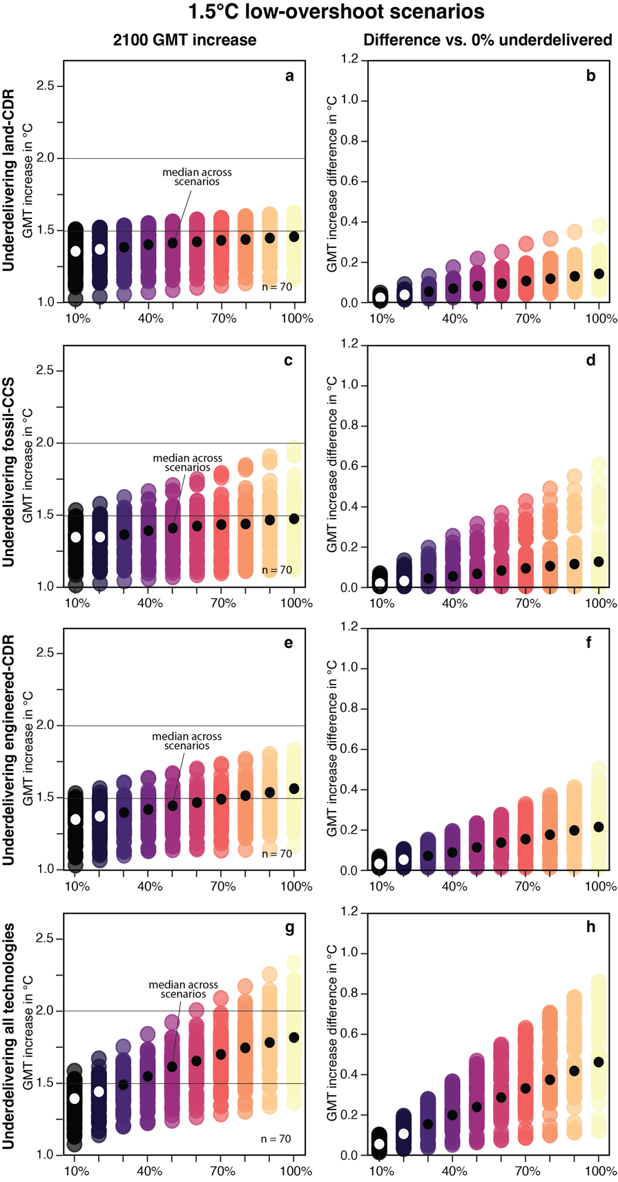
Supplementary Figure 6 | Global mean temperature increases for 70 1.5°C low-overshoot scenarios (or C1 category). Each dot represents one scenario. Panels a, c, e, g show GMT increase in 2100 compared to the mean between 1850–1900 based on percent underdelivered by technologies (i.e. land CDR, fossil CCS, engineered CDR, and all three combined). Panels b, d, f, h show the 2100 GMT increase difference in each scenario compared to its original run (i.e. 0% underdelivered).
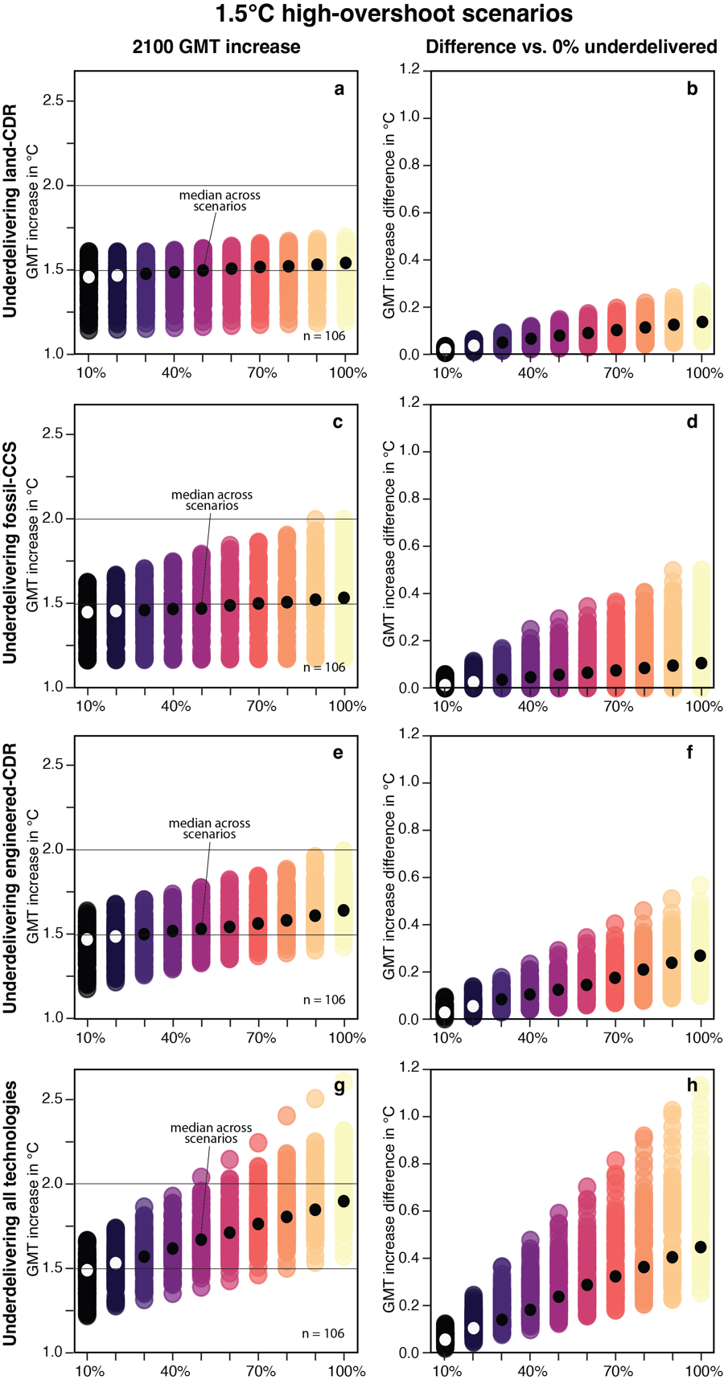
Supplementary Figure 7 | Global mean temperature increases for 106 1.5°C high-overshoot scenarios (or C2 category). Each dot represents one scenario. Panels a, c, e, g show GMT increase in 2100 compared to the mean between 1850–1900 based on percent underdelivered by technologies (i.e. land CDR, fossil CCS, engineered CDR, and all three combined). Panels b, d, f, h show the 2100 GMT increase difference in each scenario compared to its original run (i.e. 0% underdelivered).
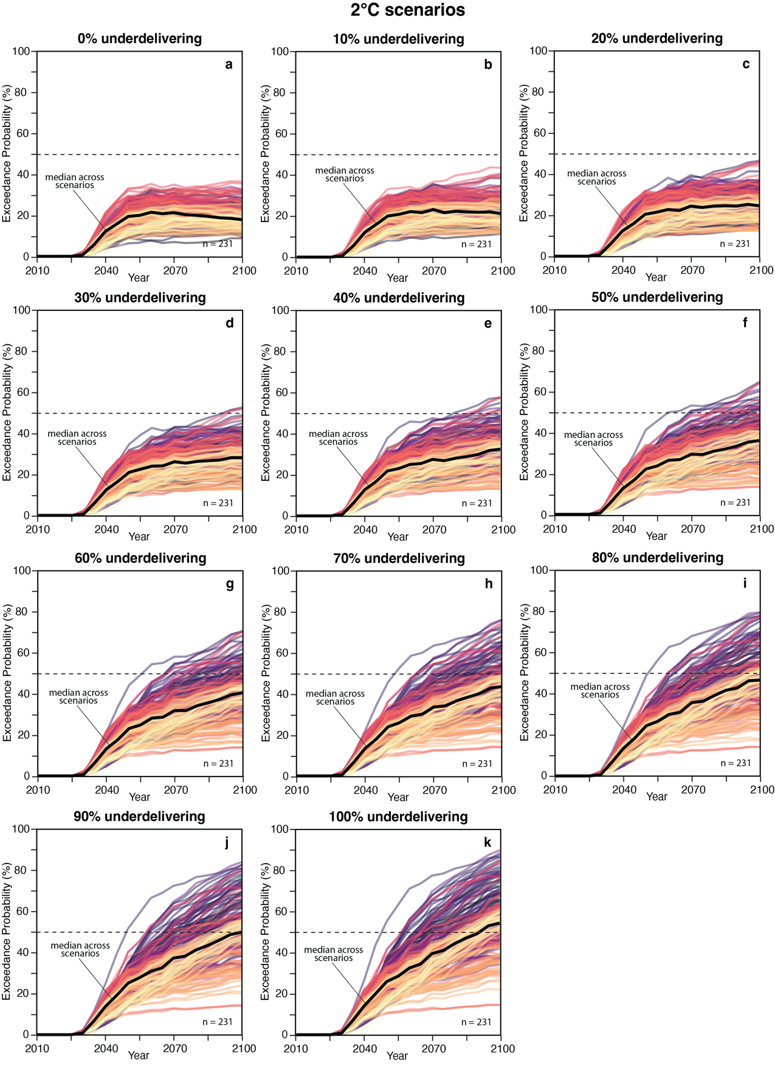
Supplementary Figure 8 | Probability of exceeding 2.0°C in each period for 231 2°C scenarios based on underdelivering different percentages of all carbon management technologies (0–100% every 10% increments). Each line is a scenario, and the black line represents the median across scenarios.
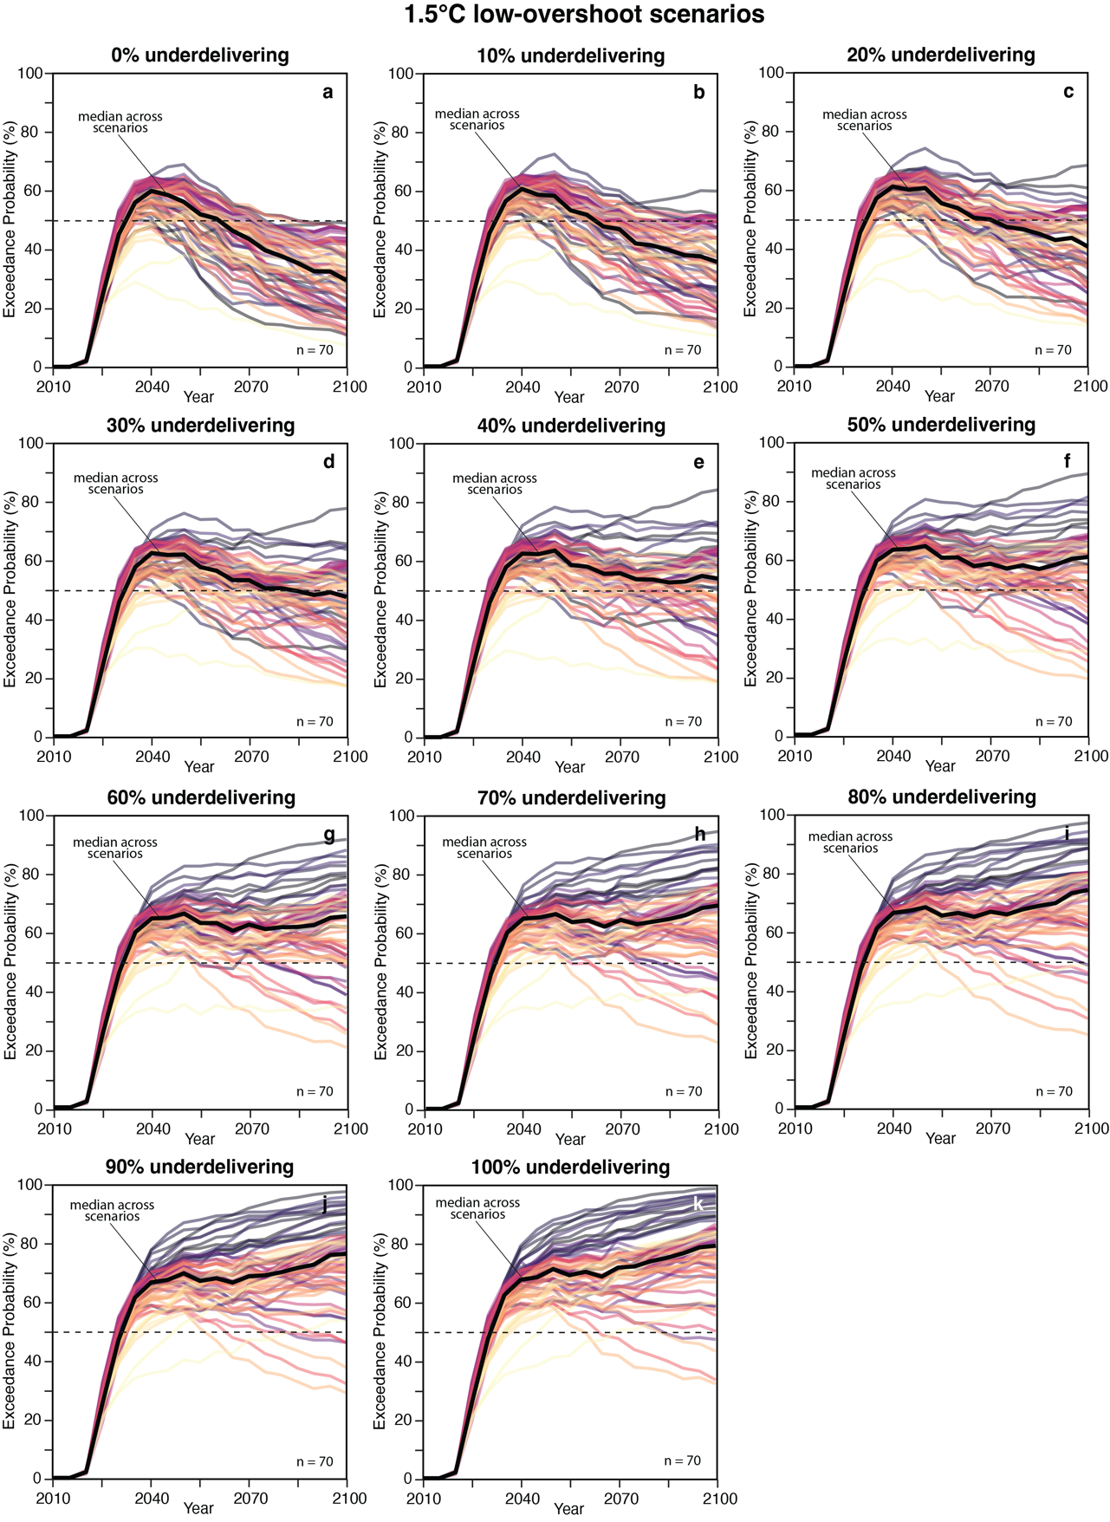
Supplementary Figure 9 | Probability of exceeding 1.5°C in each period for 70 1.5°C low-overshoot scenarios based on underdelivering different percentages of all carbon management technologies (0–100% every 10% increments). Each line is a scenario, and the black line represents the median across scenarios.
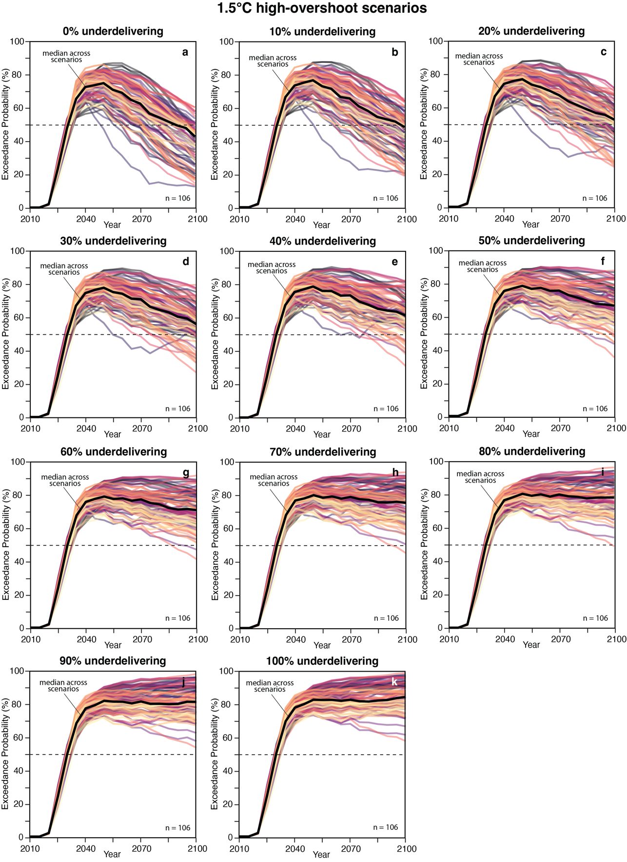
Supplementary Figure 10 | Probability of exceeding 1.5°C in each period for 106 1.5°C high-overshoot scenarios based on underdelivering different percentages of all carbon management technologies (0–100% every 10% increments). Each line is a scenario, and the black line represents the median across scenarios.
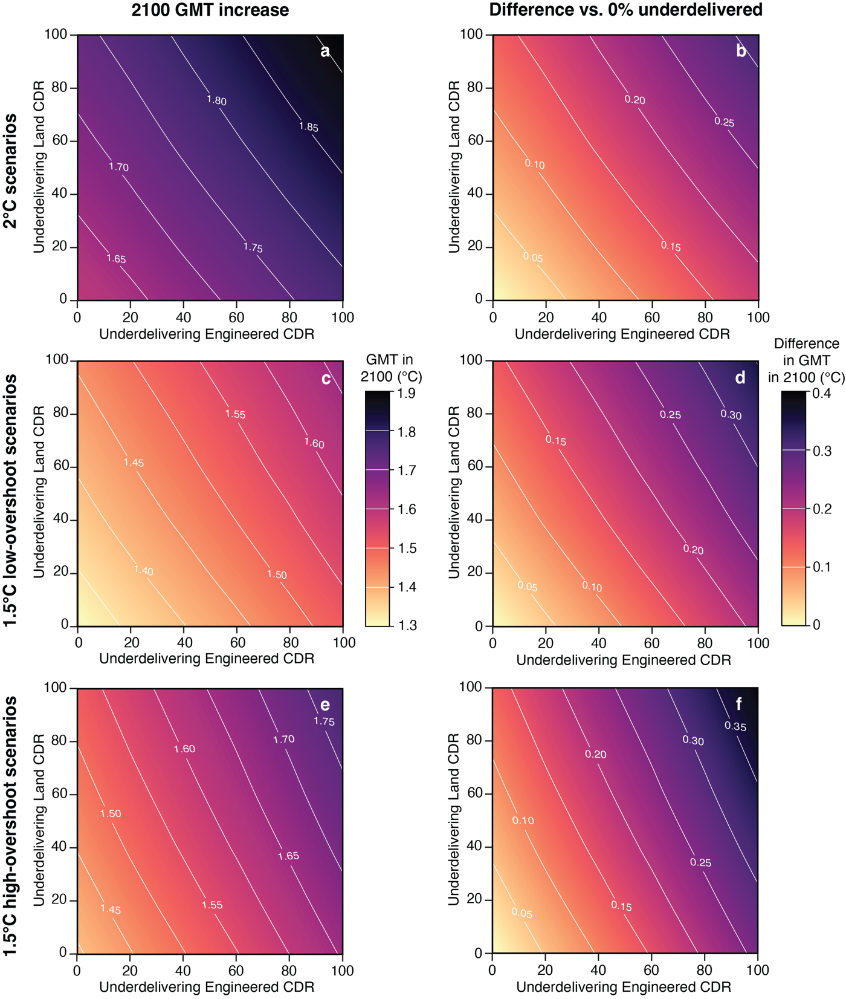
Supplementary Figure 11 | GMT increase in 2100 from underdelivering engineered CDR and land CDR from 0–100%, every 20% increments. Panels a, c, e show 2100 GMT increase compared to the mean between 1850–1900. Panels b, d, f show the difference in each scenario compared to its original run (i.e. 0% underdelivering). Values in the contours represent the mean across scenarios (n= 231 for 2°C scenarios, n = 70 for 1.5°C low-overshoot scenarios, n = 106 for 1.5°C high-overshoot scenarios).
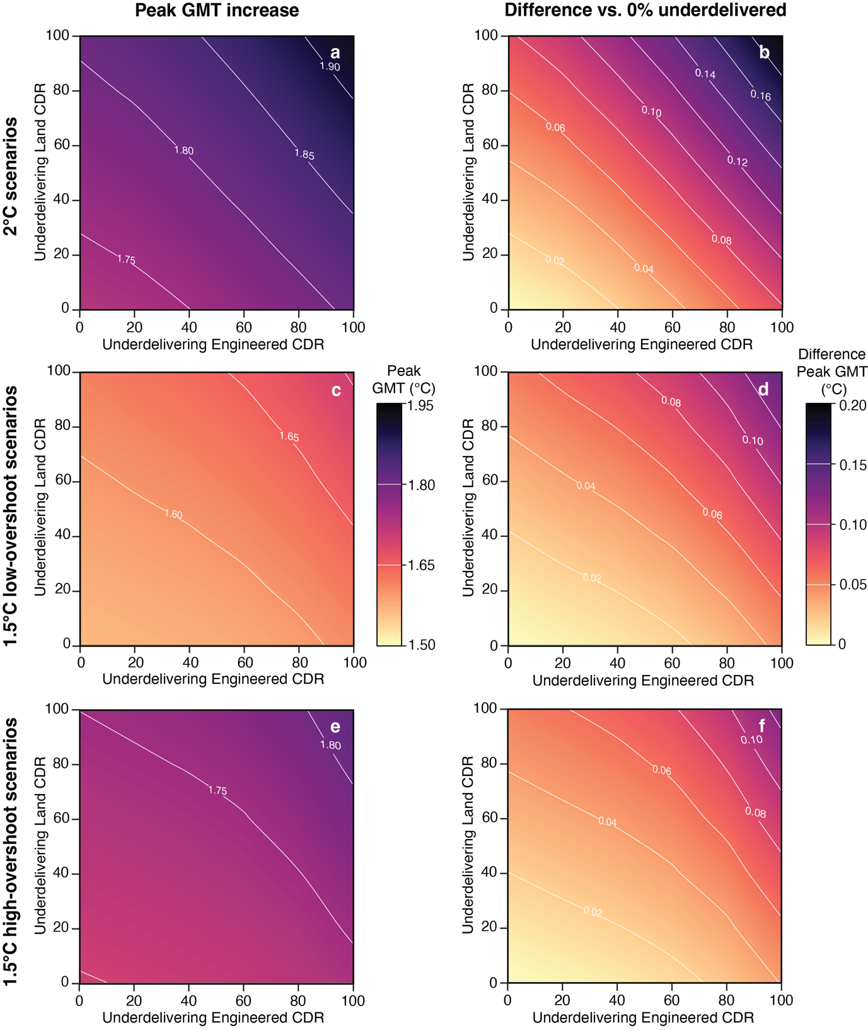
Supplementary Figure 12 | GMT increase for peak temperature from underdelivering engineered CDR and land CDR from 0–100%, every 20% increments. Panels a, c, e show peak GMT increase compared to the mean between 1850–1900. Panels b, d, f show the difference in each scenario compared to its original run (i.e. 0% underdelivering). Values in the contours represent the mean across scenarios (n= 231 for 2°C scenarios, n = 70 for 1.5°C low-overshoot scenarios, n = 106 for 1.5°C high-overshoot scenarios).
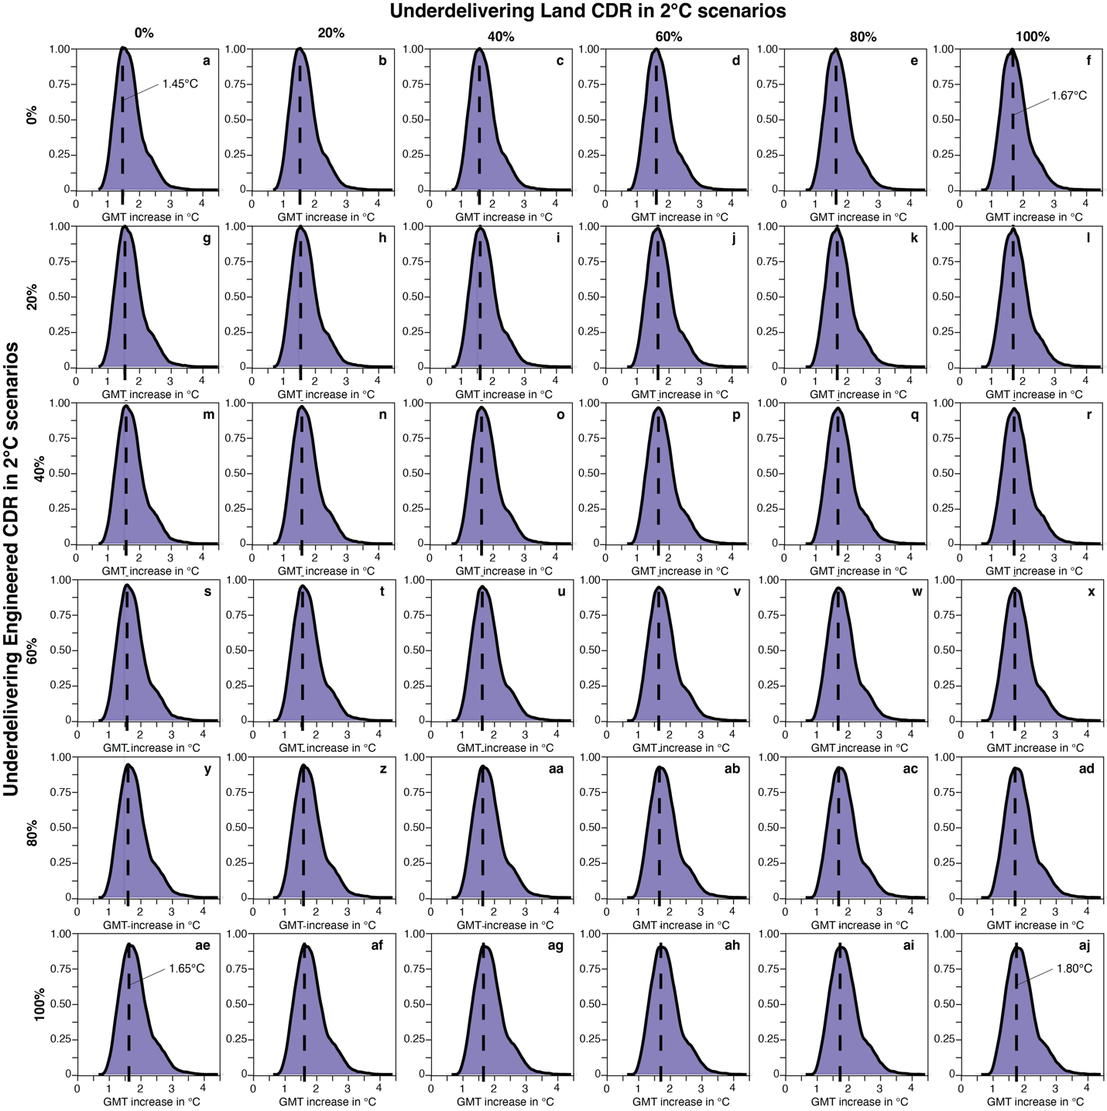
Supplementary Figure 13 | Density distributions of global mean temperature (GMT) increase in 2100 for 2°C scenario. Each panel shows results from 210 scenarios, each run with 600 ensemble members. Panels represent combinations of underdelivered levels (0% to 100%, in 20% increments) for engineered carbon dioxide removal (CDR, rows) and land-based CDR (columns). Dashed lines in each facet represent the peak GMT increase for the distribution.

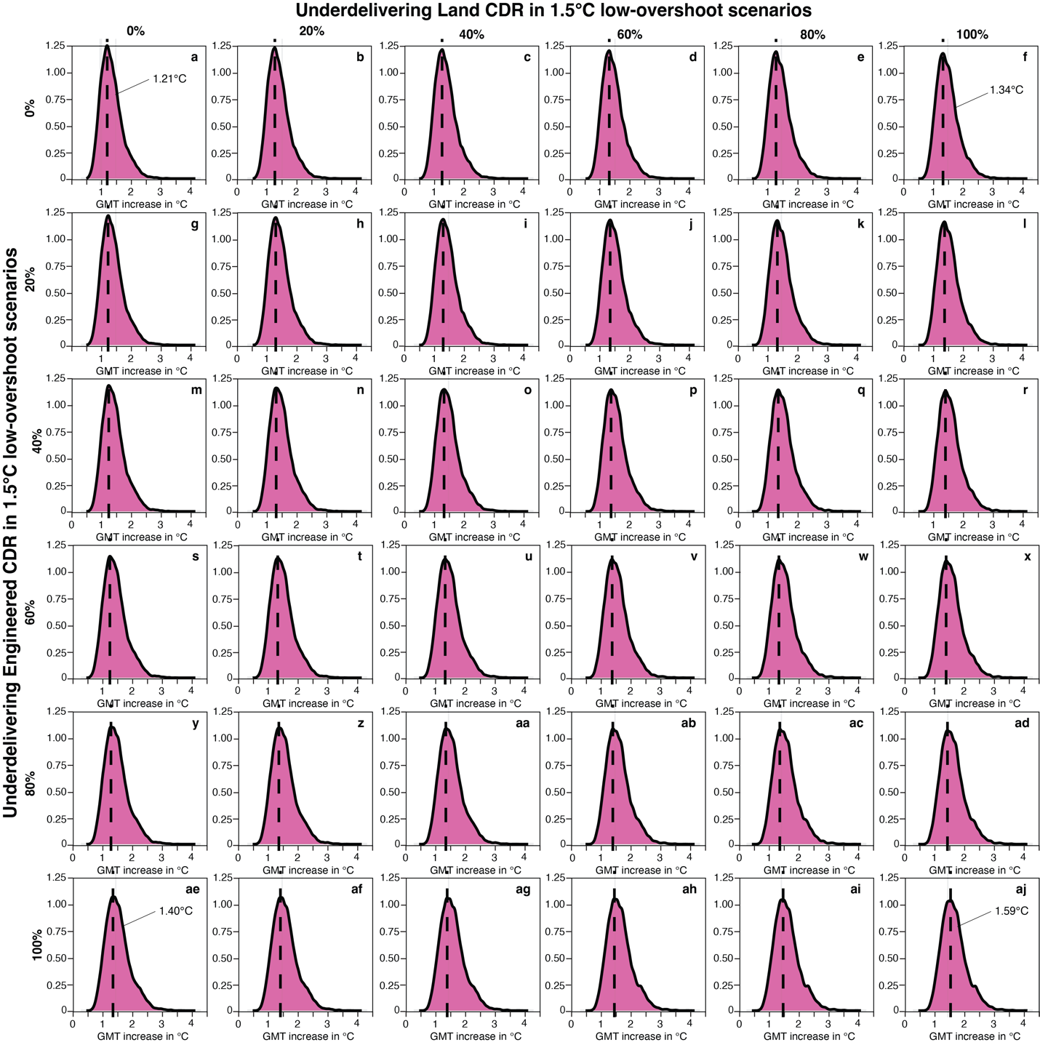
Supplementary Figure 14 | Density distributions of global mean temperature (GMT) increase in 2100 for 1.5°C low-overshoot scenario. Each panel shows results from 70 scenarios, each run with 600 ensemble members. Panels represent combinations of underdelivered levels (0% to 100%, in 20% increments) for engineered carbon dioxide removal (CDR, rows) and land-based CDR (columns). Dashed lines in each facet represent the peak GMT increase for the distribution.

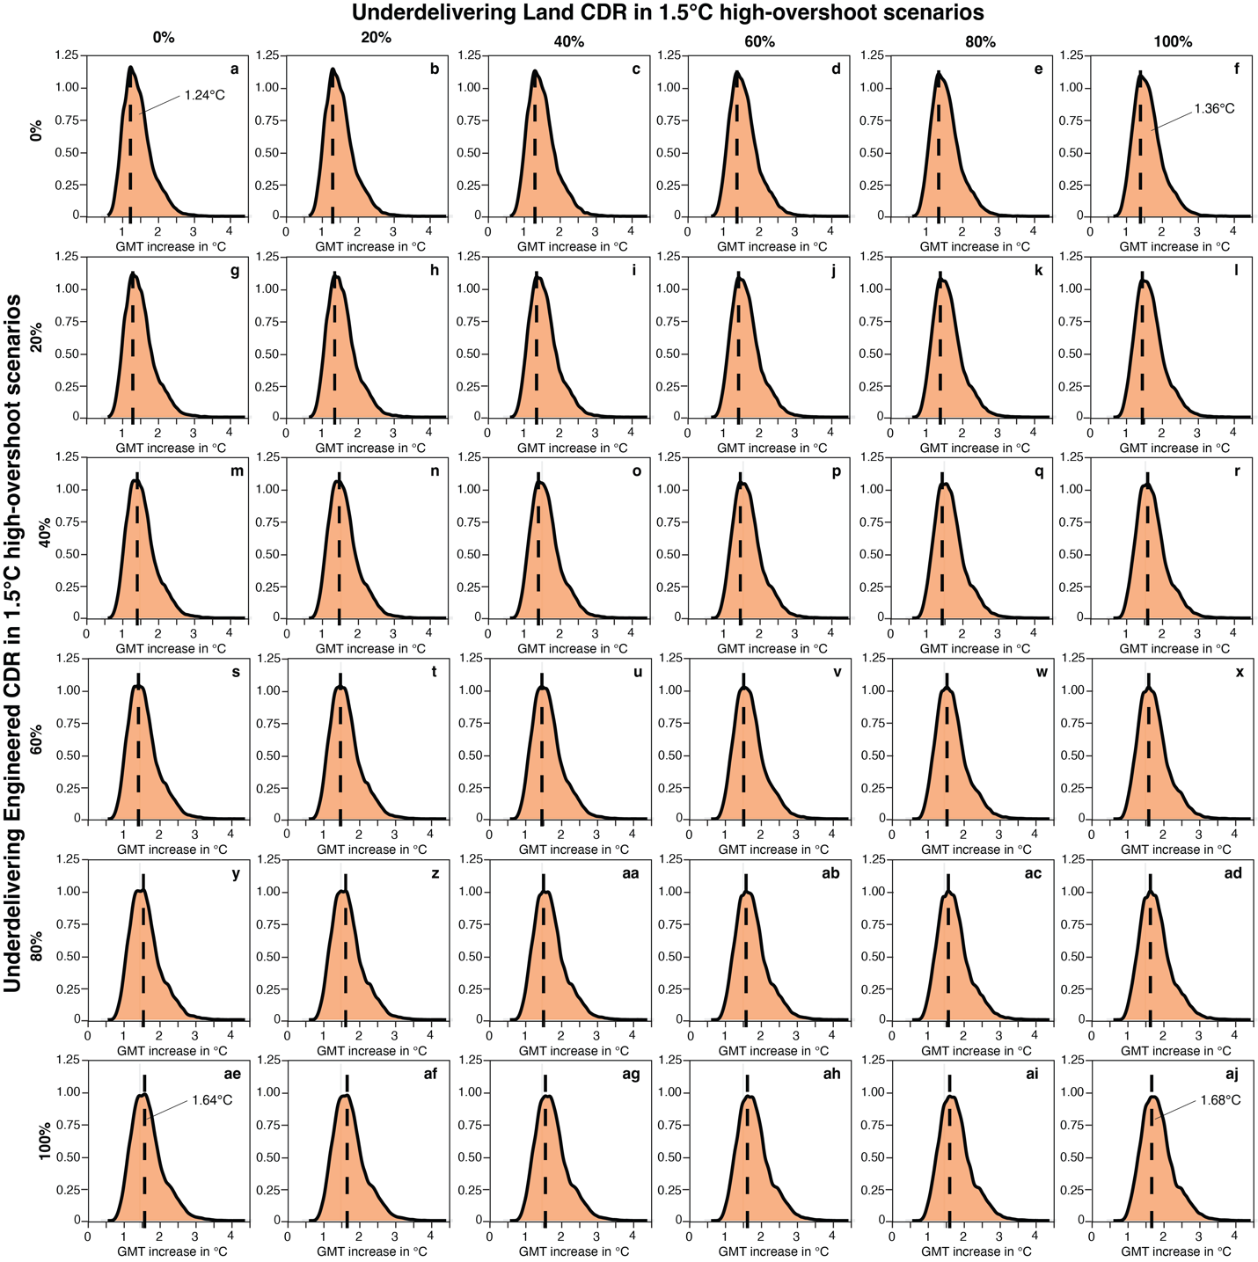
Supplementary Figure 15 | Density distributions of global mean temperature (GMT) increase in 2100 for 1.5°C high-overshoot scenario. Each panel shows results from 106 scenarios, each run with 600 ensemble members. Panels represent combinations of underdelivered levels (0% to 100%, in 20% increments) for engineered carbon dioxide removal (CDR, rows) and land-based CDR (columns). Dashed lines in each facet represent the peak GMT increase for the distribution.

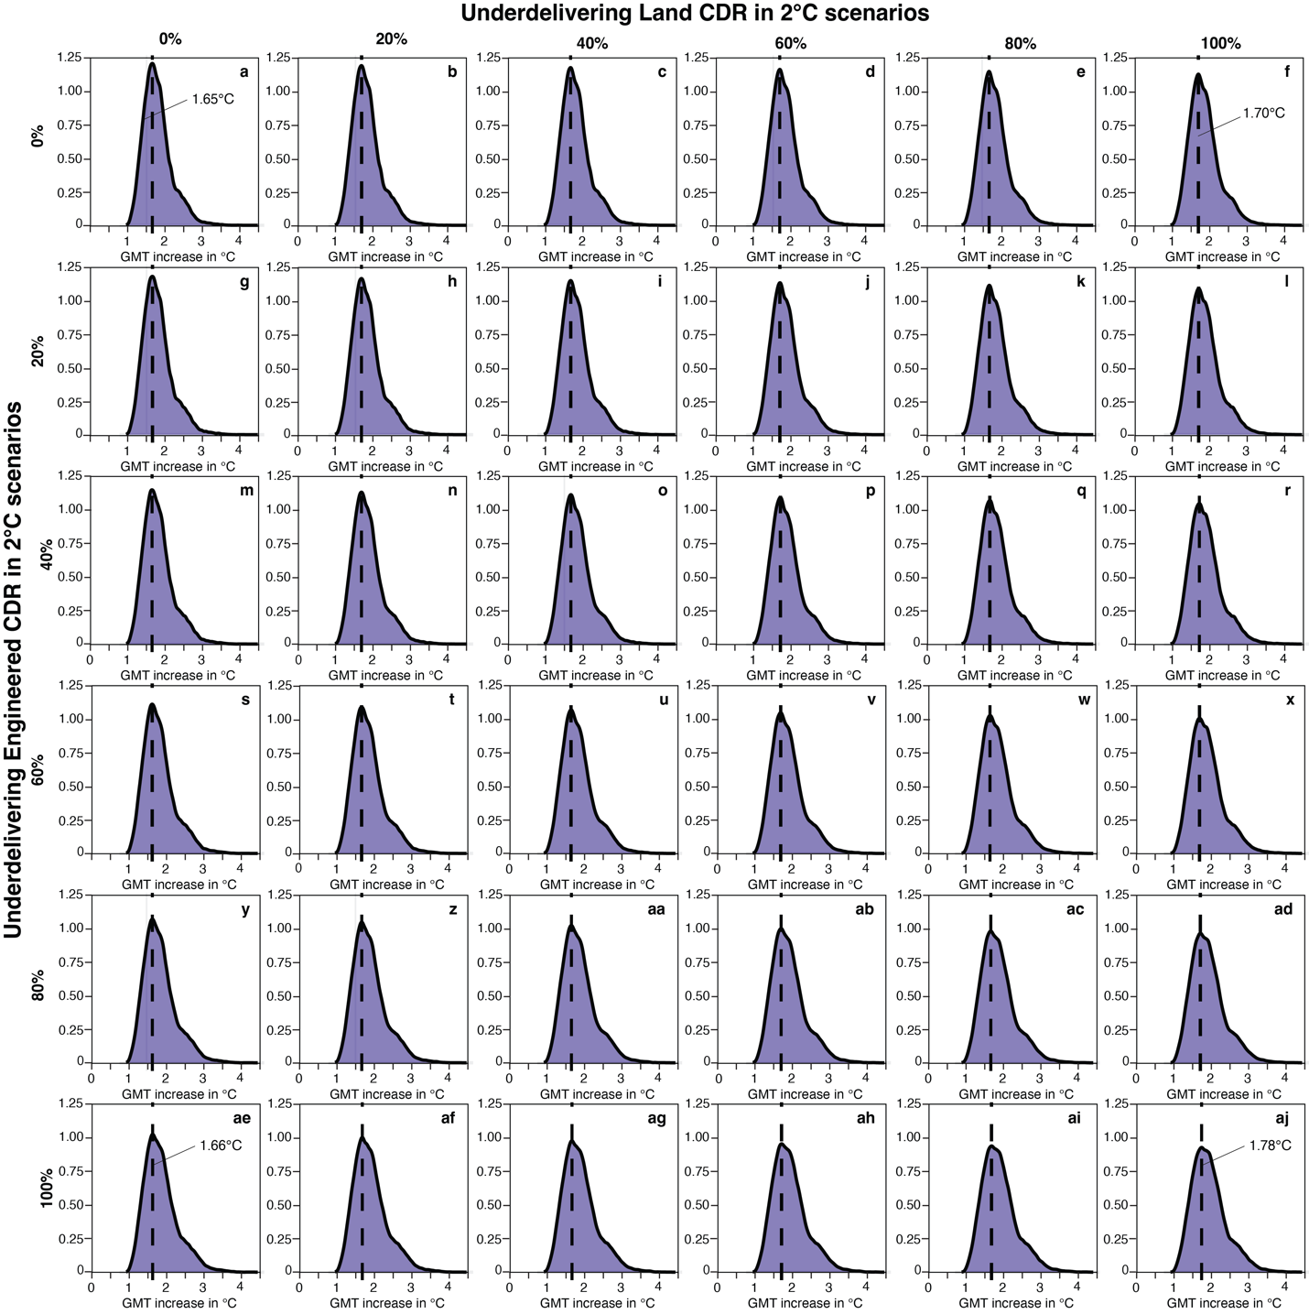
Supplementary Figure 16 | Density distributions of global mean temperature (GMT) increase in peak temperature for 2°C scenario. Each panel shows results from 210 scenarios, each run with 600 ensemble members. Panels represent combinations of underdelivered levels (0% to 100%, in 20% increments) for engineered carbon dioxide removal (CDR, rows) and land-based CDR (columns). Dashed lines in each facet represent the peak GMT increase for the distribution.

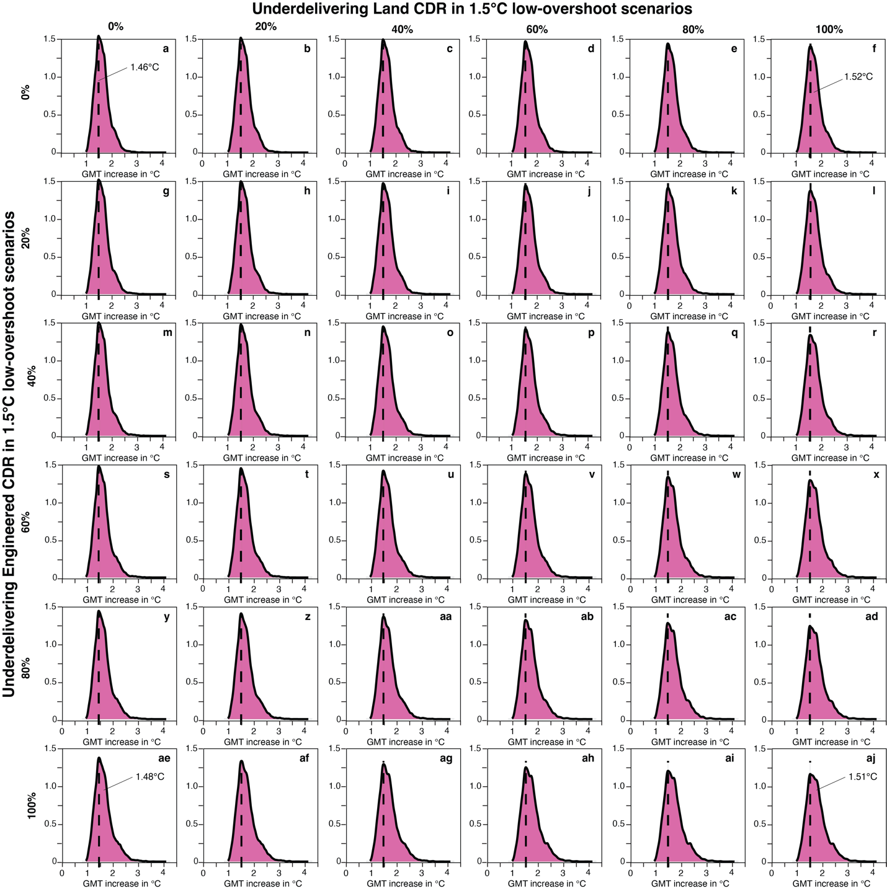Supplementary Figure 17 | Density distributions of global mean temperature (GMT) increase in peak temperature for 1.5°C low-overshoot scenario. Each panel shows results from 70 scenarios, each run with 600 ensemble members. Panels represent combinations of underdelivered levels (0% to 100%, in 20% increments) for engineered carbon dioxide removal (CDR, rows) and land-based CDR (columns). Dashed lines in each facet represent the peak GMT increase for the distribution.

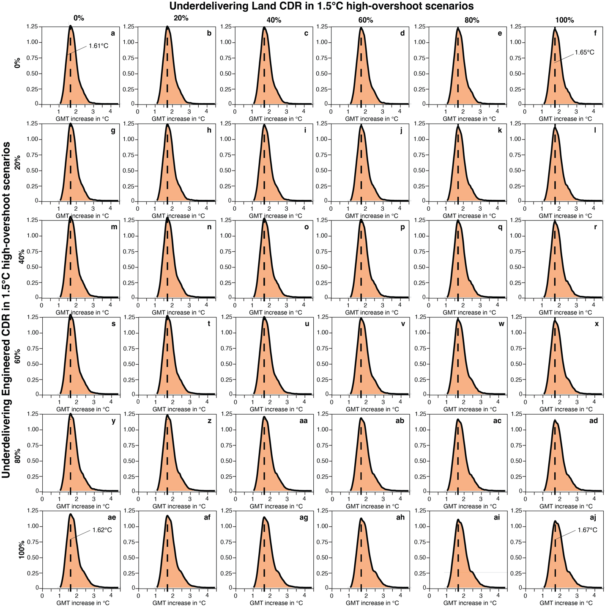Supplementary Figure 18 | Density distributions of global mean temperature (GMT) increase in peak temperature for 1.5°C high-overshoot scenario. Each panel shows results from 106 scenarios, each run with 600 ensemble members. Panels represent combinations of underdelivered levels (0% to 100%, in 20% increments) for engineered carbon dioxide removal (CDR, rows) and land-based CDR (columns). Dashed lines in each facet represent the peak GMT increase for the distribution.

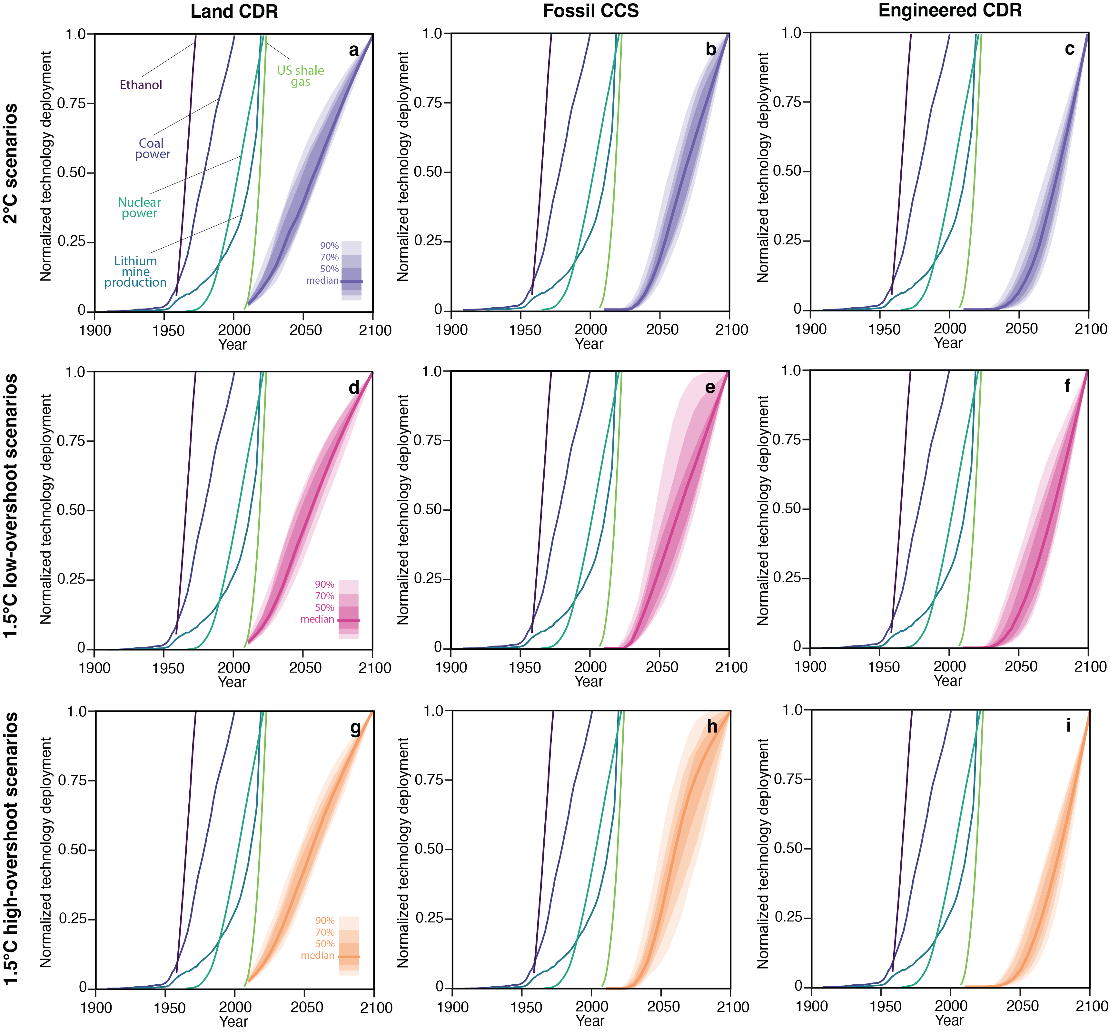Supplementary Figure 19 | Normalized technology growth. Each panel represents a scenario and carbon management technology, with shades representing the distribution across scenarios. We show deployment of analogous technologies², including ethanol production (1958–1972), coal power capacity (1908–2000), nuclear power generation (1965–2021), lithium mine production (1925–2019), and US shale gas production (2007–2023)³. Note that both ethanol and US shale gas production include few years. The horizontal dashed line marks 2015, which is the last historical year in the scenarios analyzed form AR6.
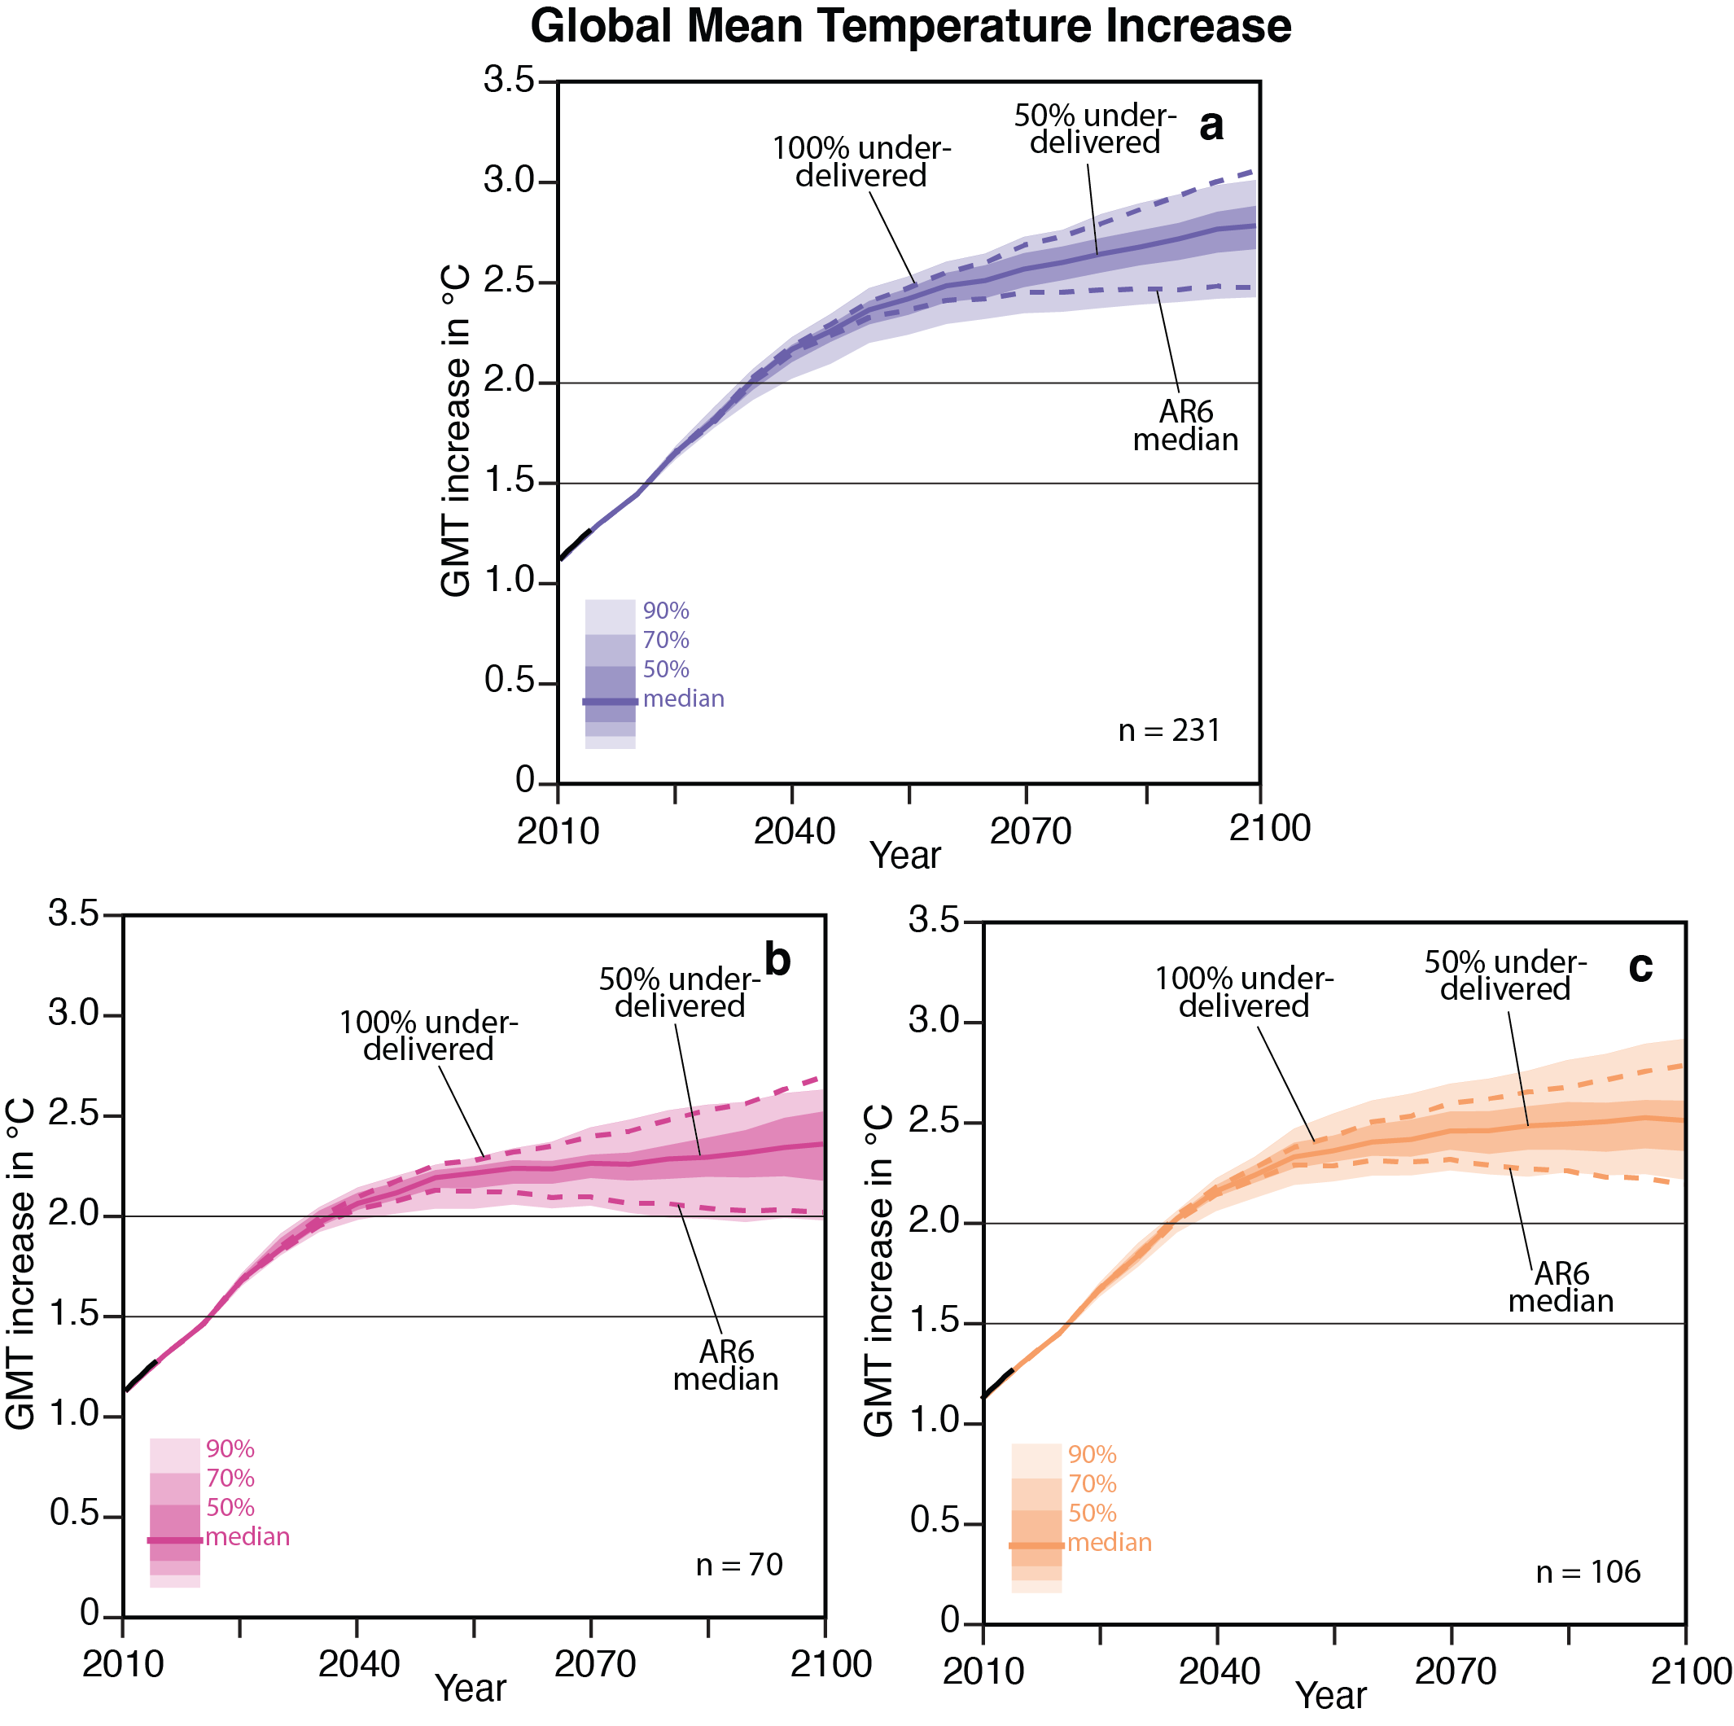
Supplementary Figure 20 | Global mean temperature increase compared to 1850–1900 for original and underdelivering carbon management scenarios based on the 95th percentile in each year (as opposed to the median). Panel a shows GMT increase for 2°C scenarios, b for 1.5°C with low-overshoot, and c for 1.5°C with high-overshoot. The shades represent the distribution of global mean temperature increase for the 95th percentile across each scenario category for underdelivering 50% of carbon management.

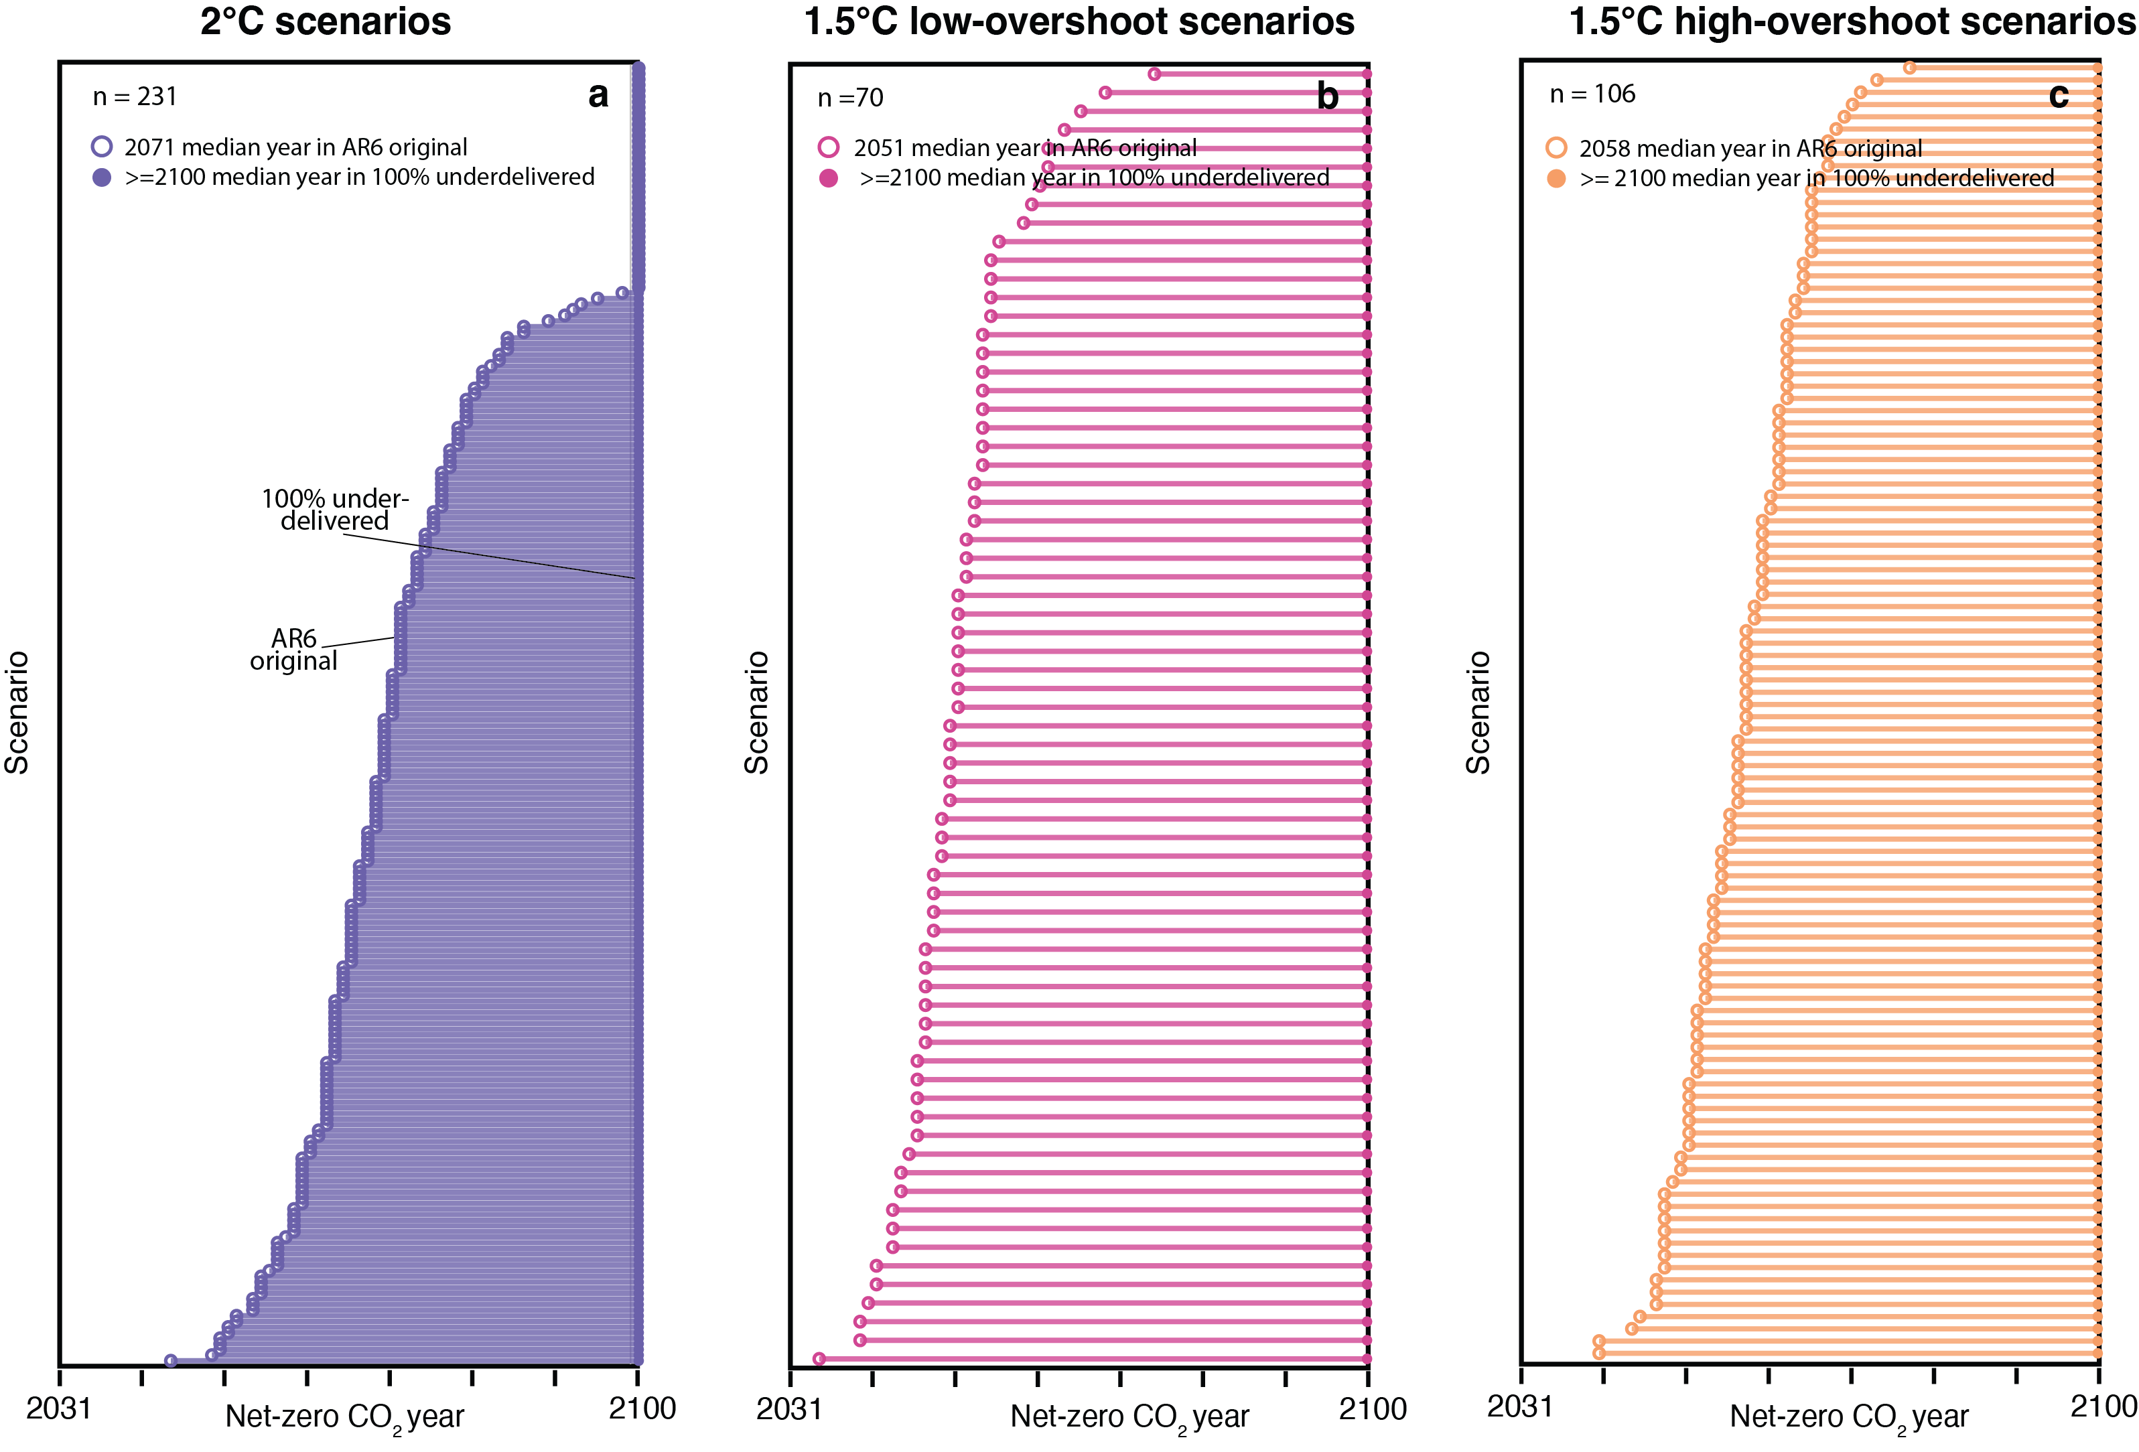
Supplementary Figure 21 | Net-zero CO₂ emission year for the 407 scenarios when underdelivering 0% (hollow circles) in AR6 original scenarios compared to underdelivering 100% (solid circles) carbon management. Note that ≥2100 is used to represent scenarios not achieving net-zero CO₂ emissions from land and energy in 2100.

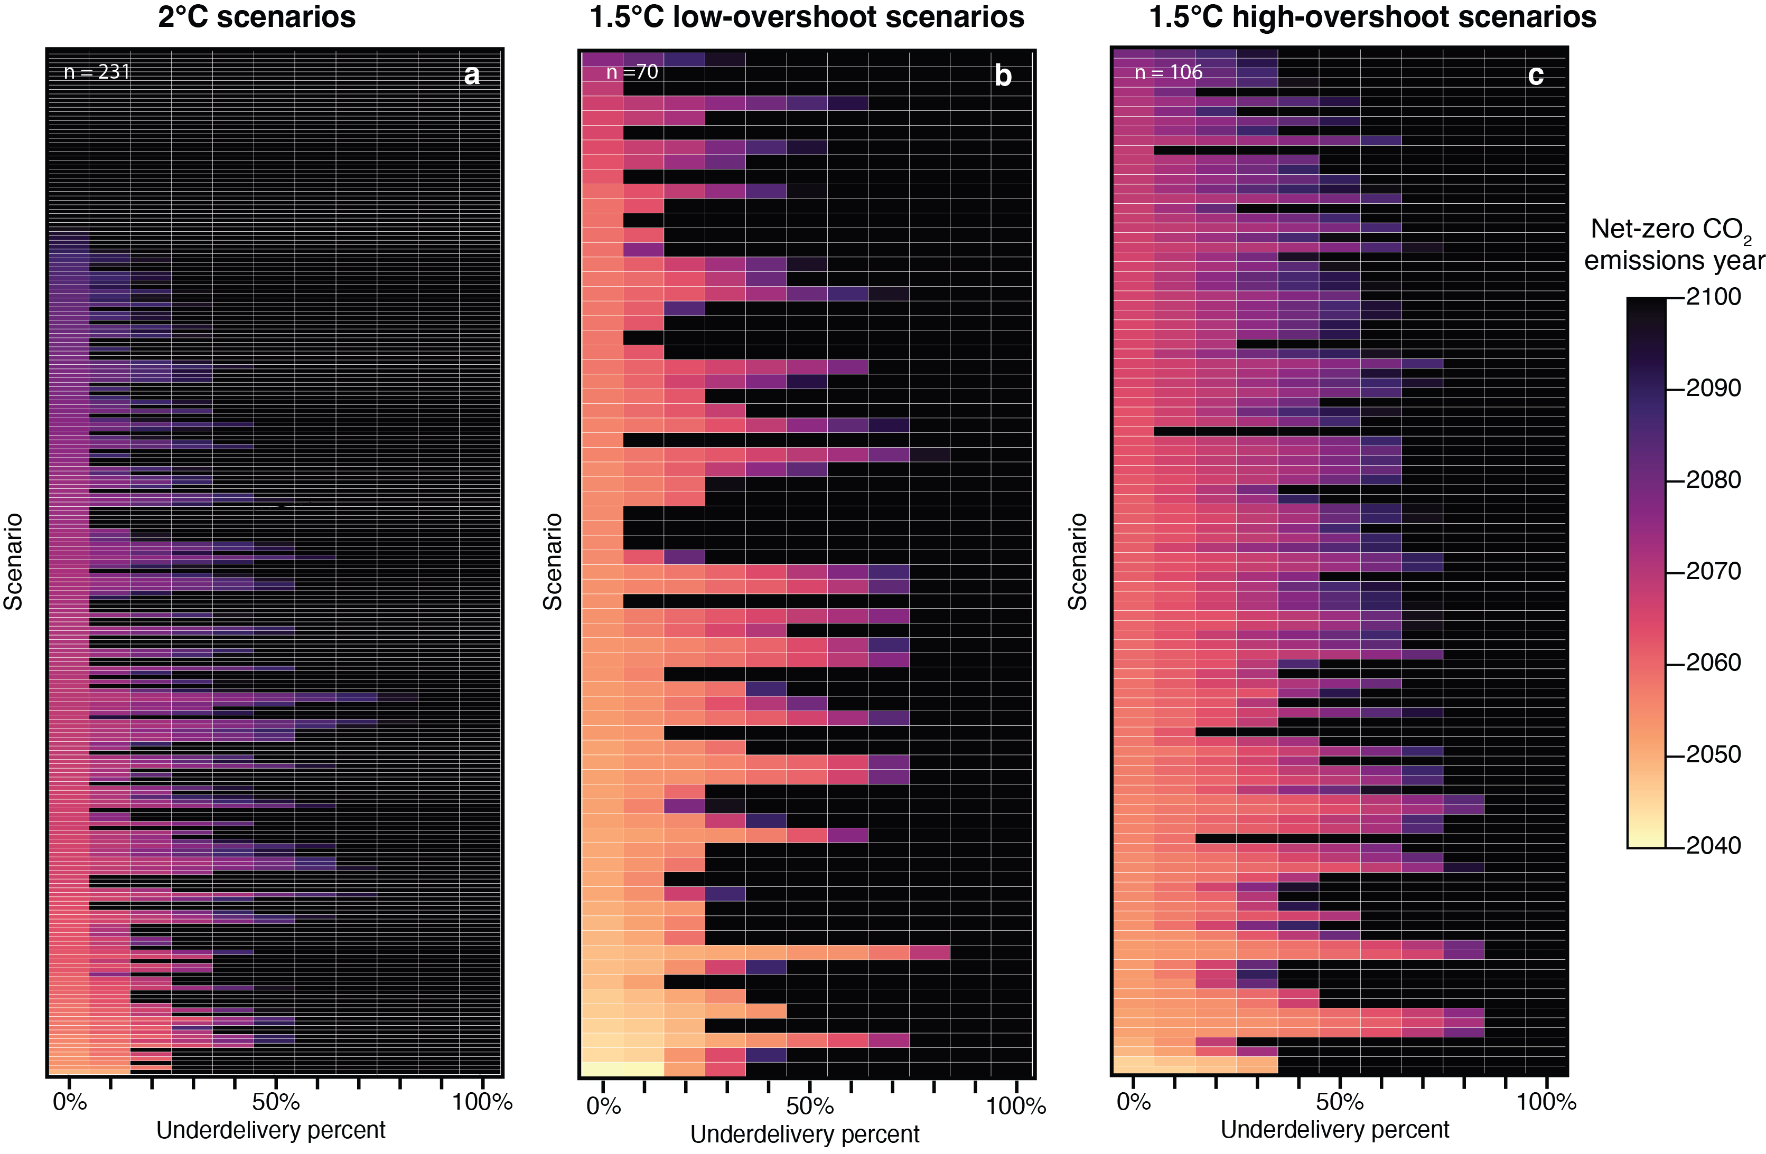
Supplementary Figure 22 | Net-zero CO₂ emission year in each scenario when underdelivering different percentages of all carbon management. Each row represents one scenario. CO₂ emissions include land and energy.

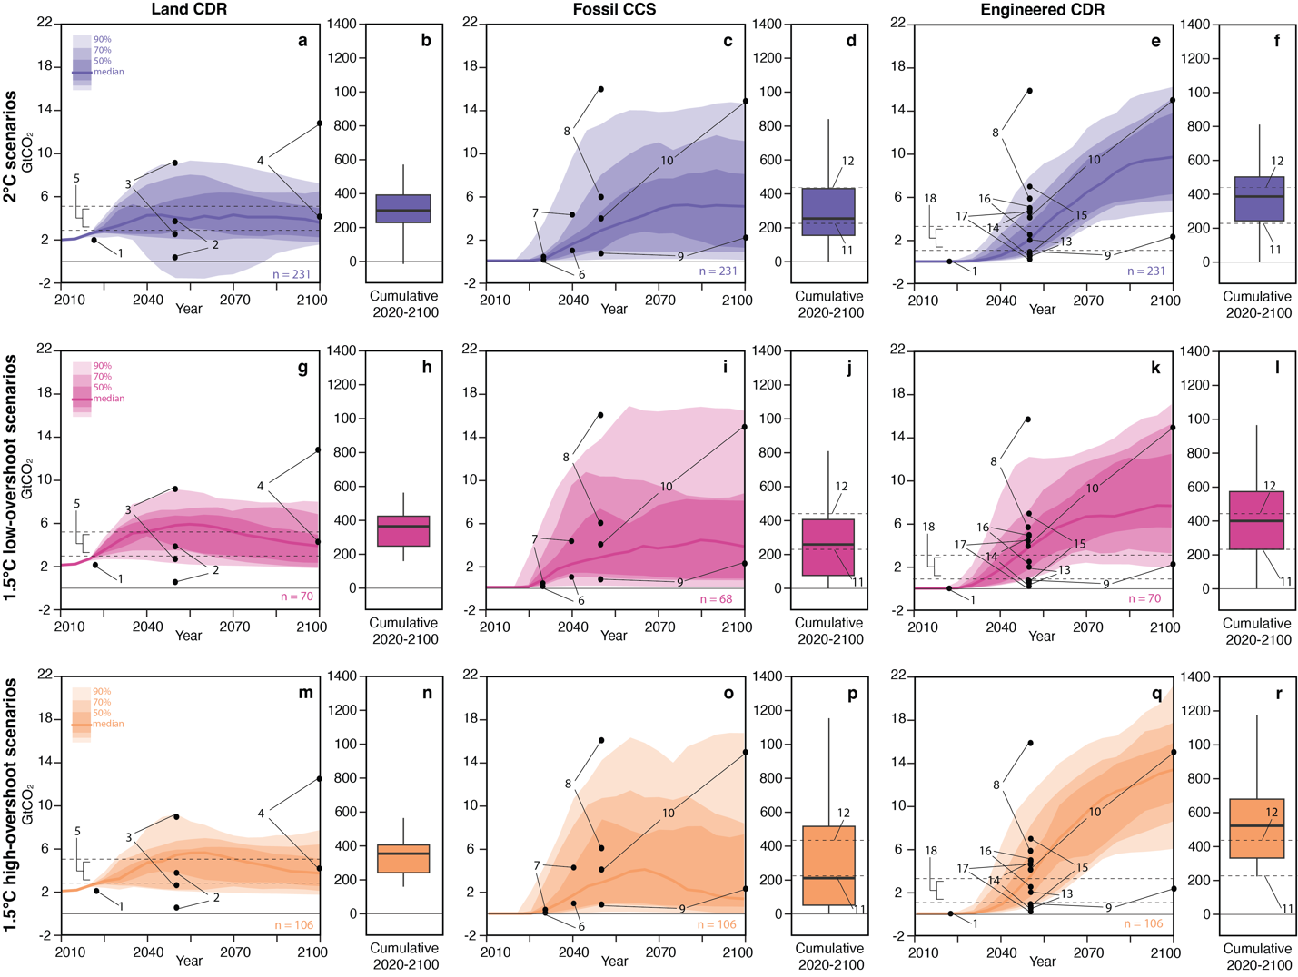
# | Year | Amount (GtCO₂) | Source | Notes
1 | 2022 | 0.002 | Powis et al.⁴ | Engineered CDR historical (panels e, k, and q).
1 | 2022 | 1.983 | Powis et al.⁴ | Land CDR historical (panels a, g, and m)
2 | 2050 | 0.5–3.6 | Lawrence et al.⁵, Rueda et al.⁶, Schaber et al⁷ | Land CDR based on feasibility, effectiveness, and side impacts, as well as land-use competition (panels a, g, and m).
3 | 2050 | 2.5–8.6 | Warszawski et al.⁸ | Land CDR based on feasibility, scale up, land use changes. Consumer impacts and non-CO₂ impacts (panels a, g, and m).
4 | 2100 | 4–12 | Lawrence et al.⁵ | Land CDR based on more realistic estimates that consider land-use competition (panels a, g, and m).
5 | 2020–2100 | 2.6–5.1 | Deprez et al.⁹ | Land CDR based on low and medium sustainability risks throughout the century (panels a, g, and m).
6 | 2030–2040 | 0.07–0.95 | Kazlou et al.¹⁰ | Fossil CCS based on realistic assumptions of fossil CCS technology scaleup (panels c, i, and o).
7 | 2030–2040 | 0.37–4.3 | Kazlou et al.¹⁰ | Fossil CCS based on optimistic assumptions of fossil CCS technology scaleup (panels c, i, and o).
8 | 2050 | 6–16 | Zhang et al.¹¹ | CO₂ storage based on geological, geographical, and technoeconomic limitations (panels c, e, i, k, o and q).
9 | 2050–2100 | 0.8–2.5 | Fuhrman et al.¹² (preprint) | CO₂ storage base on slow growth following oil and gas production activity (panels c, e, i, k, o and q).
10 | 2050–2100 | 4–15 | Fuhrman et al.¹² (preprint) | CO₂ storage based on “CCS breakthrough” growth rates (similar to shale gas) (panels c, e, i, k, o and q).
11 | 2020–2100 | 214 | Van de ven et al.¹³ | CO₂ storage cumulative based on feasibility thresholds similar to oil and gas basins (panels d, f, j, l, p and r).
12 | 2020–2100 | 420 | Grant et al.¹⁴ | CO₂ storage cumulative based on “investable potential” following financial, contractual, and institutional barriers (panels d, f, j, l, p and r).
13 | 2050 | 0.5–2 | Lawrence et al.⁵, Rueda et al.⁶, Schaber et al⁷ | Engineered CDR for biochar only based on biomass availability, feedstock type, cost assumptions, among others (panels e, k, and q).
14 | 2050 | 0.5–5 | Rueda et al.⁶ | Engineered CDR for BECCS only based on feasibility, effectiveness, and side impacts (panels e, k, and q).
15 | 2050 | 0.7–7 | Schaber et al⁷ | Engineered CDR for DACCS only based on cost assumptions (panels e, k, and q).
16 | 2050 | 2.5–5 | Schaber et al⁷ | Engineered CDR for enhanced weathering only based on cost assumptions (panels e, k, and q).
17 | 2050 | 0.2–4.9 | Edwards et al.¹⁵ | Engineered only for DACCS based on different technology growth rates (panels e, k, and q).
18 | 2020–2100 | 1.2–2.8 | Deprez et al.⁹ | Engineered CDR for BECCS based on low and medium sustainability risks (panels e, k, and q).
Supplementary Figure 23 | Carbon management by type in AR6 scenarios with estimated feasible and/or sustainable values from the literature for 407 scenarios, including those that have above 67% probability of limiting warming to 2°C (231 scenarios for C3), and those that have above 50% probability of limiting warming to 1.5°C throughout the 21st century with no or limited overshoot (70 scenarios for C1 pathways) and after a high overshoot (106 scenarios for C2).

References
1. Gidden, M. J. et al. Aligning climate scenarios to emissions inventories shifts global benchmarks. Nature 624, 102–108 (2023).
2. Nemet, G., Greene, J., Zaiser, A. & Hammersmith, A. Historical Adoption of Technologies (HATCH) Dataset. Zenodo https://doi.org/10.5281/zenodo.10035735 (2023).
3. eia. U.S. Natural Gas Gross Withdrawals and Production. https://www.eia.gov/dnav/ng/ng_prod_sum_dc_NUS_mmcf_a.htm.
4. Powis, C. M., Smith, S. M., Minx, J. C. & Gasser, T. Quantifying global carbon dioxide removal deployment. Environ. Res. Lett. 18, 024022 (2023).
5. Lawrence, M. G. et al. Evaluating climate geoengineering proposals in the context of the Paris Agreement temperature goals. Nat. Commun. 9, 3734 (2018).
6. Rueda, O., Mogollón, J. M., Tukker, A. & Scherer, L. Negative-emissions technology portfolios to meet the 1.5 °C target. Glob. Environ. Change 67, 102238 (2021).
7. Schaber, T., Ekholm, T., Merikanto, J. & Partanen, A.-I. Prudent carbon dioxide removal strategies hedge against high climate sensitivity. Commun. Earth Environ. 5, 1–9 (2024).
8. Warszawski, L. et al. All options, not silver bullets, needed to limit global warming to 1.5 °C: a scenario appraisal. Environ. Res. Lett. 16, 064037 (2021).
9. Deprez, A. et al. Sustainability limits needed for CO2 removal. Science 383, 484–486 (2024).
10. Kazlou, T., Cherp, A. & Jewell, J. Feasible deployment of carbon capture and storage and the requirements of climate targets. Nat. Clim. Change 14, 1047–1055 (2024).
11. Zhang, Y., Jackson, C. & Krevor, S. The feasibility of reaching gigatonne scale CO2 storage by mid-century. Nat. Commun. 15, 6913 (2024).
12. Fuhrman, J. et al. Rate and growth limits and the role of geologic carbon storage in meeting climate targets. Preprint at https://doi.org/10.21203/rs.3.rs-4784455/v1 (2024).
13. van de Ven, D.-J. et al. A multimodel analysis of post-Glasgow climate targets and feasibility challenges. Nat. Clim. Change 13, 570–578 (2023).
14. Grant, N., Gambhir, A., Mittal, S., Greig, C. & Köberle, A. C. Enhancing the realism of decarbonisation scenarios with practicable regional constraints on CO2 storage capacity. Int. J. Greenh. Gas Control 120, 103766 (2022).
15. Edwards, M. R. et al. Modeling direct air carbon capture and storage in a 1.5 °C climate future using historical analogs. Proc. Natl. Acad. Sci. 121, e2215679121 (2024).

