Supplementary Material to Seppey et al. 2025 - LEMMIv2: Benchmarking Framework for Metagenomic and 16S Amplicon Profilers with a Catalogue of Evaluated Tools.

Figures: pages 1- 9
Tables: pages 10 - 12

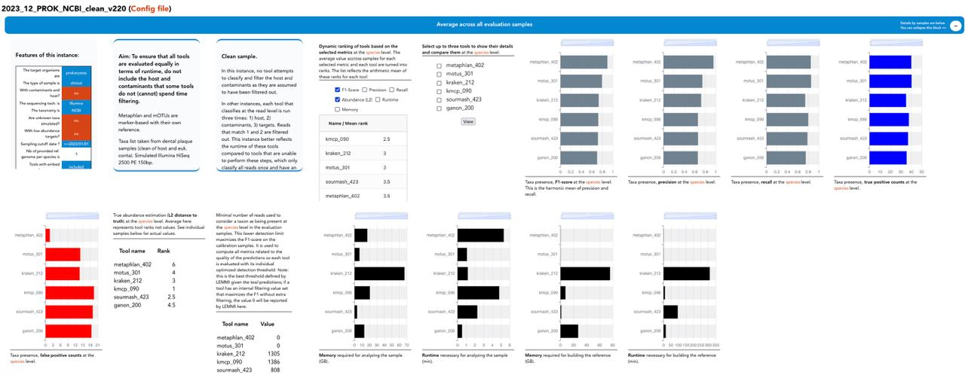

Supplementary Figure 1. Detail page of a LEMMIv2 instance, showing different widgets reporting average values for all the samples or metrics that are not specific to a sample such as resources for building the reference.

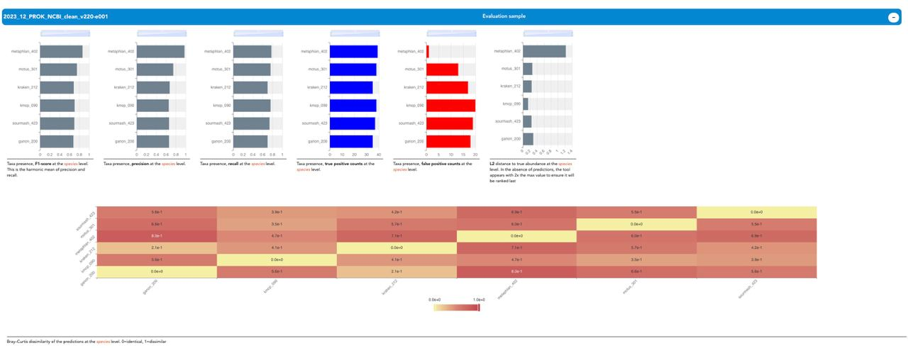

Supplementary Figure 2. Detail page of a LEMMIv2 instance, showing different widgets reporting values for a specific evaluation sample, including a heatmap on how dissimilar the predictions of each tool are for that sample.

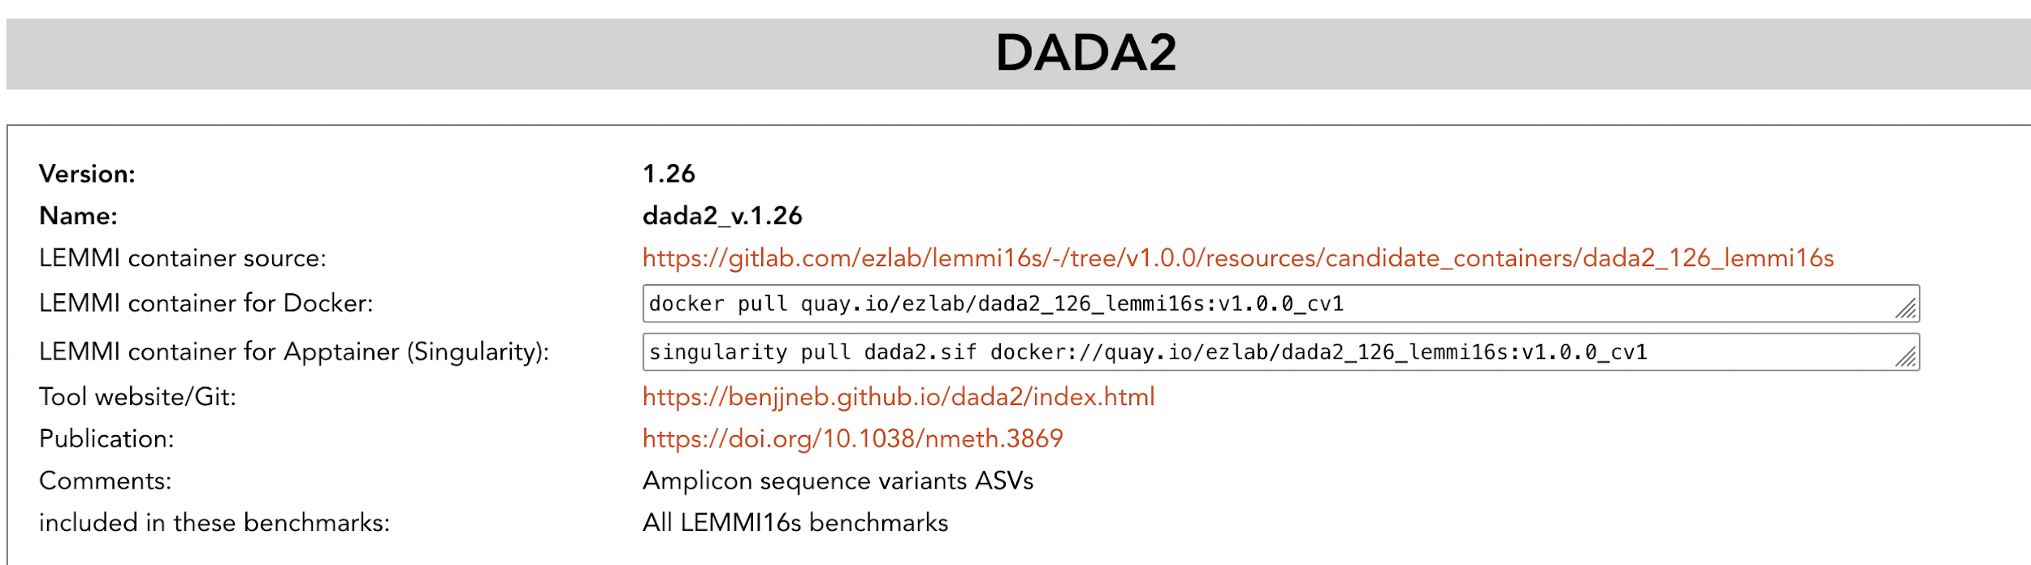

Supplementary Figure 3. Extract from the LEMMI16S catalogue. Each tool has a section where different versions can be presented, with a link to the source of the container, the built container available in a repository, and links to a website and publication for the method where applicable.
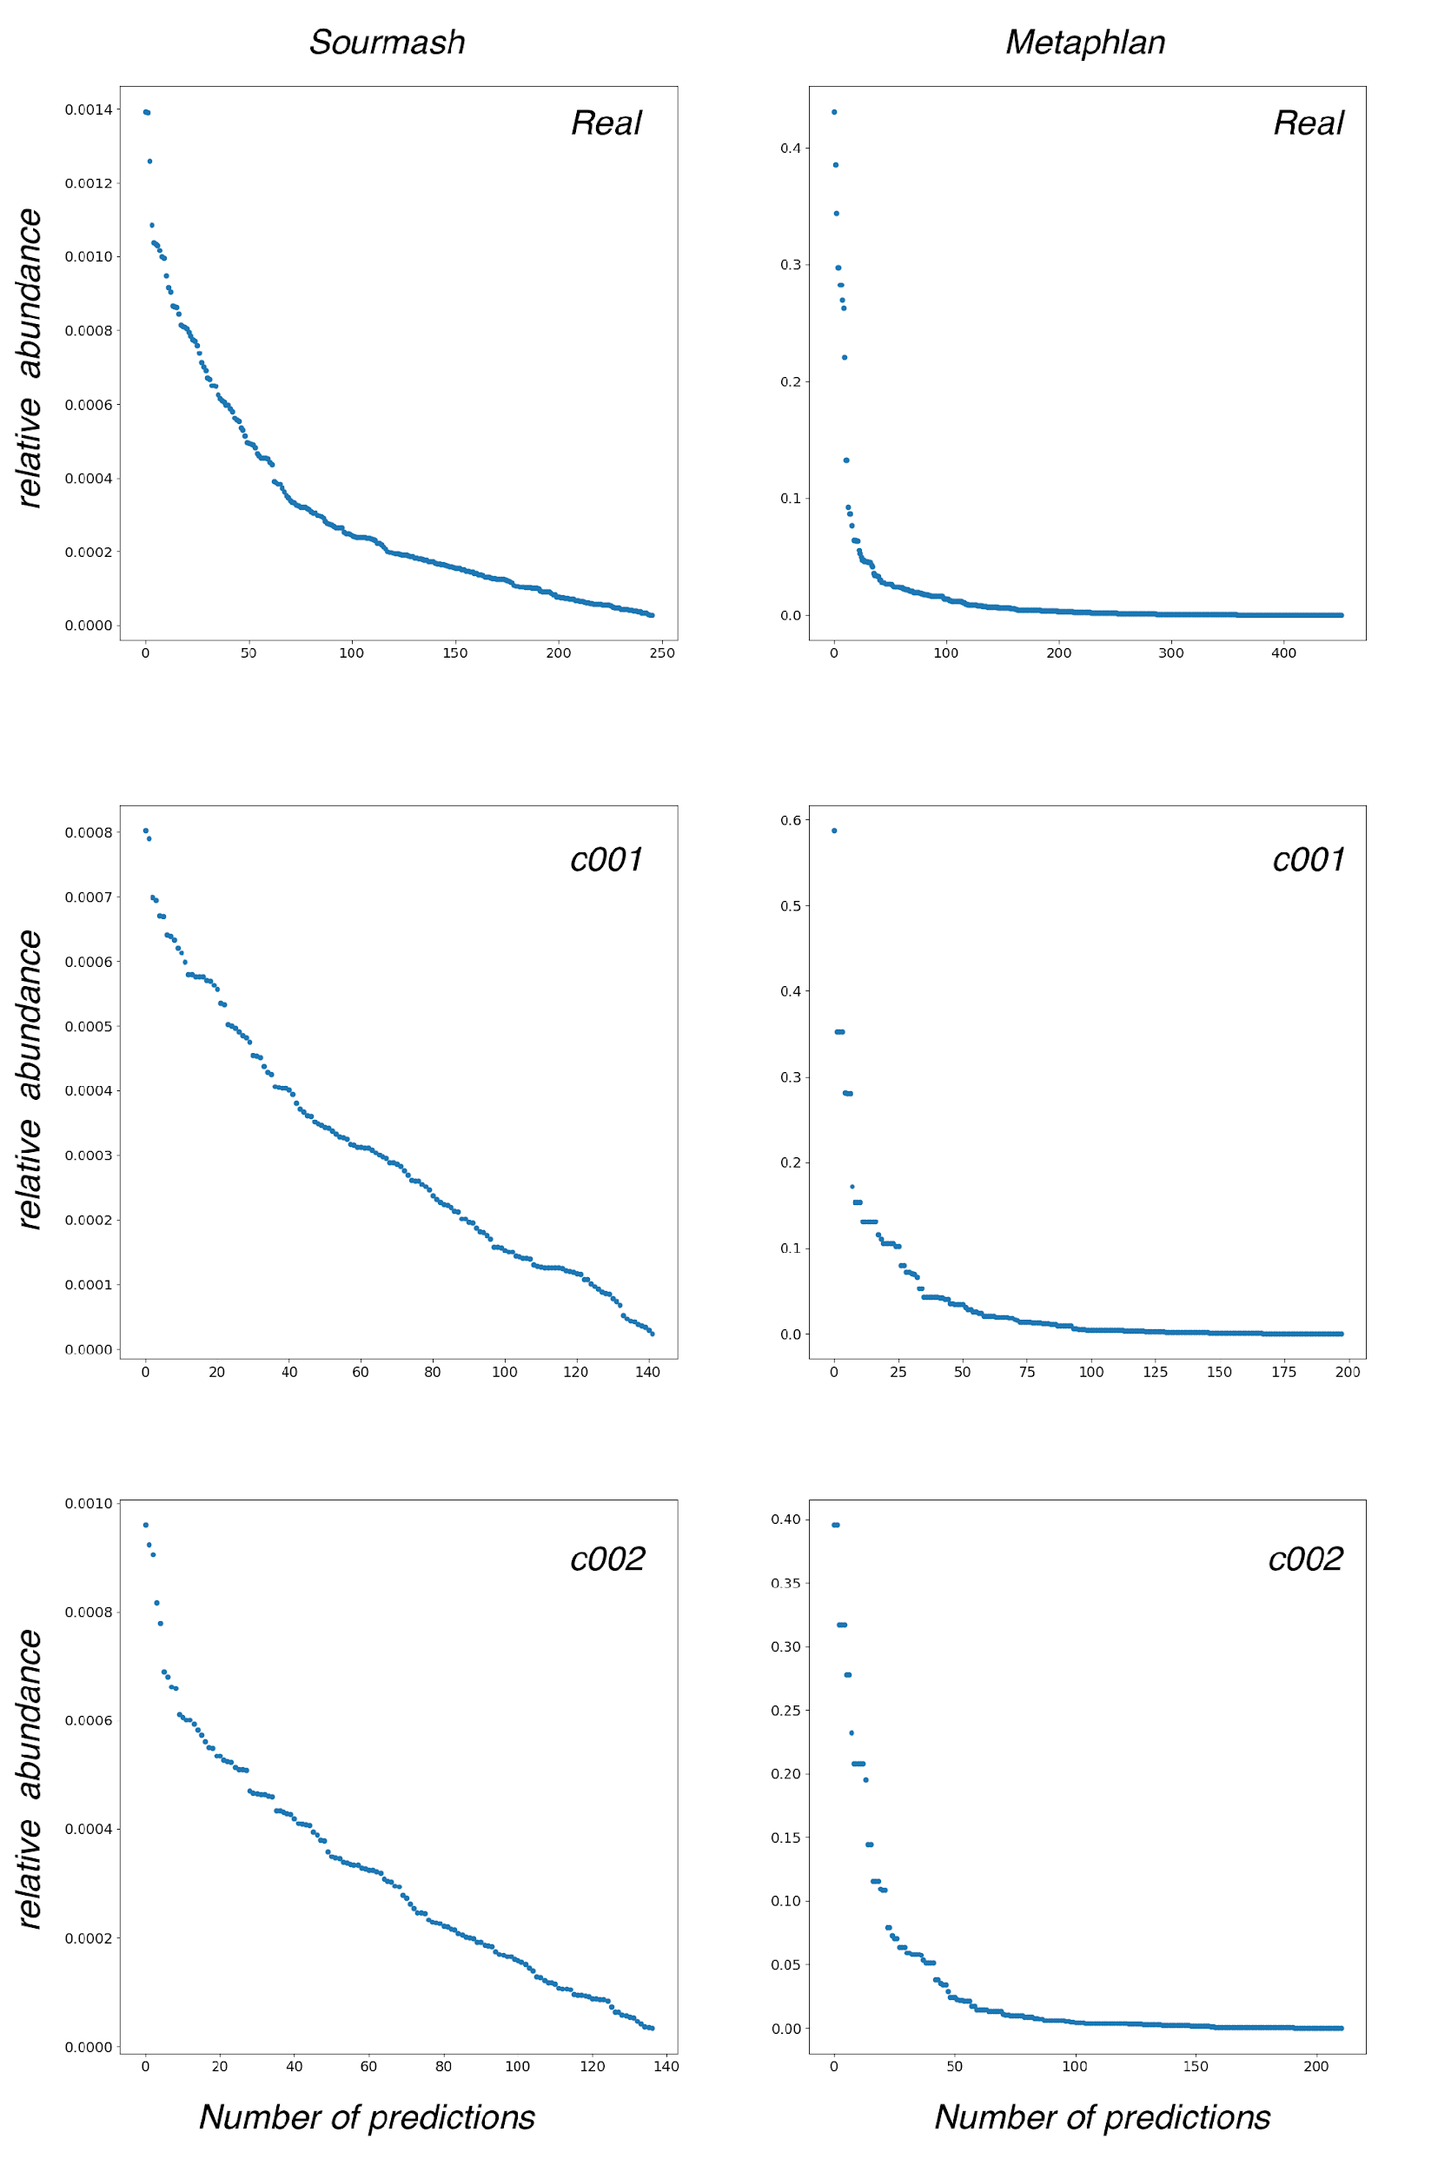
Supplementary Figure 4. Relative abundances of taxa predicted by Sourmash and Metaphlan on LEMMIv2 samples 2023_05_PROK_NCBI-c001, c002 and the corresponding real sample. Includes predictions at all taxonomic ranks.

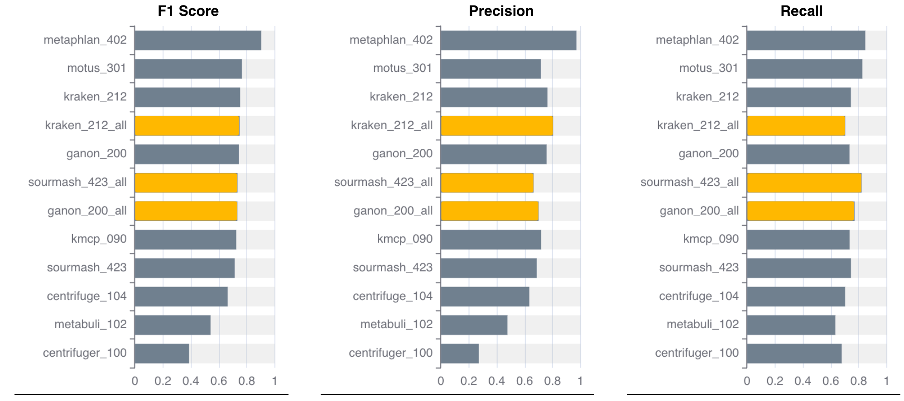
Supplementary Figure 5. Performance of methods for the identification of organisms at species level for the instance 2023_12_PROK_NCBI_v220. Methods marked with _all used up to five genomes for each species as a reference. The others used only one genome as reference.

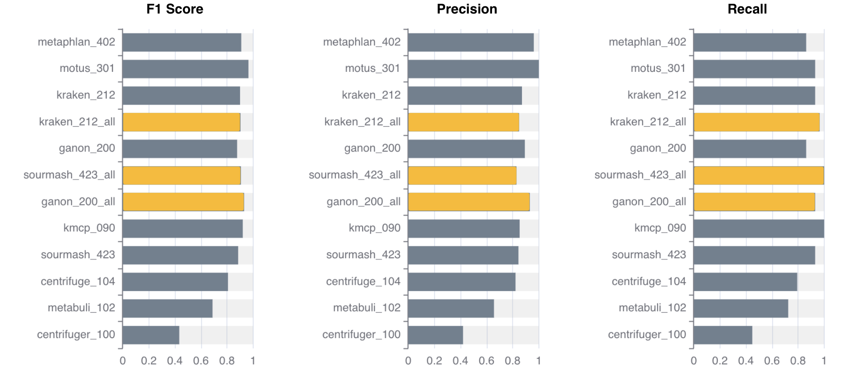

Supplementary Figure 6. Performance of methods for the identification of organisms at genus level for the instance 2023_12_PROK_NCBI_v220. Methods marked with _all used up to five genomes for each species as a reference. The others used only one genome as reference.

Supplementary Figure 7. A) Average runtime (minutes) to perform the analysis of a sample from the 2023_12_PROK_NCBI_clean_v220 instance. B) Average peak memory (GB) to perform the analysis of a sample from the 2023_12_PROK_NCBI_clean_v220 instance. C) F1 score of methods for the identification of organisms at species level for the instance 2023_11_PROK_GTDB_v220. D) F1 score of methods for the identification of organisms at species level for the instance 2022_03_PROK_NCBI_2. E) F1 score of methods for the identification of organisms at species level for the instance 2022_01_EUK_NCBI. F) F1 score of methods for the identification of organisms at species level for the instance 2021_9_VIR_NCBI. G) F1 score of methods for the identification of organisms at species level for the instance 2022_04_PROK_NCBI_LR2.
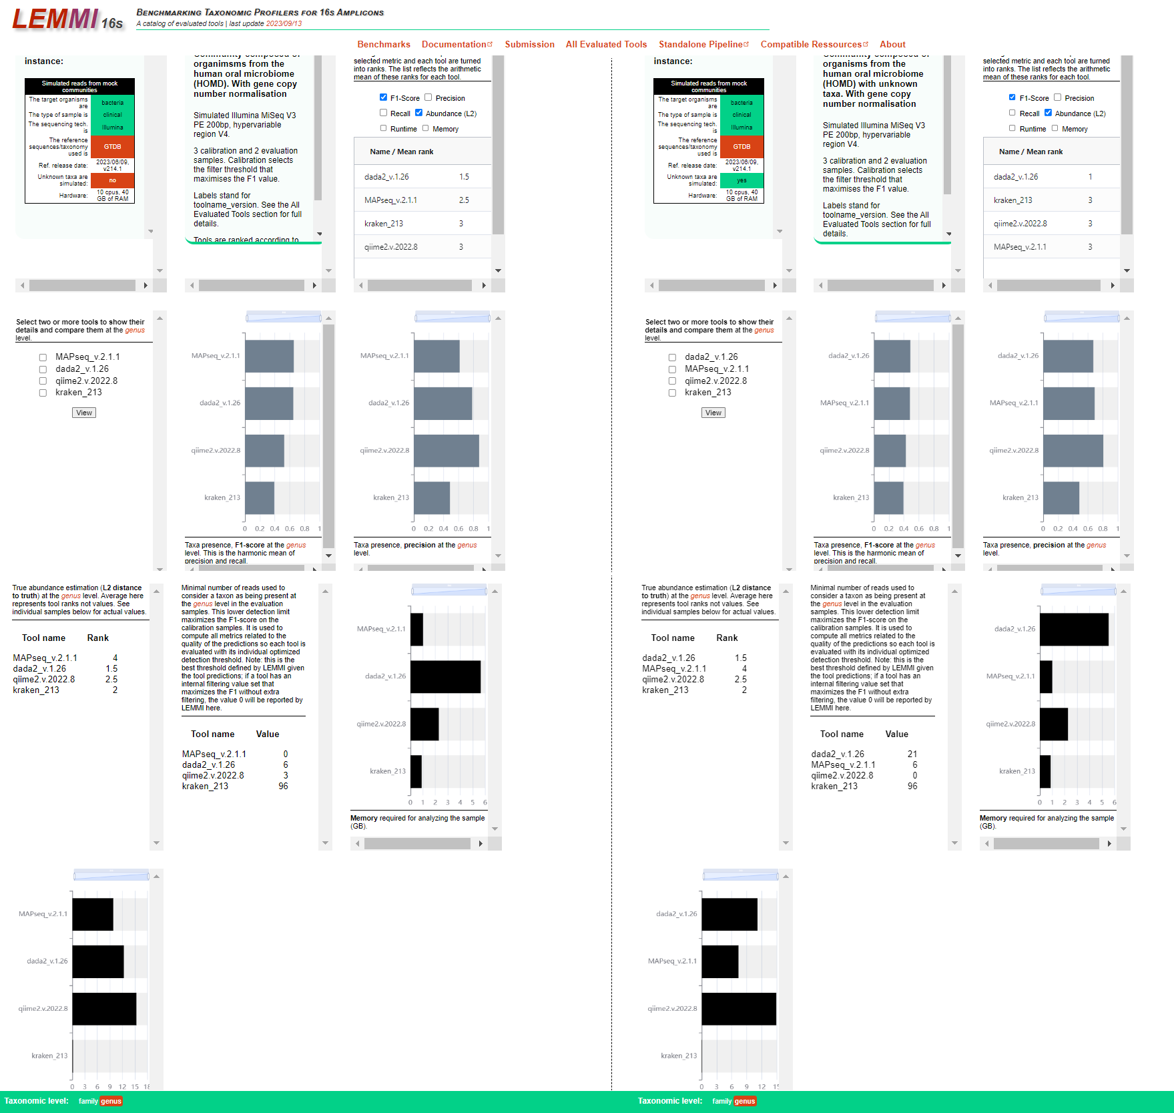
Supplementary Figure 8. Results taken from LEMMI16S instance representing Human Oral Microbiome samples with unknown organisms.

Supplementary Table 1. Characteristics of simulated samples compared to the real samples on which they are based.

 | Reads  length | Number of paired-end reads | Number of 31-mers | %GC
LEMMIv2
Plaque from a healthy patient | 151 | 21'153'159 | 2,059,607,399 | 45
Simulation  2023_05_PROK_NCBI-c001 | 150 | 20'015'528 | 2,206,174,136 | 41
Simulation  2023_05_PROK_NCBI-c002 | 150 | 20'055'700 | 2,224,328,630 | 41
LEMMI16S
Human pathogens samples | 300 | 654,196 | 354,293,576 | 53.7
Simulation  Human pathogens samples_gcn-c001 | 250 | 867,086 | 380,472,649 | 52.4
Simulation  Human pathogens samples_gcn-c002 | 250 | 892,299 | 392,439,207 | 53.6

Supplementary Table 2. Status of the tools in terms of the ability of the container to filter out off-target reads prior to final classification. In some cases, the tool does not classify at the read level, making such pre-filtering impossible, and in other cases, the process was considered too heavy in terms of runtime and memory.

Tool name | Filter host | Filter contaminants
ccmetagen_140 | Yes | No
centrifuge_104 | Yes | Yes
centrifuge_100 | Yes | Yes
deepmicrobes_g | No | No
ganon_200, _160, _100 | Yes | Yes
kmcp_090, _081 | Yes | Yes
kraken_212 | Yes | Yes
metabuli_101 | Yes | Yes
metacache_220 | Yes | Yes
metamaps_01 | Yes | Yes
metaphlan_402, _3013 | No | No
mmseqs_12113 | Yes | Yes
motus_301 | No | No
sourmash_423 | Yes | Yes
virmet_100 | Yes | Yes

Supplementary Table 3. Estimation of true abundance (L2 distance to truth) at species level. Average ranks in minimising error across all evaluation samples from instance 2023_12_PROK_NCBI_v220.

Tool name | Value
metaphlan_402 | 12
motus_301 | 3.25
kraken_212 | 4.75
kraken_212_all | 2.75
ganon_200 | 6.5
sourmash_423_all | 10
ganon_200_all | 5.25
kmcp_090 | 1.15
sourmash_423 | 11
centrifuge_104 | 4.5
metabuli_102 | 7.75
centrifuger_100 | 9

