Supplementary Material 1 – PSP Resources

- Diagnostic criteria of HDP | Page 2
- HDP Advisory Committee Members (Consortium Members) | Page 4
- First survey (paper version) | Page 5
- Second survey (paper version) | Page 9
- Categorization Codebook | Page 12
- Literature review search strategy | Page 16
- Final prioritization workshop guide | Page 17

- Diagnostic criteria of HDP
(retrieved from the 2021 International Society for the Study of Hypertension in Pregnancy classification, diagnosis & management recommendations for international practice)
Definitions:
- Hypertension in pregnancy: a clinic systolic blood pressure (sBP) ≥ 140 mmHg and/or a diastolic blood pressure (dBP) ≥ 90 mmHg, with sBP ≥ 160 mmHg and/or a dBP ≥ 110 mmHg defined as severe hypertension.
- Proteinuria: ≥ 30 mg/mmol urinary protein = creatinine ratio in a spot (random) urine sample, or albumin: creatinine ratio ≥ 8 mg/mmol, or ≥0.3 g/d in a complete 24-hour urine collection, or ≥2+ by urinary dipstick if confirmatory testing is not available.
Classification of HDPs:
Pre-pregnancy or at < 20 weeks
Chronic hypertension | Hypertension detected pre-pregnancy or before 20 weeks’ gestation
Essential | Hypertension without a known secondary cause
Secondary | Hypertension with a known secondary cause (e.g., renal disease)
White-coat hypertension | sBP ≥ 140 and/or dBP ≥ 90 mmHg when measured in the office or clinic, and BP < 135/85 mmHg
Masked hypertension | BP that is <140/90 mmHg at a clinic/office visit, but ≥135/85 mmHg at other times outside the clinic/ office

≥20 weeks of pregnancy
Gestational hypertension | Hypertension arising de novo at ≥ 20 weeks’ gestation in the absence of proteinuria or other findings suggestive of pre-eclampsia
Transient gestational hypertension | Hypertension arising at ≥20 weeks’ gestation in the clinic, which resolves with repeated BP readings
Pre-eclampsia de novo | Pre-eclampsia (de novo) is gestational hypertension accompanied by one or more of the following new onset conditions at ≥20 weeks’ gestation:  1. Proteinuria  2. Other maternal end-organ dysfunction, including:  - Neurological complications (e.g., eclampsia, altered mental status, blindness, stroke, clonus, severe headaches, or persistent visual scotomata)  - Pulmonary oedema  - Haematological complications (e.g., platelet count <150,000/μL, diffuse intravascular coagulation, haemolysis)  - Acute kidney injury (such as creatinine ≥ 90 μmol/L or 1 mg/dL)  - Liver involvement (e.g., elevated transaminases such as ALT or AST > 40 IU/L) with or without right upper quadrant or epigastric abdominal pain)  3. Uteroplacental dysfunction (e.g., placental abruption, angiogenic imbalance, fetal growth restriction, abnormal umbilical artery Doppler waveform analysis, or intrauterine fetal death).
Superimposed on chronic hypertension | Among women with chronic hypertension, development of new proteinuria, another maternal organ dysfunction(s), or evidence of uteroplacental dysfunction (as above).

- HDP Advisory Committee Members (Consortium Members)
Patient/Carers Representatives:
- Ms. Florence Kyeraa
- Ms. Naomi Asman
- Naa Korkor Aadzieoyi
- Ms. Henrietta Mensah
- Ms. Rachael Sarpomaa Afriyie
- Mr. Chris Andrew Yebuah
- Ms. Akorfa Botchway
- Ms. Emma Wilhelmina Danso
- Ms. Koiwah Loi-Larbi
Frontline healthcare providers representatives:
- Dr. Chris Fofie
- Dr. Peter Sanni Fynn
- Dr. Atta Owusu-Bempah
- First survey (paper version)
Plain language version (patients and carers)
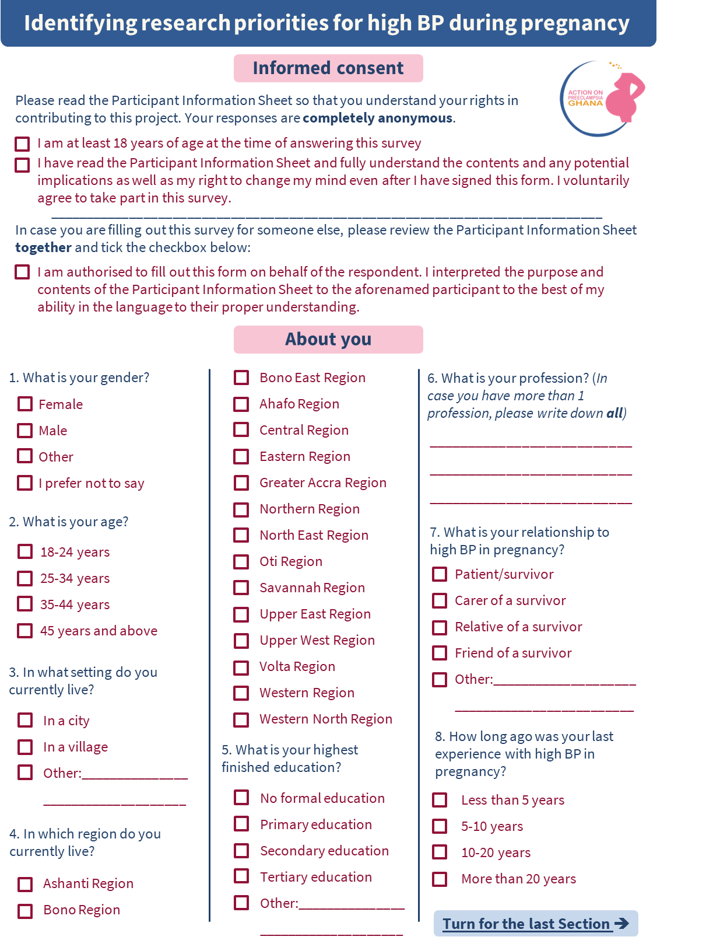

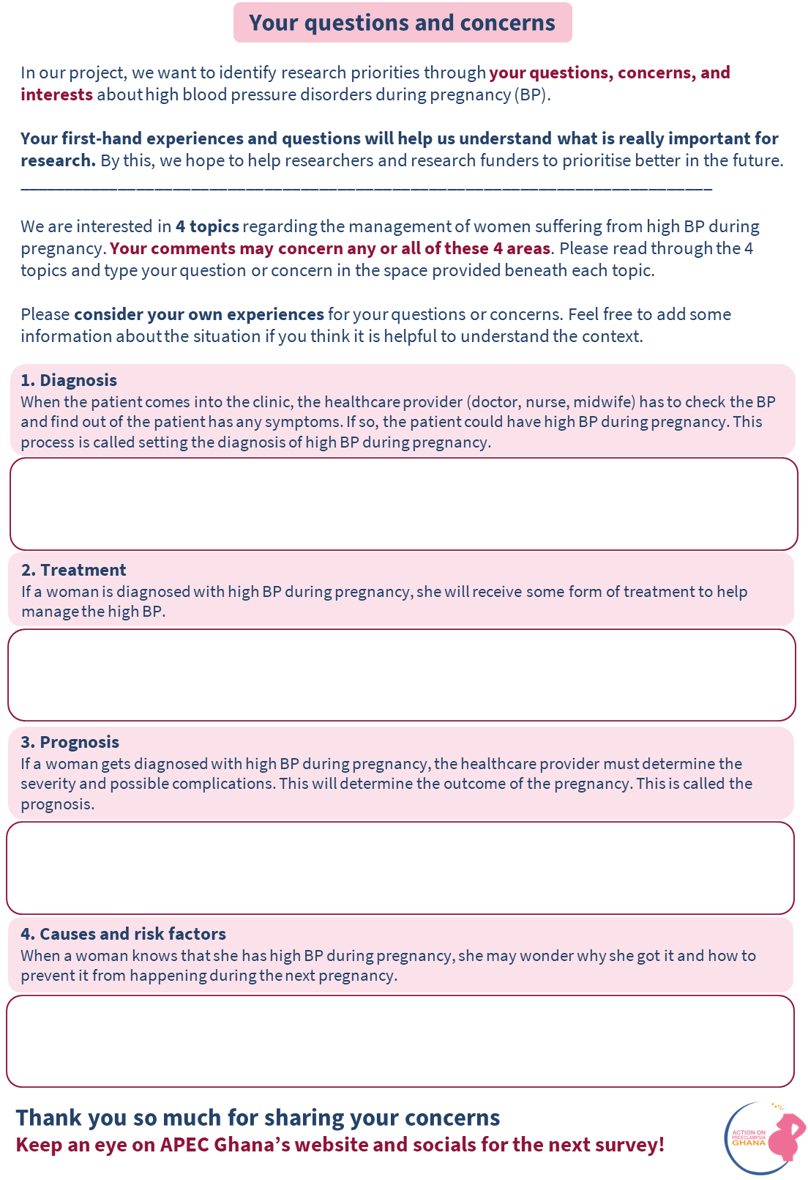
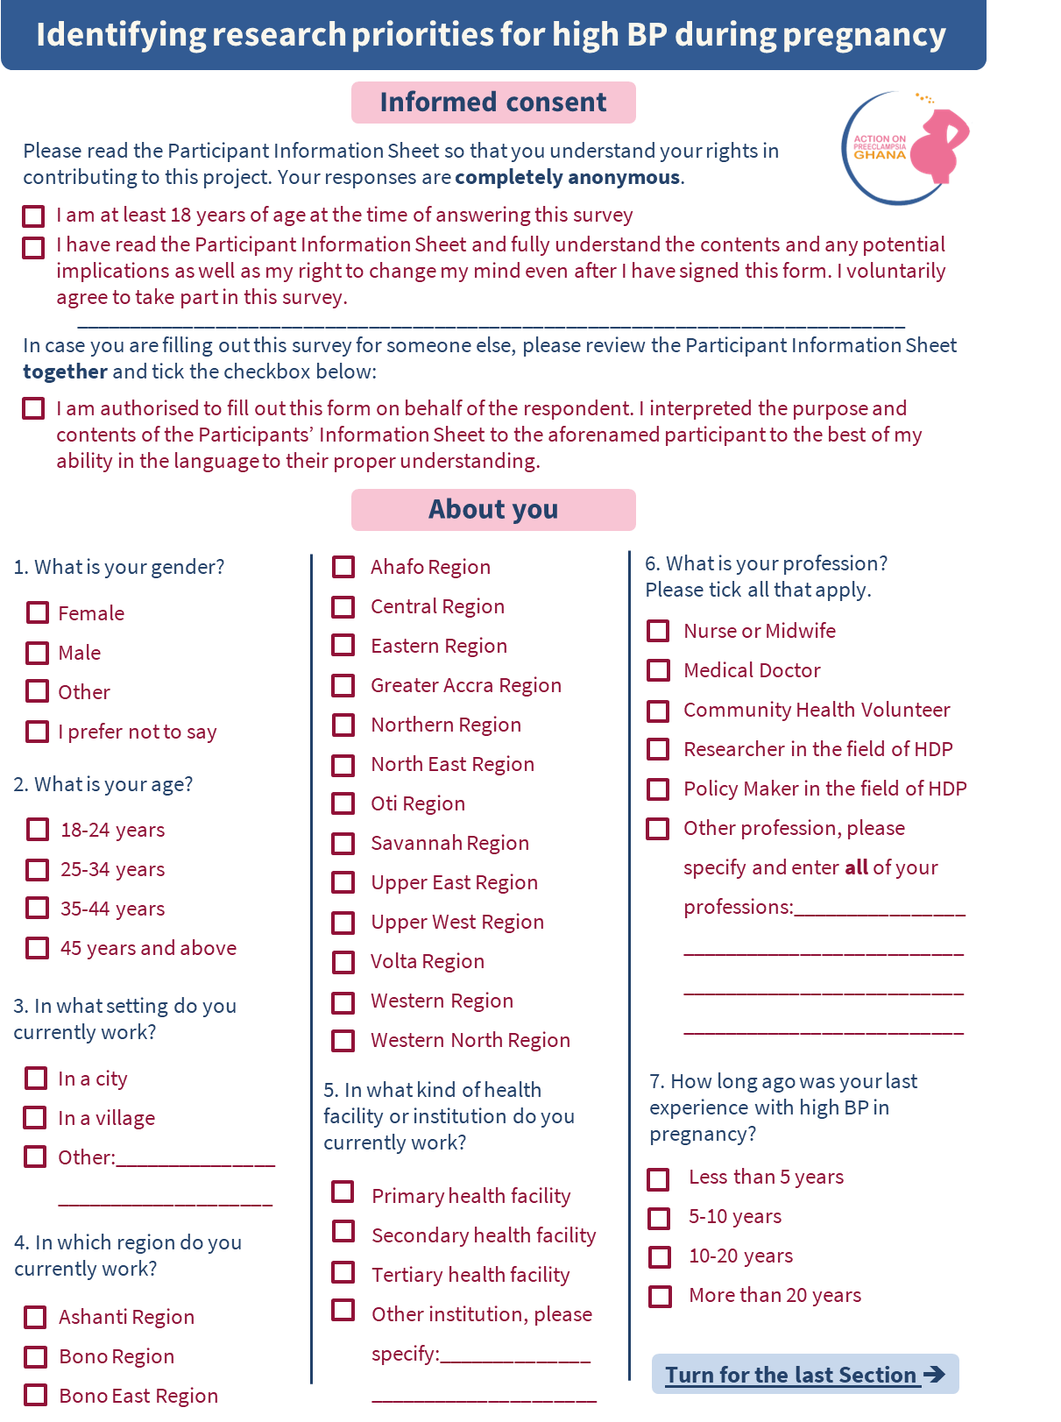
Medical language version ((healthcare) professionals

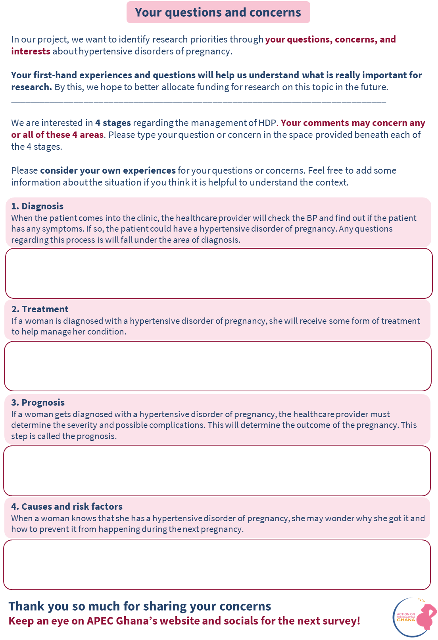

- Second project survey (paper version)
Plain language version (patients and carers):
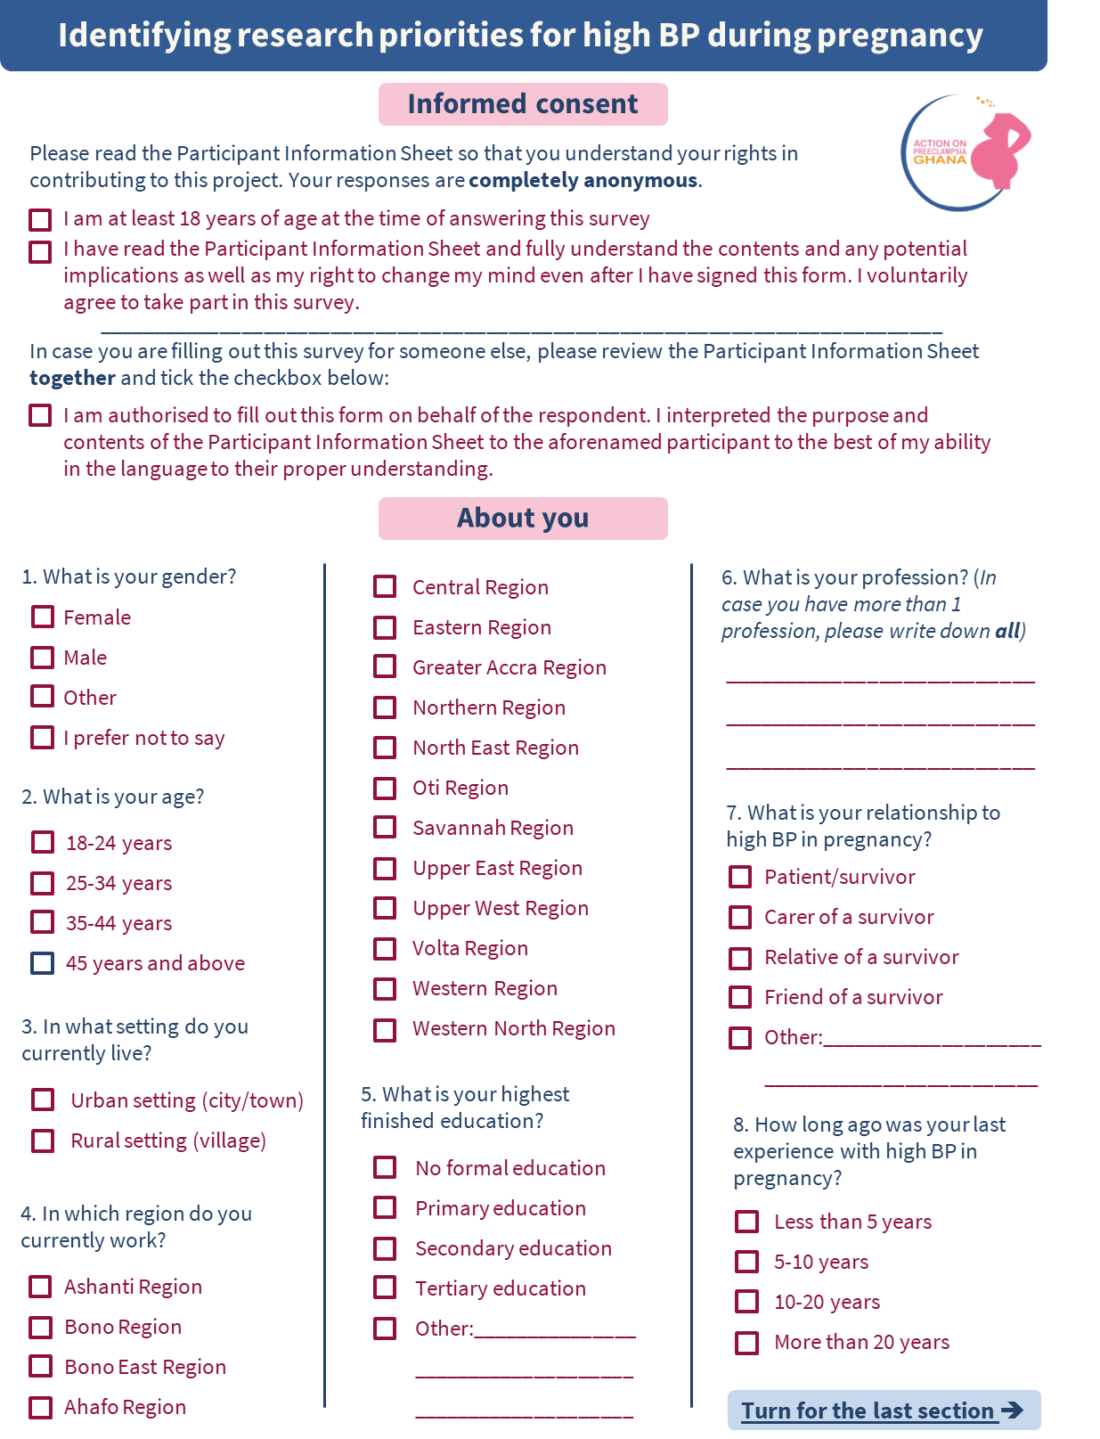
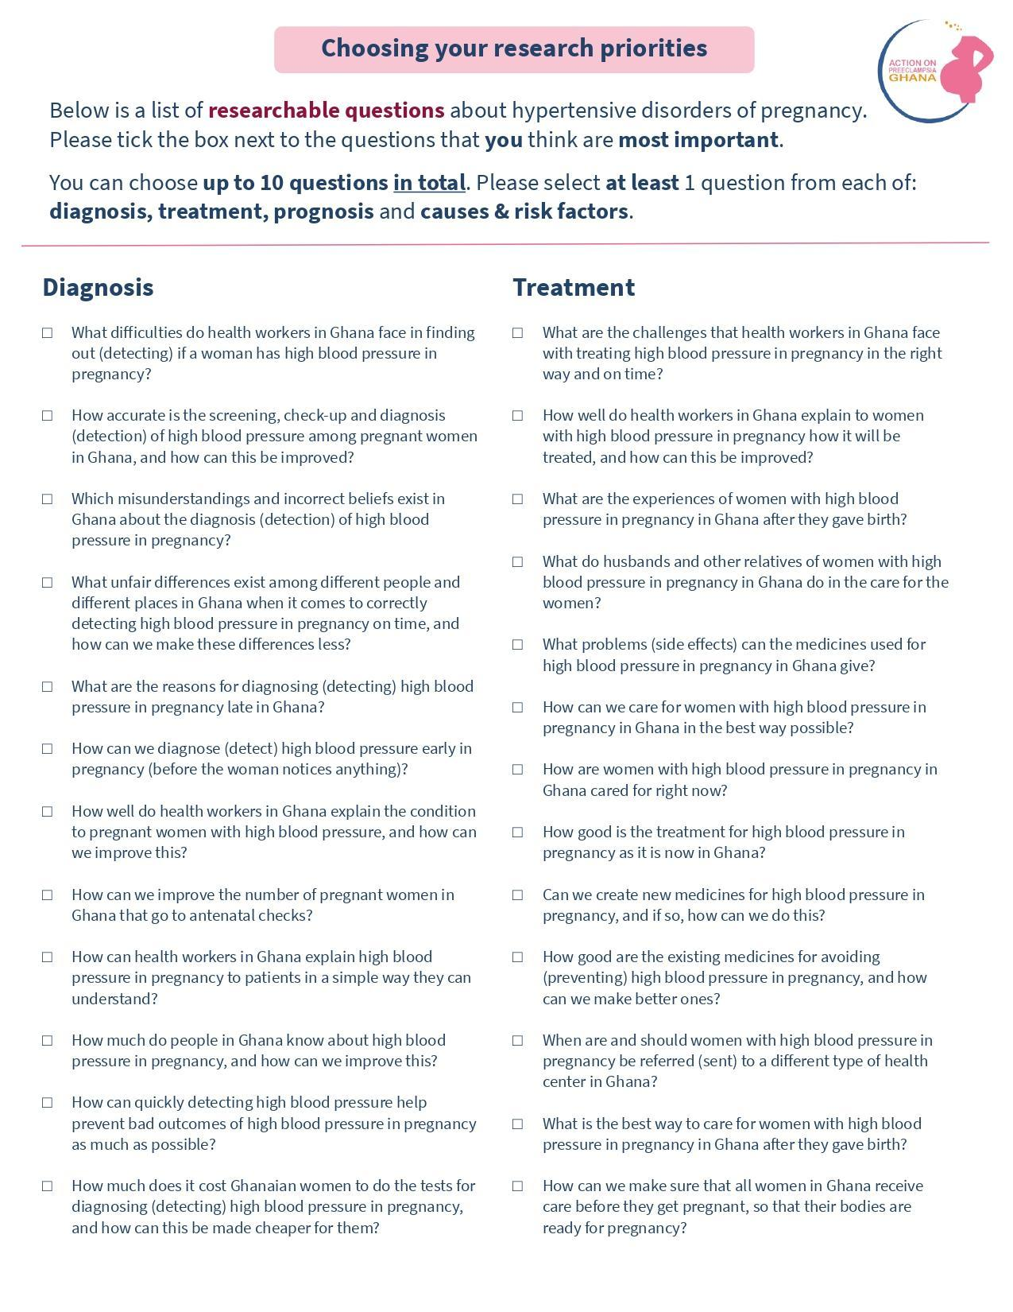

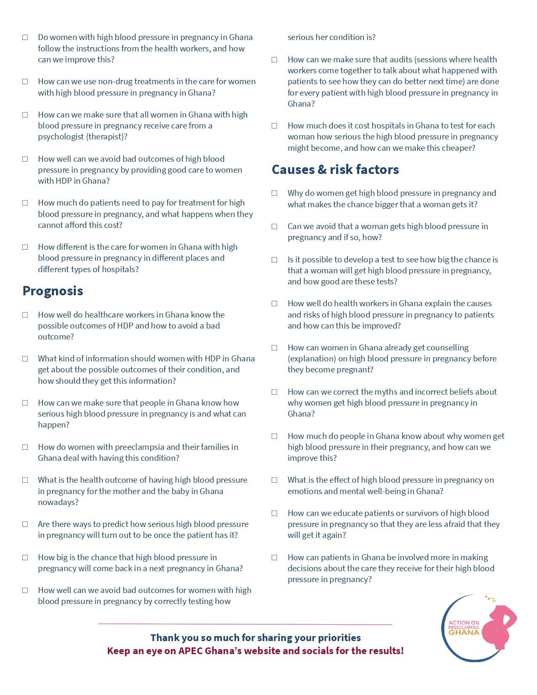

- Categorization codebook
(Sub-)category | Definition
Diagnosis
Competent, motivated human resources
Staff challenges to accurate diagnosis | Questions or concerns about the capability and role of different healthcare providers (midwives, doctors, etc) in establishing an accurate diagnosis
Evidence-based practices
Diagnostic criteria | Questions or concerns about the specific symptoms and measurements that contribute to and/or are required for the diagnosis of HDP, at different gestational ages and for different types of HDP
Diagnostic accuracy | Questions or concerns about the best way to perform the diagnostic tests, including repetition, frequency, monitoring, home BP/urine measurement and diagnosis
Myths about the diagnosis | Questions or concerns about existing myths and traditional beliefs regarding the diagnosis of HDP
Variation in diagnosis | Questions or concerns about variations in the quality of diagnostic service delivery that women receive, e.g. variation across regions, types of healthcare facilities, living settings, ethnic groups, migration status and age
Early/Timely diagnosis
Best timing for diagnosis | Questions or concerns about the best timing to establish the diagnosis of HDP
Cause for delay in diagnosis | Questions or concerns about the (late) moment on which HDP is diagnosed
Possibility of early detection/diagnosis | Questions or concerns about ways to diagnose HDP at an earlier stage of pregnancy (e.g. before manifestation/in the first trimester)
Effective communication
Informing client about diagnosis | Questions or concerns about lacking information provided to HDP patients about their diagnosis
Language and medical jargons | Questions or concerns about the difficulty of the words and/or language used to explain the condition to the patient
Public education and awareness | Questions or concerns about the general awareness in Ghana and education of pregnant women about the diagnosis of HDP
Complications
Prevention of complications | Questions or concerns about the effect of diagnosis on complications
Physical resources
Cost of diagnostic tests | Questions or concerns about the financial burden of diagnostic tests for the patient
Treatment
Competent, motivated human resources
Competent, motivated human resources | Questions or concerns about the capability and role of different healthcare providers (midwives, doctors, etc) in providing accurate treatment for HDP
Functional referral systems
Referral of HDP patients | Questions or concerns about the timing of referral of patients from a lower to a higher level healthcare facility
Effective communication
Informing clients about treatment | Questions or concerns about lacking information provided to the HDP patient about their management, including medication, daily activities and surgical interventions
Emotional support, respect and dignity
Personal experience of care postpartum | Questions or concerns about the way that postpartum HDP care is being experienced
Role of partner in care | Questions or concerns about the role of the partner in the care of the patient
Evidence based interventions
Adverse Effects of Therapy | Questions or concerns about side effects of HDP medication, including on mental health, long-term effects, for different dosages, and whether side effects always come up
Existing therapies | Questions or concerns about the available treatment options in Ghana, which ones are being used, and which options work best
Other pharmacological options | Questions or concerns about treatment options for HDP that currently do not exist yet, including new dosages, curative medication, less side effects
Preventative therapies | Questions or concerns about the possibilities for preventing HDP through medication
Postpartum management | Questions or concerns about postpartum care of HDP, including continuation of medication, follow-up, family planning and preconception care
Treatment Compliance | Questions or concerns related to patients’ adherence to HDP treatment
Non-pharmacological options | Questions or concerns about the potential of non-pharmacological options to improve the treatment of HDP, such as psychological care, diet, exercise and stress?
Complications
Prevention of complications | Questions or concerns about the effect of adequate treatment on complications
Physical resources
Cost of treatment | Questions or concerns about the financial burden of treatment for the patient
Capabilities of different facilities | Questions or concerns about variation in the quality of provided treatment across healthcare facilities and living settings
Prognosis
Competent human resources
Staff capability to identify complication and prognosis | Questions or concerns about the knowledge and capabilities of different healthcare providers (midwives, doctors, etc) regarding HDP prognosis and recognizing complications
Effective Communication
Informing client about prognosis | Questions or concerns about lacking information provided to HDP patients about the severity and prognosis of HDP
Public education and awareness | Questions or concerns about the general awareness in Ghana and education of pregnant women about the severity of HDP
Emotional support
Coping mechanisms | Questions or concerns about the coping strategies used by HDP patients and their families
Evidence-based practices
Current prognosis | Questions or concerns about the current statistics of the outcomes of HDP for the pregnant woman and fetus in Ghana, including long-term health, mental health outcomes and outcomes for different types of HDP
Prognostic factors | Questions or concerns about possibilities for prediction of disease severity, such as disease recurrence, severity in different pregnancies, type of health facility, comorbidities
Prevention of complications | Questions or concerns about the effect of adequate establishment of prognosis on complications
Quality improvement | Questions or concerns about strategies for quality improvement in the care for HDP, leading to better outcomes
Physical resources
Cost of prognostic tests | Questions or concerns about the financial burden of prognostic tests and management of complications for the healthcare sector
Causes and risk factors
Evidence-based Intervention
Potential cause | Questions or concerns about the cause/pathogenesis and risk factors of HDP, including links with environment, lifestyle, stress, age, genetics etc.
Prevention | Questions or concerns about preventing the occurrence of HDP altogether
Risk prediction | Questions or concerns about tests to predict the risk of occurrence of HDP
Effective communication
Informing patient about cause/risk factors | Questions or concerns about lacking information provided to the HDP patient about the causes and risk factors
Pre-conceptional counselling | Questions or concerns about the implementation of information provision about HDP to women before they become pregnant
Myths about HDP | Questions or concerns about existing myths and traditional beliefs regarding the causes/pathogenesis and risk factors of HDP
Public education and awareness | Questions or concerns about the general awareness in Ghana and education of pregnant women about the causes and risk factors of HDP
Emotional Support, Respect and Dignity
Emotional Impact of HDP | Questions or concerns about the effects of HDP on mental health (e.g. stress and fear of reoccurrence), and the reasons for this

- Literature review search strategy
- Make and use search string to search first database (PubMed and Cochrane, Scopus for social science questions)
  - Include a search term for each key term in the indicative question (3-5 terms per question)
  - Reuse the search terms made for frequent parts (synonyms of HDP, diagnosis, treatment, prognosis, causes and risk factors, healthcare professionals, patient communication, awareness etc.)
- Filter: published between 2021-2024
- Filter for: Meta-Analysis, Review, Systematic Review
- If <10 results: Extend time range to 2019-2024. Additionally, if still insufficient:
- 1st - remove filter for reviews to include all source types
- 2nd (If location limited): extend to West Africa → SSA → LMICs → global
- If >100-250 results: (where location range broad,) narrow down location range
- Review clinical guidelines for relevant information
  - ISSHP: The hypertensive disorders of pregnancy: ISSHP classification, diagnosis & management recommendations for international practice
  - GHS: Standard treatment guidelines
- Summarize available evidence and determine if:
  - broadly unanswered (= include for prioritization),
  - partly answered (= discuss in/exclusion with the team)
  - broadly answered (= suggest exclusion from prioritization to the team)
- Final prioritization workshop guide
Workshop aim:
During the final prioritization workshop, the participants will develop the final result of the HDP PSP Project, which is a Top 10 list of research priorities for the management of HDP in Ghana.
The participants will rank and discuss the top 20-25 questions resulting from the second survey, to develop the shared Top 10 question list that we should advocate for within the research community, funders and other institutes.
Workshop activities:
The workshop will consist of sessions with the whole group and in four smaller groups of 6-7 participants. Project team will be coordinating the full workshop and facilitating the whole group sessions. A facilitator will support and attempt to guide the discussions within the small group sessions.
Below is the preliminary workshop planning.
Time | Activity
9-9.15 am | Coffee, tea and snacks
9.15-9.45 am | Whole group:  - Introductory presentation  Explain ground rules
9.45-10.45 am | Small groups:  - Icebreaker  Discuss prepared rankings
10.45-11 am | Refreshment break
11 am-12 pm | Small groups:  Come to shared ranking
12-1 pm | Lunch break (coordinators analyzes results of small group sessions)
1-1.15 pm | Whole group: review of the outcomes of the small group sessions
1.15-2.15 pm | Small groups (different composition):  - Icebreaker  Discussion to determine Top 10 questions
2.15-2.30 pm | Refreshment break (team analyzes results of small group sessions)
2.30-3 pm | Whole group: final review and conclusion
3-4 pm | Informal mingling, feedback and interviews

There are three whole group sessions and three small group sessions. The first whole group session functions as an introduction for the project, to ensure everyone understands the context and aim of the workshop.
During the small group sessions, the groups will discuss the 20-25 questions that were chosen as most important in the second project survey. These questions will be printed with one question per paper, so that each group has 20-25 cardboards. We have two formulations of each question: one including medical language and one in general language. The simpler question will be printed largest, but the more technical version will also be on the page in smaller letters and between parentheses. Each question will have a letter assigned to it (A, B, C, etc.) to help with easy identification. The questions are divided into 4 main categories: the diagnosis, treatment, prognosis and causes & risks of HDP. These will have different color papers to help give some overview. At the back of each question paper it will say how high that question was ranked in the second survey, and also what kind of survey respondents (patient/caregiver/healthcare professional) chose for that question as very important (how high the ranking was).
The first two small group sessions will have the same participants in the group, and for the last one, we will mix the participants into different small group compositions. The groups will be equal mixes of survivors, their carers and healthcare professionals.
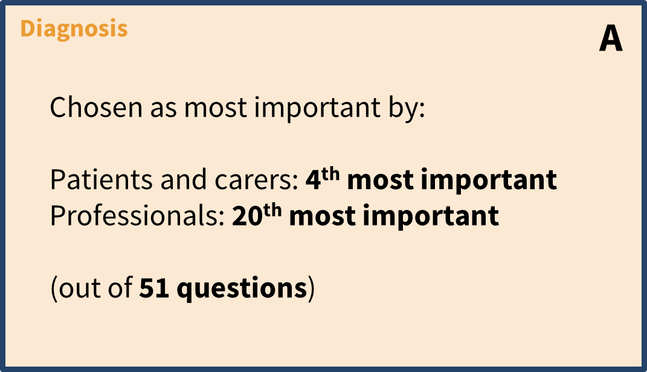
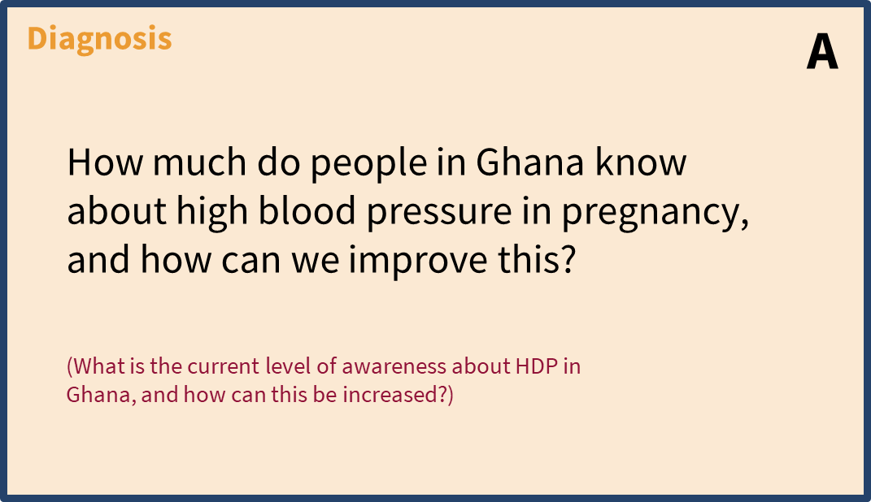
See below an example of one of the question papers (left = front, right = back):

Every participant will already choose their top and bottom 3 questions from the 20-25 questions at home before the workshop. We will make sure that they actually do this by asking everyone to confirm their choices via an online Google Form beforehand.
During the first small group session, there will be time for an icebreaker to get to know each other (see instructions at the bottom of the guide) Then, the questions cards will be laid out on a table in the middle of the group. Each participant will get 3 green pebbles and 3 red pebbles and take turns to explain the 3 questions that they find most important (ranked highest before the workshop), and why. After the participant has given their opinion, they will place a green pebble on the 3 questions they found most important. Participants then talk in turn about the three questions they feel are least important (ranked lowest before the workshop). These question papers will be given a red pebble. Then there is some time for an open discussion to see where the group agrees and where they do not, and to clarify any aspects of the questions if necessary. Dora and Jeffery will be around to support. The facilitator may change some pebbles around if this is follows from the discussion. The facilitators will have a separate paper with some extra information about the questions and what they entail, which they can use to clarify the questions to the group members.
During a short break, Dora, Jeffery and the facilitator arrange the question papers in three rough groups: those which were thought to be most important (only green pebbles), those thought to be least important (only red pebbles) and those not mentioned or where there was divergence of views (no pebbles or both red and green). There will be green, yellow and red areas on the table to make this more intuitive.
Participants are then invited to discuss the ordering of the cards within these three rough groups, with the goal to rank all 20-25 of them in order. It is important that all small groups achieve a ranked order of all the uncertainties 10 minutes before the end of the session.
The information about the second survey results on the back of each question paper can also be of help for the group members to make decisions about the ranking. For example, if many questions in their top 10 were mainly found important by professionals in the second survey, a group may decide to move some questions that were mainly chosen by patients up in the ranking.
In the last 10 minutes, the facilitator will check whether all group members agree with the ranking. There might be some minutes for a feedback round (how did the group members experience the session). The facilitator will then enter their group’s final ranking into an online Excel Sheet at the end of the session.
During the lunch break, Jeffery and Dora will combine the 4 small group rankings in the Excel Sheet into a combined ranking. They will present this to the whole group and leave some time for feedback on how the small group sessions went.
Then, the participants will break into 4 new groups. The group compositions will be determined through chance: participants will draw a group number from a box, with different boxes for patients/carers and professionals to ensure each group has an equal balance again.
The facilitator will lay all the cards out on the table in the order that was presented in the whole group. The group will then discuss and make any revisions they think are necessary. The discussion should aim to focus on the top half of the list. The facilitators will be provided with some probing questions that can be used to guide this discussion.
The information at the back of the paper (about the ranking in the second survey) can also be used again by the group members to make decisions about the ranking.
Again, the ranking should be finalized about 10 minutes before the end of the session to leave some time to double check the ranking, look back on the process and for the facilitator to enter the final ranking of their group into an online excel sheet again. This will be processed by Jeffery and Dora during a short break after the session, leading to the final Top 10 questions. This final result will be presented to the whole group and marks the end of the day.
Guidance for facilitation techniques
During the workshop, there will be many group discussions. As mentioned at the start of this document, one of the main values of our project is that every person is equal. All participants and the knowledge and experience they bring, are of equal value and their opinions are treated equally. It is very important that this principle is also applied during the decision-making at the workshop: there should not be any hierarchy between the different participants; no one individual or group's views or experiences are more valid than another’s. We want everyone’s opinions to be considered.
To achieve this, the following things are vital:
- Everyone involved in the project should feel safe, respected and able to contribute fully. That starts with a safe atmosphere within the group. We will create this partly by going through our values at the introductory whole group presentation. But then in the small groups, facilitators should take some time at the start to do an icebreaker with the group, think about games like Jenga or local games. We will discuss some more icebreaker ideas during the facilitation briefing meeting.
- Making the members feel valued when they contribute. Facilitators can do this by repeating and/or complimenting the comment that the team member made, or remembering the comments and mentioning them again at a later point when something else connects to it.
- Decision-making will happen through consensus. Facilitators should encourage open debate and transparency, to give space for the group members to resolve their differences in opinions.
- Keeping the more “vulnerable” team members in mind. Some patient and carer representatives may be less experienced than professional clinicians at contributing to open debate and are therefore careful to actively include patients and carers and ensure they have opportunities to share their views and experiences.
  - Part of this is making sure to have a clear structure for the “taking turns” of the group members. When going through the top and bottom ranked questions of the participants, the facilitator should ensure that everyone gets as much time to speak to restrict dominance of particular individuals. The easiest way to do this is by giving everyone for example 2 minutes to speak and keeping the time when they do so.
  - Furthermore, it is very important to watch the body language of the participants. This can say a lot, for example if they would like to say something but are too shy to do so. It is the responsibility of the facilitator to notice this and find a way to give the stage to this person in a non-intimidating way.
  - It is also important to be attentive to one group member trying to influence the other. In the final workshop of another PSP, healthcare professionals sometimes used their clinical expertise to advise non-professional group members. Similarly, patients or carers may use their lived experience to justify higher places on the ranking. It is important to watch these group dynamics and keep treating every one’s opinion with equal weight.
  - If the facilitator is comfortable with daily Twi, it can help to encourage the small group members to use of English and Twi in the discussion as they like (either of them or a mix) to give them more freedom of expression. We expect that all workshop participants will understand both languages, but if a facilitator doubts this, they should check this with the group at the start.
  - Acknowledging the people that are not in the room. We tried to put together a group that is representative of HDP survivors, their carers and relatives in Ghana. However, there will of course be specific groups that are less well represented - think about people from different regions/the countryside, those who do not speak English or Twi, those who do not attend health facilities, etc. It is important to explain this at the start, so that the group members try to not only think for themselves, but for anyone with direct experience with HDP.
Throughout the whole project, we used an ethical toolkit for priority setting processes that was established by Dr. Bridget Pratt. This toolkit helps to reflect on how to share power in groups, and make sure to listen to the voices that are often not heard. Many of the points above come from parts of this toolkit. We will take some time to go through these values during the introduction presentation in the morning. We will also explain some other ground rules such as raising your hand when you want to say something and addressing each other by simple names to remove that layer of hierarchy.
Icebreaker instructions for facilitators
Small group session 1:
- Introduce yourself and getting to know each other (quick introduction round, no more than 5 minutes)
- Choose an original team name together
- Explain that we’ll start off with a game to energize and get used to the group:
  - We will tell a short story about the ideal world for a pregnancy woman and rely on your collaborative drawing skills to picture this.
  - Everyone sits at the table and gets a plain A4 paper.
  - They get a short time (2-3min) to draw what the facilitator says, and then they pass on their paper to the person sitting to the right of them. Then the facilitator says what they should draw adding to the drawing in front of them
    - Draw: “a pregnant woman” (give them 2-3 minutes to draw)
    - Pass paper to the right.
    - Draw: “she will need to attend antenatal checks, so draw the hospital she goes to” (again 2-3 minutes)
    - Pass paper to the right.
    - Draw: “pregnant women need to eat well, so draw her something that will be healthy for her” (again 2-3 minutes)
  - Look at the drawings together and choose together which one is the most beautiful.
Small group session 3:
- Introduce yourself and short introduction round in the group and determine team name.
- Do same icebreaker as in first session: finish 20 minutes into the first session (observer will help with timekeeping)
  - Since our drawing game at the first session, the woman has given birth
  - Draw: “the mother with a baby” (give them a few minutes to draw, or a bit longer if needed)
  - Pass paper to the right
  - Draw: “but she needs support in taking care of the baby, so draw the one who will support her” (again a few minutes)
  - Pass paper to the right
  - Draw: “it is great that the mother has some help, but it takes a village to raise a child, so draw anything else around her that will be important to raise a child” (again a few minutes)
  - Look at the drawings together and choose together which one is the most beautiful

