Supplementary Figures and Legends
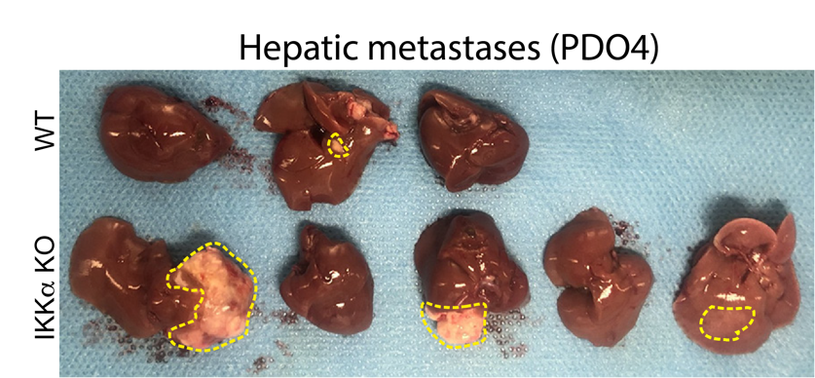
Figure S1.
Photograph showing metastases developed in the liver of nude mice upon intrasplenic injection of WT or IKK⍺ KO PDO4 cells.
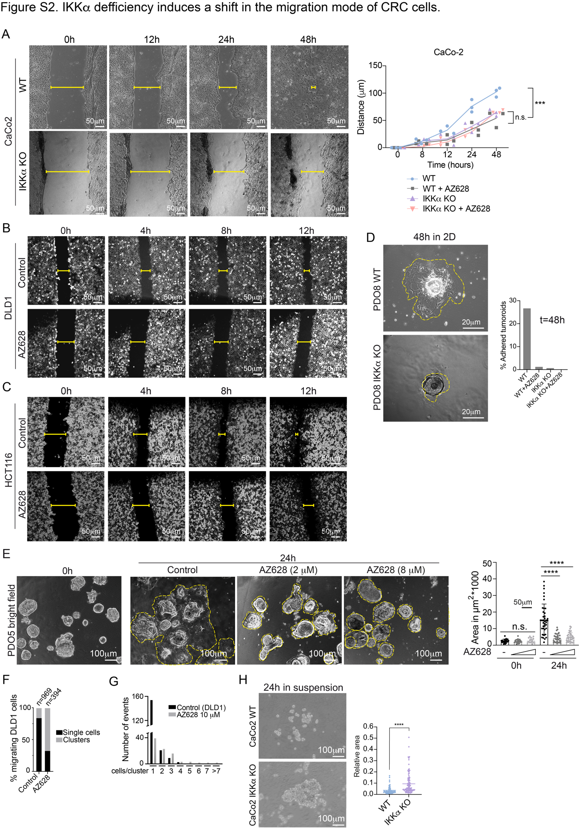
Figure S2.
(A, B, C) Representative images of wound-healing assay of CaCo2 (A), DLD1 (B) and HCT116 (C) WT and IKK⍺ KO cells untreated or treated with AZ628 10µM. Dot plot shows the quantification of wound closure at each time point (n=3) per condition. Line connects mean values per time point.
(D, E) Representative images of WT and IKK⍺ KO PDO8 (D) or PDO5 (E) cells, treated or untreated with AZ628 at indicated doses, seeded in 2D conditions. Graphs show the quantification of the percentage of adhered PDOs and area covered by the colonies at the indicated time points.
(F, G) Transwell migration assay quantification of DLD1 cells untreated or treated with AZ628 at 10µM for 24h. Number of single cells or cell clusters in the filter (F). Number of cells per cluster in each condition (G).
(H) Representative microscopic images of the cell clusters generated after 24h of seeded single WT or IKK⍺ KO cells intrasplenic injection of WT or IKK⍺ KO CaCo2 cells. Quantification of the cell clusters areas obtained by analyzing multiple images taken from randomly selected fields.
Statistical tests; (A) unpaired two-tailed t-test (***p-value<0.001 and ns p-value > 0.05).
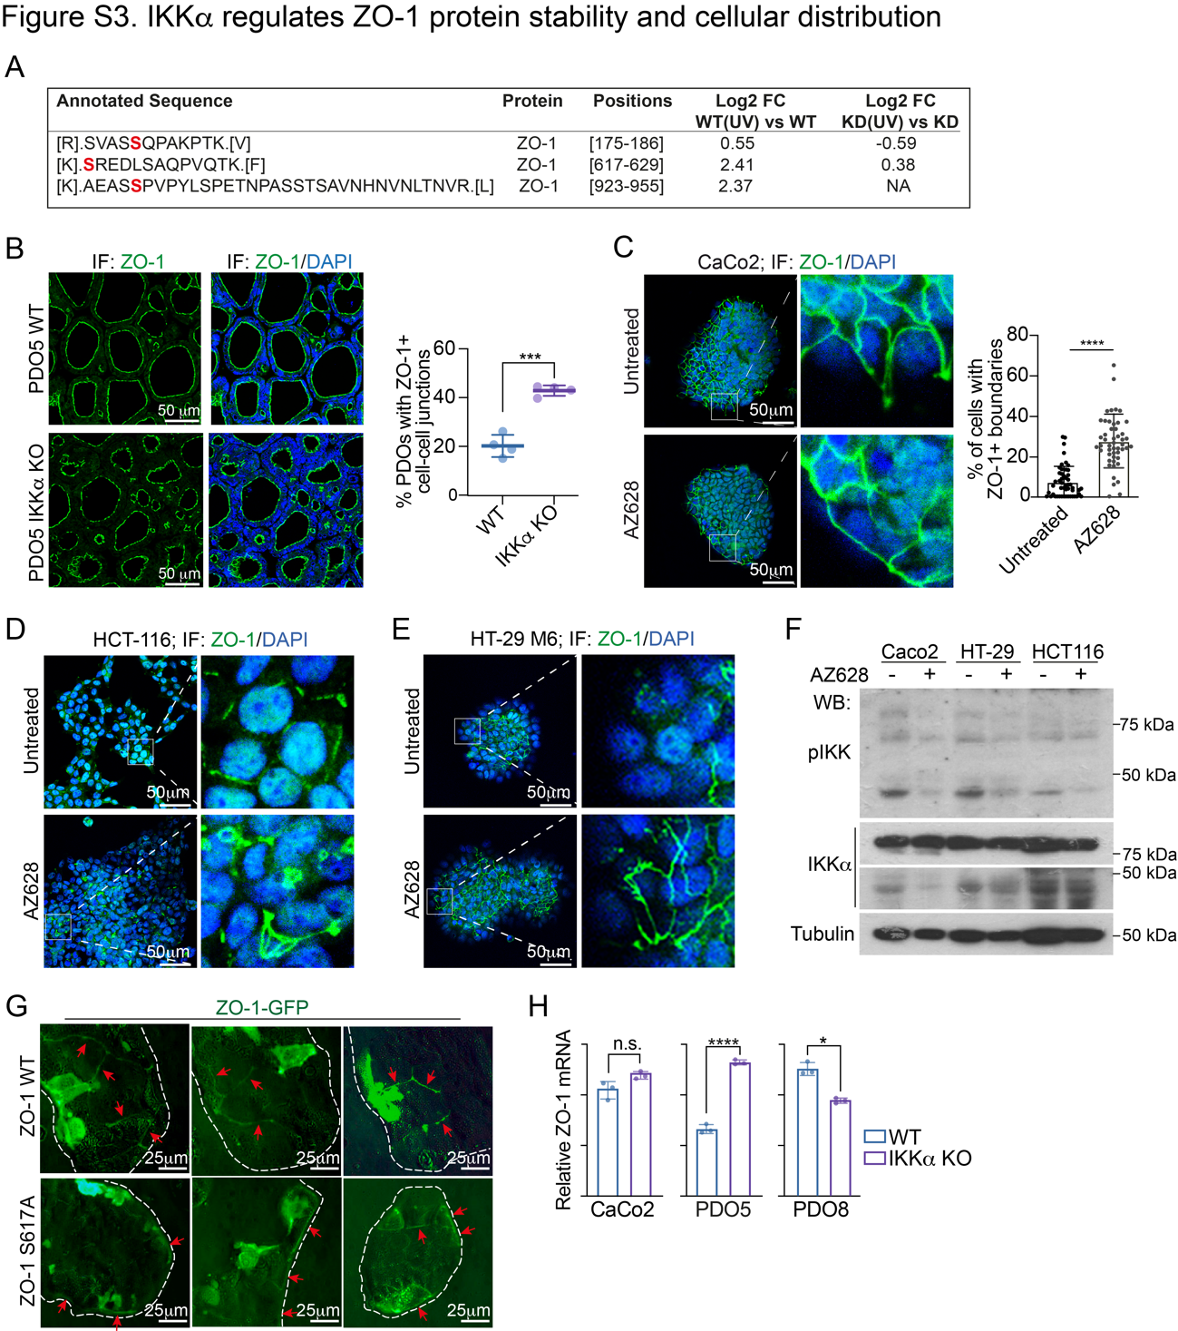
Figure S3.
(A) Table indicating ZO-1 protein residues identified as differentially phosphorylated by mass spectrometry analysis and directly phosphorylated by IKK⍺ kinase.
(B) Representative images of immunofluorescence staining of ZO-1 in WT and IKKα KO PDO5 cells and quantification of cells displaying the indicated pattern of staining.
(C-E) Representative images of immunofluorescence staining of ZO-1 in CaCo2 (C), HCT-116 (D) and HT-29 M6 (E) untreated or treated with AZ628 at 10µM for 16h. Dot plot shows the quantification of the percentage of cells displaying the indicated pattern of staining.
(F) Western Blot analysis showing pIKK blockade upon treatment with AZ628 at 10µM for 16h in different CRC cell lines.
(G) Representative images of ZO-1 WT or ZO-1 mutant (S617A)-GFP transfected in CaCo2 cells. Mutant protein displays an aberrant pattern as observed in IKK⍺ KO cells.
(H) RT-qPCR of ZO-1 in the indicated WT and IKK⍺ KO cells.

Statistical tests; (A, C and H) unpaired two-tailed t-test (****p-value<0.0001, ***p-value<0.001, *p-value<0.05 and ns p-value > 0.05).
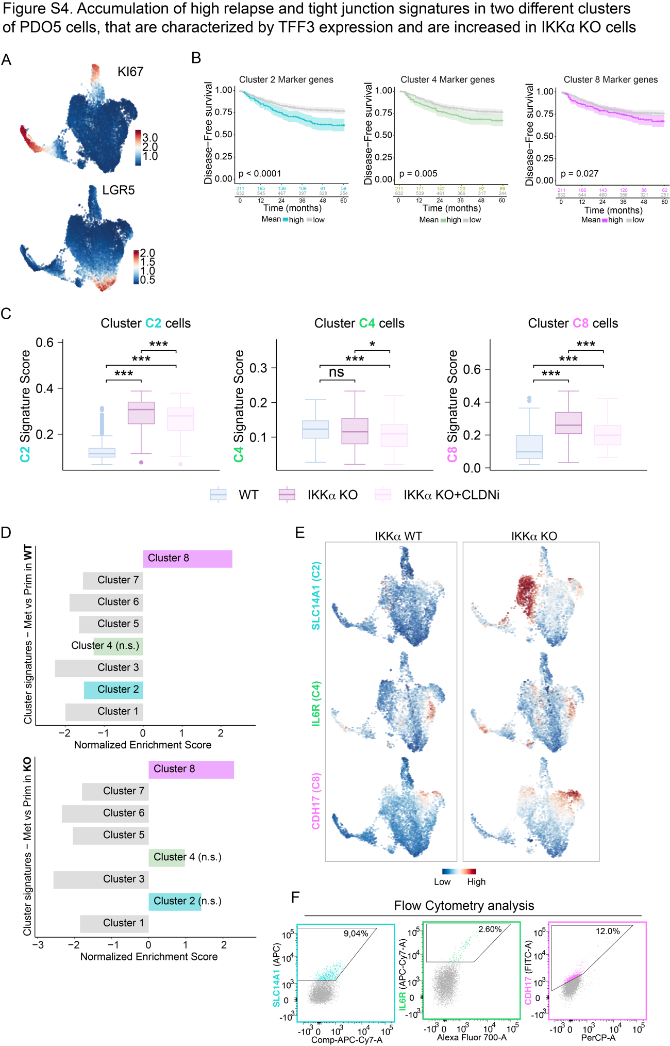
Figure S4.
(A) UMAP representations of integrated scRNA-seq data from from PDO5 cells in three experimental conditions (WT, IKKα KO, and IKKα KO treated with CLDN2 inhibitor for 16h) showing the expression levels of the proliferating marker KI67 (top) and intestinal stem cell maker LGR5 (bottom).
(B) Kaplan-Meier curves of disease-free survival over time for CRC Stage II and Stage III patients included in the in-house metacohort according to the mean expression of clusters C2 (left), C4 (mid) and C8 (right) top-50 marker genes using Q3 as cutoff for patient stratification.
(C) Boxplots showing C2 (left), C4 (mid) and C8 (right) cluster signature score levels in corresponding cluster cells from the three experimental conditions (WT, IKKα KO, and IKKα KO treated with CLDN2 inhibitor for 16h). The top-50 genes per signature have been considered for score computation. Two-sided Wilcoxon test is applied for pair comparisons.
(D) Barplots showing the Normalized Enrichment Score (NES) obtained from GSEA for liver metastasis and primary tumor PDO5 WT (top) or KO (bottom) cells against the top-50 cluster marker genes. Clusters C2, C4 and C8 are highlighted. Non-significant enrichment indicated in parenthesis (n.s.).
(E) UMAP layouts showing expression of selected cell surface markers for each scRNA-seq cell cluster in WT or IKK⍺ KO PDO5 cells: SLC14A1 (C2), IL6R (C4) and CDH17 (C8).
(F) Flow cytometry analysis of membrane markers used to sort PDO5 IKK⍺ KO cell clusters C2 (SLC14A1), C4 (IL6R) and C8 (CDH17). Percentages indicate the proportion of positive cells within each gated population.
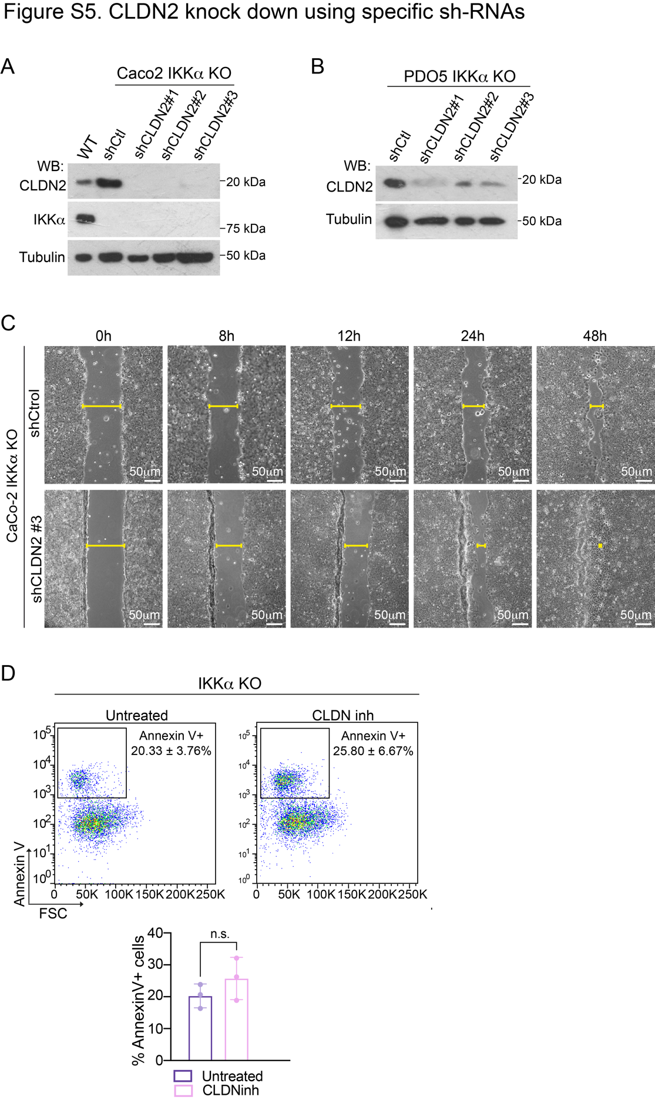
Figure S5.
(A, B) WB validation of CLDN2 knockdown using three independent shRNAs in IKK⍺ KO CaCo2 (A) and PDO5 (B).
(C) Representative images of wound-healing assay of IKK⍺ KO CaCo2 cells shControl and shCLDN2 #3 (showing same outcome as shCLDN2 #1 and #2).
(D) Flow cytometry analysis of Annexin V staining in PDO5 IKK⍺ cells untreated or treated with CLDN inhibitor YM201636 (0.5 µM 24h). Bar plot quantification shows no significant difference in the percentage of Annexin V+ cells between conditions, indicating that YM201636 does not significantly increase cell death.
Statistical test; (D) unpaired two-tailed t-test (ns p-value > 0.05).

