Supplementary Information

1. Phytophthora ramorum sampling, processing and genome sequencing. Phytophthora ramorum samples were obtained during regulatory nursery inspections by the Canadian Food Inspection Agency (CFIA) in BC, Canada. Leaf samples showing lesions were tested by qPCR for presence of P. ramorum¹ and cultures were obtained from positive samples by plating on culture media. Species and lineages of the P. ramorum isolates used for genome sequencing in this study were determined with a qPCR assays that targets 4 single nucleotide polymorphisms (SNP) in the cellulose binding elicitor lectin (CBEL)² locus using allele-specific oligonucleotide assays. This assay allows assignment to P. ramorum lineages EU1, EU2, NA1 and NA2². Genomes of P. ramorum isolates from the North American and European clonal lineages collected from different years and geographical regions (Table S2) were either sequenced for this study or obtained from published sources^{3–5} . Isolates used for genome sequencing in the current study were grown on 5% V8 juice agar⁶ overlaid with a cellophane membrane. After 7 to 10 days, the mycelium was harvested and immediately frozen at -20°C. The mycelium was shock frozen in liquid nitrogen and pulverized with a Mixer Mill (Qiagen, Hillden, Germany) for 30 seconds at a frequency of 1/30.
DNA was extracted from approximately 200 mg of tissue following a chloroform extraction protocol including RNAase treatment⁷. DNA was quantified using the Qubit dsDNA BR assay Kit following manufacturer’s instructions. Genome sequencing was done at the McGill University and Génome Québec Innovation Center (Montreal, Quebec, Canada). Illumina libraries were prepared from 100 ng DNA. Libraries were individually barcoded and amplified by 6 PCR cycles before pooling. Sequencing was performed on multiple lanes of the Illumina HiSeq X platform in 150 bp paired end mode. Forty barcoded libraries were pooled in equimolar amounts per sequencing lane. Samples 16-237-021 and 16-284-032 were sequenced on the Ion S5 System at the Canadian Food Inspection Agency (Ottawa, Canada). Single-end libraries were prepared with the Ion Plus Fragment Library Kit starting with 100 ng of DNA which was sheared to 400 bp using a Covaris M220 instrument. Libraries were amplified by 8 PCR cycles. Each library was sequenced on an individual Ion Torrent Chip 530 with read length of 400 bp. Sequencing reads were quality-trimmed using Trimmomatic version 0.36⁸ in the single-end mode (Ion Torrent reads) or paired-end mode (Illumina reads) using the following settings: LEADING:20 TRAILING:20 SLIDINGWINDOW:5:10 MINLEN:50. Adapter remnants were removed from the Illumina reads with the option: ILLUMINACLIP:TruSeq3-PE-2.fa:2:30:10. Ion Torrent adapters were removed in advance using Ion Torrent software.

2. Variant calling and filtering. Filtered reads were mapped to the P. ramorum NA1 lineage reference genome PR-102_v3.1 using bwa mem version 0.7.17⁹ with default settings. Mapped reads were sorted using SAMtools version 1.9¹⁰ and genome-wide average coverage was assessed using Qualimap version 2.2.1¹¹ with the bamqc option. Duplicated reads were annotated using the Genome Analysis Toolkit (GATK) Picard tools MarkDuplicates (https://gatk.broadinstitute.org/hc/en-us). Variant calling was performed in two steps using GATK. First, variants were called for each individual genome using GATK’s haplotype caller with the -ERC GVCF option and the ploidy was set to 2. Next, variant files were merged using GATK’s CombineGVCFs function and then joint variant calling across all individuals was performed with GenotypeGVCFs. Raw variants were reduced to SNPs only and filtered using GATK’s SelectVariants and VariantFiltration functionalities. Only SNPs satisfying the following criteria were retained: QUAL ≥ 500, QD ≥ 10, MQ ≥ 40, FS ≤ 40, SOR ≤ 3, and MQRankSum, BaseQRankSum, ReadPosRankSum ≥ -2 and ≤ 2. Read depth (DP) was restricted to ≥ 1000 (≈ 10% percentile) and ≤ 10000 (≈ 99% percentile) to further increase SNP quality and only biallelic SNPs were retained. Next, SNPs were filtered on the genotype level using VCFtools version 0.1.16 (https://vcftools.github.io/man_latest.html). Genotypes with a read depth < 10 (--minDP 10) and a genotype quality < 30 (--minGQ 30) were set to no-call, and variants with more than 5% missing genotypes were removed. Finally, invariant sites across all samples were removed. For some analyzes (e.g. minimum spanning network, admixture) the SNP set was further restricted to variants without missing genotypes.

3. Extraction of mitochondrial haplotypes. Trimmed reads were mapped to the mitochondrial contig of P. ramorum lineage NA1 strain Pr102, NCBI accession: NC_009384.1¹² and variants called as described for the nuclear genome. Variants were restricted to SNPs only and the distribution of “variant confidence normalized by unfiltered depth of variant samples (QD)” was assessed to confirm the homozygous state across individuals. SNPs were filtered using GATK’s SelectVariants and VariantFiltration functionalities with the following criteria: QUAL ≥ 1000, QD ≥ 20, MQ ≥ 59, FS ≤ 20, SOR ≤ 2 and only bi-allelic SNPs with no missing genotypes were accepted. VCFtools was then used to set genotypes with low support (read depth < 10, i.e. --minDP 10 and genotype quality < 40, i.e. --minGQ 40) to no-call. Finally, sites with more than 5% missing genotypes and invariant SNPs across all individuals were removed.

4. Bayesian assignment test. We designed an assignment procedure to test the most likely parents of the hybrid isolates. This procedure consisted in building a Bayesian naïve classifier model for n different classes (i.e. putative source populations) based on k SNP loci and obtaining the probability than an unknown P. ramorum sample (in this case the isolate 16_0237_0021) to belong to each of these classes. The assignment procedure was repeated 100 times with random samples of k = 1,000 loci. For each replicate, n = 14 putative source populations were considered: NA1 (29 diploid individuals), NA2 (29), EU1 (30) and EU2 (5); 8 artificial ‘hybrid’ populations (of 50 individuals each) were added by randomly recombining SNPs from two parent lineages i.e. NA1xNA2, NA1 x EU1, NA1 x EU2, NA2xEU1, NA2xEU2, EU1xEU2 and two back crosses (NA2xEU1) x EU1 and (NA2xEU1) x NA2; The two last classes consisted in “mutants” populations. A first mutant population was created with 50 random NA2 isolates for which 18.3% of the loci (randomly picked) were mutated by changing one of the alleles. This proportion of mutated loci was estimated by counting in 16_0237_0021 the number of loci for which at least one of the alleles could not have a NA2 origin, given the alleles found in the whole NA2 lineage for this locus (EstimateProportion.py script). The same procedure was done with 50 EU1 isolates with a proportion of mutated loci of 16.8%, to create the second “mutant” population. The naïve bayes classifier algorithm was implemented in a custom Python script using the Python package scikit-learn 0.24.1 and assuming Multinomial distribution of the data (Pedregosa et al. 2011).
5. Phenotyping of hybrid and parental lineages. Isolates of P. ramorum lineages and the EU1 x NA2 hybrid were grown on carrot agar (CA) plates for four days at 20°C and 7-mm plugs were transferred to fresh CA plates (3 replicates) and incubated in the dark at 20°C. The colony diameters were measured after 2, 3, 6, 7 and 9 days and mean daily radial growth rate was calculated using linear regression (lm(log(radius) ~ hours) in R. The r-squared values were verified to ensure the model’s good fit. One North American isolate of NA1 and NA2, a North American and a European isolate of EU1, and two hybrid isolates were included in the growth experiments. Rhododendron leaves were inoculated by placing a 7-mm plug from a 7-day-old colony of P. ramorum in the center of a detached leaf and measuring lesion development over 10 days. Necrotic area was measured as the surface area with necrosis (mm²).

Table S1. Genotyping assay to assign Phytophthora ramorum lineages. Cellulose-binding elicitor of defense in plants and lectin-like (CBEL) genotypes were obtained by qPCR assay to identify P. ramorum lineages EU1, EU2, NA1, NA2⁶. The putative hybrid isolates, 16-237-021 and 16-284-032, are homozygous at the CBEL412 locus, a pattern absent in other lineages
 | CBEL locus
Lineageª | CBEL245 | CBEL349 | CBEL373 | CBEL412
EU1 | G/C | C/T | A/A | C/T
EU2 | G/G | C/C | G/G | C/C
NA1 | G/G | C/T | A/A | C/C
NA2 | G/G | C/T | A/A | C/T
16-237-021 | G/C | C/T | A/A | T/T
16-284-032 | G/C | C/T | A/A | T/T
ªFor list of additional samples used for genotyping of the three lineages present in North America see Gagnon et al.²

Table S2. Phytophthora ramorum genomes used in this study cover locations in Europe and North America over more than 20 years.
Lineage | Number of genomes | Geographic origin (number of isolates) | Collection years | Genome coverageª
EU1 | 30 | BC, Canada (16), USA (2), Belgium (1), Netherlands (1), France (3), Germany (1), United Kingdom (6) | 1995-2017 | 29.9-78.7
EU2 | 5 | United Kingdom | 2007- 2011 | 38.7-56.5
NA1 | 29 | BC, Canada (5), USA (24) | 2001-2017 | 36.5-100.0
NA2 | 29 | BC, Canada | 2004-2017 | 26.8-92.4
Hybrid | 2 | BC, Canada | 2016 | 26.8-49.1
ªAverage genome coverage, calculated as N x L/G, where N is the number of reads, L is the average read length and G is the length of the original genome (57.45 Mb).

Table S3. Genotypic combinations in Phytophthora ramorum parental lineages and hybrid. Number and percentage of SNPs in each genotypic combination in the parental lineages and the P. ramorum hybrid samples 16-237-021 and 16-284-032
Parental lineage genotypes | Hybrid genotype | Observed genotypes (%) | Expected genotype (meiotic recombination) | Expected genotype (somatic recombination)
0/0 x 1/1 | 0/0 or 1/1 | 1049 (3,4%) | 0 (0.0%)^{b} | 0 (0.0%)^{b}
 | 0/1ª | 29,998 (96.6%) | 31,047 (100.0%)^{b} | 31,047 (100.0%)^{b}
0/1 x 0/1 | 0/0ª | 12,295 (24,7%) | 12,465 (25.0%)^{b} | 0 (0%)^{c}
 | 1/1ª | 12,222 (24,5%) | 12,465 (25.0%)^{b} | 0 (0%)^{c}
 | 0/1 | 25,343 (50.8%) | 24,930 (50.0%)^{b} | 49,860 (100%)^{c}
0/1 x  (0/0 or 1/1) | 0/0 or 1/1 | 114,604 (50.1%) | 114,510 (50.0%)^{b} | 114,510 (50.0%)^{b}
 | 0/1 | 114,415 (49.9%) | 114,510 (50.0%)^{b} | 114,510 (50.0%)^{b}
ªNovel genotypic combinations in the hybrid not observed in the parental lineages, totaling 54,515 SNPs
^{b}Observed genotype frequencies are not different from expected under the recombination model (chi-square test performed on 1000 subsamples of 100 random loci; p > 0.05 for ≥ 95.0% of the subsamples)
^{c}Observed genotype frequencies are different from expected under the recombination model (chi-square test performed on 1000 subsamples of 100 random loci; p ≤ 0.05 for 100% of the subsamples)

Table S4. Genome-wide test of interspecific hybridization among Phytophthora ramorum lineages. HyDe inference of hybridization between Phytophthora ramorum lineages. P1 and P2 indicate the lineage of the parental lineage and hyb, the hybrids 16-237-021 and 16-284-032. Z-statistic was used to test for significance and p-values were adjusted for multiple testing using Bonferroni adjustment. The γ-value is expected to be 0.50 in parents to progeny comparisons
P1-hybrid-P2 | Z-score (SD) | p-value (SD) | γ-value (SD)
EU1_hyb_NA2 | 8.78 (0.24) | 0 (0.0) | 0.48 (0.02)
NA1_hyb_NA2 | 3.71 (0.54) | 0 (0.0) | 0.22 (0.03)
EU1_hyb_NA1 | -1.95 (0.18) | 0.97 (0.01) | -12.54 (156.51)

Table S5. Predicted functional impact of SNPs in hybrid Phytophthora ramorum. Impact by functional class for variants that generate novel genotypic combinations in the hybrid P. ramorum compared to the parents
Variant Impact (functional class)ª | Counts^{b} | Percent
Missense | 6,718 | 35.73%
Nonsense | 18 | 0.10%
Silent | 12,066 | 64.17%
Total | 18,802
ªFunctional impact predicted using SNPeff¹³. Missense are non-synonymous mutations, nonsense are mutations that cause stop codon loss or gain and frameshifts and silent mutations are synonymous (see Cingolani et al.¹³ for additional information).
^{b}Intralineage polymorphic sites and those with missing data were excluded

Table S6. Predicted impact type of SNPs in hybrid Phytophthora ramorum. Impact by type of variant for SNPs in novel genotypic combinations in the hybrid P. ramorum compared to the parents
Variant Impact (Type)ª | Counts^{b} | Percent (%)
High | 59 | 0.03
Moderate | 6693 | 3.16
Low | 12,458 | 5.89
Modifier | 192,346 | 90.92
Total | 211,556
ªType of impact predicted using SNPeff¹³. High impact mutations result in stop codon loss and gain and frameshifts; moderate impact mutations cause a codon to change the amino acid; low modifier mutations are in codon that produce the same amino acid; modifier mutations are in introns, upstream or downstream regions (see Cingolani et al.¹³ for additional information and full list of impact types).
^{b}Intralineage polymorphic sites and those with missing data were excluded. The totals are larger than the number of SNPs because each SNP can be a modifier of up to five genes upstream or downstream.

Table S7. Predicted impact of hybridization in gene families associated with pathogenicity. Impact of the mutations was assessed for genes that contained SNPs with novel genotypic combinations in the Phytophthora ramorum hybrid (see Table S3). Mutation impact was assessed with SNPeff and reported for members of gene families known to be involved in pathogenicity in Phytophthora spp.
Genotypes | Mutation Impactª | CAZY^{b} | Peptidases | RxLR | CRN
Homozygous for different SNPs in parents, heterozygous in hybrid | high | 0 | 0 | 1 (1) | 0
 | moderate | 53 (113) | 0 | 19 (41) | 4 (5)
Heterozygous in parents, homozygous in hybrid | high | 1 (1) | 0 | 0 | 0
 | moderate | 25 (55) | 11 (21) | 23 (52) | 4 (5)
Total | - | 79 | 11 | 43 | 8
Total predicted in genome | - | 332 | 147 | 143 | 31
ªImpact predicted using SNPeff¹³. High impact mutations result in stop codon loss and gain and frameshifts; moderate impact mutations cause a codon to change the amino acid; low modifier mutations are in codon that produce the same amino acid; modifier mutations are in introns, upstream or downstream regions (see Cingolani et al.¹³ for additional information and full list of impact types).
^{b}Number of genes (number of SNPs)

Table S8. Runs of homozygosity (ROH) identified in the Phytophthora ramorum hybrid. Regions with ROH contain stretches of SNPs (11 to 82 loci) with fixed differences in the parental lineages NA2 and EU1 that are homozygous in the hybrid sample 16_284_032ª, a pattern unexpected for first generation hybrids
Scaffold:position | Region size (bp) | No. of homozygous “diagnostic” SNPsª | Total No. of SNPs | No. of heterozygous sites^{b} | No. of genes^{c} | Gene model and putative function^{d}
 |  |  |  |  |  | 5-flanking region | Region of interest |  | 3’-flanking region
Phyram_PR-102_s0004:  2,193,974-2,213,187 | 18,309 | 82 | 93 | 0  (82; p < 0.001) | 0  (4; p < 0.001) | Carbohydrate-binding protein | - | Carbohydrate-binding protein
Phyram_PR-102_s0001:  3,197,107-3,260,781 | 33,637 | 55 | 61 | 0  (140; p < 0.001) | 2  (7; p < 0.001) | Flavin oxidoreductase | DNA binding protein, Hypothetical protein | Ubiquitin-specific protease
Phyram_PR-102_s0010:  1,124,548-1,169,435 | 35,120 | 42 | 121 | 0  (151; p < 0.001) | 2  (7; p < 0.001) | Putative F-box domain-containing protein | Glyceraldehyde-3-phosphate dehydrogenase, Putative restriction endonuclease | Glyceraldehyde 3-phosphate dehydrogenase
Phyram_PR-102_s0001:  4,517,898-4,524,817 | 5,274 | 28 | 119 | 0  (27; p < 0.001) | 0  (1; p < 0.001) | RNA recognition motif-containing protein | - | 3-ketoacyl-CoA thiolase
Phyram_PR-102_s0010:  1,586,355-1,813,851 | 220,473 | 25 | 161 | 54  (819; p < 0.001) | 4  (47; p < 0.001) | Hypothetical protein | Hypothetical protein, RXLR effector, Hypothetical protein (x2) | -
Phyram_PR-102_s0013:  753,236-782,526 | 11,994 | 18 | 92 | 0  (56; p < 0.001) | 0  (3; p < 0.001) | RxLR effector | - | PpiC-type peptidyl-prolyl cis-trans isomerase
Phyram_PR-102_s0014:  331,057-331,564 | 327 | 17 | 18 | 0  (2; p < 0.001) | 0  (0; ns) | Hypothetical protein | - | Hypothetical protein
Phyram_PR-102_s0001:  1,622,653-1,630,898 | 3,201 | 16 | 25 | 0  (17; p < 0.001) | 0  (1; p < 0.001) | Folate-biopterin Transporter | - | RxLR effector
Phyram_PR-102_s0002:  682,281-686,516 | 4,182 | 16 | 18 | 0  (23; p < 0.001) | 0  (1; p < 0.001) | Hypothetical protein | - | RxLR effector
Phyram_PR-102_s0003:  5,004,466-5,039,189 | 15,673 | 16 | 52 | 0  (72; p < 0.001) | 1  (3; p < 0.001) | Mar9 Transposase | Hypothetical protein | Hypothetical protein
Phyram_PR-102_s0005:  3,381,020-3,381,802 | 679 | 13 | 21 | 0  (4; p < 0.001) | 0  (0; ns) | RxLR effector | - | Hypothetical protein
Phyram_PR-102_s0015:  955,229-973,820 | 2,622 | 12 | 49 | 0  (17; p < 0.001) | 1  (1; ns) | Concanavalin A | RxLR effector (Avh111) | Hypothetical protein
Phyram_PR-102_s0003:  3,681,996-3,696,630 | 5,380 | 11 | 15 | 0  (28; p < 0.001) | 0  (1; p < 0.001) | Lipase | - | POC1 centriolar A
ªSNPs that are homozygous for different alleles in the parental lineages NA2 and EU1 and homozygous in the hybrid sample 16_284_032.
^{b}The expected number of heterozygous sites in a region of same size based on the distribution of heterozygous sites across the genome is in parentheses; the p-value is the result of a one sample t-test between the observed value and the distribution of expected values.
^{c}The expected number of genes found in a region of the same size based on the distribution of genes across the genome is in parentheses; the p-value is the result of a one sample t-test between the observed value and the distribution of expected values.
^{d}Putative transposable elements are in bold.

Fig. S1. Assignment of hybrids to Phytophthora ramorum lineages. Probability of assignment (obtained from a naïve Bayes classifier) of the hybrid P. ramorum sample 16_237_021 to different populations. A, Assignment based on 100 sets of 1,000 randomly selected SNP loci selected along the nuclear genome of P. ramorum; error bars (standard deviation) are represented in red. B, assignment based on the 103 SNP loci retrieved from the mitochondrial genome of P. ramorum.
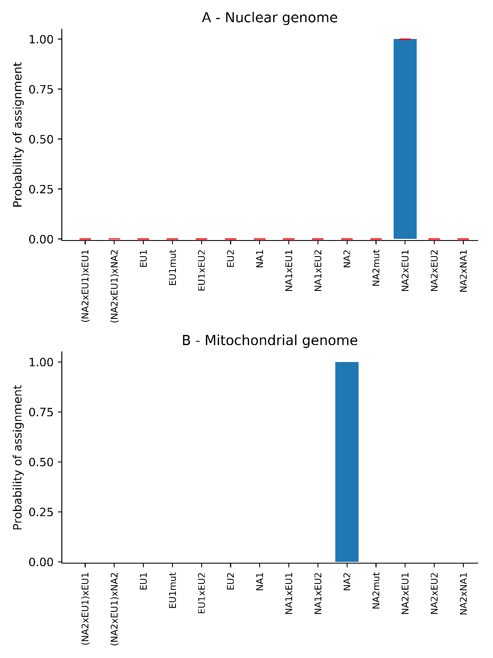

Fig. S2. Phylogenetic tree of hybrid and Phytophthora ramorum lineages and simulated populations. Neighbour-joining tree of EU1 and NA2 P. ramorum isolates, two hybrid samples (Hybrid), 10 simulated F1 hybrids (SimulF1) and 10 simulated backcrosses to each putative parental lineage, NA2 (SimulBCNA2) and EU1 (SimulBCEU1).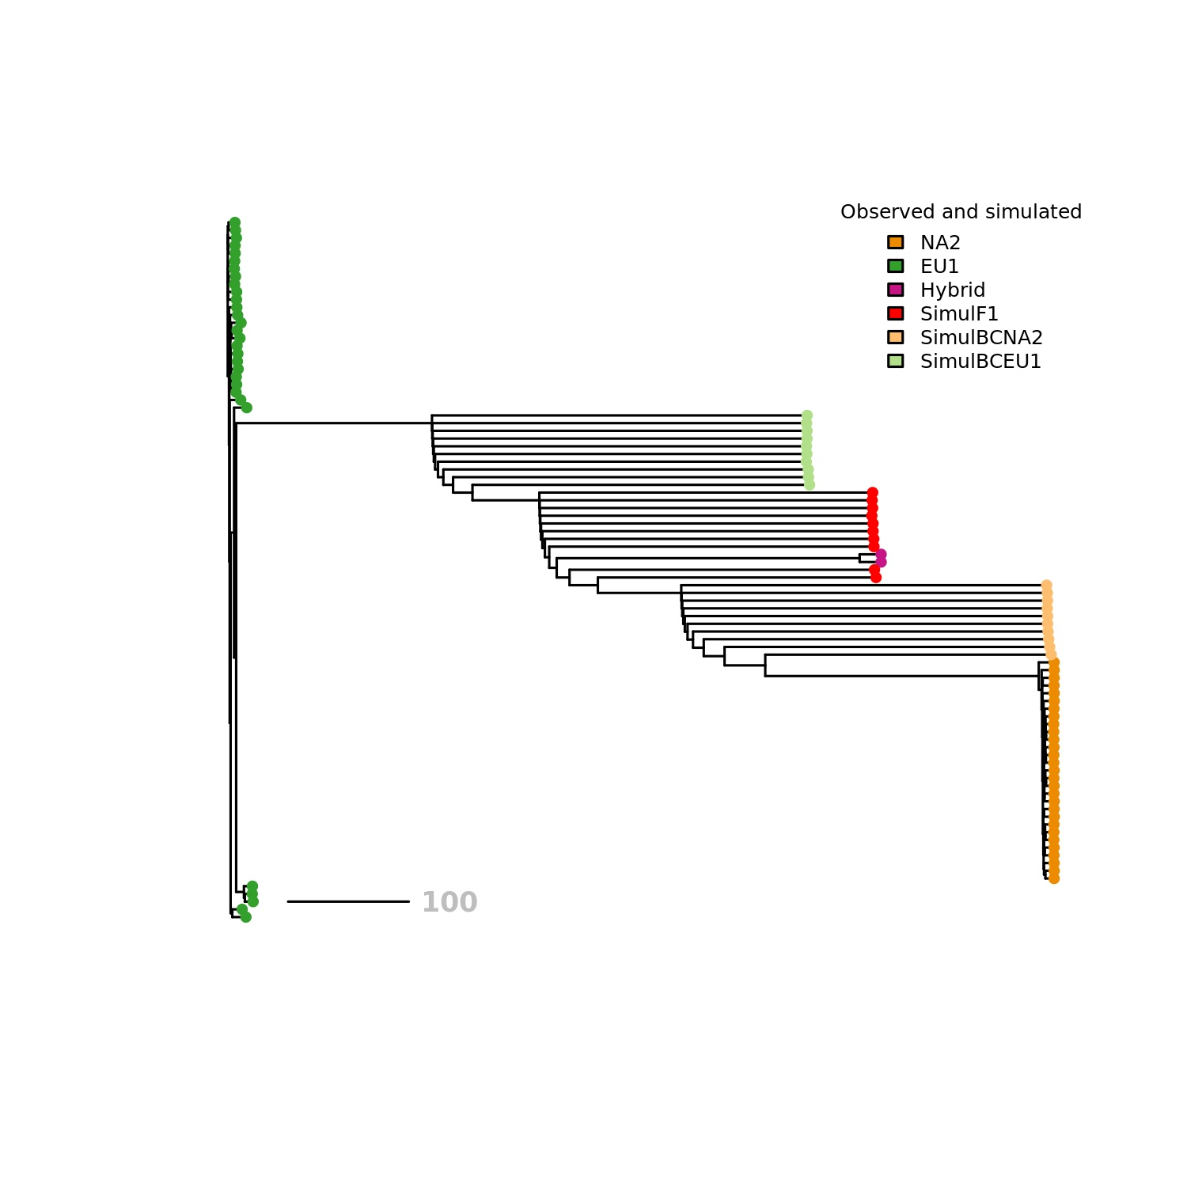

Fig. S3. Mitotic recombination in the Phytophthora ramorum hybrid. Distribution of single nucleotide polymorphisms with fixed differences in the EU1 and NA2 lineages that are also homozygous in the hybrid sample 16_284_032 (the other hybrid sample, 16_237_021, had higher proportion of missing values and was not used for this analysis). The 1049 SNPs were sorted into bins of contiguous (1 to >10 SNPs). A. Observed distribution of the number of contiguous SNPs in 16_284_032; B. Expected distribution of the contiguous SNPs under the assumption of random distribution, with 100 replications.

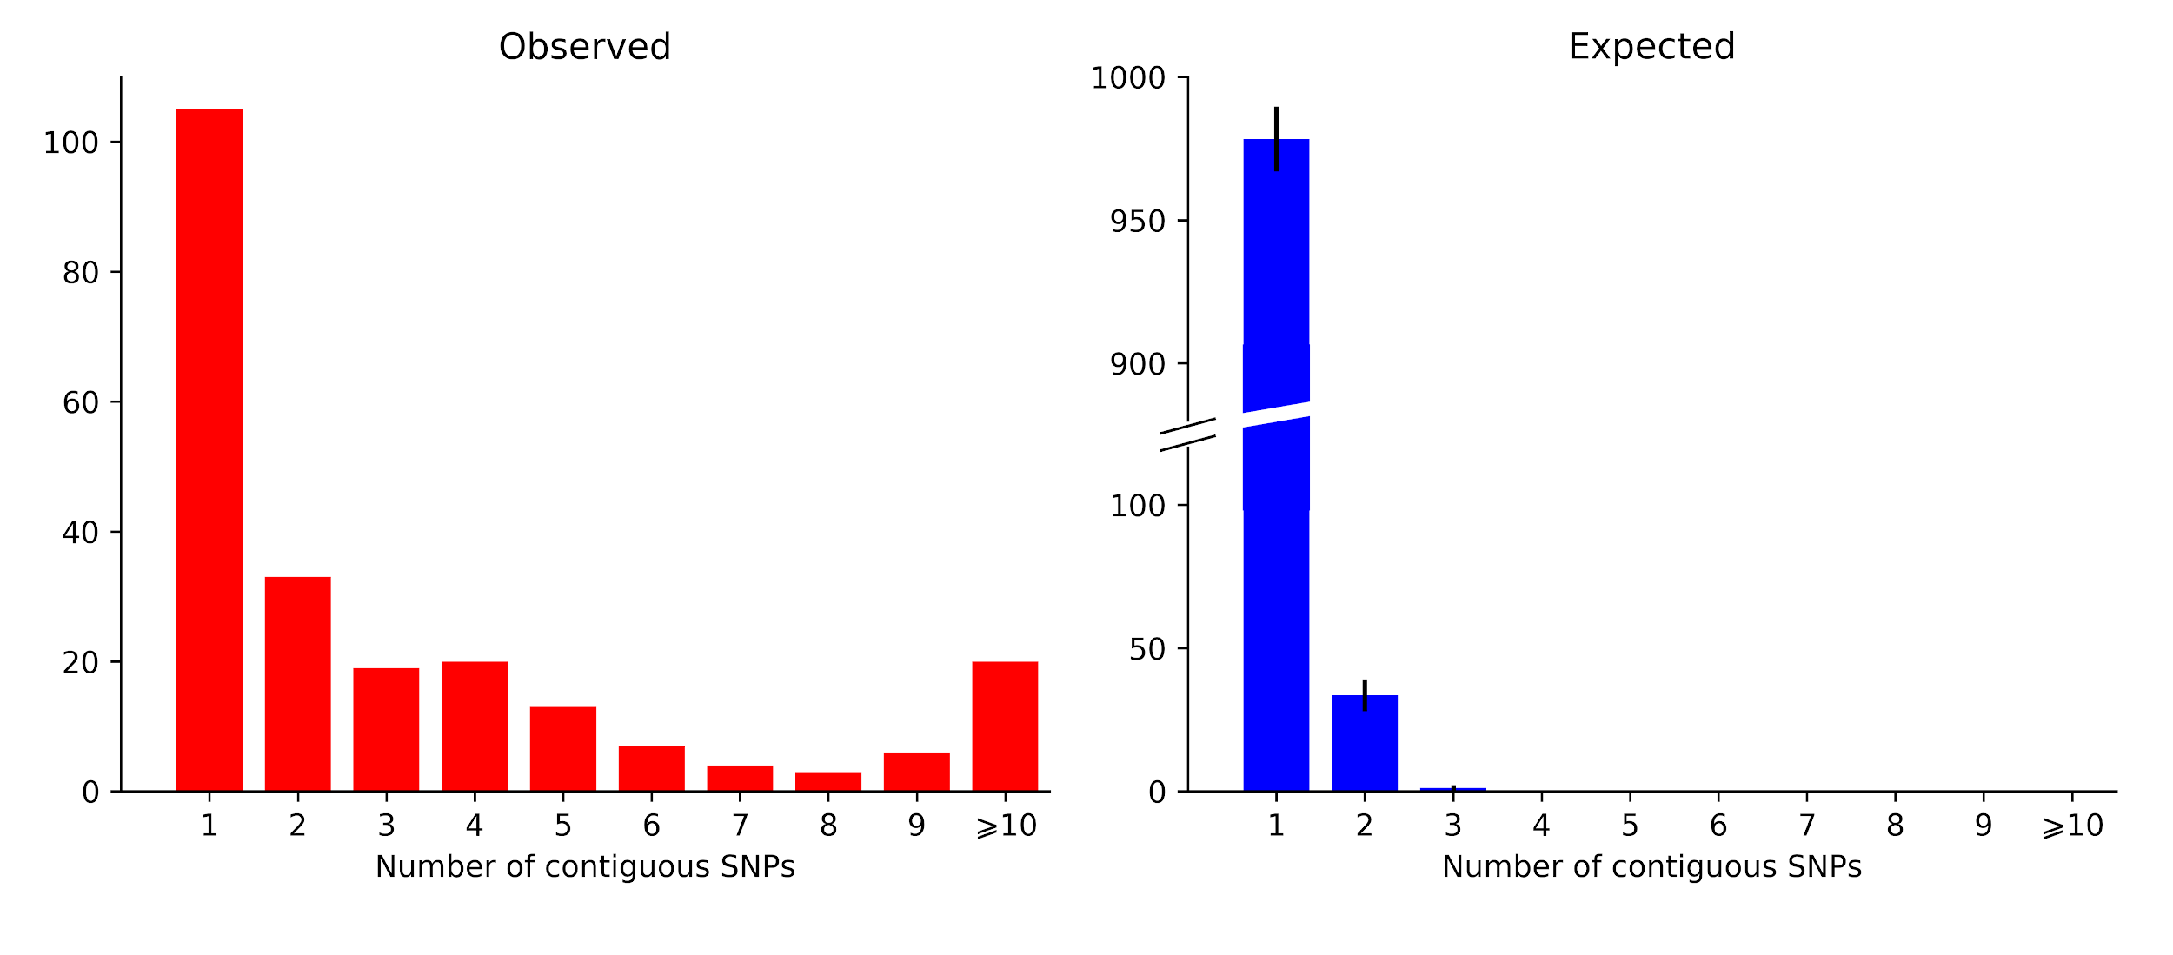

Cited references

1. Bilodeau, G. J. et al. Molecular detection of Phytophthora ramorum by real-time PCR using Taqman, SYBR Green and molecular beacons with three genes. Phytopathology 97, 632–642 (2007).
2. Gagnon, M.-C., Bergeron, M.-J., Hamelin, R. C., Grünwald, N. J. & Bilodeau, G. J. Real-time PCR assay to distinguish Phytophthora ramorum lineages using the cellulose binding elicitor lectin (CBEL) locus. Canadian Journal of Plant Pathology 36, 367–376 (2014).
3. Dale, A. L. et al. Mitotic recombination and rapid genome evolution in the invasive forest pathogen Phytophthora ramorum. mBio 10, e02452-18 (2019).
4. Yuzon, J., Rizzo, D. M., Tripathy, S., Kasuga, T., & others. Resequencing of the Phytophthora ramorum genome to characterize genetic variation and population dynamics of the invasive pathogen. in Proceedings of the sudden oak death sixth science symposium. Gen. Tech. Rep. GTR-PSW-255. Albany, CA: US Department of Agriculture, Forest Service, Pacific Southwest Research Station: 105-106. 105–106 (2017).
5. Turner, J. et al. Genome sequences of 12 isolates of the EU1 lineage of Phytophthora ramorum, a fungus-like pathogen that causes extensive damage and mortality to a wide range of trees and other plants. Genomics Data 12, 17–21 (2017).
6. Miller, P. M. V-8 juice agar as a general-purpose medium for fungal and bacteria. Phytopathology 45, 461–462 (1955).
7. Möller, E., Bahnweg, G., Sandermann, H. & Geiger, H. A simple and efficient protocol for isolation of high molecular weight DNA from filamentous fungi, fruit bodies, and infected plant tissues. Nucleic acids research 20, 6115 (1992).
8. Bolger, A. M., Lohse, M. & Usadel, B. Trimmomatic: a flexible trimmer for Illumina sequence data. Bioinformatics 30, 2114–2120 (2014).
9. Li, H. Aligning sequence reads, clone sequences and assembly contigs with BWA-MEM. arXiv preprint arXiv:1303.3997 (2013).
10. Li, H. et al. The sequence alignment/map format and SAMtools. Bioinformatics 25, 2078–2079 (2009).
11. Okonechnikov, K., Conesa, A. & García-Alcalde, F. Qualimap 2: advanced multi-sample quality control for high-throughput sequencing data. Bioinformatics 32, 292–294 (2016).
12. Martin, F. N., Bensasson, D., Tyler, B. M. & Boore, J. L. Mitochondrial genome sequences and comparative genomics of Phytophthora ramorum and P. sojae. Current Genetics 51, 285–296 (2007).
13. Cingolani, P. et al. A program for annotating and predicting the effects of single nucleotide polymorphisms, SnpEff: SNPs in the genome of Drosophila melanogaster strain w1118; iso-2; iso-3. Fly 6, 80–92 (2012).

