Supporting Information
Icosahedron [Cl₁₂]¹²⁻ Templated Gigantic Gd₁₅₈Co₃₈ Nanocluster with the Largest Ln₁₅₈ Core for Magnetic Cooling
Ning-Fang Li, ª Xi-Ming Luo ª Jia Wang, ^{b} Ji-Lei Wang, ª You Song, *^{b} Hua Mei, ^{*, a} and Yan Xu ^{*, a, b}
ªCollege of Chemical Engineering, State Key Laboratory of Materials-Oriented Chemical Engineering, Nanjing Tech University, Nanjing 210009, P. R. China
^{b}State Key Laboratory of Coordination Chemistry, School of Chemistry and Chemical Engineering, Nanjing University, Nanjing 210023, P. R. China.

Content:
Section 1. Materials and Methods 3
X-ray crystallography. 3
Section 2. Synthesis and Discussion 4
Synthetic Route 4
Synthetic Discussion 4
Section 3. Crystal Structures 9
The Confirmation of Counterions and Guest Molecules 9
Structure 10
The Coordination Modes of Ligands 10
The Coordination Modes of Metal Ions 12
The Crystal Structure Figures 14
Section 4. Characterization 23
PXRD 23
FT-IR 24
TGA 26
XRF 28
EDS 28
XPS 31
Section 5. Thermal Stability 32
Section 6. Magnetic Studies 34
Section 6. Tables 40
Supplementary References 44

Section 1. Materials and Methods

X-ray crystallography.
Single-crystal XRD value was harvested by a Bruker Apex Ⅱ CCD featuring a sealed tube X-ray source (Mo-K_{α} radiation, λ = 0.71073 Å). To resolve and refine the structures were performed by SHELX software package. The SADABS program was implemented to obtain empirical absorption corrections. The structures were defined by direct methods. Then full-matrix least-squares in the SHELXL-2018/3 program package were used to refine structures. In addition, anisotropic thermal parameters were utilized empirically in order to refine the whole non-H atoms. The crystallographic data (Table S1), selected bond lengths and selected bond angles (Table S8 – S9) were offered. Some water molecules in both compounds Cl₁₂@Gd₁₅₈Co₃₈ and Br₁₂@Gd₁₅₈Co₃₈ were removed by SQUEEZE in the refinement, but accurately confirmed by TG and elemental analyses.

Section 2. Synthesis and Discussion

Synthetic Route
Scheme S1. Synthetic Route for Cl₁₂@Gd₁₅₈Co₃₈.
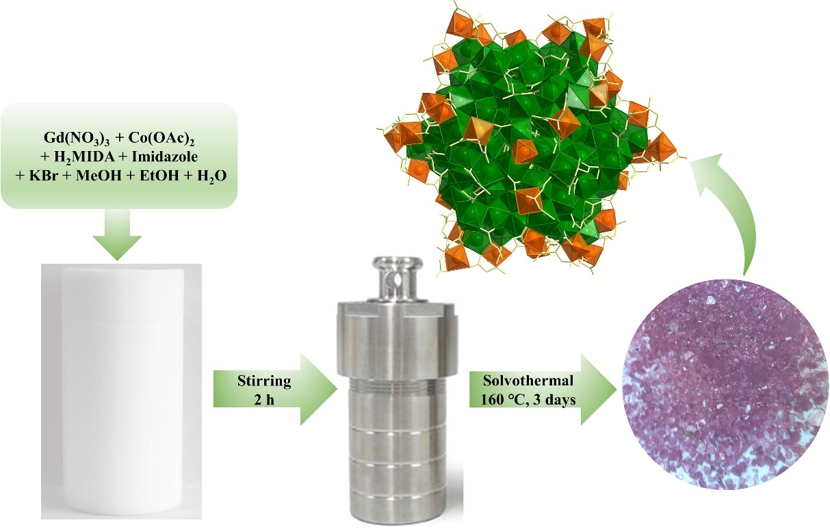

Synthetic Discussion
Figure S1. Scheme for H₂IDA (a) and H₂MIDA (b).
As everyone knows, the successful assembly of high-nuclearity metal clusters is a complex process, which is greatly sensitively dependent on a number of factors.¹⁻³ These involve the reactants (kinds of the metal salts and hydrolysis-limiting ligands, the ligand/metal ratio, possible involvement of anion templates, and so on), and reaction condition (pH, temperature, and duration).¹⁻³
The hydrolysis-limiting ligand
In this article, we choose N-Methyliminodiacetic acid (abbreviated as H₂MIDA) as the hydrolysis-limiting ligand. In terms of the hard-soft-acid-base theory, the lanthanide ions tend to link with hard atoms such as O and F, while transition metal ions are inclined to coordinate with soft atoms like S and N. At the same time, the reported literature shows controlling the hydrolysis of metal ions in the presence of organic ligands with N and O donors is very powerful to isolate high-nuclearity 3d-4f clusters. The iminodiacetic acid (H₂IDA), possessing one -NH and two -COOH groups, is a common organic ligand and a good choice in assembly of 3d-4f complexes. For example, [La₇₆Ni₈₈],⁷ [La₆₈Ni₉₀],⁷ [Gd₉₆Ni₆₄],⁸ [Gd₅₂Ni₅₆],¹³ [Gd₇₈Ni₆₄],⁹ [Gd₄₀Ni₄₄],⁴ and [Gd₂₀Ni₂₁]⁴⁰ have been isolated by the organic ligands of H₂IDA. Owing to the similarity of H₂IDA and H₂MIDA (Figure S1), H₂MIDA is inspired to be as the bridging ligand to construct high-nuclearity 3d-4f clusters. Meanwhile, H₂MIDA was chosen its established success in the assembly of 3d-4f metal clusters. In 2013, Wu obtained four isostructural cluster complexes based on H₂MIDA, {[Ln₂Ni(MIDA)₄(H₂O)₆](H₂O)₄} [Ln=La (1), Ce (2), Pr (3), and Nd (4)].⁴ In 2006, Eldik isolated a 3d metal coordination compound, Na[Fe(MIDA)₂][NaClO₄]₂·3H₂O, by the hydrolysis of Fe³⁺ salts in the presence of H₂MIDA under solvothermal conditions.⁵ So the organic ligand H₂MIDA is one of the best candidates for the assembly of 3d-4f metal clusters.
Anion templates
Previous literature illustrates that anion template plays a significant role in synthesis of metal high-nuclearity clusters, on the basis of their versatile coordination modes to bridge building units, and various dispersion of positive charges. For example, the halide ions (Cl⁻, Br⁻, I⁻) and oxo-anions (NO₃⁻, ClO₄⁻, CO₃²⁻) as simple anion templates have been widely applied in the synthesis of high-nuclearity lanthanide-based clusters.²⁻³ Similarly, in the synthesis of Cl₁₂@Gd₁₅₈Co₃₈ and Br₁₂@Gd₁₅₈Co₃₈, the halide ions (Cl⁻ and Br⁻ as anion template) play a decisive role in the formation of the metal cluster skeletons.
Firstly, Cl⁻ ions (from GdCl₃) are used as anion templates. Fortunately, Cl₁₂@Gd₁₅₈Co₃₈ was successfully obtained and was templated by 12 Cl⁻ ions (see the structural discussion for detailed information). If Cl⁻ ions were replaced with Br⁻, Br₁₂@Gd₁₅₈Co₃₈ was synthesized and was templated by Br⁻ ions. Interestingly, if I⁻ ions act as the anionic templates, the synthesis is failed. Moreover, without the halide ions in synthetic process, no crystal was obtained, which showed that the halide ions (Br⁻ and Cl⁻ as anion templates) are especially important to assemble compounds Cl₁₂@Gd₁₅₈Co₃₈ and Br₁₂@Gd₁₅₈Co₃₈.
pH
For Cl₁₂@Gd₁₅₈Co₃₈ and Br₁₂@Gd₁₅₈Co₃₈, the pH value of the mixed solution (without imidazole) is about 3.0. In this case, there was no crystal obtained. After adding imidazole, compounds Cl₁₂@Gd₁₅₈Co₃₈ and Br₁₂@Gd₁₅₈Co₃₈ were successfully synthesized when the pH value increased significantly (pH = 5.5 approximately), suggesting it may exist as a base. Compounds Cl₁₂@Gd₁₅₈Co₃₈ and Br₁₂@Gd₁₅₈Co₃₈ could not be obtained without imidazole. Meanwhile, though imidazole did not appear in the final structure, it also plays a critical role in the structural orientation. Above all, imidazole is important to assembly of compounds Cl₁₂@Gd₁₅₈Co₃₈ and Br₁₂@Gd₁₅₈Co₃₈. Besides, compounds Cl₁₂@Gd₁₅₈Co₃₈ was obtained under pH = 5.5 approximately, while Br₁₂@Gd₁₅₈Co₃₈ was gained with pH = 4.5.
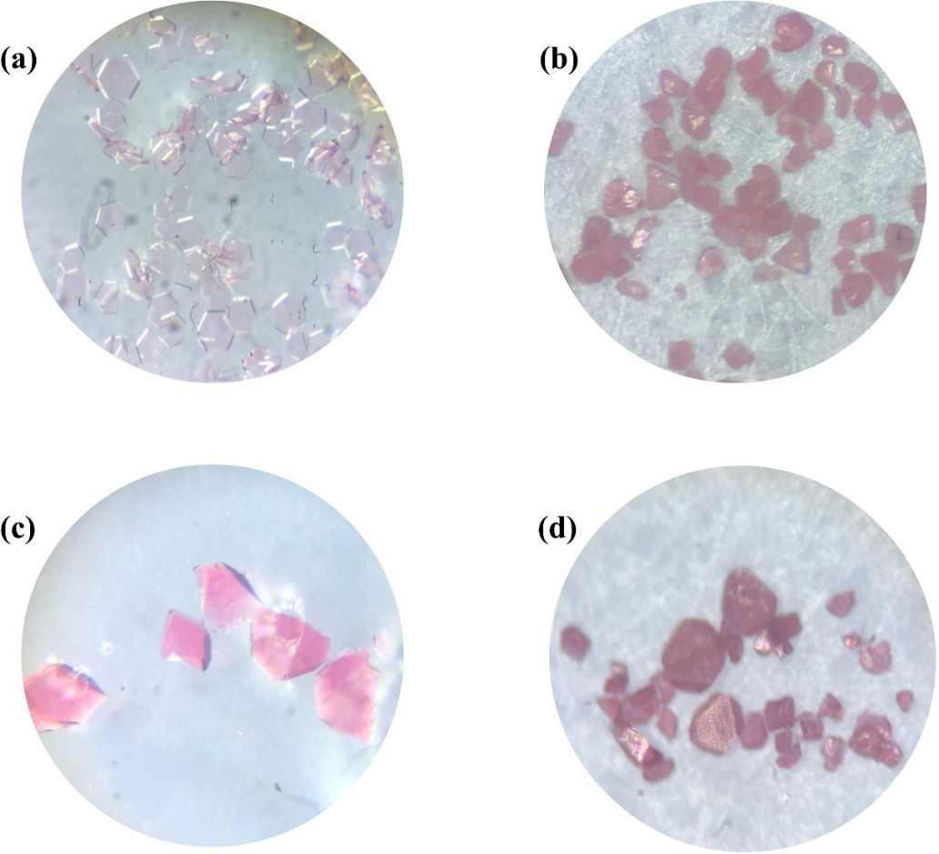
Figure S2. The image of Cl₁₂@Gd₁₅₈Co₃₈ crystal under optical microscope (a), (b); the image of Br₁₂@Gd₁₅₈Co₃₈ crystal under optical microscope (c), (d).
Temperature
For Cl₁₂@Gd₁₅₈Co₃₈ and Br₁₂@Gd₁₅₈Co₃₈, 160 °C is the best choice (as shown in Figure S2b, S2d), while a small number of crystals can be obtained at 140 °C (as shown in Figure S2a, S2c). Meanwhile, a slow release or production of CO₃²⁻ ions can be attained via an in-situ decomposition of ligands (H₂MIDA) under high temperature (solvothermal conditions). Most importantly, the high temperature and acidic conditions, what makes it possible for a slow release or production of CO₃²⁻ ions, are beneficial to construct high-nuclearity 3d-4f clusters. Similar cases have been observed before in H₂IDA ligands (Inorg. Chem. 2019, 58, 10883−10889).⁶
Scheme S1. The situ hydrolysis of H₂MIDA.
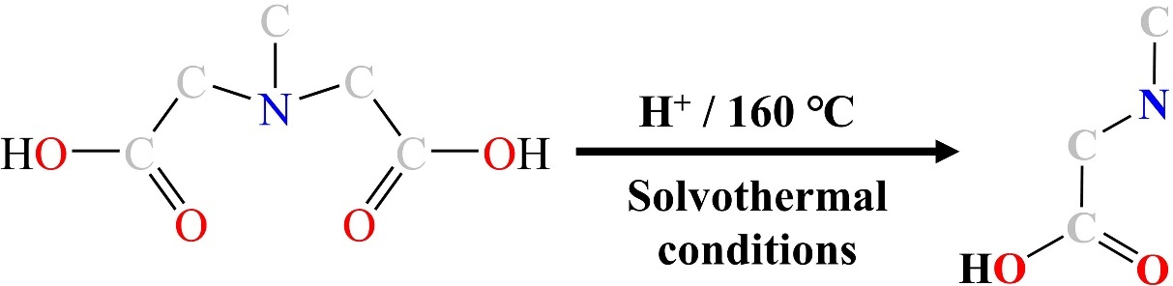

Table S1. Crystal data and structure refinements for Cl₁₂@Gd₁₅₈Co₃₈ and Br₁₂@Gd₁₅₈Co₃₈.
Compound | Cl₁₂@Gd₁₅₈Co₃₈ | Br₁₂@Gd₁₅₈Co₃₈
Formula | C₃₅₄H₁₁₂₄Cl₃₆Co₃₈Gd₁₅₈N₄₈O₉₅₀ | C₃₆₀H₁₀₃₀Br₁₈Cl₁₂Co₃₈Gd₁₅₈N₄₈O₉₀₀
Formula weight | 49617.99 | 49382.88
T (K) | 296(2) | 296(2)
Crystal system | Trigonal | Trigonal
Space group | R-3 | R-3
a (Å) | 37.6349(3) | 37.596(2)
b (Å) | 37.6349(3) | 37.596(2)
c (Å) | 88.833(2) | 88.527(10)
α (deg) | 90 | 90
β (deg) | 90 | 90
γ (deg) | 120 | 120
V (Å³) | 108965(3) | 108364(18)
Z | 3 | 3
D_{c} (mg m⁻³) | 2.268 | 2.270
μ (mm⁻¹) | 7.678 | 8.169
F (000) | 68802 | 68094
θ range (deg) | 0.665-25.003 | 1.380-26.158
Crystal size (mm³) | 0.13 × 0.13  × 0.12 | 0.15 × 0.13  × 0.10
Limiting indices | -44<=h<=41,  -41<=k<=44,  -80<=l<=105 | -37<=h<=44,  -46<=k<=34,  -103<=l<=109
Reflections collected / unique | 167088/42686 | 178280/48071
R(int) | 0.0804 | 0.0569
Data/restraints/parameters | 42686 / 506 / 2397 | 48071 / 253 / 2386
GOF | 1.097 | 1.130
R₁ª,  wR₂ [I>2σ(I)] | R₁ = 0.0453  wR₂ = 0.1247 | R₁ = 0.0559  wR₂ = 0.1352
R₁, wR₂  (all data) | R₁ = 0.0836  wR₂ = 0.1421 | R₁ = 0.1033  wR₂ = 0.1615
ª R₁ = Σ||F_{o}|－|F_{c}||/Σ|F_{o}|; ^{b} wR₂ = Σ[w(F_{o}²－F_{c}²)²]/Σ[w(F_{o}²)²]^{1/2}.

Section 3. Crystal Structures

The Confirmation of Counterions and Guest Molecules
The skeletons (cationic core [Cl₁₂@Gd₁₅₈Co₃₈(MIDA)₄₂(CO₃)₉₀(μ₃-OH)₂₃₆(OAc)₁₈(CH₃NH₂CH₂COO)₆(H₂O)₈₄]²⁴⁺) of compound Cl₁₂@Gd₁₅₈Co₃₈, and (cationic core [Br₁₂@Gd₁₅₈Co₃₈(MIDA)₄₂(CO₃)₉₀(μ₃-OH)₂₃₆(OAc)₁₈(CH₃O)₆
(CH₃NH₂CH₂COO)₆(H₂O)₇₈]¹⁸⁺) of Br₁₂@Gd₁₅₈Co₃₈ are determined by SCXRD, while the counterions and guest molecules are confirmed by elemental analysis, TG, IR, XRF, EDS and charge balance.
For compounds Cl₁₂@Gd₁₅₈Co₃₈ and Br₁₂@Gd₁₅₈Co₃₈, FT-IR spectra analysis suggested the no existence of NO₃²⁻ molecules due to no typical peaks of N=O at 1385 cm^{–1}, while compounds should contain CO₃²⁻ molecules due to typical peaks of C=O at 1409 cm^{–1}. The XRF, EDS, and mapping analysis suggested the present of the halide ions (Cl⁻ ions in Cl₁₂@Gd₁₅₈Co₃₈; Cl⁻ and Br⁻ ions in Br₁₂@Gd₁₅₈Co₃₈). TGA analysis displayed 144 free H₂O molecules in Cl₁₂@Gd₁₅₈Co₃₈ and 94 free H₂O molecules in Br₁₂@Gd₁₅₈Co₃₈. Combining charge conservation, we hold the view that the counterions and guest molecules of compounds Cl₁₂@Gd₁₅₈Co₃₈ and Br₁₂@Gd₁₅₈Co₃₈.
Cl₁₂@Gd₁₅₈Co₃₈
[Cl₁₂@Gd₁₅₈Co₃₈(MIDA)₄₂(CO₃)₉₀(μ₃-OH)₂₃₆(OAc)₁₈(CH₃NH₂CH₂COO)₆ (H₂O)₈₄]·
Cl₂₄·144(H₂O)
Br₁₂@Gd₁₅₈Co₃₈
[Br₁₂@Gd₁₅₈Co₃₈(MIDA)₄₂(CO₃)₉₀(μ₃-OH)₂₃₆(CH₃NH₂CH₂COO)₆(OAc)₁₈(CH₃O)₆
(H₂O)₇₈]·Br₆Cl₁₂·94(H₂O)

Structure

The Coordination Modes of Ligands
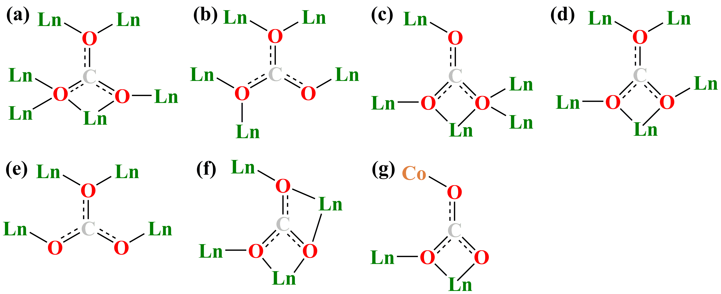
Figure S3. The coordination modes of CO₃²⁻ in compound Cl₁₂@Gd₁₅₈Co₃₈.
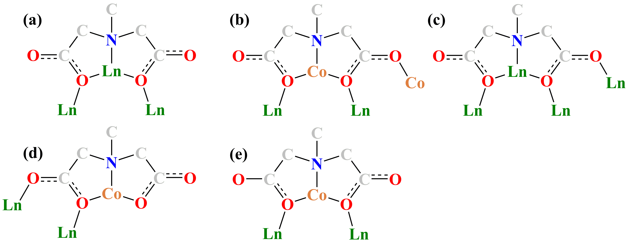
Figure S4. The coordination modes of H₂MIDA in compound Cl₁₂@Gd₁₅₈Co₃₈.
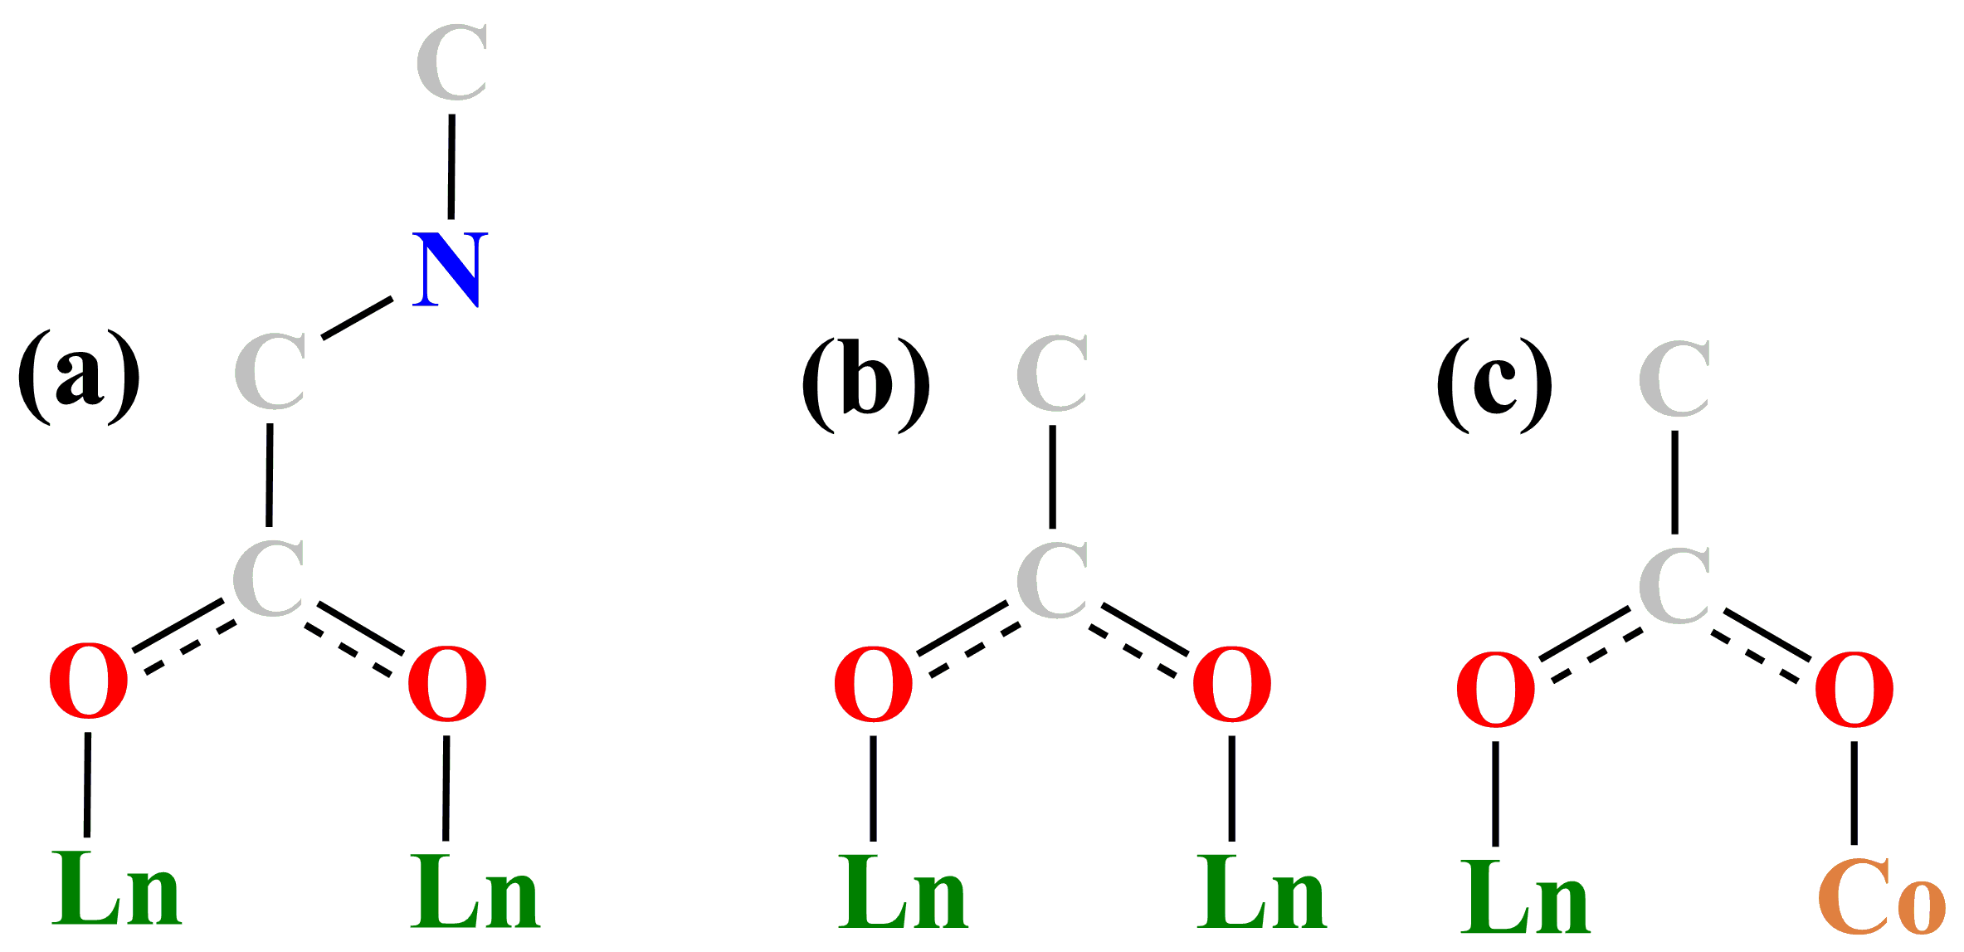
Figure S5. The coordination modes of sarcosine (a), and CH₃COO⁻ (b-c) in compound Cl₁₂@Gd₁₅₈Co₃₈.
For ninety CO₃²⁻ ions in this work show seven coordination modes (Figure S3). (I) CO₃²⁻ ion is coordinated with six Ln ions, showing μ₆: η²: η³: η² (Figure S3a); (II) CO₃²⁻ ion is coordinated with five Ln ions, showing μ₅: η²: η²: η¹ (Figure S3b); (III) CO₃²⁻ ion is coordinated with five Ln ions, showing μ₅: η³: η²: η¹ (Figure S3c); (IV) CO₃²⁻ ion is coordinated with five Ln ions, showing μ₅: η²: η²: η¹ (Figure S3d); (V) CO₃²⁻ ion is coordinated with four Ln ions, showing μ₄: η²: η¹: η¹ (Figure S3e); (VI) CO₃²⁻ ion is coordinated with four Ln ions, showing μ₄: η²: η²: η² (Figure S3f); (VIII) CO₃²⁻ ion is coordinated with three metal ions (one Co and two Ln ions, showing μ₃: η²: η¹: η¹, Figure S3g).
In this work, there are five coordination modes for H₂MIDA ligands (Figure S4). (I) MIDA²⁻ ligand is linked with three Ln ions, forming the mode I (μ₃: η²: η¹: η²; Figure S4a); (II) MIDA²⁻ ligand is linked with two Ln and two Co ions, forming the mode II (μ₄: η²: η¹: η²: η¹; Figure S4b); (III) MIDA²⁻ ligand is linked with four Ln ions, forming the mode III (μ₄: η²: η¹: η²: η¹; Figure S4c); (IV) MIDA²⁻ ligand is linked with one Co and two Ln ions, forming the mode IV (μ₃: η¹: η²: η¹; Figure S4d); (V) MIDA²⁻ ligand is linked with one Co and two Ln ions, forming the mode V (μ₃: η²: η¹: η²; Figure S4e).
Besides, the sarcosine (CH₃NH₂CH₂COO⁻) only exhibits one coordination mode and links with two Ln ions (Figure S5a), showing μ₂: η¹: η¹.
For CH₃COO⁻ ligands, it is coordinated with two Ln ions, forming the mode I (showing μ₂: η¹: η¹, Figure S5b), and CH₃COO⁻ ligand is coordinated with one Ln and one Co ion, forming the mode II (showing μ₂: η¹: η¹, Figure S5c).

The Coordination Modes of Metal Ions
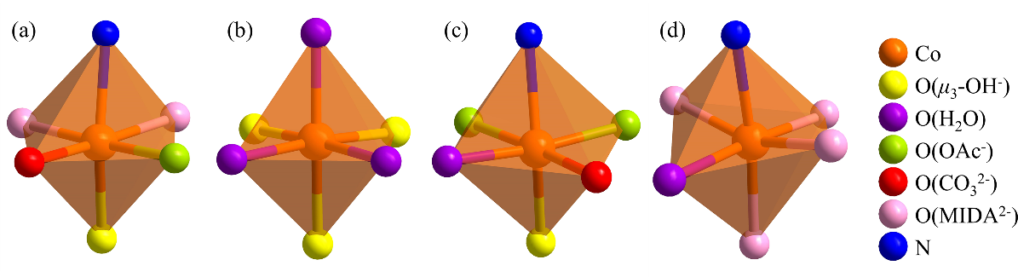
Figure S6. The coordination modes of Co ions in compounds Cl₁₂@Gd₁₅₈Co₃₈.
In compound 1, there are seven coordination modes of all Co ions. And those Co ions are hexa-coordinate, displaying near-octahedral geometry (Figure S6). (I) as shown in Figure S6a, Co ion is coordinated to one N atom (from one H₂MIDA) and five O atoms (from one H₂MIDA, one CH₃COO⁻, one CO₃²⁻, and one μ₃-OH⁻ groups); (II) as shown in Figure S6b, Co is coordinated to six O atoms (from one three coordination H₂O, and three μ₃-OH⁻ groups); (III) as shown in Figure S6c, Co3 is coordinated to one N atom (from one H₂MIDA) and five O atoms (from one H₂MIDA, one H₂O, one CO₃²⁻, and one μ₃-OH⁻ groups); (IV) as shown in Figure S6d, Co3 is coordinated to one N atom (from one H₂MIDA) and five O atoms (from one H₂O, and three H₂MIDA groups).
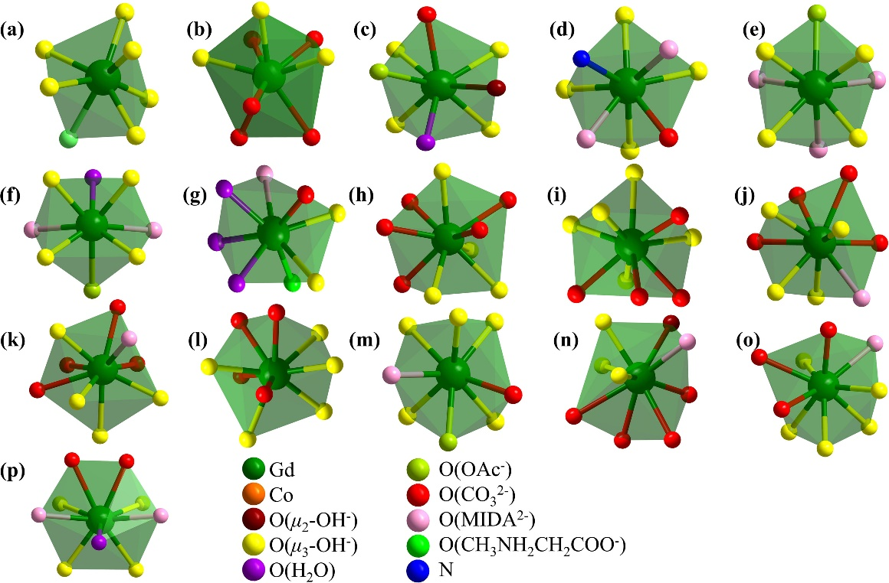
Figure S7. The coordination modes of Gd ions in compounds Cl₁₂@Gd₁₅₈Co₃₈.
As shown in Figure S7a, Gd ion is seven-coordination, lined with seven O atoms (from six μ₃-OH⁻, and one sarcosine).
As shown in Figure S7b-7h, Gd ions are all eight-coordination, showing seven coordination modes. Gd (Figure S7b) ion is coordinated to eight O (five O-donors from four CO₃²⁻, and three O atoms from the μ₃-OH⁻ groups); Gd (Figure S7c) ion is coordinated to eight O (from one CO₃²⁻, one μ₂-OH⁻, four μ₃-OH⁻, one H₂O, and one CH₃COO⁻); Gd (Figure S7d) ion is coordinated to eight O (from six μ₃-OH⁻, one MIDA²⁻, and one CH₃COO⁻); Gd (Figure S7e) ion is coordinated to seven O and one N (from one CO₃²⁻, four μ₃-OH⁻, and one MIDA²⁻); Gd (Figure S7f) ion is coordinated to eight O (from four μ₃-OH⁻, three H₂MIDA ligands, and one CH₃COO⁻); Gd (Figure S7g) ion is coordinated to eight O (from four μ₃-OH⁻, one H₂O, two H₂MIDA ligands, and one CH₃COO⁻); Gd (Figure S7h) ion is coordinated to eight O (from one CO₃²⁻, two μ₃-OH⁻, three H₂O, one MIDA²⁻ ligand, and one sarcosine).
The rest of Gd ions are all nine-coordination (as shown in Figure S7i-7p), showing eight coordination modes: (I) Gd (Figure S7i) ion is both coordinated with nine O atoms (from six CO₃²⁻, and three μ₃-OH⁻ groups); (II) Gd (Figure S7j) ion is coordinated with nine O atoms (from three CO₃²⁻, and five μ₃-OH⁻ groups); (III) Gd (Figure S7k) ion is coordinated with nine O atoms (from four CO₃²⁻, and four μ₃-OH⁻ groups); (IV) Gd (Figure S7l) ion is coordinated with nine O atoms (from three CO₃²⁻, one CH₃COO⁻, and four μ₃-OH⁻ groups); (V) Gd (Figure S7m) ion is coordinated with nine O atoms (from three CO₃²⁻, one μ₂-OH⁻, and four μ₃-OH⁻ groups); (VI) Gd (Figure S7n) ion is coordinated with nine O atoms (from three CO₃²⁻, one CH₃COO⁻, one μ₂-OH⁻, and three μ₃-OH⁻ groups); (VII) Gd (Figure S7o) ion is coordinated with nine O atoms (from three CO₃²⁻, one MIDA²⁻ ligand, and four μ₃-OH⁻ groups); (VIII) Gd (Figure S7p) ion is coordinated with nine O atoms (from one CO₃²⁻, two MIDA²⁻ ligands, one H₂O, and four μ₃-OH⁻ groups).

The Crystal Structure Figures
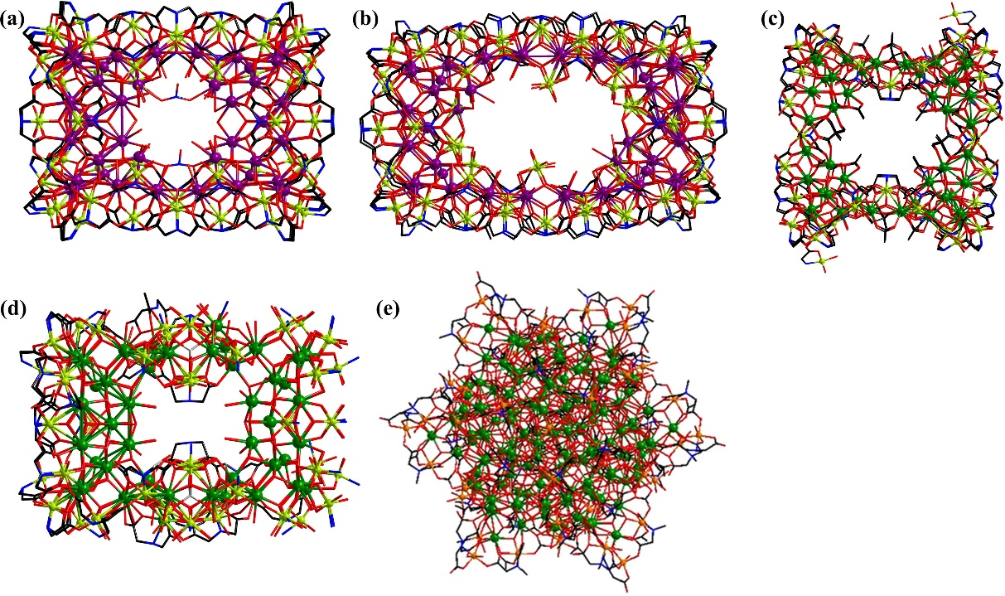
Figure S8. The view of compounds La₇₆Ni₈₈ (a)⁷; La₆₈Ni₉₀ (b)⁷; Gd₉₆Ni₆₄ (c)⁸; Gd₇₈Ni₆₄ (d)⁹; Cl₁₂@Gd₁₅₈Co₃₈ (e). Color code: green, Gd; purple, La; orange, Co; lime, Ni; blue: N; red, O; black, C.
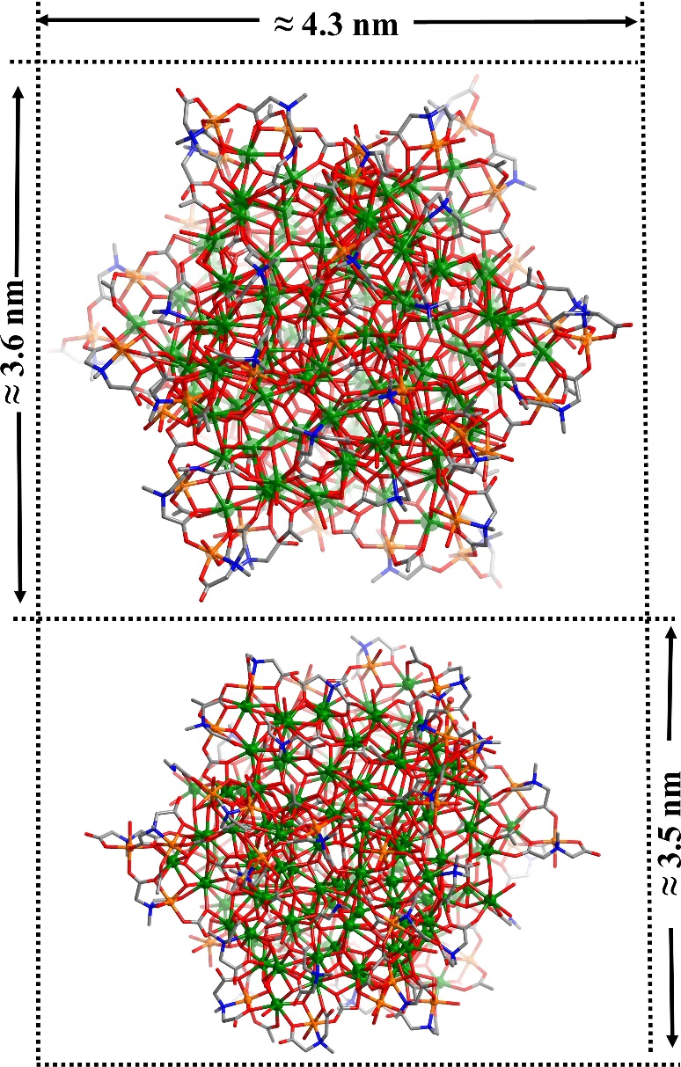
Figure S9. Ball-and-stick views of the cationic Cl₁₂@Gd₁₅₈Co₃₈.
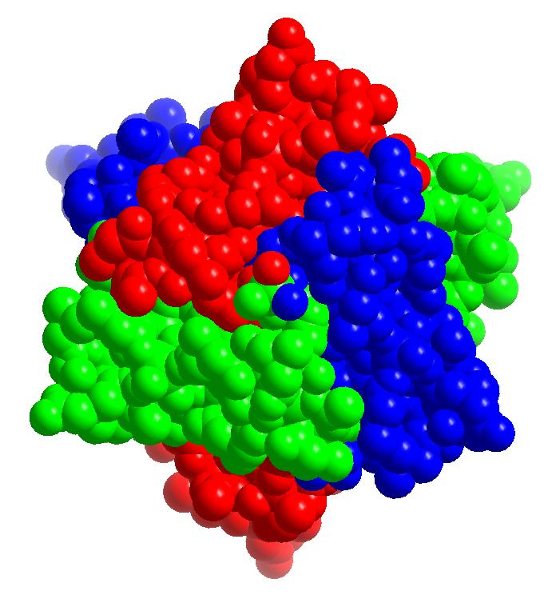
Figure S10. The space-filling view of compound Cl₁₂@Gd₁₅₈Co₃₈.
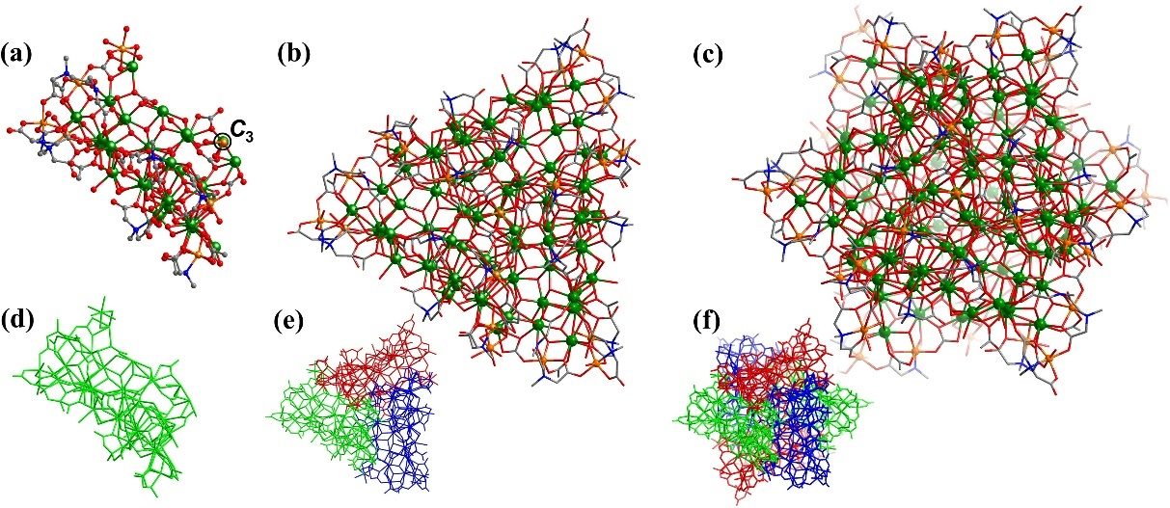
Figure S11. Ball-and-stick view and the arrangement of asymmetric building block Gd₂₇Co₇ (a, d); ball-and-stick view and the arrangement of Gd₇₉Co₁₉ (b, e); Ball-and-stick view and the arrangement of Cl₁₂@Gd₁₅₈Co₃₈ (c, f).
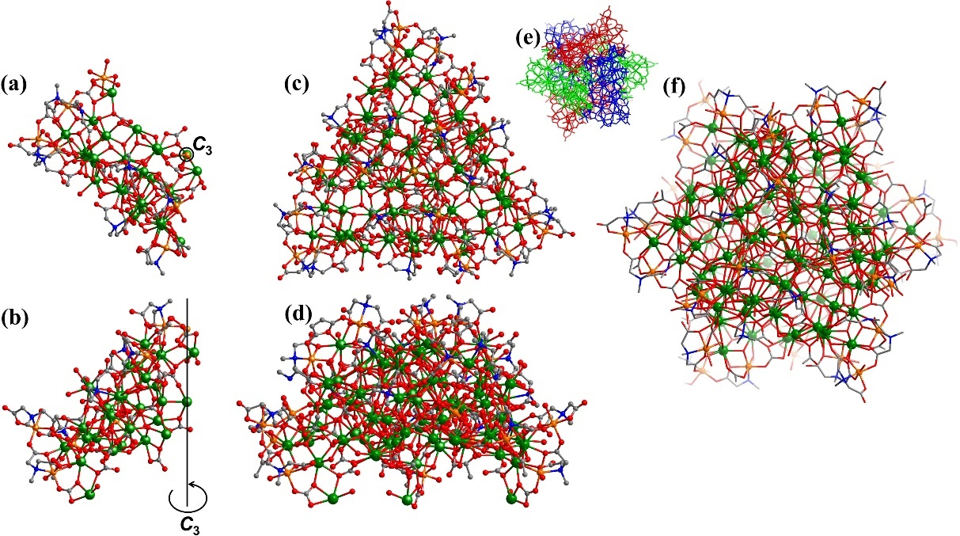
Figure S12. Ball-and-stick view of asymmetric building block Gd₂₇Co₇ (a, b); ball-and-stick view of Gd₇₉Co₁₉ (c, d); Ball-and-stick view and the arrangement of Cl₁₂@Gd₁₅₈Co₃₈ (e, f).
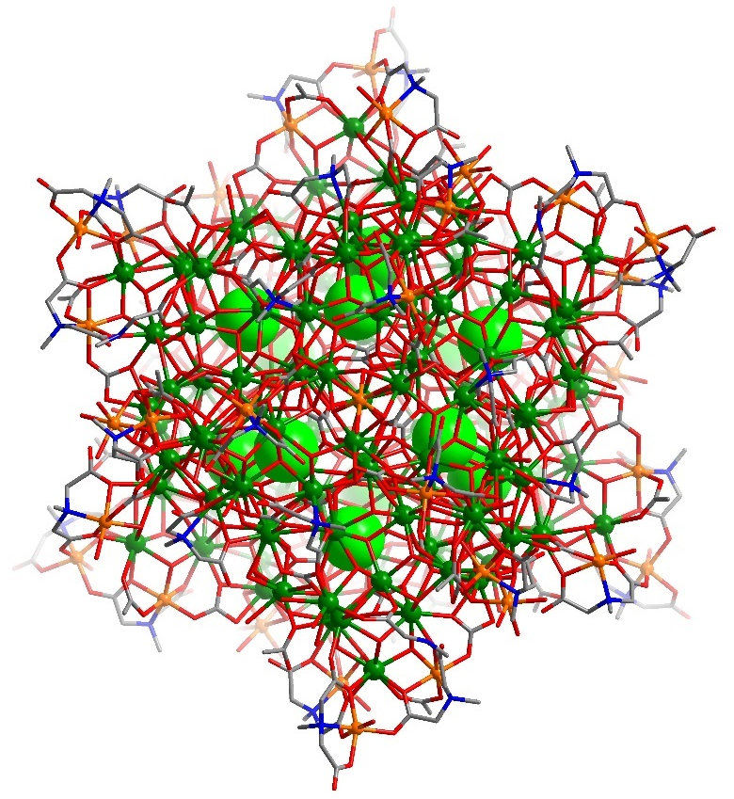
Figure S13. The arrangement of compound Cl₁₂@Gd₁₅₈Co₃₈.
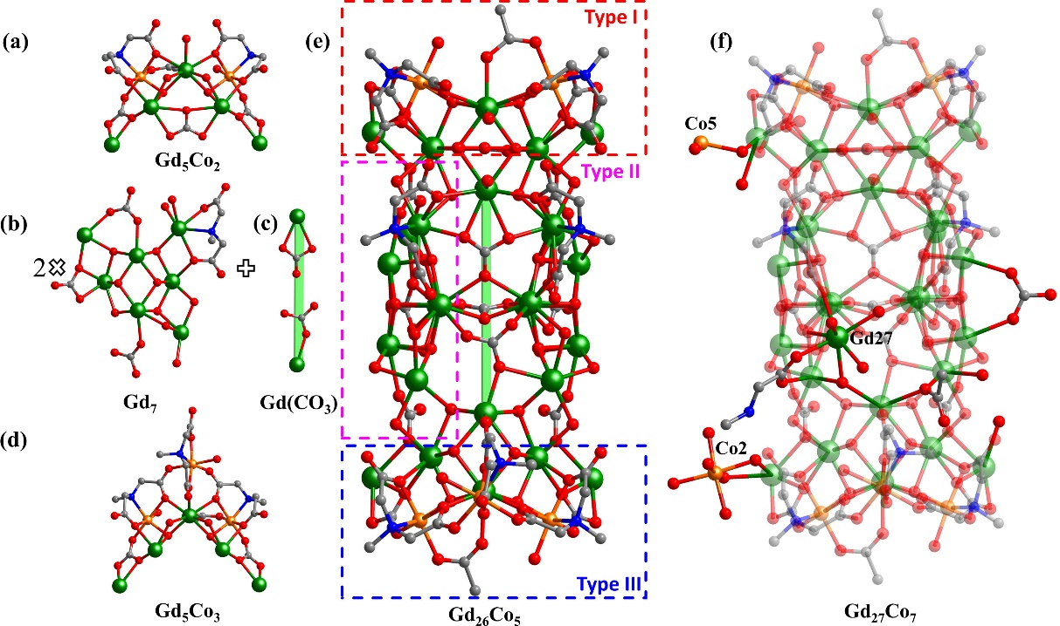
Figure S14. Ball-and-stick view of Gd₅Co₂ (a); Gd₇ (b); Gd(CO₃) (c); Gd₅Co₃ (d); Gd₂₆Co₅ (e); Gd₂₇Co₇ (f). Color code: green, Gd; orange, Co; blue: N; red, O; gray, C. H, Cl atoms and free H₂O molecules are omitted for clarity.
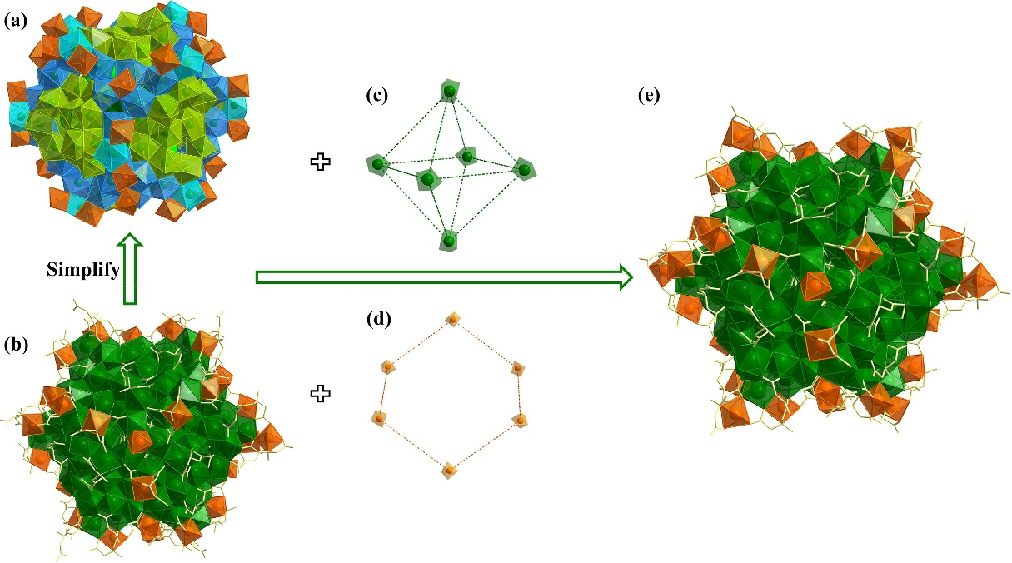
Figure S15. The view of compound Gd₁₅₂Co₃₂ (a), (b); Gd(MIDA)₂(CO₃)(μ₃-OH)₂ (c); Co(MIDA)₃ (d); Cl₁₂@Gd₁₅₈Co₃₈ (e).
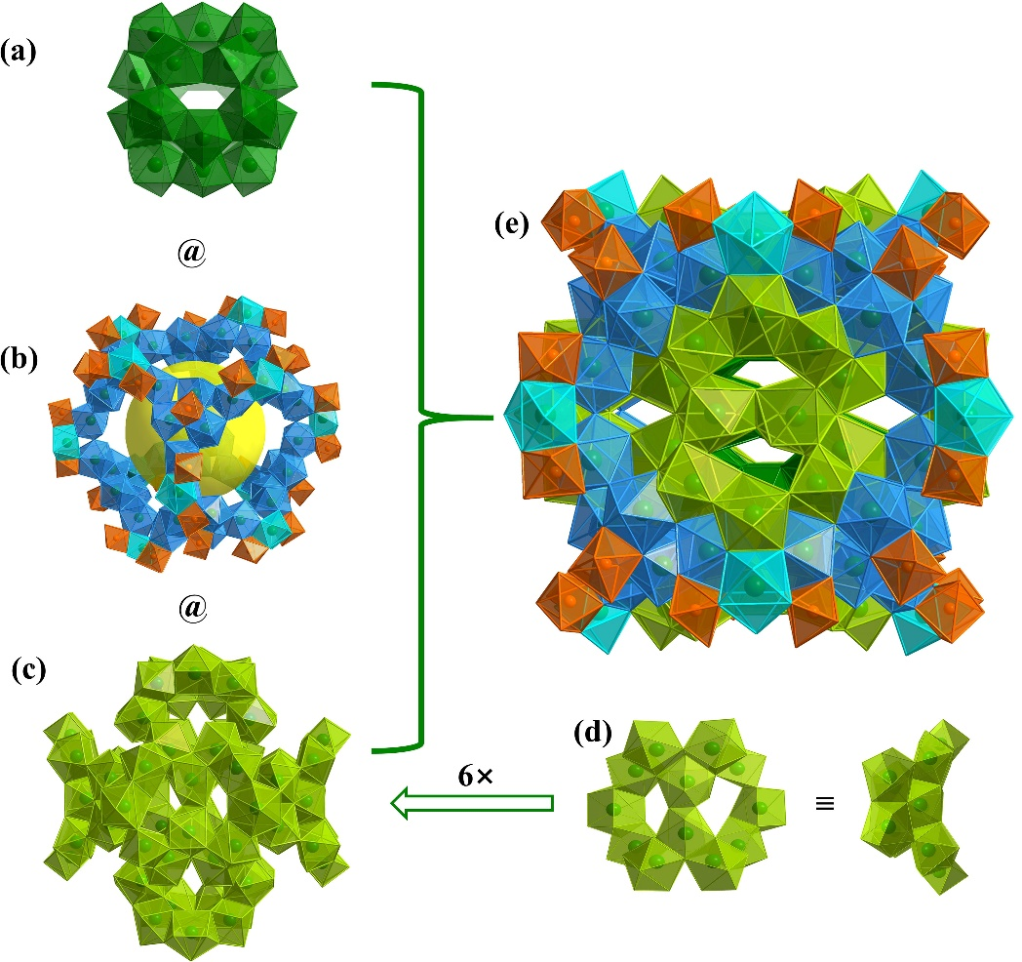
Figure S16. The view of compound Gd₂₀ (a); Gd₄₈Co₃₂@(Gd)₁₂ (b); (Gd₁₂)₆ (c); Gd₁₂ (d); Gd₁₅₂Co₃₂ (e).
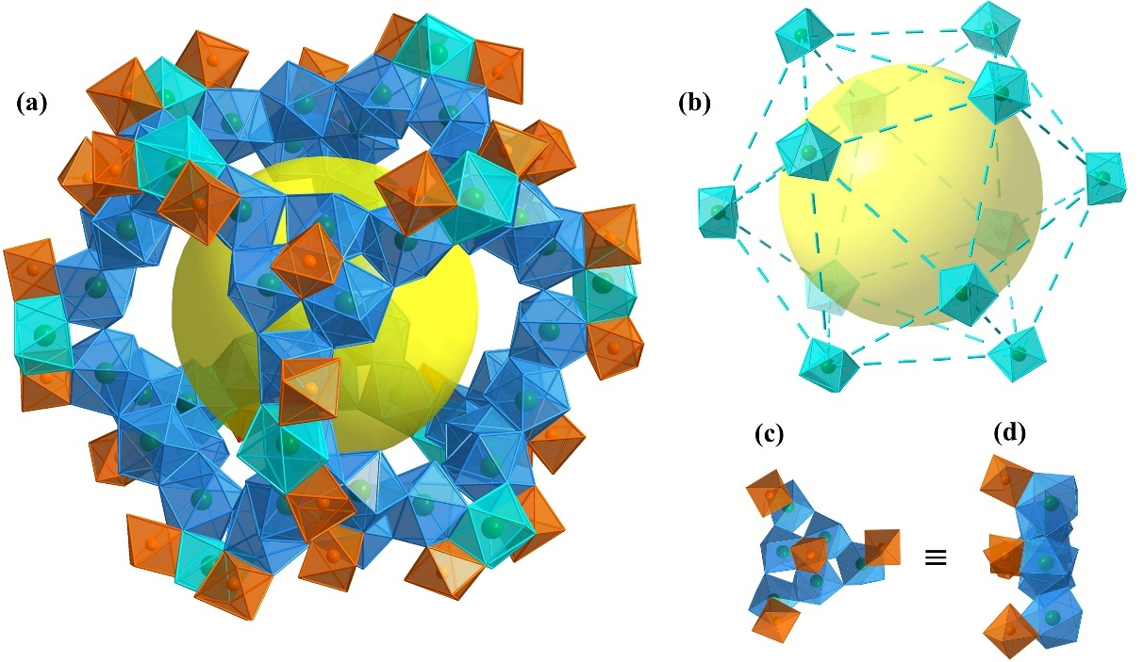
Figure S17. The view of compound Gd₄₈Co₃₂@(Gd)₁₂ (a); Gd₁₂ (b); Gd₆Co₄ (c), (d).
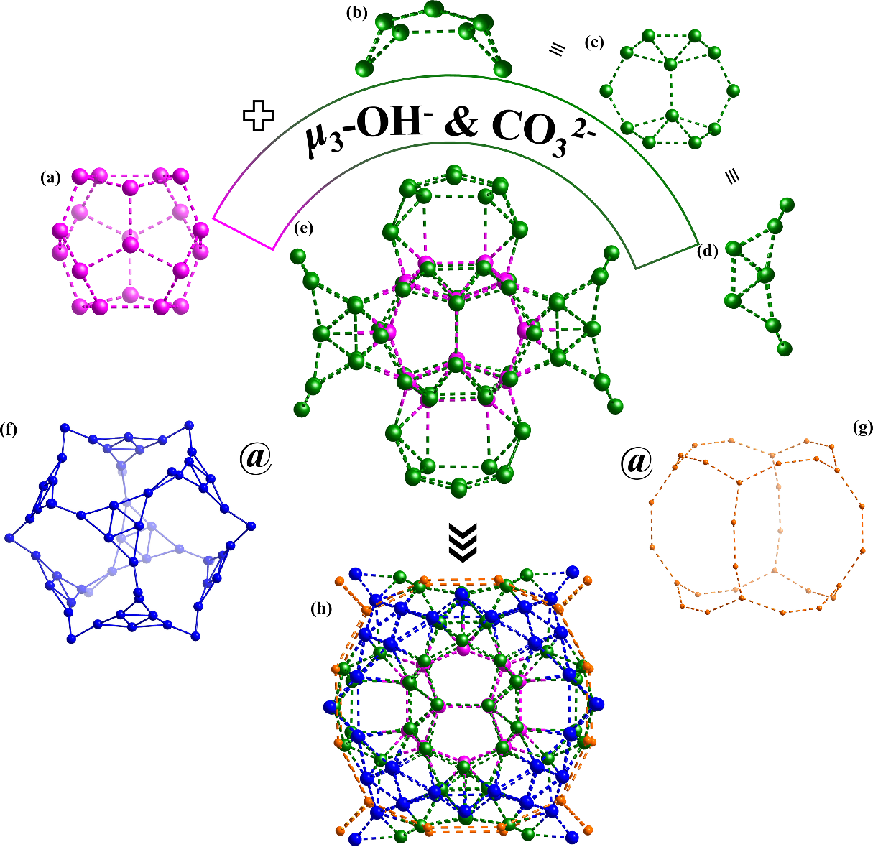
Figure S18. The view of compound Gd₂₀ (a); Gd₁₂ (b), (c), (d); Gd₉₂ (e); Gd₆₀ (f); Co₃₂ (g); Gd₁₅₂Co₃₂ (h).
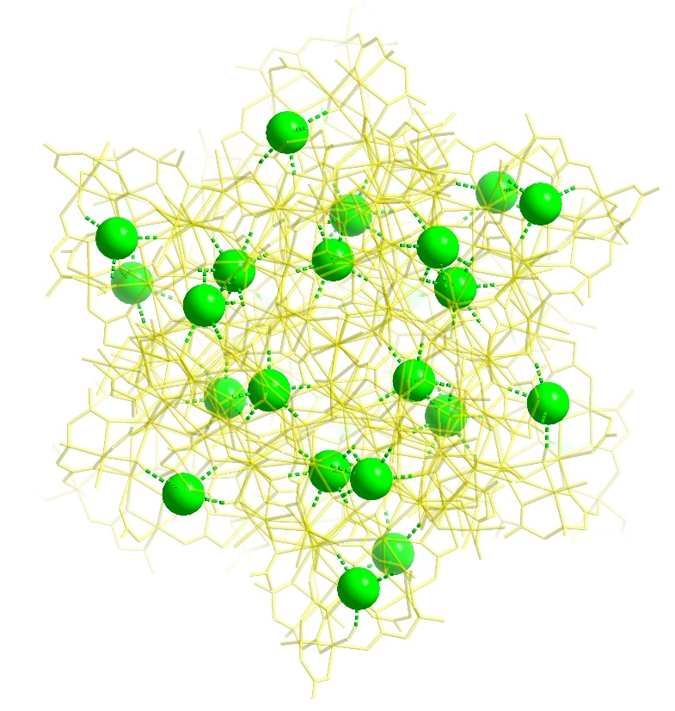
Figure S19. The view of compound Cl₁₂@Gd₁₅₈Co₃₈. Color code: bright green, Cl; bond with bright green, Cl···H.
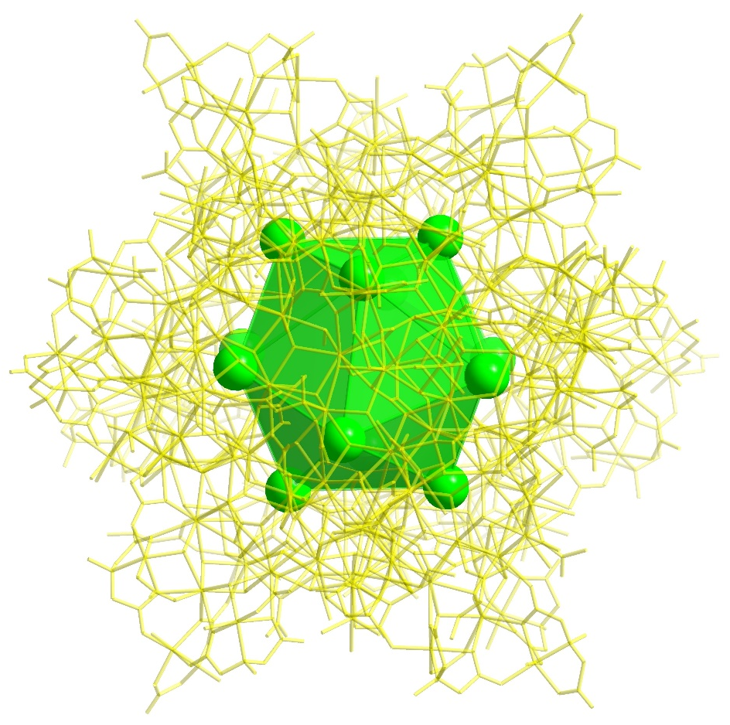
Figure S20. The view of compound Cl₁₂@Gd₁₅₈Co₃₈ templated by [Cl₁₂]¹²⁻. Color code: bright green, Cl.
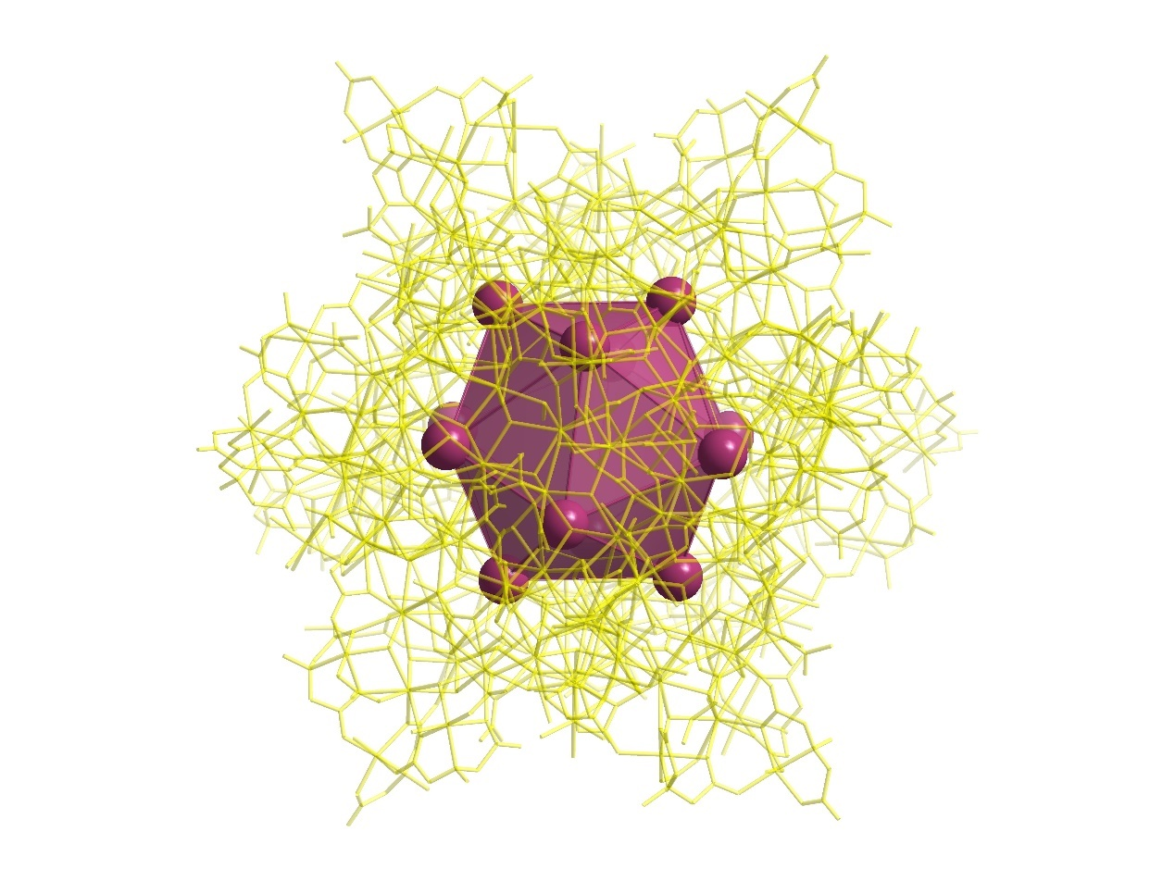
Figure S21. The view of compound Br₁₂@Gd₁₅₈Co₃₈ templated by [Br₁₂]¹²⁻. Color code: plum, Br.
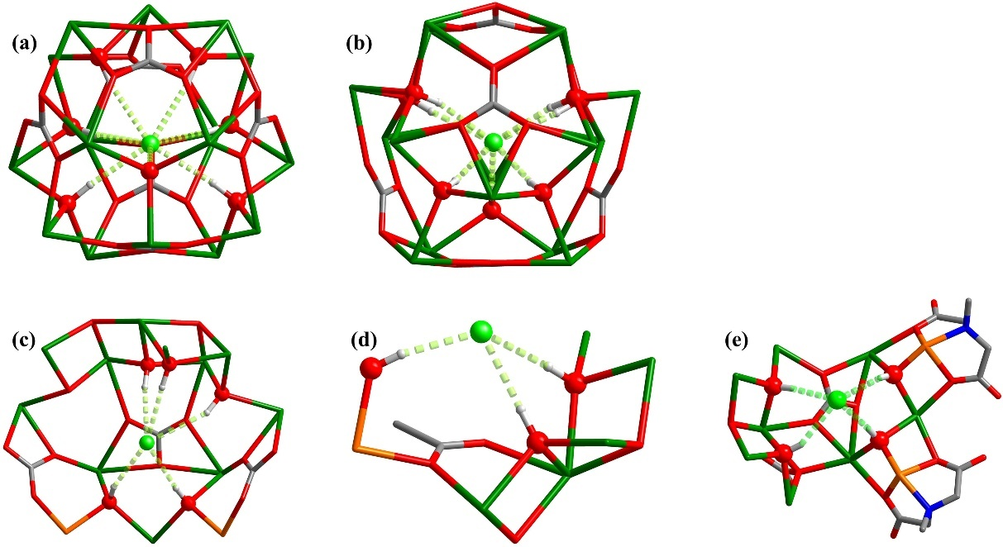
Figure S22. Ball-and-stick view of Gd₁₆(CO₃)₆(μ₃-OH)₇ templated by crystallographically independent Cl1 (a) and Cl2 (b); ball-and-stick view of Gd₁₁Co₂(CO₃)₃(μ₃-OH)₈ is templated by crystallographically independent Cl3 (c); Gd₅Co(OAC)(μ₃-OH)₅ is templated by crystallographically independent Cl4 (d); Gd₈Co₂(MIDA)₂(CO₃)₂(μ₃-OH)₅ is templated by crystallographically independent Cl5 (e).
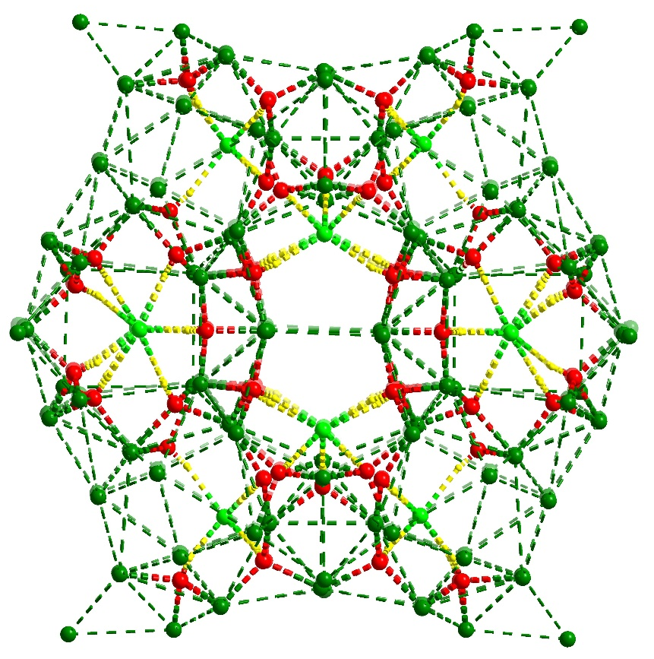
Figure S23. The view of Gd₁₅₈ core templated by [Cl₁₂]¹²⁻ anion template. Color code: bright green, Cl; red, O; green, Gd; bond with yellow, Cl···H.
As shown in Figure S19, Cl₁₂@Gd₁₅₈Co₃₈ was induced by 30 Cl⁻ ions, which act as anion templates and play the important role in the assembly of metal frame. Interesting, Cl1 and Cl2 are found in the inside of the metal structure. Cl3, Cl4, and Cl5 are distributed in the periphery of metal skeleton. Gd₁₆(CO₃)₆(μ₃-OH)₇ unit is templated by Cl1 (Figure S22a); Gd₁₆(CO₃)₆(μ₃-OH)₇ is templated by Cl2 (Figure S22b); Gd₁₁Co₂(CO₃)₃(μ₃-OH)₈ is templated by Cl3 (Figure S22c); Gd₅Co(OAC)(μ₃-OH)₅ is templated by Cl4 (Figure S22d); Gd₈Co₂(MIDA)₂(CO₃)₂(μ₃-OH)₅ is templated by Cl5 (Figure S22e). (Cl···O from 3.08 Å to 3.69 Å, Cl···H-O from 155.15° to 176.16°).

Section 4. Characterization

PXRD
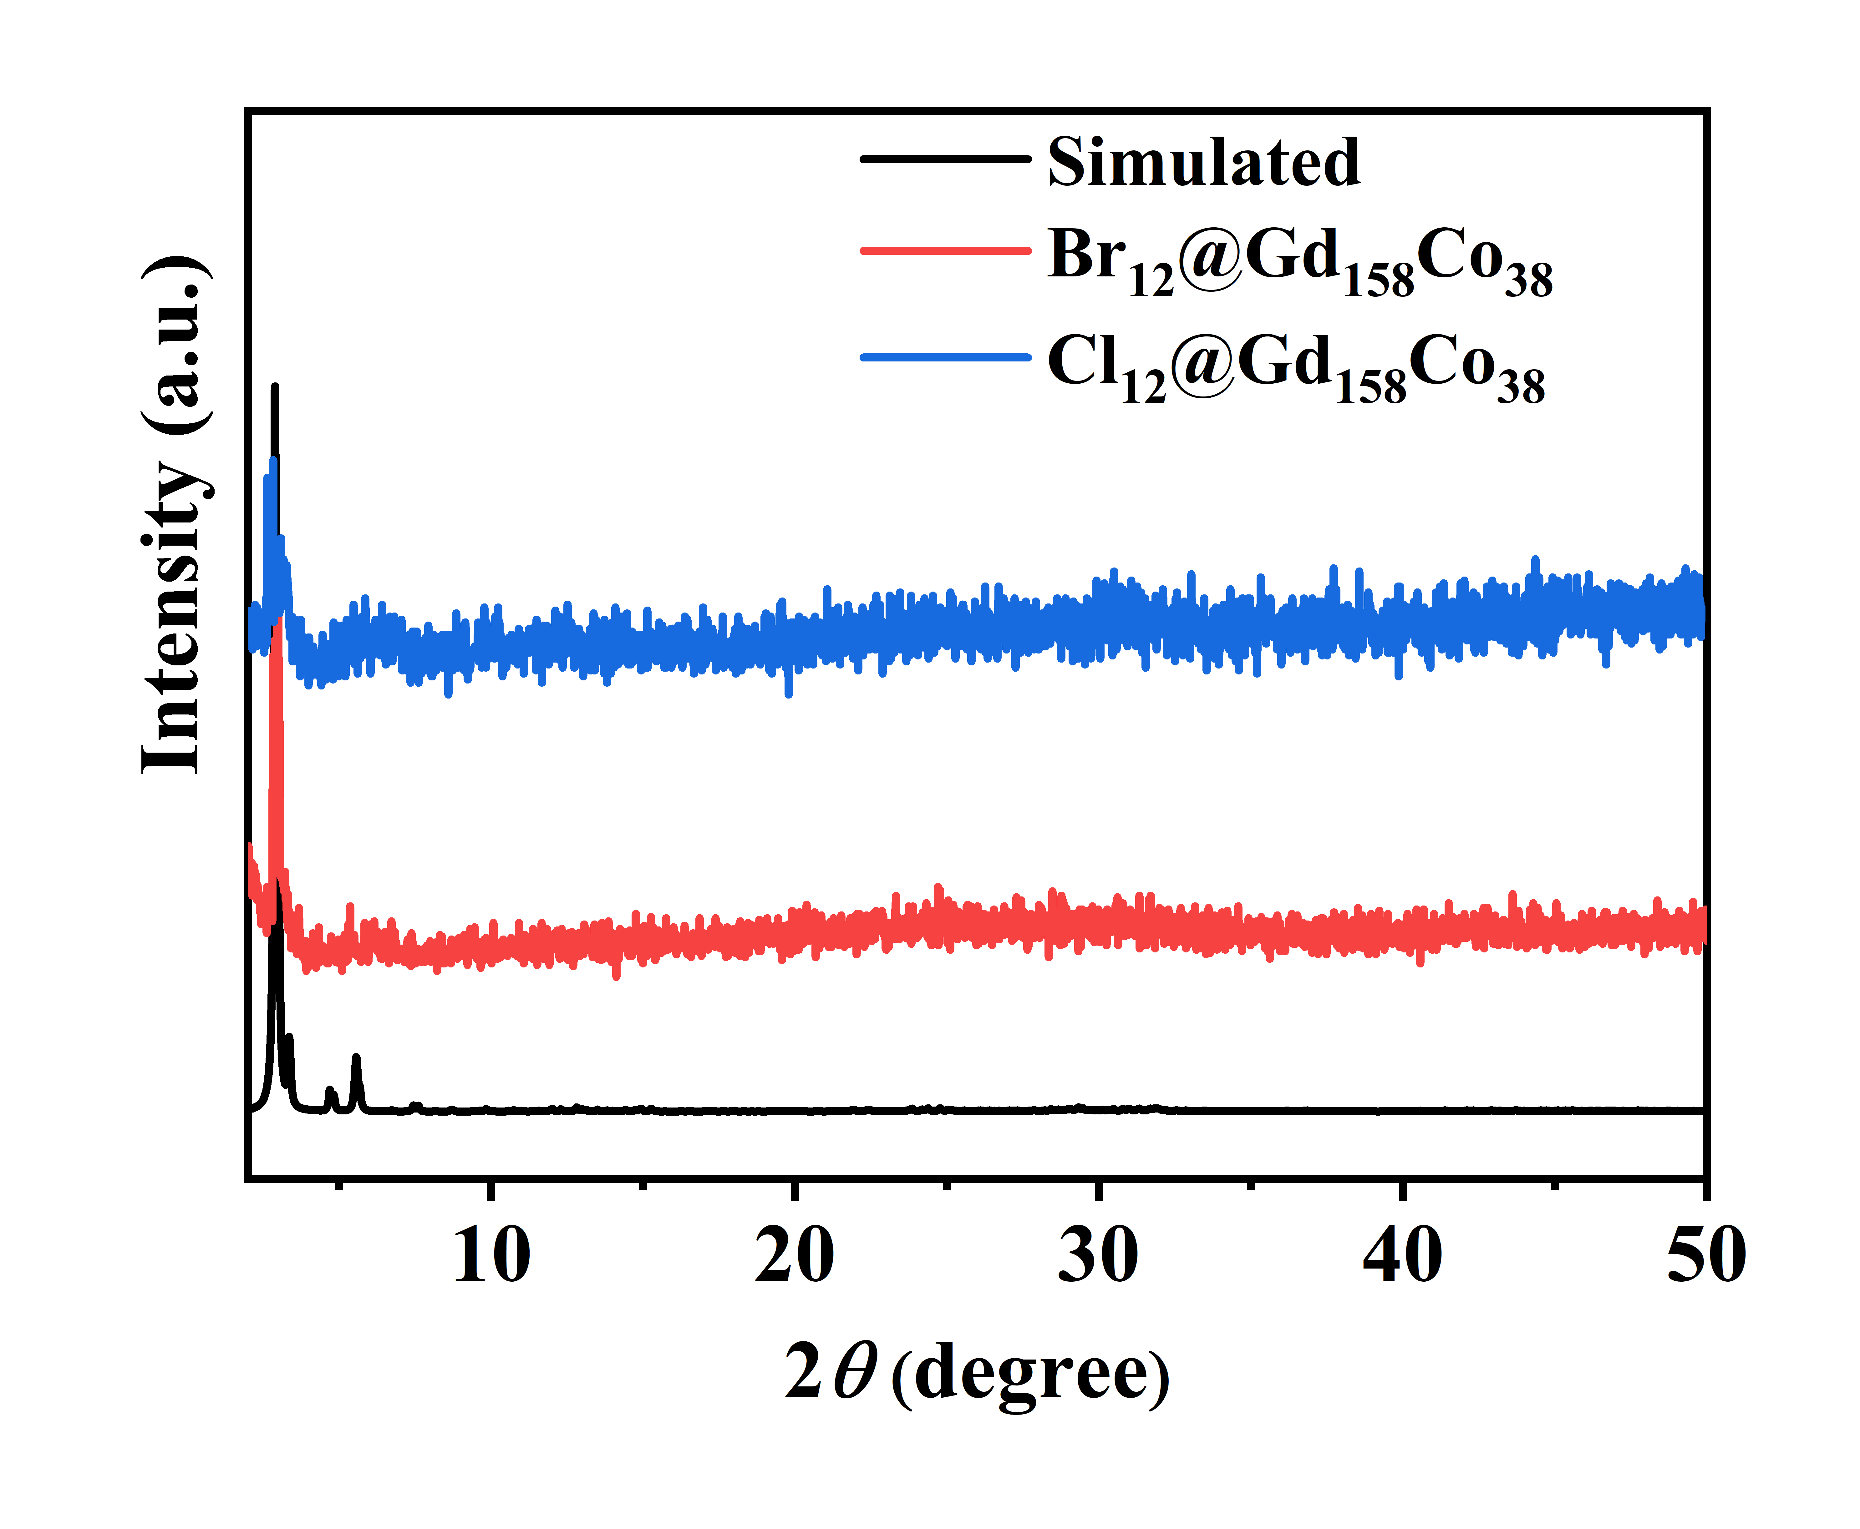
Figure S24. The simulated and experimental PXRD patterns of Cl₁₂@Gd₁₅₈Co₃₈ and Br₁₂@Gd₁₅₈Co₃₈.
PXRD curves were measured with crystalline powder at room temperature. As shown in Figures S24, the experimental curves are likely to the simulated patterns, suggesting that the acquired crystals were pure materials. Meanwhile, the similar curves of Cl₁₂@Gd₁₅₈Co₃₈ and Br₁₂@Gd₁₅₈Co₃₈ imply that the structure of two compounds are semblable.

FT-IR
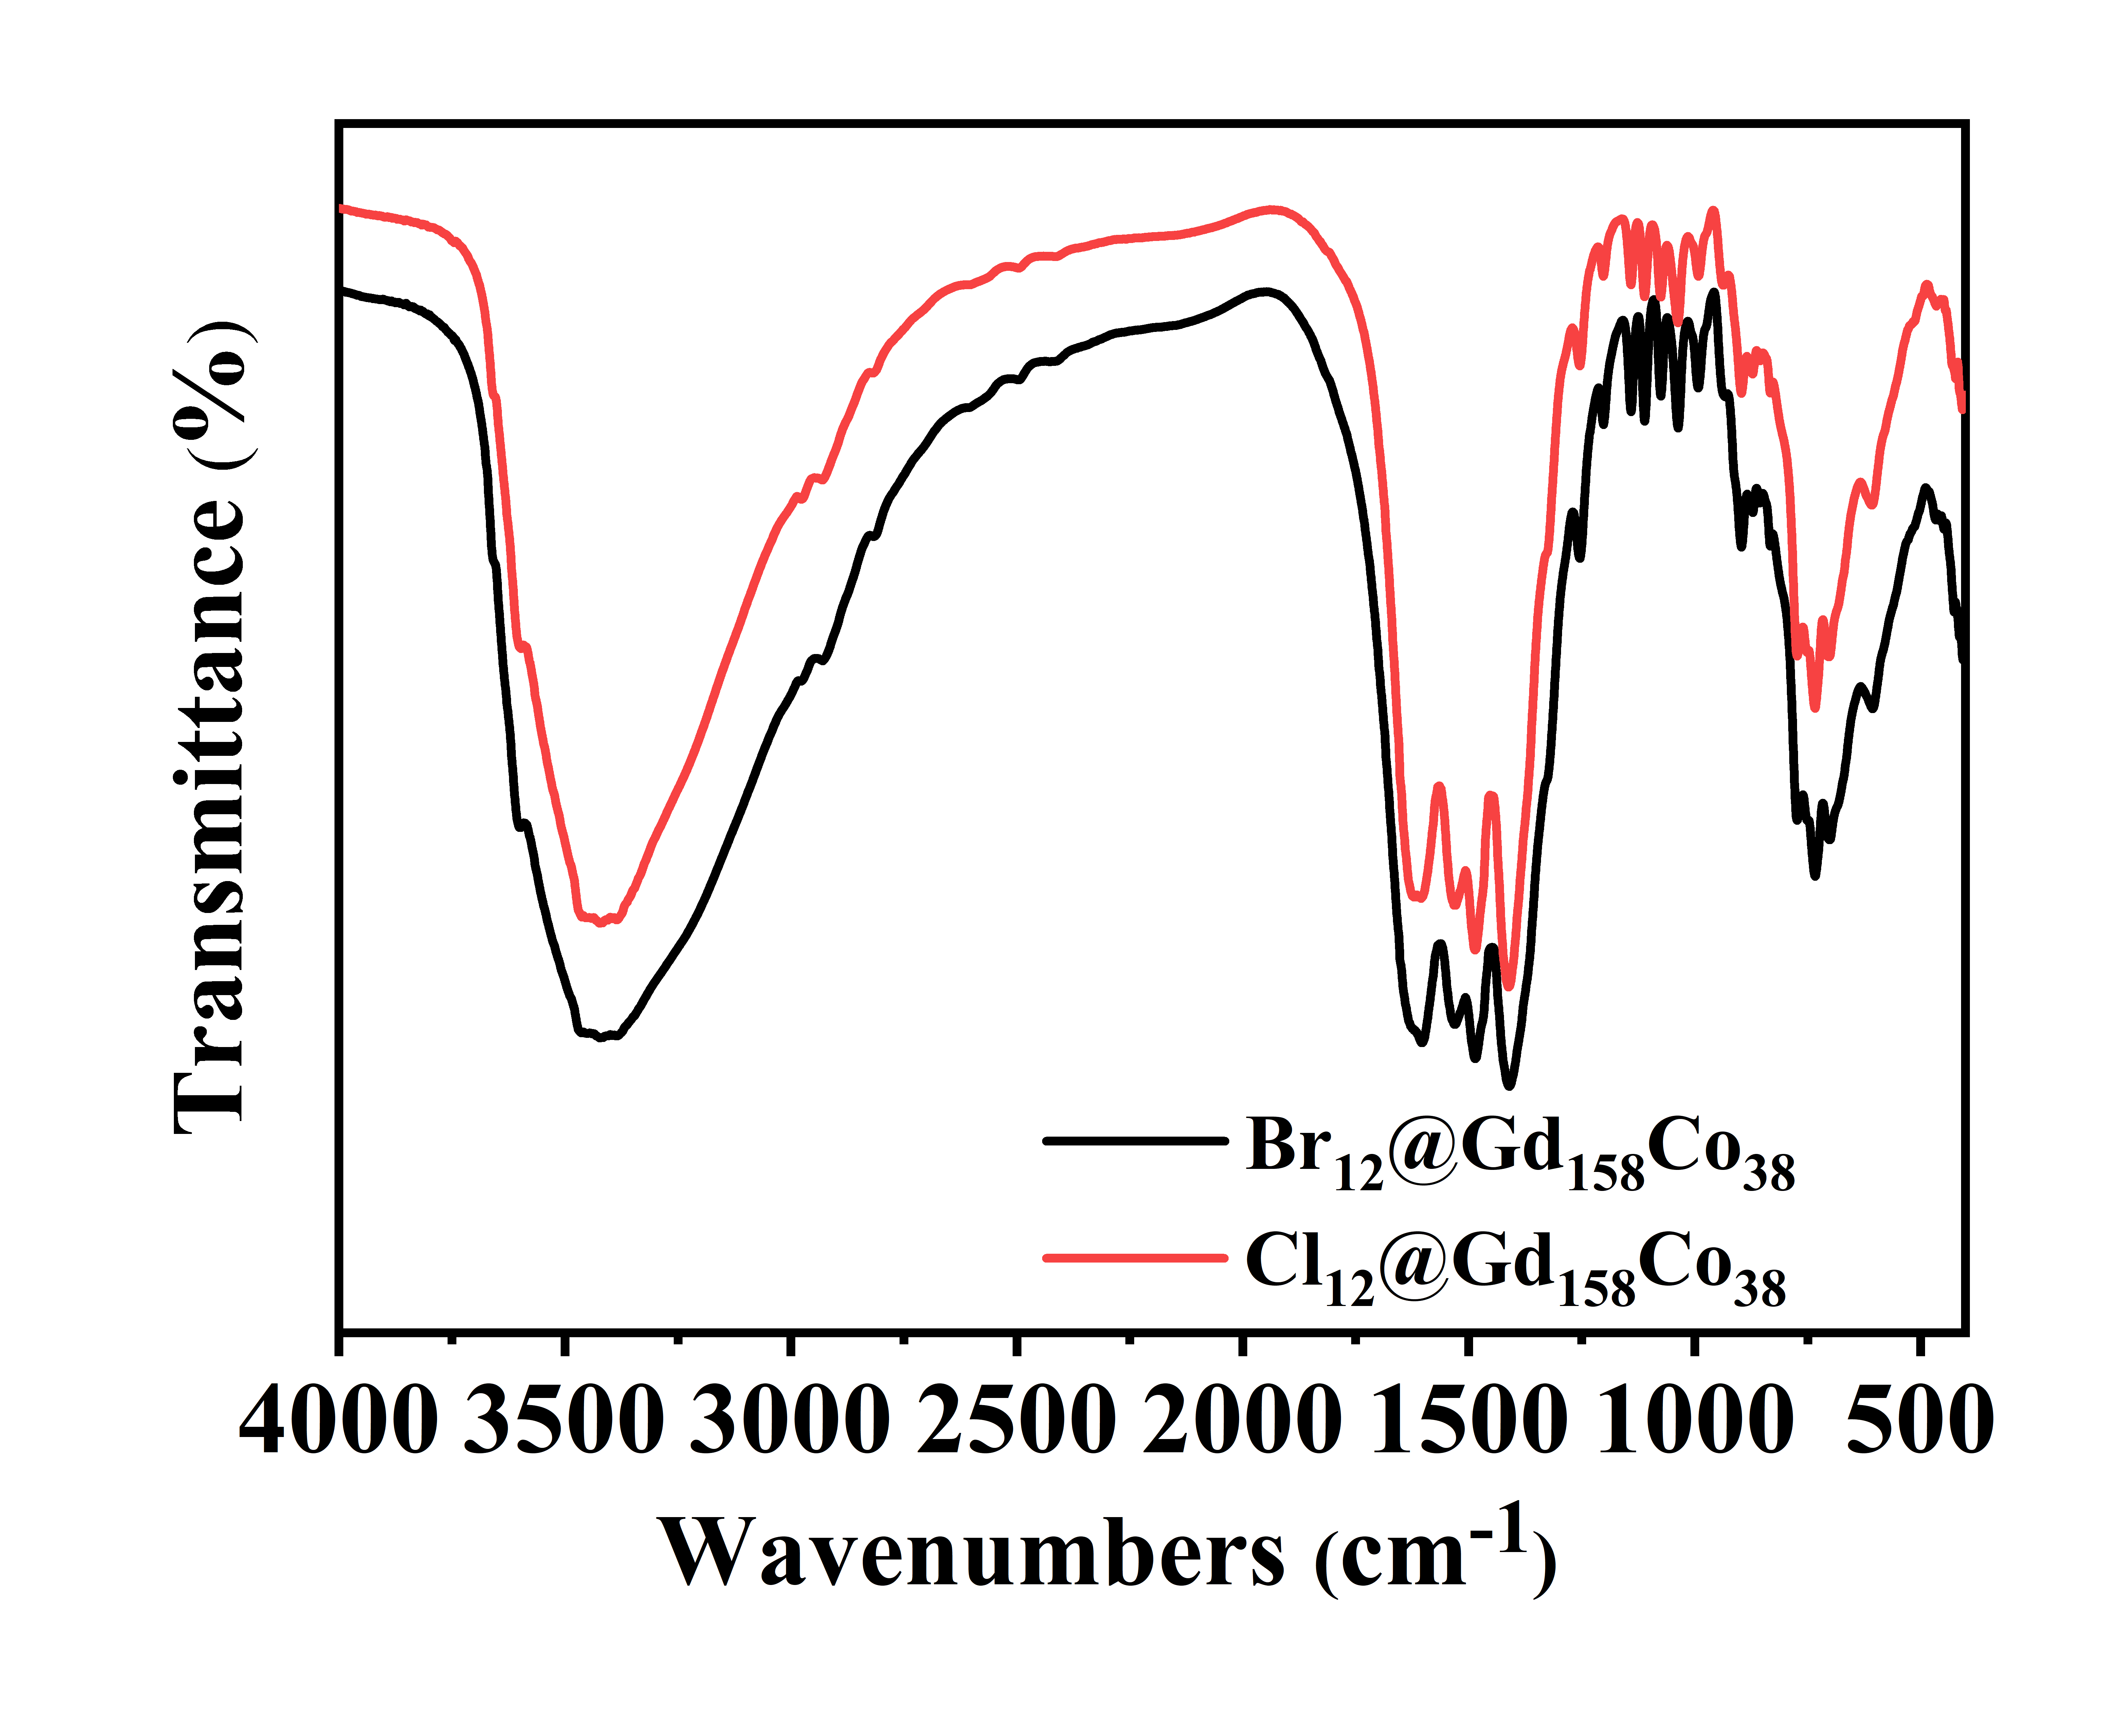
Figure S25. FT-IR spectra of of Cl₁₂@Gd₁₅₈Co₃₈ and Br₁₂@Gd₁₅₈Co₃₈.
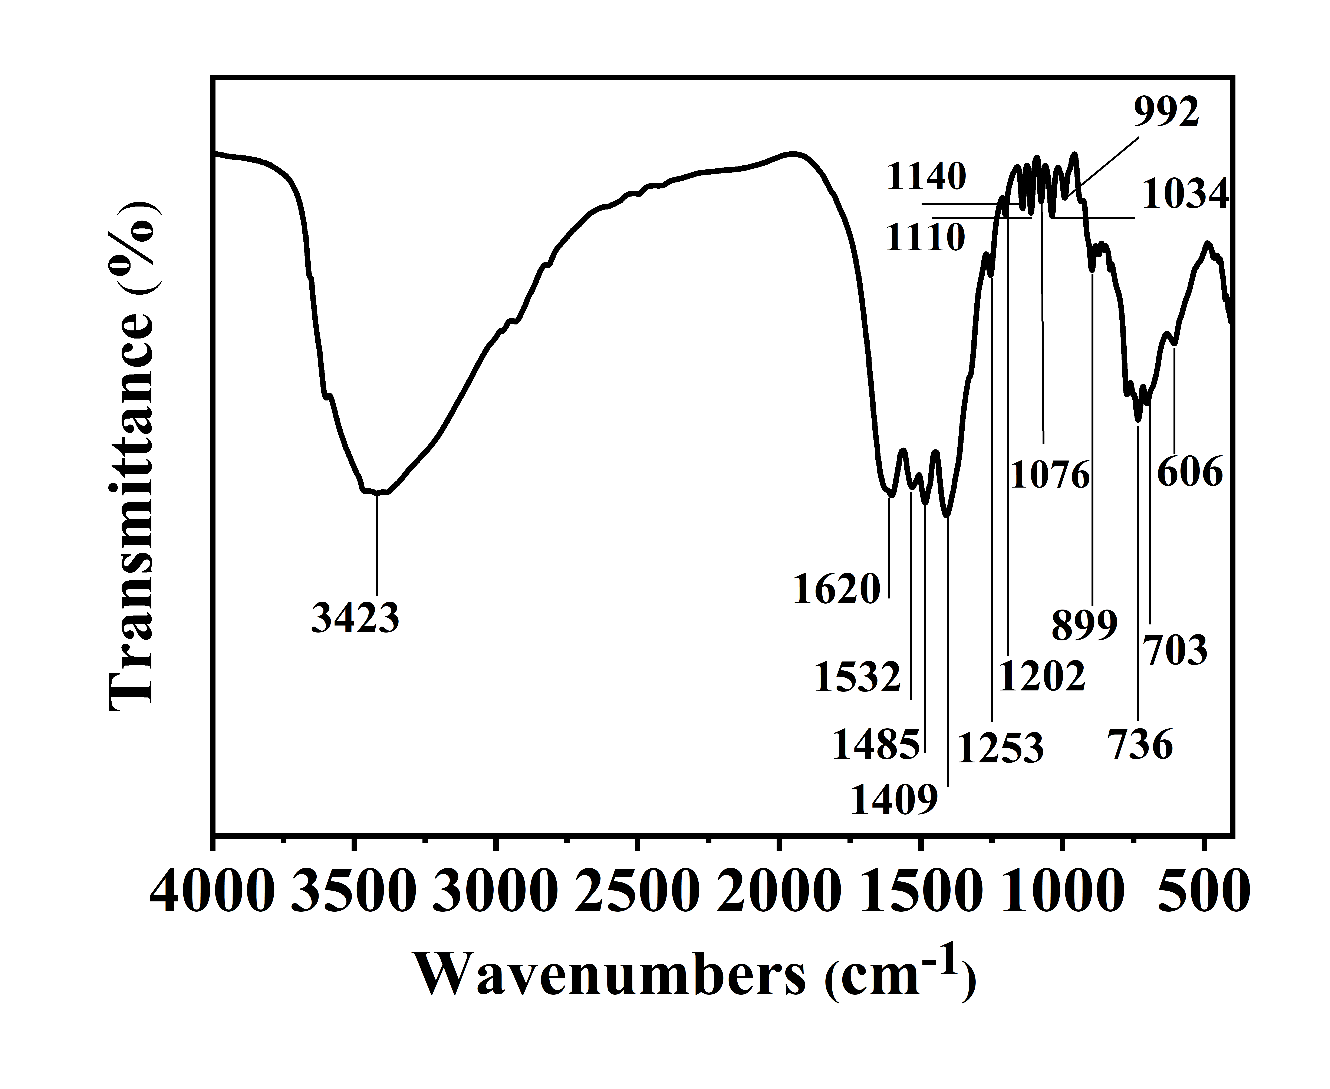
Figure S26. FT-IR spectra of Cl₁₂@Gd₁₅₈Co₃₈.
FT-IR spectra (Figure S25 – S26) of Cl₁₂@Gd₁₅₈Co₃₈ and Br₁₂@Gd₁₅₈Co₃₈ were acquired (v = 400 - 4000 cm⁻¹). Taking Cl₁₂@Gd₁₅₈Co₃₈ as an example, the strong and broad absorption band in the area around 3423 cm^{–1} can be considered as the -OH stretching vibration. The sharp peaks at 1620, 1532, and 1485 cm^{–1} are attributed to the -COO⁻ antisymmetric and symmetric stretching vibration. The peaks at 1409, and 1140 cm^{–1} are attributed to the presence of CO₃²⁻ groups. The peaks at 1110, and 1040 cm^{–1} are attributed to the C-O stretching vibration. Meanwhile, FT-IR spectra analysis suggested the no existence of NO₃²⁻ molecules due to no typical peaks of N=O at 1385 cm^{–1}. The phenomenon of the above characteristic peaks is accordance with those of analogous compounds documented in literature.^{1,2,6}

TGA
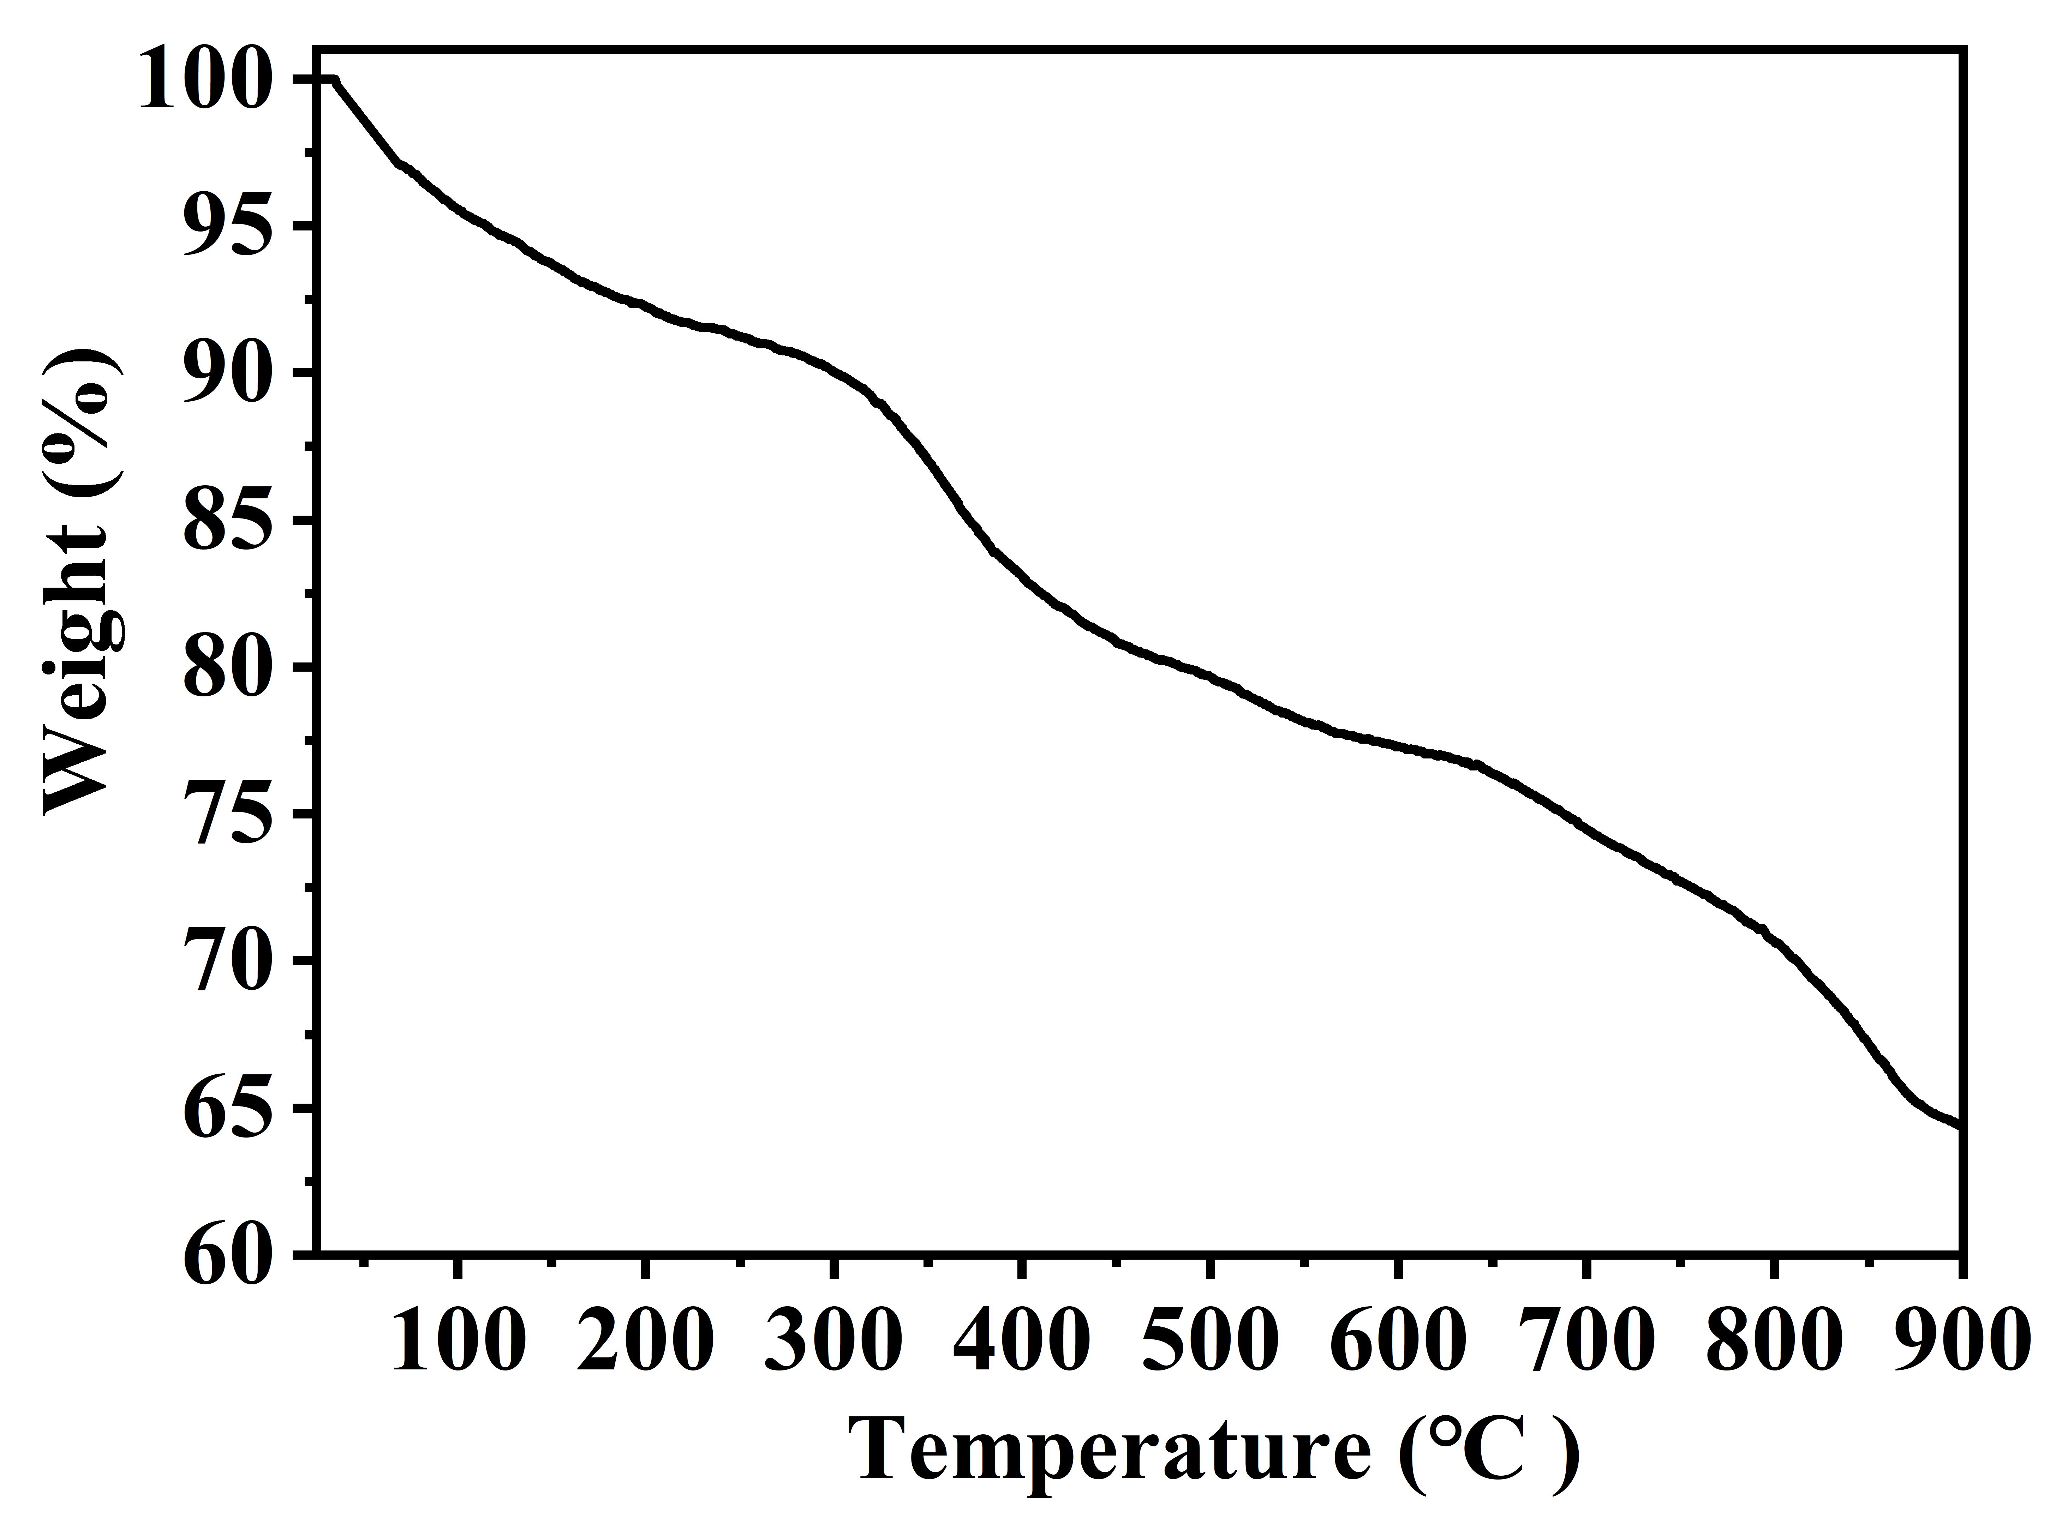
Figure S27. TGA curve of Cl₁₂@Gd₁₅₈Co₃₈.
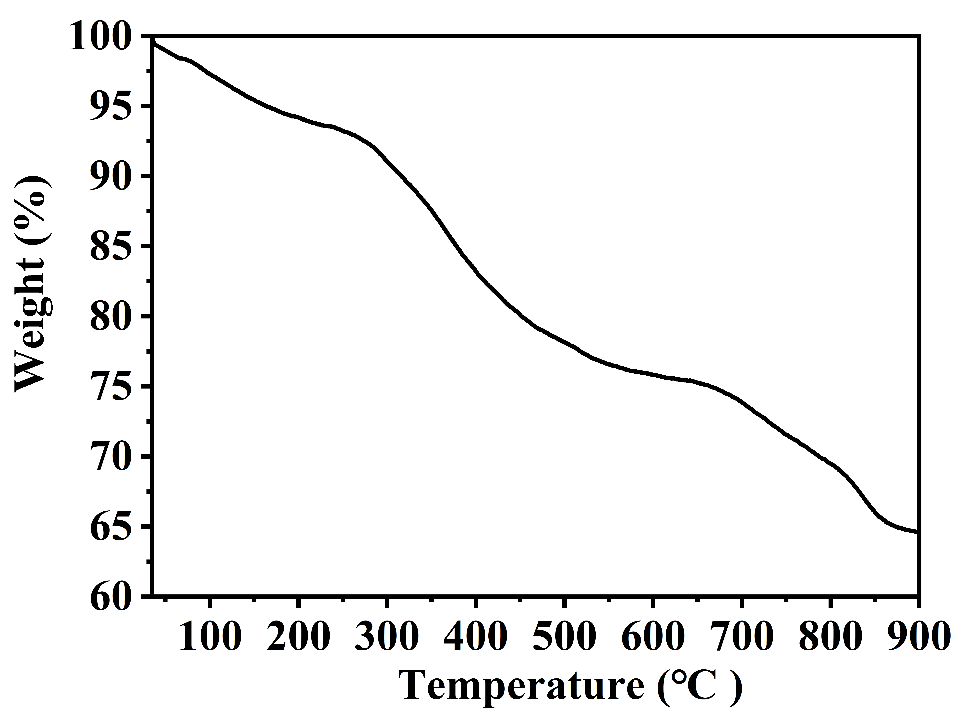
Figure S28. TGA curve of Br₁₂@Gd₁₅₈Co₃₈.
TGA was performed (T = 25 - 900 °C) in a N₂ atmosphere at a heating rate of 10 °C min^{–1} for Cl₁₂@Gd₁₅₈Co₃₈ and Br₁₂@Gd₁₅₈Co₃₈. As shown in Figures S27-28, the TGA diagrams of Cl₁₂@Gd₁₅₈Co₃₈ and Br₁₂@Gd₁₅₈Co₃₈ display two weight loss phases. For Cl₁₂@Gd₁₅₈Co₃₈, an initial weight loss between room temperature and 220 °C (8.29 %; calcd: 8.27 %), resulting from the removal of the 144 free H₂O and 84 coordination H₂O. The second weight loss between 220 °C and 900 °C is corresponding with the thermal decomposition of MIDA²⁻ and CO₃²⁻ ligands.
TGA analyses of Br₁₂@Gd₁₅₈Co₃₈ yielded similar results (Figure S28). The first stage of weight loss occurred between room temperature and 220 °C (6.24 %; calcd: 6.26 %), resulting from the removal of the 94 free H₂O and 78 coordination H₂O. The second weight loss between 220 °C and 900 °C is corresponding with the thermal decomposition of MIDA²⁻ and CO₃²⁻ ligands.

XRF
Table S2. The XRF data of Cl₁₂@Gd₁₅₈Co₃₈.
Component | mass%
Cl | 2.512

Table S3. The XRF data of Br₁₂@Gd₁₅₈Co₃₈.
Component | mass%
Cl | 0.907
Br | 3.033

EDS
Table S4. The Cl component of Cl₁₂@Gd₁₅₈Co₃₈ recorded from the EDS quantitative analyses.
component | Percentage by weight / %
Cl | 2.590

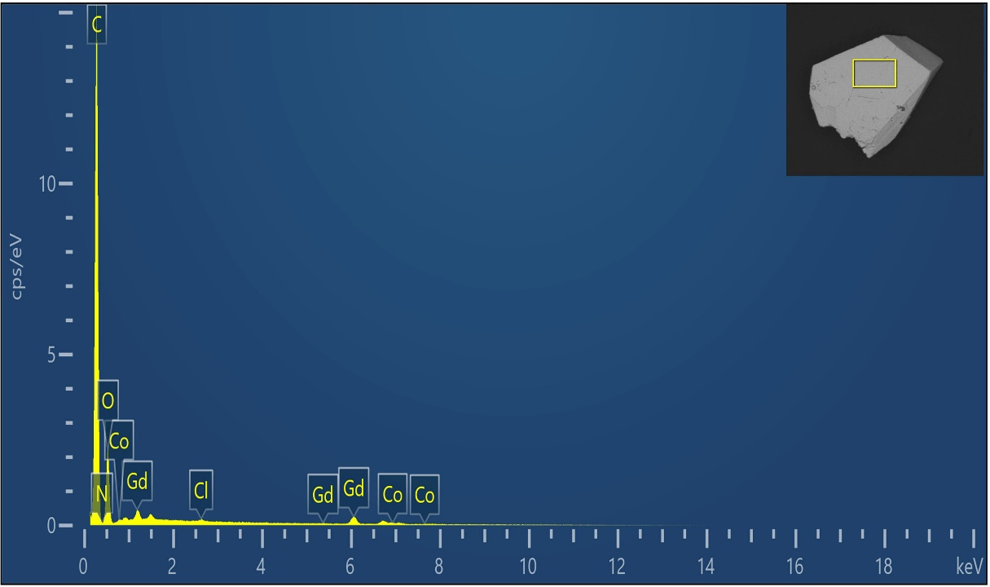
Figure S29. The EDS measurement of Cl₁₂@Gd₁₅₈Co₃₈.

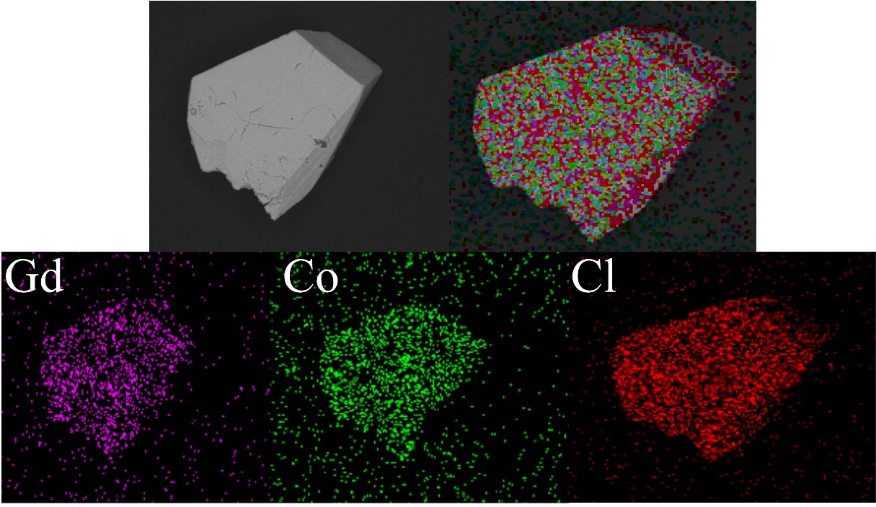
Figure S30. The SEM-EDS mapping of compound Cl₁₂@Gd₁₅₈Co₃₈.

Table S5. The Cl, Br components of Br₁₂@Gd₁₅₈Co₃₈ recorded from the EDS quantitative analyses.
component | Percentage by weight / %
Cl | 0.91
Br | 3.13
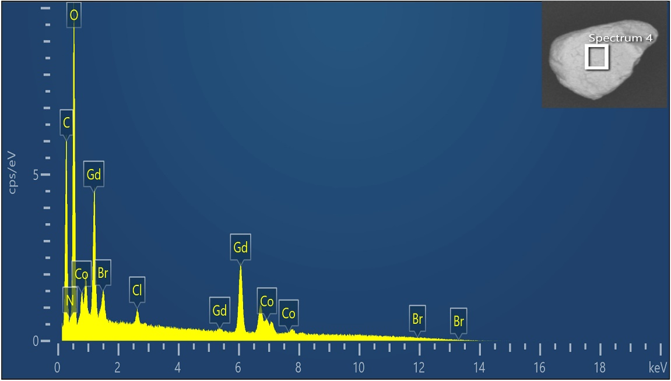
Figure S31. The EDS measurement of Br₁₂@Gd₁₅₈Co₃₈.

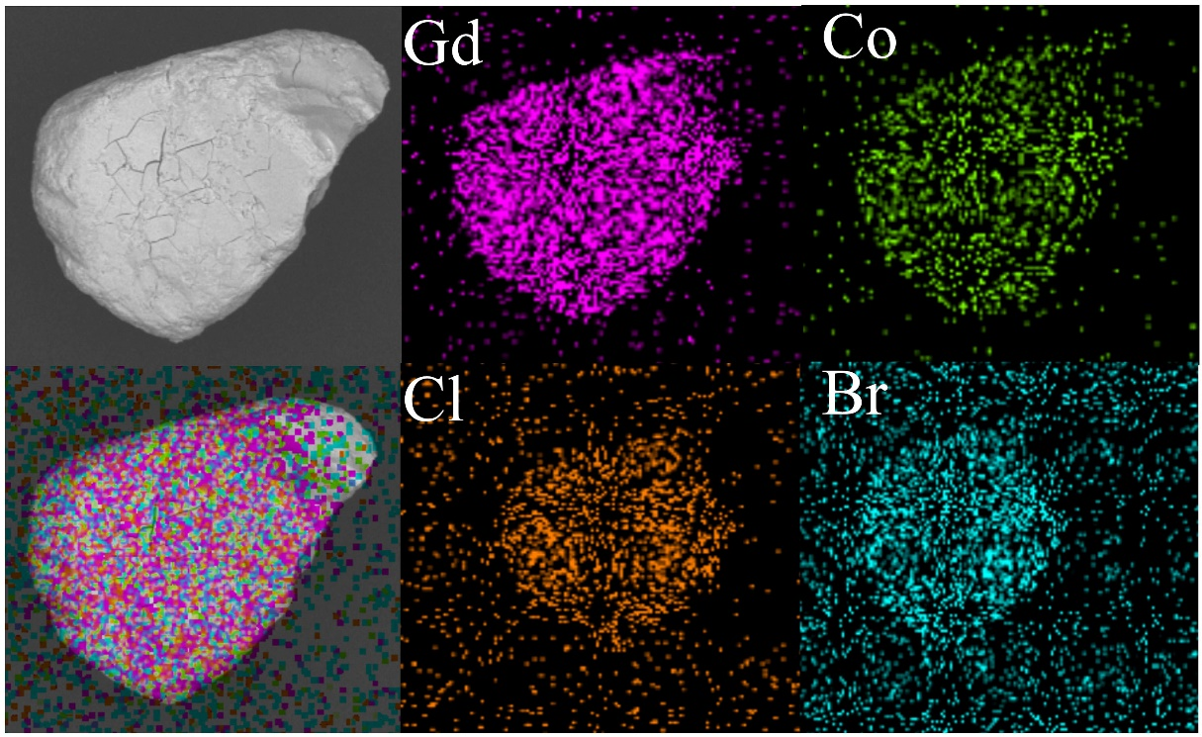
Figure S32. The SEM-EDS mapping of compound Br₁₂@Gd₁₅₈Co₃₈.

XPS
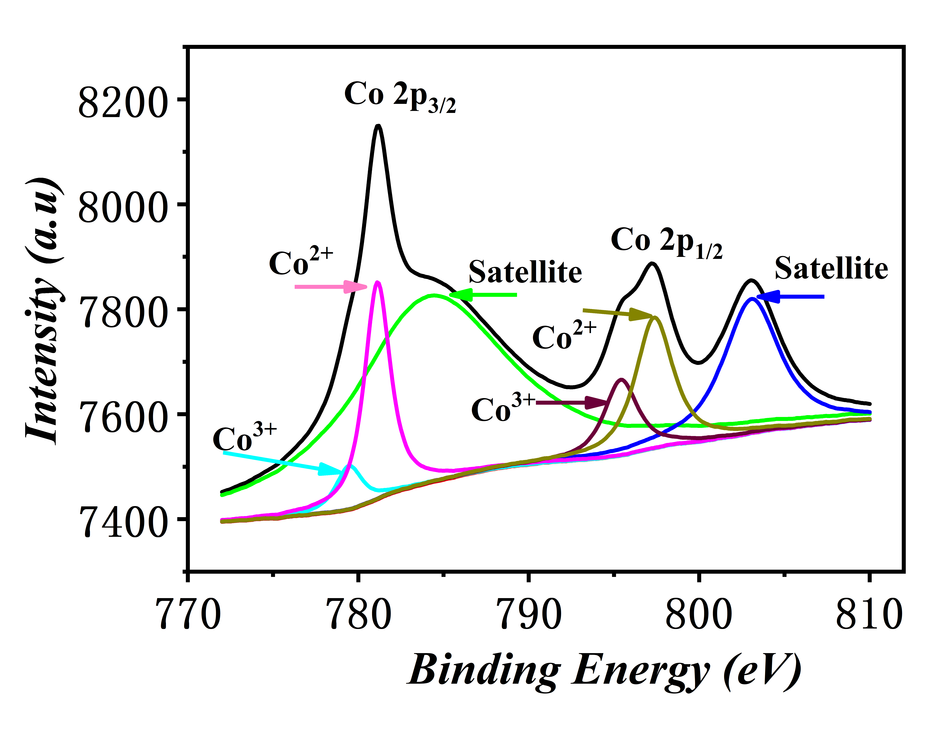
Figure S33. High resolution XPS spectra of Co 2p (d) of the as-synthesized Cl₁₂@Gd₁₅₈CO₃₈.
In the high resolution of Co 2p XPS spectrum (Figure S33), there are three fitting peaks at 780.05 eV (Co³⁺), 781.28 eV (Co²⁺), 783.81 eV (satellite) for Co 2p_{3/2}, and three fitting peaks at 796.09 eV (Co³⁺), 797.57 eV (Co²⁺), and 803.35 eV (satellite) for Co 2p_{1/2}, respectively.¹⁰⁻¹¹ The ratio of Co²⁺ and Co³⁺ can be determined to be about 2.8 by calculating the peak areas, which is consistent with the result obtained from the charge balance.

Section 5. Thermal Stability
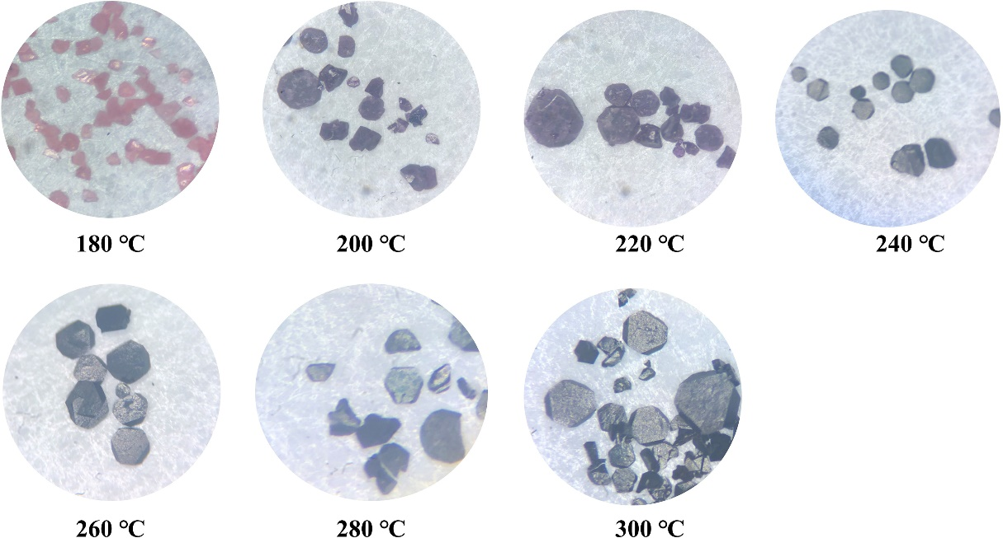
Figure S34. Coloration changes of Cl₁₂@Gd₁₅₈Co₃₈ at different temperatures.
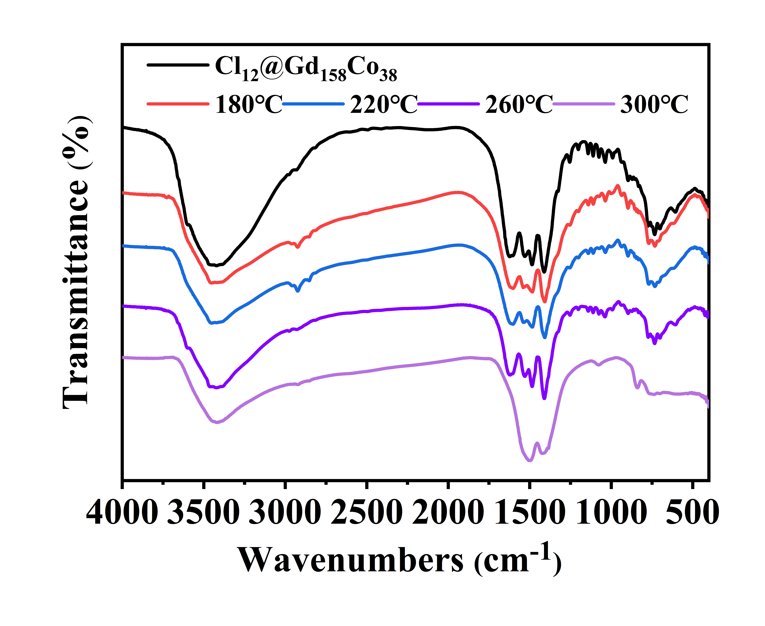
Figure S35. Variable-temperature FT-IR spectra for Cl₁₂@Gd₁₅₈Co₃₈.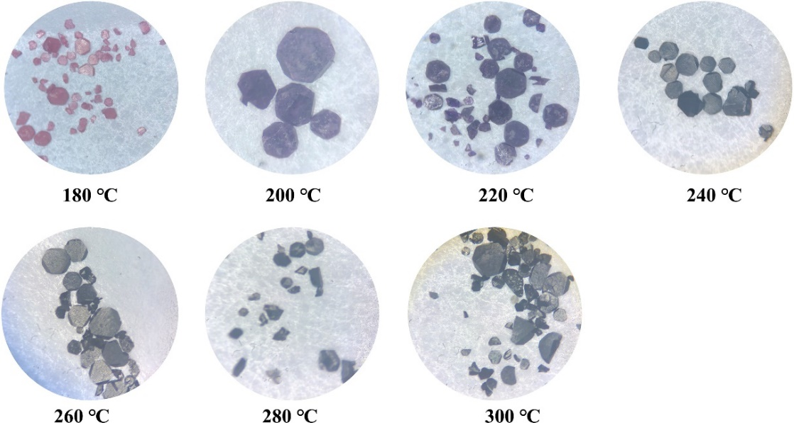
Figure S36. Coloration changes of Br₁₂@Gd₁₅₈Co₃₈ at different temperatures.
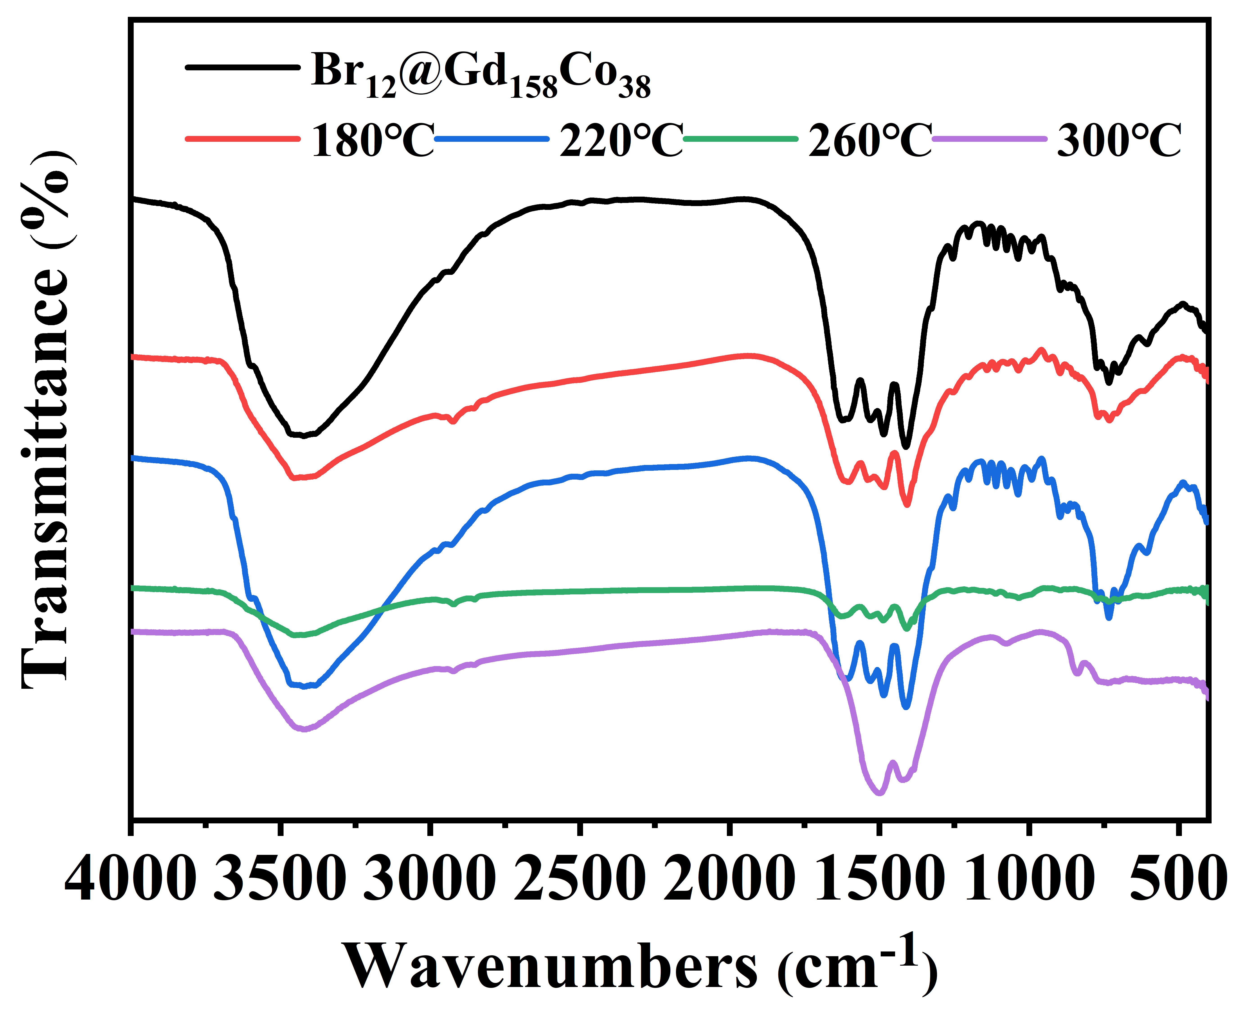
Figure S37. (a) Variable-temperature FT-IR spectra for Br₁₂@Gd₁₅₈Co₃₈.
In order to further understand the thermal stability, the single crystals Cl₁₂@Gd₁₅₈Co₃₈ and Br₁₂@Gd₁₅₈Co₃₈ were heated from 180 - 300 ℃. Here Cl₁₂@Gd₁₅₈Co₃₈ as the example to be discussed, owing to the similar result. As temperature rises, the pink crystals become dark, which is derived from the carbonization of MIDA²⁻ ligands (Figure S34, S36). Besides, the variable-temperature FT-IR spectra have been collected to study the thermal stability. As shown in Figure S35, S37, the characteristic peaks in the corresponding FT-IR spectra can be still kept. As the temperature rises to 300 °C, the ν(-COO⁻) vibration bands in IR spectra completely disappeared, which indicated the removal of CH₃COO⁻ and MIDA²⁻.

Section 6. Magnetic Studies
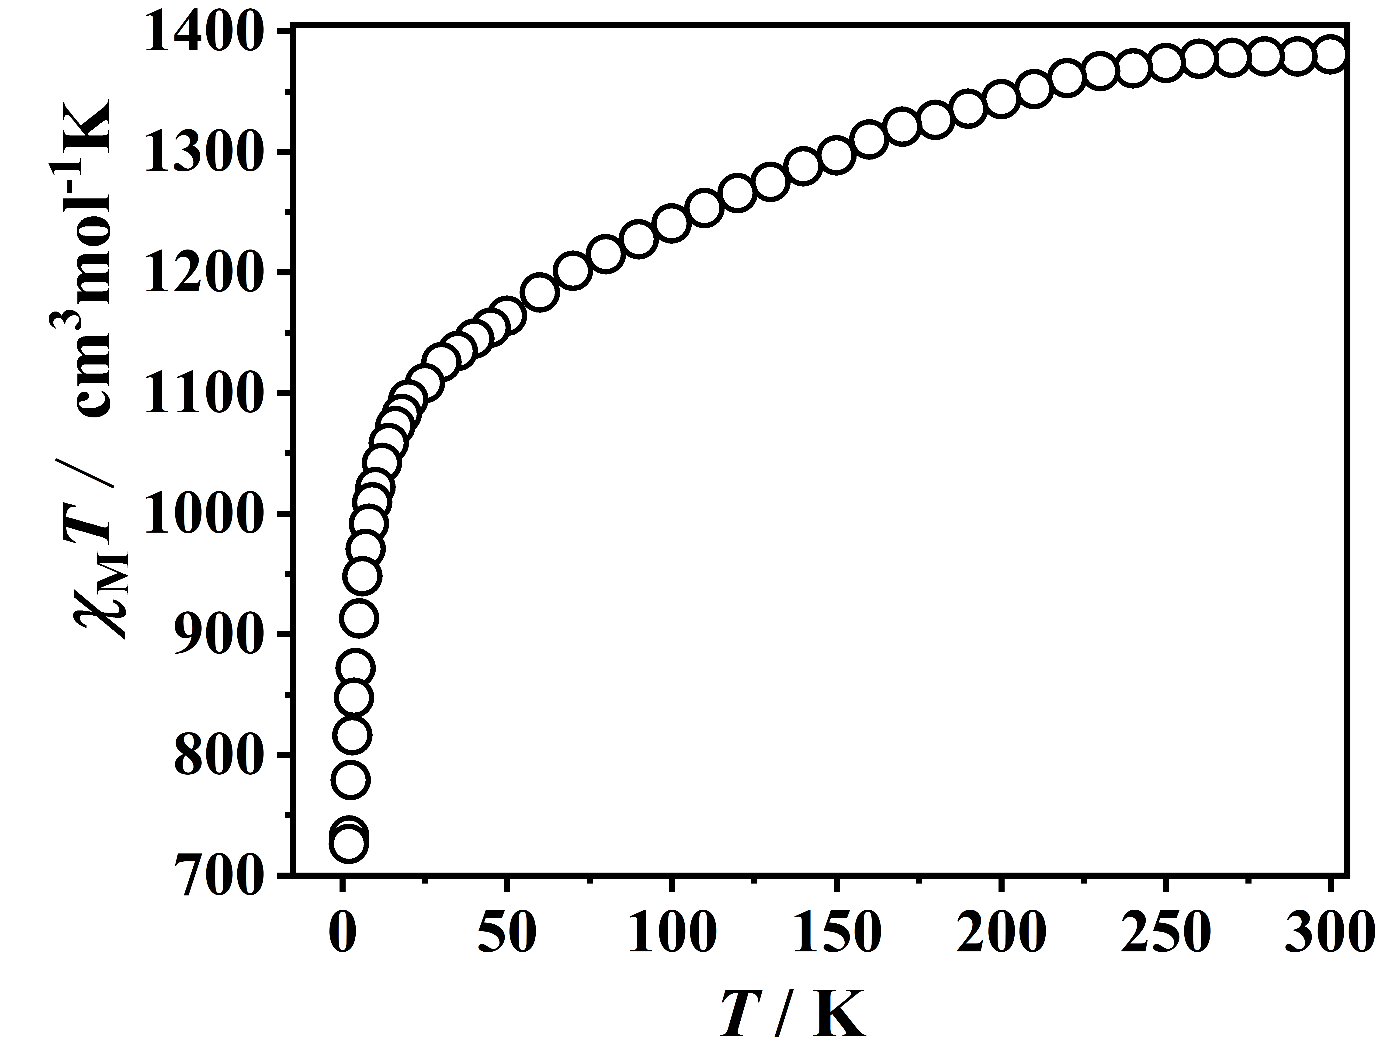
Figure S38. Magnetic susceptibility versus temperature from 1.8 to 300 K under 1.0 kOe dc field for Cl₁₂@Gd₁₅₈Co₃₈.
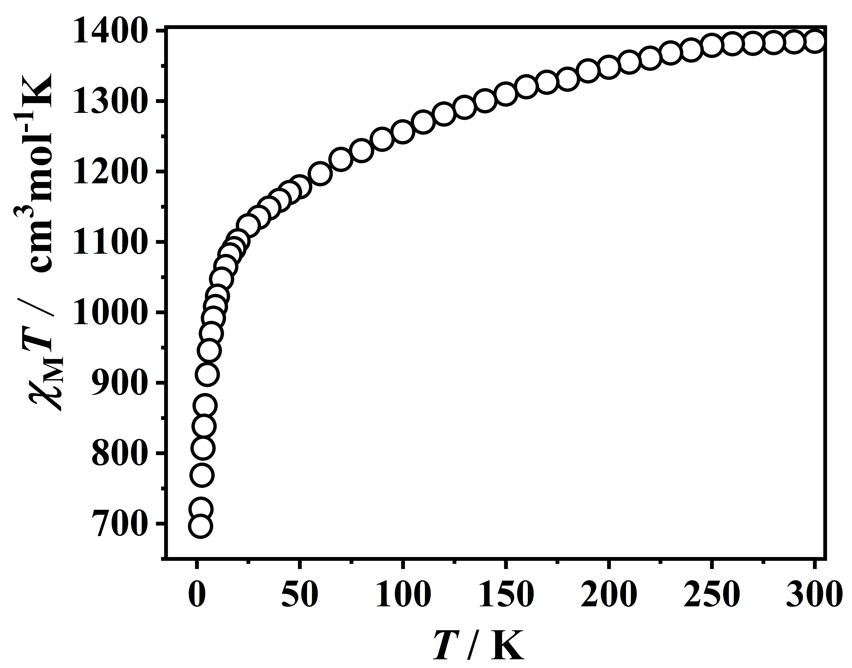
Figure S39. Magnetic susceptibility versus temperature from 1.8 to 300 K under 1.0 kOe dc field for Br₁₂@Gd₁₅₈Co₃₈.
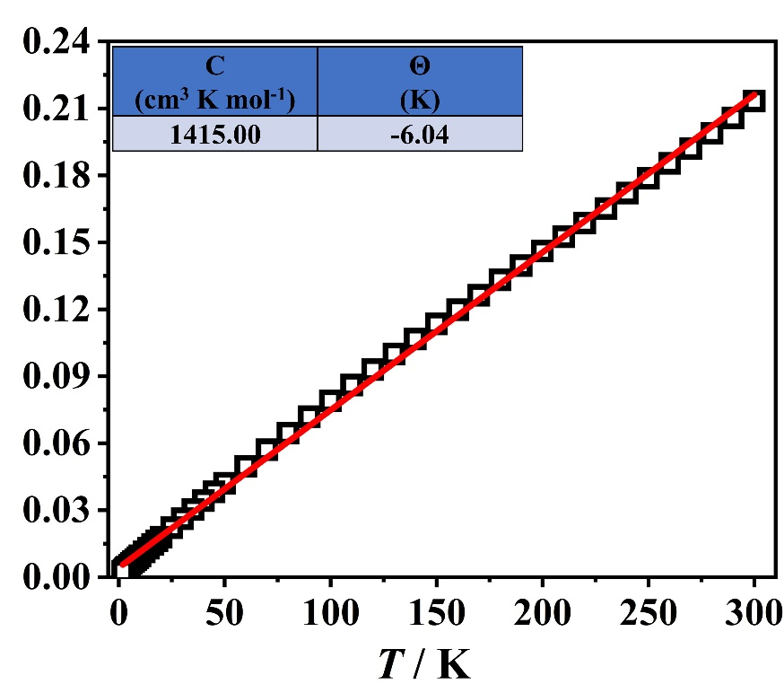
Figure S40. χ_{M}⁻¹ versus T plot of complex Cl₁₂@Gd₁₅₈Co₃₈. The red line is fitting result with χ_{M} = C /(T- θ).
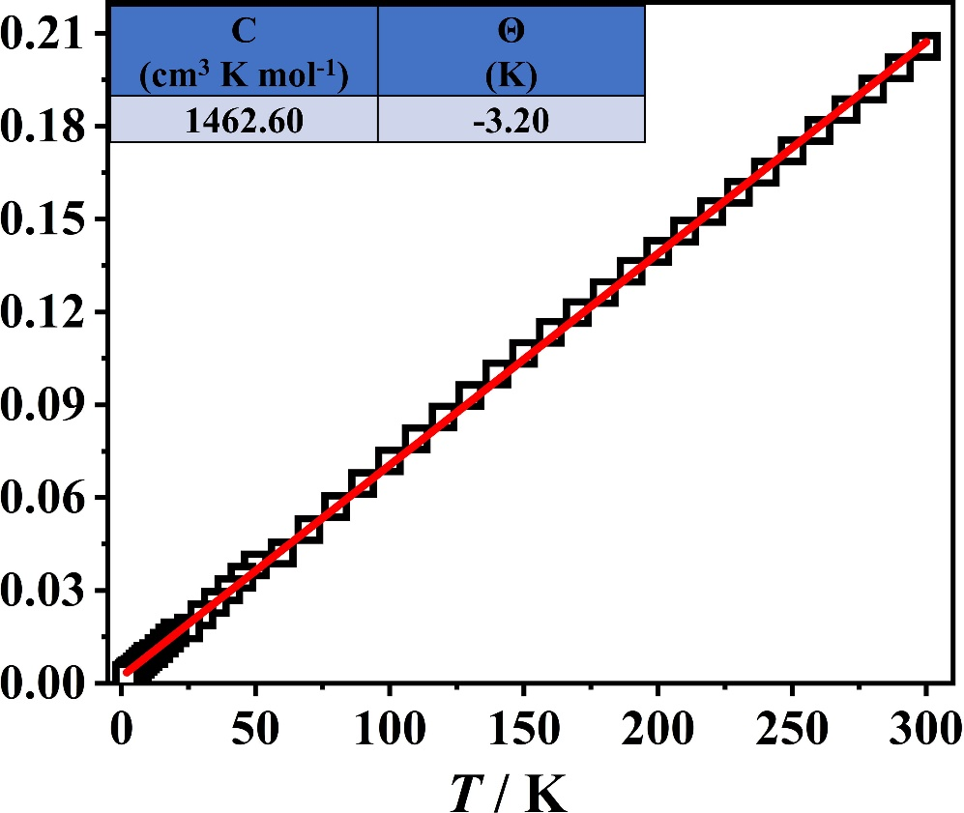
Figure S41. χ_{M}⁻¹ versus T plot of complex Br₁₂@Gd₁₅₈Co₃₈. The red line is fitting result with χ_{M} = C /(T- θ).
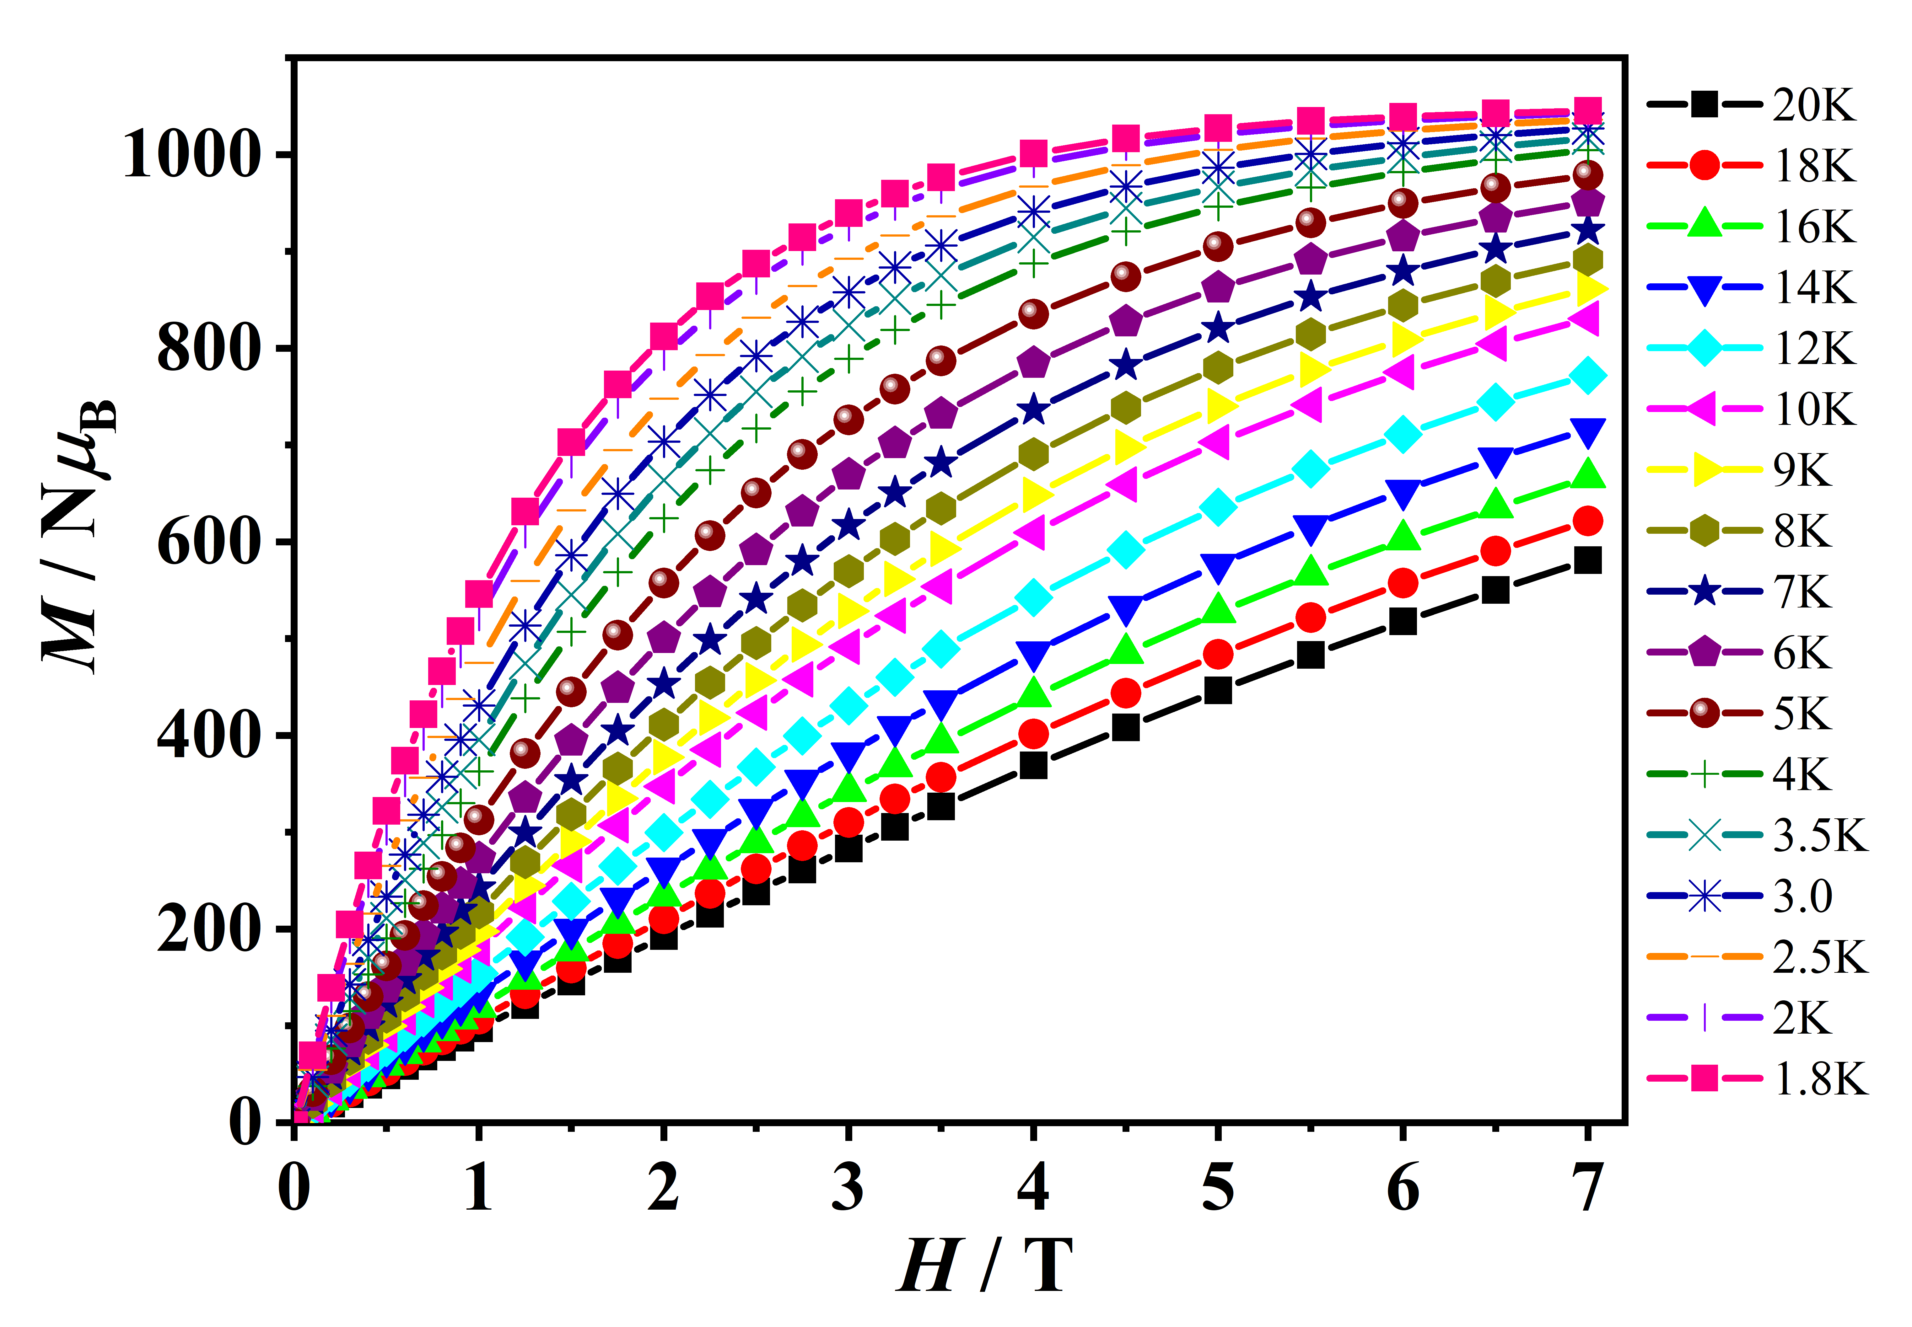
Figure S42. The isothermal field-dependence magnetization at low temperatures for Cl₁₂@Gd₁₅₈Co₃₈. (1.8 - 20 K).
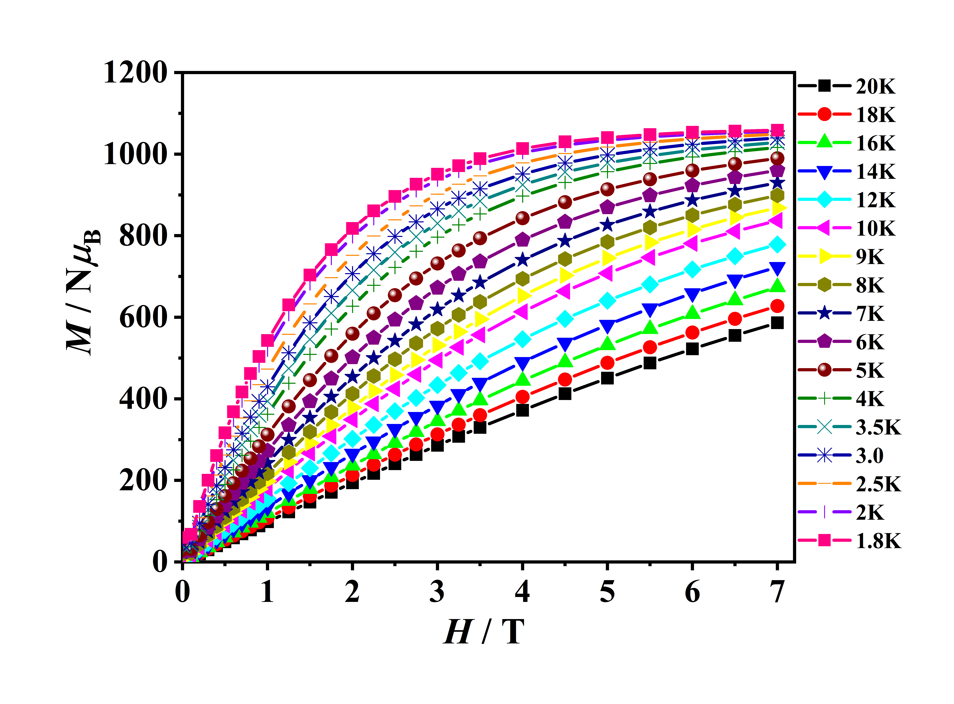
Figure S43. The isothermal field-dependence magnetization at low temperatures for Cl₁₂@Gd₁₅₈Co₃₈. (1.8 - 20 K).
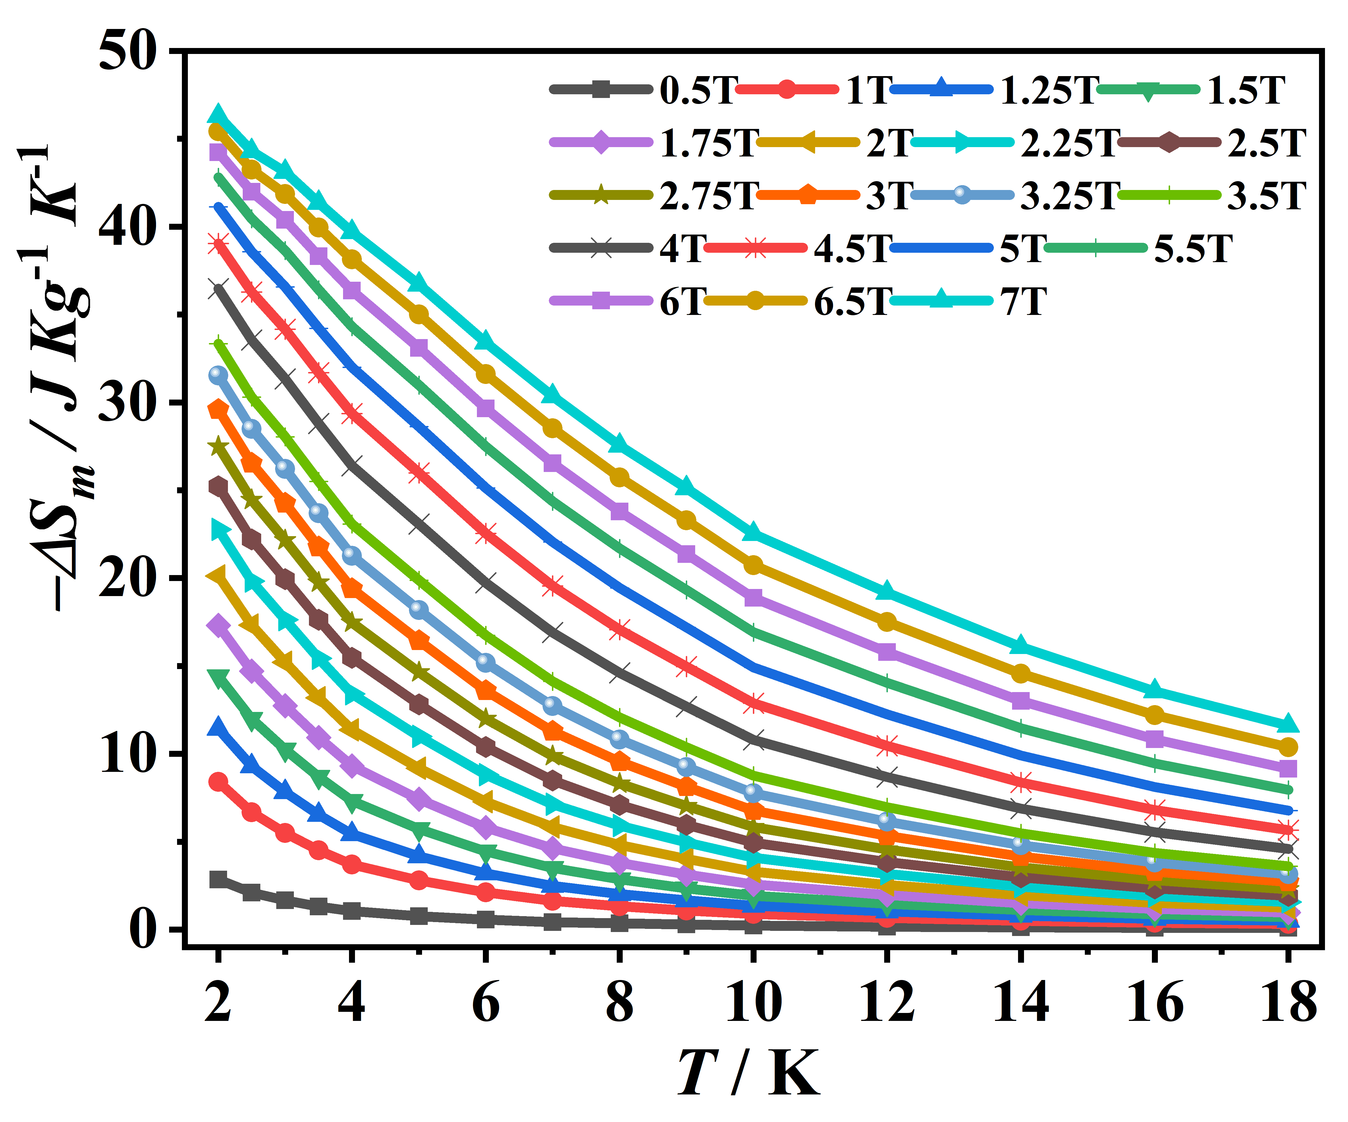
Figure S44. Values of -∆S_{m} calculated from the magnetization data for Cl₁₂@Gd₁₅₈Co₃₈ at various ﬁelds (0.50-7.00 T) and temperatures (1.8 - 18 K).

Table S6. Summary of some reported –ΔS_{m} for 3d–4f clusters.
Compound | –ΔS_{m}  (J kg^{–1} K^{–1}) | –ΔS_{m}  (J kg^{–1} K^{–1})  theoretical value | T  (K) | ΔH  (T) | Ref
{Cl₁₂@Gd₁₅₈Co₃₈} | 46.95 | 64.6 | 2.0 | 7.0 | This work
{Br₁₂@Gd₁₅₈Co₃₈} | 46.30 | 62.3 | 2.0 | 7.0 | This work
{Gd₉₆Ni₆₄} | 42.8 | 54.1 | 3.0 | 7.0 | 8
{Gd₁₀₂Ni₃₆} | 41.3 | 49.3 | 2.0 | 7.0 | 12
{Gd₅₂Ni₅₆} | 40.5 | 52.4 | 3.0 | 7.0 | 13
{Gd₇₈Ni₆₄} | 40.6 | 65.2 | 3.0 | 7.0 | 9
{Gd₄₂Co₁₀} | 41.3 | 51.9 | 2.0 | 7.0 | 14
{Gd₄₅Co₇} | 40.5 | 53.0 | 2.0 | 7.0 | 15
{Gd₃Cr₂} | 38.3 | 43.4 | 2.0 | 7.0 | 16
{Gd₄₅Ni₇} | 38.4 | 52.7 | 2.0 | 7.0 | 15
{Gd₄₂Ni₁₀} | 38.2 | 49.1 | 2.0 | 7.0 | 14
{Gd₄Ni₅} | 37.3 | 49.9 | 3.0 | 7.0 | 17
{Gd₁₈Co₇} | 36.9 | 43.8 | 2.0 | 7.0 | 18
{Gd₃₆Ni₁₂} | 36.3 | 64.8 | 3.0 | 7.0 | 19
{Gd₄₀Ni₄₄} | 36.0 | 61.2 | 3.0 | 7.0 | 6
{Gd₅₂Ni₅₂} | 35.6 | 62.3 | 4.2 | 7.0 | 20
{Gd₈Cr₄} | 33.8 | 50.0 | 2.0 | 7.0 | 21
{Gd₆Mn₄} | 33.7 | 41.8 | 3.0 | 7.0 | 22
{Gd₉Co₂} | 33.1 | 39.6 | 3.0 | 7.0 | 23
{Gd₁₀Co₄} | 32.6 | 41.9 | 2.0 | 7.0 | 24
{Gd₄Co₅} | 31.0 | 54.5 | 3.5 | 7.0 | 17
{Gd₈Co₆} | 28.6 | 47.6 | 3.0 | 7.0 | 25
{Gd₉Mn₉} | 28.0 | 41.8 | 3.0 | 7.0 | 26
{Gd₆Co₂} | 27.8 | 31.3 | 3.0 | 7.0 | 23
{Gd₆Cu₆} | 27.4 | 28.3 | 3.0 | 7.0 | 27
{Gd₆Ni₆} | 26.5 | 37.4 | 3.0 | 7.0 | 28
{Gd₂₄Co₁₆} | 26.0 | 44.6 | 3.8 | 7.0 | 29
{Gd₅Cr₂} | 25.2 | 34.5 | 5.0 | 7.0 | 21
{Gd₆Cu₆} | 23.5 | 28.3 | 2.3 | 9.0 | 30
{Gd₄Ni₈} | 23.0 | 34.4 | 3.8 | 7.0 | 31
{Gd₇Cu₁₅} | 22.2 | 33.5 | 2.5 | 9.0 | 32
{Gd₂₄Cu₃₆} | 21.0 | 35.7 | 2.1 | 7.0 | 33
{Gd₄Co₈} | 19.9 | 48.3 | 4.0 | 7.0 | 31

Table S7. Summary some -∆S_{m} at low-field for published Gd-based heterometallic metal clusters.
Compound | -ΔS_{m}  (J·kg⁻¹·K⁻¹)  2.0 T | -ΔS_{m}  (J·kg⁻¹·K⁻¹)  1.0 T | T  (K) | Ref
{1-(Gd₁₈Ni₂₄)_{n}} | 20.95 | 12.25 | 2.0 | 34
{Cl₁₂@Co₃₈Gd₁₅₈} | 20.81 | 8.83 | 2.0 | This work
{Br₁₂@Co₃₈Gd₁₅₈} | 20.13 | 8.39 | 2.0 | This work
{Ni₂₁Gd₂₀} | 19.8 | 14.1 | 2.0/1.1 | 35
{Ni₆₄Gd₉₆} | 17 | 7.0 | 3.0 | 8
{Co₄Gd₁₀} | 15 | 3.7 | 3.0 | 24
{Co₁₀Gd₄₂} | 14 | 5.0 | 2.0 | 14
{Ni₁₀Gd₄₂} | 13.5 | 4.8 | 2.0 | 14
{Mn₄Gd₆} | 13.5 | 5.0 | 2.0 | 22

Section 6. Tables
Table S8. The selected bond lengths (Å) and bond angles (°) for Cl₁₂@Gd₁₅₈Co₃₈.
Gd(1)-O(12) | 2.415(12) | Gd(6)-O(53)#4 | 2.531(13) | Co(1)-O(91)#3 | 2.021(16)
Gd(1)-O(58)#1 | 2.429(12) | Gd(6)-O(3) | 2.860(12) | Co(1)-O(48) | 2.069(13)
Gd(1)-O(46)#2 | 2.434(12) | Gd(7)-O(95)#1 | 2.389(15) | Co(1)-O(13W) | 2.091(17)
Gd(1)-O(19) | 2.485(12) | Gd(7)-O(40) | 2.384(12) | Co(1)-O(10A) | 2.091(17)
Gd(1)-O(55)#1 | 2.492(12) | Gd(7)-O(14) | 2.384(12) | Co(1)-O(110) | 2.117(15)
Gd(1)-O(2) | 2.483(12) | Gd(7)-O(54) | 2.397(13) | Co(1)-O(111) | 2.119(18)
Gd(1)-O(10) | 2.482(12) | Gd(7)-O(68) | 2.451(13) | Co(1)-N(7) | 2.17(2)
Gd(1)-O(47) | 2.491(12) | Gd(7)-O(39) | 2.453(12) | Co(2)-O(108) | 2.042(14)
Gd(1)-O(13) | 2.519(12) | Gd(7)-O(57) | 2.484(14) | Co(2)-O(8W) | 2.043(15)
Gd(2)-O(86)#3 | 2.314(13) | Gd(7)-O(94)#1 | 2.516(14) | Co(2)-O(80) | 2.076(13)
Gd(2)-O(11) | 2.360(12) | Gd(8)-O(23)#1 | 2.407(11) | Co(2)-O(73) | 2.118(13)
Gd(2)-O(10) | 2.380(13) | Gd(8)-O(5) | 2.414(12) | Co(2)-N(4) | 2.154(17)
Gd(2)-O(46)#2 | 2.411(11) | Gd(8)-O(62) | 2.421(13) | Co(2)-O(28) | 2.240(14)
Gd(2)-O(27)#2 | 2.419(12) | Gd(8)-O(19)#1 | 2.432(12) | Co(3)-O(116) | 2.018(16)
Gd(2)-O(1) | 2.439(12) | Gd(8)-O(64) | 2.438(12) | Co(3)-O(10B) | 2.082(16)
Gd(2)-O(51)#1 | 2.512(12) | Gd(8)-O(47)#1 | 2.450(12) | Co(3)-O(12W) | 2.082(16)
Gd(2)-O(18) | 2.508(11) | Gd(8)-O(4)#1 | 2.487(12) | Co(3)-O(41) | 2.069(13)
Gd(3)-O(6) | 2.369(12) | Gd(8)-O(109) | 2.528(13) | Co(3)-O(89) | 2.106(17)
Gd(3)-O(23)#1 | 2.404(11) | Gd(8)-O(16)#1 | 2.772(12) | Co(3)-O(92) | 2.155(15)
Gd(3)-O(31) | 2.427(12) | Gd(8)-C(9A)#1 | 3.000(18) | Co(3)-N(6) | 2.17(2)
Gd(3)-O(55)#1 | 2.425(12) | Gd(9)-O(5) | 2.351(12) | Co(4)-O(83) | 2.098(14)
Gd(3)-O(62) | 2.423(12) | Gd(9)-O(118)#4 | 2.365(14) | Co(4)-O(83)#3 | 2.098(14)
Gd(3)-O(2) | 2.463(12) | Gd(9)-O(64) | 2.394(13) | Co(4)-O(83)#2 | 2.098(14)
Gd(3)-O(15) | 2.520(12) | Gd(9)-O(44) | 2.384(13) | Co(4)-O(10W) | 2.113(17)
Gd(3)-O(35) | 2.523(13) | Gd(9)-O(45) | 2.420(14) | Co(4)-O(10W)#2 | 2.113(18)
Gd(3)-O(21) | 2.833(13) | Gd(9)-O(61) | 2.424(12) | Co(4)-O(10W)#3 | 2.113(17)
Gd(4)-O(27) | 2.424(12) | Gd(9)-O(72) | 2.509(13) | Co(5)-O(84) | 2.091(14)
Gd(4)-O(27)#3 | 2.424(12) | Gd(9)-N(1) | 2.667(18) | Co(5)-O(49) | 2.111(12)
Gd(4)-O(27)#2 | 2.424(12) | Gd(10)-O(75)#4 | 2.378(13) | Co(5)-O(6W) | 2.137(17)
Gd(4)-O(11)#2 | 2.507(12) | Gd(10)-O(87)#2 | 2.389(14) | Co(5)-O(7W) | 2.125(16)
Gd(4)-O(11)#3 | 2.507(12) | Gd(10)-O(42)#4 | 2.371(14) | Co(5)-O(1W) | 2.108(17)
Gd(4)-O(11) | 2.507(12) | Gd(10)-O(76)#2 | 2.400(14) | Co(5)-O(42) | 2.096(14)
Gd(4)-O(25)#2 | 2.503(13) | Gd(10)-O(66) | 2.452(13) | Co(6)-O(82) | 2.057(15)
Gd(4)-O(25)#3 | 2.503(13) | Gd(10)-O(9) | 2.490(12) | Co(6)-O(52) | 2.033(15)
Gd(4)-O(25) | 2.503(13) | Gd(10)-O(84)#4 | 2.499(14) | Co(6)-O(36) | 2.056(13)
Gd(5)-O(67) | 2.329(13) | Gd(10)-O(79) | 2.525(12) | Co(6)-O(78) | 2.104(13)
Gd(5)-O(47) | 2.368(12) | Gd(10)-O(8) | 2.573(12) | Co(6)-N(5) | 2.162(18)
Gd(5)-O(55) | 2.392(11) | Gd(11)-O(9) | 2.334(12) | Co(6)-O(81) | 2.216(14)
Gd(5)-O(12) | 2.396(11) | Gd(11)-O(54) | 2.361(13) | Co(7)-O(101) | 2.062(15)
Gd(5)-O(58) | 2.415(12) | Gd(11)-O(57) | 2.366(13) | Co(7)-O(96) | 2.097(15)
Gd(5)-O(23) | 2.454(12) | Gd(11)-O(66) | 2.375(13) | Co(7)-O(70) | 2.132(13)
Gd(5)-O(51)#4 | 2.528(12) | Gd(11)-O(37) | 2.387(12) | Co(7)-O(100) | 2.116(15)
Gd(5)-O(18)#2 | 2.525(12) | Gd(11)-O(117) | 2.404(16) | Co(7)-N(2) | 2.189(18)
Gd(6)-O(7) | 2.383(12) | Gd(11)-O(24) | 2.419(13) | Co(7)-O(9W) | 2.22(2)
O(12)-Gd(1)-O(58)#1 | 74.1(4) | O(86)#3-Gd(2)-O(11) | 82.3(4) | O(91)#3-Co(1)-O(48) | 98.8(6)
O(58)#1-Gd(1)-O(46)#2 | 74.0(4) | O(11)-Gd(2)-O(10) | 133.4(4) | O(48)-Co(1)-O(13W) | 97.5(6)
O(58)#1-Gd(1)-O(19) | 137.6(4) | O(11)-Gd(2)-O(46)#2 | 119.3(4) | O(48)-Co(1)-O(10A) | 97.5(6)
O(46)#2-Gd(1)-O(19) | 139.1(4) | O(10)-Gd(2)-O(46)#2 | 69.9(4) | O(91)#3-Co(1)-O(110) | 91.1(6)
O(12)-Gd(1)-O(55)#1 | 72.2(4) | O(86)#3-Gd(2)-O(27)#2 | 152.3(4) | O(48)-Co(1)-O(110) | 85.8(6)
O(58)#1-Gd(1)-O(55)#1 | 68.1(4) | O(11)-Gd(2)-O(27)#2 | 70.2(4) | O(13W)-Co(1)-O(110) | 175.2(7)
O(46)#2-Gd(1)-O(55)#1 | 134.4(4) | O(10)-Gd(2)-O(27)#2 | 118.6(4) | O(10A)-Co(1)-O(110) | 175.2(7)
O(19)-Gd(1)-O(55)#1 | 69.7(4) | O(46)#2-Gd(2)-O(27)#2 | 53.4(4) | O(91)#3-Co(1)-O(111) | 177.2(7)
O(12)-Gd(1)-O(2) | 139.4(4) | O(86)#3-Gd(2)-O(1) | 93.0(4) | O(48)-Co(1)-O(111) | 84.0(6)
O(58)#1-Gd(1)-O(2) | 89.4(4) | O(11)-Gd(2)-O(1) | 68.4(4) | O(13W)-Co(1)-O(111) | 88.1(7)
O(46)#2-Gd(1)-O(2) | 137.2(4) | O(10)-Gd(2)-O(1) | 68.7(4) | O(10A)-Co(1)-O(111) | 88.1(7)
O(19)-Gd(1)-O(2) | 78.1(4) | O(46)#2-Gd(2)-O(1) | 80.6(4) | O(110)-Co(1)-O(111) | 88.7(7)
O(55)#1-Gd(1)-O(2) | 67.2(4) | O(27)#2-Gd(2)-O(1) | 80.0(4) | O(91)#3-Co(1)-N(7) | 98.0(8)
O(12)-Gd(1)-O(10) | 134.4(4) | O(86)#3-Gd(2)-O(51)#1 | 81.4(4) | O(48)-Co(1)-N(7) | 158.3(7)
O(58)#1-Gd(1)-O(10) | 72.1(4) | O(11)-Gd(2)-O(51)#1 | 139.6(4) | O(13W)-Co(1)-N(7) | 95.5(7)
O(46)#2-Gd(1)-O(10) | 67.8(4) | O(10)-Gd(2)-O(51)#1 | 80.3(4) | O(10A)-Co(1)-N(7) | 95.5(7)
O(19)-Gd(1)-O(10) | 136.1(4) | O(46)#2-Gd(2)-O(51)#1 | 90.2(4) | O(110)-Co(1)-N(7) | 80.3(7)
O(55)#1-Gd(1)-O(10) | 120.1(4) | O(27)#2-Gd(2)-O(51)#1 | 117.7(4) | O(111)-Co(1)-N(7) | 79.2(7)
O(2)-Gd(1)-O(10) | 69.6(4) | O(1)-Gd(2)-O(51)#1 | 149.0(4) | O(108)-Co(2)-O(8W) | 92.9(7)
O(12)-Gd(1)-O(47) | 68.0(4) | O(86)#3-Gd(2)-O(18) | 82.5(4) | O(108)-Co(2)-O(80) | 97.5(6)
O(58)#1-Gd(1)-O(47) | 134.5(4) | O(11)-Gd(2)-O(18) | 80.9(4) | O(8W)-Co(2)-O(80) | 98.1(6)
O(46)#2-Gd(1)-O(47) | 72.1(4) | O(10)-Gd(2)-O(18) | 139.6(4) | O(108)-Co(2)-O(73) | 87.8(6)
O(19)-Gd(1)-O(47) | 67.0(4) | O(46)#2-Gd(2)-O(18) | 116.2(4) | O(8W)-Co(2)-O(73) | 176.5(7)
O(55)#1-Gd(1)-O(47) | 120.1(4) | O(27)#2-Gd(2)-O(18) | 90.0(4) | O(80)-Co(2)-O(73) | 85.1(5)
O(2)-Gd(1)-O(47) | 136.0(4) | O(1)-Gd(2)-O(18) | 149.3(4) | O(108)-Co(2)-N(4) | 107.7(7)
O(10)-Gd(1)-O(47) | 119.7(4) | O(51)#1-Gd(2)-O(18) | 60.4(4) | O(8W)-Co(2)-N(4) | 96.1(7)

Table S9. The selected bond lengths (Å) and bond angles (°) for Br₁₂@Gd₁₅₈Co₃₈Br₁₈.
Gd(1)-O(12A) | 2.344(10) | Gd(5)-O(22B) | 2.409(9) | Gd(9)-O(33A) | 2.521(8)
Gd(1)-O(27B) | 2.359(9) | Gd(5)-O(23B) | 2.419(10) | Gd(9)-O(27A)#2 | 2.527(9)
Gd(1)-O(22B) | 2.365(9) | Gd(5)-O(26B) | 2.419(9) | Gd(9)-O(26A)#2 | 2.543(10)
Gd(1)-O(19A) | 2.405(9) | Gd(5)-O(32A)#3 | 2.449(9) | Gd(9)-O(1) | 2.551(9)
Gd(1)-O(21A) | 2.409(9) | Gd(5)-O(24A) | 2.492(9) | Gd(10)-O(34) | 2.350(9)
Gd(1)-O(25B) | 2.438(9) | Gd(5)-O(27A) | 2.505(9) | Gd(10)-O(12B) | 2.359(9)
Gd(1)-O(43A)#1 | 2.502(9) | Gd(5)-O(33A)#3 | 2.822(9) | Gd(10)-O(11B) | 2.360(10)
Gd(1)-O(20A)#2 | 2.516(9) | Gd(5)-C(11A)#3 | 3.035(14) | Gd(10)-O(24B) | 2.376(9)
Gd(1)-C(7A) | 2.874(13) | Gd(6)-O(44A) | 2.413(9) | Gd(10)-O(23B) | 2.392(9)
Gd(2)-O(19A) | 2.410(9) | Gd(6)-O(44A)#4 | 2.414(9) | Gd(10)-O(1C) | 2.478(10)
Gd(2)-O(45A)#1 | 2.413(9) | Gd(6)-O(44A)#1 | 2.414(9) | Gd(10)-O(1W) | 2.499(9)
Gd(2)-O(21A)#3 | 2.426(9) | Gd(6)-O(14A)#1 | 2.480(9) | Gd(10)-O(5A) | 2.648(11)
Gd(2)-O(32A)#4 | 2.473(9) | Gd(6)-O(14A) | 2.480(9) | Gd(11)-O(10B)#2 | 2.380(9)
Gd(2)-O(22A)#3 | 2.477(9) | Gd(6)-O(14A)#4 | 2.480(9) | Gd(11)-O(1B) | 2.382(9)
Gd(2)-O(27B) | 2.479(9) | Gd(6)-O(21B) | 2.487(9) | Gd(11)-O(1A) | 2.413(9)
Gd(2)-O(15B)#4 | 2.481(9) | Gd(6)-O(21B)#1 | 2.487(9) | Gd(11)-O(2A) | 2.417(9)
Gd(2)-O(22B)#3 | 2.493(9) | Gd(6)-O(21B)#4 | 2.487(9) | Gd(11)-O(11B)#2 | 2.444(9)
Gd(2)-O(17A) | 2.504(9) | Gd(7)-O(9B) | 2.384(9) | Gd(11)-O(24B)#2 | 2.455(9)
Gd(3)-O(11A)#1 | 2.316(9) | Gd(7)-O(28A) | 2.393(10) | Gd(11)-O(3B) | 2.466(10)
Gd(3)-O(15B)#1 | 2.369(9) | Gd(7)-O(12B) | 2.402(9) | Gd(11)-O(24A)#2 | 2.484(9)
Gd(3)-O(21B)#1 | 2.372(9) | Gd(7)-O(11B) | 2.441(9) | Gd(11)-O(33A) | 2.539(9)
Gd(3)-O(45A) | 2.405(9) | Gd(7)-O(8B) | 2.450(9) | Gd(12)-O(36B)#1 | 2.384(9)
Gd(3)-O(44A) | 2.417(9) | Gd(7)-O(7) | 2.501(9) | Gd(12)-O(18B) | 2.385(9)
Gd(3)-O(18B)#1 | 2.444(9) | Gd(7)-O(26A)#2 | 2.523(10) | Gd(12)-O(21B) | 2.418(9)
Gd(3)-O(20A)#5 | 2.501(9) | Gd(7)-O(25A)#2 | 2.530(9) | Gd(12)-O(19B) | 2.422(9)
Gd(3)-O(43A)#4 | 2.505(9) | Gd(7)-O(23A) | 2.555(9) | Gd(12)-O(20B) | 2.427(9)
Gd(3)-C(15A) | 2.879(14) | Gd(8)-O(14B) | 2.363(9) | Gd(12)-O(14A)#1 | 2.460(9)
Gd(3)-Gd(8)#1 | 3.8663(9) | Gd(8)-O(18B) | 2.383(9) | Gd(12)-O(15A) | 2.488(9)
Gd(4)-O(25B) | 2.405(9) | Gd(8)-O(15B) | 2.414(9) | Gd(12)-O(34A)#1 | 2.518(10)
Gd(4)-O(26B) | 2.406(9) | Gd(8)-O(19B) | 2.428(9) | Gd(12)-O(13A)#1 | 2.859(9)
Gd(4)-O(29B) | 2.412(9) | Gd(8)-O(16B) | 2.434(8) | Gd(13)-O(9B) | 2.364(9)
Gd(4)-O(22A)#3 | 2.413(9) | Gd(8)-O(17A)#1 | 2.452(9) | Gd(13)-O(5A) | 2.371(9)
Gd(4)-O(28B) | 2.427(9) | Gd(8)-O(35A)#1 | 2.464(10) | Gd(13)-O(6B) | 2.380(9)
Gd(4)-O(27B) | 2.433(8) | Gd(8)-O(31A) | 2.483(9) | Gd(13)-O(5B) | 2.405(9)
Gd(4)-O(18A) | 2.477(10) | Gd(8)-O(16A)#1 | 2.865(9) | Gd(13)-O(12) | 2.430(10)
Gd(4)-O(25A) | 2.511(9) | Gd(9)-O(6B) | 2.369(9) | Gd(13)-O(12B) | 2.435(10)
Gd(4)-O(23A)#3 | 2.770(9) | Gd(9)-O(1A) | 2.396(9) | Gd(13)-O(13B) | 2.463(11)
Gd(4)-C(8A)#3 | 3.020(15) | Gd(9)-O(7B) | 2.400(9) | Gd(13)-O(34) | 2.520(10)
Gd(5)-O(24B) | 2.367(9) | Gd(9)-O(4B) | 2.402(9) | Gd(14)-O(10B) | 2.368(9)
Gd(5)-O(25B) | 2.387(8) | Gd(9)-O(5B) | 2.488(10) | Gd(14)-O(2B)#3 | 2.387(10)
O(12A)-Gd(1)-O(27B) | 80.8(3) | O(45A)#1-Gd(2)-O(22B)#3 | 133.5(3) | O(3A)-Co(1)-O(7B) | 96.9(4)
O(12A)-Gd(1)-O(22B) | 81.9(3) | O(21A)#3-Gd(2)-O(22B)#3 | 67.9(3) | O(3A)-Co(1)-O(31) | 88.9(4)
O(27B)-Gd(1)-O(22B) | 133.6(3) | O(32A)#4-Gd(2)-O(22B)#3 | 67.2(3) | O(7B)-Co(1)-O(31) | 97.0(4)
O(12A)-Gd(1)-O(19A) | 151.3(3) | O(22A)#3-Gd(2)-O(22B)#3 | 70.1(3) | O(3A)-Co(1)-O(1) | 90.3(4)
O(27B)-Gd(1)-O(19A) | 70.5(3) | O(27B)-Gd(2)-O(22B)#3 | 120.2(3) | O(7B)-Co(1)-O(1) | 85.7(4)
O(22B)-Gd(1)-O(19A) | 119.2(3) | O(15B)#4-Gd(2)-O(22B)#3 | 119.8(3) | O(31)-Co(1)-O(1) | 177.2(4)
O(12A)-Gd(1)-O(21A) | 152.1(3) | O(19A)-Gd(2)-O(17A) | 137.6(3) | O(3A)-Co(1)-N(1) | 102.7(5)
O(27B)-Gd(1)-O(21A) | 119.8(3) | O(45A)#1-Gd(2)-O(17A) | 90.8(3) | O(7B)-Co(1)-N(1) | 156.8(5)
O(22B)-Gd(1)-O(21A) | 70.2(3) | O(21A)#3-Gd(2)-O(17A) | 140.2(3) | O(31)-Co(1)-N(1) | 95.6(5)
O(19A)-Gd(1)-O(21A) | 53.6(3) | O(32A)#4-Gd(2)-O(17A) | 77.7(3) | O(1)-Co(1)-N(1) | 82.0(4)
O(12A)-Gd(1)-O(25B) | 91.2(3) | O(22A)#3-Gd(2)-O(17A) | 77.1(3) | O(3A)-Co(1)-O(3) | 177.9(4)
O(27B)-Gd(1)-O(25B) | 68.9(3) | O(27B)-Gd(2)-O(17A) | 69.3(3) | O(7B)-Co(1)-O(3) | 85.1(4)
O(22B)-Gd(1)-O(25B) | 68.8(3) | O(15B)#4-Gd(2)-O(17A) | 67.8(3) | O(31)-Co(1)-O(3) | 91.0(4)
O(19A)-Gd(1)-O(25B) | 80.3(3) | O(22B)#3-Gd(2)-O(17A) | 135.6(3) | O(1)-Co(1)-O(3) | 89.7(4)
O(21A)-Gd(1)-O(25B) | 80.6(3) | O(11A)#1-Gd(3)-O(15B)#1 | 82.3(3) | N(1)-Co(1)-O(3) | 75.2(4)
O(12A)-Gd(1)-O(43A)#1 | 83.7(3) | O(11A)#1-Gd(3)-O(21B)#1 | 81.9(3) | O(3B)-Co(2)-O(1B) | 82.3(4)
O(27B)-Gd(1)-O(43A)#1 | 80.7(3) | O(15B)#1-Gd(3)-O(21B)#1 | 133.6(3) | O(3B)-Co(2)-O(2B) | 82.0(4)
O(22B)-Gd(1)-O(43A)#1 | 139.2(3) | O(11A)#1-Gd(3)-O(45A) | 152.0(3) | O(1B)-Co(2)-O(2B) | 82.1(4)
O(19A)-Gd(1)-O(43A)#1 | 89.9(3) | O(15B)#1-Gd(3)-O(45A) | 70.0(3) | O(3B)-Co(2)-O(4W) | 93.0(4)
O(21A)-Gd(1)-O(43A)#1 | 116.3(3) | O(21B)#1-Gd(3)-O(45A) | 120.1(3) | O(1B)-Co(2)-O(4W) | 93.7(4)
O(25B)-Gd(1)-O(43A)#1 | 149.6(3) | O(11A)#1-Gd(3)-O(44A) | 152.2(3) | O(2B)-Co(2)-O(4W) | 173.8(4)
O(12A)-Gd(1)-O(20A)#2 | 83.8(3) | O(15B)#1-Gd(3)-O(44A) | 119.2(3) | O(3B)-Co(2)-O(5W) | 174.0(4)
O(27B)-Gd(1)-O(20A)#2 | 139.4(3) | O(21B)#1-Gd(3)-O(44A) | 70.4(3) | O(1B)-Co(2)-O(5W) | 93.5(4)
O(22B)-Gd(1)-O(20A)#2 | 80.2(3) | O(45A)-Gd(3)-O(44A) | 53.9(3) | O(2B)-Co(2)-O(5W) | 93.3(4)
O(19A)-Gd(1)-O(20A)#2 | 117.0(3) | O(11A)#1-Gd(3)-O(18B)#1 | 92.9(3) | O(4W)-Co(2)-O(5W) | 91.5(4)
O(21A)-Gd(1)-O(20A)#2 | 89.6(3) | O(15B)#1-Gd(3)-O(18B)#1 | 68.8(3) | O(3B)-Co(2)-O(6W) | 93.6(4)
O(25B)-Gd(1)-O(20A)#2 | 149.0(3) | O(21B)#1-Gd(3)-O(18B)#1 | 68.7(3) | O(1B)-Co(2)-O(6W) | 173.4(4)
O(43A)#1-Gd(1)-O(20A)#2 | 60.3(3) | O(45A)-Gd(3)-O(18B)#1 | 81.0(3) | O(2B)-Co(2)-O(6W) | 92.3(4)
O(19A)-Gd(2)-O(45A)#1 | 73.5(3) | O(44A)-Gd(3)-O(18B)#1 | 80.3(3) | O(4W)-Co(2)-O(6W) | 91.7(4)
O(19A)-Gd(2)-O(21A)#3 | 73.0(3) | O(11A)#1-Gd(3)-O(20A)#5 | 81.7(3) | O(5W)-Co(2)-O(6W) | 90.2(4)
O(45A)#1-Gd(2)-O(21A)#3 | 72.9(3) | O(15B)#1-Gd(3)-O(20A)#5 | 80.2(3) | O(30A)-Co(3)-O(3W) | 93.2(4)
O(19A)-Gd(2)-O(32A)#4 | 139.2(3) | O(21B)#1-Gd(3)-O(20A)#5 | 139.4(3) | O(30A)-Co(3)-O(8B) | 97.4(4)
O(45A)#1-Gd(2)-O(32A)#4 | 137.1(3) | O(45A)-Gd(3)-O(20A)#5 | 89.5(3) | O(3W)-Co(3)-O(8B) | 100.0(4)
O(21A)#3-Gd(2)-O(32A)#4 | 89.8(3) | O(44A)-Gd(3)-O(20A)#5 | 117.4(3) | O(30A)-Co(3)-O(7) | 87.4(4)
O(19A)-Gd(2)-O(22A)#3 | 89.7(3) | O(18B)#1-Gd(3)-O(20A)#5 | 149.0(3) | O(3W)-Co(3)-O(7) | 174.5(4)
O(45A)#1-Gd(2)-O(22A)#3 | 139.4(3) | O(11A)#1-Gd(3)-O(43A)#4 | 82.1(3) | O(8B)-Co(3)-O(7) | 85.3(4)
O(21A)#3-Gd(2)-O(22A)#3 | 137.7(3) | O(15B)#1-Gd(3)-O(43A)#4 | 139.3(3) | O(30A)-Co(3)-N(2) | 108.2(5)
O(32A)#4-Gd(2)-O(22A)#3 | 78.5(3) | O(21B)#1-Gd(3)-O(43A)#4 | 80.6(3) | O(3W)-Co(3)-N(2) | 94.2(5)
O(19A)-Gd(2)-O(27B) | 68.5(3) | O(45A)-Gd(3)-O(43A)#4 | 116.5(3) | O(8B)-Co(3)-N(2) | 149.9(5)
O(45A)#1-Gd(2)-O(27B) | 72.7(3) | O(44A)-Gd(3)-O(43A)#4 | 90.1(3) | O(7)-Co(3)-N(2) | 80.4(4)
O(21A)#3-Gd(2)-O(15B)#4 | 72.4(3) | O(25B)-Gd(4)-O(22A)#3 | 82.9(3) | O(9)-Co(4)-O(4) | 96.2(4)
O(32A)#4-Gd(2)-O(15B)#4 | 69.4(3) | O(26B)-Gd(4)-O(22A)#3 | 149.0(3) | O(9)-Co(4)-O(6) | 89.4(4)
O(22A)#3-Gd(2)-O(15B)#4 | 136.2(3) | O(29B)-Gd(4)-O(22A)#3 | 117.2(3) | O(4)-Co(4)-O(6) | 94.1(4)
O(27B)-Gd(2)-O(15B)#4 | 120.0(3) | O(25B)-Gd(4)-O(28B) | 109.1(3) | O(9)-Co(4)-O(11) | 158.1(4)
O(19A)-Gd(2)-O(22B)#3 | 72.0(3) | O(26B)-Gd(4)-O(28B) | 70.2(3) | O(4)-Co(4)-O(11) | 105.3(4)

Supplementary References
- X. M. Luo, Z. B. Hu, Q. F. Lin, W. Cheng, J. P. Cao, C. H. Cui, H. Mei, Y. Song, Y. Xu, J. Am. Chem. Soc. 2018, 140, 11219-11222.
- X. M. Luo, N.-F. Li, Z.-B. Hu, J.-P. Cao, C.-H. Cui, Q.-F. Lin, Y. Xu, Inorg. Chem. 2019, 58, 2463-2470.
- C. Cui, W. W. Ju, X. M. Luo, Q. F. Lin, J. P. Cao, Y. Xu, Inorg. Chem. 2018, 57, 8608-8614.
- W.-X. Chen, G.-L. Zhuang, S.-T. Wu, Z. Anorg. Allg. Chem. 2013, 639, 817-820.
- R. Meier, M. Molinier, C. Anson, A. K. Powell, B. Eldik, R. V. Bernd, Dalton Trans. 2006, 46, 5506-5514.
- N.-F. Li, Q.-F. Lin, X.-M. Luo, J.-P. Cao, Y. Xu, Inorg. Chem. 2019, 58, 10883-10889.
- M.-H. Du, X.-Y. Zheng, X.-J. Kong, L.-S. Long, L.-S. Zheng, Matter 2020, 3, 1-16.
- W.-P. Chen, P.-Q. Liao, Y. Yu, Z. Zheng, X.-M. Chen, Y. Zheng, Angew. Chem., Int. Ed. 2016, 128, 9521-9525.
- Q.-F. Lin, J. Li, X.-M. Luo, C.-H. Cui, Y. Song, Y. Xu, Inorg.Chem., 2018, 57, 4799-4802.
- B.-W. Qin, K-C. Huang, Y. Zhang, L. Zhou, Z. Cui, K. Zhang, X. Y. Zhang, J.-P. Zhang, Chem. Eur. J. 2018, 24, 1962-1970.
- X. Hang, W. Yang, S. Wang, H. Han, W. Liao, B. Jia, ACS Appl. Nano Mater. 2019, 2, 4232-4237.
- W.-P. Chen, P.-Q. Liao, P.-B. Jin, L. Zhang, B.-K. Ling, S.-C. Wang, Y.-T. Chan, X.-M. Chen, Y.-Z. Zheng, J. Am. Chem. Soc. 2020, 142, 4663-4670.
- D.-P. Liu, X.-P. Lin, H. Zhang, X.-Y. Zheng, G.-L. Zhuang, X.-J. Kong, L.-S. Long, L.-S. Zheng, Angew. Chem., Int. Ed. 2016, 55, 4532-4536.
- J. B. Peng, Q. C. Zhang, X. J. Kong, Y. Z. Zheng, Y. P. Ren, L. S. Long, R. B. Huang, L. S. Zheng, Z. Zheng, J. Am. Chem. Soc. 2012, 134, 3314-3317.
- S. Fan, S.-H. Xu, X.-Y. Zheng, Z.-H. Yan, X.-J. Long, L.-S. Zheng, CrystEngComm. 2018, 20, 2120-2125.
- K. S. Pedersen, G. Lorusso, J. J. Morales, T. Weyhermüller, S. Piligkos, S. K. Singh, D. Larsen, M. Schau-Magnussen, G. Rajaraman, M. Evangelisti, J. Bendix, Angew. Chem., Int. Ed. 2014, 53, 2394-2397.
- F. Shao, J.-J. Zhuang, M.-G. Chen, N. Wang, H.-Y. Shi, J.-P. Tong, G. Luo, J. Tao, L.-S. Zheng, Dalton Trans. 2018, 47, 16850-16854.
- H.-J. Lun, M.-H. Du, D.-H. Wang, X.-J. Kong, L.-S. Long, L.-S. Zheng, Inorg. Chem. 2020, 59, 7900-7904.
- J. B. Peng, Q. C. Zhang, X. J. Kong, Y. P. Ren, L. S. Long, R. B. Huang, L. S. Zheng, Z. Zheng, Angew. Chem., Int. Ed. 2011, 50, 10649-10652.
- Q. Lin, J. Li, Y. Dong, G. Zhou, Y. Song, Y. Xu, Dalton Trans. 2017, 46, 9745-9749.
- J.-J. Yin, C. Chen, G.-L. Zhuang, J. Zheng, X.-Y. Zheng, X.-J. Kong, Inorg. Chem. 2020, 59, 1959-1966.
- Y.-Z. Zheng, E. M. Pineda, M. Helliwell, R. E. P. Winpenny, Chem. Eur. J. 2012, 18, 4161-4165.
- J. A. Sheikh, A. Clearfield, Inorg. Chem. 2016, 55, 8254-8256.
- E. Moreno Pineda, F. Tuna, R. G. Pritchard, A. C. Regan, R. E. P. Winpenny, E. J. L. McInnes, Chem. Commun. 2013, 49, 3522-3524.
- Y.-Z. Zheng, M. Evangelisti, R. E. P. Winpenny, J. Am. Chem. Soc. 2012, 134, 1057-1065.
- Y.-Z. Zheng, E. M. Pineda, M. Helliwell, R. E. P. Winpenny, Chem. Eur. J. 2012, 18, 4161-4165.
- A. S. Dinca, A. Ghirri, A. M. Madalan, M. Affronte, M. Andruh, Inorg. Chem. 2012, 51, 3935-3937.
- Y.-Z. Zheng, M. Evangelisti, R. E. P. Winpenny, Angew. Chem., Int. Ed. 2011, 50, 3692-3695.
- Z.-M. Zhang, L.-Y. Pan, W.-Q. Lin, J.-D. Leng, F.-S. Guo, Y.-C. Chen, J.-L. Liu, M.-L. Tong, Chem. Commun. 2013, 49, 8081-8083.
- A. S. Dinca, A. Ghirri, A. M. Madalan, M. Affronte, M. Andruh, Inorg. Chem. 2012, 51, 3935-3937.
- T. N. Hooper, R. Inglis, G. Lorusso, J. Ujma, P. E. Barran, D. Uhrin, J. Schnack, S. Piligkos, M. Evangelisti, E. K. Brechin, Inorg. Chem. 2016, 55, 10535-10546.
- D. Dermitzaki, G. Lorusso, C. P. Raptopoulou, V. Psycharis, A. Escuer, M. Evangelisti, S. P. Perlepes, T. C. Stamatatos, Inorg. Chem. 2013, 52, 10235-10237.
- H. Ke, X. Lu, W. Wei, W. Wang, G. Xie, S. Chen, Dalton Trans. 2017, 46, 8138-8145.
- N. Li, Q. Lin, Y. Han, Z. Du, Y. Xu, Chin. Chem. Letter. 2021, DOI: 10.1016/j.cclet.2021.04.042.
- W. P. Chen, J. Singleton, L. Qin, A. Camon, L. Engelhardt, F. Luis, R. E. P. Winpenny, Y. Z. Zheng, Nat. Commun. 2018, 9, 1-6.

