CT Acquisition and Image Processing Protocol

Scanner Models and General Protocol
Cardiac computed tomography (CCT) was performed using two high-end multidetector computed tomography (CT) systems:
Philips iCT 256-slice scanner (Philips Healthcare, Cleveland, OH, USA)
Toshiba Aquilion ONE 320-row scanner (Toshiba Medical Systems, Tokyo, Japan)
All studies were conducted following a standardized institutional protocol for the pre-ablation evaluation of patients with atrial fibrillation. Imaging was performed during apnea and with ECG-gating. No pharmacologic premedication was administered.
The protocol included three acquisition phases:
Non-contrast phase: for coronary calcium scoring
Early contrast-enhanced phase: for anatomical mapping of the left atrium and pulmonary veins
Late phase: for detection of blood stasis or perfusion abnormalities
All contrast-enhanced acquisitions were ECG-gated and performed in apnea. Acquisition parameters for the contrast-enhanced phase were as follows:
Tube voltage: 100–120 kV
Slice thickness: 0.5 mm
Reconstruction interval: 0.25–0.3 mm
Matrix size: 512 × 512
Acquisition window: 30–50% of the RR interval (prospective ECG gating)
Radiation reduction: ECG-based dose modulation and scanner-specific optimization techniques were applied

Post-Processing and Image Analysis
All CT images were retrieved from the hospital’s Picture Archiving and Communication System (PACS) and processed using IntelliSpace Portal (Philips, Version 12.1.5). Left atrial (LA) volume was calculated using an automated segmentation algorithm that excluded the pulmonary veins and the left atrial appendage. Manual corrections were not applied. Volumes were indexed to body surface area (BSA). Figure 1.
Additional variables assessed when indicated included the number and diameter of pulmonary veins, morphology of the left atrial appendage, and the presence or absence of thrombus (assessed in the late phase). Segmentations were reviewed visually for anatomical consistency, and studies with poor image quality were excluded.
The use of IntelliSpace Portal for atrial volume quantification has been validated in prior studies. In particular, it has also been employed for comprehensive assessment of atrial remodeling and function. A recent study demonstrated that functional parameters derived from left atrial CT analysis using IntelliSpace Portal provide additional predictive value for atrial fibrillation recurrence, beyond clinical risk factors and atrial volume alone (Aronson et al. 2025).
Observer Expertise and Quality Control
Image analysis was conducted by board-certified cardiologists with formal subspecialty training in cardiovascular imaging. All readers had completed a 2–3 year advanced fellowship at the same institution, covering cardiac CT, MRI, echocardiography, and nuclear cardiology. Additionally, all participating specialists successfully completed the official Cardiac CT and MRI Certification Program of the Argentine Society of Cardiology (SAC).

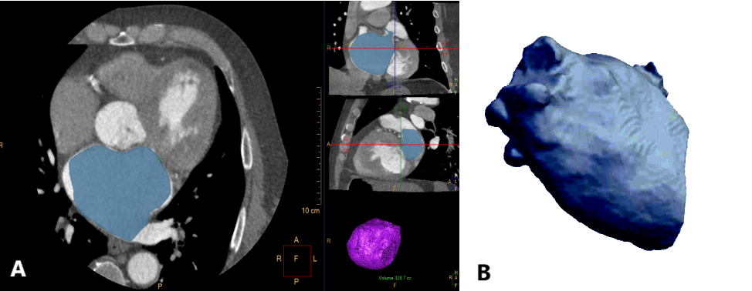
Figure 1- A. Cardiac computed tomography image showing the interface of IntelliSpace Portal software (Philips, version 12.1.5), used for the automatic segmentation and volume calculation of the left atrium (blue-shaded area). B. Three-dimensional volumetric reconstruction of the left atrium, automatically generated by the same software, excluding the left atrial appendage and pulmonary veins.

