Confined Irradiation Vacuum Ultraviolet Abatement Technique for Perfluorinated Compounds
Yanei Xueª, Wenjun Sun^{a,#}, Wentao Li^{b}, Guoqing Jiangª, Ranlong Xuª, Yuanna Zhangª

ª School of Environment
Tsinghua University
Beijing, 100084, China
E-mail: wsun@tsinghua.edu.cn

^{b} School of Science and Engineering
Shanghai Jiao Tong University
Shanghai, 200030, China

contents
Table 1. Available performance and conditions for reactions of PFASs in related VUV₁₈₅ reactors. 2
Table 2. The structure of PFASs and BDE (bond dissociation energy) of C–C bonds in PFAS molecule. 3
Table 3. The k_{ors} and DeF% of PFASs by VUV_CI/CB with various confined height. 5
Table 4. The chain reaction between the various free radicals. 6
Figure S1. Time distributions of decay rate of 10 PFASs under VUV_DI, VUV_CI and VUV_CI/CB. 7
Fig. 2. the EPR spectra of FRs in the VUV_CI. 8
Fig. 5 Identified representative transfer products(TPs) of PFASs under VUV_CI/CB irradiation. 9
Text 1. Detailed Information on Materials and Methods 19
Text 2. Measurement of PFAS Parent Compound. 19
Text 3. Identification of TPs via non-target screening analysis. 19
Table 5. UPLC‒QTOF/MS analysis conditions for the identification of TPs. 20
References 21

Supplementary Information

Table 1. Available performance and conditions for reactions of PFASs in related VUV₁₈₅ reactors.
PFAS | deC%  (k_{ros}, min⁻¹) | DeF%  (VOF) | TOC% | Reaction conditions | Ref
PFOA | 62%  (0.0018) | 27% | -- | pH 12, 480min, light sources(LS): 8.0 mW/cm², closed quartz tubes, 40mL | [1]
PFOA | 99%  (0.012) | 20% | -- | pH (original), 180min, SEN Light Corporation:20.73 mW/cm², glass reactor, 1.5L | [2]
PFOA | 88%  (0.0045) | 15% | -- | pH 10, 360min, Sankyo Electric Corporation, closed Pyrex glass reactor, 2L | [3]
PFOA | 80%  (0.025) | 25% | -- | pH (original), 120min, Cnlight Corporation: 62–69 mW/cm², tubular glass reactor,0.8L | [4]
PFOA | -- | 43.2% | -- | pH 5, 360min, Shanghai Jiguang Special Lighting Appliance Factory, China, cylindrical glass reactor, 250mL | [5]
PFOA | 61.7%  (0.0558) | 17.1% | -- | pH 3.7, 120min, LS, tubular glass reactor, 800mL | [6]
C7 HFPO-TA | 58%  (0.0021) | 27% | 30% | pH 12, 480min, LS: 8.0 mW/cm², closed quartz tubes, 40mL | [1]
HFPO-DA | 40%  (0.016) | 56%  (40%) | -- | pH 6, 180min, Sankyo Electric Corporation:0.65mW/cm², batch-type photoreactor, 1.2L | [7]
PFAS | 2%–100%  (0-0.299) | 3–54%  (0–26%) | 6–63% | pH(original), 180min, LS:0.095mW/cm², stainless steel chamber photoreactor, dynamic irradiation, 0.237L | this article
PFAS | 100%  (0.039–0.715) | 46−81%  (4–15%) | 56−88% | pH(original), 80min, LS:0.095mW/cm², stainless steel chamber photoreactor, CI, 0.237L | this article
PFAS | 100%  (0.0738–0.914) | 100%  (3.5–15%) | 87−100% | pH(original), 55min, LS: 0.13mW/cm², VUV_CB,80 mL | this article

Table 2. The structure of PFASs and BDE (bond dissociation energy) of C–C bonds in PFAS molecule.
- PFOA
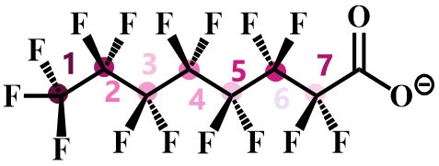
Bond | BDE(kcal/mol) | Bond(left to right) | BDE(kcal/mol)
C–C 1 | 90.95004438 | C−F | 120.7730846
C–C 2 | 86.87938701 | C−F | 113.1601333
C–C 3 | 86.01342321 | C−F | 111.06927
C–C 4 | 86.1759483 | C−F | 111.3503945
C–C 5 | 86.85303159 | C−F | 110.6933915
C–C 6 | 81.54115944 | C−F | 111.9195461
C–C 7 | 87.8200245 | C−F | 106.6767
- GenX
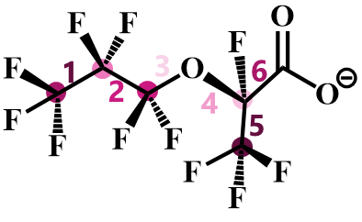
Bond | BDE(kcal/mol) | Bond(left to right) | BDE(kcal/mol)
C–C 1 | 90.29804382 | C−F | 121.3761218
C–C 2 | 84.889112 | C−F | 111.5706505
C–C 3 | 77.32740227 | C−F | 115.025093
C–C 4 | 78.53810945 | C−F | 102.9430155
C–C 5 | 88.90237690 | C−F | 123.2699469
C–C 6 | 85.035892
- 6:2 FTS
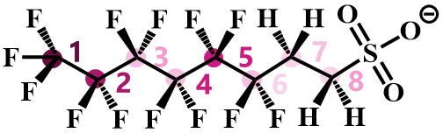
Bond | BDE(kcal/mol) | Bond(left to right) | BDE(kcal/mol)
C–C 1 | 90.50427831 | C−F | 120.43608612
C–C 2 | 87.38421904 | C−F | 115.20951743
C–C 3 | 83.01447206 | C−F | 107.59247012
C–C 4 | 86.19985103 | C−F | 106.32857229
C–C 5 | 86.893632 | C−F | 112.754209
C–C 6 | 68.43205318 | C−F | 104.32188723
C–C 7 | 71.724016 | C−H | 55.690352186
C–S 8 | 70.24509445 | C−H | 57.903461

- PFOS
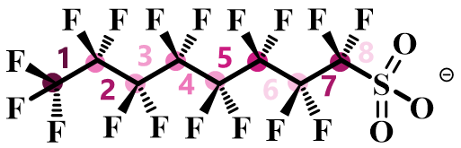
Bond | BDE(kcal/mol) | Bond(left to right) | BDE(kcal/mol)
C–C 1 | 89.13465795 | C−F | 120.763672
C–C 2 | 85.08470841 | C−F | 110.6419357
C–C 3 | 84.26016027 | C−F | 109.3455
C–C 4 | 84.56073756 | C−F | 110.6400532
C–C 5 | 84.94665621 | C−F | 109.4383715
C–C 6 | 84.64419639 | C−F | 111.1690441
C–C 7 | 87.67130463 | C−F | 109.2865141
C–S 8 | 64.73455911 | C−F | 112.2063181

Table 3. The k_{ors} and DeF% of PFASs by VUV_CI/CB with various confined height.
Confined height(mm) | 6:2FTS  (k_{ors}/DeF%) | GenX (k_{ors}/DeF%) | PFOA  (k_{ors}/DeF%) | PFOS  (k_{ors}/DeF%)
4 | 0.384/67% | 0.113/71% | 0.085/69% | 0.012/38%
5 | 0.531/73% | 0.192/78% | 0.108/81% | 0.033/55%
6 | 0.609/82% | 0.236/89% | 0.122/90% | 0.0414/63%
7 | 0.712/91% | 0.284/91% | 0.135/93% | 0.062/80%
8 | 0.754/100% | 0.305/98% | 0.144/100% | 0.084/95%
9 | 0.799/100% | 0.314/100% | 0.148/100% | 0.086/100%
10 | 0.799/100% | 0.314/100% | 0.148/100% | 0.086/100%
11 | 0.799/100% | 0.314/100% | 0.148/100% | 0.086/100%
12 | 0.799/100% | 0.314/100% | 0.148/100% | 0.086/100%
13 | 0.799/100% | 0.314/100% | 0.148/100% | 0.086/100%
14 | 0.645/87% | 0.309/98% | 0.131/91% | 0.084/95%
15 | 0.513/78% | 0.275/90% | 0.117/82% | 0.075/86%
16 | 0.431/73% | 0.218/87% | 0.109/80% | 0.068/67%
17 | 0.330/69% | 0.194/84% | 0.096/71% | 0.051/45%
18 | 0.271/65% | 0.187/80% | 0.091/64% | 0.044/32%
19 | 0.218/59% | 0.173/78% | 0.088/62% | 0.044/32%
20 | 0.187/56% | 0.166/73% | 0.087/62% | 0.044/32%
25 | 0.174/56% | 0.166/73% | 0.087/62% | 0.044/32%
30 | 0.173/55% | 0.166/73% | 0.086/62% | 0.044/32%
35 | 0.171/55% | 0.165/73% | 0.086/62% | 0.044/32%
40 | 0.170/54% | 0.165/93% | 0.086/62% | 0.044/32%

Table 4. The chain reaction between the various free radicals.
 | Reaction | Constant
R1 | $${\text{H}}_{\text{2}}\text{O}\text{+}{\text{hv}}_{\text{185nm}}\text{→}{\text{HO}}^{\text{•}}\text{+}{\text{H}}^{\text{•}}$$ | $${\text{Φ}}_{1}\text{=0.33}$$
R2 | $${\text{H}}_{\text{2}}\text{O}\text{+}{\text{hv}}_{\text{185}}\text{→}{\text{H}\text{O}}^{\text{•}}\text{+}{\text{H}}^{\text{+}}\text{+}{\text{e}}_{\text{aq}}^{\text{-}}$$ | $${\text{Φ}}_{2}\text{=0.045}$$
R3 | $${\text{H}}_{\text{2}}{\text{O}}_{\text{2}}\text{+}{\text{hv}}_{\text{185}}\text{→}\text{2}{\text{HO}}^{\text{•}}$$ | $${\text{Φ}}_{3}\text{=0.5}$$
R4 | $${\text{H}}_{\text{2}}{\text{O}}_{\text{2}}\text{+}{\text{hv}}_{\text{254}}\text{→}\text{2}{\text{HO}}^{\text{•}}$$ | $${\text{Φ}}_{4}\text{=0.5}$$
R5 | $${\text{O}}_{\text{2}}\text{+}{\text{H}}^{\text{•}}\text{→}{\text{HO}}_{\text{2}}^{\text{•}}$$ | $$k_{5}\text{=2.1×}{\text{10}}^{\text{10}}M^{-1}s^{-1}$$
R6 | $${\text{O}}_{\text{2}}\text{+}{\text{e}}_{\text{aq}}^{\text{-}}\text{→}{\text{O}}_{\text{2}}^{\text{•}\text{-}}$$ | $$k_{6}\text{=2.0×}{\text{10}}^{\text{10}}M^{-1}s^{-1}$$
R7 | $${\text{H}}_{\text{2}}{\text{O}}_{\text{2}}\text{+}{\text{HO}}^{\text{•}}\text{→}{\text{HO}}_{\text{2}}^{\text{•}}\text{+}{\text{H}}_{\text{2}}\text{O}$$ | $$k_{7}\text{=2.7×}{\text{10}}^{7}M^{-1}s^{-1}$$
R8 | $${\text{H}}_{\text{2}}{\text{O}}_{\text{2}}\text{+}{\text{HO}}_{\text{2}}^{\text{•}}\text{→}{\text{HO}}^{\text{•}}\text{+}{\text{O}}_{\text{2}}\text{+}{\text{H}}_{\text{2}}\text{O}$$ | $$k_{8}\text{=5.3×}{\text{10}}^{2}M^{-1}s^{-1}$$
R9 | $${\text{H}}_{\text{2}}{\text{O}}_{\text{2}}\text{+}{\text{O}}_{\text{2}}^{\text{•}\text{-}}\text{→}{\text{HO}}^{\text{•}}\text{+}{\text{O}}_{\text{2}}\text{+}{\text{HO}}^{\text{-}}$$ | $$k_{9}\text{=1.6×}{\text{10}}^{1}M^{-1}s^{-1}$$
R10 | $${\text{H}}_{\text{2}}\text{+}{\text{HO}}^{\text{•}}\text{→}{\text{H}}_{\text{2}}\text{O}\text{+}{\text{H}}^{\text{•}}$$ | $$k_{10}\text{=6.0×}{\text{10}}^{7}M^{-1}s^{-1}$$
R11 | $${\text{HO}}^{\text{•}}\text{+}{\text{HO}}^{\text{•}}\text{→}{\text{H}}_{\text{2}}{\text{O}}_{\text{2}}$$ | $$k_{11}\text{=4.0×}{\text{10}}^{9}M^{-1}s^{-1}$$
R12 | $${\text{HO}}_{\text{2}}^{\text{•}}{\text{+}\text{HO}}_{\text{2}}^{\text{•}}\text{→}{\text{H}}_{\text{2}}{\text{O}}_{\text{2}}\text{+}{\text{O}}_{\text{2}}$$ | $$k_{12}\text{=2.6×}{\text{10}}^{6}M^{-1}s^{-1}$$
R13 | $${\text{H}}^{\text{•}}\text{+}{\text{H}}^{\text{•}}\text{→}{\text{H}}_{\text{2}}$$ | $$k_{13}\text{=1.0×}{\text{10}}^{10}M^{-1}s^{-1}$$
R14 | $${\text{HO}}^{\text{•}}\text{+}{\text{H}}^{\text{•}}\text{→}{\text{H}}_{\text{2}}\text{O}$$ | $$k_{14}\text{=7.0×}{\text{10}}^{9}M^{-1}s^{-1}$$
R15 | $${\text{HO}}^{\text{•}}\text{+}{\text{O}}_{\text{2}}^{\text{•}\text{-}}\text{→}{\text{O}}_{\text{2}}\text{+}{\text{HO}}^{\text{-}}$$ | $$k_{15}\text{=7.0×}{\text{10}}^{9}M^{-1}s^{-1}$$
R16 | $${\text{HO}}^{\text{•}}\text{+}{\text{HO}}_{\text{2}}^{\text{•}}\text{→}{\text{H}}_{\text{2}}\text{O}\text{+}{\text{O}}_{\text{2}}$$ | $$k_{16}\text{=6.6×}{\text{10}}^{9}M^{-1}s^{-1}$$
R17 | $${\text{HO}}_{\text{2}}^{\text{•}}\text{+}{\text{O}}_{\text{2}}^{\text{•}\text{-}}\text{→}{\text{O}}_{\text{2}}\text{+}{\text{HO}}_{\text{2}}^{\text{-}}$$ | $$k_{17}\text{=9.7×}{\text{10}}^{7}M^{-1}s^{-1}$$
R18 | $${\text{e}}_{\text{aq}}^{\text{-}}\text{+}{\text{HO}}^{\text{•}}\text{→}{\text{HO}}^{\text{-}}$$ | $$k_{18}\text{=3.0×}{\text{10}}^{10}M^{-1}s^{-1}$$
R19 | $$\text{2}{\text{O}}_{\text{2}}^{\text{•}\text{-}}\text{+}\text{2}{\text{H}}_{\text{2}}\text{O}\text{→}{\text{O}}_{\text{2}}\text{+}{\text{H}}_{\text{2}}{\text{O}}_{\text{2}}\text{+2}{\text{HO}}^{\text{-}}$$ | $$k_{19}\text{=3.0×}{\text{10}}^{-1}M^{-1}s^{-1}$$
R20 | $${\text{e}}_{\text{aq}}^{\text{-}}\text{+}{\text{H}}^{\text{•}}\text{+}{\text{H}}_{\text{2}}\text{O}\text{→}{\text{H}}_{\text{2}}\text{+}{\text{HO}}^{\text{-}}$$ | $$k_{20}\text{=2.5×}{\text{10}}^{10}M^{-1}s^{-1}$$
R21 | $${\text{HO}}^{\text{•}}\text{+}{\text{HO}}_{\text{2}}^{\text{-}}\text{→}{\text{HO}}_{\text{2}}^{\text{•}}\text{+}{\text{HO}}^{\text{-}}$$ | $$k_{21}\text{=7.5×}{\text{10}}^{9}M^{-1}s^{-1}$$
R22 | $${\text{HO}}^{\text{•}}\text{+}{\text{HO}}^{\text{-}}\text{→}{\text{O}}^{\text{•}\text{-}}\text{+}{\text{H}}_{\text{2}}\text{O}$$ | $$k_{22}\text{=3.9×}{\text{10}}^{8}M^{-1}s^{-1}$$
R23 | $${\text{H}}^{\text{•}}\text{+}{\text{HO}}^{\text{-}}\text{→}{\text{e}}_{\text{aq}}^{\text{-}}\text{+}{\text{H}}_{\text{2}}\text{O}$$ | $$k_{23}\text{=3.6×}{\text{10}}^{8}M^{-1}s^{-1}$$
R24 | $${\text{H}}_{\text{2}}{\text{O}}_{\text{2}}\text{+}{\text{e}}_{\text{aq}}^{\text{-}}\text{→}{\text{HO}}^{\text{•}}\text{+}{\text{HO}}^{\text{-}}$$ | $$k_{24}\text{=1.1×}{\text{10}}^{10}M^{-1}s^{-1}$$
R25 | $${\text{e}}_{\text{aq}}^{\text{-}}\text{+}{\text{H}}^{\text{+}}\text{→}{\text{H}}^{\text{•}}$$ | $$k_{25}\text{=2.3×}{\text{10}}^{10}M^{-1}s^{-1}$$
R26 | $${\text{e}}_{\text{aq}}^{\text{-}}\text{+}{\text{H}}_{\text{2}}\text{O}\text{→}{\text{H}}^{\text{•}}\text{+}{\text{HO}}^{\text{-}}$$ | $$k_{26}\text{=1.9×}{\text{10}}^{1}M^{-1}s^{-1}$$
R27 | $${\text{H}}^{\text{•}}\text{+}{\text{HO}}_{\text{2}}^{\text{-}}\text{→}{\text{HO}}_{\text{2}}^{\text{•}}\text{+}{\text{HO}}^{\text{-}}$$ | $$k_{27}\text{=1.0×}{\text{10}}^{10}M^{-1}s^{-1}$$
R28 | $${\text{H}}^{\text{•}}\text{+}{\text{H}}_{\text{2}}{\text{O}}_{\text{2}}\text{→}{\text{H}}_{\text{2}}\text{O}\text{+}{\text{HO}}^{\text{•}}$$ | $$k_{28}\text{=9.0×}{\text{10}}^{7}M^{-1}s^{-1}$$
R29 | $${\text{e}}_{\text{aq}}^{\text{-}}\text{+}{\text{HO}}_{\text{2}}^{\text{-}}\text{+}{\text{H}}_{\text{2}}\text{O}\text{→2}{\text{HO}}^{\text{-}}\text{+}{\text{HO}}^{\text{•}}$$ | $$k_{29}\text{=3.5×}{\text{10}}^{9}M^{-1}s^{-1}$$
R30 | $${\text{H}}^{\text{•}}\text{+}{\text{O}}_{\text{2}}^{\text{•}\text{-}}\text{→}{\text{HO}}_{\text{2}}^{\text{-}}$$ | $$k_{30}\text{=2.0×}{\text{10}}^{10}M^{-1}s^{-1}$$
R31 | $${\text{H}}_{\text{2}}\text{O↔}{\text{H}}^{\text{+}}\text{+}{\text{HO}}^{\text{-}}$$ | $$k_{{\text{H}}_{\text{2}}\text{0}}\text{=}{10}^{-14}$$
R32 | $${\text{H}}_{\text{2}}{\text{O}}_{\text{2}}\text{↔}{\text{H}}^{\text{+}}\text{+}{\text{HO}}_{\text{2}}^{\text{-}}$$ | $$k_{{\text{H}}_{\text{2}}{\text{O}}_{\text{2}}}\text{=}{2.23\text{×10}}^{-12}$$

Figure S1. Time distributions of decay rate of 10 PFASs under VUV_DI, VUV_CI and VUV_CI/CB.
When C_{PFAS}=10 mg L⁻¹, the pH values of the samples were all at their initial values, and no buffering was performed.
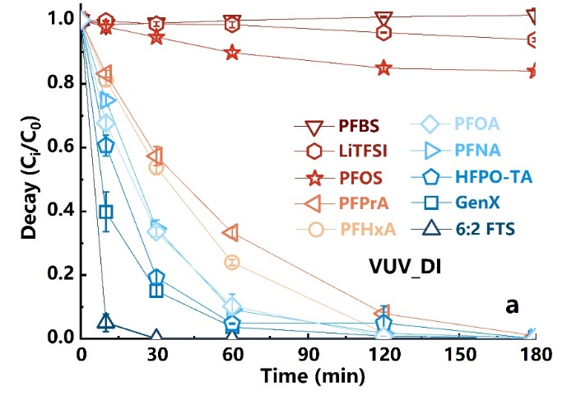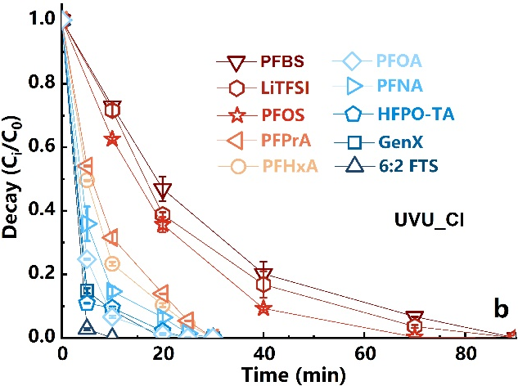
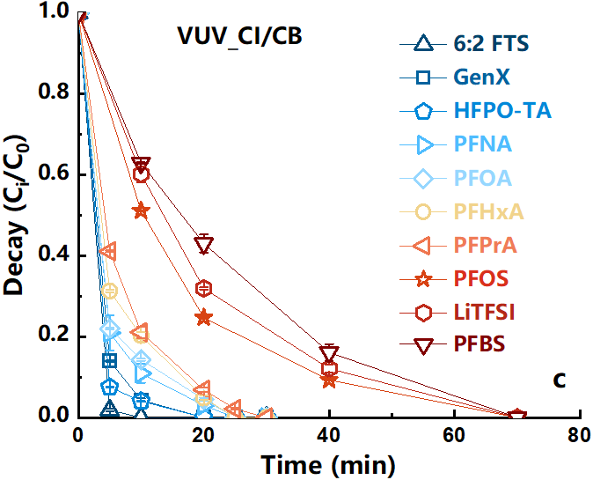

Fig. 2. the EPR spectra of FRs in the VUV_CI.
EPR spectra of TEMPO trapped by a RFR with a reaction time(a) and (b), the OFR(·OH) response spectra of trapped by DMPO(c).

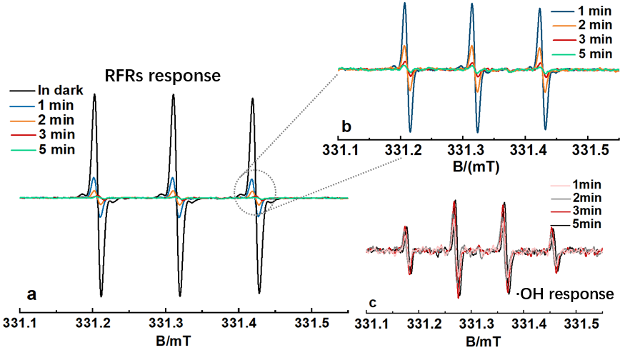

Fig. 5 Identified representative transfer products(TPs) of PFASs under VUV_CI/CB irradiation.
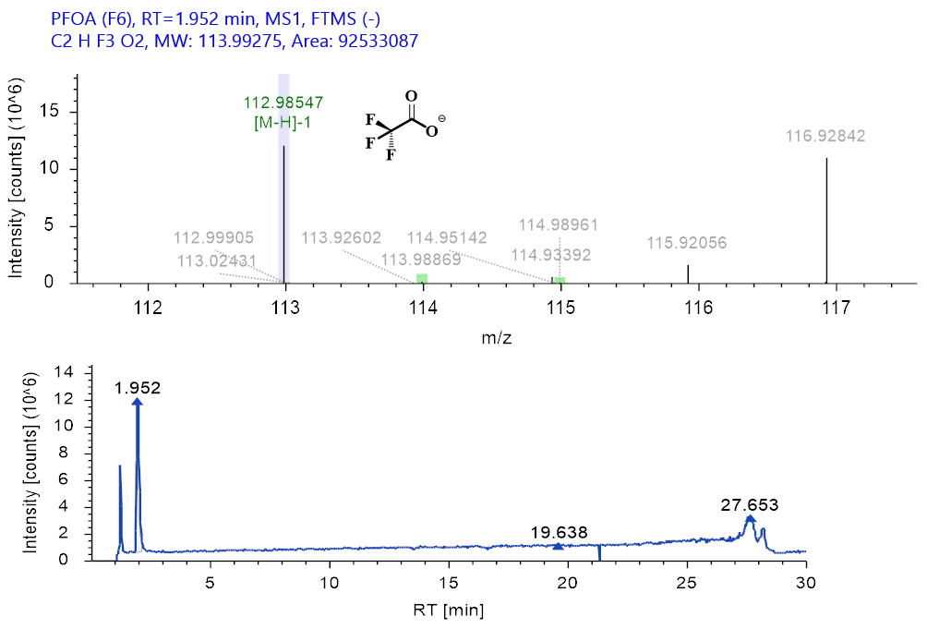

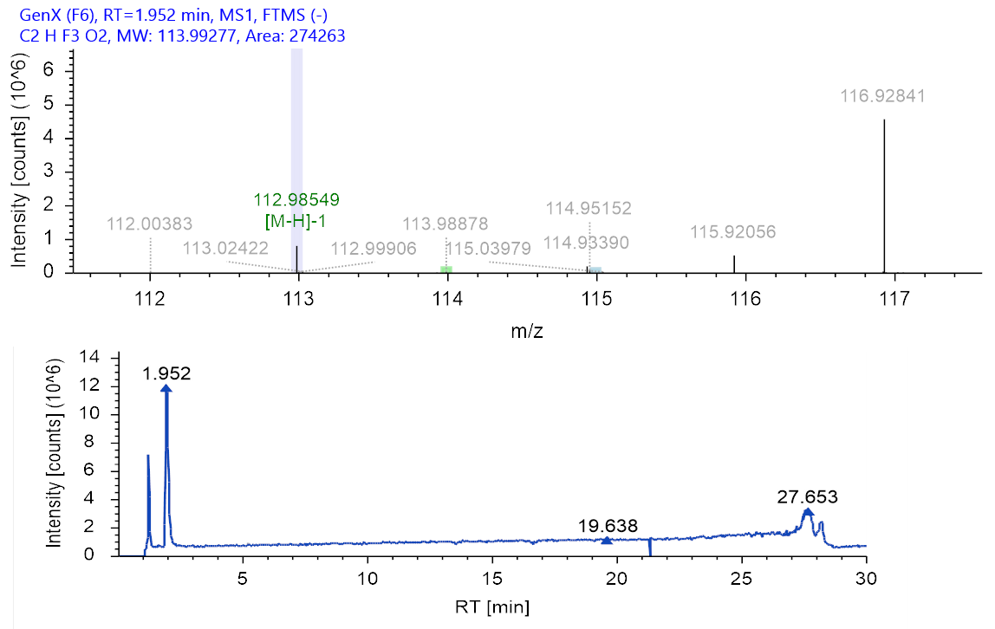

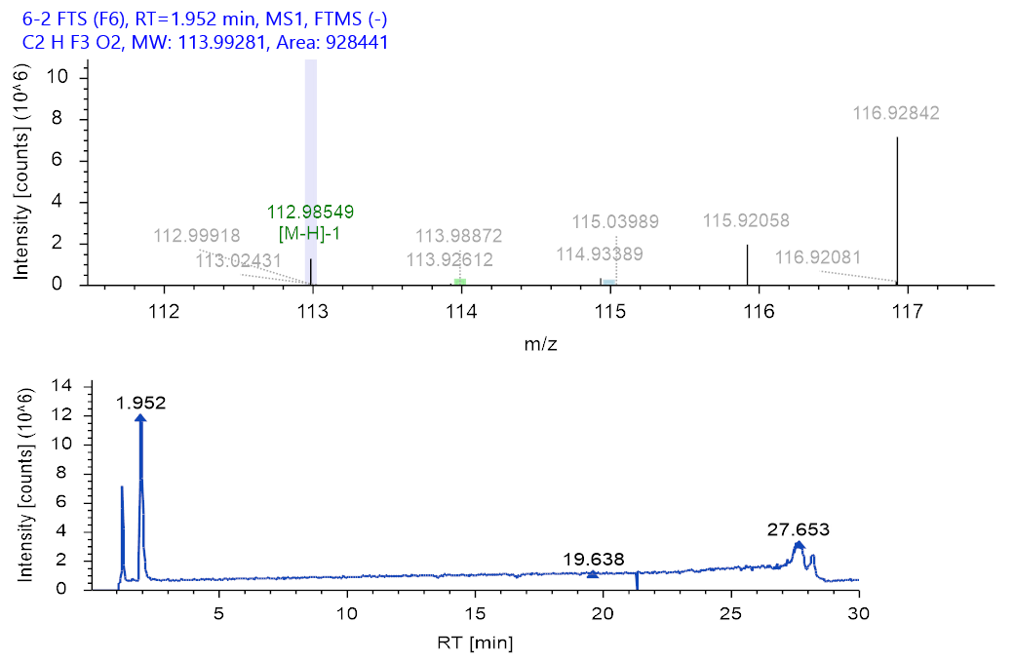

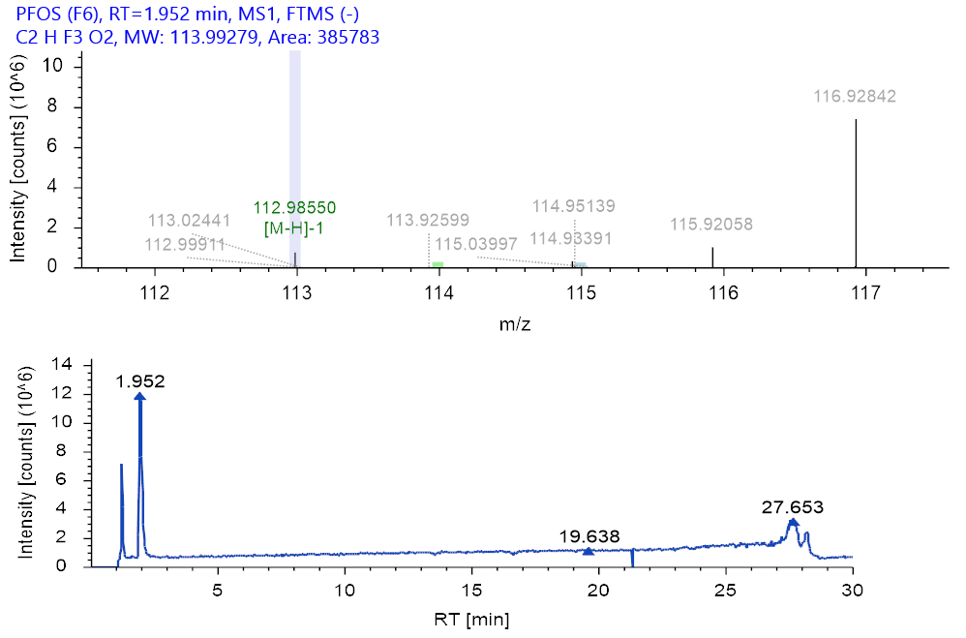

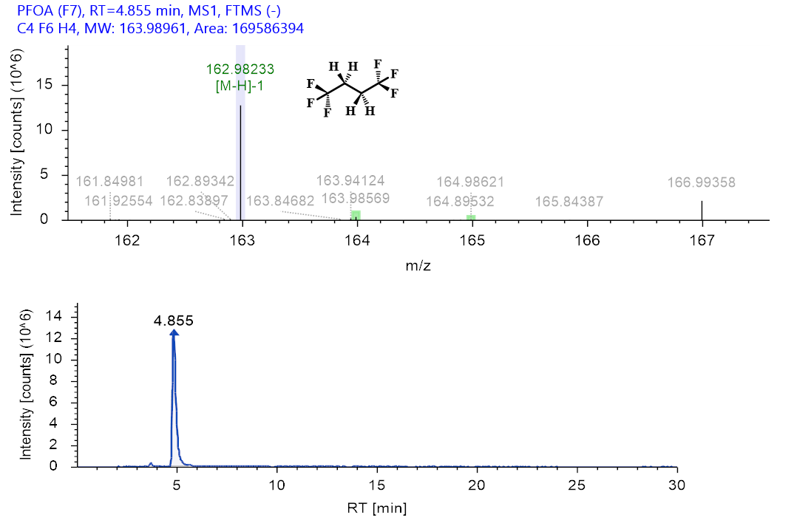

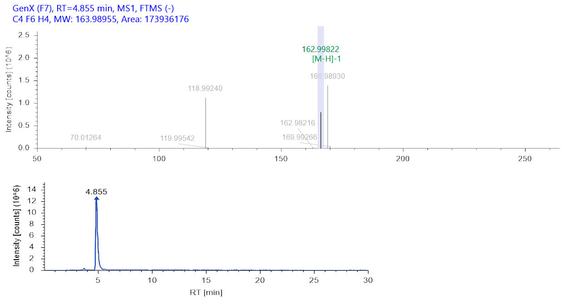

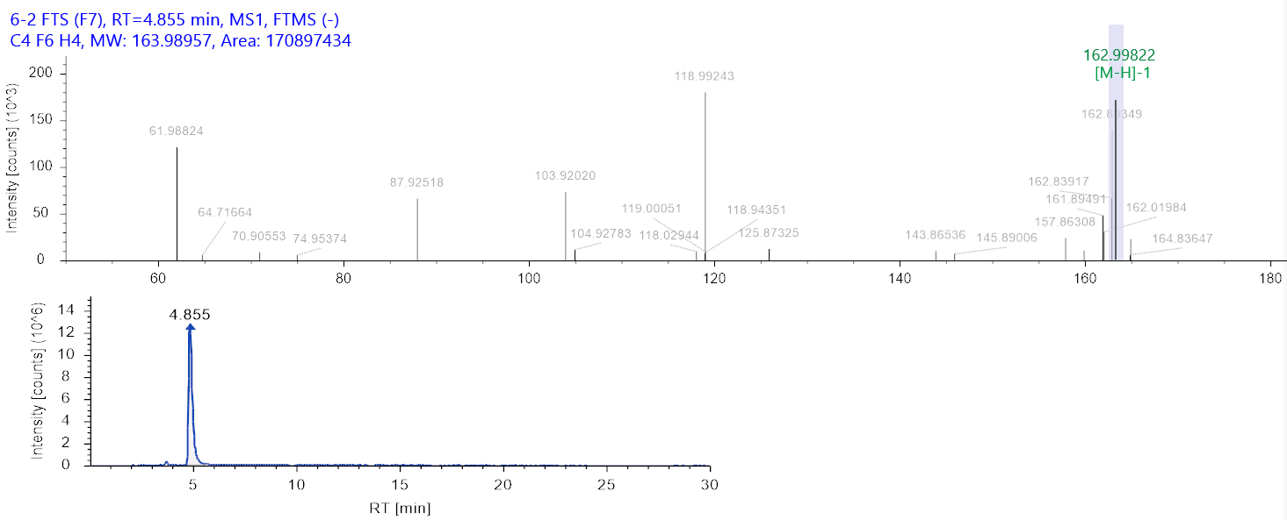

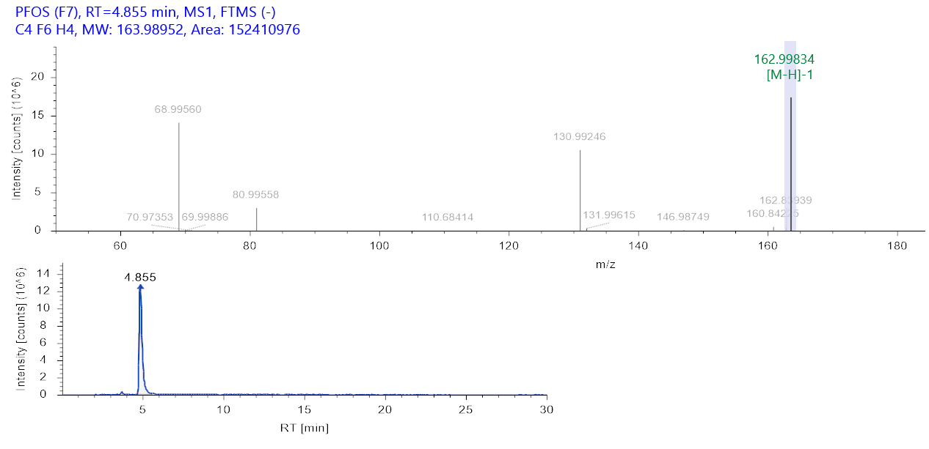

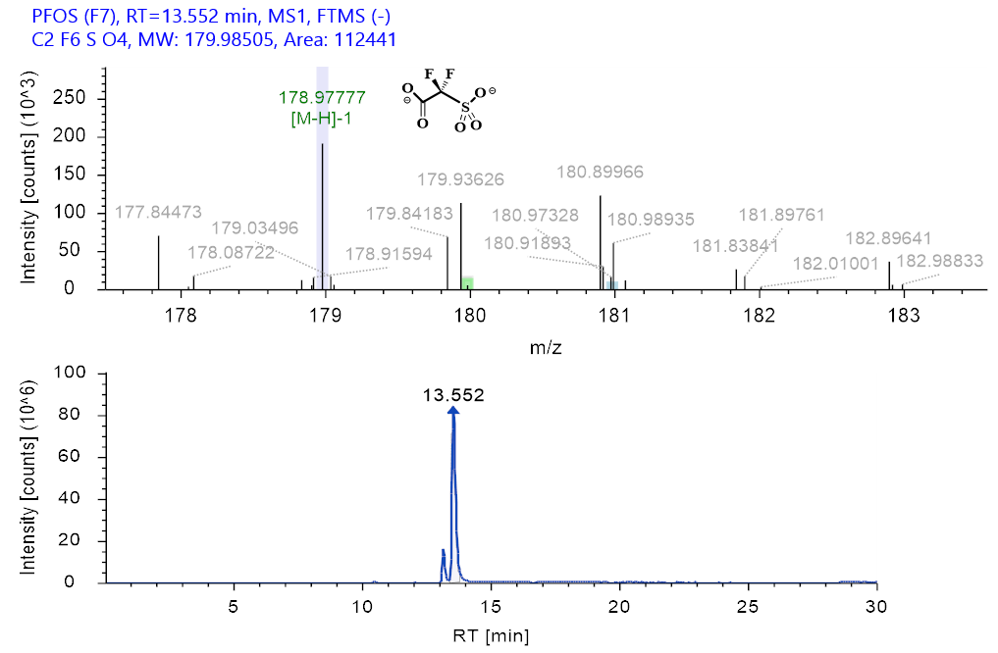

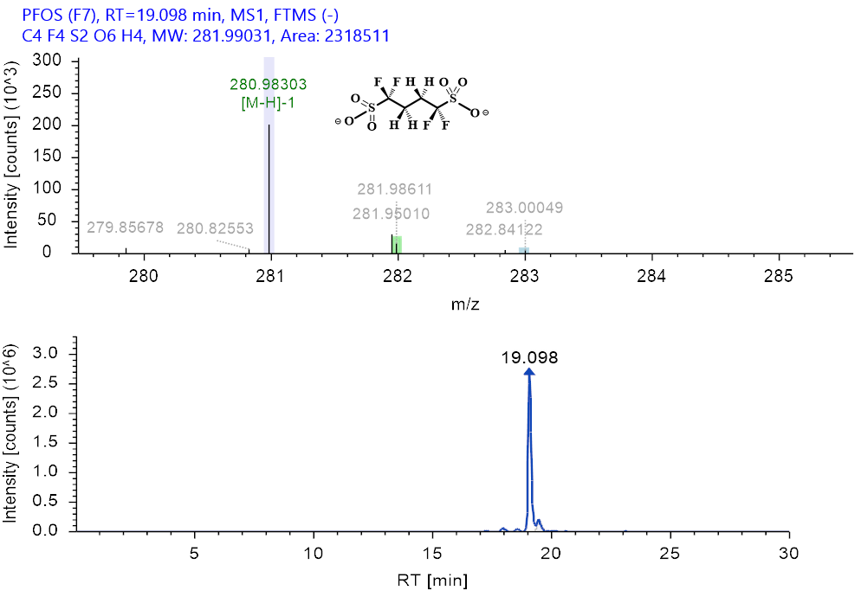

Text 1. Detailed Information on Materials and Methods
The four PFCAs (PFPrA, PFHxA, PFOA, PFNA, ≥96%) and two PFECA (GenX and HFPO-TA, ≥96%) and 6:2 FTS (≥96%) were purchased from Macklin Reagent and ANPEL-TRACE Stard Technical Services Co., Ltd. (Shanghai, China). Three PFISA (LiTFSI, PFBS and PFOS) (≥96%), 4-Chlorobenzoic acid (pCBA, ≥99.0%) were obtained from Macklin Reagent Co., Ltd. Individual PFAS were dissolved in deionized water (produced by a Milli-Q system) as 10 mM stock solutions. All stock solutions were stored on benchtop at room temperature (20°C).

Text 2. Measurement of PFAS Parent Compound.
The concentrations of individual PFAS during the reaction were measured using a high performance liquid chromatography coupled with a tripe-stage quadrupole mass spectrometer (HPLC-MS/MS, API3200; Applied Biosystems). The HPLC separation was performed with a HPLC BEH C18 column (2.1 mm × 50 mm, 1.7 μm) at 40 °C, A in-line filter column(2μm) and a Eclipse XDB-C18 protective column(4.6×12.5mm, 5μm ) should be placed before the column to filter out the micro-particle catalysts that may be present in the sample; In the detection process, the mobile phase needs to cross the mobile phase degassing device of high performance liquid chromatography, and the mobile phase was degassed by non-on-line degassing device; Mobile phase was a gradient composition of solvent A(ammonium acetate methanol solution, 10mM) and solvent B (ammonium acetate aqueous solution, 10 mM). The gradient expressed as the concentration of solvent A was as follows: 0−7.5 min, a linear increase from 60% to 100%; 7.5−11 min, held at 100% A; 11−16.5 min, a linear decrease from 100% to 75%; 16.5−17 min, hold at 60% A. The flow rate was 0.3 mL min⁻¹. An electrospray negative ionization mode was used to identify the products in the liquid phase. The pressure of sheath gas (N₂) was 0.4 MPa. The capillary potential was −4.5 kV. The source temperature was 120 °C, and the desolvation temperature was 450 °C. The analysis was carried out in multiple reaction monitoring (MRM) mode.

Text 3. Identification of TPs via non-target screening analysis.
The non-targeted qualitative analysis data analyzed by LC-QTOF/MS went through the suspect screening process using UNIFI software (Waters, USA). Among the substances identified through the screening process, those that met all the following criteria were defined as TPs: (ⅰ) mass error < 10 ppm; (ⅱ) isotope match intensity RMS percent < 20%; and (ⅲ) peak area showing a continuous pattern over time, such as steady increase or a decrease after increase. After all, the confidence levels for the identified TPs were designated according to whether MSE fragmentation data was provided on UNIFI program.

Table 5. UPLC‒QTOF/MS analysis conditions for the identification of TPs.
Instrument |  | Parameter | Value
UPLC‒QTOF/MS | UPLC | Column | Waters, ACQUITY UPLC BEH C18 (2.1 × 100 mm, 1.7 µm)
 |  | Column temperature | 40 °C
 |  | Sample temperature | 10 °C
 |  | Injection volume | 10 µL
 |  | Flow rate | 0.3 mL/min
 |  | Mobile phase | (A) Deionized water with 2 mM ammonium acetate  (B) Methanol with 2 mM ammonium acetate
  Time (min) | Flow (mL/min) | %A | %B | Curve
  0.0 | 0.3 | 100 | 0 | -
  0.5 | 0.3 | 80 | 20 | 6
  3.0 | 0.3 | 55 | 45 | 6
  6.0 | 0.3 | 20 | 80 | 6
  7.0 | 0.3 | 5 | 95 | 6
  8.0 | 0.3 | 5 | 95 | 6
  9.0 | 0.3 | 100 | 0 | 1
  10.0 | 0.3 | 100 | 0 | 1
 | QTOF/MS | Ionization mode | ESI negative
 |  | Acquisition range | 50–1200 Da
 |  | Collision voltage | Low: 4 V / High: 20–70 V
 |  | Cone voltage | 40 V
 |  | Capillary voltage | 1.5 kV
 |  | Source temperature | 100 °C
 |  | Desolvation temperature | 250 °C
 |  | Cone gas flow | 0 L/h
 |  | Desolvation gas flow | 800 L/h
 |  | Nebuliser gas flow | 6.5 bar

References
(1) Gu, M.; Liu, L.; Yu, G.; Huang, J. Deeper Defluorination and Mineralization of a Novel PFECA (C7 HFPO-TA) in Vacuum UV/Sulfite: Unique Mechanism of H/OCF ₃ Exchange. Environ. Sci. Technol. 2023, 57 (40), 15288–15297.
(2) Giri, R. R.; Ozaki, H.; Guo, X.; Takanami, R.; Taniguchi, S. Oxidative–Reductive Photodecomposition of Perfluorooctanoic Acid in Water. Int. J. Environ. Sci. Technol. 2014, 11 (5), 1277–1284.
(3) Park, H.; Kim, T.; Kim, J.; Kim, M.-K.; Eom, S.; Choi, Y.; Zoh, K.-D. Reductive Degradation Mechanism of Perfluorooctanoic Acid (PFOA) during Vacuum Ultraviolet (VUV) Reactions Combining with Sulfite and Iodide. Chemosphere 2024, 348, 140759.
(4) Cao, M. H.; Wang, B. B.; Yu, H. S.; Wang, L. L.; Yuan, S. H.; Chen, J. Photochemical Decomposition of Perfluorooctanoic Acid in Aqueous Periodate with VUV and UV Light Irradiation. J. Hazard Mater. 2010, 179 (1–3), 1143–1146.
(5) Li, Y.; Lin, Q.; Li, C.; Weiguo, Z.; Xu, L.; Zhang, K. The Defluorination of Perfluorooctanoic Acid by Different Vacuum Ultraviolet Systems in the Solution. Water Environ. Res. 2021, 93 (3), 455–463.
(6) Chen, J.; Zhang, P.; Liu, J. Photodegradation of Perfluorooctanoic Acid by 185 Nm Vacuum Ultraviolet Light. J Environ. Sci. 2007, 19 (4), 387–390.
(7) Kim, J.; Kim, T.; Park, H.; Kim, M.-K.; Eom, S.; Choe, Y.; Choe, J. K.; Zoh, K.-D. Kinetics and Proposed Mechanisms of Hexafluoropropylene Oxide Dimer Acid (GenX) Degradation via Vacuum-UV (VUV) Photolysis and VUV/Sulfite Processes. J. Hazard Mater. 2024, 463, 132864.

