Receptor-free discrimination of peptide native bound conformations suggests limited transferability of the “cen_std+score4L” Rosetta energy function from proteins to peptides
SUPPLEMENTARY INFORMATION

Andrea Bazzoli¹ and Alessandro Contini^{1*}

¹Università degli Studi di Milano, Dipartimento di Scienze Farmaceutiche, Sezione di Chimica Generale e Organica “A. Marchesini”, Via Venezian, 21 20133 Milano, Italy

*To whom correspondence should be addressed. E-mail: alessandro.contini@unimi.it

CONTENTS
Table S1. Distributions of decoy conformations
Table S2. Convergence of the ten weight optimizations on similar weight sets
Table S3. Negative optimized weights often correspond to unfavorable energies of native-like conformations
Table S4. Optimized weights produced with Alam et al.’s training set
Figure S1. Starting decoy conformations
Figure S2. Optimized weights from the cbeta_10x and uniform initial weights are essentially equivalent in discriminating native-like decoys
Figure S3. Optimized weights improve discrimination of native-like peptide conformations even with Alam et al.’s training set
Figure S4. Optimized weights often define a better classifier of native-like decoys than default weights
Table S1. Distributions of decoy conformations
 |  | peptide ID | RMSD from native conformation (Å)ª
 |  | peptide ID | ≤ 1 | ≤ 2 | ≤ 3 | ≤ 4 | ≤ 5 | ≤ 6 | ≤ 7 | ≤ 8 | > 8
 | training set | 1czy | 859 | 198 | 1206 | 2635 | 2115 | 41 | 0 | 0 | 0
 | training set | 1er8 | 666 | 952 | 990 | 1963 | 1772 | 711 | 0 | 0 | 0
 | training set | 1jd5 | 721 | 234 | 1399 | 2159 | 2182 | 359 | 0 | 0 | 0
 | training set | 2fmf | 1834 | 1341 | 926 | 781 | 170 | 12 | 1014 | 522 | 454
 | training set | 1mfg | 616 | 456 | 1429 | 625 | 1572 | 2114 | 242 | 0 | 0
 | training set | 2a3i | 733 | 266 | 170 | 3743 | 642 | 503 | 71 | 923 | 3
 | training set | 2cch | 562 | 352 | 728 | 422 | 247 | 1282 | 552 | 1454 | 1455
 | training set | 2ds8 | 1861 | 1474 | 1278 | 1998 | 443 | 0 | 0 | 0 | 0
 | training set | 2hpl | 1016 | 2577 | 3461 | 0 | 0 | 0 | 0 | 0 | 0
 | test set | 1awr | 819 | 1624 | 1978 | 2633 | 0 | 0 | 0 | 0 | 0
 | test set | 1eg4 | 571 | 305 | 91 | 785 | 143 | 1127 | 489 | 1412 | 2131
 | test set | 1elw | 747 | 1259 | 119 | 421 | 1666 | 2382 | 460 | 0 | 0
 | test set | 1jwg | 910 | 1088 | 373 | 3135 | 1538 | 10 | 0 | 0 | 0
 | test set | 1lvm | 986 | 1439 | 1758 | 2660 | 211 | 0 | 0 | 0 | 0
 | test set | 1ntv | 556 | 356 | 784 | 2299 | 2472 | 587 | 0 | 0 | 0
 | test set | 1nvr | 1644 | 495 | 902 | 4013 | 0 | 0 | 0 | 0 | 0
 | test set | 1nx1 | 2594 | 325 | 177 | 725 | 976 | 1191 | 1066 | 0 | 0
 | test set | 1ou8 | 591 | 414 | 558 | 3376 | 2115 | 0 | 0 | 0 | 0
 | test set | 1rxz | 678 | 289 | 34 | 2680 | 2305 | 180 | 657 | 231 | 0
 | test set | 1ssh | 579 | 179 | 974 | 136 | 688 | 669 | 494 | 1965 | 1370
 | test set | 1u00 | 689 | 366 | 1233 | 501 | 1555 | 1414 | 1261 | 35 | 0
 | test set | 1x2r | 933 | 68 | 1116 | 1342 | 2549 | 80 | 206 | 760 | 0
 | test set | 2b9h | 497 | 439 | 92 | 590 | 2702 | 2150 | 575 | 9 | 0
 | test set | 2c3i | 911 | 992 | 986 | 1861 | 1538 | 764 | 2 | 0 | 0
 | test set | 2h9m | 2317 | 1636 | 3101 | 0 | 0 | 0 | 0 | 0 | 0
 | test set | 2o02 | 685 | 299 | 2344 | 1734 | 724 | 1268 | 0 | 0 | 0
 | test set | 3d1e | 1466 | 663 | 892 | 3681 | 352 | 0 | 0 | 0 | 0
Reported for each peptide is the number of decoy conformations as a function of RMSD from the native conformation. ªRMSD was computed over atoms C^{α}. Decoys whose RMSD is ≤ 1 Å (column in bold) are those that we classified as native-like.

Table S2. Convergence of the ten weight optimizations on similar weight sets
initial weights | energy term |  |  |  |  |  |  |  | f_{ntv}
initial weights | env | cbeta | pair | vdw | hbond_lr_bb | hbond_sr_bb | rama | rg | f_{ntv}
env_10x | -7.93E+11 | -3.98E+11 | -1.27E+12 | 7.67E+10 | 5.25E+11 | -5.99E+11 | 4.54E+10 | -1.84E+11 | -8.41
cbeta_10x | -2.38E+00 | -7.19E-01 | -8.48E+00 | 1.79E+00 | 1.97E+00 | -1.92E+00 | 1.73E-01 | -7.30E-01 | -8.54
pair_10x | -2.18E+14 | 5.75E+13 | -4.17E+14 | 2.71E+14 | 4.62E+13 | -1.87E+14 | 1.26E+13 | -5.44E+13 | -8.34
vdw_10x | -1.04E+13 | -2.14E+12 | -3.35E+13 | 8.60E+12 | 9.14E+12 | -8.53E+12 | 7.27E+11 | -3.00E+12 | -8.53
hbond_lr_bb_10x | -1.30E+12 | -1.27E+11 | -2.62E+12 | 3.24E+12 | 1.65E+12 | -9.86E+11 | 8.69E+10 | -4.42E+11 | -8.37
hbond_sr_bb_10x | -2.24E+02 | -3.32E+01 | -5.76E+02 | 5.09E+02 | 8.92E+01 | -1.85E+02 | 1.50E+01 | -5.99E+01 | -8.44
rama_10x | -4.35E+12 | -4.06E+11 | -1.23E+13 | 5.84E+12 | 3.82E+12 | -3.46E+12 | 2.94E+11 | -1.21E+12 | -8.51
rg_10x | -3.24E+11 | -1.14E+11 | -1.30E+11 | 1.62E+11 | 4.83E+10 | -2.56E+11 | 2.17E+10 | -9.28E+10 | -8.23
default | -2.12E+12 | -6.70E+10 | 1.09E+11 | 2.56E+12 | -1.43E+11 | -1.51E+12 | 1.20E+11 | -8.24E+11 | -8.11
uniform | -1.53E+01 | -4.63E+00 | -5.45E+01 | 1.16E+01 | 1.27E+01 | -1.24E+01 | 1.11E+00 | -4.69E+00 | -8.54
Each row of the table reports a different optimized weight set, produced by a run of the Nelder‒Mead algorithm^{1,2} that had started from the weight set indicated in the first column. Initial weight sets are labeled as in Figure 1 of the main text. The last column reports the value of the native discrimination function f_{ntv} for the optimized weights. Although the optimized weight of each energy term has, across runs, absolute values that differ by several orders of magnitude, the sign and relative value of each weight in its optimized weight set tend to be conserved. The optimized weight set obtained from the cbeta_10x initial set (highlighted in bold) was chosen for testing and discussion in the main text, after normalization with respect to the env weight.

Table S3. Negative optimized weights often correspond to unfavorable energies of native-like conformations
energy term | % training set | % test set | % all
env | 78 (22) | 72 (33) | 74 (30)
cbeta | 78 (11) | 83 (39) | 81 (30)
pairª | 67 (0) | 71 (0) | 70 (0)
vdw | 22 (0) | 11 (0) | 15 (0)
hbond_lr_bb^{b} | 88 (0) | 88 (0) | 88 (0)
hbond_sr_bb | 89 (22) | 89 (22) | 89 (22)
rama | 33 (11) | 6 (0) | 15 (4)
rg | 78 (22) | 83 (44) | 81 (37)
For each energy term of the cen_std+score4L function, the table reports the percentage of benchmark peptides for which the average unweighted energy of native-like decoys (μ_{ntv}) is higher than that of non-native decoys (μ_{other}). In parentheses is the percentage of peptides for which μ_{ntv} is higher than μ_{other} by more than the summed standard deviations of the two distributions (i.e., μ_{ntv} – μ_{other} > σ_{ntv} + σ_{other}). Energy terms whose optimized weight is negative are highlighted in bold. ªData from peptides of length > 9 only (3 training peptides, 7 test peptides); for shorter peptides, pair energies are always 0 by definition³. ^{b}Data from peptides of length > 5 only (8 training peptides, 16 test peptides); for shorter peptides, hbond_lr_bb energies are always 0 by definition⁴.

Table S4. Optimized weights produced with Alam et al.’s training set
 | energy term | optimized weight with Alam et al.’s training set
 | env | -1.0000
 | cbeta | -0.2165
 | pair | -1.5730
 | vdw | 3.7550
 | hbond_lr_bb | 0.0989
 | hbond_sr_bb | -0.9598
 | rama | 0.0696
 | rg | -0.3185
Compared to our training set, Alam et al.’s⁵ contains coiled peptide 1jwg instead of helical peptide 2fmf. The optimized weights listed here were obtained by running the Nelder–Mead optimization algorithm on Alam et al.’s training set using the cbeta_10x initial weights (defined in Figure 1 of the main text). These optimized weights have the same signs as those obtained from our training set (listed in Table 1 in the main text). Weight magnitude is also consistent between the two optimized sets, with only three terms (pair, vdw, and hbond_lr_bb) showing a magnitude increase or decrease larger than twofold.

Figure S1. Starting decoy conformations. (A) Native. (B) Extended, where (φ, ψ) = (–135.0°, 135.0°) for all residues. (C) Hairpin, where (φ_{t}, ψ_{t}) = (–60.0°, 120.0°) and (φ_{t+1}, ψ_{t+1}) = (80.0°, 0.0°), while (φ, ψ) = (–135.0°, 135.0°) for all other residues; here, t = ⌈N/2⌉, where N is peptide length. (D) Helical, where (φ, ψ) = (–57.8°, –47.0°) for all residues. For extended, hairpin, and helical conformations, ω = 180° for all residues. (E) Fragment assembled. In all cases, for clarity, only backbone heavy atoms are shown. Used as the starting point of local-search simulations, each conformation in (A–D) yielded 1,000 decoys; each of the 50 fragment-assembled conformations yielded 60 decoys.
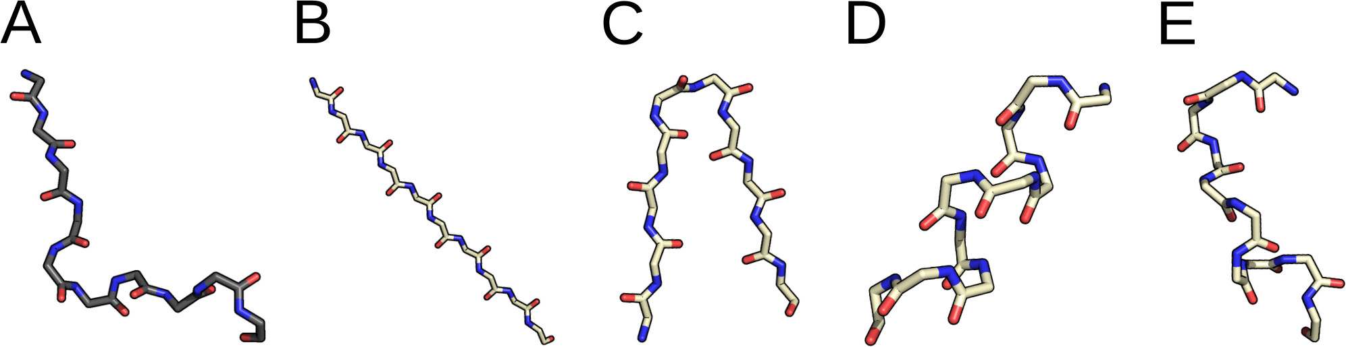

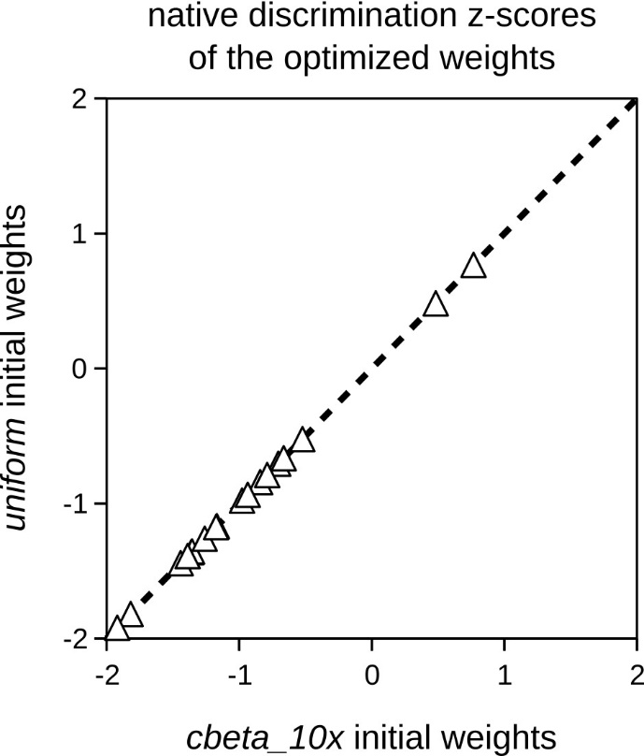

Figure S2. Optimized weights from the cbeta_10x and uniform initial weights are essentially equivalent in discriminating native-like decoys. Native discrimination z-scores (Z_{p} in the main text) of all 18 peptides of the test set are compared for the two optimized weight sets that produced the best value of the native discrimination function (f_{ntv} = –8.54) upon training. The two optimized sets were obtained, respectively, from the uniform initial set, which had all weights equal to 1.0, and from the cbeta_10x initial set, which had the cbeta weight equal to 1.0 and all others equal to 0.1. Each triangle represents a different peptide. Because the native discrimination z-scores by the two compared weight sets are within 0.001 of each other for every peptide, all triangles lie on the diagonal line of equal discrimination.

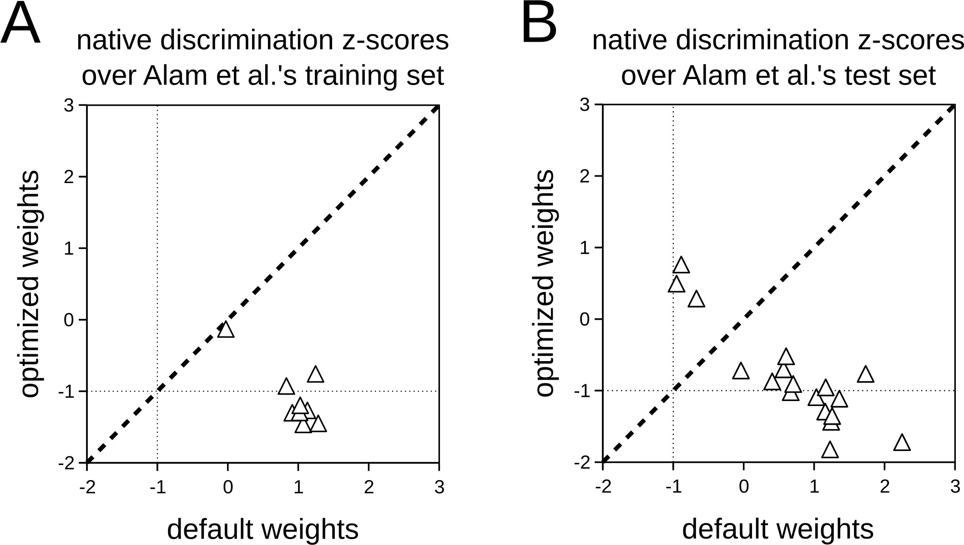
Figure S3. Optimized weights improve discrimination of native-like peptide conformations even with Alam et al.’s training set. Alam et al.’s training and test sets⁵ are identical to ours except for the swapping of peptides 1jwg and 2fmf (Table 2 in the main text). Weight optimization using Alam et al.’s training set yielded the optimized weights listed in Table S4. Shown here are the native discrimination z-scores of the cen_std+score4L energy function under such optimized weights versus the default weights, for the 9 training peptides (A) and the 18 test peptides (B) of Alam et al.’s work. Comparison with Figures 2B–C in the main text indicates that choosing our training set instead of Alam et al.’s was irrelevant to the degree of improvement of native discrimination.
Figure S4. Optimized weights often define a better classifier of native-like decoys than default weights. For each test peptide, ROC curves are plotted for the discrimination of native-like decoys (RMSD from native ≤ 1 Å) by default and optimized weights, respectively, where the discrimination thresholds are the energy ranks (∈ {1,…,7054}). The diagonal line denotes random classification. Plots were made with the ROCR package⁶.
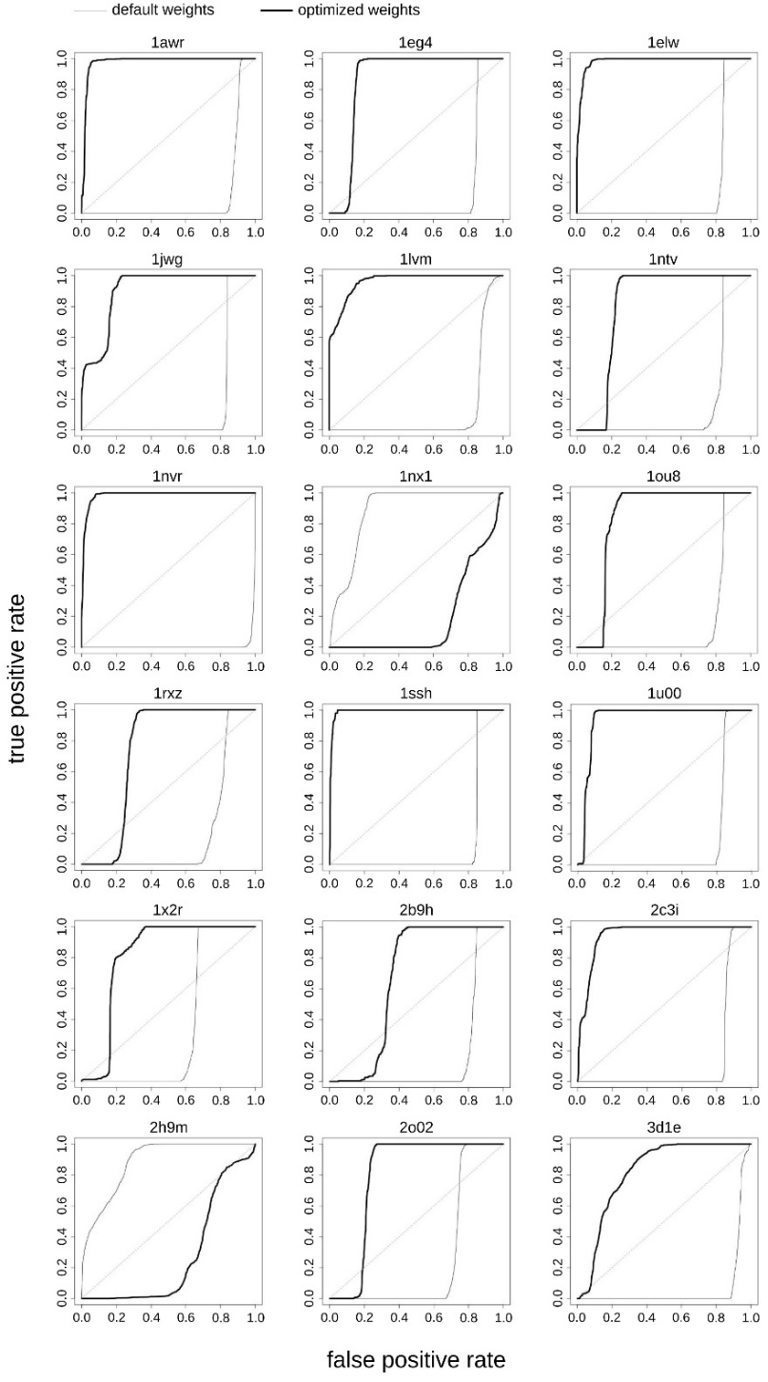
References
(1) Nelder, J. A.; Mead, R. A Simplex Method for Function Minimization. Comput. J. 1965, 7 (4), 308–313. https://doi.org/10.1093/comjnl/7.4.308.
(2) Galassi, M.; Davies, J.; Theiler, J.; Gough, B.; Jungman, G.; Alken, P.; Booth, M.; Rossi, F. GNU Scientific Library Reference Manual - Third Edition; Network Theory Limited, 2009.
(3) Rohl, C. A.; Strauss, C. E. M.; Misura, K. M. S.; Baker, D. Protein Structure Prediction Using Rosetta. Methods Enzymol. 2004, 383, 66–93. https://doi.org/10.1016/S0076-6879(04)83004-0.
(4) Alford, R. F.; Leaver-Fay, A.; Jeliazkov, J. R.; O’Meara, M. J.; DiMaio, F. P.; Park, H.; Shapovalov, M. V.; Renfrew, P. D.; Mulligan, V. K.; Kappel, K.; et al. The Rosetta All-Atom Energy Function for Macromolecular Modeling and Design. J. Chem. Theory Comput. 2017, 13, 3031–3048. https://doi.org/10.1021/acs.jctc.7b00125.
(5) Alam, N.; Goldstein, O.; Xia, B.; Porter, K. A.; Kozakov, D.; Schueler-Furman, O. High-Resolution Global Peptide-Protein Docking Using Fragments-Based PIPER-FlexPepDock. PLoS Comput. Biol. 2017, 13 (12), e1005905. https://doi.org/10.1371/journal.pcbi.1005905.
(6) Sing, T.; Sander, O.; Beerenwinkel, N.; Lengauer, T. ROCR: Visualizing Classifier Performance in R. Bioinformatics 2005, 21, 3940–3941. https://doi.org/10.1093/bioinformatics/bti623.

