Additional File

Additional File 1: Research Recruitment Poster

Research Participation Invitation

Join Our Study on Nature-Based Activities for Mental Vitality!

Are you an older adult looking to enhance your mental well-being and cognitive abilities?
We invite you to participate in an exciting research project exploring the benefits of "outdoor nature-based activities on mental vitality and cognitive empowerment in older adults". This study is conducted with the approval of Babol University of Medical Sciences.

Who Can Participate?
✔ Women aged 60 years and above
✔ Able to engage in mild physical activity
✔ No severe cognitive impairments or major health conditions
✔ Willing to commit to an 8-week study with follow-up

What Will You Do?
- Be randomly assigned to one of three groups:
- Walking with meaningful conversation
- Meditation practice
- Control group (no intervention)
- Attend 8 sessions over 8 weeks in a safe, guided environment
- Complete simple assessments before, after, and 3 months post-study

Why Join?
- Improve your mental vitality and cognitive function
- Engage in enjoyable outdoor and mindfulness activities
- Contribute to valuable scientific research
- Receive expert guidance throughout the study

Location: large park in Khafr County
Duration: 8 weeks + follow-up

📞 Interested? Contact us today!
📧 Email:
📱 Phone:

Your participation can make a difference!

Additional File 2: Demographic Information Questionnaire
Dear Senior Citizen
With greetings and respect, please be informed: This questionnaire is in line with the research on the topic of "The Effect of Nature-Based Activities in the Open Air on Mental Vitality and Cognitive Empowerment of Elderly People: A Randomized Trial Study". Please be careful when answering the questions so that we can benefit from the needs and conditions necessary to better understand the situation of the elderly and analyze it from your in-depth perspective. (Thank you)
1. Age: ............(years)
2. Gender: a) Female b) Male
3. Level of education: a) Primary b) Secondary c) Diploma d) University In years:
4. Employment status: a) Housewife b) Employed c) Retired
5. Marital status : a) Married b) Single (single) c) Single (deceased) d) Single (divorced)
6. Retirement : a) Yes, with salary b) Yes, without salary c) No
7. Number of children:
8. Are your child/children dependent on you in any way? a) Yes b) No
9. Are you dependent on your child/children in any way? a) Yes b) No
10. Adequacy of economic situation:
a) Income equal to expenses b) Income less than expenses c) Income more than expenses
11. Who do you live with?
a) Alone b) Spouse c) Single children d) Married children e) Other
12. Frequency of medication use (more than 5 medications per day) a) Yes b) No
13. History of chronic diseases: a) No b) Yes
14. Chronic comorbidity (presence of more than or equal to two chronic diseases) a) Yes b) No
15. Uncorrected disability (vision, hearing, tooth loss) a) Yes b) No
16. History of hospitalization during the past year a) Yes b) No
17. Physical activity (≥ half an hour per day for at least 3 times a week) a) Yes b) No
18. Perception of own health: a) Better than peers b) No difference c) Worse than peers

Additional File 3: Balance Test (Tandem Gait Test)

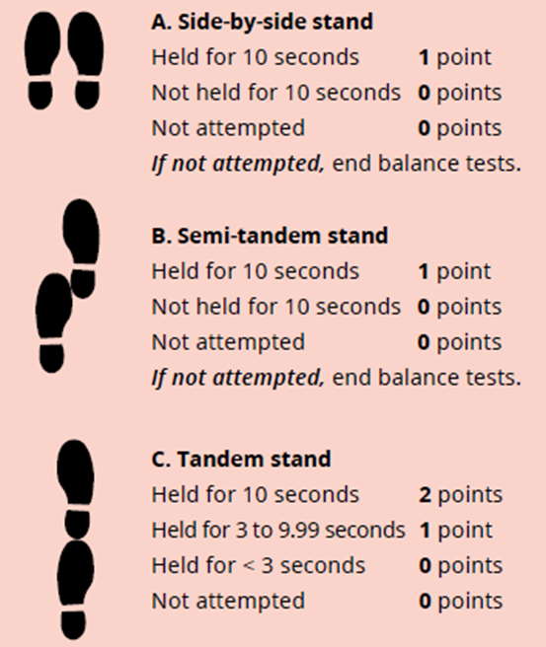

Additional File 4: Informed consent

Hello,
I hereby give my consent to participate in a study titled: “The Effect of Outdoor Nature-Based Activities on Mental Well-Being and Cognitive Empowerment in Older Adults: A Randomized Trial Study” conducted by Fatemeh Mehriyan. Before signing this form, the following was fully explained to me:
1. This study involves an organized program that will be implemented in the natural environment of Ghadir Park, Khafar County. The aim of this study is to investigate the effect of nature-based activities on improving the mental state and cognitive empowerment of older adults. Participants will be randomly assigned to one of the following three groups:
- Walking and Meaningful Conversation Group: This group will participate in group walking sessions that will be accompanied by guided conversations about meaningful topics and life experiences.
- Nature Meditation Group: This group will participate in guided meditation sessions that will be held in a natural setting and will include deep breathing exercises, mindfulness, and relaxation.
- Control Group: This group will not receive any specific intervention and will only receive routine care from health care centers.
- The study will be conducted for four weeks.
- Sessions for the two intervention groups (walking and talking, meditation) will be held two days a week.
- Each session will last approximately 60 minutes.
- All activities will be conducted under the supervision of the researcher and the research team.
- 2. Participation in this study is completely voluntary, and I can withdraw from the study at any time. The decision to withdraw will not have any negative impact on my medical or health services.
3. All of my personal information in this study will remain completely confidential and will only be used for research purposes.
4. I will not be charged any fees for participating in this study. If there are any costs associated with the study, the researcher will cover them.
5. There are potential risks during this intervention. These risks include fatigue, muscle strain, or falling while walking or doing light physical activity outdoors. Older adults may also encounter natural obstacles such as uneven surfaces, rocks, or tree roots. There is also a possibility of anxiety or stress from new activities or interactions with other participants, although this is unlikely and will be managed immediately if observed. The researcher will make every effort to prevent any risks.
6. I have the right to ask questions about the study and to receive additional information from the researcher if needed.
7. The results of this study may be published in scientific journals or conferences, but no identifying or personal information about the participants will be released in this process.
Researcher Information:
Researcher Name: Fatemeh Mehriyan
Contact Number: 09164133059
I, with full knowledge of the above, declare my consent to participate in this research.
Participant's Name and Surname:
Signature:

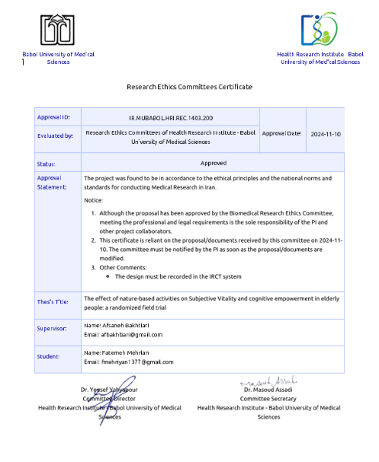
Additional File 5: Research Ethics Committee Certificate

