SUPPLEMENTARY MATERIALS

Photocatalytic Degradation of Toluene and BTEX Compounds in Gas Reactor Modified by TiO₂/Ti Net Nanotubes

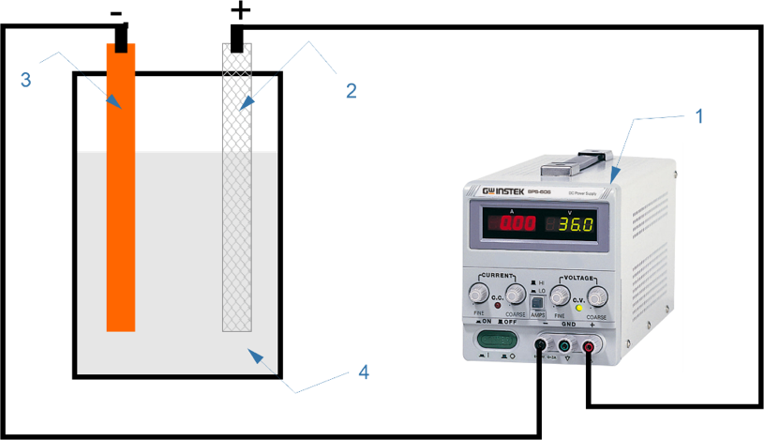

Figure S1. Electrolysis scheme. (1) Power supply, (2) Ti net, (3) Cu plat, and (4) NH₄F electrolyte solution.

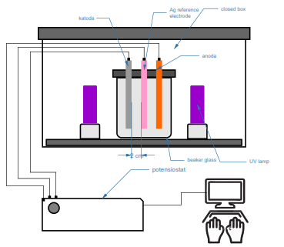

Figure S2. The flow diagram of the test on TiO₂ photocatalytic activity
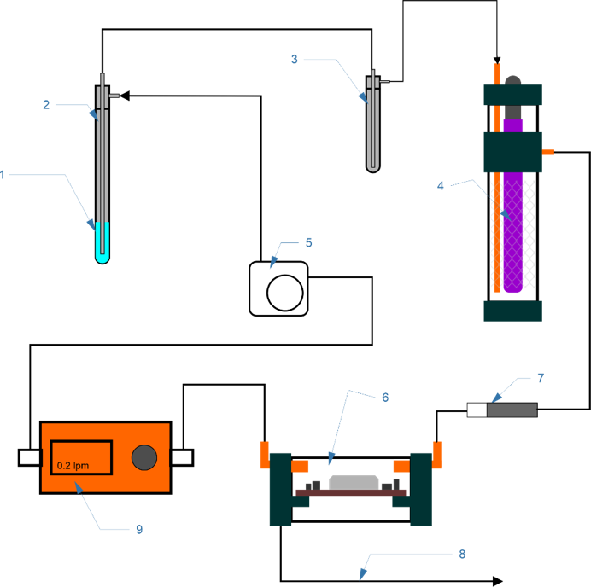

Figure S3. Experiment scheme for photocatalytic degradation of toluene steam. (1) liquid toluene, (2) toluene steam, (3) condenser, (4) reactor, (5) diaphragm pump, (6) CO₂ sensor, (7) charcoal tube, (8) data to PC, and (9) mass flow meter.

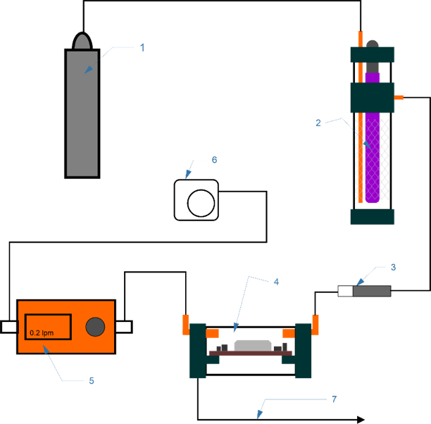

Figure S4. Experiment scheme for photocatalytic degradation of BTEX standard gas. (1) standard gas, (2) reactor, (3) charcoal tube, (4) CO₂ sensor, and (5) mass flow meter.
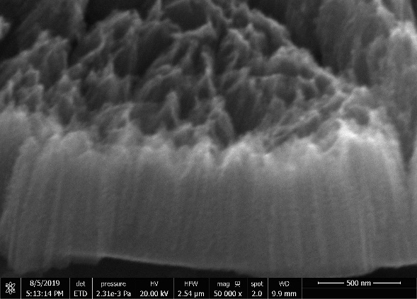

Figure S5. SEM micrograph (cross-section) of TiO2/Ti Net Nanotubes plate after anodizing.

Figure S6. The photocatalytic activity test result of TiO₂ net; blue line – blank; yellow line – 8 hours anodization; green line – 4 hours anodization

