Supplementary Materials

Title of the manuscript: Lower and higher dietary intake of branched-chain amino acids impact cardiac structure and functions in high-fat fed LDLR-/- mice

Author list: Qingxia Li^{1,2,†}, Xian Gao^{3,†}, Fen Chen^{1,†}, Huaxing Zhang⁴, Tianyi Zhao^{1,2}, Shiyao Liu¹, Ziyi Liu¹, Ziyue Tang¹, Yuanyuan Liu¹, Tianao Ling¹, Yang Liu¹, Chunfei Dang¹, Yili Xu¹, Yuxia Ma^{1,2}, Yandong Deng^{5,*}, Wenhua Ling^{1,2,6,*}.

Table S1.Nutrient Composition of Custom High-Fat Diets with Varied BCAA Ratios: 1/2 BCAA, Standard BCAA, and 2× BCAA Enrichment

Product XT108C | 1/2 BCAA |  | 1BCAA |  | 2BCAA
Macronutrients | gm% | kcal% | gm% | kcal% | gm% | kcal%
Protein | 20.61 | 18.14 | 20.61 | 18.14 | 20.61 | 18.14
Carbohydrate | 46.70 | 41.10 | 46.70 | 41.10 | 46.70 | 41.10
Fat | 20.58 | 40.76 | 20.58 | 40.76 | 20.58 | 40.76
Total | 87.90 | 100 | 87.90 | 100 | 87.90 | 100
kcal/gm | 4.55 |  | 4.55 |  | 4.55
Amino Acids | gm | kcal% | gm | kcal% | gm | kcal%
L-Arginine | 7.02 | 28.09 | 6.30 | 25.20 | 4.86 | 19.42
L-Histidine | 5.02 | 20.06 | 4.50 | 18.00 | 3.47 | 13.87
L-Lysine HCl | 17.95 | 71.78 | 16.10 | 64.40 | 12.41 | 49.64
L-Tyrosine | 10.25 | 41.02 | 9.20 | 36.80 | 7.09 | 28.37
L-Tryptophan | 2.34 | 9.36 | 2.10 | 8.40 | 1.62 | 6.47
L-Phenylalanine | 9.70 | 38.79 | 8.70 | 34.80 | 6.71 | 26.82
L-Methionine | 5.02 | 20.06 | 4.50 | 18.00 | 3.47 | 13.87
L-Cystine | 4.12 | 16.50 | 3.70 | 14.80 | 2.85 | 11.41
L-Threonine | 7.36 | 29.43 | 6.60 | 26.40 | 5.09 | 20.35
L-Leucine | 7.65 | 30.60 | 15.30 | 61.20 | 30.60 | 122.40
L-Isoleucine | 4.20 | 16.80 | 8.40 | 33.60 | 16.80 | 67.20
L-Valine | 4.95 | 19.80 | 9.90 | 39.60 | 19.80 | 79.20
Glycine | 3.46 | 13.82 | 3.10 | 12.40 | 2.39 | 9.56
L-Proline | 22.74 | 90.95 | 20.40 | 81.60 | 15.72 | 62.90
L-Glutamic Acid | 40.35 | 161.39 | 36.20 | 144.80 | 27.90 | 111.61
L-Alanine | 5.02 | 20.06 | 4.50 | 18.00 | 3.47 | 13.87
L-Aspartic Acid | 12.59 | 50.38 | 11.30 | 45.20 | 8.71 | 34.84
L-Serine | 10.48 | 41.91 | 9.40 | 37.60 | 7.25 | 28.98
Total | 180.2 | 720.80 | 180.2 | 720.80 | 180.2 | 720.80
Other Ingredients
Corn Starch | 212 | 848.00 | 212 | 848.00 | 212 | 848.00
Maltodextrin 2 | 71 | 284.00 | 71 | 284.00 | 71 | 284.00
Sucrose | 124.41 | 497.64 | 124.41 | 497.64 | 124.41 | 497.64
Cellulose | 50 | 0.00 | 50 | 0.00 | 50 | 0.00
Soybean Oil | 25 | 225.00 | 25 | 225.00 | 25 | 225.00
Lard | 155 | 1395.00 | 155 | 1395.00 | 155 | 1395.00
Mineral Mix S10020 | 5 | 0.00 | 5 | 0.00 | 5 | 0.00
Calcium Phosphate | 13 | 0.00 | 13 | 0.00 | 13 | 0.00
Calcium Carbonate | 5.5 | 0.00 | 5.5 | 0.00 | 5.5 | 0.00
PotassiumCitrate,1H₂O | 16.5 | 0.00 | 16.5 | 0.00 | 16.5 | 0.00
Sodium Chloride | 2.59 | 0.00 | 2.59 | 0.00 | 2.59 | 0.00
Vitamin Mix V10001C | 1 | 4.00 | 1 | 4.00 | 1 | 4.00
Choline Bitartrate | 2 | 0.00 | 2 | 0.00 | 2 | 0.00
Cholesterol | 11.25 | 0.00 | 11.25 | 0.00 | 11.25 | 0.00
Total | 874.45 | 3974.44 | 874.45 | 3974.44 | 874.45 | 3974.44

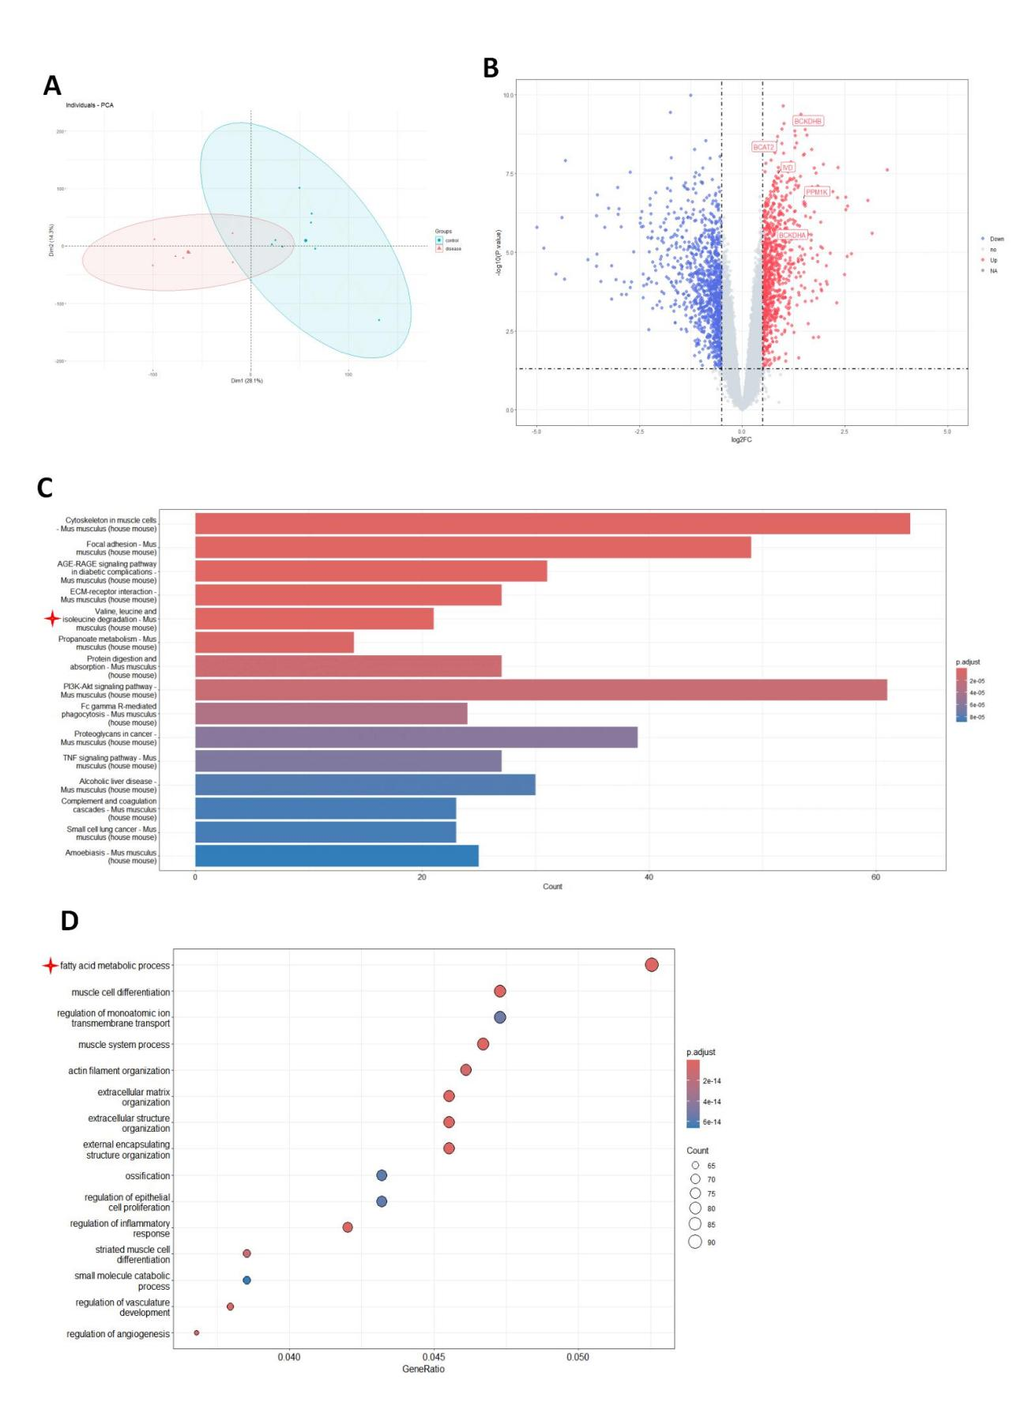
Figure S1. Bioinformatics analysis of GSE136308 and GSE137442 datasets.
GSE136308 and GSE137442 datasets were downloaded from the GENE EXPRESSION OMNIBUS （GEO） database. To ensure accurate results, 5 samples from GSE136308 (GSM4044415, GSM404416, GSM404417, GSM40441, GSM404419) and 3 samples from GSE137442(GSM4079374, GSM4079375, GSM4079376) were integrated into the control group. 4 samples from GSE136308 (GSM4044420, GSM404421, GSM404422, GSM404423) and 3 samples from GSE137442(GSM4079377, GSM4079378, GSM4079379) were integrated into the heart failure group. Platform annotation data using the GEO query download and convert the matrix probes into gene symbols using R. When multiple probes correspond to a gene ID, average values are utilized for analysis. The batch effect was removed using the remove Batch Effect function in Limma, which was also employed to identify differentially expressed genes (DEGs). Finally, the genes with P<0.05 and log2 fold change (FC)>0.5 were considered as differential genes, and R was used for visualization. The GO (Gene Ontology) and KEGG (Kyoto Encyclopedia of Genes and Genomes) enrichment analyses were conducted using the cluster Profiler package, and their values were < 0.05. For the analysis of GSE136308 and GSE137442 datasets, 1881 differentially expressed genes were screened out between the heart failure group and the control group. A. The principal component analysis (PCA). The control group is shown in blue. The disease group (heart failure) is shown in yellow. B. Volcano plot of differential gene expression, red dots represent up-regulated DEGs and blue dots represent down-regulated DEGs. C. Bar plots of KEGG enrichment analysis of the top 15 pathways based on p-values and gene percentages. The red star indicates branched-chain amino acid degradation. D. The GO enrichment analysis bubble plots of the top 20 biological pathways based on p-values and gene percentages. Red star indicates a fatty acid metabolic process.

