CoFe-LDO nanoparticles as a novel catalyst of permonosulfate (PMS) for amino acid removal
Yuye Luo¹, Cheng Liu¹*, Meiqi Zhao¹
¹Key Laboratory of Integrated Regulation and Resource Development on Shallow Lake of Ministry of Education, College of Environment, Hohai University, Nanjing 210098, China
*College of Environment, Hohai University, Nanjing 210098, China, 107489860@qq.com

Text S1. Specific experimental conditions for HPLC, HPLC-MS and GC
Amino acids were analyzed by HPLC using 6-aminoquinolyl-N-hydroxysuccinimidyl (AQC) derivatization. The reaction between AQC, amino acids, and ammonia led to the formation of fluorescent complexes, which were separated on an AccQ. Tag Waters (Shanghai, China) C18 HPLC column (3.924 mm × 150 mm) and detected at excitation and emission wavelengths of 240 and 395 nm, respectively. The HPLC system consisted of a Waters TM 600 gradient pump, a Merck (Germany) AS-4000 autosampler, a column heater, and a 474 Waters TM fluorescence detector.
High performance liquid chromatography mass spectrometry (HPLC-MS) has been widely used in analytical studies of chemical composition. In the present study, we established a method for the determination of amino acid oxidation products using HPLC-MS. Amino acid oxidation products were identified by ultrahigh-performance liquid chromatography–tandem mass spectrometry (UPLC/MS/MS; Agilent, Waldbronn, Germany). Chromatographic separation was performed at a flow rate of 0.2 mL/min on a Zorbax Eclipse Plus C18 column (2.1 mm × 50 mm, 1.8 μm), which was preceded by a C18 guard column. This column was kept at a temperature of 35 °C during the separation period. The mobile phase consisted of a 2 mmol/L ammonium acetate solution (eluent A) and acetonitrile (eluent B) filtered through a membrane with a pore size of 0.22 μm. The injection volume was 5 μL. Detection was performed with an Agilent 6460 Series triple quadrupole mass spectrometer equipped with an electrospray ionization source. Qualitative metabolite analysis was conducted via UPLC/MS/MS in full-scan mode. Ion-source parameters were as follows: drying temperature of 300°C, drying flow rate of 5 L/min, nebulizer gas pressure of 45 psi, sheath-gas temperature of 250°C, sheath-gas flow rate of 5 L/min, capillary voltage of 3500 V, and nozzle voltage of 500 V.
GC experiments (Agilent, Waldbronn, Germany) were used to determine the formation potential of the N-DBPs DCAN and DCAcAm. The test method parameters for DCAN were as follows: HP-5 capillary gas chromatographic column (30 m × 0.25 mm × 1 μm), inlet temperature of 250°C, ECD detector temperature of 250°C, high-purity nitrogen carrier gas (99.99% purity), flow rate of 2 mL/min, tail gas flow rate of 50 mL/min, injection mode for split injection (split ratio 2:1), and sample volume of 1 μL. The test method parameters for DCAcAm were as follows: HP-5 capillary gas chromatographic column (30 m × 0.25 mm × 1 μm), inlet temperature of 235°C; ECD detector temperature of 250°C; high-purity nitrogen carrier gas (99.99% purity), flow rate of 2 mL/min, tail gas flow rate of 50 mL/min, injection mode for splitless injection, and sample volume of 1 μL.
Table S1. Relevant properties on histidine
Amino acid | Branched  chain | Chemical Formulas | Molecular Weight  (g·mol⁻¹) | Chemical Structure
Histidine | alkalinity | C₆H₉N₃O₂ | 155 | 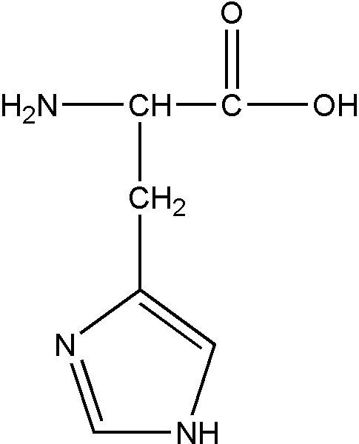

Table S2 The leaching of cobalt and iron ions
The number of catalyst cycle | 0 | 1 | 2 | 3 | 4
Co | 0.028 mg/L | N/A | N/A | N/A | N/A
Fe | 0.015 mg/L | N/A | N/A | N/A | N/A

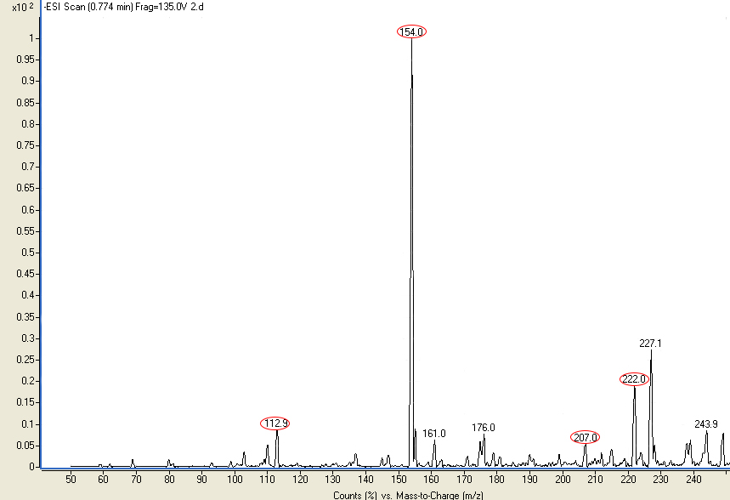
Fig. S1 Mass spectrum of histidine solution after the reaction
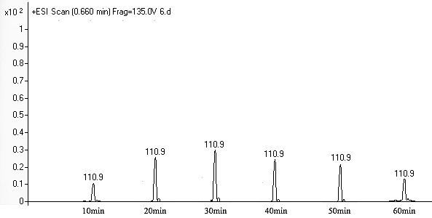
Fig. S2 The mass spectra of histidine at different time in the CoFe-LDO/PMS system (10 mg/L histidine; 0.04 g/L CoFe-LDO; 0.5 mmol/L PMS)

