Supplementary information

Turn-on Quinoline Probe for Selective Sensing of Hypochlorite in Live Cells

Fiyinfolu F. Olubiyo,^{1,2} Sebastian Y. S. Klu,³ Rebecca J. Burgess,^{3,*} and Yuqing Hou^{1,2,*}

¹The Meyers Institute for Interdisciplinary Research in Organic and Medicinal Chemistry,
²School of Chemical and Biomolecular Sciences
³Division of Biochemistry and Molecular Biology, Department of Biomedical Sciences, Southern Illinois University School of Medicine, Carbondale, IL 62901, USA

Corresponding authors: Rebecca J. Burgess, rebecca.burgess@siu.edu
Yuqing Hou houyq@siu.edu

Synthesis of 6 (11-methyl-2,4-bis(trifluoromethyl)-11H-pyrido[2,3-b]phenothiazine 6-oxide).

Compound 5 (50 mg) was dissolved in 2 ml ethanol and stirred. Sodium hypochlorite (0.2 ml) was added, and reaction stirred at room temperature for 3 h. After completion, the solvent was removed. Compound 6 was isolated as a light yellow solid. ¹H NMR (500 MHz, CDCl₃) δ 8.37 (dq, J = 9.7, 1.9 Hz, 1H), 8.17 (dd, J = 7.7, 1.6 Hz, 1H), 8.00 (s, 1H), 7.98 (d, J = 9.7 Hz, 1H), 7.74 (ddd, J = 8.7, 7.2, 1.6 Hz, 1H), 7.57 (d, J = 8.4 Hz, 1H), 7.44 (td, J = 7.5, 1.0 Hz, 1H), 4.02 (s, 3H). ¹⁹F NMR (471 MHz, CDCl₃) δ -60.85, -67.36 (d, J = 2.6 Hz). HRMS (EI-TOF) m/z: [M+H]⁺ Calcd for C₁₈H₁₁F₆N₂OS 417.0496; Found: 417.0494.

Fluorescence Analysis of probe
- Probe preparation
A 0.65 mM stock solution of probe 5 in acetonitrile was prepared and used for all analyses. Stock was diluted to required concentrations in toluene, acetonitrile, ethanol, DMSO or PBS (Fig 5). All dilutions for cell analysis were done in PBS. Resulting solutions were 3% acetonitrile to 97% PBS for live cell studies.

- Fluorescence
Analytes were all prepared from their corresponding salts up to 100 µM in ultra-pure water.
To various test-tubes containing 1 ml, 50 µM probe in 3 % acetonitrile: PBS solution, was added 1 ml 100 µM of freshly prepared analytes; OH,, SO₃²⁻, NO₃⁻, H₂O₂, OH⁻, Fe²⁺, Zn²⁺, Sn²⁺, Ca²⁺, Na²⁺, Cl⁻, Br⁻, F⁻, NO₂⁻ and 20 µM ClO⁻ (Fig 6 S.I). Fluorescence was recorded on a spectrophotometer. To determine sensitivity of probe towards hypochlorite, a series of 20 µM to 90 µM hypochlorite solutions were prepared freshly from NaOCl in ultra-pure water. To test-tubes containing 1 ml of 5 µM probe was added 1 ml increasing concentrations of ClO⁻. Fluorescence was recorded immediately on a spectrophotometer. Time sensitivity was recorded in the same fashion with 50 µM hypochlorite over a time range of 10 sec to 20 mins.

Probe cytotoxicity analysis in live cells
2x10⁶ freshly isolated mouse whole bone marrow cells were incubated with various concentrations of probe 5 in PBS for 30 minutes at 37 ºC. Then, the cells were washed with 1x PBS and resuspended in 200 μl of 1x PBS containing 1 μg/ml 4’6-diamidino-2-phenylindole (DAPI) and incubated for 10 minutes at room temperature. The cells were washed and resuspended in 1x PBS for immediate analysis on an Attune NxT flow cytometer at 440/50nm, VL1 channel. The percentage of DAPI positive cells were recorded as a measure of cell death.

ANALYSIS
¹H, ¹³C, ¹⁹F NMR were recorded in CDCl₃ with TMS as internal standard on a Bruker 500 MHz spectrometer at 500, 125, and 471 MHz, respectively, unless otherwise specified.
UV-Vis Spectroscopy was recorded on a Carey Eclipse UV-vis Spectrophotometer with a 1 cm cuvette. Fluorescence was recorded with a Carey Eclipse Spectrometer with excitation and emission slits set at 5, and scan rate 600 nm /min in a 1 cm cuvette and samples were excited near 400 nm. Mass spectrometry data were collected on a time-of-flight mass spectrometer with electron ionization technique unless otherwise specified.

¹H NMR of 2 (2,4-bis(trifluoromethyl)quinolin-7-amine)

¹³C NMR of 2 (2,4-bis(trifluoromethyl)quinolin-7-amine)

¹⁹F NMR of 2 (2,4-bis(trifluoromethyl)quinolin-7-amine)

¹H NMR of 3 (N-methyl-2,4-bis(trifluoromethyl)quinolin-7-amine)

¹⁹F NMR of 3 (N-methyl-2,4-bis(trifluoromethyl)quinolin-7-amine)

¹³C NMR of 3 (N-methyl-2,4-bis(trifluoromethyl)quinolin-7-amine)

¹H NMR of 4 (N-methyl-2,4-bis(trifluoromethyl)quinolin-7-amine--N-methyl-N-phenyl-2,4-bis(trifluoromethyl)quinolin-7-amine)

¹⁹F NMR of 4 (N-methyl-2,4-bis(trifluoromethyl)quinolin-7-amine--N-methyl-N-phenyl-2,4-bis(trifluoromethyl)quinolin-7-amine)

¹H NMR of 5 (11-methyl-2,4-bis(trifluoromethyl)-11H-pyrido[2,3-b] phenothiazine)

¹⁹F NMR of 5 (11-methyl-2,4-bis(trifluoromethyl)-11H-pyrido[2,3-b] phenothiazine)

¹H NMR of crude 6 (11-methyl-2,4-bis(trifluoromethyl)-11H-pyrido[2,3-b]phenothiazine 6-oxide)

¹⁹F NMR of crude 6 (11-methyl-2,4-bis(trifluoromethyl)-11H-pyrido[2,3-b]phenothiazine 6-oxide)

Fig S1: Uv-Vis spectra of probe precursor 4 at 50 µM

Fig S2: Fluorescence spectra of probe precursor 4 is solvent dependent at 50 µM. 4 is fluorescent in PBS

Fig S3: Fluorescence spectra of 6 is solvent dependent at 20 µM

Fig S4: Fluorescence spectra of 5 (50 µM) in various solvents

Fig S5. Probe 5 (50 µM in 3% acetonitrile: PBS) interaction with 100 µM analytes; OH•, SO₃²⁻, NO₃⁻, H₂O₂, OH⁻, Fe²⁺, Zn²⁺, Sn²⁺, Ca²⁺, Na²⁺, Cl⁻, Br⁻, F⁻, NO₂⁻ and 20 µM ClO⁻

(a) (b)

Fig S6. (a) Sensitivity of 5 (5 µM in 3% acetonitrile: PBS) towards hypochlorite at 523nm; (b) Line graph showing concentration relationship with intensity

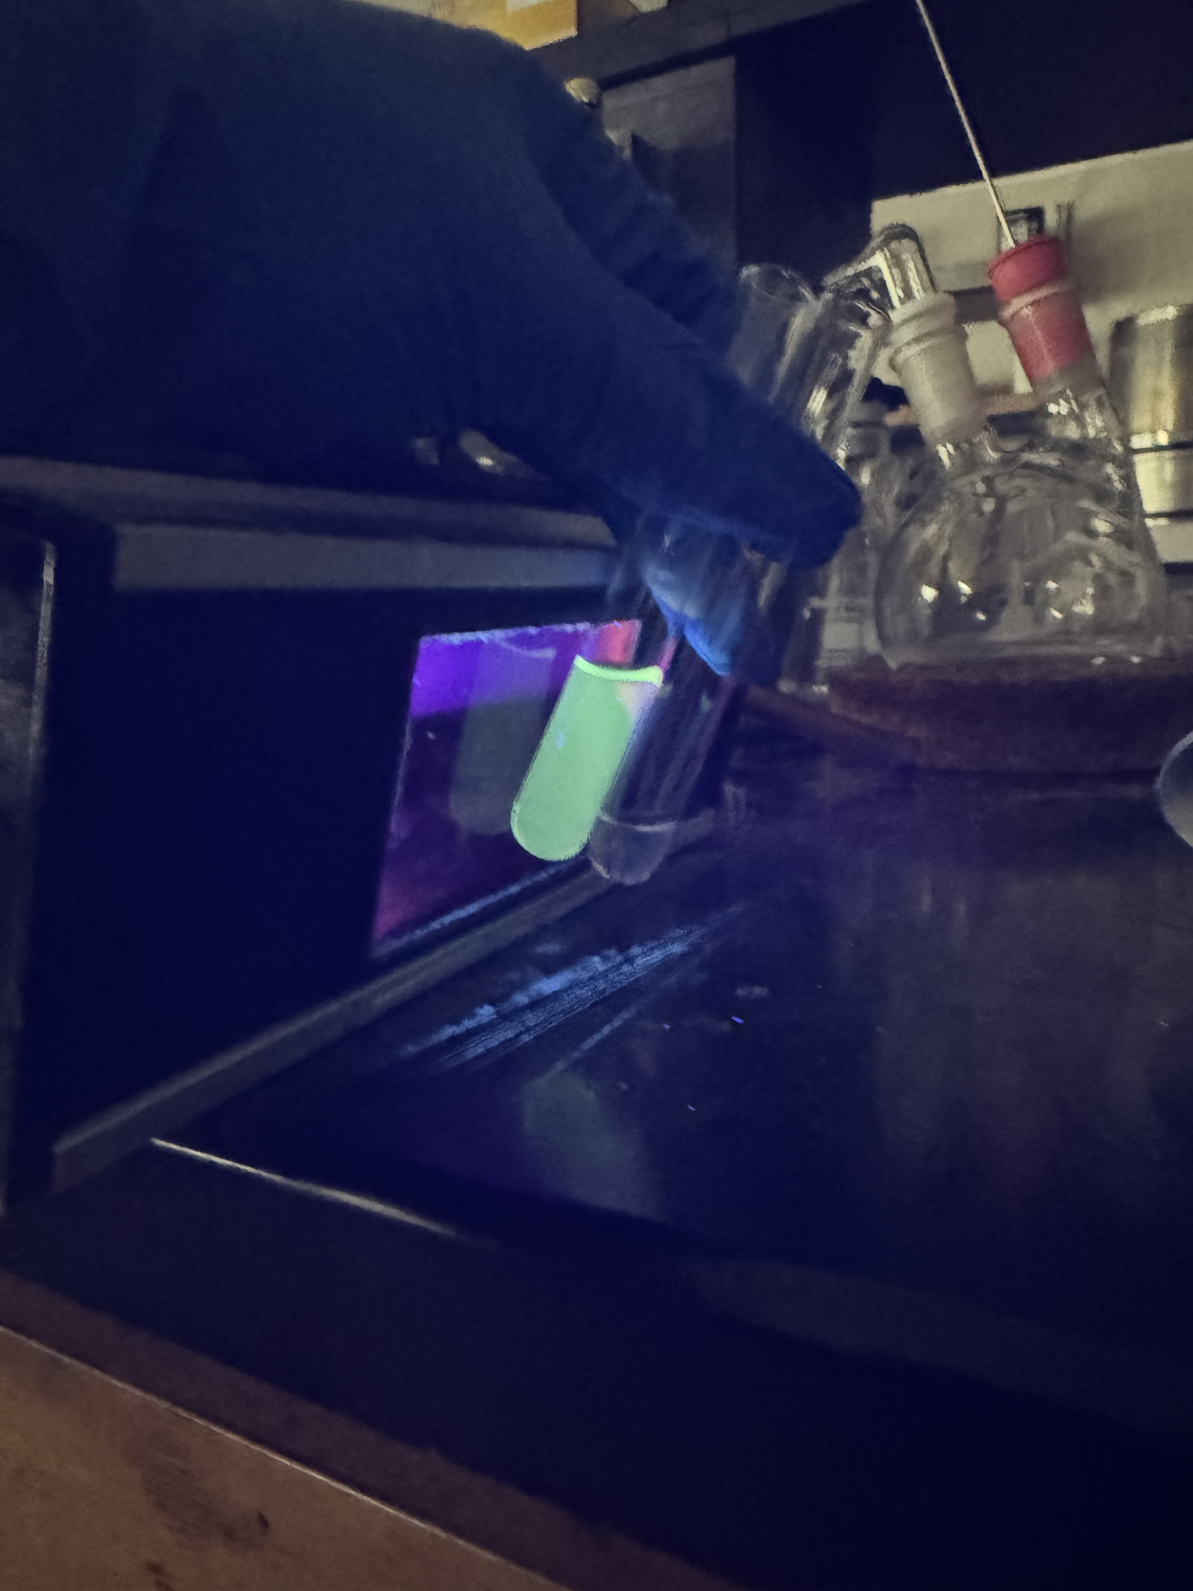

Fig S7. Probe 5 interaction with hypochlorite is visible to the naked eye at 50 µM (L) and not fluorescent without hypochlorite (R)

- (b)

Fig S8. (a) Time dependence plot of 5 (5 µM in 3% acetonitrile: PBS) towards hypochlorite (50 µM) at 523 nm (b) Line graph showing intensity rise with increasing time

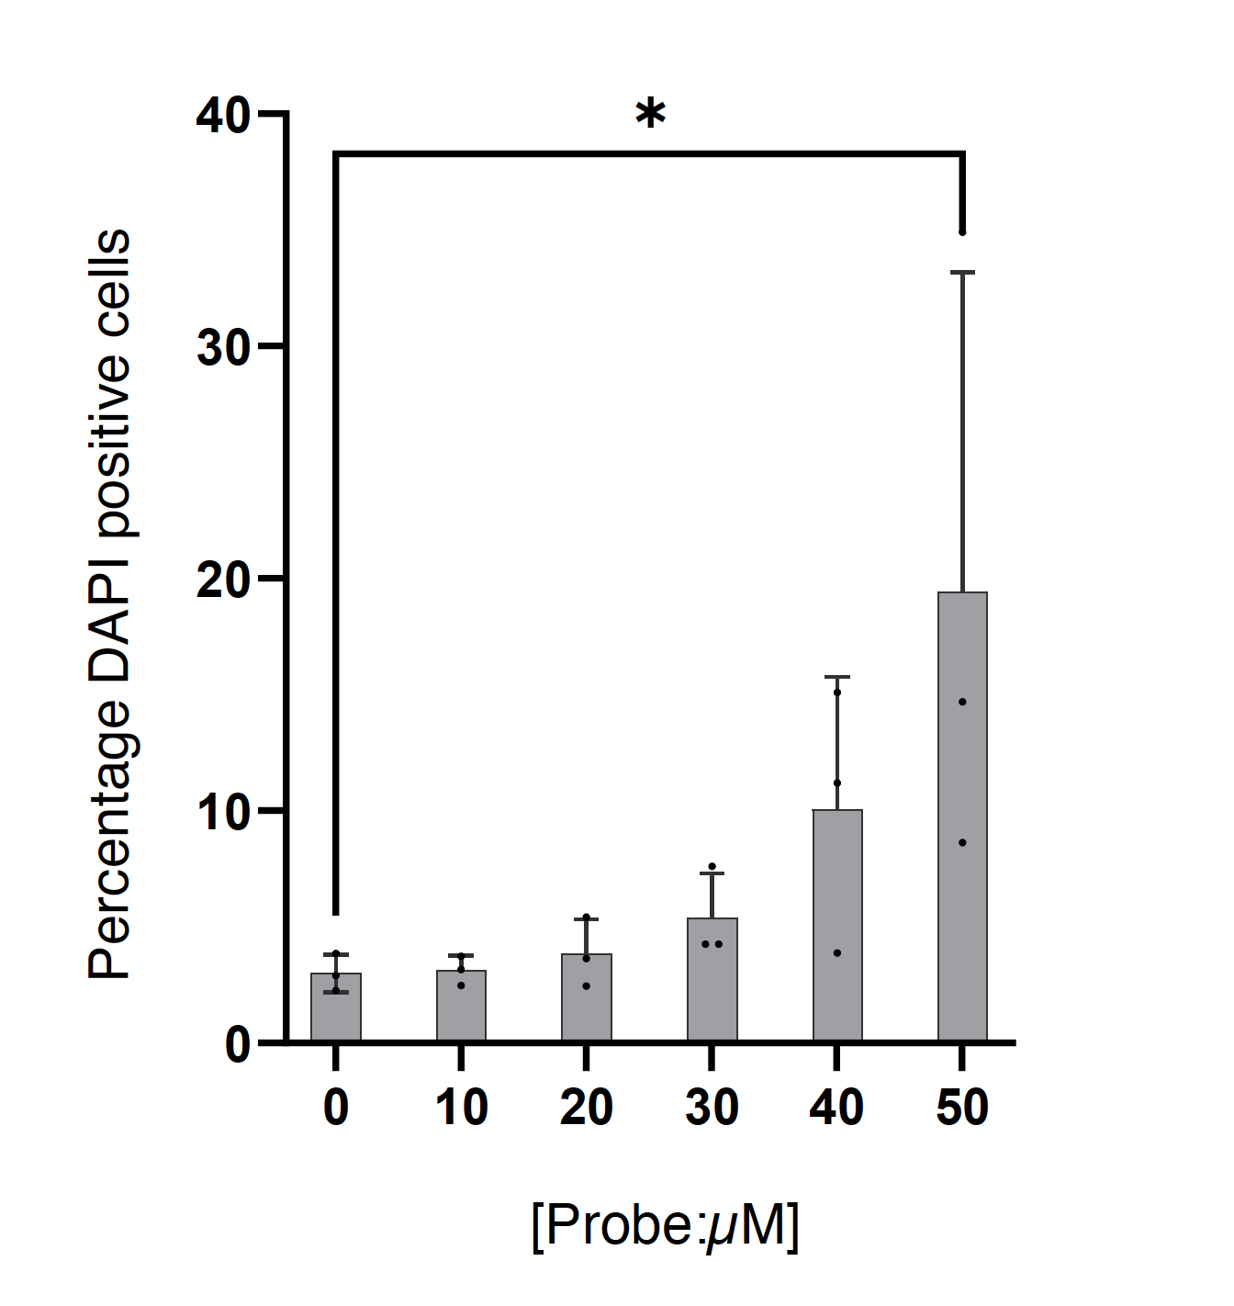
Fig S9. Percentage of DAPI positive (dead) cells after treatment of live bone marrow cells with the indicated concentrations of probe 5. Each dot represents a single sample collected in 3 independent experiments, where each experiment was performed on cells from a single mouse. Zero (0) indicates cells with no probe 5 added. *p<0.05 using one-way ANOVA.

