Supplementary Information
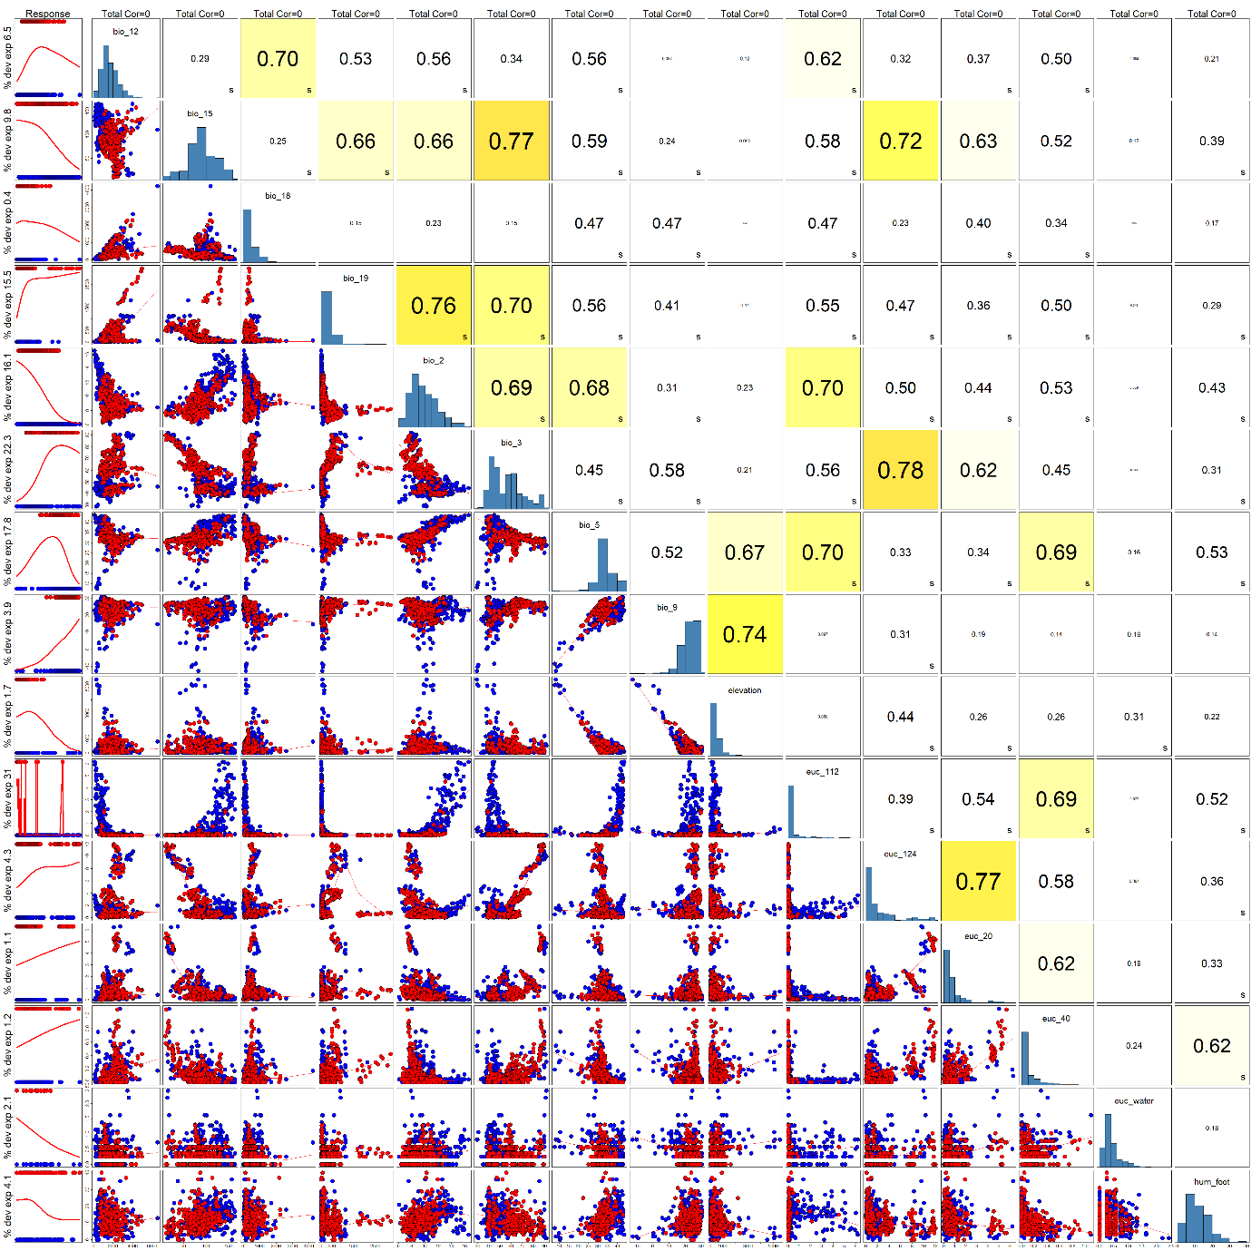

Fig. S1 The correlation between the covariates chosen for final model for Asian elephants. The Pearson correlation coefficient is the primarily used here. However, if the Spearman or Kendall correlation coefficient exceeds the Pearson correlation coefficient, an "s" or "k" will be displayed in the bottom-right corner of the variable box.

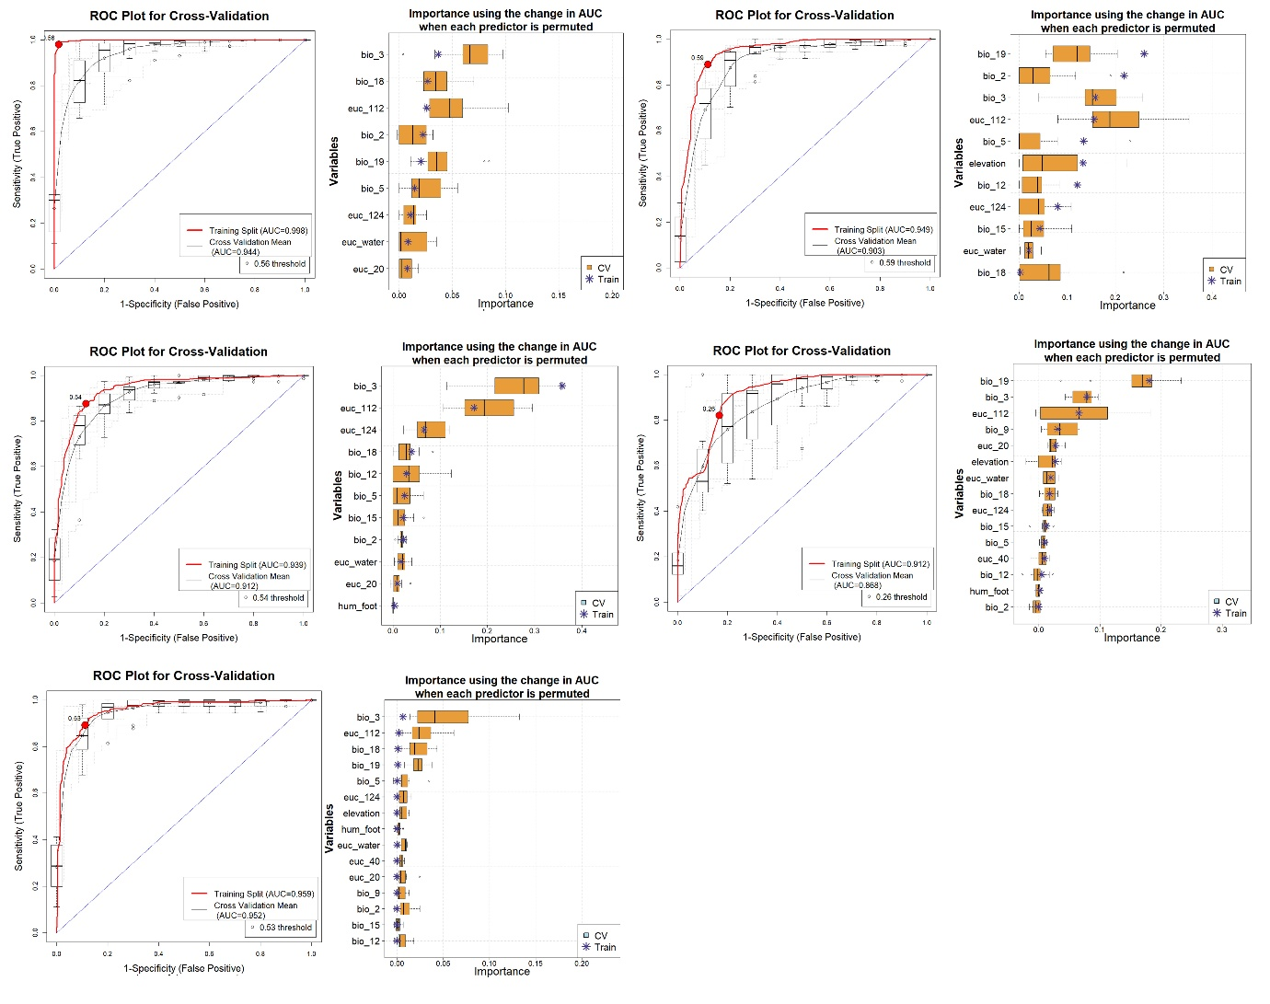

Fig. S2 Model evaluation plots depicting the average training ROC for both training and cross-validation (CV), along with the predictors selected by the model across replicate runs under five different models. (A) Boosted Regression Tree, (b) Generalized Linear Model (GLM) (C) Multivariate Adaptive Regression Splines (MARS), (D) Maximum Entropy (MaxEnt) and (E) Random Forest.

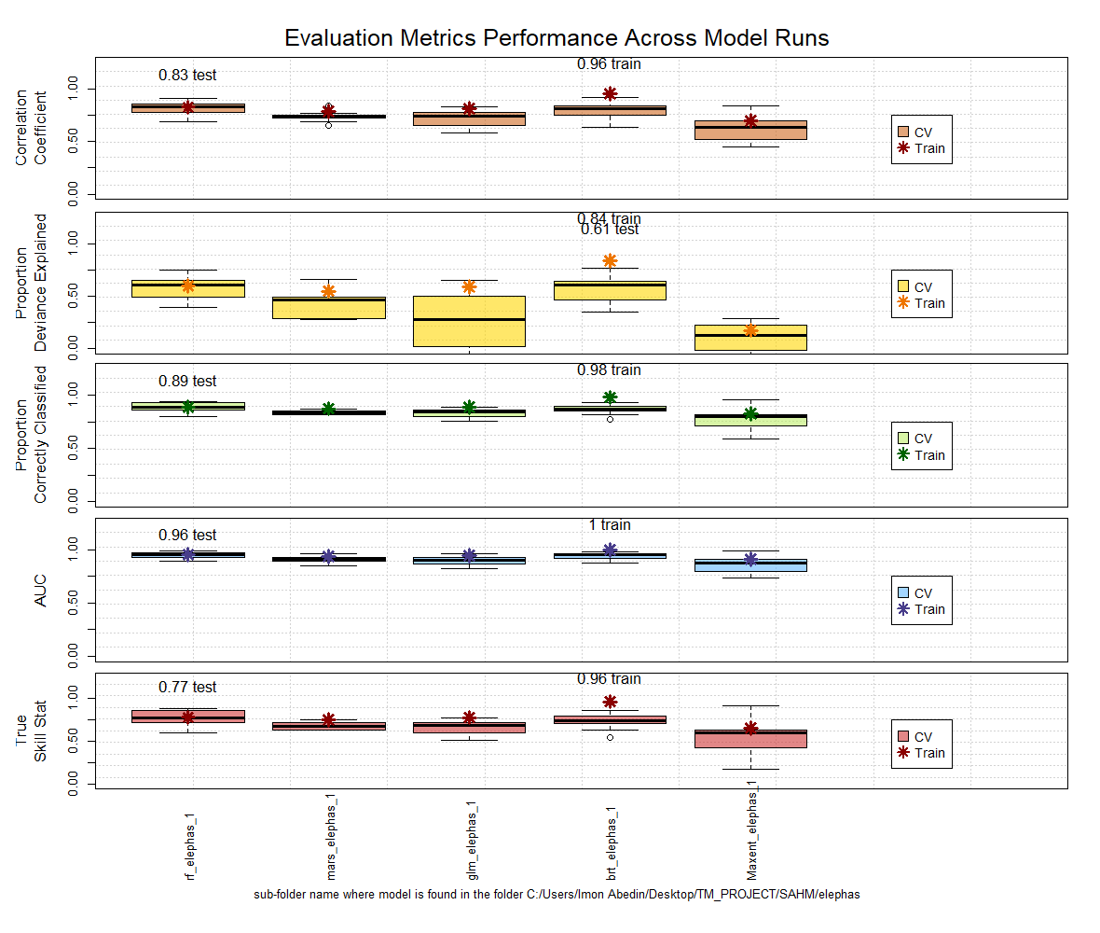

Fig. S3 Evaluation Matrix performance across model runs for Asian elephants. Brown - represents the correlation coefficient among the 5 different models. Yellow - represents the proportion of deviance explained; Green - represents the Proportion of correctly classified; Blue - represents Area under curve (AUC) and Pink - represents true skill statistics.

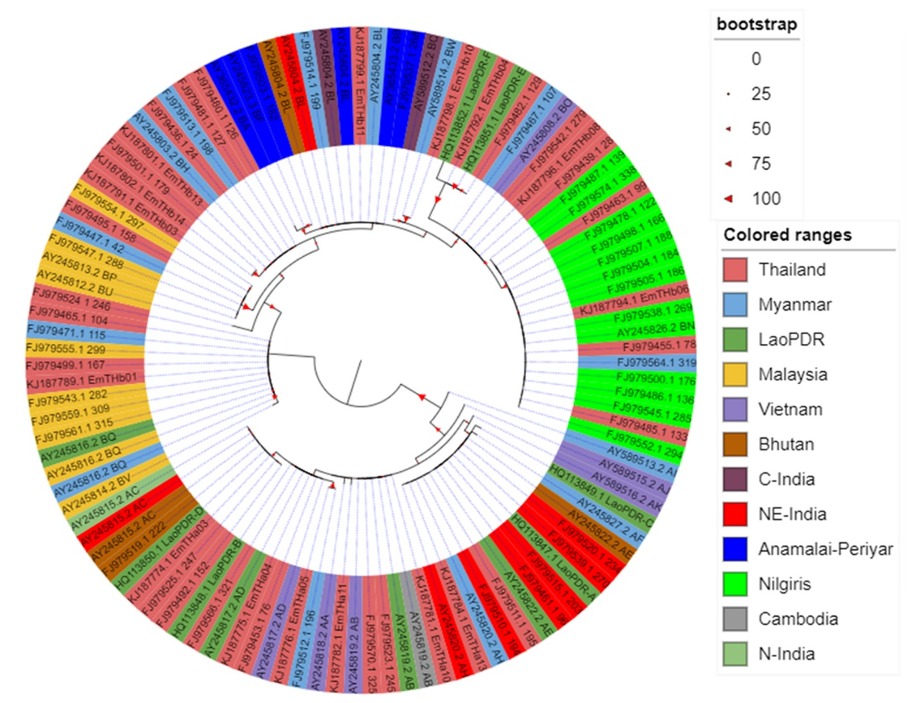
Fig. S4 Maximum Likelihood phylogenetic tree of the Asian elephant using HKY+G+I model in RAxML v8 software. NE-India=Northeast India, C-India=Central India and N-India=Northern India.
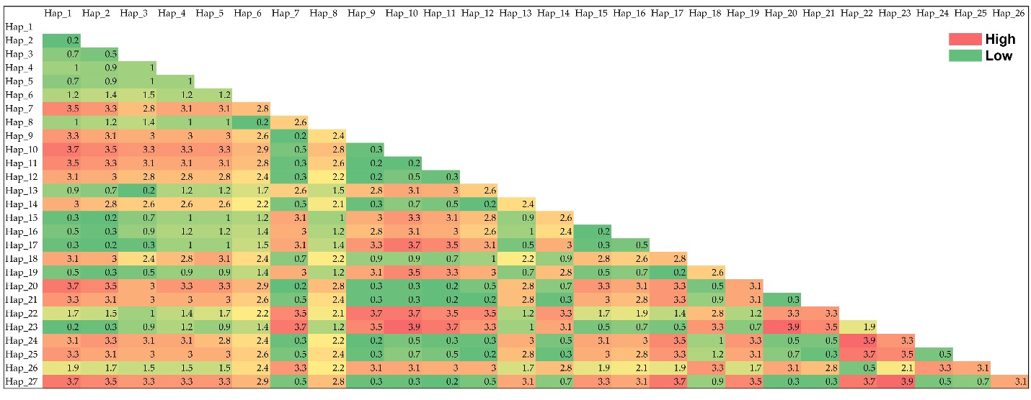
Fig. S5 Genetic distance estimated for all the generated haplotypes of Asian elephants.

Table S1 Number of occurrences of Asian elephants in different range countries (Source: GeoCAT Secondary Data Repository).
Country | No. of Occurrences
Bhutan (BTN) | 10
India (IND) | 375
Malaysia (MYS) | 91
Indonesia (IDN) | 11
Nepal (NPL) | 22
Sri Lanka (LKA) | 226
Thailand (THA) | 154
Bangladesh (BGD) | 2

Table S2 List of sequences used in this study including accession numbers, geographic origin and references. NE-India=Northeast India, C-India=Central India and N-India=Northern India.

Sl. No. | NCBI Accession No. | Origin | References
1 | AY245803.2 | Myanmar | Fernando et al. 2003
2 | AY245804.2 | Anamalai-Periyar | Fernando et al. 2003
3 | AY245804.2 | Bhutan | Fernando et al. 2003
4 | AY245804.2 | C-India | Fernando et al. 2003
5 | AY245804.2 | Myanmar | Fernando et al. 2003
6 | AY245804.2 | NE-India | Fernando et al. 2003
7 | AY245808.2 | Vietnam | Fernando et al. 2003
8 | AY245812.2 | Malaysia | Fernando et al. 2003
9 | AY245813.2 | Malaysia | Fernando et al. 2003
10 | AY245814.2 | Malaysia | Fernando et al. 2003
11 | AY245815.2 | Bhutan | Fernando et al. 2003
12 | AY245815.2 | NE-India | Fernando et al. 2003
13 | AY245815.2 | N-India | Fernando et al. 2003
14 | AY245816.2 | LaoPDR | Fernando et al. 2003
15 | AY245816.2 | Malaysia | Fernando et al. 2003
16 | AY245816.2 | Myanmar | Fernando et al. 2003
17 | AY245817.2 | LaoPDR | Fernando et al. 2003
18 | AY245817.2 | Vietnam | Fernando et al. 2003
19 | AY245818.2 | Vietnam | Fernando et al. 2003
20 | AY245819.2 | Cambodia | Fernando et al. 2003
21 | AY245819.2 | LaoPDR | Fernando et al. 2003
22 | AY245819.2 | Vietnam | Fernando et al. 2003
23 | AY245820.2 | Myanmar | Fernando et al. 2003
24 | AY245820.2 | NE-India | Fernando et al. 2003
25 | AY245822.2 | Bhutan | Fernando et al. 2003
26 | AY245822.2 | LaoPDR | Fernando et al. 2003
27 | AY245823.3 | Anamalai-Periyar | Fernando et al. 2003
28 | AY245826.2 | Nilgiris | Fernando et al. 2003
29 | AY245827.2 | Myanmar | Fernando et al. 2003
30 | AY365432.2 | Anamalai-Periyar | Vidya et al. 2009
31 | AY365433.2 | Anamalai-Periyar | Vidya et al. 2009
32 | AY589512.2 | C-India | Vidya et al. 2009
33 | AY589513.2 | Myanmar | Vidya et al. 2009
34 | AY589514.2 | Myanmar | Vidya et al. 2009
35 | AY589515.2 | Vietnam | Vidya et al. 2007
36 | AY589516.2 | Vietnam | Vidya et al. 2007
37 | FJ979436.1 | Thailand | Lei et al. 2011
38 | FJ979439.1 | Thailand | Lei et al. 2011
39 | FJ979447.1 | Myanmar | Lei et al. 2011
40 | FJ979453.1 | Thailand | Lei et al. 2011
41 | FJ979455.1 | Thailand | Lei et al. 2011
42 | FJ979461.1 | India | Lei et al. 2011
43 | FJ979463.1 | Thailand | Lei et al. 2011
44 | FJ979465.1 | Thailand | Lei et al. 2011
45 | FJ979467.1 | Myanmar | Lei et al. 2011
46 | FJ979471.1 | Myanmar | Lei et al. 2011
47 | FJ979478.1 | India | Lei et al. 2011
48 | FJ979480.1 | Thailand | Lei et al. 2011
49 | FJ979481.1 | Thailand | Lei et al. 2011
50 | FJ979482.1 | Thailand | Lei et al. 2011
51 | FJ979485.1 | Thailand | Lei et al. 2011
52 | FJ979486.1 | India | Lei et al. 2011
53 | FJ979487.1 | India | Lei et al. 2011
54 | FJ979492.1 | Thailand | Lei et al. 2011
55 | FJ979495.1 | Thailand | Lei et al. 2011
56 | FJ979498.1 | India | Lei et al. 2011
57 | FJ979499.1 | Thailand | Lei et al. 2011
58 | FJ979500.1 | India | Lei et al. 2011
59 | FJ979501.1 | Thailand | Lei et al. 2011
60 | FJ979503.1 | India | Lei et al. 2011
61 | FJ979504.1 | India | Lei et al. 2011
62 | FJ979505.1 | India | Lei et al. 2011
63 | FJ979507.1 | India | Lei et al. 2011
64 | FJ979510.1 | India | Lei et al. 2011
65 | FJ979511.1 | Thailand | Lei et al. 2011
66 | FJ979512.1 | Myanmar | Lei et al. 2011
67 | FJ979513.1 | Myanmar | Lei et al. 2011
68 | FJ979514.1 | Myanmar | Lei et al. 2011
69 | FJ979515.1 | India | Lei et al. 2011
70 | FJ979519.1 | Bhutan | Lei et al. 2011
71 | FJ979520.1 | India | Lei et al. 2011
72 | FJ979523.1 | Thailand | Lei et al. 2011
73 | FJ979524.1 | Thailand | Lei et al. 2011
74 | FJ979525.1 | Thailand | Lei et al. 2011
75 | FJ979537.1 | India | Lei et al. 2011
76 | FJ979538.1 | India | Lei et al. 2011
77 | FJ979539.1 | India | Lei et al. 2011
78 | FJ979542.1 | Thailand | Lei et al. 2011
79 | FJ979543.1 | Malaysia | Lei et al. 2011
80 | FJ979545.1 | India | Lei et al. 2011
81 | FJ979547.1 | Malaysia | Lei et al. 2011
82 | FJ979552.1 | India | Lei et al. 2011
83 | FJ979554.1 | Malaysia | Lei et al. 2011
84 | FJ979555.1 | Malaysia | Lei et al. 2011
85 | FJ979559.1 | Malaysia | Lei et al. 2011
86 | FJ979561.1 | Malaysia | Lei et al. 2011
87 | FJ979564.1 | Myanmar | Lei et al. 2011
88 | FJ979566.1 | Thailand | Lei et al. 2011
89 | FJ979570.1 | Thailand | Lei et al. 2011
90 | FJ979574.1 | India | Lei et al. 2011
91 | HQ113847.1 | LaoPDR | Ahlering et al. 2011
92 | HQ113848.1 | LaoPDR | Ahlering et al. 2011
93 | HQ113849.1 | LaoPDR] | Ahlering et al. 2011
94 | HQ113850.1 | LaoPDR | Ahlering et al. 2011
95 | HQ113851.1 | LaoPDR | Ahlering et al. 2011
96 | HQ113852.1 | LaoPDR] | Ahlering et al. 2011
97 | KJ187774.1 | Thailand | Thitaram et al. 2015
98 | KJ187775.1 | Thailand | Thitaram et al. 2015
99 | KJ187776.1 | Thailand | Thitaram et al. 2015
100 | KJ187781.1 | Thailand | Thitaram et al. 2015
101 | KJ187782.1 | Thailand | Thitaram et al. 2015
102 | KJ187784.1 | Thailand | Thitaram et al. 2015
103 | KJ187789.1 | Thailand | Thitaram et al. 2015
104 | KJ187791.1 | Thailand | Thitaram et al. 2015
105 | KJ187792.1 | Thailand | Thitaram et al. 2015
106 | KJ187794.1 | Thailand | Thitaram et al. 2015
107 | KJ187796.1 | Thailand | Thitaram et al. 2015
108 | KJ187798.1 | Thailand | Thitaram et al. 2015
109 | KJ187799.1 | Thailand | Thitaram et al. 2015
110 | KJ187801.1 | Thailand | Thitaram et al. 2015
111 | KJ187802.1 | Thailand | Thitaram et al. 2015

Table S3 List of haplotypes and their geographic locality. NE-India=Northeast India, C-India=Central India and N-India=Northern India.

 | Myanmar | Bhutan | NE_India | C_India | Anamalai_Periyar | Vietnam | Malaysia | N_India | LaoPDR | Cambodia | Nilgiris | Thailand
Hap_1 | 2 | 0 | 0 | 0 | 0 | 0 | 0 | 0 | 0 | 0 | 0 | 4
Hap_2 | 2 | 1 | 1 | 1 | 3 | 0 | 0 | 0 | 0 | 0 | 0 | 1
Hap_3 | 1 | 0 | 0 | 0 | 0 | 1 | 0 | 0 | 0 | 0 | 0 | 3
Hap_4 | 0 | 0 | 0 | 0 | 0 | 0 | 1 | 0 | 0 | 0 | 0 | 0
Hap_5 | 1 | 0 | 0 | 0 | 0 | 0 | 3 | 0 | 0 | 0 | 0 | 2
Hap_6 | 0 | 0 | 0 | 0 | 0 | 0 | 1 | 0 | 0 | 0 | 0 | 0
Hap_7 | 0 | 2 | 1 | 0 | 0 | 0 | 0 | 1 | 1 | 0 | 0 | 3
Hap_8 | 2 | 0 | 0 | 0 | 0 | 0 | 5 | 0 | 1 | 0 | 0 | 4
Hap_9 | 0 | 0 | 0 | 0 | 0 | 1 | 0 | 0 | 2 | 0 | 0 | 3
Hap_10 | 0 | 0 | 0 | 0 | 0 | 1 | 0 | 0 | 0 | 0 | 0 | 0
Hap_11 | 0 | 0 | 0 | 0 | 0 | 1 | 0 | 0 | 1 | 1 | 0 | 3
Hap_12 | 1 | 1 | 6 | 0 | 0 | 0 | 0 | 0 | 2 | 0 | 0 | 2
Hap_13 | 1 | 0 | 0 | 0 | 0 | 0 | 0 | 0 | 0 | 0 | 13 | 4
Hap_14 | 1 | 0 | 0 | 0 | 0 | 0 | 0 | 0 | 0 | 0 | 0 | 0
Hap_15 | 0 | 0 | 0 | 0 | 2 | 0 | 0 | 0 | 0 | 0 | 0 | 0
Hap_16 | 0 | 0 | 0 | 0 | 1 | 0 | 0 | 0 | 0 | 0 | 0 | 0
Hap_17 | 0 | 0 | 0 | 1 | 0 | 0 | 0 | 0 | 0 | 0 | 0 | 0
Hap_18 | 1 | 0 | 0 | 0 | 0 | 0 | 0 | 0 | 0 | 0 | 0 | 0
Hap_19 | 1 | 0 | 0 | 0 | 0 | 0 | 0 | 0 | 0 | 0 | 0 | 1
Hap_20 | 0 | 0 | 0 | 0 | 0 | 1 | 0 | 0 | 0 | 0 | 0 | 0
Hap_21 | 0 | 0 | 0 | 0 | 0 | 1 | 0 | 0 | 0 | 0 | 0 | 0
Hap_22 | 0 | 0 | 0 | 0 | 0 | 0 | 0 | 0 | 1 | 0 | 0 | 2
Hap_23 | 0 | 0 | 0 | 0 | 0 | 0 | 0 | 0 | 0 | 0 | 0 | 2
Hap_24 | 1 | 0 | 0 | 0 | 0 | 0 | 0 | 0 | 0 | 0 | 0 | 1
Hap_25 | 0 | 0 | 0 | 0 | 0 | 0 | 0 | 0 | 1 | 0 | 0 | 0
Hap_26 | 0 | 0 | 0 | 0 | 0 | 0 | 0 | 0 | 1 | 0 | 0 | 0
Hap_27 | 0 | 0 | 0 | 0 | 0 | 0 | 0 | 0 | 0 | 0 | 0 | 1

Table S4 The mean suitability of Asian elephants within the study area in South and Southeast Asia.

Sl. No. | Country and ISO Code | Mean Habitat Suitability
1 | Malaysia (MYS) | 0.338154
2 | Vietnam (VNM) | 0.231971
3 | Laos (LAO) | 0.256617
4 | Cambodia (KHM) | 0.352548
5 | India (IND) | 0.608751
6 | Thailand (THA) | 0.395147
7 | Myanmar (MMR) | 0.227204
8 | Bangladesh (BGD) | 0.194435
9 | Bhutan (BTN) | 0.170375
10 | Nepal (NPL) | 0.352093

