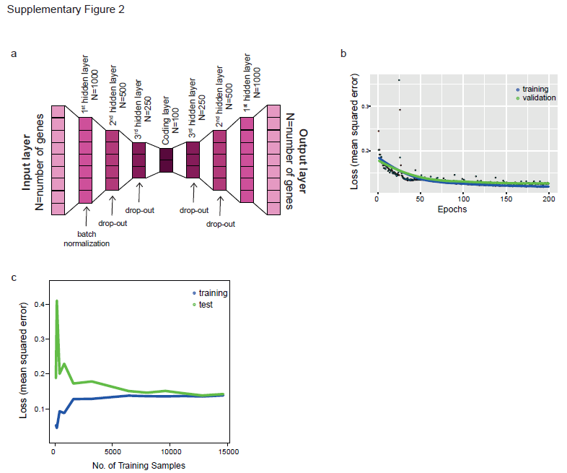
Supplementary Figure 1: a) Autoencoder design representation. N represents the number of nodes per layer. In the first hidden layer in the encoder batch normalization is applied, the second and third hidden layers were trained with 5% dropout to avoid overfitting. Exponential linear unit was used as activation function in all nodes. b) Training curve displaying loss (mean squared error) across training iterations (epochs) for training and validation sets. c) Plot showing model loss for training and test set (80/20) with increasing number of training samples, using epochs = 100. Because of 5% dropout rate in 2nd and 3rd hidden layers during training, test loss is lower than training loss at the highest number of training samples.

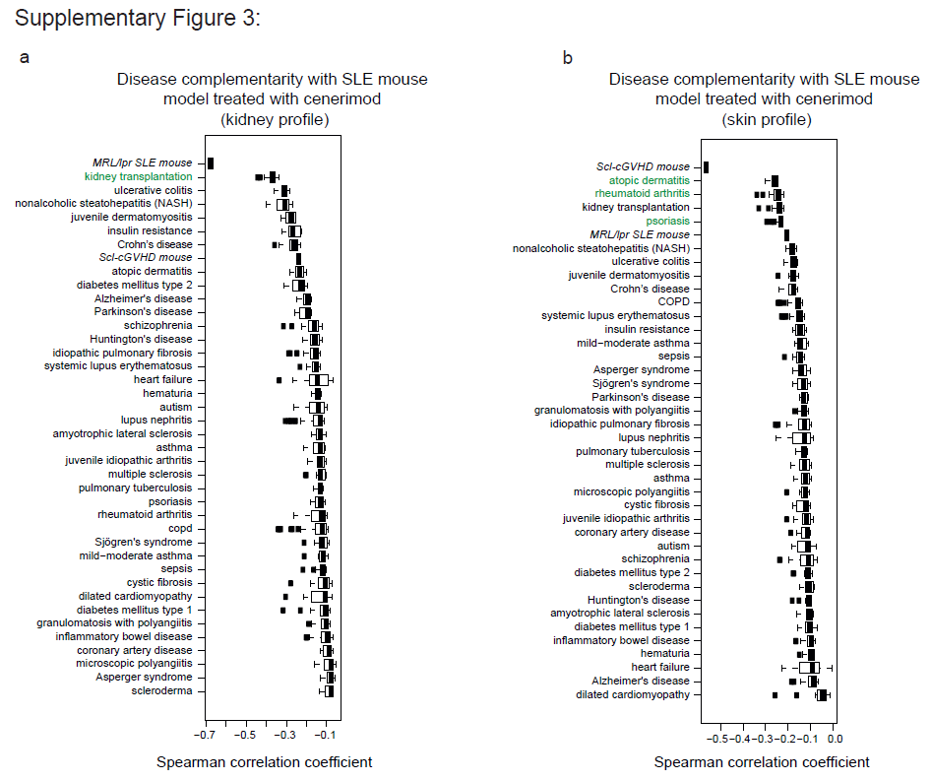
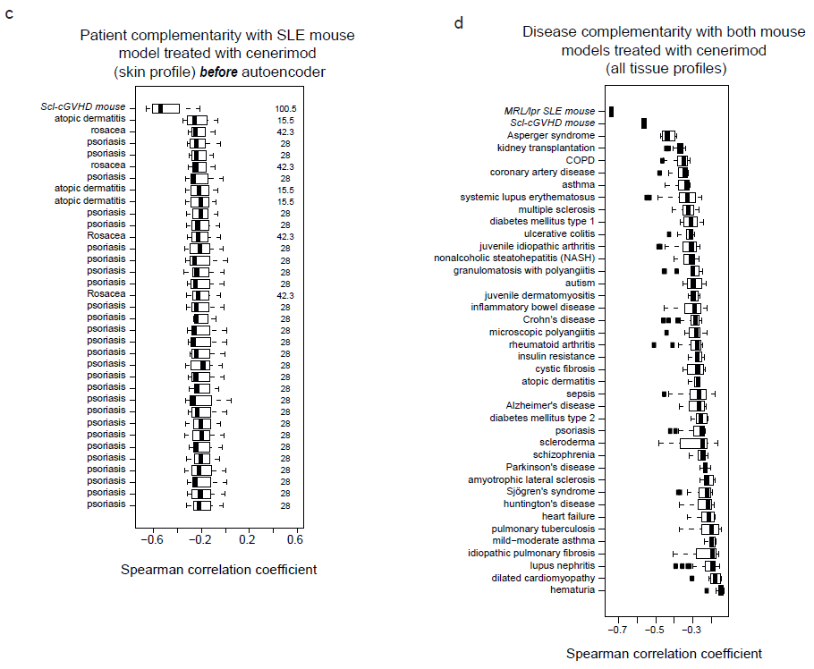Supplementary Figure 2: a) Boxplots of human disease complementarity with MRL/lpr SLE mouse model with cenerimod in kidney (disease-level analysis). b) Boxplots of human disease complementarity with Scl-cGVHD mouse model with cenerimod in skin (disease-level analysis). c) Boxplots of human patient samples complementarity with Scl-cGVHD mouse model with cenerimod in skin before autoencoder processing. a) Boxplots of human disease complementarity with both mouse models with cenerimod in all tissues (disease-level analysis).

