Cellulose–TBPH interactions from diffusion NMR, rheology and SAXS studies: supporting information
Soline Quilliard^{1☆}, Djibril Rouzaud^{2☆}, Cassandre Kouvatas^{2*}, Philippe Bazin², Arnaud Prigent¹, Arnaud Travert² , Benoit Duchemin^{1*}
¹ Université Le Havre Normandie, Normandie Université, Laboratoire Ondes et Milieux Complexes (LOMC UMR6294)
² Laboratory of catalysis and spectrochemistry (LCS UMR 6506), University of Caen Normandy

* Corresponding authors : cassandre.kouvatas@ensicaen.fr; benoit.duchemin@univ-lehavre.fr
☆ : these authors contributed equally

Tables S1.Fitting parameters and results from the data treatment of the rheological measurements:
MCC160 Fitting results PL
C (wt.%) | K (mPa.s^{1-n}) | n
10 | 4220 ± 1 | 0.8062 ± 0.00009
7,5 | 884.0 ± 0.65 | 0.9301 ± 0.0002
5 | 172.78 ± 0.3 | 0.9482 ± 0.0004
3 | 62.36 ± 0.31 | 0.984 ± 0.001
2 | 30.89 ± 0.54 | 0.9933 ± 0.0036
1 | 19.92 ± 0.45 | 0.9968 ± 0.0040
0,5 | 18.12 ± 0.63 | 0.9973 ± 0.0051
0,1 | 11.79 ± 0.64 | 0.9951 ± 0.0080
TBPH (40 wt.% aq.) | 9.94 ± 0.27 | 0.9984 ± 0.0045

MCC680 Fitting results CY
C  (wt.%) | η₀ (mPa) (×10³) | η_{inf} (mPa) | λ (s⁻¹) | a | n
10 | 125.7±6.6 | 9.83±1478 | 0.36±0.38 | 0.53 ± 0.20 | 0.08±0.93
7.5 | 682.3 ± 0.0005 | 4.76×10⁻¹³ ± 9.2×10⁴ | 7.53 ±2.19 | 3.99 ± 0.85 | 0.50 ± 0.22
5 | 44.19±0.03 | 9.8 ± 22.8 | 0.188±0.005 | 0.570 ± 0.003 | 0.308 ± 0.007
3 | 28.08±0.24 | 10.16 ± 10.49 | 0.65 ± 0.05 | 0.578 ± 0.007 | 0.391 ± 0.01
2 | 3.554 ±0.014 | 10.17 ± 2.32 | 0.172±0.013 | 0.509 ± 0.006 | 0.491 ± 0.007
MCC680 Fitting results PL
C (wt.%) | K (mPa.s) |  | n
1 | 63.28 ± 0.30 |  | 0.989 ± 0.0015
0,5 | 36.11 ± 0.23 |  | 0.9933 ± 0.0017
0,1 | 13.19 ± 0.19 |  | 0.9954 ± 0.0035

Fitting results MCC680
Two Power laws |  | Huggins equation |  | Lyons-Tobolsky
R² | 0.94 | R² | 0.99 | R² | 0.008
a_{(C<C*)} | 0.61 ± 0.30 | [η] | 487 ± 25 | [η] | (6.68 ± 2.40) × 10²
ln(KM^{b})_{(C<C*)} | 6.8 ± 1.9 | k_{H} | 0.029 ± 0.014 | k_{H} | 0.121 ±0.077
a_{(C>C*)} | 3.5 ± 0.3 |  |  | b | 0 ± 4
ln(KM^{b})_{(C>C*)} | 21.4 ± 1.1
c* | (0.67 ± 0.14)×10⁻²

Fitting results MCC160
Two Power laws |  | Huggins equation |  | Lyons-Tobolsky
R² | 0.98 | R² | 0.87 | R² | 0.99
a_{(C<C*)} | 0.29 ± 0.16 | [η] (mL.g⁻¹) | 105 ± 11 | [η] (mL.g⁻¹) | 116 ± 25
ln(KM^{b})_{(C<C*)} | 4.5 ± 0.8 | k_{H} | 0 ± 0.06 | k_{H} | 0.126 ±0.075
a_{(C>C*)} | 3.3 ± 0.4 |  |  | b | 5.04 ± 1.70
ln(KM^{b})_{(C>C*)} | 15.2 ± 1.1
c* | (2.7 ± 0.5)×10⁻²

Fitting methods parameters
Ostwald –de Waele law |  |  |  | Carreau-Yasuda |  |  |  |  |  | least_square()
 | lower lim | upper lim | start values |  | lower lim | upper lim |  | start values |  | method: | trf' | xtol: |  | 1,00E-15
K | 9 | inf | 10 | n0 | 0 | 10*var |  | var |  | jac: | 3-point' | ftol: |  | 1,00E-15
n | -1,1 | 1,1 | 1 | ninf | 9,5 | 10,5 |  | 10 |  | loss: | soft_l1' | gtol: |  | 1,00E-15
 |  |  |  | lambda | 0 |  | 10 |  | 1,1 | max_nfev: | 100000
 |  |  |  | a | 0 |  | 10 |  | 1
 |  |  |  | n | 0 |  | 10 |  | 1
MCC160: Two Power laws |  |  |  | MCC160: Lyons-Tobolsky |  |  |  |  |  | MCC160: Huggins
 | lower lim | upper lim | start values |  | lower lim | upper lim |  | Start values |  |  | lower lim | upper lim |  | Start values
a_{(C<C*)} | 0 | 10 | 1 | [η] | 20 | 1000 |  | 20 |  | [η] | 10 | 500 |  | 120
ln(KM^{b})_{(C<C*)} | 0 | 100 | 3 | k_{H} | 0,05 | 6 |  | 1 |  | k_{H} | 0 | 10 |  | 0,5
a_{(C>C*)} | 0 | 10 | 3 | b | 0 | 5000 |  | 32
ln(KM^b)_{(C>C*)} | 0 | 100 | 15
MCC680: Two Power laws |  |  |  | MCC680: Lyons-Tobolsky |  |  |  |  |  | MCC680: Huggins
 | lower lim | upper lim | start values |  | lower lim | upper lim |  | start values |  |  | lower lim | upper lim |  | start values
a_{(C<C*)} | 0 | 10 | 1 | v_{int} | 50 | 1000 |  | 200 |  | v_{int} | 10 | 500 |  | 200
ln(KM^b)_{(C<C*)} | 0 | 100 | 3 | k_{H} | 0,1 | 6 |  | 1 |  | k_{H} | 0 | 10 |  | 0,5
a_{(C>C*)} | 0 | 10 | 3 | b | 0 | 5000 |  | 32
ln(KM^b)_{(C>C*)} | 0 | 1000 | 15

Table S2: Fitting parameters entered in SASView guinier_porod model and optimized results:
MCC160
Concentration (wt.%) |  | 2 | 3 | 5 | 7.5 | 10
Scale | result | 13.5 ± 4.3 | 48.2 ± 9.1 | 136 ± 133 | 125 ± 33 | 23.5 ± 2.7
Scale | lower limit | 0.0 | 0.0 | 0.0 | 0.0 | 0.0
Scale | upper limit | +∞ | +∞ | +∞ | +∞ | +∞
Background | result | 2.6012 * | 3.18 ± 0.06 | 2.67 ± 0.06 | 1.68 ± 0.06 | 2.82 ± 0.06
Background | lower limit | -∞ | -∞ | -∞ | -∞ | -+∞
Background | upper limit | +∞ | +∞ | +∞ | +∞ | +∞
rg | result | 21.4 ± 1.4 | 31.2 ± 0.9 | 48.1 ± 6.1 | 39.2 ±1.5 | 25.8 ± 0.6
rg | lower limit | 0.0 | 0.0 | 0.0 | 0.0 | 2.0
rg | upper limit | +∞ | +∞ | +∞ | +∞ | +∞
s | result | 0.0 ± 0.09 | 0.0 ± 0.05 | 0.0 ± 0.24 | 0.0 ± 0.07 | 0.24 ± 0.03
s | lower limit | 0.0 | 0.0 | 0.0 | 0.0 | 0.0
s | upper limit | +∞ | +∞ | +∞ | +∞ | ++∞
porod_exp | result | 2.13 ± 0.07 | 2.58 ± 0.06 | 1.88 ± 0.01 | 1.93 ± 0.01 | 2.81 ± 0.07
porod_exp | lower limit | 0.0 | 0.0 | 0.0 | 0.0 | 0.0
porod_exp | upper limit | 4 | +∞ | +∞ | +∞ | +∞
(*) parameter not optimized

Figures S3: Micrographies obtained by POM
MCC160 in TBPH_{(aq)} 40 wt.%
0.5 wt.% | 1 wt.%
 | 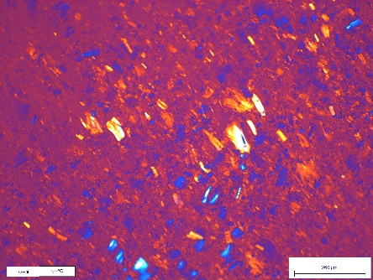
5 wt.% | 10 wt.%

MCC680 TBPH_{(aq)} 40 wt.%
0.5 wt.% | 1 wt.% | 3 wt.%
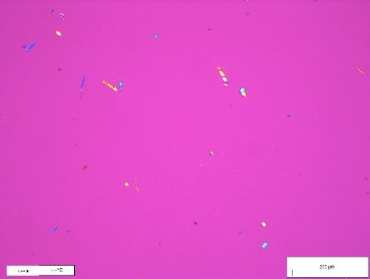 |  | 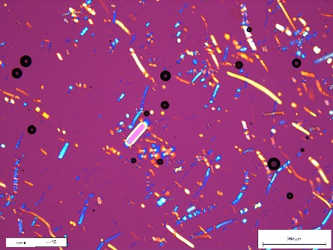
5 wt.% | 7.5 wt.% | 10 wt.%

Balooning seen in MCC680 solution at 5wt.% | MCC680 5 wt.% | MCC680 5 wt.%
 | 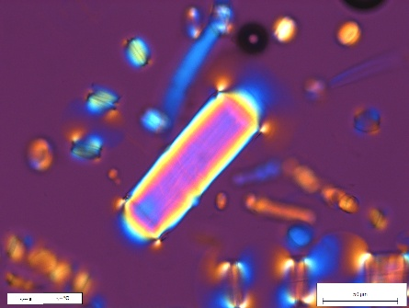
Balooning from MCC680 7.5 wt.% solution | MCC680 10 wt.%

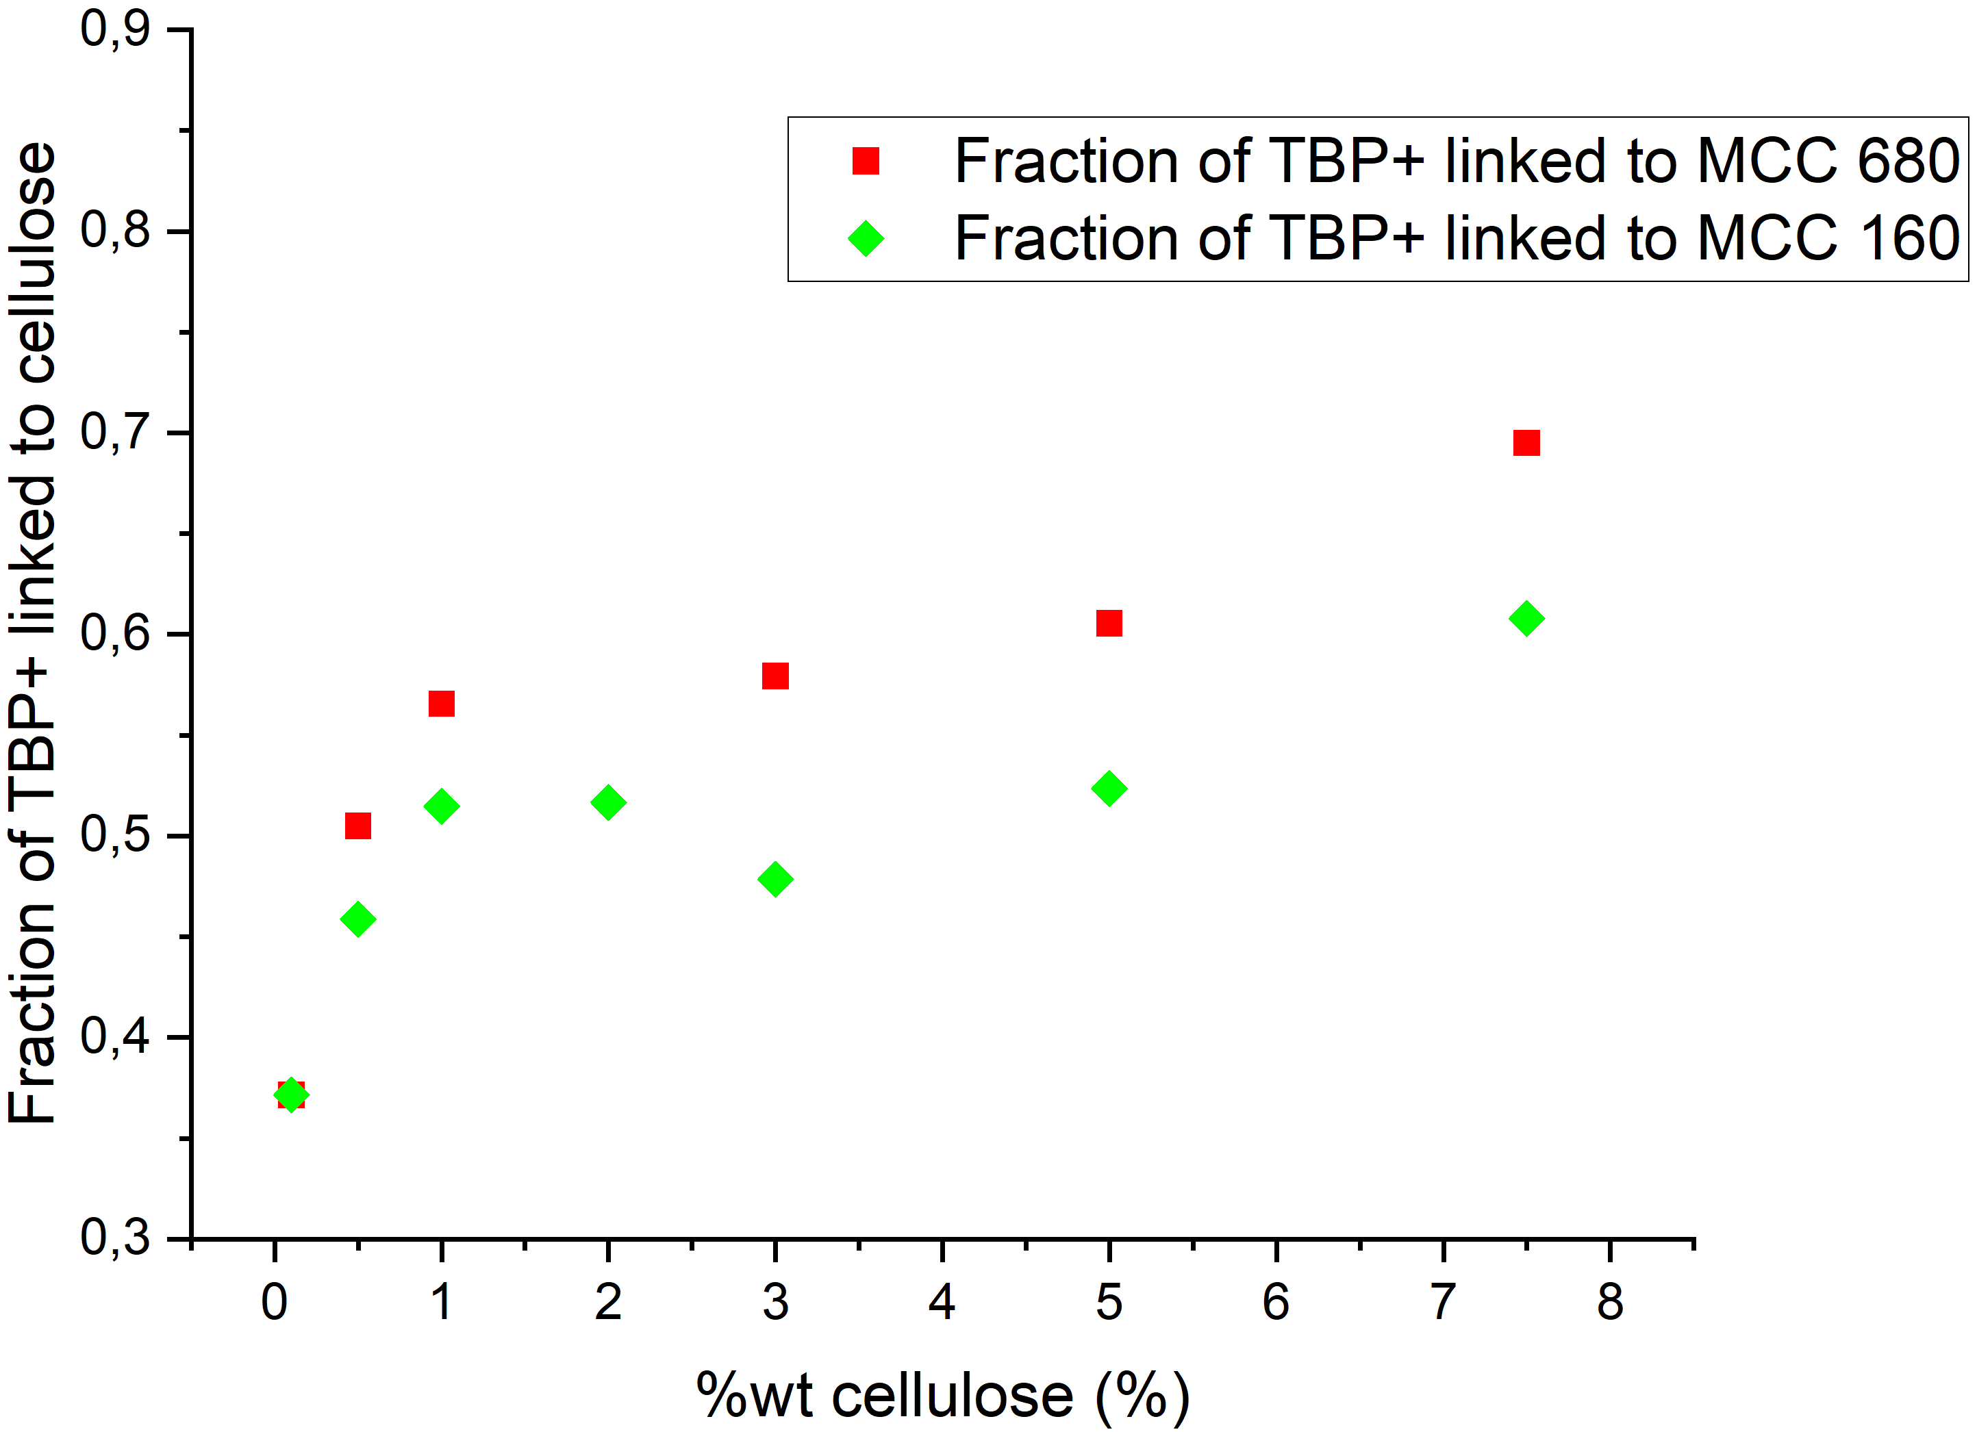Support Figure S4 fraction of bounded TBP⁺ ions to cellulose for both MCC 680 (red squares) and MCC 160 (green diamonds) at different cellulosic concentrations

Support Figure S5 Linearization of Stejskal-Tanner's equation for cellulose signals at 7.5%wt of MCC 160. It shows 2 components within the exponential decay, corresponding to 2 diffusivities for cellulose within the solution

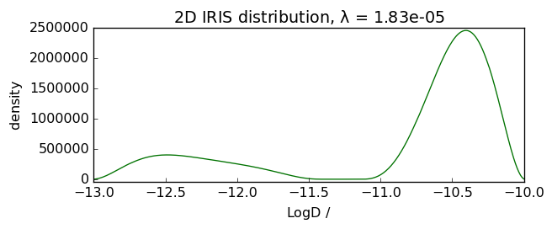
Support Figure S6 Diffusivity distribution for cellulose in the solution of MCC 160 at 7.5%wt in TBPH

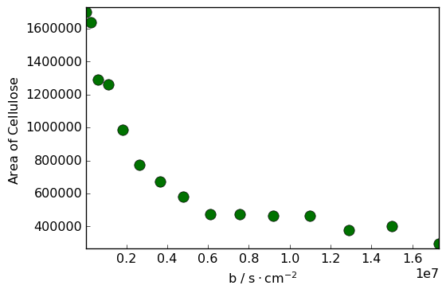
Figure S7 Exponential decay of the signal for cellulose in the solution of MCC 160 at 7.5%wt in TBPH

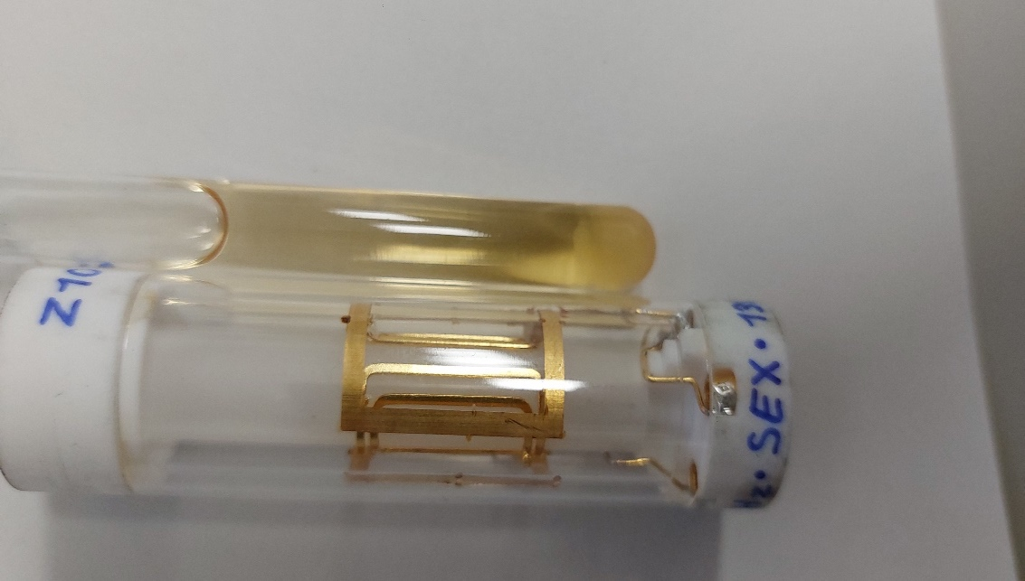
Figure S8: A picture of a 8mm NMR tube, and a ¹³C NMR insert. The heterogeneous portion of the tube is delimited by a red box. The portion of the tube where the diffusion experiment takes place is limited by blue lines. The heterogenous part is never considered during the diffusion experiments
Probed zone
Heterogenous zone

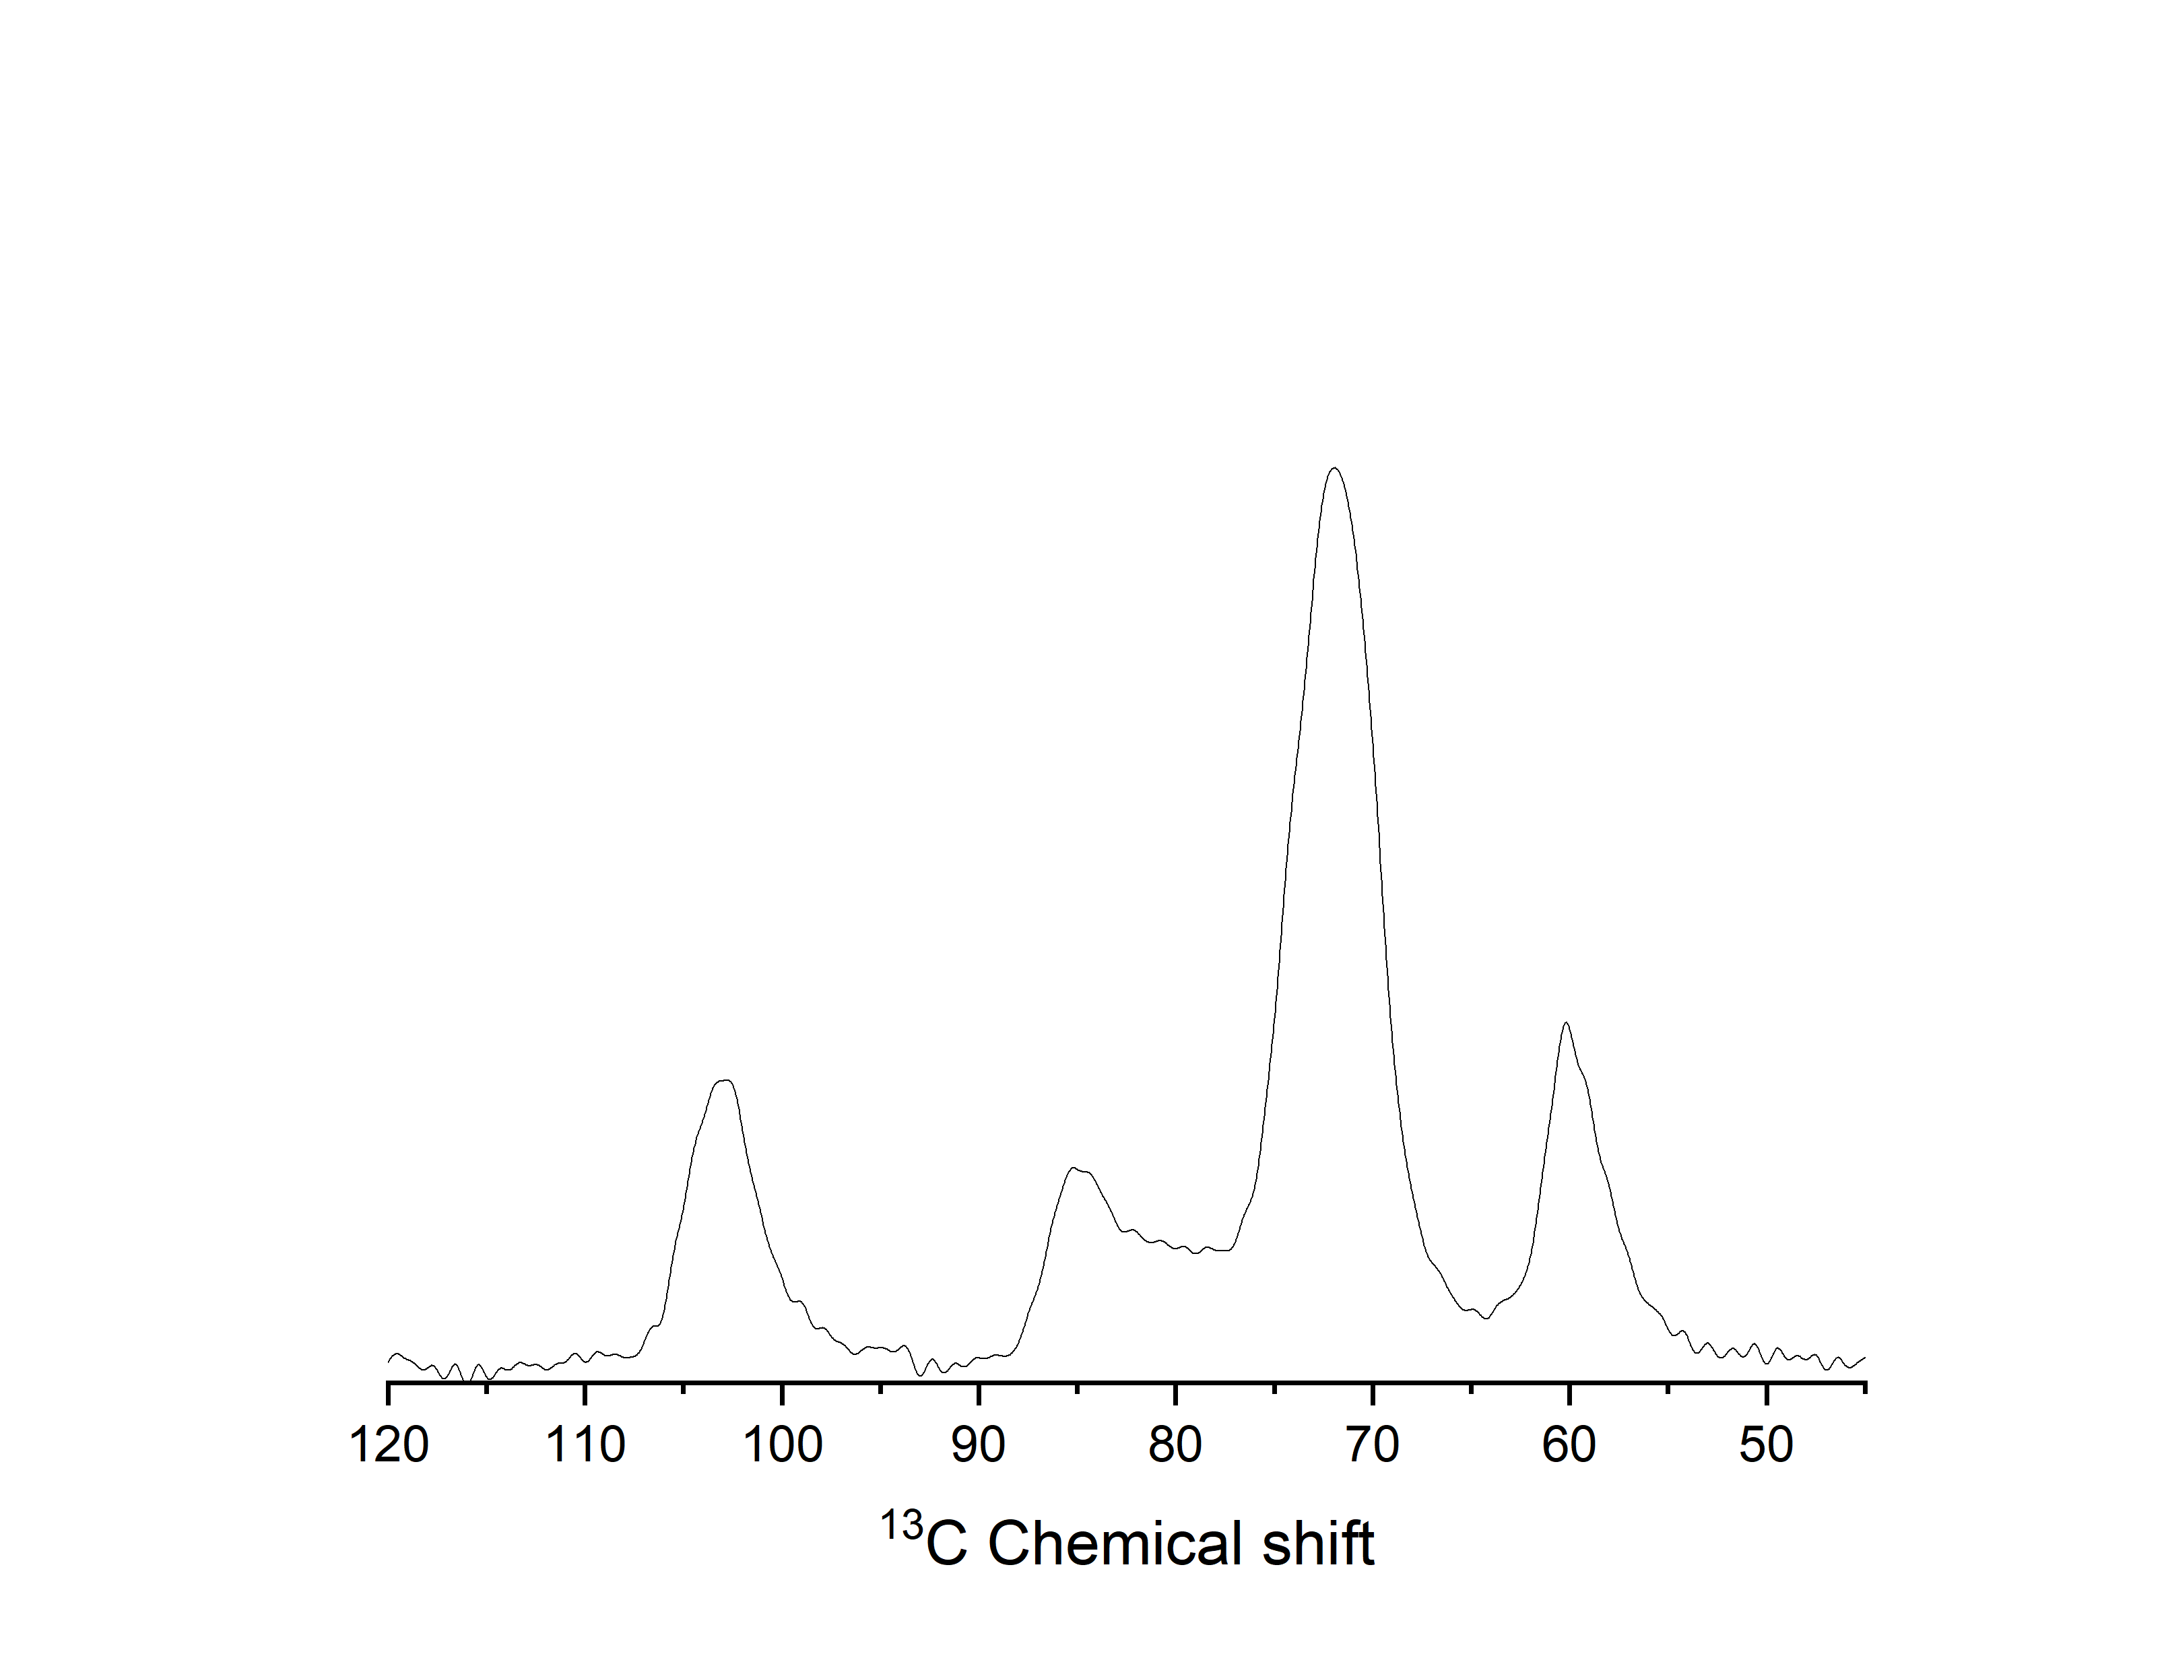
C1
C6
C2,3,5
C4
Figure S9 ¹³C CP MAS NMR of a dried cellulosic sample of 3%wt of MCC 680 in TBPH at a spin rate of 5kHz, a contact time of 1000us , an acquisition time of 0.04s, D₁ = 5s and 4096 scans

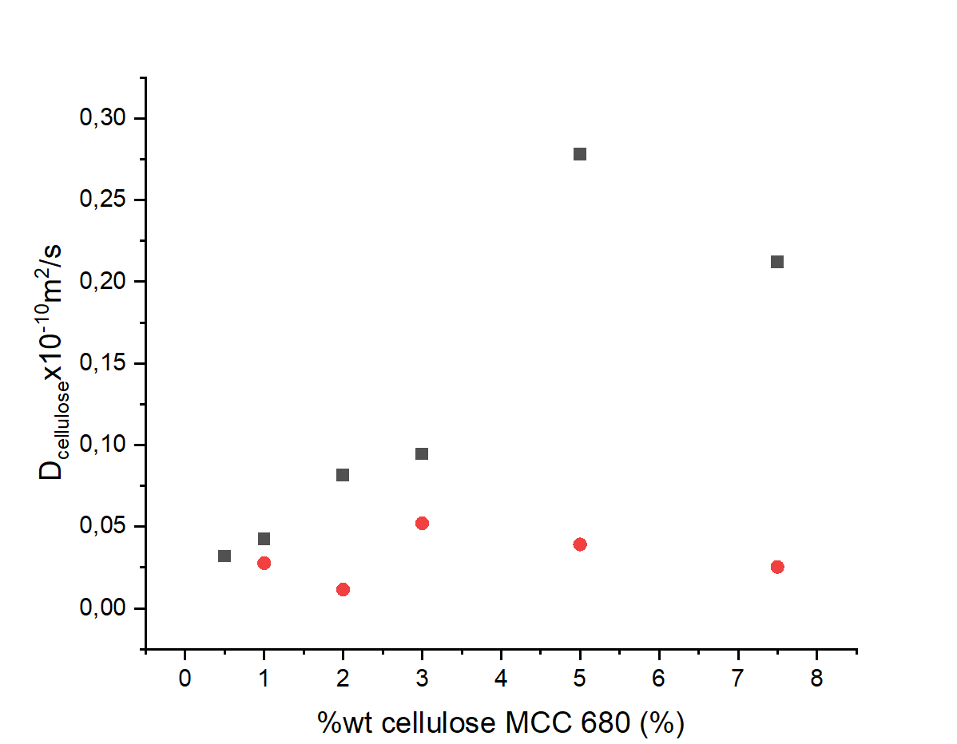 Figure S10 linearization of cellulose’s echo decay in function of the weight percentage of MCC 680. Both fast (black squares) and slow (red circles) are represented

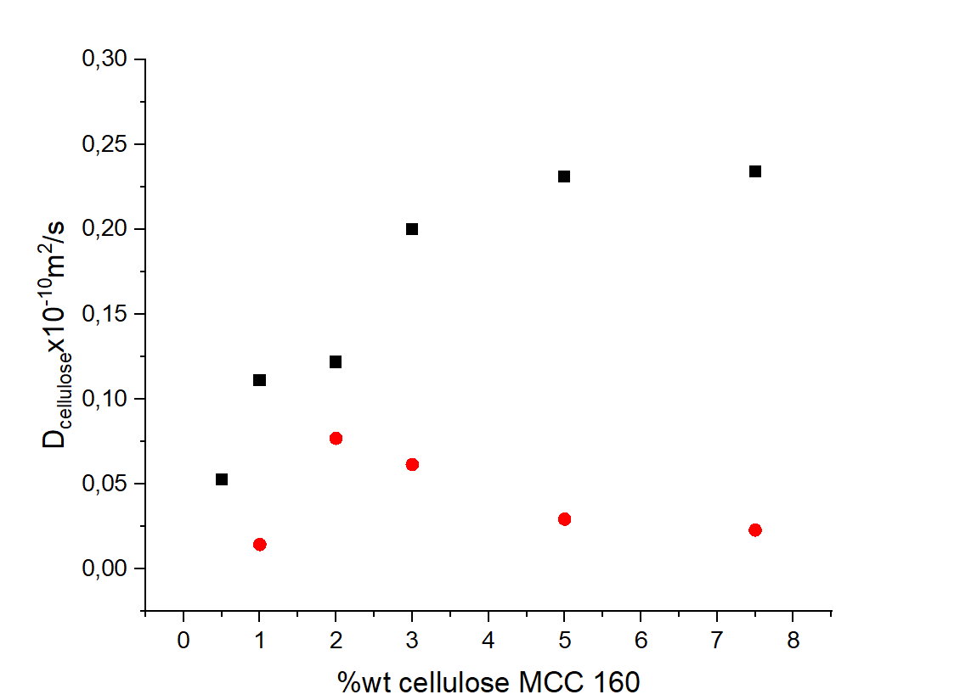
Figure S11 linearization of cellulose’s echo decay in function of the weight percentage of MCC 680. Both fast (black squares) and slow (red circles) are represented

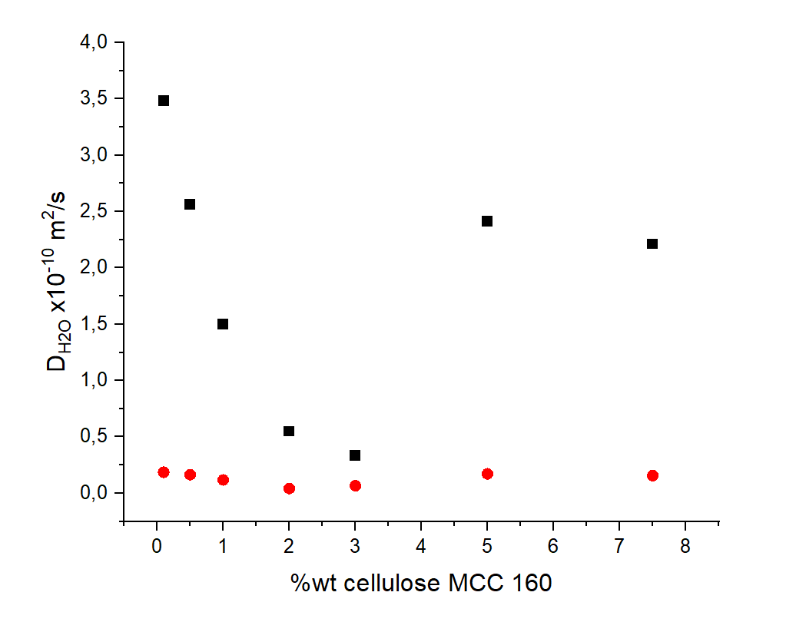
Figure S12 linearization of water’s echo decay in function of the weight percentage of MCC 160. Both fast (black squares) and slow (red circles) are represented

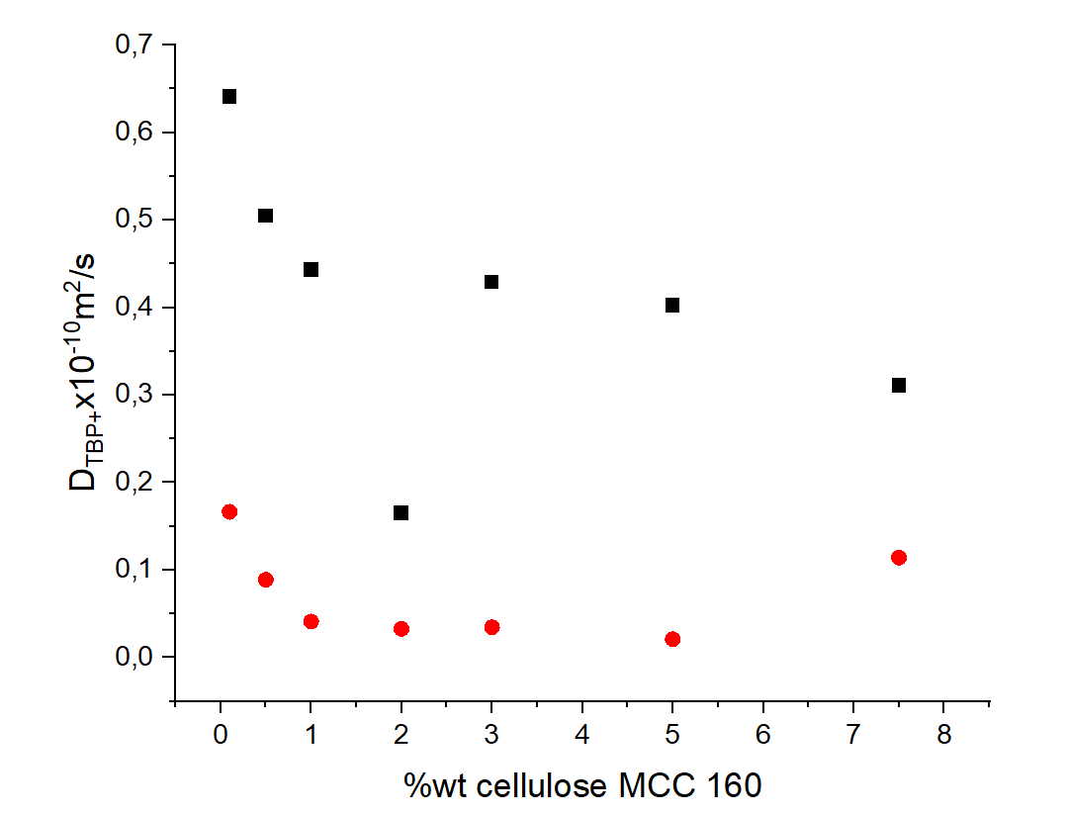Figure S13 linearization of TBP⁺ echo decay in function of the weight percentage of MCC 160. Both fast (black squares) and slow (red circles) are represented

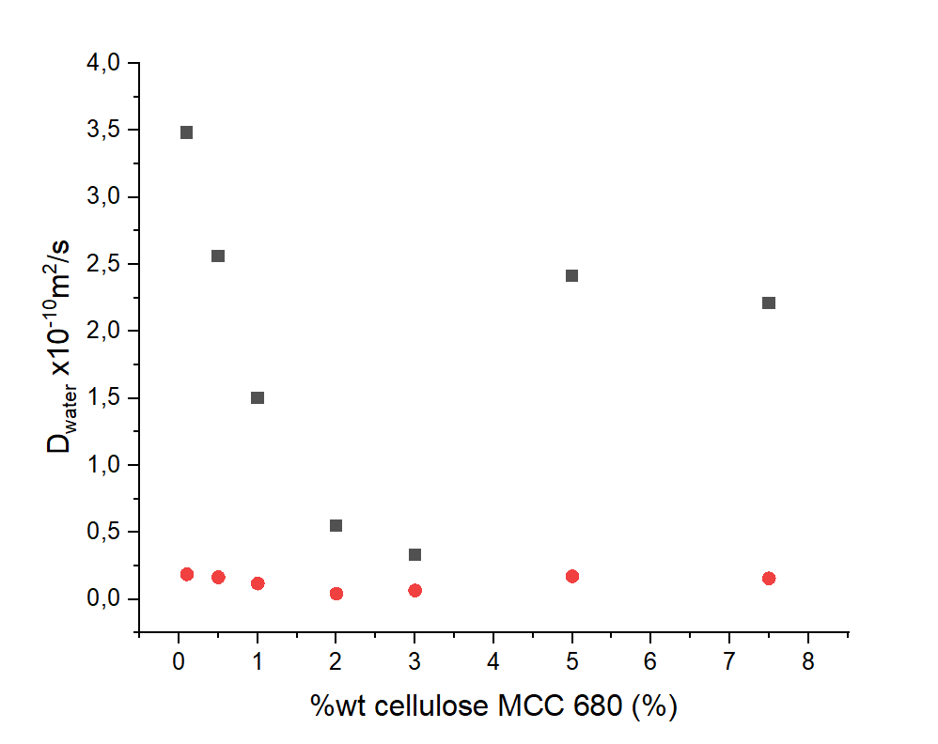 Figure S14 linearization of water’s echo decay in function of the weight percentage of MCC 680. Both fast (black squares) and slow (red circles) are represented

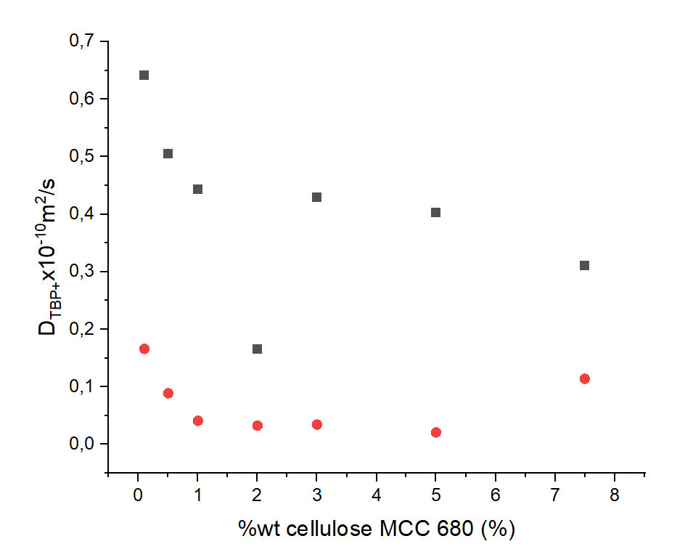Figure S15 linearization of TBP⁺ echo decay in function of the weight percentage of MCC 680. Both fast (black squares) and slow (red circles) are represented

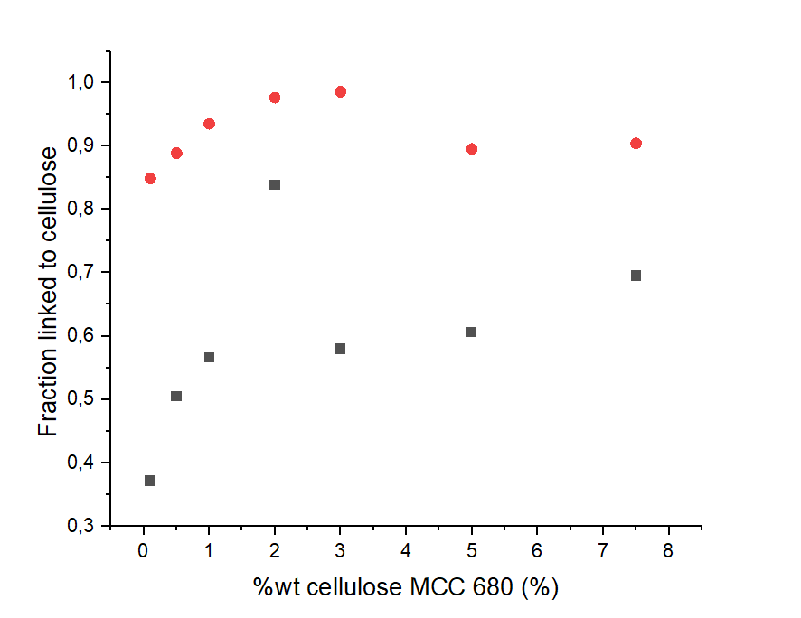
Figure S16 fraction of water (red circles) and of TBP⁺ (black squares) linked to MCC 680

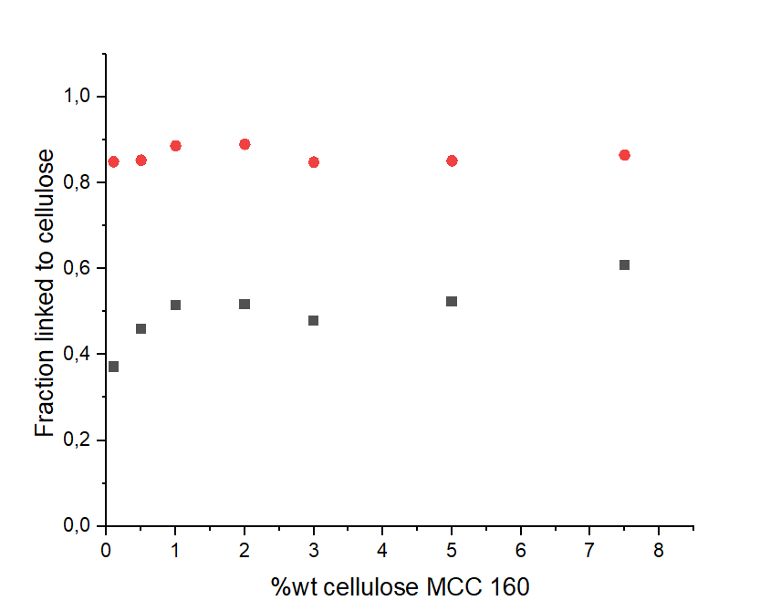

Figure S17 fraction of water (red circles) and of TBP⁺ (black squares) linked to MCC 160

