Live Imaging and Interactome Analysis of Zika and Chikungunya Viral RNAs Via Dual-Action Aptamer Tag

Supplemental information index
Figure S1 Viral RNA colocalizes with lysosomes in infected cells, related to Figure 4
Figure S2. Top 200 hits identified from the vgRNA pulldown results, related to Figure 5
Figure S3. The impact of SFPQ knockdown in JEG-3 cells, related to Figure 7
Video S1. ZIKV-MFP infection in a live JEG-3 cell, related to Figure 4A
Video S2. ZIKV-MFP infection in a live JEG-3 cell, related to Figure 4B
Video S3. CHIKV-MFP infection in a live U2OS cell, related to Figure 4C
Video S4. CHIKV-MFP infection in a live U2OS cell, related to Figure 4D
Table S1. Primers and sequences, related to Figures 1 and 7
Table S2. Excel file containing Mass Spectrometry data, related to Figures 5 and 6
Table S3. Comparison of Mass Spectrometry data to literature, related to Figures 5 and 6

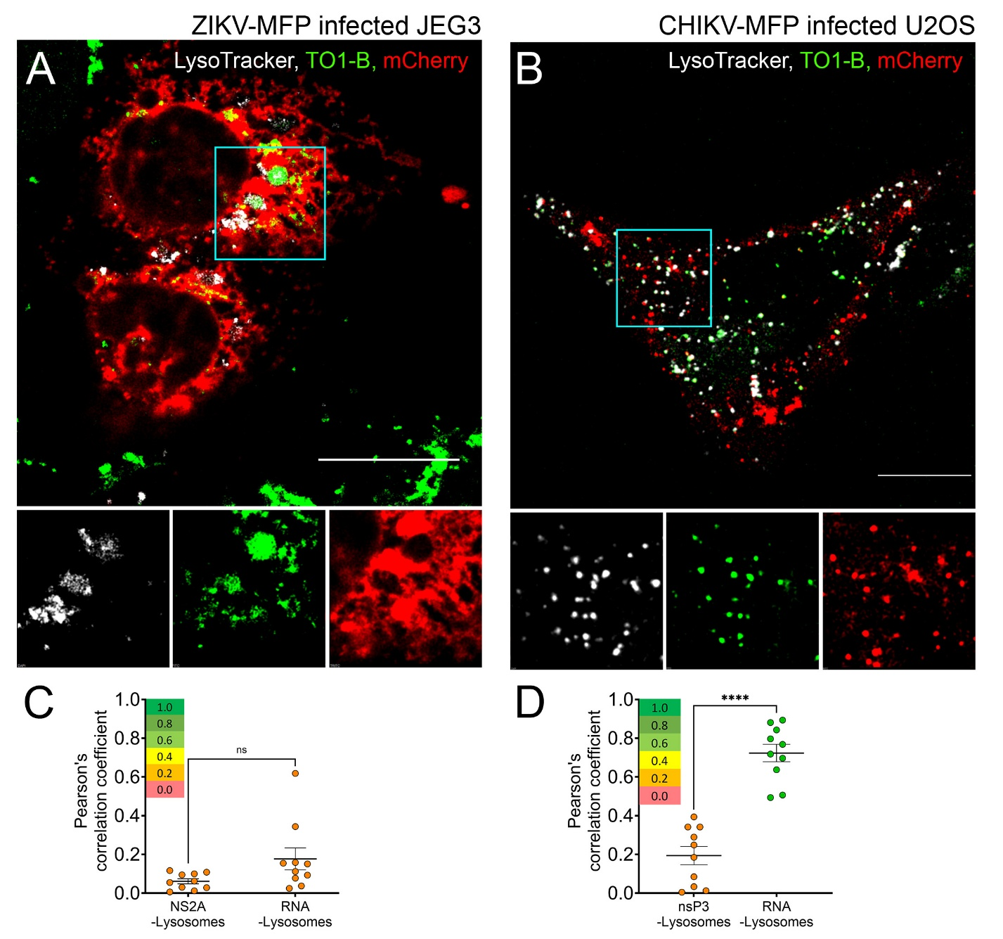
Figure S1. Viral RNA colocalizes with lysosomes in infected cells.
(A-B) Fluorescent micrograph of live ZIKV-MFP infected JEG-3 cells (A) or CHIKV-MFP infected U2OS cells (B) treated with LysoTracker (blue, pseudocolored white). Expanded ROI corresponding to cyan square for merge and individual blue, green, and red channels shown below.
(C-D) Colocalization of green (535 nm) and blue (460 nm) channels for A and B, respectively, measured by Pearson's correlation (n = 10; error bars represent mean ± SEM). Significance was calculated by One-way ANOVA using Prism software. n.s. p > 0.05, ∗∗∗∗p < 0.0001
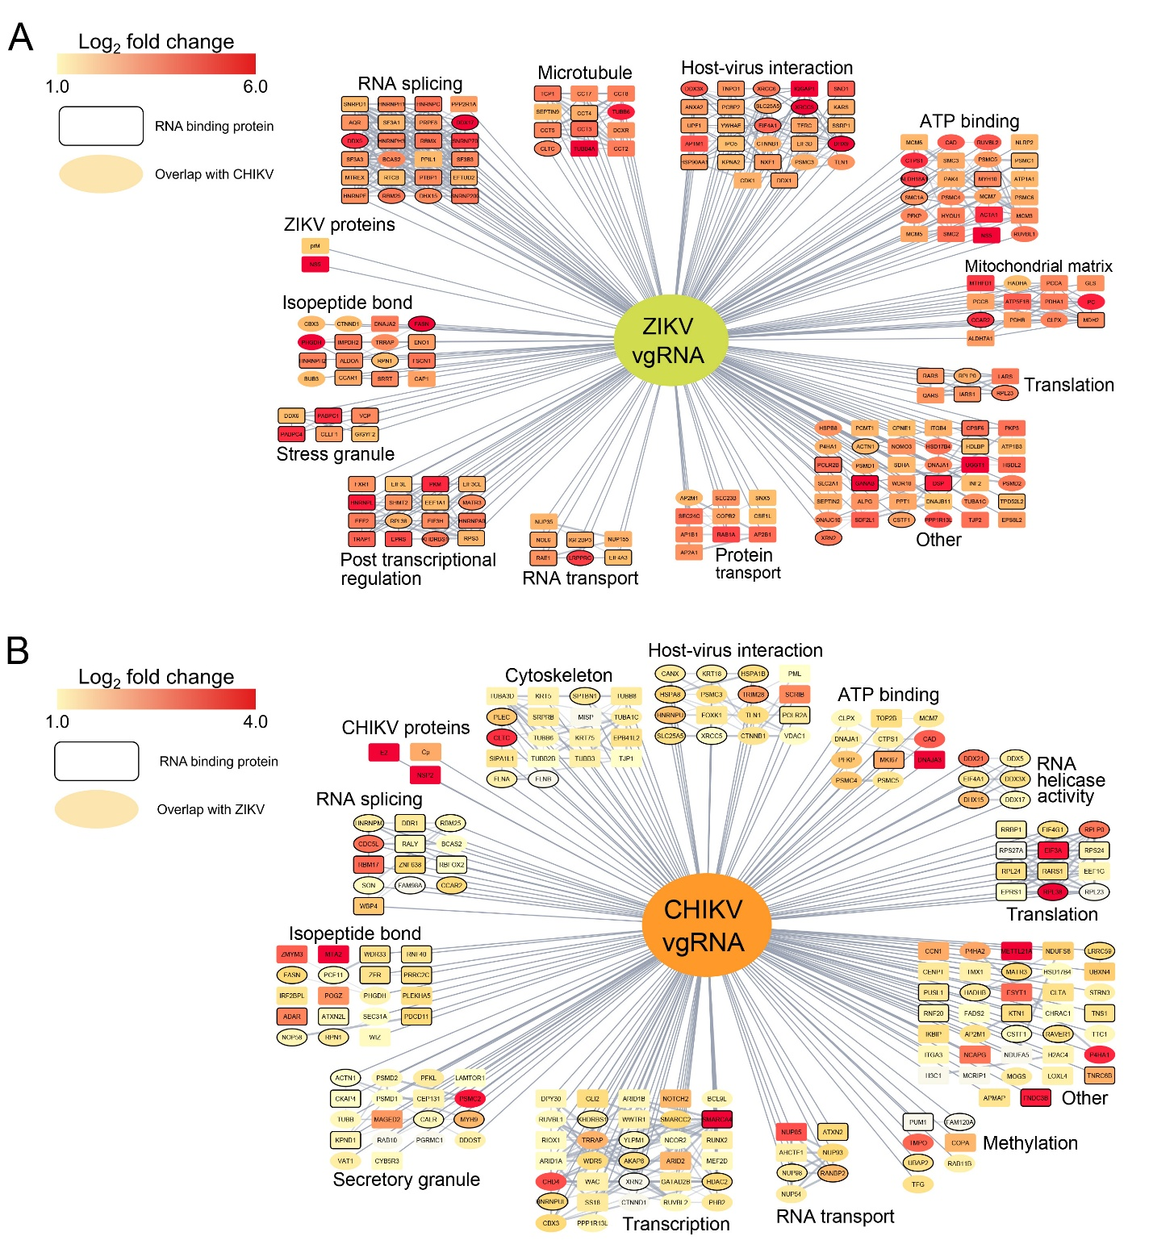
Figure S2. The highest fold change of the top 200 hits was identified from the vgRNA pulldown results.
(A) Interactome map of ZIKV vgRNA with the top 200 high-confidence hits. Color is mapped to the relative log₂ of the fold change value, as indicated in the legend at the top left.
(B) Interactome map of CHIKV vgRNA interactions with the top 200 high-confidence hits. Color is mapped to the relative log₂ of the fold change value, as indicated in the legend at the top left.
The black border indicates RNA-binding proteins. Ovals indicate common hits identified in both ZIKV and CHIKV vgRNA pulldowns. Protein clusters were determined by STRING enrichment in Cytoscape.
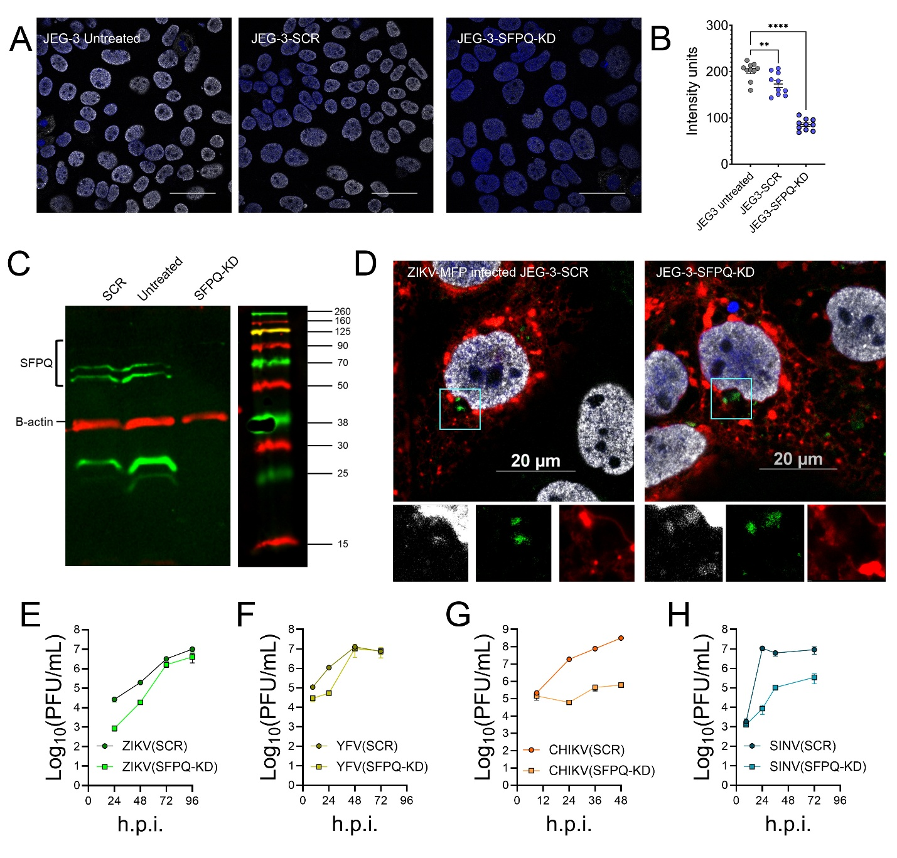
Figure S3. The impact of SFPQ knockdown in JEG-3 cells.
(A) Confocal micrographs of JEG-3, JEG-3 SCR, and JEG-3-SFPQ knockdown uninfected cells fixed and treated with an antibody targeting SFPQ (far red, pseudo-colored white) and Hoechst nuclear stain.
(B) Intensity measurements from the far-red channel in (A). (n=10; Error bars represent the mean and SEM. Significance determined by One-way ANOVA.)
(C) Western blot of cell lysate from JEG-3 SCR, JEG-3, and JEG-3 SFPQ knockdown cells treated with antibody targeting SPFQ (green) and β-actin (red). SFPQ antibody (Cell Signaling, #23020) is known to detect a ~32 kDa band of unknown origin.
(D) Confocal micrographs of immunofluorescence assay of ZIKV-MFP infected JEG-3 SCR or JEG-3 SFPQ knockdown cells using antibody targeting SFPQ (far red, pseudo-colored white). The expanded region of interest for individual far red, green, and red channels is shown below.
(E-H) Growth kinetic analysis of virus infection in JEG-3 SCR compared to JEG-3 SFPQ knockdown cells for ZIKV (E), YFV (F), CHIKV (G), and SINV (H).

