Supporting Information
Tailoring N Configurations for Enhanced Methanol Oxidation on Pt Nanoparticles
Hui Li *,†
*Lanzhou University of Arts and Science, Lanzhou 730050, P. R. China; Email: 1518236380@qq.com

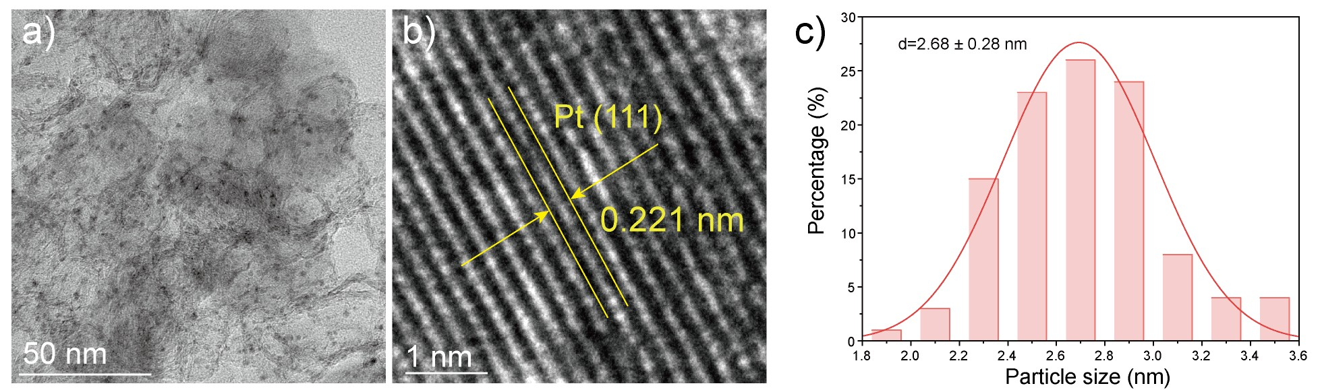
Figure S1. (a) TEM image of Pt/NPC-1000. (b) HRTEM of Pt/NPC-1000.
(c) particle size distribution histogram.
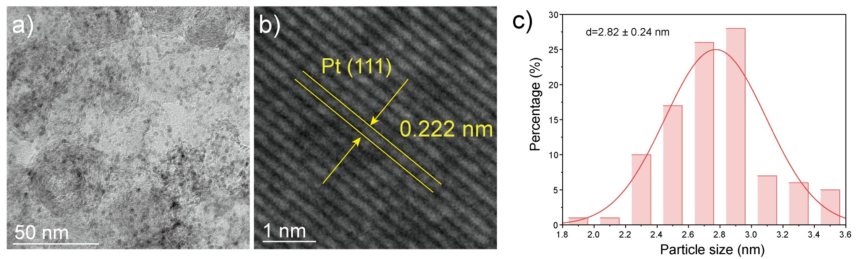
Figure S2. (a) TEM image of Pt/NPC-800. (b) HRTEM of Pt/NPC-800.
(c) particle size distribution histogram.

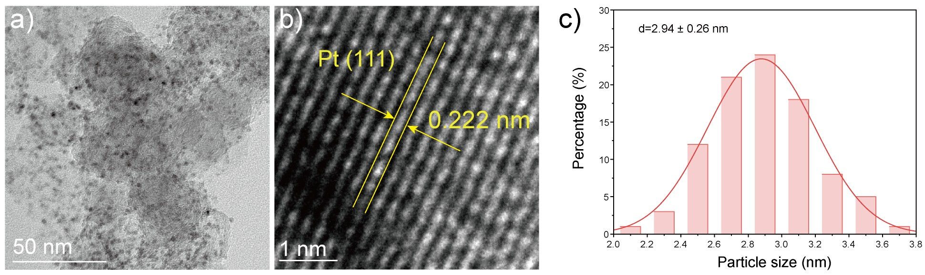
Figure S3. (a) TEM image of Pt/NPC-700. (b) HRTEM of Pt/NPC-700.
(c) particle size distribution histogram.

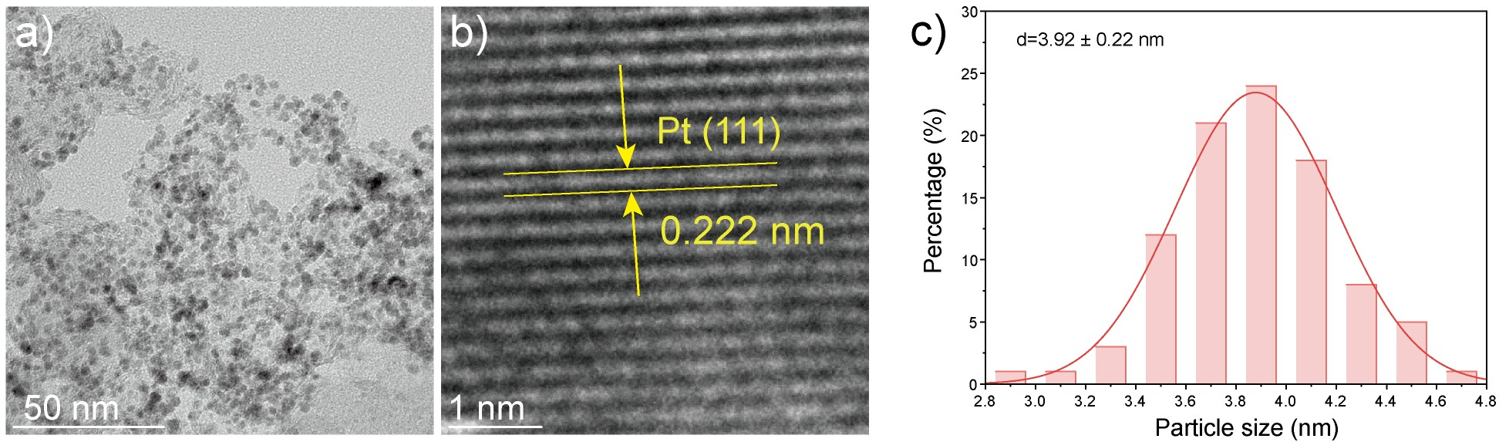
Figure S4. (a) TEM image of Pt/PC. (b) HRTEM of Pt/PC.
(c) particle size distribution histogram.

Table S1. Summary of Total Nitrogen Content and Proportions of Pyridinic-N, Pyrrolic-N, and Graphitic-N in all samples
Samples | Total N content (at %) | Pyridinic-N  (%) | Pyrrolic-N  (%) | Graphitic-N  (%)
Pt/NPC-700 | 9.78 | 65.7 | 20.1 | 14.2
Pt/NPC-800 | 7.26 | 61.4 | 22.6 | 16
Pt/NPC-900 | 6.53 | 56.7 | 25.2 | 18.1
Pt/NPC-1000 | 5.48 | 53.4 | 26.3 | 20.3

Table S2. Evaluation data of electrochemical properties of synthetic catalysts
 | Reverse scan |  | Forward scan
Sampels | Peak potential  (V vs.RHE) | Peak current density (mA/mg) | Peak potential  (V vs.RHE) | Peak current density (mA/mg)
Pt/NPC-700 | -0.331 | 561.5 | -0.199 | 2456
Pt/NPC-800 | -0.321 | 1190 | -0.236 | 3042
Pt/NPC-900 | -0.319 | 1880 | -0.215 | 4687.5
Pt/NPC-1000 | -0.321 | 843.8 | -0.212 | 3649
Pt/PC | -0.314 | 181.4 | -0.220 | 1074

Table S3. Catalytic performance of advanced electrocatalysts reported previously for methanol electro-oxidation in alkaline medium.
Catalysts | Test condition | scan rate (mV/s) | mass activity (mA·mg⁻¹) | Ref
Pt/NPC-900 | 1.0 M KOH +1.0 M CH₃OH | 50 mV/s | 4687.5 | This work
Pt doped Ni(OH)₂ | 1.0 M KOH +1.0 M CH₃OH | 50 mV/s | 1356 | 1
Ni-Pt | 1.0 M KOH +1.0 M CH₃OH | 50 mV/s | 2546 | 2
PtCu Nanoframes | 1.0 M KOH +1.0 M CH₃OH | 50 mV/s | 2260 | 3
Pt-2D Fe₂O₃ | 1.0 M KOH +1.0 M CH₃OH | 50 mV/s | 343 | 4
Au/Ag/Pt Nanocrystals | 1.0 M KOH +1.0 M CH₃OH | 50 mV/s | 960 | 5
Pt-CoOOH-CDs/C | 1.0 M KOH +1.0 M CH₃OH | 50 mV/s | 856 | 6

Reference
(1) Yuan, G.; Wang, L.; Zhang, X.; Wang, Q. Self-supported Pt nanoflakes-doped amorphous Ni(OH)₂ on Ni foam composite electrode for efficient and stable methanol oxidation. Journal of Colloid and Interface Science 2019, 536, 189-195. DOI: https://doi.org/10.1016/j.jcis.2018.10.049.
(2) Artal, R.; Serrà, A.; Michler, J.; Philippe, L.; Gómez, E. Electrodeposition of Mesoporous Ni-Rich Ni-Pt Films for Highly Efficient Methanol Oxidation. Nanomaterials 2020, 10 (8), 1435.
(3) Zhang, Z.; Luo, Z.; Chen, B.; Wei, C.; Zhao, J.; Chen, J.; Zhang, X.; Lai, Z.; Fan, Z.; Tan, C.; et al. One-Pot Synthesis of Highly Anisotropic Five-Fold-Twinned PtCu Nanoframes Used as a Bifunctional Electrocatalyst for Oxygen Reduction and Methanol Oxidation. Advanced Materials 2016, 28 (39), 8712-8717. DOI: https://doi.org/10.1002/adma.201603075 (acccessed 2025/06/27).
(4) Hu, S.; Jiang, L.; Wang, B.; Ma, Y. Enhanced Electrocatalytic Methanol Oxidation Properties by Photo-Assisted Fe₂O₃ Nanoplates. International Journal of Hydrogen Energy 2019, 44 (26), 13214-13220. DOI: https://doi.org/10.1016/j.ijhydene.2019.03.178.
(5) Xie, X.; Gao, G.; Kang, S.; Shibayama, T.; Lei, Y.; Gao, D.; Cai, L. Site-Selective Trimetallic Heterogeneous Nanostructures for Enhanced Electrocatalytic Performance. Advanced Materials 2015, 27 (37), 5573-5577. DOI: https://doi.org/10.1002/adma.201501133 (acccessed 2025/06/27).
(6) Tu, W.; Sun, Y.; Wu, D.; Wang, H.; Huang, H.; Shao, M.; Liu, Y.; Kang, Z. Cobalt oxyhydroxide and carbon dots modified by platinum as superior electrocatalyst for methanol oxidation. Materials Chemistry and Physics 2019, 225, 64-71. DOI: https://doi.org/10.1016/j.matchemphys.2018.12.066.

