Supplementary Information

Table S1. Solubility product constants at 25°C and 1 bar of salts previously detected on the surface of Mars⁷⁸. Perchlorate mineral solubility product constants are from a previous study⁸¹. All other mineral solubility product constants are from a version of the Laurence Livermore National Lab (LLNL) Thermodynamic Database⁷⁹ modified to update the thermodynamic constants of salts relevant for Mars geochemistry⁸⁰. The first and second carbonic acid dissociation constants are from the LLNL database.
Mineral | Reaction | log10(K)
Gypsum | CaSO₄×2H₂O = Ca²⁺ + SO₄^{2–} + 2H₂O | –4.5805
Bassanite | CaSO₄×0.5H₂O = Ca²⁺ + SO₄^{2–} + 0.5H₂O | –3.6615
Anhydrite | CaSO₄ = Ca²⁺ + SO₄^{2–} | –4.3617
Epsomite | MgSO₄×7H₂O = Mg²⁺ + SO₄^{2–} + 7H₂O | –1.8809
Hexahydrite | MgSO₄×6H₂O = Mg²⁺ + SO₄^{2–} + 6H₂O | –1.6346
Pentahydrite | MgSO₄×5H₂O = Mg²⁺ + SO₄^{2–} + 5H₂O | –1.2850
Starkeyite | MgSO₄×4H₂O = Mg²⁺ + SO₄^{2–} + 4H₂O | –0.8466
Kieserite | MgSO₄×H₂O = Mg²⁺ + SO₄^{2–} + H₂O | –0.1230
K-Jarosite | KFe₃(SO₄)₂(OH)₆ + 6H⁺ = 2SO₄^{2–} + 3Fe³⁺ + 1K⁺ + 6H₂O | –11.6656
Na-Jarosite | NaFe₃(SO₄)₂(OH)₆ + 6H+ = 2SO₄^{2–} + 3Fe³⁺ + 1Na⁺ + 6H₂O | –6.0431
H₃O-Jarosite | (H₃O)Fe₃(SO₄)₂(OH)₆ + 5H+ = 2SO₄^{2–} + 3Fe³⁺ + 7H₂O | –6.0431
Alunite | KAl₃(SO₄)₂(OH)₆ + 6H+ = 2SO₄^{2–} + 3Al³⁺ + K⁺ + 6H₂O | –0.3479
Calcite | CaCO₃ + H+ = Ca²⁺ + HCO₃– | 1.9333
Aragonite | CaCO₃ + H+ = Ca²⁺ + HCO₃– | 2.1200
Magnesite | MgCO₃ + H+ = Mg²⁺ + HCO₃– | 2.5055
Dolomite | CaMg(CO₃)₂ + 2H+ = Ca²⁺ + Mg²⁺ + 2HCO₃– | 3.5960
Siderite | FeCO₃ + H+ = Fe²⁺ + HCO₃– | –0.1920
Halite | NaCl = Na⁺ + Cl– | 1.5700
Sylvite | KCl = K⁺ + Cl– | 0.8998
Bischofite | MgCl₂×6H₂O = Mg²⁺ + 2Cl– + 6H₂O | 4.3923
NaClO₄×H₂O | NaClO₄×H₂O = Na⁺ + ClO₄– + H₂O | 2.1878
NaClO₄×2H₂O | NaClO₄×2H₂O = Na⁺ + ClO₄– + 2H₂O | 2.3080
KClO₄ | KClO₄ = K⁺ + ClO₄– | –1.9693
Mg(ClO₄)₂×6H₂O | Mg(ClO₄)₂×6H₂O = Mg²⁺ + 2ClO₄– + 6H₂O | 5.6577
Mg(ClO₄)₂×8H₂O | Mg(ClO₄)₂×8H₂O = Mg²⁺ + 2ClO₄– + 8H₂O | 4.8576
Ca(ClO₄)₂×6H₂O | Ca(ClO₄)₂×6H₂O = Ca²⁺ + 2ClO₄– + 6H₂O | 5.9286
– | H2CO3 = HCO3– + H+ | –6.3447
– | HCO3– = CO32– + H+ | –10.3288

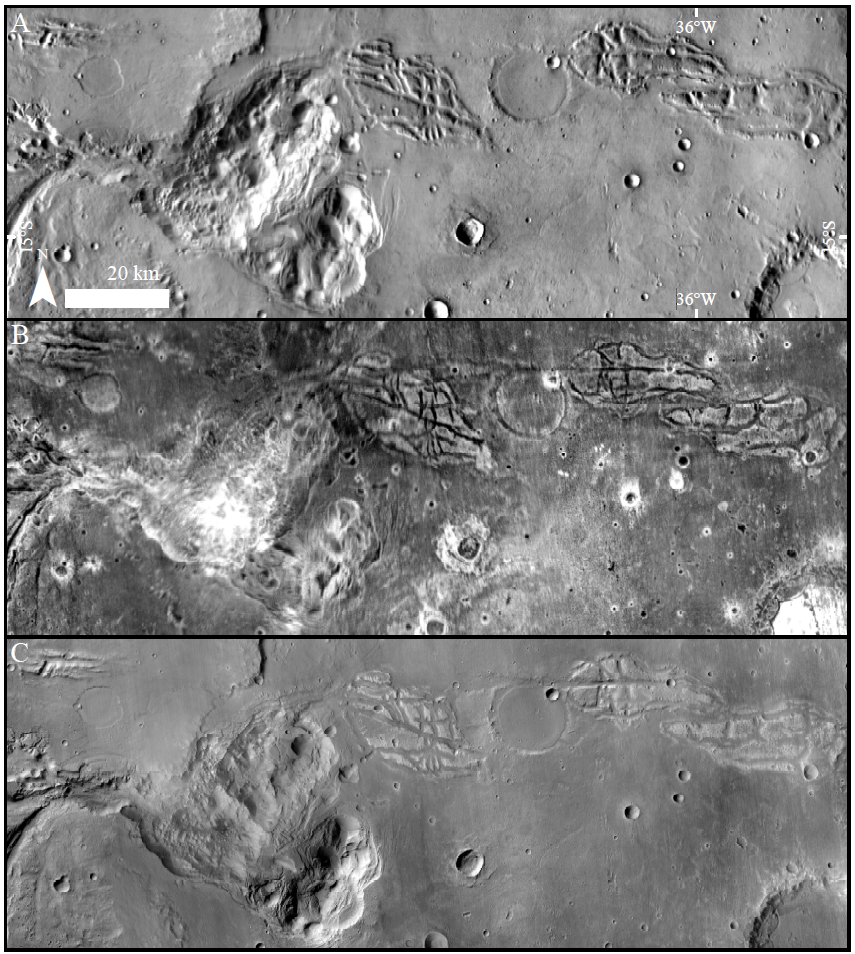
Figure S1. Examples of data sources that informed the geologic mapping. (A) THEMIS Day IR. The variation in temperature, which arises predominantly from variation in slope orientation, enhances topography and texture. For example, several positive relief structures (PRSs) in the upper part of the image stand out from the otherwise smooth terrain. (B) THEMIS Night IR. Variation in thermal inertia among different surfaces informs potential variation in composition or physical properties, which supported the designation of specific surfaces as belonging to geomorphological units, and the correlation between surfaces. For example, the PRSs appear bright (hot) with respect to their surroundings. (C) CTX Mosaic. Variation in albedo is an additional property that contributed to the choice of unit definition and boundaries. For example, the PRSs appear bright (high albedo) with respect to their surroundings.
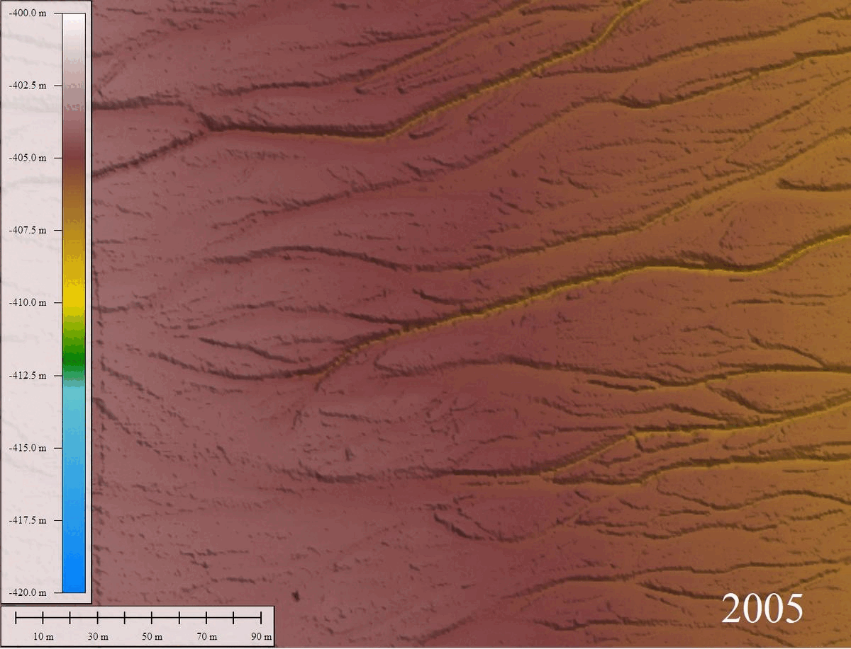
Figure S2. Animated evolution of the Dead Sea sinkhole site (31.34° N, 35.41° E), shown with repeat 0.5 m/pixel airborne LiDAR from 2005 to 2022.

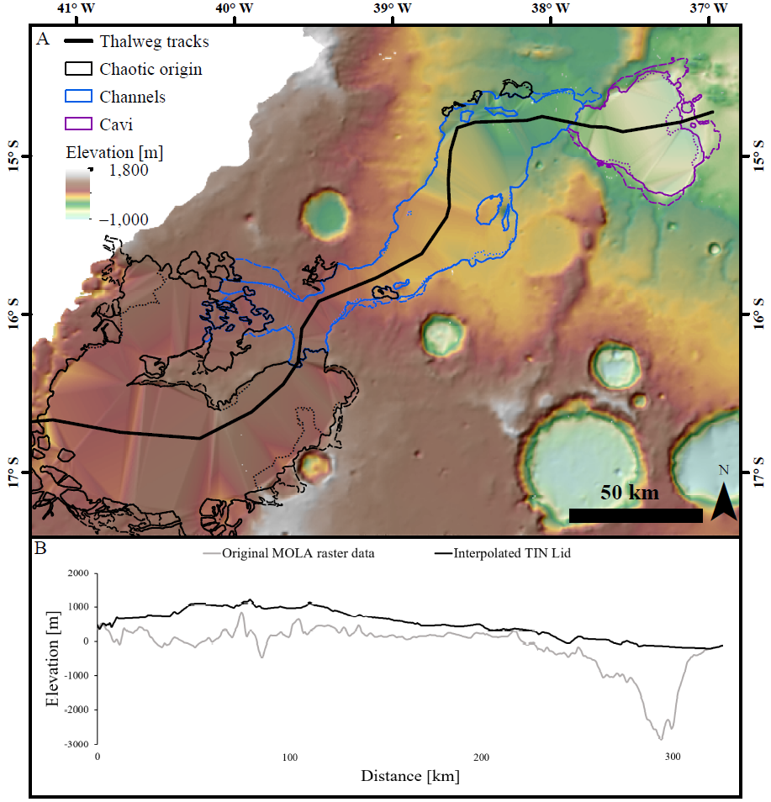
Figure S3. Estimated pre-outflow surface. (A) Color-keyed elevation map, showing the triangular-irregular network-based reconstructed surface. (B) Elevation cross-section along the chaotic origin, channels (along the thalweg), and cavi, which displays both the measured topography and the interpolated pre-outflow topography.

