Supplementary Figures

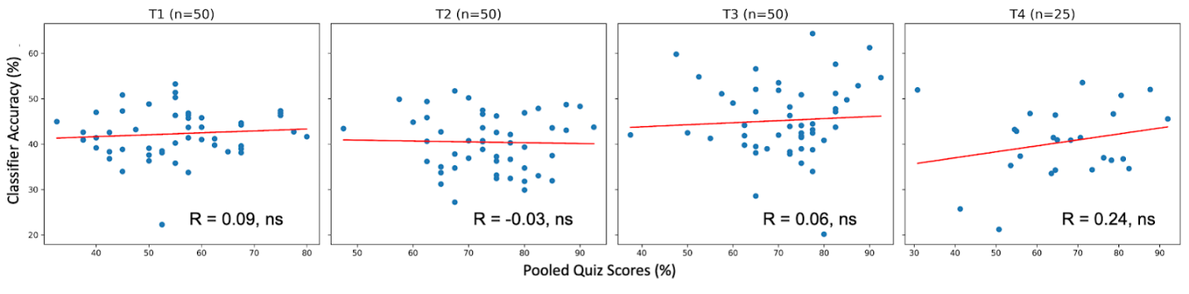
Supplementary Figure 1. Quiz Score versus Similarity Rating Classification by Time Point. Scatter plots show relationship between quiz scores (topics 1 and 2 pooled) and accuracy of the SVM classifier on the behavioral similarity probe data at each time point. No significant correlation between these measures was observed at any time point. The behavioral similarity probe is not analyzed further in this paper, due to lack of evidence that this task as administered was able to measure the relevant constructs.

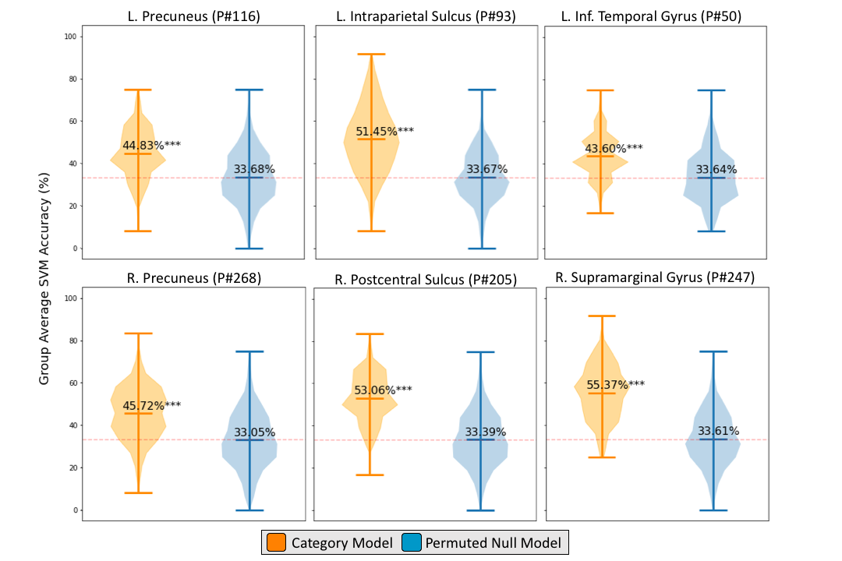
Supplementary Figure 2. Distributions of observed and permuted classification accuracies for significant parcels. Violin plots show SVM classification accuracies over 1,000 iterations in each parcel of interest for the category model and the permuted null model. The horizontal lines indicate the maximum, mean, and minimum score within each parcel, while the curves represent frequency of the result in the distribution. Chance accuracy (33%) is indicated by the dashed lines. Significance values from a one-tailed t-test comparing the category model and null model are also reported (* = p < 0.05, ** = p < 0.01, *** = p < 0.001).

