Supplementary Information
Predicting hydrogen diffusion in random alloys using machine-learning potentials: A case study on Ni–Mn
Kazuma Ito ª, Naoki Matsumura ^{b}, Yuto Iwasaki^{b}, Yasufumi Sakai ^{b}, Misaho Yamamura ^{c}, Tomohiko Omura ^{c}, Junichiro Yamabe ^{d}, Hisao Matsunaga ^{e f g}

ªAdvanced Technology Research Laboratories, Nippon Steel Corporation, 20-1, Shintomi, Futtsu city, Chiba 293-8511, Japan
^{b} Fujitsu Research, Fujitsu Limited, 4-1-1, Kamiodanaka, Nakahara-ku, Kawasaki, Kanagawa 211-8588, Japan
^{c}Steel Research Laboratories, Nippon Steel Corporation, 20-1, Shintomi, Futtsu city, Chiba 293-8511, Japan
^{d}Department of Mechanical Engineering, Fukuoka University, 8-19-1 Nanakuma, Jonan-ku, Fukuoka, 814-0180, Japan
^{e}Department of Mechanical Engineering, Kyushu University, 744 Motooka, Nishi-ku, Fukuoka, 819-0395, Japan
^{f}Research Center for Hydrogen Industrial Use and Storage (HYDROGENIUS), Kyushu University, 744 Moto-oka, Nishi-ku, Fukuoka, 819-0395, Japan
^{g}International Institute for Carbon-Neutral Energy Research (WPI-I²CNER), Kyushu University, 744 Moto-oka, Nishi-ku, Fukuoka, 819-0395, Japan

* Corresponding author. Advanced Technology Research Laboratories, Nippon Steel Corporation, 20-1, Shintomi, Futtsu city, Chiba 293-8511, Japan
Email :ito.nn3.kazuma@jp.nipponsteel.com (K. Ito)

* Corresponding author.
E-mail address: ito.nn3.kazuma@jp.nipponsteel.com (K. Ito)

Supplementary Note 1. DP accuracy for hydrogen diffusion in Ni–Mn random alloys
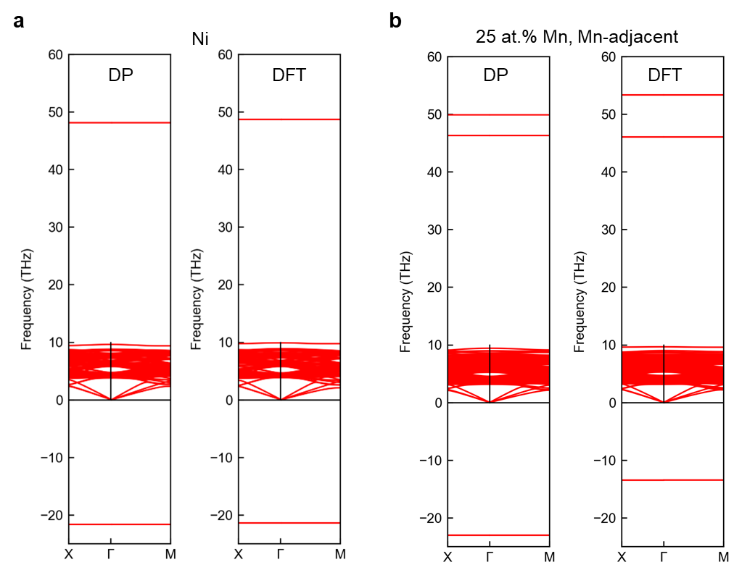
Figures S1a and S1b show the phonon dispersion relations for pure Ni and Ni–25.0 at.% Mn with hydrogen in solid solution. These plots represent the phonon dispersion for the site in the transition states. As discussed in the main article, for the transition state, the accuracy achieved by the DP in reproducing the Mn-induced effects was lower than that achieved for pure Ni. This lower accuracy may have been due to the increased variety of diffusion pathways in the alloy system compared to that of pure Ni, which made sufficient sampling of the transition states more challenging. Nevertheless, the DP qualitatively reproduced the influence of Mn reasonably well. In the hydrogen diffusion coefficient in Ni, the vibration frequency in the transition state has only a relatively small effect on the pre-factor of the diffusion coefficient¹. Therefore, the experimental results of the hydrogen diffusion coefficient in Ni-Mn alloys were accurately calculated by MD using the developed DP.
Fig. S1. DP accuracy for hydrogen diffusion in Ni–Mn random alloys. a Phonon dispersion of hydrogen atom occupying site in the transition state in Ni calculated using DP and DFT. b Phonon dispersion of hydrogen atom occupying site in the transition state in Ni–25.0 at.% Mn calculated using DP and DFT. In a and b, the structure corresponds to the transition state configuration in which a single Mn atom is adjacent to the hydrogen, as shown on the second from the left side of Fig. 3c.

Supplementary Note 2. Hydrogen diffusion behavior in in Ni–Mn alloys
Figures S2a, b, and c show examples of MD simulations of hydrogen diffusion conducted using the developed DP for pure Ni-7.5 at.% Mn, and Ni-12.5 at.% Mn, respectively. In these systems, a linear relationship existed between time and the mean square displacement (MSD), validating fitting with the Einstein equation. Figure S2c presents Arrhenius plots of the diffusion coefficients obtained from the Einstein relation at each temperature. The linearity of these plots validates the approach in which a single activation energy was used for fitting. This consistency also validates the computational conditions and atomic structure models used in the hydrogen diffusion analysis.
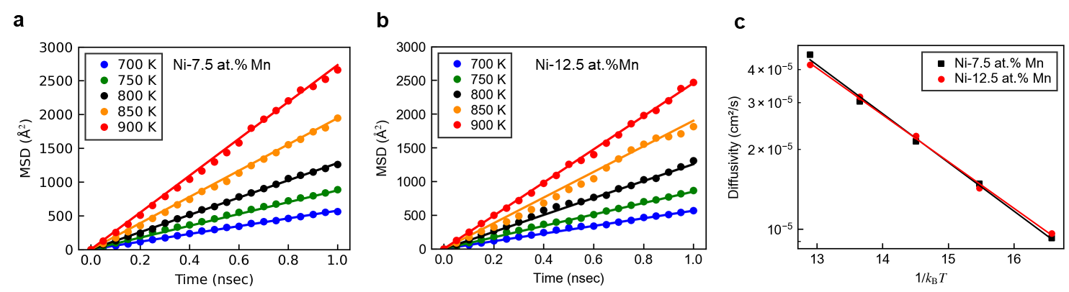
Fig. S2. Hydrogen diffusion behavior in in Ni–Mn alloys. Relationship between annealing time and mean squared displacement (MSD) of hydrogen in a –7.5 at.% Mn, b Ni–12.5 at.% Mn. c Arrhenius plots of hydrogen diffusion coefficients versus 1/𝑘_{B}T for these three systems.

Supplementary Note 3. Training DP including three-body embedding descriptors
In addition to the DP using two embedded descriptors used in the main article, we also tested DP including three embedded descriptors. The model architecture and hyperparameters were set based on a previous study on Fe–H DP². Specifically, A hybrid descriptor of se_e2_a and se_e3 types was employed with the following configuration: cutoff radius 6.5 Å, configuration of embedding net (30, 60, 120), and number of axis neurons 32 for se_e2_a type descriptor, as well as the cutoff radius 5.0 Å, and configuration of embedding net (10, 20) for se_e3 type descriptor. We adopted the hybrid descriptor consisting of the descriptor se_e2_a with a large cutoff radius of 6.5 Å and the descriptor se_e3 with a small cutoff radius of 5.0 Å. The following fitting net of deep neural network model in the training stage was used: the configuration of fitting net (320, 320, 320), initial learning rate 10⁻³, final learning rage 2.2 × 10⁻⁸, and training steps 2 × 10⁶. The deep neural network architecture contains three hidden layers, each containing 320 neurons. The activation function was set in hyperbolic tangent form for each hidden layer. Due to the same size of each hidden layer, a “skip” connection was also built.
The root mean square errors (RMSEs) of the DP using two-body and three-body embedding descriptors for energy (normalized by the number of atoms) and atomic force in the entire training dataset were 5.20 meV/atom and 55.46 meV/Å, respectively. As shown in the main article, the RMSEs of the DP using only two-body embedding descriptors for energy (normalized by the number of atoms) and atomic force in the entire training dataset were 5.70 meV/atom and 68.41 meV/Å, respectively. In other words, the fitting accuracy did not change significantly between the two DPs. Therefore, for computational efficiency in MD simulations requiring long timescales and a large number of cases, we employed the 2-body embedded descriptor DP model.
References
1 Wimmer, E. et al. Temperature-dependent diffusion coefficients from ab initio computations: Hydrogen, deuterium, and tritium in nickel. Phys. Rev. B 77, 134305, doi:10.1103/PhysRevB.77.134305 (2008).
2 Zhang, S., Meng, F., Fu, R. & Ogata, S. Highly efficient and transferable interatomic potentials for α-iron and α-iron/hydrogen binary systems using deep neural networks. Comput. Mater. Sci. 235, 112843, doi:https://doi.org/10.1016/j.commatsci.2024.112843 (2024).

