Supporting Information

Novel Octapeptide Containing the RGD Sequence as a Potential Anti-SARS-CoV-2 Agent: Design, Synthesis, and Theoretical Studies

Reiner Lemos,^{[1]*} Orlando Ortiz,^{[1]} Luis Almagro,^{[1]} Kamil Makowski,^{[2]} Hortensia Rodríguez,^{[3]} Fernando Albericio,^{[4]*} Margarita Suarez^{[1]*}
^{[1]} Laboratorio de Síntesis Orgánica, Facultad de Química, Universidad de la Habana, 10400-La Habana, Cuba.
^{[2]} Department of Surfactants and Nanobiotechnology, Institute for Advanced Chemistry of Catalonia. (IQAC-CSIC), 08034 Barcelona (Spain) and Centro de Investigación Biomédica en Red Bioingeniería Biomateriales y Nanomedicina (CIBER-BBN) 28029-Madrid (Spain)
^{[3]} Yachay Tech Medicinal Chemistry Research Group (MedChem-YT), School of Chemical Sciences and Engineering, Yachay Tech University, 100119-Urququi, Ecuador.
^{[4]}School of Chemistry and Physics, University of KwaZulu-Natal, Durban 4001, South Africa and Department of Organic Chemistry, University of Barcelona, Barcelona, Spain.

Corresponding authors: reinier.lemos@fq.uh.cu (RL), albericio@ub.edu; albericio@ukzn.ac.za (FA), msuarez@fq.uh.cu (MS)

1. Spectroscopy characterization S1
1.1. Spectra of peptide 1 (Mal-LARGDVGA) S1
Figure S1. ¹H NMR spectrum of peptide Mal-LARGDVGA. S1
Figure S2. ¹³C NMR spectrum of peptide 1. S2
Figure S4. HSQC spectrum of peptide 1 S3
Figure S5. HMBC spectrum of peptide 1 S3
Figure S6. COSY spectrum of peptide 1. S4
Figure S7. ¹⁵N-¹H correlation HMBC spectrum of peptide 1 S4
Figure S8. FTIR spectrum of peptide 1. S5
2. HPLC chromatogram S6
Figure S9. RP-HPLC spectrum of peptide 1 S6
3. Mass spectrometry S7
Figure S10. ESI-MS of peptide 1 S7
4. Thermogravimetric analysis S7
Figure S11. Thermogravimetric analysis of peptide 1 S7
5. Theoretical calculations S8
Table S1. Cartesian atom coordinates of peptide 1 S8

Spectroscopy characterization

Spectra of peptide 1 (Mal-LARGDVGA)

Figure S1. ¹H NMR spectrum of peptide Mal-LARGDVGA.

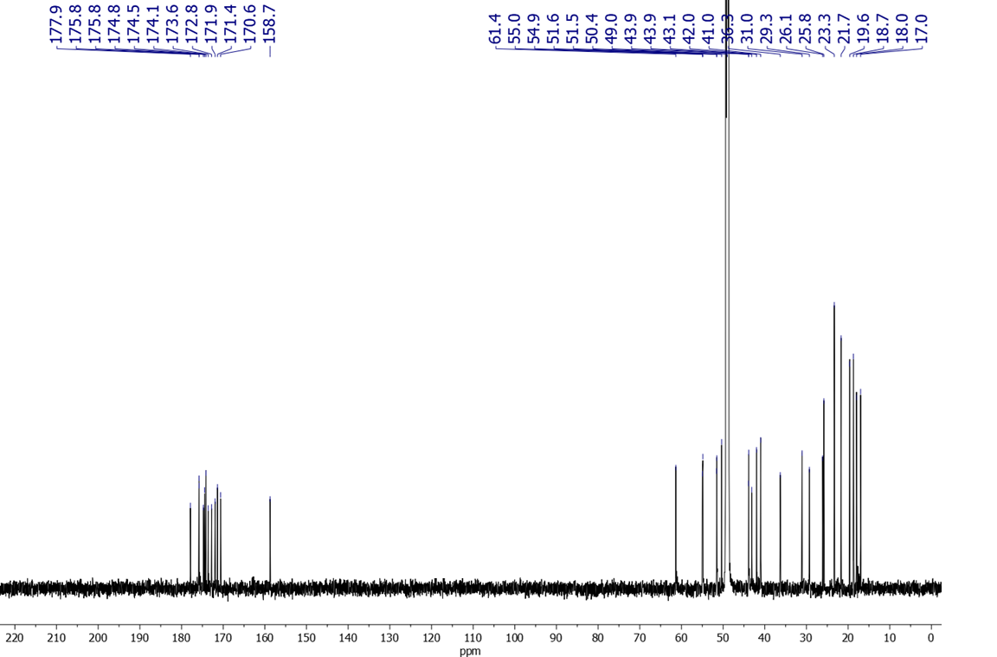

Figure S2. ¹³C NMR spectrum of peptide 1.

Figure S3. DEPT spectrum of peptide Mal-LARGDVGA.

Figure S4. HSQC spectrum of peptide 1

Figure S5. HMBC spectrum of peptide 1

Figure S6. COSY spectrum of peptide 1.

Figure S7. ¹⁵N-¹H correlation HMBC spectrum of peptide 1

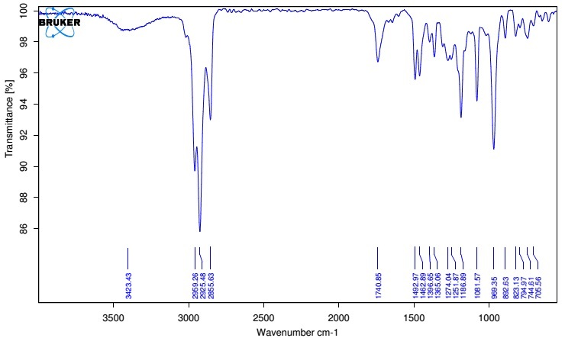

Figure S8. FTIR spectrum of peptide 1.

HPLC chromatogram

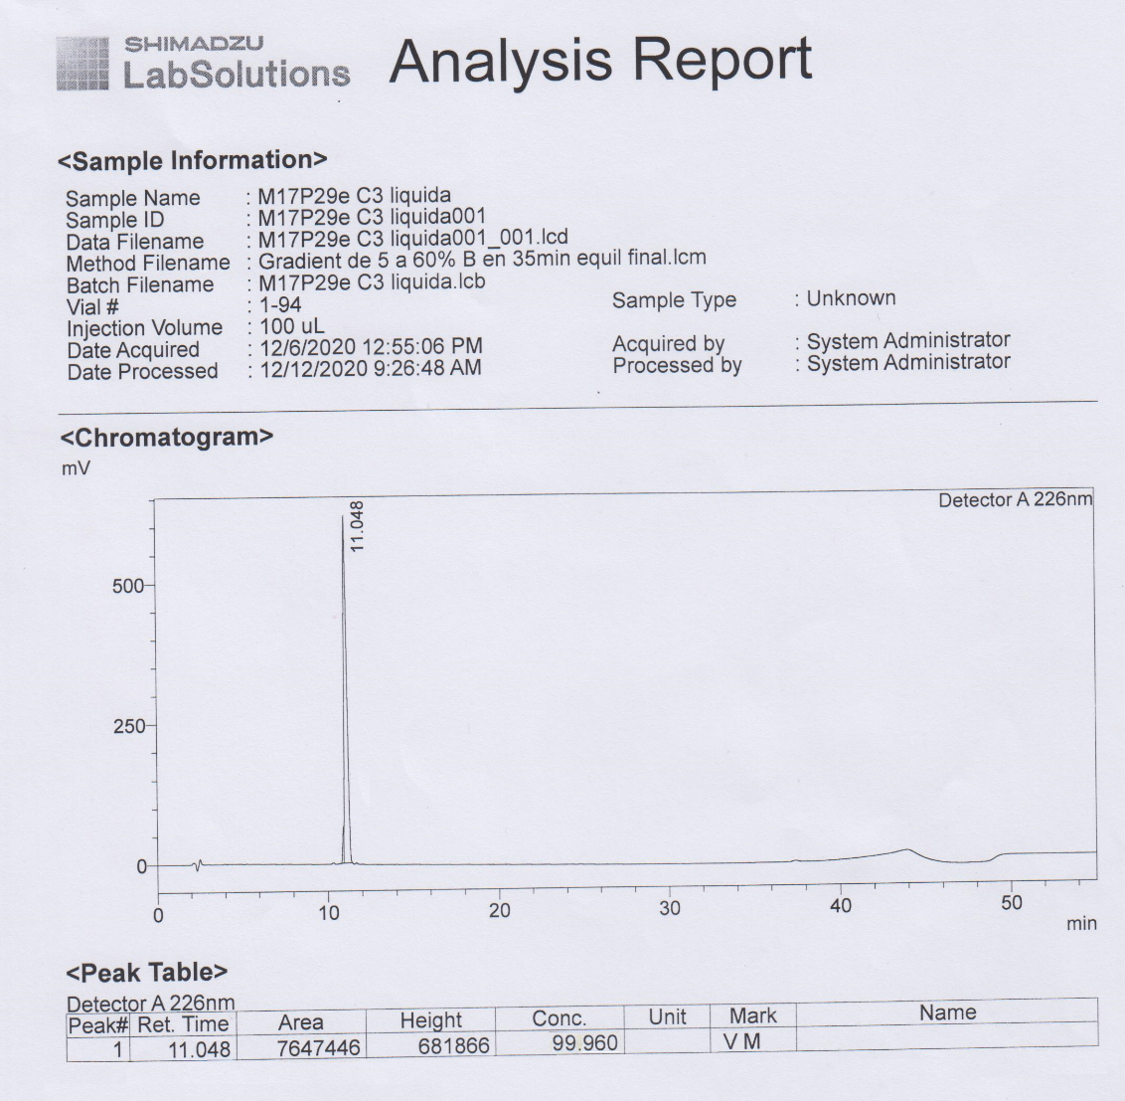
Figure S9. RP-HPLC spectrum of peptide 1, t_{R} 11.0 min. (TFA:acetonitrile, 9.5:0.5, flow rate 0.8 mL/min).

Mass spectrometry

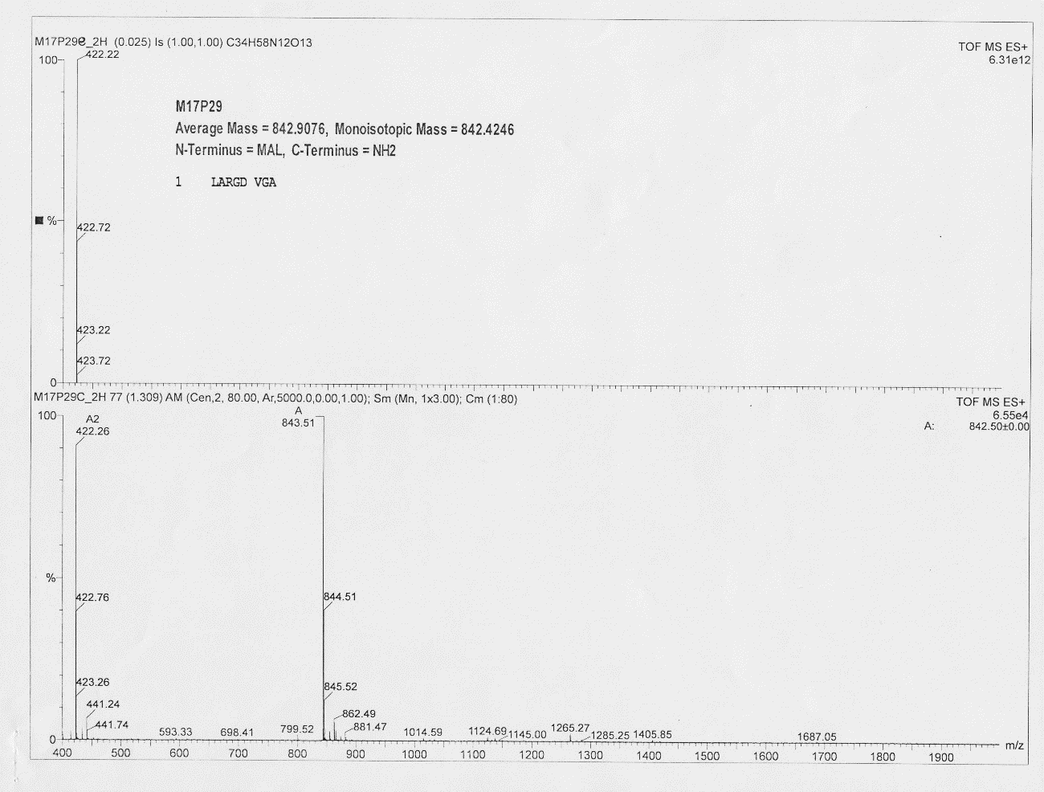

Figure S10. ESI-MS of peptide 1

Thermogravimetric analysis
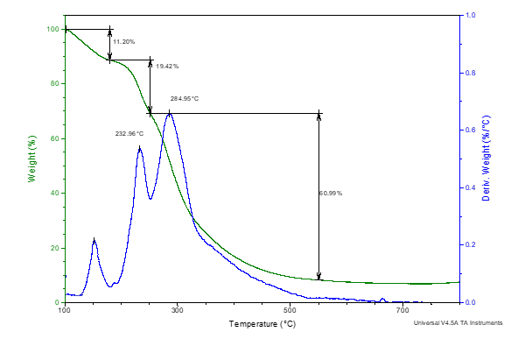

Figure S11. Thermogravimetric analysis of peptide 1

Theoretical calculations
Table S1. Cartesian atom coordinates of peptide 1.

Atom | X | Y | Z
H | -5.61100 | 7.05200 | -1.65000
O | 9.96100 | -4.78000 | 2.04500
C | -7.61300 | 6.69900 | -0.13000
C | -6.30700 | 5.91200 | -0.03700
C | -6.55500 | 4.46900 | -0.49500
N | -5.29900 | 6.55900 | -0.82700
O | -6.36900 | 4.11400 | -1.63500
C | -7.06200 | 2.22900 | 0.22800
C | -5.64300 | 1.66600 | 0.32500
N | -7.05800 | 3.64600 | 0.46700
O | -4.84700 | 2.15900 | 1.09500
C | -4.19000 | -0.17700 | -0.48500
C | -4.21600 | -1.16100 | 0.68900
N | -5.39000 | 0.62600 | -0.49100
O | -5.03900 | -1.11900 | 1.57700
C | -1.97300 | 0.10200 | -1.70300
C | -2.07800 | 0.78200 | 0.70900
C | -2.86900 | 0.64800 | -0.59200
C | -2.93700 | -2.95800 | 1.74000
C | -1.48200 | -3.40500 | 1.55200
N | -3.25500 | -2.11300 | 0.62100
O | -0.86900 | -3.15900 | 0.52800
O | -4.95500 | -5.76700 | 3.25100
O | -3.31600 | -4.59400 | 4.10500
C | -4.01100 | -4.82900 | 3.15700
C | -3.92500 | -4.13300 | 1.81700
C | 0.45300 | -4.40800 | 2.54700
C | 1.31900 | -3.15600 | 2.69100
N | -0.94200 | -4.09500 | 2.56800
O | 0.89800 | -2.16000 | 3.22500
C | 3.71400 | -2.49400 | 2.49400
C | 4.25200 | -2.90500 | 3.87200
N | 2.56600 | -3.29900 | 2.16400
O | 3.55200 | -3.45700 | 4.68600
C | 2.32600 | 0.89800 | 1.23800
C | 2.90300 | -0.50300 | 1.12000
N | 0.57500 | 2.68100 | -1.40200
N | 0.76800 | 3.27100 | 0.81300
C | 1.07700 | 2.48200 | -0.15400
N | 1.88600 | 1.37500 | -0.05400
C | 3.44900 | -0.98100 | 2.45900
C | 7.60800 | -1.29500 | 4.00200
C | 6.58500 | -2.14200 | 3.24900
C | 7.31700 | -3.27000 | 2.51700
N | 5.55300 | -2.58900 | 4.15300
O | 8.06500 | -2.98600 | 1.58800
C | 7.74700 | -5.72900 | 2.44900
C | 9.27700 | -5.75400 | 2.61700
N | 7.12800 | -4.51200 | 2.97200
O | 9.81400 | -6.65400 | 3.19400
C | 4.82500 | -5.74100 | 1.12200
C | 5.81900 | -8.01800 | 1.49000
C | 5.98000 | -6.67700 | 0.78100
C | 7.36700 | -6.05800 | 0.99700
C | -3.95400 | 6.31700 | -0.81100
C | -3.43800 | 5.45900 | 0.32900
O | -3.21500 | 6.83500 | -1.61300
C | -2.09600 | 4.83400 | 0.01600
O | -1.22500 | 4.99000 | 0.97400
O | -1.91100 | 4.20700 | -1.00500
H | 9.37300 | -4.09300 | 1.66100
H | -7.46200 | 7.72500 | 0.20300
H | -7.98000 | 6.71800 | -1.15700
H | -8.38700 | 6.24700 | 0.48800
H | -5.99200 | 5.91000 | 1.01200
H | -7.52400 | 2.02900 | -0.73900
H | -7.67500 | 1.74200 | 0.98900
H | -6.91900 | 3.92300 | 1.42500
H | -4.25900 | -0.78400 | -1.39400
H | -6.14200 | 0.30700 | -1.07500
H | -1.11600 | 0.76200 | -1.83600
H | -1.57900 | -0.89500 | -1.48100
H | -2.49800 | 0.04900 | -2.65900
H | -1.38900 | 1.62000 | 0.62000
H | -2.71900 | 0.98900 | 1.56200
H | -1.48200 | -0.10700 | 0.92800
H | -3.16500 | 1.65100 | -0.90000
H | -3.00900 | -2.38200 | 2.66900
H | -2.53700 | -2.06100 | -0.08700
H | -5.47100 | -5.83300 | 2.44100
H | -3.70700 | -4.86700 | 1.03400
H | -4.91700 | -3.72800 | 1.59400
H | 0.70500 | -4.96100 | 1.63900
H | 0.67500 | -5.06000 | 3.39500
H | -1.45000 | -4.14900 | 3.43900
H | 4.46200 | -2.71900 | 1.72700
H | 2.78000 | -4.19900 | 1.76700
H | 1.49900 | 0.85700 | 1.95800
H | 3.07700 | 1.58400 | 1.64200
H | 3.69400 | -0.52100 | 0.36400
H | 2.11400 | -1.17600 | 0.77600
H | 1.16600 | 2.51000 | -2.19500
H | -0.13700 | 3.39600 | -1.49600
H | 1.06300 | 2.93900 | 1.72000
H | 1.62600 | 0.64200 | -0.69600
H | 2.76300 | -0.71900 | 3.26200
H | 4.38700 | -0.45900 | 2.67100
H | 7.11900 | -0.43400 | 4.45500
H | 8.09600 | -1.86900 | 4.79200
H | 8.38000 | -0.93700 | 3.32500
H | 6.15300 | -1.51600 | 2.46700
H | 5.81200 | -2.72300 | 5.12100
H | 7.39300 | -6.53000 | 3.09500
H | 6.51100 | -4.62000 | 3.76000
H | 3.88100 | -6.17400 | 0.78600
H | 4.74000 | -5.57200 | 2.19700
H | 4.94200 | -4.77300 | 0.62900
H | 6.63900 | -8.69800 | 1.25400
H | 5.78400 | -7.91000 | 2.57600
H | 4.89100 | -8.50500 | 1.19200
H | 5.92300 | -6.87100 | -0.29500
H | 8.10200 | -6.77900 | 0.62600
H | 7.47600 | -5.17200 | 0.36900
H | -3.37200 | 6.07700 | 1.22800
H | -4.10600 | 4.62800 | 0.57000
H | -0.40400 | 4.39600 | 0.83800

