Electronic Supplementary Information
Effect of pH on the conformational transition of silk fibroin in aqueous solution monitored by Thioflavin-T fluorescence
Ben Jia, Lan Jia*, Jing-Xin Zhu
College of Material Science and Engineering, Taiyuan University of Technology, Taiyuan, 030001, P. R. China

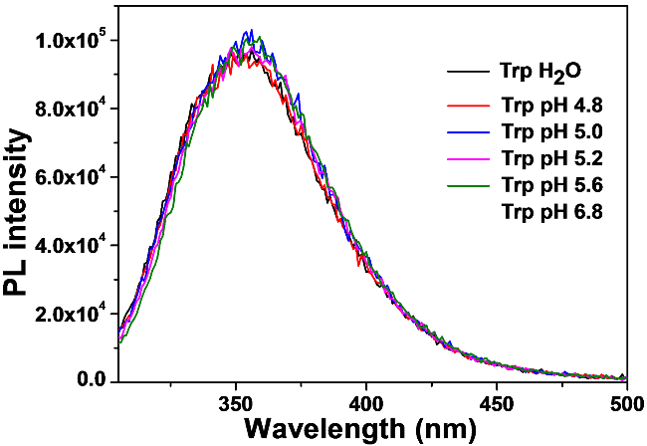
Fig. S1 Intrinsic fluorescence emission spectra of SF (5mg mL⁻¹) under different pH conditions

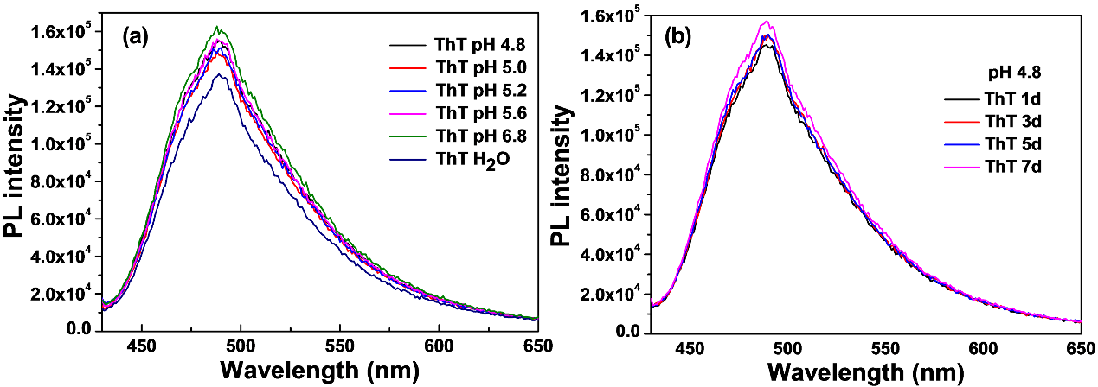
Fig. S2 Fluorescence emission spectra of ThT (20 μM) under (a) different pH conditions and (b) different incubation time

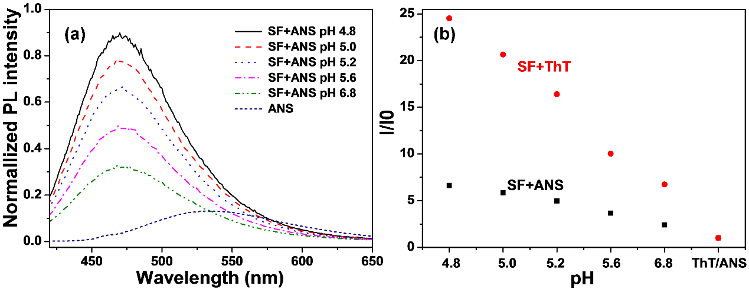
Fig. S3 (a) Fluorescence emission spectra of SF+ANS at different pH conditions (b) Plot of the relative fluorescence intensity I1/I0 as a function of pH, where I1 refer to the fluorescence intensity at 485 nm/470nm of SF+ThT/SF+ANS solutions at different pH, I0 refer to the fluorescence intensity at 485 nm/542 nm of free ThT/ANS, respectively.

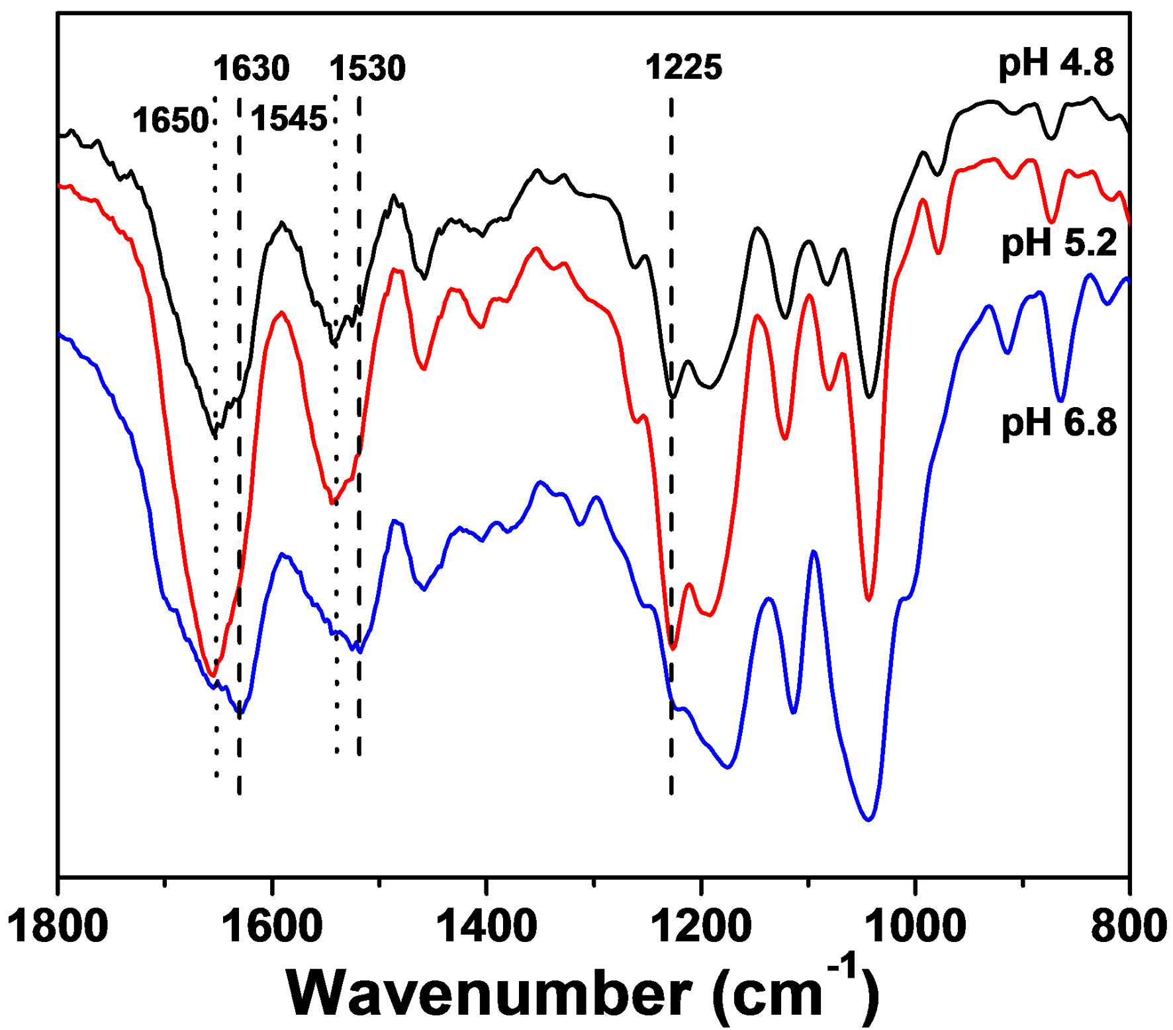
Fig. S4 FTIR spectra of SF (5mg mL-1) at different pH values.

