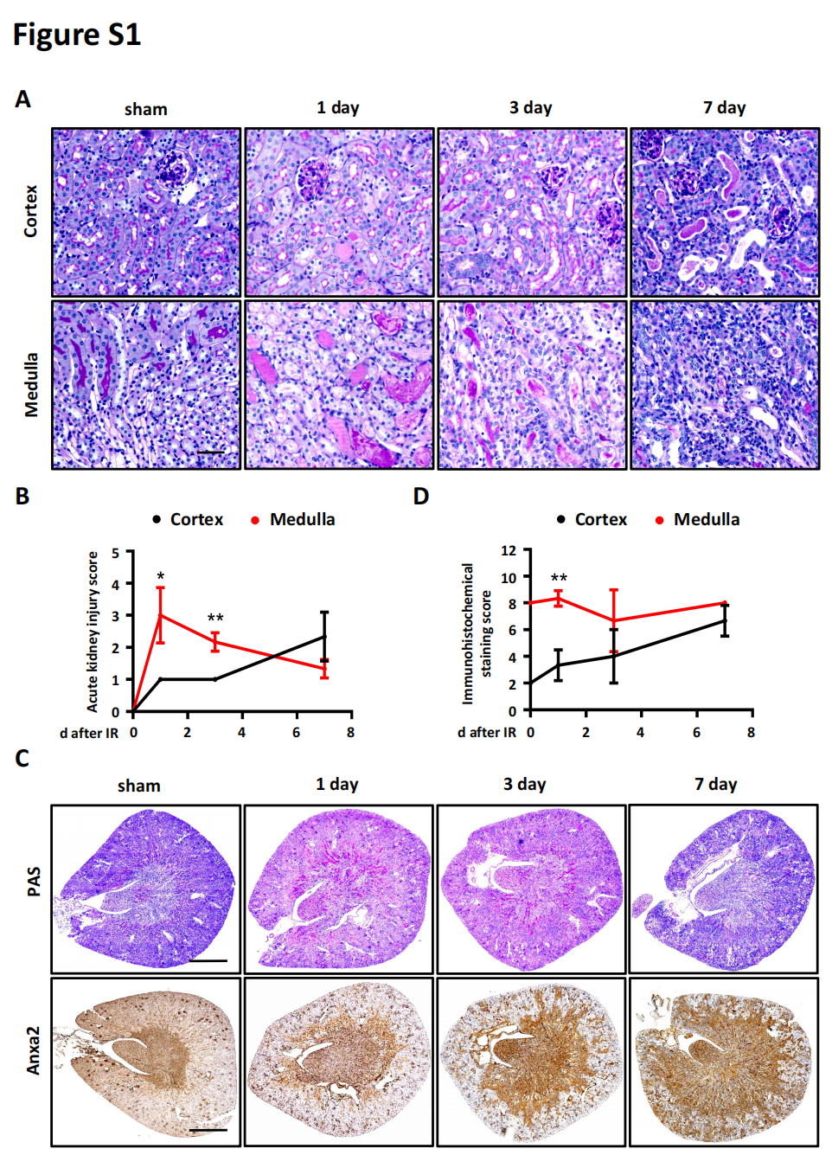
Figure S1.The expression pattern of Anxa2 in the kidney is consistent with the pattern of injury after IR. Mice were subjected to IR modeling, with the renal pedicle clamped for 30 minutes, and tissue samples were collected on the 1st, 3rd, and 7th days after reperfusion. The immunohistochemical staining score was evaluated based on the product of the proportion of positive cells and the staining intensity (proportion of positive cells: 0 points for no cells stained, 1 for 0–25%, 2 for 26–50%, 3 for 51–75%, and 4 for 76–100%; staining intensity: 0 points for no staining, 1 for pale yellow, 2 for deep yellow, and 3 for dark brown). (A) PAS staining was performed to evaluate the pattern of injury as time passes after renal reperfusion. Each sample is assigned a acute injury score for the medulla and cortex of the kidney, respectively, using a acute injury scoring method mentioned before. Bar=50μm. (B) The line chart of renal IRI at different time points after reperfusion. Data are expressed as the mean±SEM. n=3, *P < 0.05, **P < 0.01. (C) Anxa2 immunohistochemical staining was performed to evaluate the expression pattern of Anxa2 as time passes after renal reperfusion. Each sample is assigned a immunohistochemical staining score for the medulla and cortex of the kidney, respectively, using a immunohistochemical staining scoring method mentioned before. Bar=1mm. (D) The line chart of Anxa2 expression at different time points after reperfusion. Data are expressed as the mean±SEM. n=3, **P < 0.01.

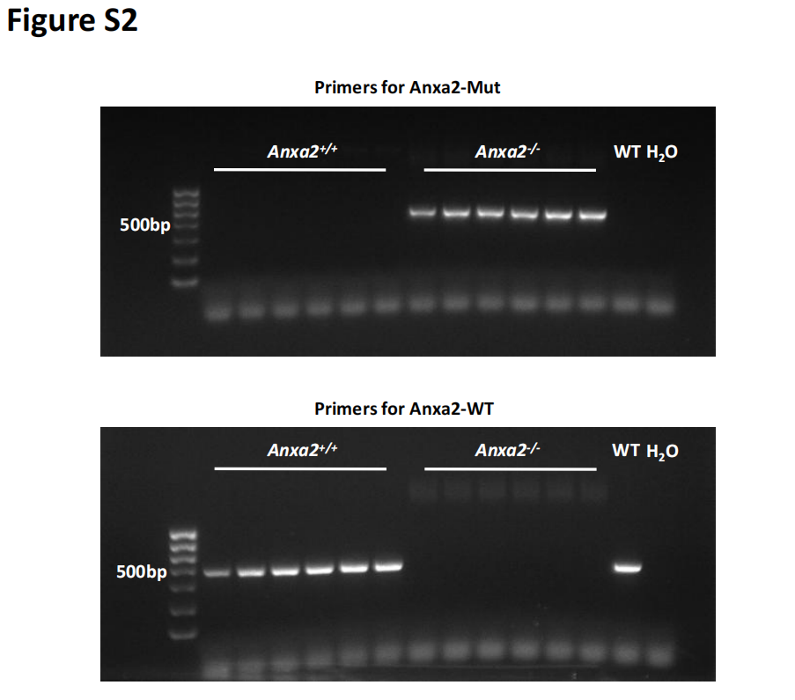
Figure S2. Results of DNA identification of Anxa2 knockout mice. Newborn 4-week-old male mice were subjected to DNA extraction from tails. The product of PCR were subjected to agarose gel electrophoresis. PCR products of 399 bp and 503 bp were for wild-type and CRISPR-Cas9 modified allele DNA respectively. A defined wild-type mouse was used as a positive control and H₂O as a negative control. Each mouse was identified twice.

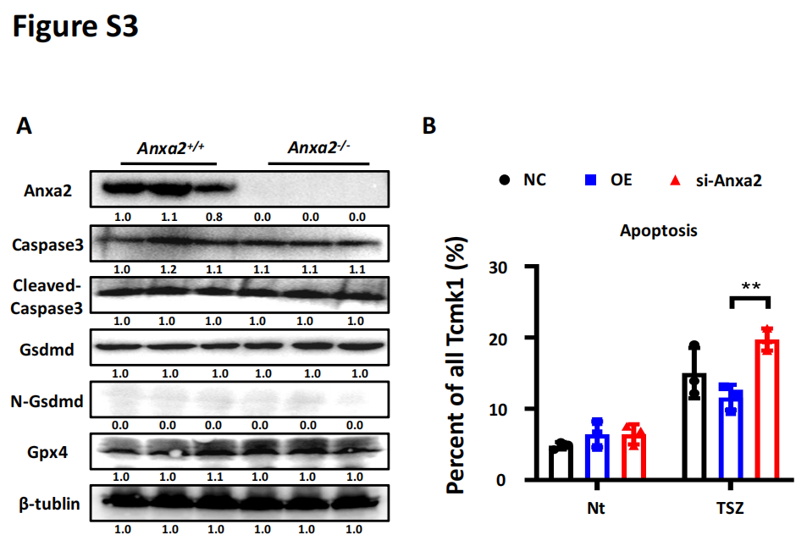
Figure S3. Validation of other ways of death in renal medulla and the effect of siRNA knockdown in Tcmk1. All model mice were clamped for 30 minutes, and tissue samples were collected 24 hours after reperfusion. (A) The medullary kidney tissue was specifically isolated from the clamped kidney for western-blotting to evaluate protein levels associated with other ways of cellular death in tubular epithelial cells after renal IR in Anxa(+/+) and Anxa2(-/-) mice. (B) The proportion of cells with apoptosis to all cells in each group was counted to evaluate the level of apoptosis. Annexin V+/PI- cells were considered as cells of apoptosis. 3 independent replicates were performed for each group of cells. Data are expressed as the mean±SEM.

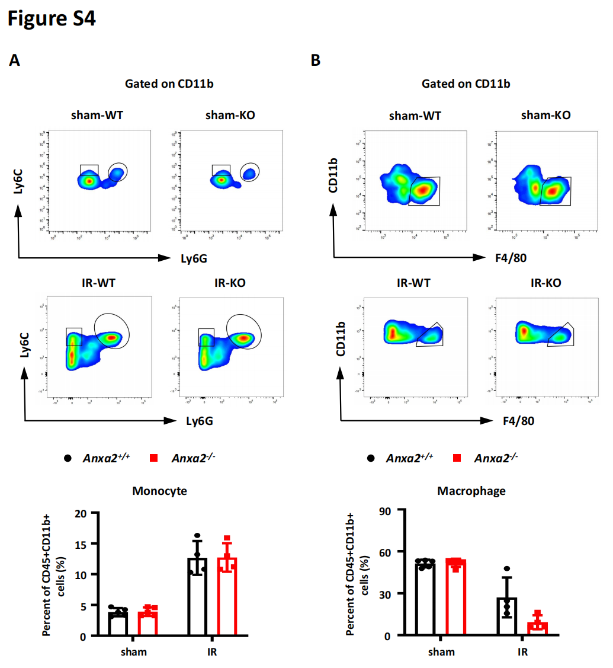
Figure S4. Anxa2 has no significant regulatory effect on the infiltration of monocytes and macrophages after renal IR. All model mice were clamped for 30 minutes, and tissue samples were collected 24 hours after reperfusion. (A) The whole kidney was collected for flow cytometry to examine the infiltration of monocytes after renal IR. CD45+CD11b+Ly6G-Ly6C^{high} cells were considered as monocytes. The percent of monocytes in CD45+CD11b+ cells was counted after renal IR in Anxa(+/+) and Anxa2(-/-) mice. Data are expressed as the mean±SEM. sham, n=5; IR, n=4. (B) CD45+CD11b+F4/80+ cells were considered as macrophages. Data are expressed as the mean±SEM. sham, n=5; IR, n=4.

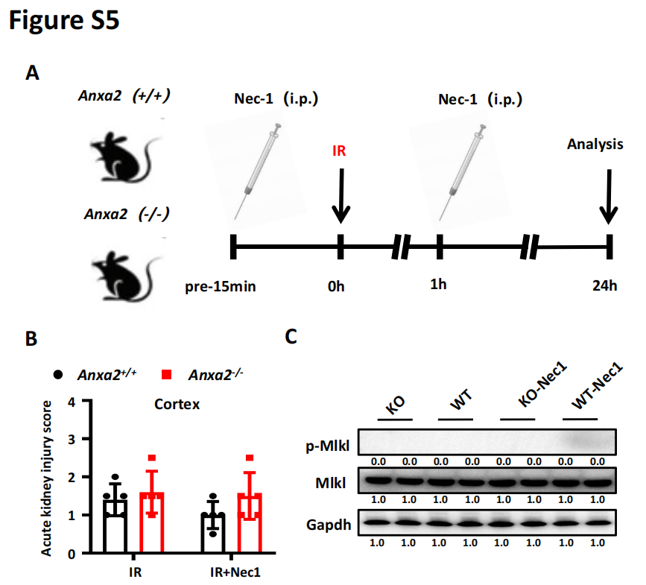
Figure S5. Schematic diagram of the dosing experiment of Nec1 and associated negative results. All model mice were clamped for 30 minutes, and tissue samples were collected 24 hours after reperfusion. (A) Schematic diagram of the Nec1 intervention method used to intervene in renal IR injury. (B) Each sample was scored for early renal injury after IR with acute kidney scoring method in the cortex. Data are expressed as the mean±SEM. n=5. (C) The medullary kidney tissue was used for western-blotting to evaluate protein level associated with necroptosis before IR with or without Nec1 intervention in Anxa(+/+) and Anxa2(-/-) mice.

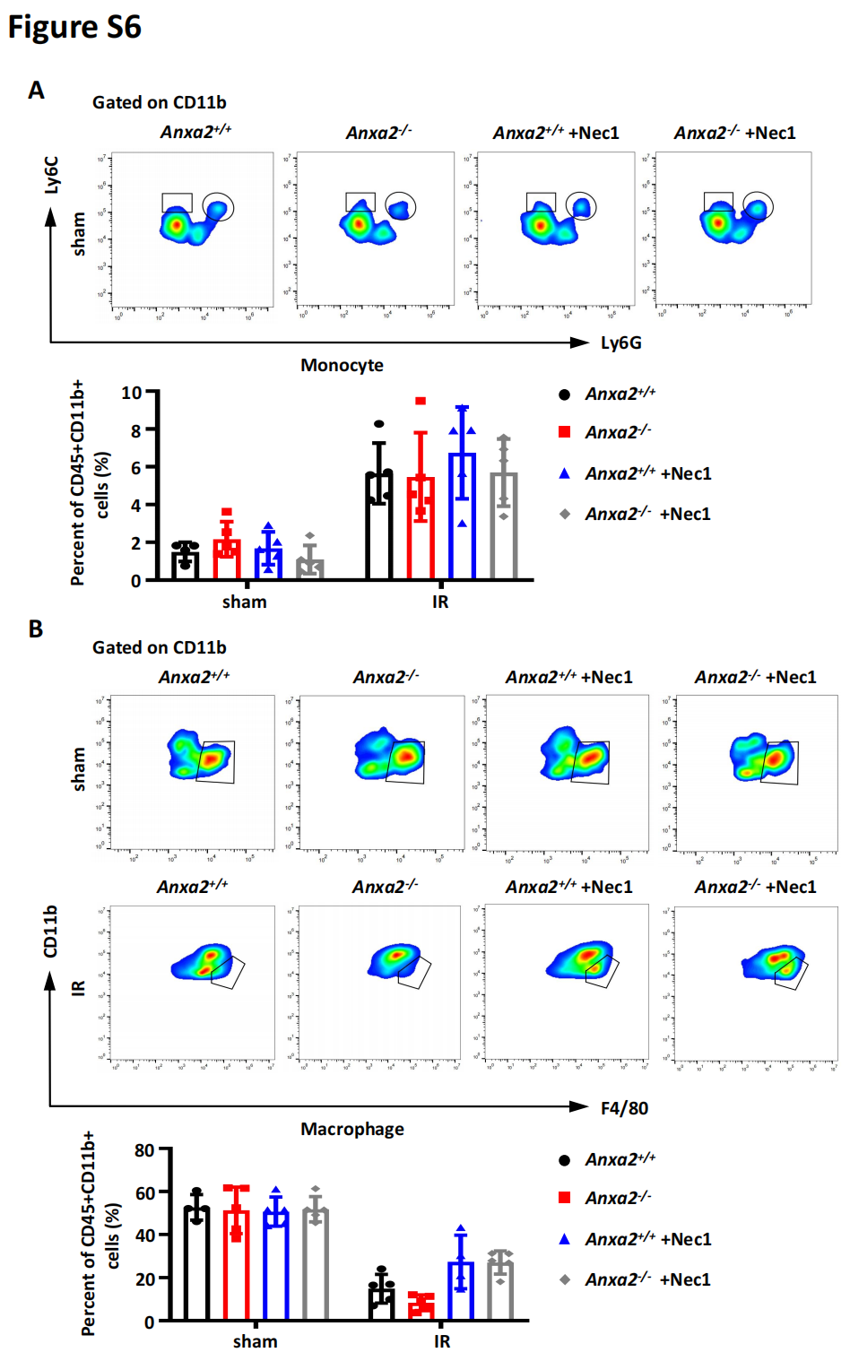
Figure S6. Anxa2 deficiency induced necroptosis of medullary tubular epithelial cells have no significant effect on the infiltration monocytes and macrophages. All model mice were clamped for 30 minutes, and tissue samples were collected 24 hours after reperfusion. (A) The whole kidney was collected for flow cytometry to examine the infiltration of monocytes after renal IR. CD45+CD11b+Ly6G-Ly6C^{high} cells were considered as monocytes. The percent of monocytes in CD45+CD11b+ cells was counted after renal IR in Anxa(+/+) and Anxa2(-/-) mice. Data are expressed as the mean±SEM. n=5. (B) CD45+CD11b+F4/80+ cells were considered as macrophages. Data are expressed as the mean±SEM. n=5.

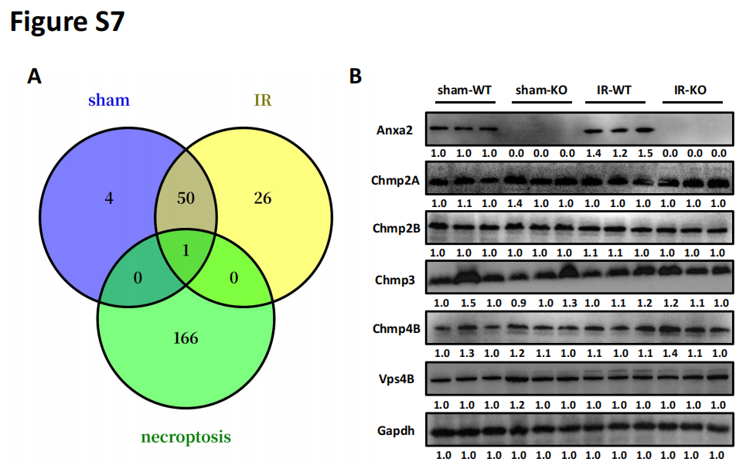
Figure S7. Venn diagram of IP-MS results and the expression levels of ESCRT-III complex component protein molecules in cytoplasmic proteins. All model mice were clamped for 30 minutes, and tissue samples were collected 24 hours after reperfusion. (A) IP-MS (Anxa2 IP) was performed to analyze the renal medulla of mice before and after renal IR. The high abundance protein molecules binding with Anxa2 were screened in sham and IR groups and took the intersection of sham group, IR group and necroptosis related molecule set. Screening criteria: Abundance > 10 million; Coverage > 2. (B) The cytoplasmic proteins were used to detect the expression of component proteins of ESCRT-III complex, such as Chmp2A, Chmp2B, Chmp3, Chmp4B and Vps4B, by western blotting in Anxa(+/+) and Anxa2(-/-) mice.

