FeVO₄/rGO as high-performance supercapacitor electrode: synthesis and characterization
Xiancai zeng^{1,2} · meng guo^{1,2} · xin Luo^{1,2} · Mingjian Zhao^{1,2} · jingyi ren^{1,2} · Jiling Tan^{1,2}
1, School of Biological and Chemical Engineering, Nanyang Institute of Technology, Nanyang 473000, China
2, Henan Key Laboratory of Industrial Microbial Resources and Fermentation Technology, Nanyang 473000, China

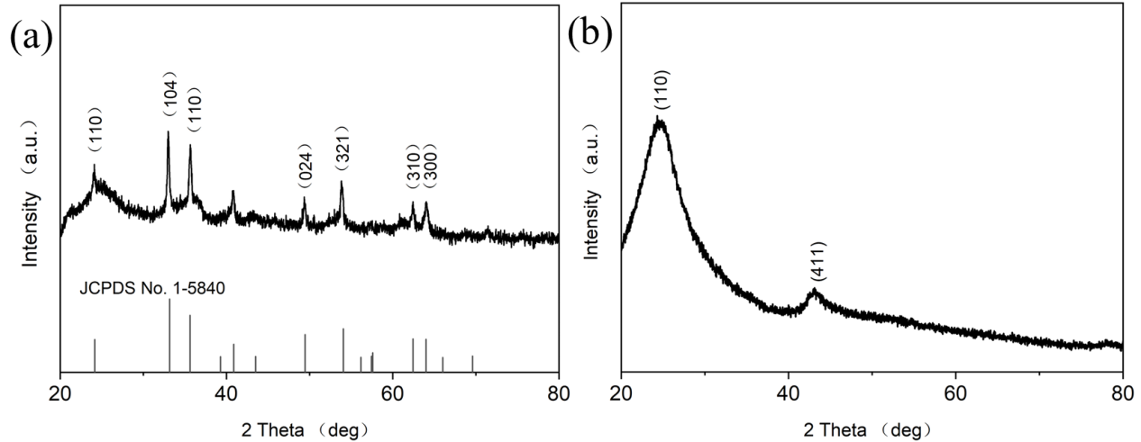
Fig. S1 XRD pattern of (a) Fe₂O₃/G, and (b) V₂O₅/G composites

Fig. S2 High-resolution XPS spectrum for O 1s of FeVO₄/G-2 composite

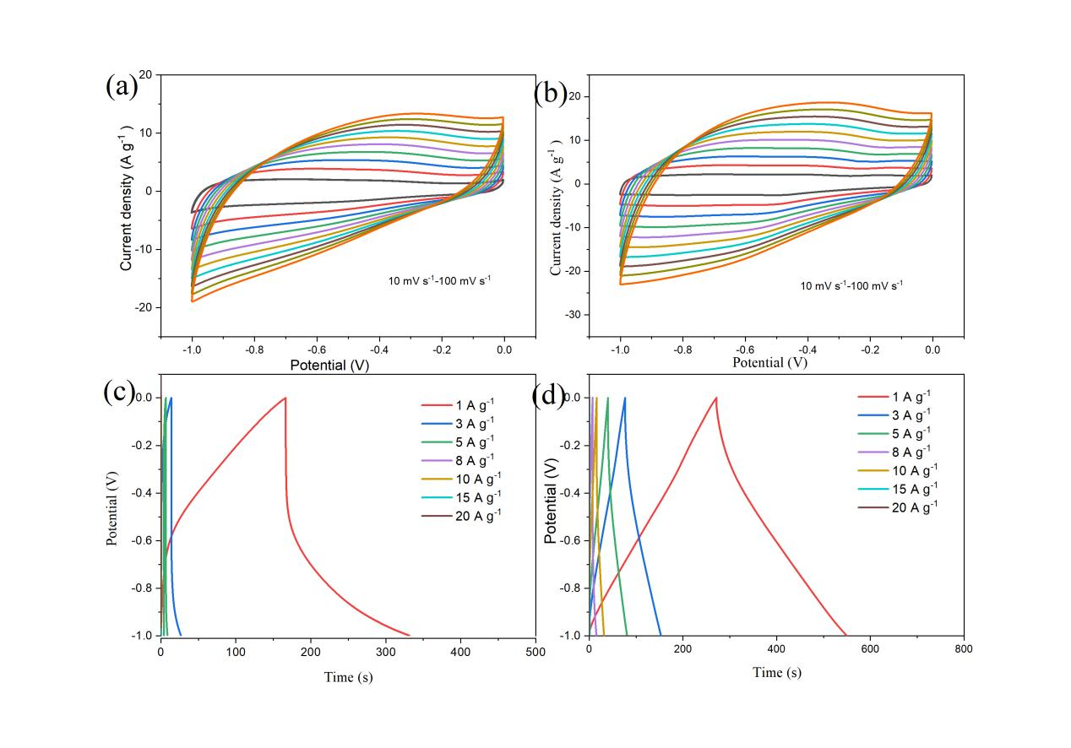
Fig. S3 CV curves at different scan rates of (a) Fe₂O₃/G, and (b) V₂O₅/G composites ;GCD curves at various current densities of (c) Fe₂O₃/G, and (d) V₂O₅/G composites

