Supplementary Table S1: patient’s characteristics and reasons for genomic analysis exclusion

Patient ID | Cancer type | Biopsy site | Biopsy failure | Low cellularity <20% | No targetable alteration | Targetable alteration but early death, or loss of follow-up, or no drug access | Whole genome (>40X) | Whole exome (>150X) | RNAseq | promotor methylation
P1 | Low grade serous ovarian carcinoma | Peritoneal carcinomatosis | N | N | N | N | 86% | >90% | Y | N
P2 | High grade MPNST | Primary tumor | N | N | N | N | >90% | >90% | Y | N
P3 | ER+ breast cancer | Bone | N | N | N | N | >90% | >90% | Y | N
P4 | High grade serous ovarian cancer | Pelvic lymph node | N | N | N | N | >90% | >90% | Y | N
P5 | Osteosarcoma | Primary tumor | N | N | N | N | >90% | >90% | N (low c) | N
P6 | High grade endometrioid carcinoma | Pelvic lymph node | N | N | N | N | >90% | >90% | Y | N
P7 | Urothelial carcinoma (bladder) | Pelvic lymph node | N | N | N | N | >90% | >90% | Y | N
P8 | UCNT | Liver | N | N | N | N | >90% | >90% | N (IQ) | N
P9 | Clear-cell endometrial carcinoma | Bone | N | N | N | N | >90% | >90% | Y | N
P10 | Pancreatic adenocarcinoma | Lung | N | N | N | N | 83% | >90% | Y | RAD51C, BRCA1
P11 | Type II papillary carcinoma of the kidney | Peritoneal carcinomatosis | N | N | N | N | >90% | >90% | N (IQ) | N
P12 | Epithelioid hemangioendothelioma | Spleen | N | N | N | N | 68% | >90% | Y | N
P13 | Cholangiocarcinoma | Lung | N | N | N | N | 87% | >90% | N (IQ) | N
P14 | TNBC | Axillary lymph node | N | N | N | N | >90% | >90% | Y | N
P15 | TNBC | Breast localization | N | N | N | N | >90% | >90% | Y | N
P16 | Low grade neuroendocrine tumor | Lung | N | N | N | N | 86% | >90% | Y | N
P17 | HER2 overexpressing breast carcinoma | Axillary lymph node | N | N | N | N | 65% | >90% | Y | N
P18 | ER+ breast cancer | Axillary lymph node | N | N | N | N | 85% | >90% | N (IQ) | N
P19 | ER+ breast cancer | Bone | N | N | N | N | 80% | >90% | N (IQ) | N
P20 | High grade serous ovarian carcinoma | Coeliac lymph node | N | N | N | N | 84% | >90% | N (IQ) | N
P21 | Squamous cell carcinoma of nasopharynx | Primary tumor | N | N | N | N | >90% | >90% | N (IQ) | N
P22 | Cholangiocarcinoma | Liver | N | N | N | N | 84% | >90% | Y | N
P23 | High grade clear-cell endometrial carcinoma | Peritoneal carcinomatosis | N | N | N | N | >90% | >90% | Y | N
P24 | Endometrial leiomyosarcoma | Lung | N | N | N | N | >90% | >90% | N (IQ) | N
P25 | TNBC | Skin | N | N | N | N | 70% | >90% | N (IQ) | N
P26 | TNBC | Liver | N | N | N | N | 87% | >90% | Y | BRCA1
P27 | Head and Neck squamous cell carcinoma | Lymph node | N | N | N | N | >90% | >90% | Y | N
P28 | Low grade neuroendocrine carcinoma |  | N | N | N | Y | 81% | >90% | Y | N
P29 | Pancreatic adenocarcinoma |  | Y | N | N | N | N | N | N | N
P30 | Clear-cell renal cell carcinoma |  | Y | N | N | N | N | N | N | N
P31 | Colon carcinoma |  | N | N | Y | N | >90% | >90% | Y | N
P32 | TNBC |  | N | N | N | Y | >90% | >90% | N (IQ) | N
P33 | Peritoneal mesothelioma |  | N | N | N | Y | 67% | >90% | Y | N
P34 | High grade undifferentiated pleiomorphic sarcoma |  | N | N | N | Y | >90% | >90% | N (IQ) | N
P35 | ALK+ lung carcinoma |  | N | N | N | Y | 67% | >90% | Y | N
P36 | Pancreatic adenocarcinoma |  | N | N | Y | N | 43% | >90% | Y | N
P37 | Clear-cell renal cell carcinoma |  | N | N | Y | N | >90% | >90% | Y | N
P38 | Cholangiosarcoma |  | N | N | Y | N | 75% | >90% | Y | N
P39 | GIST |  | N | N | Y | N | N (low c) | >90% | N (IQ) | N
P40 | High grade MPNST |  | N | N | N | Y | >90% | >90% | Y | N
P41 | High grade serous ovarian carcinoma |  | N | N | Y | N | 88% | >90% | Y | N
P42 | Epidermoid endometrial carcinoma |  | N | N | Y | N | >90% | >90% | Y | N
P43 | Head and Neck squamous cell carcinoma |  | N | N | N | Y | 77% | >90% | Y | N
P44 | Squamous cell carcinoma of nasopharynx |  | N | N | N | Y | 78% | >90% | Y | N
P45 | Gastric sarcoma |  | N | N | N | Y | >90% | >90% | Y | N
P46 | Bronchogenetic lung carcinoma |  | Y
P47 | Colon carcinoma |  |  | Y
P48 | UCNT |  | Y
P49 | TNBC |  | Y
P50 | Ethmoid adenocarcinoma |  |  |  |  | Y | 78% | >90% | Y | N
P51 | High grade serous ovarian carcinoma |  |  |  |  | Y | 88% | >90% | Y | BRCA1, RAD51C
P52 | Colon carcinoma |  | Y
P53 | Colon carcinoma |  |  | Y
MPNST : malignant peripheral nerve sheat tumor ; ER : estrogen receptor ; UCNT : undifferenicated carcinoma of nasopharyngeal type ; TNBC : triple negative breast cancer ; ALK : anaplastic lymphoma kinase ; GIST : gastrointestinal stromal tumor ;

Supplementary Table S2: Patient’s characteristics
Patient ID | Cancer type | Age at the time of inclusion (yr) | Sex | Reason for SeqOIA inclusion | Metastatic disease | Biopsy site
P1 | Low grade serous ovarian carcinoma | 62 | W | Therapeutic failure | Y | Peritoneal carcinomatosis
P2 | High grade MPNST | 27 | M | Rare histological cancer type | N | Primary tumor
P3 | ER+ breast cancer | 37 | W | Therapeutic failure | Y | Bone
P4 | High grade serous ovarian cancer | 57 | W | Therapeutic failure | Y | Pelvic lymph node
P5 | Osteosarcoma | 42 | W | Rare histological cancer type | N | Primary tumor
P6 | High grade endometrioid carcinoma | 36 | W | Therapeutic failure | Y | Pelvic lymph node
P7 | Urothelial carcinoma (bladder) | 43 | M | Therapeutic failure | Y | Pelvic lymph node
P8 | UCNT | 33 | M | Rare histological cancer type | Y | Liver
P9 | Clear-cell endometrial carcinoma | 58 | W | Rare histological cancer type | Y | Bone
P10 | Pancreatic adenocarcinoma | 65 | W | Therapeutic failure | Y | Lung
P11 | Unclassified tumor of the kidney (tumor with translocation Xp11.2) | 29 | M | Rare histological cancer type | Y | Peritoneal carcinomatosis
P12 | Epithelioid hemangioendothelioma | 66 | W | Rare histological cancer type | Y | Spleen
P13 | Cholangiocarcinoma | 64 | M | Therapeutic failure | Y | Lung
P14 | TNBC | 32 | W | Therapeutic failure | Y | Axillary lymph node
P15 | TNBC | 51 | W | Therapeutic failure | Y | Breast localization
P16 | neuroendocrine tumor ((tumor with translocation Xp11.2) | 72 | M | Rare histological cancer type | Y | Lung
P17 | HER2 overexpressing breast carcinoma | 67 | W | Therapeutic failure | Y | Axillary lymph node
P18 | ER+ breast cancer and secondarily expansion of a TNBC clone | 64 | W | Therapeutic failure | Y | Axillary lymph node
P19 | ER+ breast cancer | 54 | W | Therapeutic failure | Y | Bone
P20 | High grade serous ovarian carcinoma | 55 | W | Therapeutic failure | Y | Coeliac lymph node
P21 | Squamous cell carcinoma of nasopharynx | 42 | W | Rare histological cancer type | Y | Primary tumor
P22 | Cholangiocarcinoma | 59 | W | Resort situation | Y | Liver
P23 | High grade clear-cell endometrial carcinoma | 62 | W | Rare histological cancer type | Y | Peritoneal carcinomatosis
P24 | Endometrial leiomyosarcoma | 53 | W | Rare histological cancer type | Y | Lung
P25 | TNBC | 66 | W | Therapeutic failure | Y | Skin
P26 | TNBC | 43 | W | Therapeutic failure | Y | Liver
P27 | Head and Neck squamous cell carcinoma | 56 | M | Therapeutic failure | Y | Lymph node

Supplementary Figures Legends
Supplementary Figure S1: The flow diagram of the cohort of patients; WGS: Whole-genome sequencing.
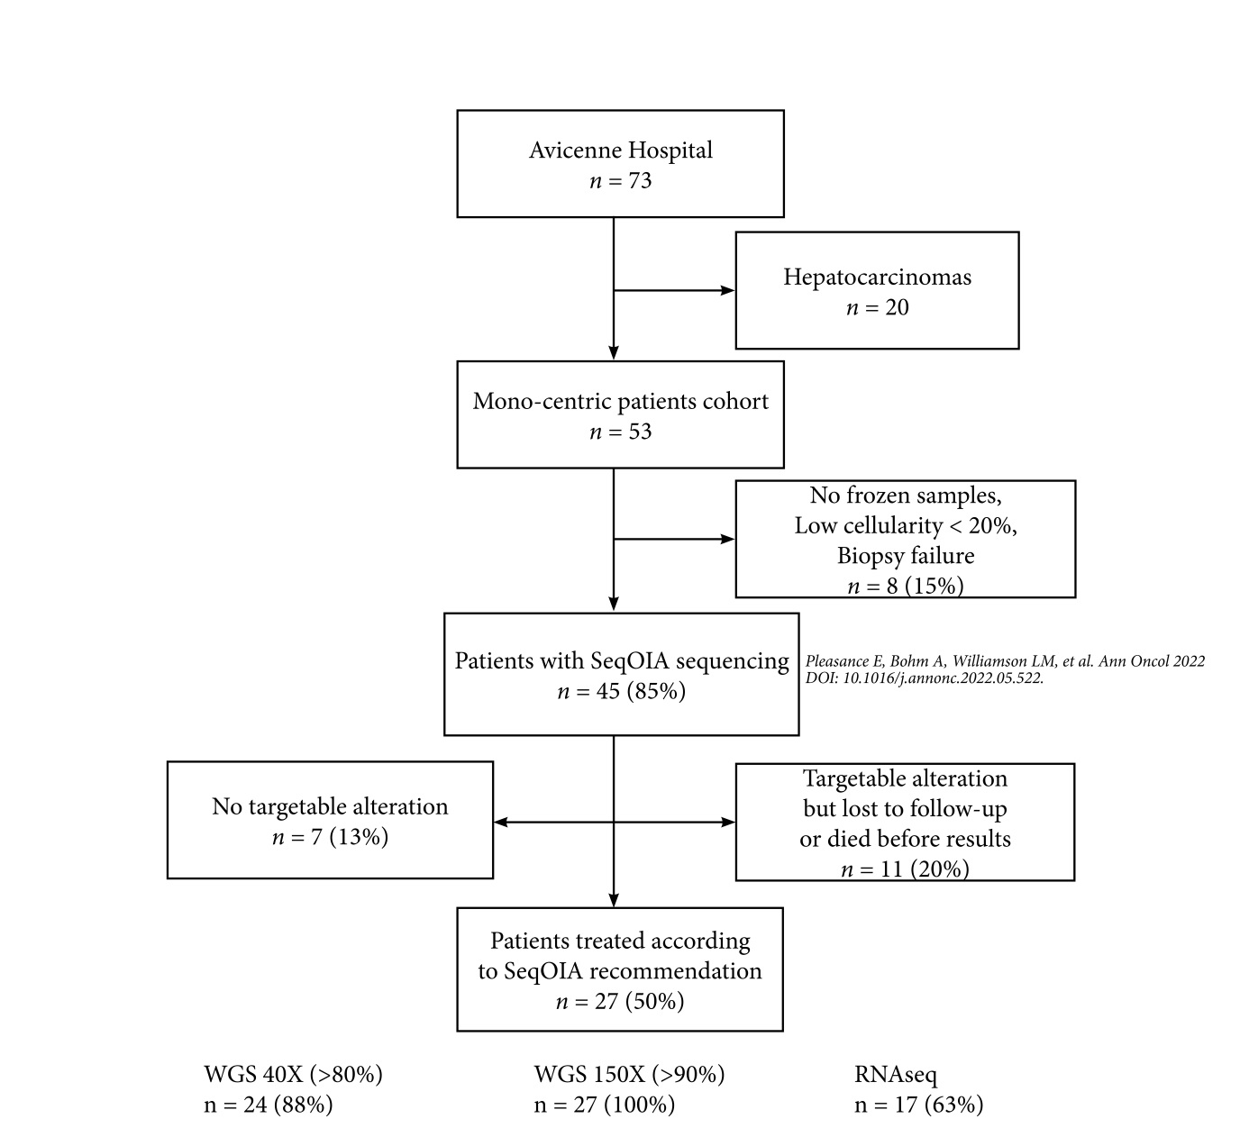

Supplementary Figure S2: Immunostainings of PIK3CA protein on tumor samples of patients 17 and 15 at x100 and x400 magnifications. P17 illustrates a membrane staining of moderate intensity of 100% tumor cells, corresponding to a IHC score of 8 (panel A). P15 illustrates a maximal IHC score of 12 with a high intensity staining of all cancer cells (panel B).
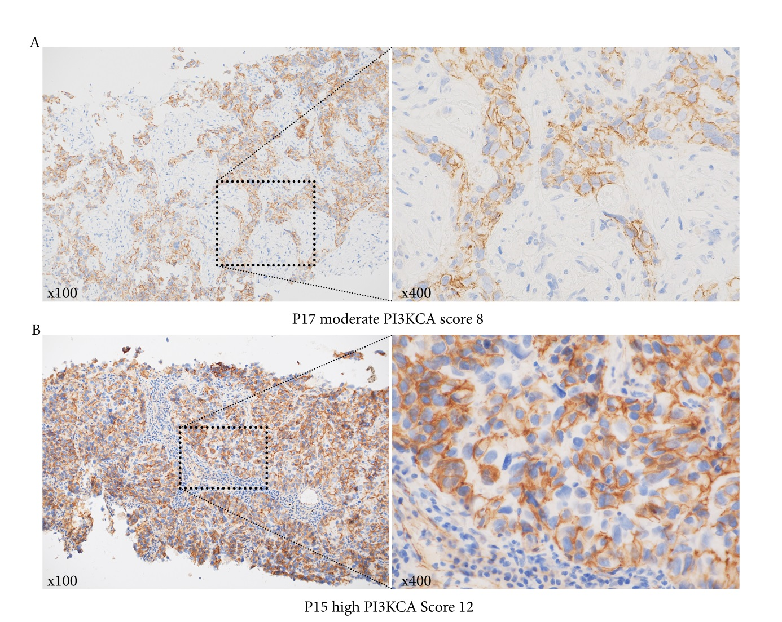

Supplementary Figure S3: Genomic signatures profiles for the 27 patients included in the study.
The most prevalent are SBS1 (spontaneous deamination of 5-mehtylcytosine) and SBS5 (unknown etiology). They are present in 13 (52%) and 12 tumors (48%), respectively. The SBS3 signature, indicative of defective homologous recombination DNA damage repair is present in two tumors of the 11 with a positive HRD score (P5 and P26, HRD scores = 50 and 97, respectively); HRD: Homologous Recombination Deficiency; mmrd: mis-match repair deficiency; UV: ultra-violet.
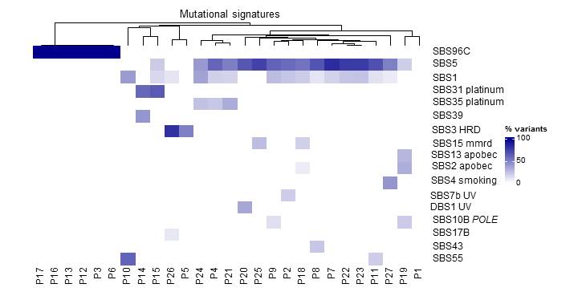

Supplementary Figure S4: Gene list with copy number variations for the 27 patients included in the study. There are 160 copy gains, with up to 64 copies of the CCNE1 gene (CYCLIN-E1) in P15 tumor sample. There are also 131 homozygous deletions of tumor suppressor genes. Copy gains are recurrent for genes like MYC, NCOA2, or PREX2, while homozygous deletion are frequently found in tumor suppressor genes like CDKN2A, CDKN2B or MTAP (22%, 15%, and 19% of patients, respectively).
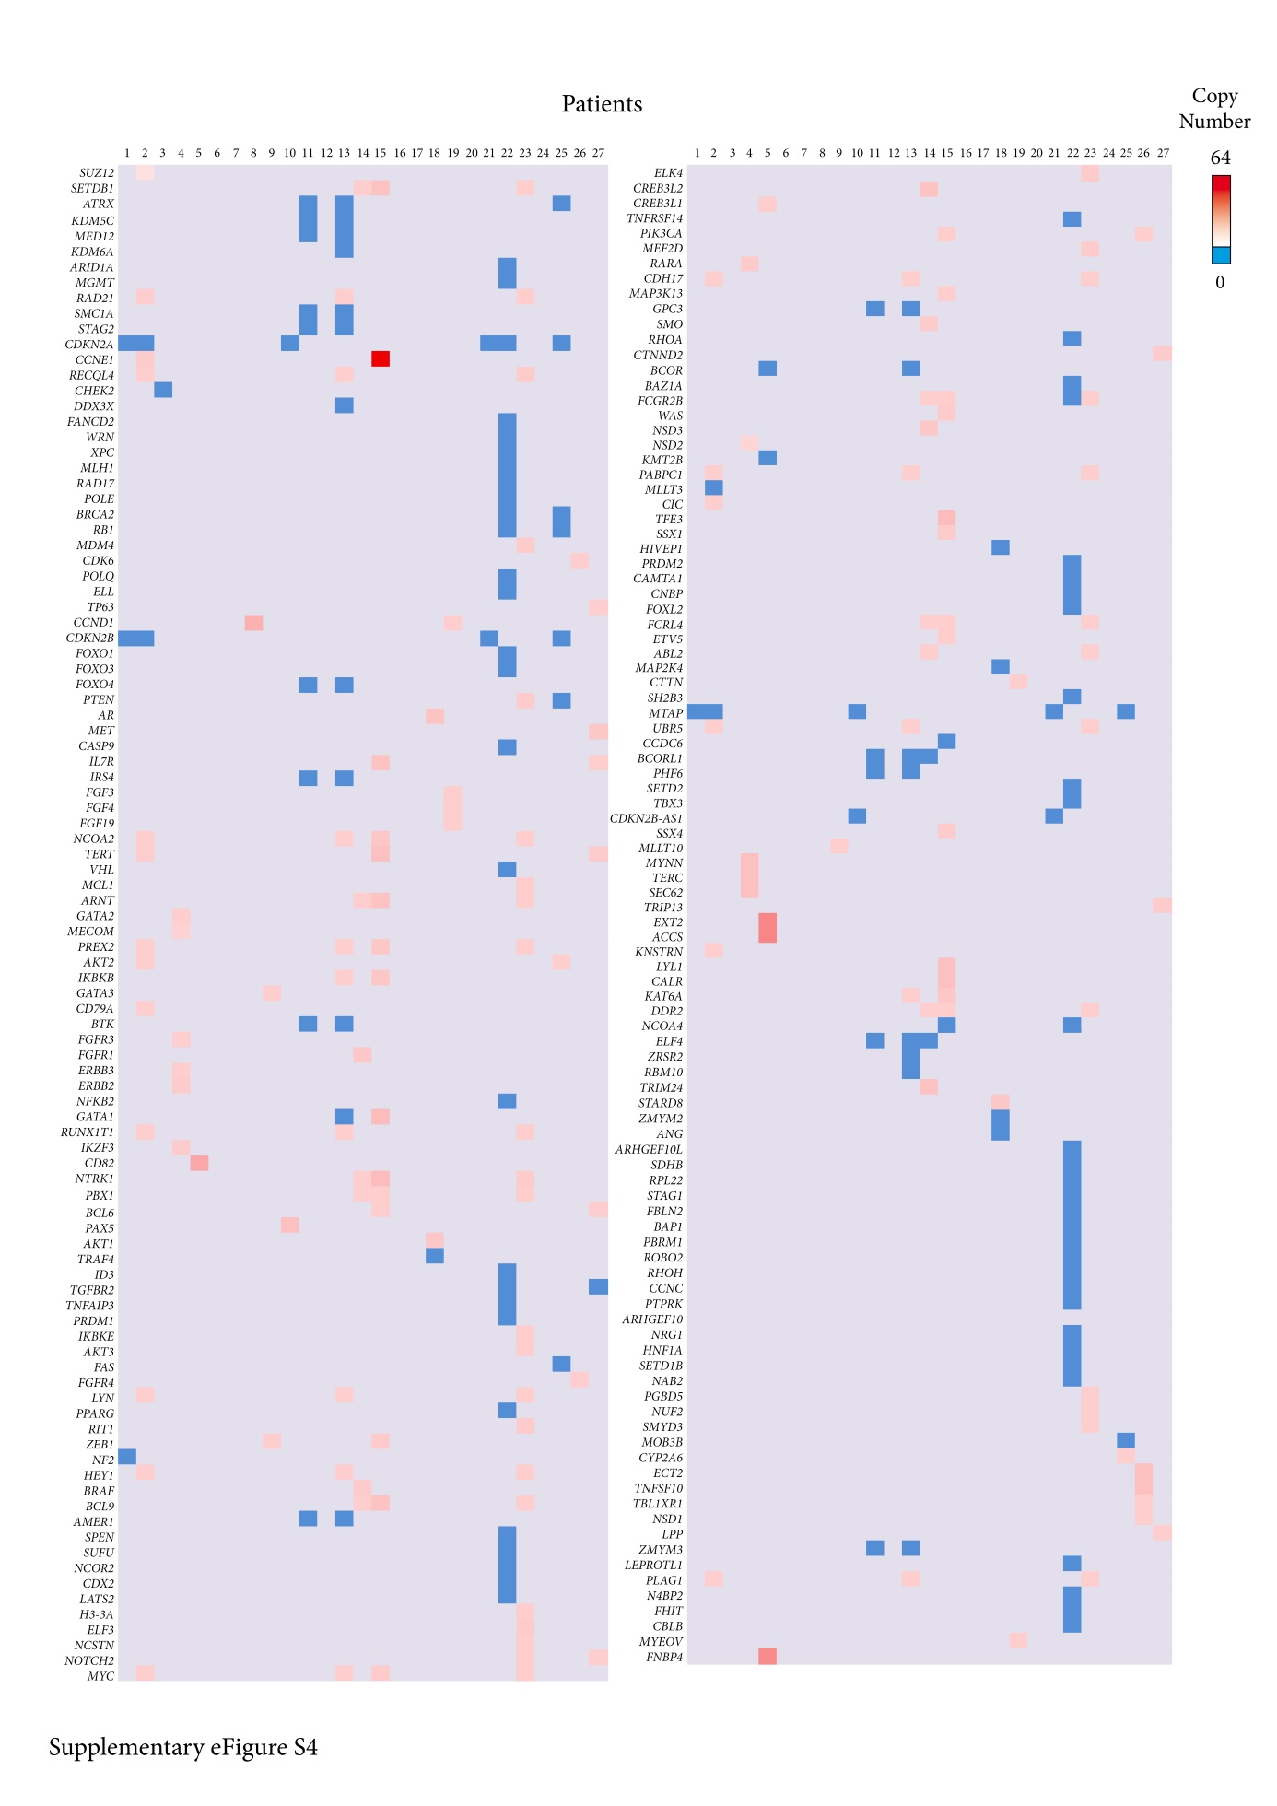

Supplementary Figure S5: Transcriptomic analysis for the 18 patients (66% of total patients) included in the study for whom RNA quantity and quality were sufficient. The whole SeqOIA cohort served as a reference for gene expression level. We particularly focused on immune and repair deficit signatures. Nine patients have an overall overexpression of immune markers, including three patients whose biopsy is a metastatic lymph node (P9, P17, P27), and one patient (P12) with a metastatic hemangioendothelioma and a class E immune-high signature. Ten patients have low expression of multiple repair deficit markers, with HRD status identified in five patients (P2, P3, P8, P10, P26). HER2 mRNA expression exceeded the 80th percentile in nine patients, while HER2 gene amplification and protein overexpression was observed in only one patient (P4). MET mRNA expression was above the 90th percentile in two patients (P10 and P27). Finally, there is an activation of the PIK3-AKT-mTOR pathway in 8 patients (P1, P3, P4, P6, P7, P12, P16, and P27), including one patient with a PIK3CA mutation (P6); TMB: tumor mutational burden; MSI: microsatellite stability status; HRD: homologous recombination deficiency; NK: Natural killer; P: patient.
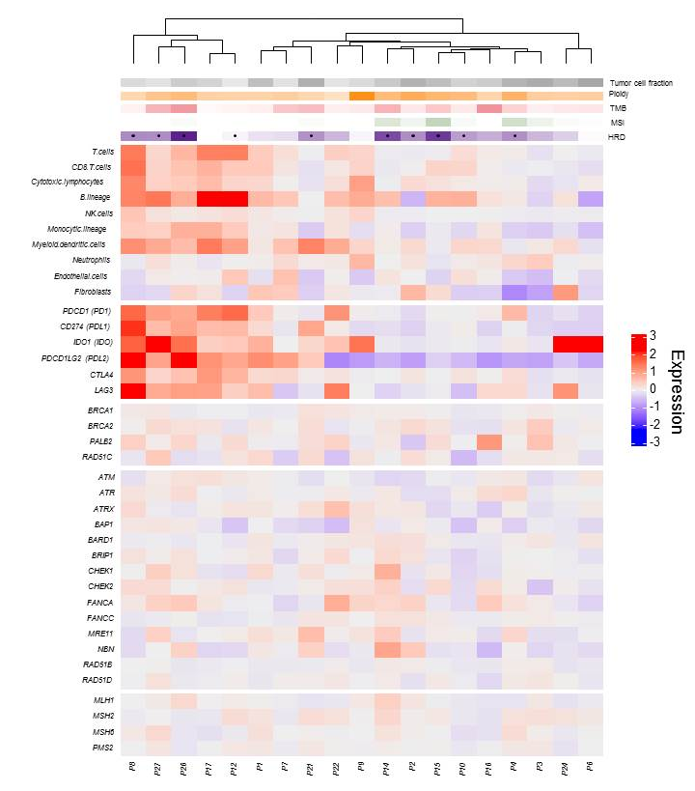

Supplementary Figure S6: Tumor response assessment using PET-CT, ∆SULpeak, ∆MTV, and ∆TLG for 17 patients employing a cut-off of 30% from baseline for progression according to PERCIST criteria. With this cut-off, 68% of patients have a controlled disease; PET-CT: Positron Emission Tomography – Computed Tomography; SULpeak: Standardized Uptake Value Corrected for Lean Body Mass; MTV: Metabolic Tumoral Volume; TLG: Total Lesion Glycolysis; P: Patient; M: Month.

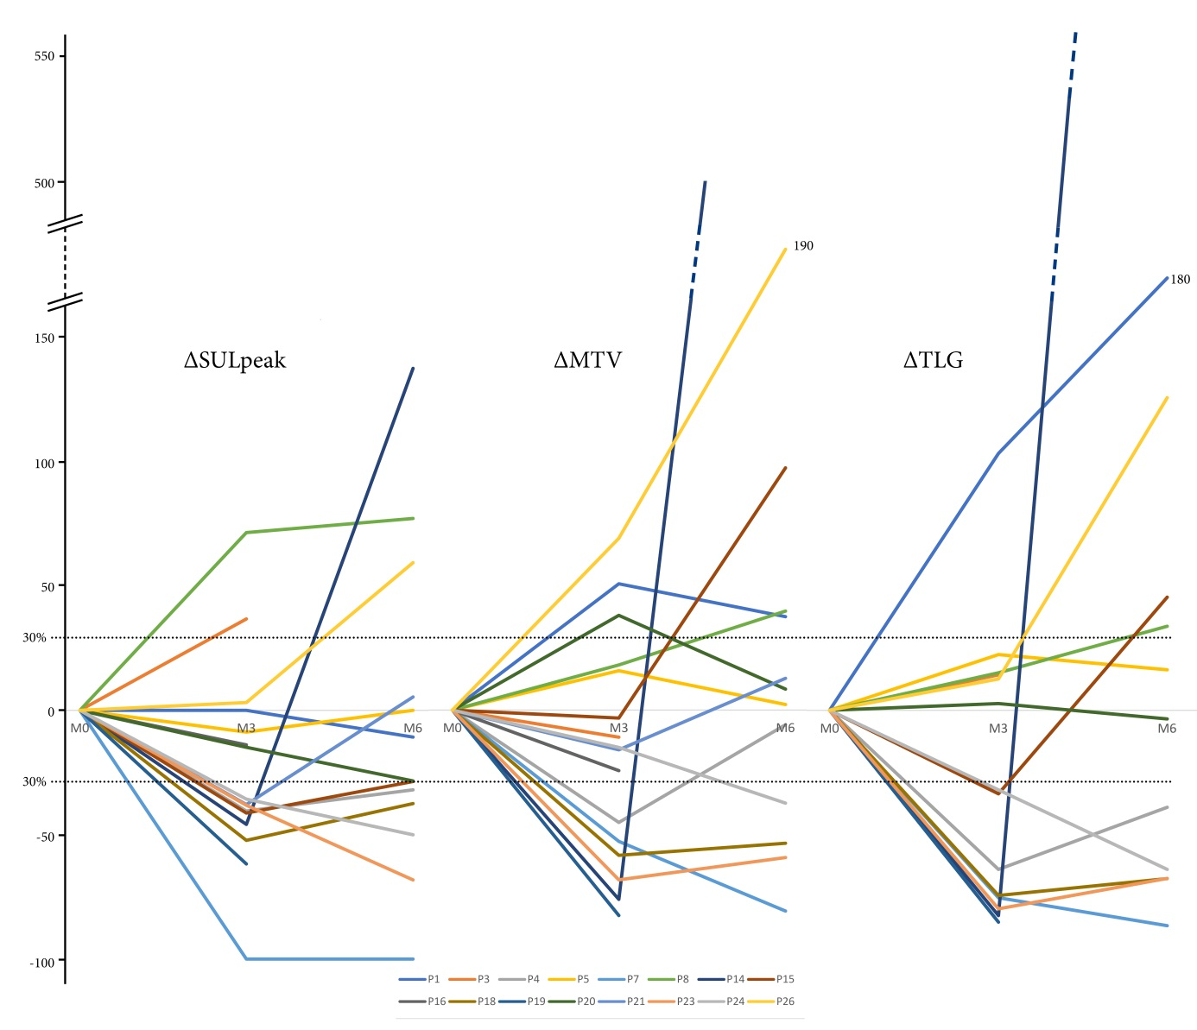

Supplementary Figure S7: P18 treatment history and genomic analysis. She has an amplification of androgen receptor (10 copies) and three other genomic alterations: a pathogenic variant of AKT1 c.49G>A p.(Glu17Lys) with AKT1 amplification (9 copies) leading to PIK3CA/mTOR pathway activation, and a bi-allelic deletion of MAP2K4 in favor of a sensitivity to MEK inhibitors (upper panel). Middel panel shows a strong nuclear immunostaining of androgen receptor in the breast cancer sample of the patient. With an anti-androgen therapy followed by a combination of trametinib (a MEK inhibitor) and everolimus (an mTOR inhibitor), she had a disease control of 15.5 months, the second line being interrupted for severe toxicity (lower panel).
AR: anti-androgen; PET: Positron Emission Tomography; PR: Partial Response; LOH: Loss Of Heterozygosity; Jul: July; Aug: August.
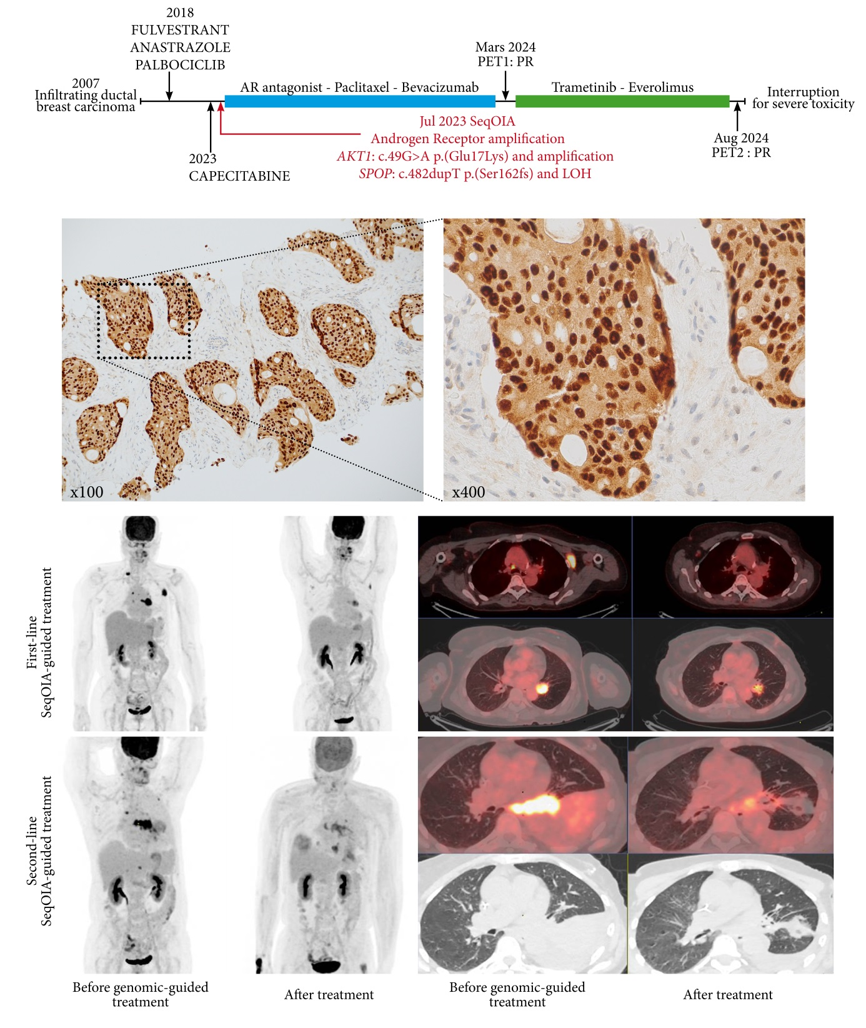

Supplementary methods
Patients’ selection
Patients included in this part of the PFMG25 program have either a rare cancer in terms of incidence (sarcoma, germ-cell tumors, rare histological sub-types or anatomic localizations) or an advanced cancer progressive after several therapeutic lines. From October 2020 to May 2024, a total of 1,049 patients have been included in the PFMG25 program in these indications, including 73 patients treated at Avicenne hospital (Assistance-Publique Hôpitaux de Paris) between January 2021 and May 2024.
All patients had cancer genetic counseling and signed a written informed consent for genomic analyses, and the program is currently validated by a national ethic committee. For each patient, a blood sample and a recent frozen tumor biopsy, ideally from a metastatic localization, are required. Tumor samples should have more than 30% tumor cells. Blood samples are directly addressed to the SEQOIA laboratory and DNA is automatically extracted on a QiASymphony. Tumor sections are prepared on a cryostat and centrally extracted using QIAamp DNA and RNA kits, quantified by fluorometry (SPARK® (TECAN®)), qualified by Fragment Analyzer®, Agilent® and included in the sequencing process at the SEQOIA laboratory, according to quantity and quality.
In optimal conditions, each patient benefit from integrative multiomics analysis with germline (WGS-G) and tumor (WGS-T) whole-genome sequencing, tumor whole-exome (WES-T) and RNAseq (WTS) sequencing. If tumor material is of insufficient quality, patients benefit, at least , from exome analysis : germline (WES-C) and tumor (WES-T) whole-exome with or without WTS.

Genomic analyses
Genome and exome sequencing
Different DNA sequencing strategies were used before and after 2024.
Before 2024, whole-genome sequencing (germline and somatic) was performed after fragmentation by sonication (LE220plus®, Covaris) and size selection and subsequent purifications on magnetic beads (Sera-Mag magnetic beads®, GE Healthcare®).
For genome sequencing, libraries were prepared without amplification (NEBNext® Ultra II End repair/A-tailing module & Ligation module, New England Biolabs®).
For exome sequencing, the prepared libraries pre-capture (NEBNext® Ultra II End repair/A-tailing module & Ligation module, New England Biolabs®) were amplified by PCR (KAPA Hifi HotStart ReadyMix, Roche®). The exome was captured by single-plex hybridization (Twist Human Core Exome Kit + IntegraGen Custom v1, Twist BioScience®) and the captured regions were amplified by PCR (KAPA Hifi HotStart ReadyMix, Roche®).
The libraries were qualified by capillary migration (Fragment Analyzer®, Agilent®) and quantified by qPCR (NEBNext® Custom 2X Library Quant Kit Master Mix, New England Biolabs® ; QuantStudio 6 Flex Real-Time PCR System®, Life Technologies®). Then, they were sequenced in paired-end (2 x 150 cycles) using SBS technology (Flow Cell S4, NovaSeq 6000®, Illumina®).
After 2024, process was modified without mechanical fragmentation.
For genome sequencing, libraries were prepared without amplification using the Illumina DNA PCR-Free Library Prep, Tagmentation (Illumina®), qualified and normalized after pre-sequencing in paired-end (2x50 cycles), using SBS technology (Flowcell SP, NovaSeq 6000®, Illumina®). Final sequencing was performed in paired-end (2 x 150 cycles) using SBS technology (Flow Cell S4, NovaSeq 6000®, Illumina®).
For exome sequencing, libraries were prepared with Library Preparation EF 2.0 with Enzymatic Fragmentation and Twist Universal Adapter System according to the Twist Target Enrichment Standard Hybridization v2 Protocol (Twist Bioscience®). The obtained libraries were quantified and qualified by Qubit Kit dsDNA HS (Thermo®) and Fragment Analyzer (Agilent®) and subsequently sequenced in paired-end (2 x 100 cycles) using SBS technology (Flow Cell S1/S2, NovaSeq 6000®, Illumina®).
RNA sequencing
Tumor RNAseq was performed when sufficient quantity and adequate quality of RNA, qualified by Fragment Analyzer® (Agilent®), was obtained after tumor extraction.
Before 2024, oriented complementary DNA libraries were generated by reverse transcription of messenger RNA after poly(A) capture (NEBNext® Poly(A) mRNA Magnetic Isolation Modules, NEBNext® Ultra II RNA First Strand Synthesis Module & Directional RNA Second Strand Module, New England Biolabs®). Size selection and subsequent purification steps were carried out on magnetic beads (Sera-Mag magnetic beads®, GE Healthcare®). Libraries preparations (NEBNext® Ultra II End repair/A-tailing module & Ligation module, New England Biolabs®) were amplified by PCR (KAPA Hifi HotStart ReadyMix, Roche®). The final libraries were qualified by capillary migration (Fragment Analyzer®, Agilent®) and quantified by qPCR (NEBNext® Custom 2X Library Quant Kit Master Mix, New England Biolabs® ; QuantStudio 6 Flex Real-Time PCR System®, Life Technologies®). The libraries were sequenced in paired-end (2 x 100 cycles) using SBS technology (Flow Cell S2, NovaSeq 6000®, Illumina®).
After 2024, libraries were prepared according to the Illumina® Stranded mRNA Prep kit (Illumina®), quantified and qualified by Qubit Kit dsDNA High Sensitivity (Thermo®) and Fragment Analyzer (Agilent®) and sequenced in paired-end (2 x 100 cycles) using SBS technology (Flow Cell S1/S2, NovaSeq 6000®, Illumina®).

Bioinformatic analysis
Dedicated pipelines are applied to the raw sequencing data : Pipeline_bcl2bam_wgs v2.2.1 and pipeline_cancer_WGS v4.1.0 with regular upgrading
During the demultiplexing step, the raw sequencing files (.BCL) of WGS-G, WES-G, WES-T, WGS-T and WTS, if available, are converted to FASTQ format. Alignment: bwa-mem2 (v2.2.1) ; STAR (star 2.7.2d), (GRCh38.92.fa (GRCh38, release-92, Jul 02 2018, ftp.ensembl.org ).
After this step, the cancer pipeline is applied to the different sequencing data (WGS-WES-WTS) from the same patient. Base quality scores are recalibrated based on the alignment files (BaseRecalibrator, GATK4 (v4.1.0.0)). Variants (SNPs and Indels) are called on WGS-C, WES-C and WTS-T using Haplotype Caller (GATK4, v4.1.0.0) and on the WES-T by Mutect2 (GATK4, v4.1.2.0). Variants are annotated using SNPeff(4.3t) and SnpSift(4.3t); the databases queried are as follows: SNPEff (v4.3t), 1000Genomes (phase3, v2013-05-02), gnomAD exomes (v2.1. 1), gnomAD genomes (v3), ClinVar (v20240107), COSMIC (coding, v89), COSMIC (non-coding, v89), dbscSNV (v1.1), dbSNP (v20180418), dbNSFP (v4.0), phastCons (v08-May-2015). Somatic variants are used to calculate mutational load (pyTMB (v1.3.0)) and extract mutational signatures (COSMIC (v3) databases integrated with SigProfiler (v1.0.9)).
WGS-C and WGS-T or WES-C and WES-T alignment files are used to assess microsatellite instability (MSIsensor2 (v20191121)).
CNVs are detected by Facet (v0.5.14) and WisecondorX (v1.1.5), then annotated by AnnotSV (v3.0.7) and databases: Cytoband (December 2013, UCSC), COSMIC (v90).
The HRD score is calculated using scarHRD_0.1.1.
Fusions on WTS are called independently by Arriba (v1.2.0), STAR-Fusion (v1.9.0) and FusionCatcher (v1.10); and subsequently validated by FusionInspector (STAR-Fusion v1.9.0)
WTS count tables are generated by Star (v2.7.2d) and Salmon (v1.4.0) and analysed by TransCUPtomics (2.0.1).
The SeqOIA laboratory implemented method validation based on the French National Institute of cancer recommendations (March 2016), the NGS-DIAG network network (NGSDiag_002_V1, NGSDiag_003_V1, NGSDiag_004_V1), as well as the literature¹.

Data interpretation
Pathogenic and probably pathogenic variants (class 5 and 4), and variants of uncertain significance (class 3), but predicted driver by classification tools as CGI, were reported. Other variants of uncertain significance were not reported.
Reported variants met internal quality criteria, but were not confirmed either by a complementary method or on a second sample, except if specifically requested.
Known limitation of the analysis is that short-read genome sequencing remains a screening test. Analytical sensitivity varies according to the type of molecular alteration and may vary locally according to the content or complexity of the genomic regions. Absence of detection of alterations cannot be considered as a definitive negative result.
For each patient, results are discussed in a dedicated molecular tumor board for therapeutic proposition.

Radiological assessment of treatment response
All the patients who received a personalized treatment guided by SeqOIA analyses had ¹⁸flurorodeoxyglucose positron emission tomography - computed tomography (¹⁸FDG PET-CT) or plain computed tomography before treatment initiation, and after 3 and 6 months of treatment.
For each patient, when available, the PET-CTs were reviewed by two nuclear medicine physicians (MS, EA) to produce specific response parameters, including ∆SUL_{peak}, ∆MTV, and ∆TLG. The two first parameters were obtained automatically using dedicated software. SUL_{peak} was defined as a measurement of mean SUL performed in a 1 cc voxel of interest centered on the hottest spot of the tumor target, SUL being the standardized uptake value normalized by lean body mass. MTV (metabolic tumor volume) was calculated as the volume of each metastatic localization using a SUL cut-off ≥ 2.5. TLG or total lesion glycolysis was calculated as a product of SUL_{peak} x MTV for each localization. For each patient, a comparison between M3 (month 3) and M0, and then M6 and M0 was calculated for each parameter.
The clinical benefit was defined as the physician-assessed complete response, partial response or stable disease according to the RECIST or PERCIST criteria, depending on the imaging method used ^{2,3}. For each patient within our cohort, the growth modulation index (GMI) was calculated as the ratio of the time to progression between the n^{th} line (TTP(n)) of treatment (the SeqOIA lines) to the TTP(n ‒1) corresponding to the treatment n ‒1th line before SeqOIA treatment. A GMI ≥ 1.33 is considered as a sign of activity in phase II trials ^{4,5}.
Immunostainings
In order to confirm the presence of specific gene alterations at the protein level, we performed a series of complementary immunostainings using the formaldehyde-fixed and paraffin-embedded parts of the same biopsy samples that had previously been used for genomic analyses. All tissue sections were performed with an HM-340 automatic microtome (Microm) at 4 µm and stained either with PI3KCA (clone SP139, 1/100, Zytomeb Systems), or TFE3 (clone EP285, 1/100, BioSB) as primary antibodies. An indirect immunoperoxidase method was used, with controls having no primary antibody or an irrelevant primary antibody of the same isotype. The number of stained cancer cells was counted on five different fields at ×400 magnification, on a Provis-aX-70 microscope (Olympus, Tokyo). Results were expressed as mean ± standard error of the mean (SEM).
The nuclear staining of TFE3 was considered positive. For PI3KCA staining, a membranous and cytoplasmic distribution was considered positive. For each field, a minimum of 100 tumor cells were analyzed. The percentage of PI3KCA -expressing cells was the number of positive cells among these 100 tumor cells. Each sample was given a score by multiplying the stain intensity grade (0 = no staining, 1 = low intensity, 2 = medium intensity, 3 = strong intensity) by the numerical code for the percentage of positive cells (0 = 0%, 1 = under 10%, 2 = 10–50%, 3 = 51–80%, 4 = over 81%). The maximum score was 12 points when more than 81% of the cells expressed PI3KCA with a strong intensity signal.

References

1. Jennings LJ, Arcila ME, Corless C, et al. Guidelines for Validation of Next-Generation Sequencing-Based Oncology Panels: A Joint Consensus Recommendation of the Association for Molecular Pathology and College of American Pathologists. J Mol Diagn 2017;19(3):341-365. DOI: 10.1016/j.jmoldx.2017.01.011.
2. Chalian H, Tore HG, Horowitz JM, Salem R, Miller FH, Yaghmai V. Radiologic assessment of response to therapy: comparison of RECIST Versions 1.1 and 1.0. Radiographics 2011;31(7):2093-105. DOI: 10.1148/rg.317115050.
3. Wahl RL, Jacene H, Kasamon Y, Lodge MA. From RECIST to PERCIST: Evolving Considerations for PET response criteria in solid tumors. J Nucl Med 2009;50 Suppl 1(Suppl 1):122S-50S. DOI: 10.2967/jnumed.108.057307.
4. Penel N, Demetri GD, Blay JY, et al. Growth modulation index as metric of clinical benefit assessment among advanced soft tissue sarcoma patients receiving trabectedin as a salvage therapy. Ann Oncol 2013;24(2):537-542. DOI: 10.1093/annonc/mds470.
5. Wu J, Chen L, Wei J, Weiss H, Miller RW, Villano JL. Phase II trial design with growth modulation index as the primary endpoint. Pharm Stat 2019;18(2):212-222. DOI: 10.1002/pst.1916.

