Online Resource 1
Table 1 Additive models of maximal CRF parameters (V̇O_{2peak} and WR_{peak}) for females (n = 323)ª and males (n = 309)ª in the different age groups.
Age | Body height |  | Body mass | Percentiles
 |  | (cm) | (kg) | 3 | 10 | 25 | 50 | 75 | 90 | 97
V̇O_{2peak} (L/min)

Females
55 |  | 169 | 74.4 | 2.20 | 2.17 | 2.15 | 2.12 | 2.09 | 2.06 | 2.04
60 |  | 169 | 72.2 | 2.06 | 2.04 | 2.03 | 2.01 | 1.99 | 1.98 | 1.96
65 |  | 167 | 68.6 | 1.90 | 1.89 | 1.88 | 1.87 | 1.85 | 1.84 | 1.83
70 |  | 165 | 66.6 | 1.79 | 1.77 | 1.75 | 1.73 | 1.71 | 1.69 | 1.67
75 |  | 165 | 66.6 | 1.72 | 1.69 | 1.66 | 1.63 | 1.60 | 1.57 | 1.54
Males
55 |  | 182 | 88.6 | 3.59 | 3.50 | 3.41 | 3.31 | 3.21 | 3.12 | 3.03
60 |  | 183 | 86.2 | 3.02 | 2.98 | 2.95 | 2.91 | 2.87 | 2.83 | 2.80
65 |  | 180 | 84.5 | 2.69 | 2.66 | 2.63 | 2.60 | 2.56 | 2.53 | 2.50
70 |  | 180 | 83.2 | 2.55 | 2.51 | 2.48 | 2.45 | 2.41 | 2.38 | 2.35
75 |  | 180 | 83.2 | 2.22 | 2.15 | 2.07 | 1.98 | 1.90 | 1.82 | 1.74
WR_{peak} (W)
Females
55 |  | 169 | 74.4 | 193 | 191 | 189 | 187 | 185 | 183 | 181
60 |  | 169 | 72.2 | 181 | 180 | 178 | 177 | 176 | 174 | 173
65 |  | 167 | 68.6 | 166 | 165 | 164 | 163 | 162 | 161 | 160
70 |  | 165 | 66.6 | 154 | 152 | 151 | 149 | 148 | 146 | 145
75 |  | 165 | 66.6 | 146 | 143 | 141 | 139 | 136 | 134 | 132
Males
55 |  | 182 | 88.6 | 305 | 301 | 298 | 293 | 289 | 286 | 282
60 |  | 183 | 86.2 | 268 | 266 | 265 | 263 | 261 | 259 | 258
65 |  | 180 | 84.5 | 238 | 236 | 235 | 233 | 231 | 230 | 229
70 |  | 180 | 83.2 | 220 | 219 | 217 | 216 | 214 | 212 | 211
75 |  | 180 | 83.2 | 209 | 205 | 202 | 198 | 195 | 191 | 188
Abbreviations: CRF, cardiorespiratory fitness; V̇O_{2peak}, oxygen uptake at peak exercise; WR_{peak}, work rate at peak exercise.
ª n = 632 for V̇O_{2peak} and WR_{peak}, as 29 participants did not perform a maximal cardiorespiratory effort.

a
ª for V̇O_{2peak}, WR_{peak}, and V̇O_{2VAT}/V̇O_{2peak}, n = 632 because 29 participants did not perform a maximal cardiorespiratory effort.

Table 2 Additive models of submaximal CRF parameters (V̇O_{2VAT} and OUES) for females (n = 336) and males (n = 325) in the different age groups.
Age | Body height |  | Body mass | Percentiles
 |  | (cm) | (kg) | 3 | 10 | 25 | 50 | 75 | 90 | 97
V̇O_{2VAT} (L/min)

Females
55 |  | 169 | 74.4 | 1.28 | 1.25 | 1.21 | 1.17 | 1.13 | 1.09 | 1.06
60 |  | 169 | 72.2 | 1.30 | 1.28 | 1.26 | 1.24 | 1.22 | 1.20 | 1.18
65 |  | 167 | 68.6 | 1.19 | 1.17 | 1.16 | 1.14 | 1.12 | 1.10 | 1.09
70 |  | 165 | 66.6 | 1.21 | 1.19 | 1.17 | 1.15 | 1.12 | 1.10 | 1.08
75 |  | 165 | 66.6 | 1.19 | 1.14 | 1.09 | 1.03 | 0.98 | 0.93 | 0.88
Males
55 |  | 182 | 88.6 | 1.89 | 1.82 | 1.75 | 1.67 | 1.60 | 1.53 | 1.46
60 |  | 183 | 86.2 | 1.55 | 1.52 | 1.50 | 1.47 | 1.44 | 1.41 | 1.38
65 |  | 180 | 84.5 | 1.56 | 1.53 | 1.51 | 1.49 | 1.46 | 1.44 | 1.42
70 |  | 180 | 83.2 | 1.43 | 1.41 | 1.39 | 1.36 | 1.33 | 1.31 | 1.28
75 |  | 180 | 83.2 | 1.43 | 1.37 | 1.31 | 1.25 | 1.18 | 1.12 | 1.06
OUES
Females
55 |  | 169 | 74.4 | 2.46 | 2.39 | 2.33 | 2.25 | 2.18 | 2.11 | 2.04
60 |  | 169 | 72.2 | 2.48 | 2.45 | 2.41 | 2.38 | 2.34 | 2.30 | 2.27
65 |  | 167 | 68.6 | 2.25 | 2.22 | 2.19 | 2.15 | 2.12 | 2.09 | 2.06
70 |  | 165 | 66.6 | 2.23 | 2.19 | 2.16 | 2.12 | 2.08 | 2.04 | 2.00
75 |  | 165 | 66.6 | 2.11 | 2.02 | 1.93 | 1.83 | 1.73 | 1.64 | 1.55
Males
55 |  | 182 | 88.6 | 3.58 | 3.54 | 3.51 | 3.46 | 3.42 | 3.38 | 3.34
60 |  | 183 | 86.2 | 3.37 | 3.34 | 3.32 | 3.29 | 3.27 | 3.24 | 3.22
65 |  | 180 | 84.5 | 3.10 | 3.09 | 3.07 | 3.05 | 3.03 | 3.02 | 3.00
70 |  | 180 | 83.2 | 2.94 | 2.92 | 2.89 | 2.87 | 2.84 | 2.82 | 2.80
75 |  | 180 | 83.2 | 2.80 | 2.77 | 2.73 | 2.70 | 2.66 | 2.62 | 2.59
Abbreviations: CRF, cardiorespiratory fitness; OUES, oxygen uptake efficiency slope; V̇O_{2VAT}, oxygen uptake at the ventilatory anaerobic threshold.

Table 3 Additive models of maximal CRF parameters (V̇O_{2peak} and WR_{peak}) corrected for lean body mass for females (n = 323)ª and males (n = 309)ª in the different age groups.
Age | Body height |  | Body mass | Percentiles
 |  | (cm) | (kg) | 3 | 10 | 25 | 50 | 75 | 90 | 97
V̇O_{2peak} (mL/kg lean body mass/min)
Females
55 |  | 169 | 74.4 | 50.1 | 49.7 | 49.2 | 48.7 | 48.2 | 47.7 | 47.3
60 |  | 169 | 72.2 | 47.5 | 47.2 | 46.9 | 46.6 | 46.3 | 46.0 | 45.7
65 |  | 167 | 68.6 | 45.4 | 45.2 | 45.0 | 44.7 | 44.5 | 44.2 | 44.0
70 |  | 165 | 66.6 | 43.7 | 43.3 | 43.0 | 42.6 | 42.3 | 41.9 | 41.6
75 |  | 165 | 66.6 | 41.9 | 41.4 | 40.9 | 40.3 | 39.8 | 39.2 | 38.7
Males
55 |  | 182 | 88.6 | 53.8 | 53.3 | 52.8 | 52.2 | 51.7 | 51.2 | 50.7
60 |  | 183 | 86.2 | 50.0 | 49.7 | 49.3 | 49.0 | 48.6 | 48.3 | 47.9
65 |  | 180 | 84.5 | 46.3 | 46.1 | 45.9 | 45.6 | 45.3 | 45.1 | 44.9
70 |  | 180 | 83.2 | 43.1 | 42.8 | 42.5 | 42.2 | 41.9 | 41.6 | 41.3
75 |  | 180 | 83.2 | 40.1 | 39.6 | 39.2 | 38.7 | 38.1 | 37.7 | 37.2
WR_{peak} (W/kg lean body mass)
Females
55 |  | 169 | 74.4 | 4.42 | 4.38 | 4.35 | 4.31 | 4.27 | 4.24 | 4.20
60 |  | 169 | 72.2 | 4.18 | 4.15 | 4.13 | 4.11 | 4.08 | 4.06 | 4.04
65 |  | 167 | 68.6 | 3.97 | 3.95 | 3.93 | 3.91 | 3.89 | 3.88 | 3.86
70 |  | 165 | 66.6 | 3.76 | 3.74 | 3.71 | 3.69 | 3.66 | 3.63 | 3.61
75 |  | 165 | 66.6 | 3.56 | 3.52 | 3.48 | 3.44 | 3.39 | 3.35 | 3.32
Males
55 |  | 182 | 88.6 | 4.80 | 4.75 | 4.70 | 4.65 | 4.59 | 4.54 | 4.49
60 |  | 183 | 86.2 | 4.40 | 4.38 | 4.35 | 4.32 | 4.29 | 4.27 | 4.24
65 |  | 180 | 84.5 | 4.04 | 4.02 | 4.00 | 3.97 | 3.95 | 3.93 | 3.91
70 |  | 180 | 83.2 | 3.76 | 3.74 | 3.71 | 3.69 | 3.66 | 3.64 | 3.61
75 |  | 180 | 83.2 | 3.53 | 3.48 | 3.44 | 3.39 | 3.34 | 3.29 | 3.25
Abbreviations: CRF, cardiorespiratory fitness; V̇O_{2peak}, oxygen uptake at peak exercise; WR_{peak}, work rate at peak exercise
ª n = 632 for V̇O_{2peak} and WR_{peak}, as 29 participants did not perform a maximal cardiorespiratory effort.

Table 4 Additive models of submaximal CRF parameters (V̇O_{2VAT} and OUES) corrected for lean body mass for females (n = 336) and males (n = 325) in the different age groups.
Age | Body height |  | Body mass | Percentiles
 |  | (cm) | (kg) | 3 | 10 | 25 | 50 | 75 | 90 | 97
V̇O_{2VAT} (mL/kg lean body mass/min)
Females
55 |  | 169 | 74.4 | 30.6 | 29.4 | 28.1 | 26.6 | 25.2 | 23.9 | 22.7
60 |  | 169 | 72.2 | 26.0 | 25.5 | 25.0 | 24.5 | 23.9 | 23.4 | 22.9
65 |  | 167 | 68.6 | 26.5 | 26.1 | 25.7 | 25.3 | 24.8 | 24.4 | 24.0
70 |  | 165 | 66.6 | 24.3 | 23.9 | 23.4 | 22.9 | 22.4 | 22.0 | 21.6
75 |  | 165 | 66.6 | 25.1 | 24.0 | 22.9 | 21.7 | 20.5 | 19.4 | 18.3
Males
55 |  | 182 | 88.6 | 29.1 | 28.4 | 27.7 | 26.9 | 26.2 | 25.5 | 24.8
60 |  | 183 | 86.2 | 29.7 | 29.4 | 29.0 | 28.6 | 28.2 | 27.9 | 27.5
65 |  | 180 | 84.5 | 28.4 | 28.1 | 27.8 | 27.4 | 27.1 | 26.7 | 26.4
70 |  | 180 | 83.2 | 29.6 | 29.2 | 28.8 | 28.4 | 28.0 | 27.6 | 27.2
75 |  | 180 | 83.2 | 28.3 | 27.4 | 26.5 | 25.4 | 24.4 | 23.4 | 22.5
OUES/kg lean body mass
Females
55 |  | 169 | 74.4 | 55.8 | 54.6 | 53.4 | 52.0 | 50.6 | 49.3 | 48.1
60 |  | 169 | 72.2 | 56.9 | 56.3 | 55.6 | 54.9 | 54.2 | 53.6 | 53.0
65 |  | 167 | 68.6 | 53.4 | 52.9 | 52.3 | 51.7 | 51.1 | 50.5 | 49.9
70 |  | 165 | 66.6 | 54.4 | 53.7 | 53.1 | 52.3 | 51.5 | 50.9 | 50.2
75 |  | 165 | 66.6 | 50.4 | 48.7 | 47.0 | 45.1 | 43.3 | 41.6 | 39.9
Males
55 |  | 182 | 88.6 | 58.1 | 57.4 | 56.7 | 56.0 | 55.2 | 54.5 | 53.8
60 |  | 183 | 86.2 | 55.1 | 54.7 | 54.3 | 53.8 | 53.3 | 52.8 | 52.4
65 |  | 180 | 84.5 | 52.3 | 52.0 | 51.7 | 51.3 | 51.0 | 50.7 | 50.4
70 |  | 180 | 83.2 | 50.2 | 49.8 | 49.4 | 48.9 | 48.5 | 48.1 | 47.7
75 |  | 180 | 83.2 | 48.4 | 47.8 | 47.1 | 46.4 | 45.7 | 45.1 | 44.5
Abbreviations: CRF, cardiorespiratory fitness; OUES, oxygen uptake efficiency slope; V̇O_{2VAT}, oxygen uptake at the ventilatory anaerobic threshold.

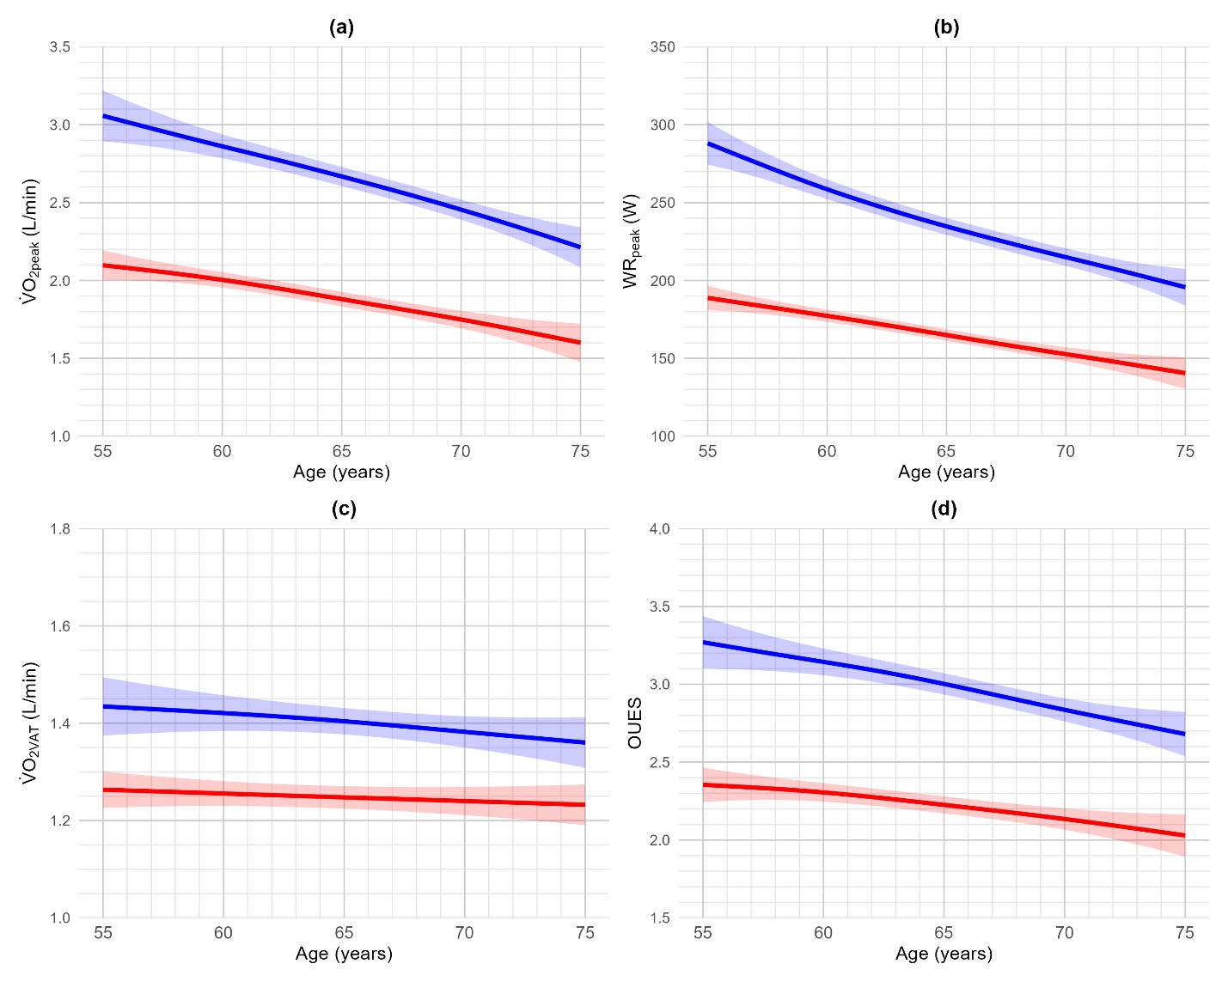
Figure 1. Cardiopulmonary exercise testing-derived, age-dependent transformation of a) oxygen uptake at peak exercise (V̇O_{2peak}), b) work rate at peak exercise (WR_{peak}), c) oxygen uptake at the ventilatory anaerobic threshold (V̇O_{2VAT}) and d) oxygen uptake efficiency slope (OUES) in females (red) and males (blue) using generalized additive models. Shading represents 95% confidence intervals.
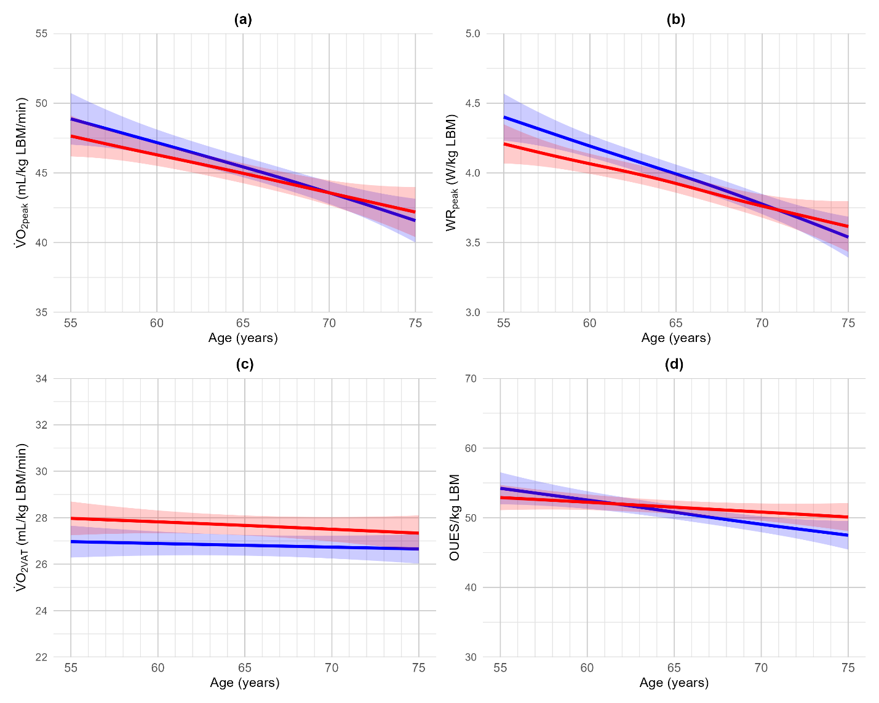
Figure 2. Cardiopulmonary exercise testing-derived, age-dependent transformation of a) oxygen uptake at peak exercise (V̇O_{2peak}), b) work rate at peak exercise (WR_{peak}), c) oxygen uptake at the ventilatory anaerobic threshold (V̇O_{2VAT}) and d) oxygen uptake efficiency slope (OUES) corrected for lean body mass in females (red) and males (blue) using generalized additive models. Shading represents 95% confidence intervals.

