Supplementary Materials
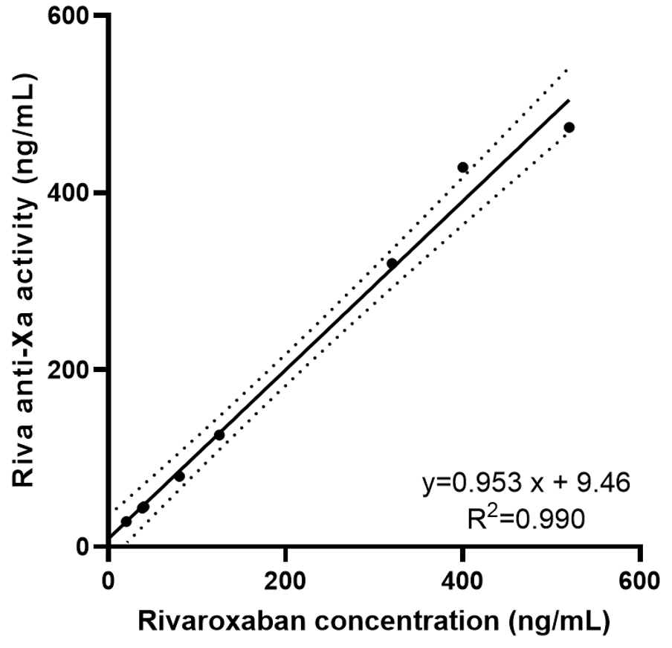
Figure S1. Correlation between the spiked rivaroxaban concentration in plasma samples and the measured rivaroxaban concentration using Riva anti-Xa assay. X-axis represents the expected rivaroxaban concentration. Y-axis represents the measured rivaroxaban concentration by Riva anti-Xa assay. The solid line represents the linear regression fit (y = 0.953x + 9.46, r² = 0.990, while the dashed lines indicate the 95% confidence interval.
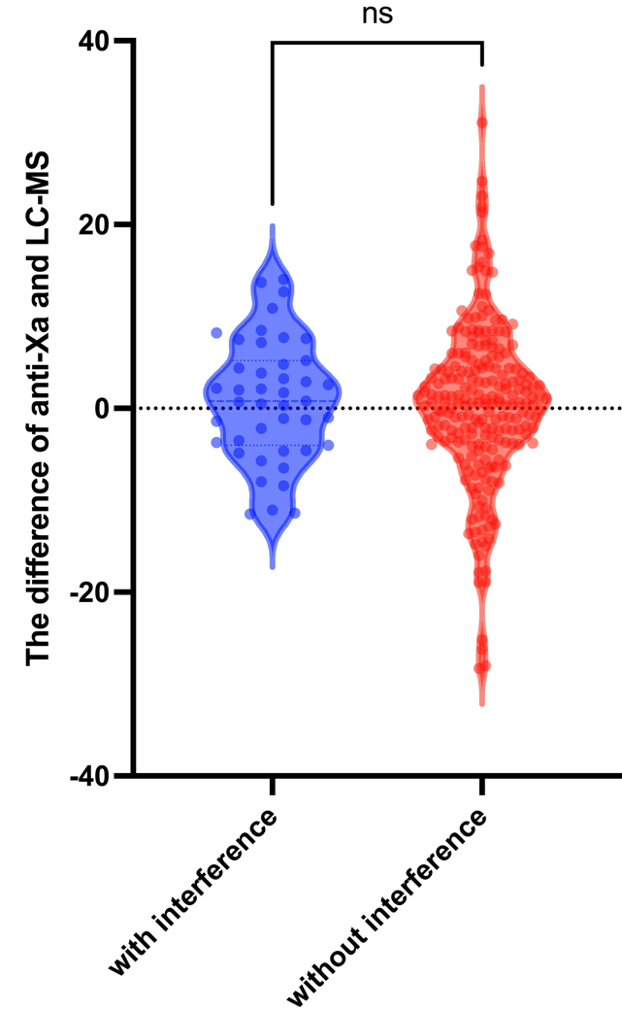
Figure S2. Violin plot illustrating the evaluation of interference resistance of Riva anti-Xa assay in clinical samples. X-axis represents groups with (blue) and without (red) potential interferents, while y-axis represents the difference between Riva anti-Xa assay and Riva LC-MS. Each dot corresponds to an individual measurement, and the violin plot displays the distribution density of data points. Statistical analysis was performed using the Mann-Whitney U test with no significant difference (ns) between the two groups (ns).

