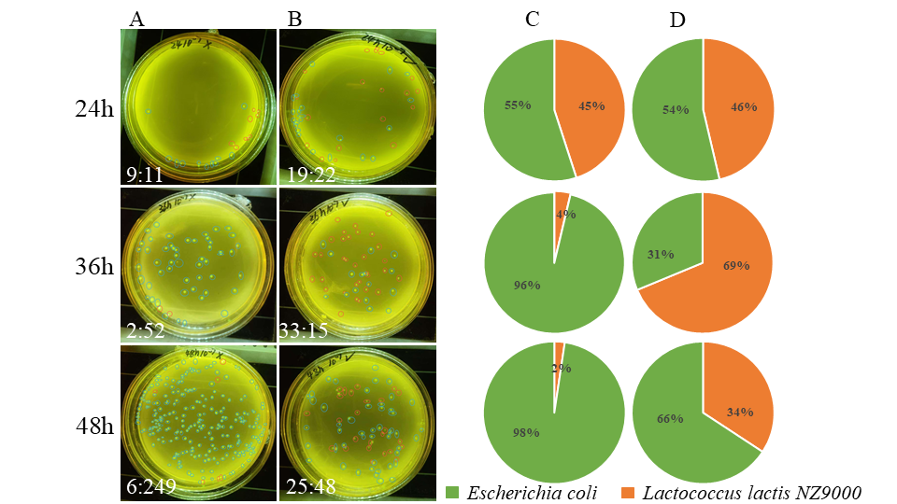
Supplementary Figure S1. Effect of xylan hydrolysis products (prebiotics) of Lc-Xyn81 on the co-culture of intestinal microbiota.
Note:Column A&C represents the control group, and column B&D represents the experimental group with added prebiotics. Blue circles indicate Escherichia coli, and red circles indicate Lactobacillus species. The bottom left corner of column A&B shows the ratio of E. coli to Lactobacillus (A:B = L. lactis NZ9000: Escherichia coli). Columns C&D are pie charts of the percentage proportions of the two strains.

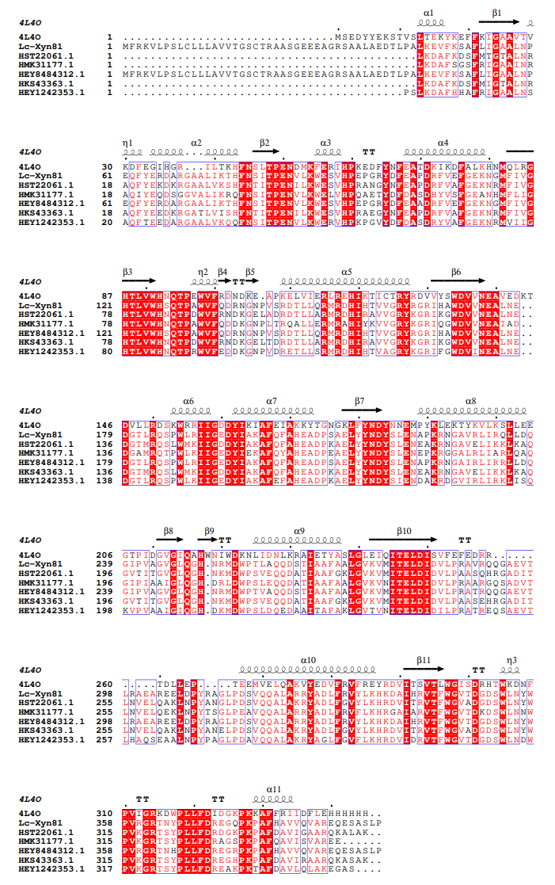
Supplementary Figure S2. Multiple sequence alignment
Supplementary Table S1 Molecular docking parameters of Lc-Xyn81 and xylooligosaccharides
xylooligosaccharides | Molecular docking parameters
X2 | center_x = 7.945  center_y = 0.0  center_z = 0.0  size_x = 32.25  size_y = 39.0  size_z = 45.75
X3 | center_x = 4.142  center_y = 0.0  center_z = 0.0  size_x = 35.25  size_y = 42.75  size_z = 44.25
X4 | center_x = 8.034  center_y = -1.61  center_z = 2.828  size_x = 27.0  size_y = 38.25  size_z = 36.75
X5 | center_x = 5.668  center_y = 0.0  center_z = 1.12  size_x = 40.0  size_y = 42.0  size_z = 54.0

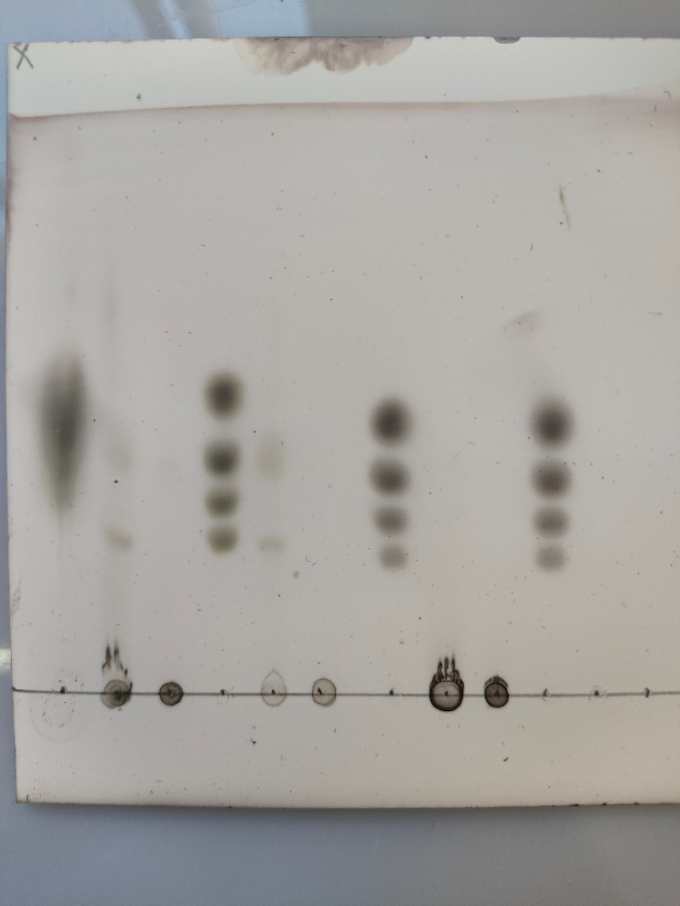
Blots or gels images
Original photo
Original photo
M:X1~X4.

1: Corncob xylan+LC-Xyn81

2: Corncob xylan+ LC-Xyn81( Inactivated enzyme)

3: Beechwood xylan +LC-Xyn81

4:Beechwood xylan + LC-Xyn81( Inactivated enzyme)

5: Bagasse xylan+LC-Xyn81

6:Bagasse xylan + LC-Xyn81( Inactivated enzyme)

Because the first standard sample did not perform well, the lanes 1, 2, 3 and 4 shared the second standard sample.
No oligosaccharide of xylose was detected in lane 5 and lane 6, so it was not included in the main text.

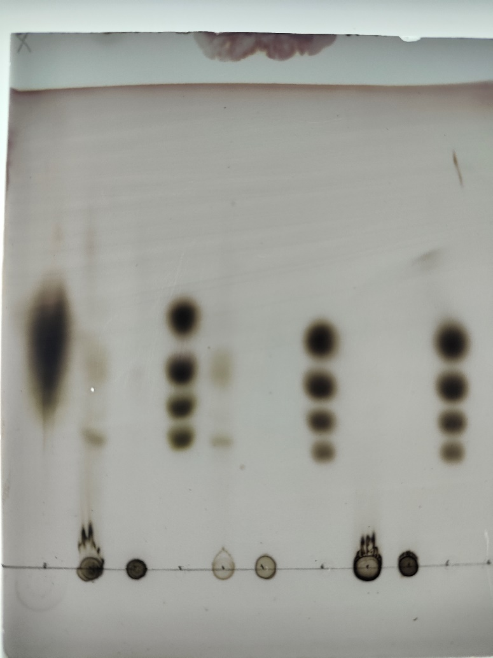
M
M
M
M
1
2
3
4
5
6

The above are TLC images without editing.
The following are TLC images with editing.

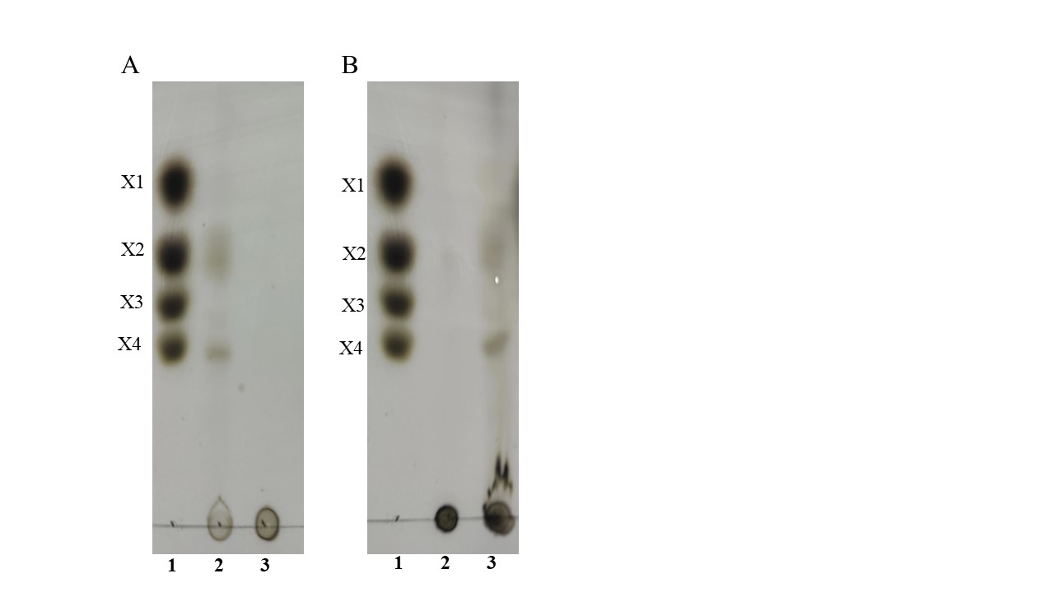

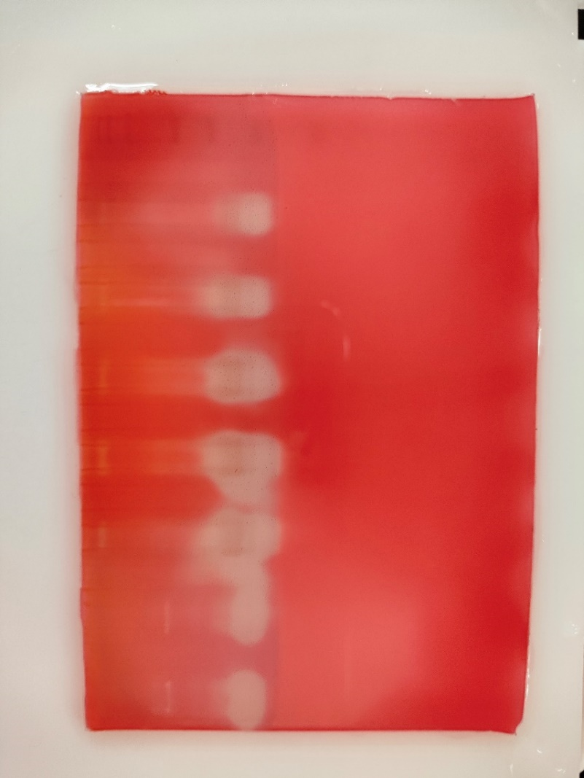
1
2
3
Other xylanases
5
4
1, 2, 3, 4 and 5 lanes all added LC-Xyn81, but the amount of xylanase added to each lane was different.

1：6 µl LC-Xyn81
2: 8 µl LC-Xyn81
3: 10 µl LC-Xyn81
4、5：15 µl LC-Xyn81

2
1

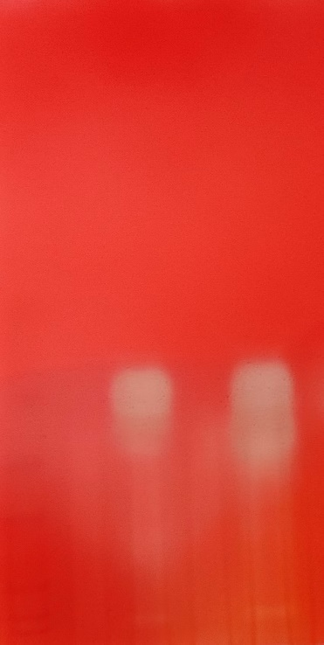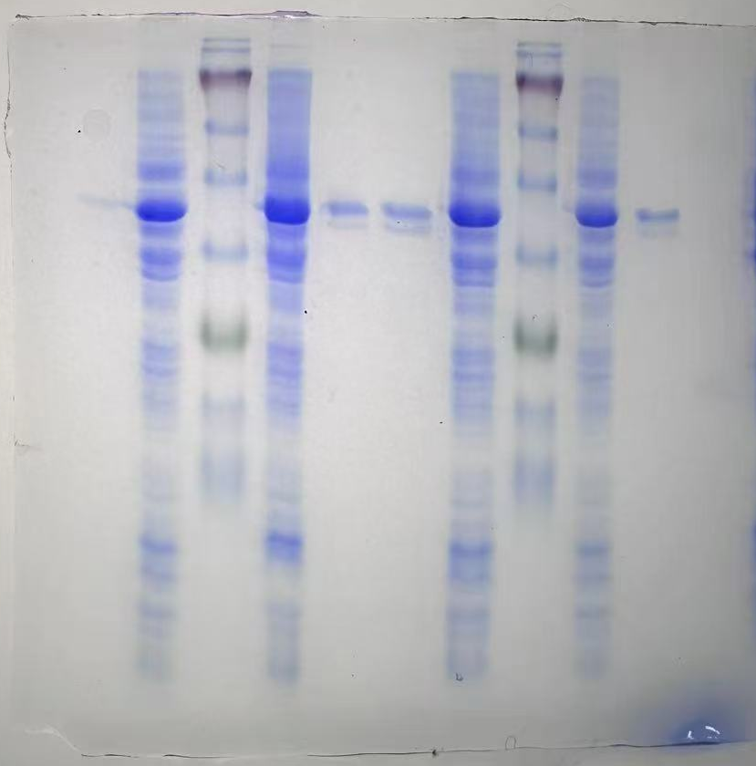

The above are zymogram and protein gel images without editing.
The following are zymogram and protein gel images with editing.

