Article Title: Identifying and Mapping Meaningful Cognitive Symptoms and Their Impacts in Huntington’s Disease.
Journal Name: Scientific Reports
Author Names: Cali M Roiboit¹; Jennifer R Mammen²; Jamie L Adams^{3,4}; Julie C Stout¹
Affiliations:
¹ Turner Institute for Brain and Mental Health, Monash University, Clayton, VIC, Australia.
² University of Massachusetts, Dartmouth, College of Nursing and Health Sciences, Dartmouth, MA, USA.
³ Center for Health + Technology, University of Rochester, Rochester, NY, USA.
⁴ Department of Neurology, University of Rochester, Rochester, NY, USA.
Corresponding Author: Julie C Stout (email: julie.stout@monash.edu)

Supplementary Materials
Appendix A
Figure 1A. Worked example of a symptom map which was created collaboratively with a participant.
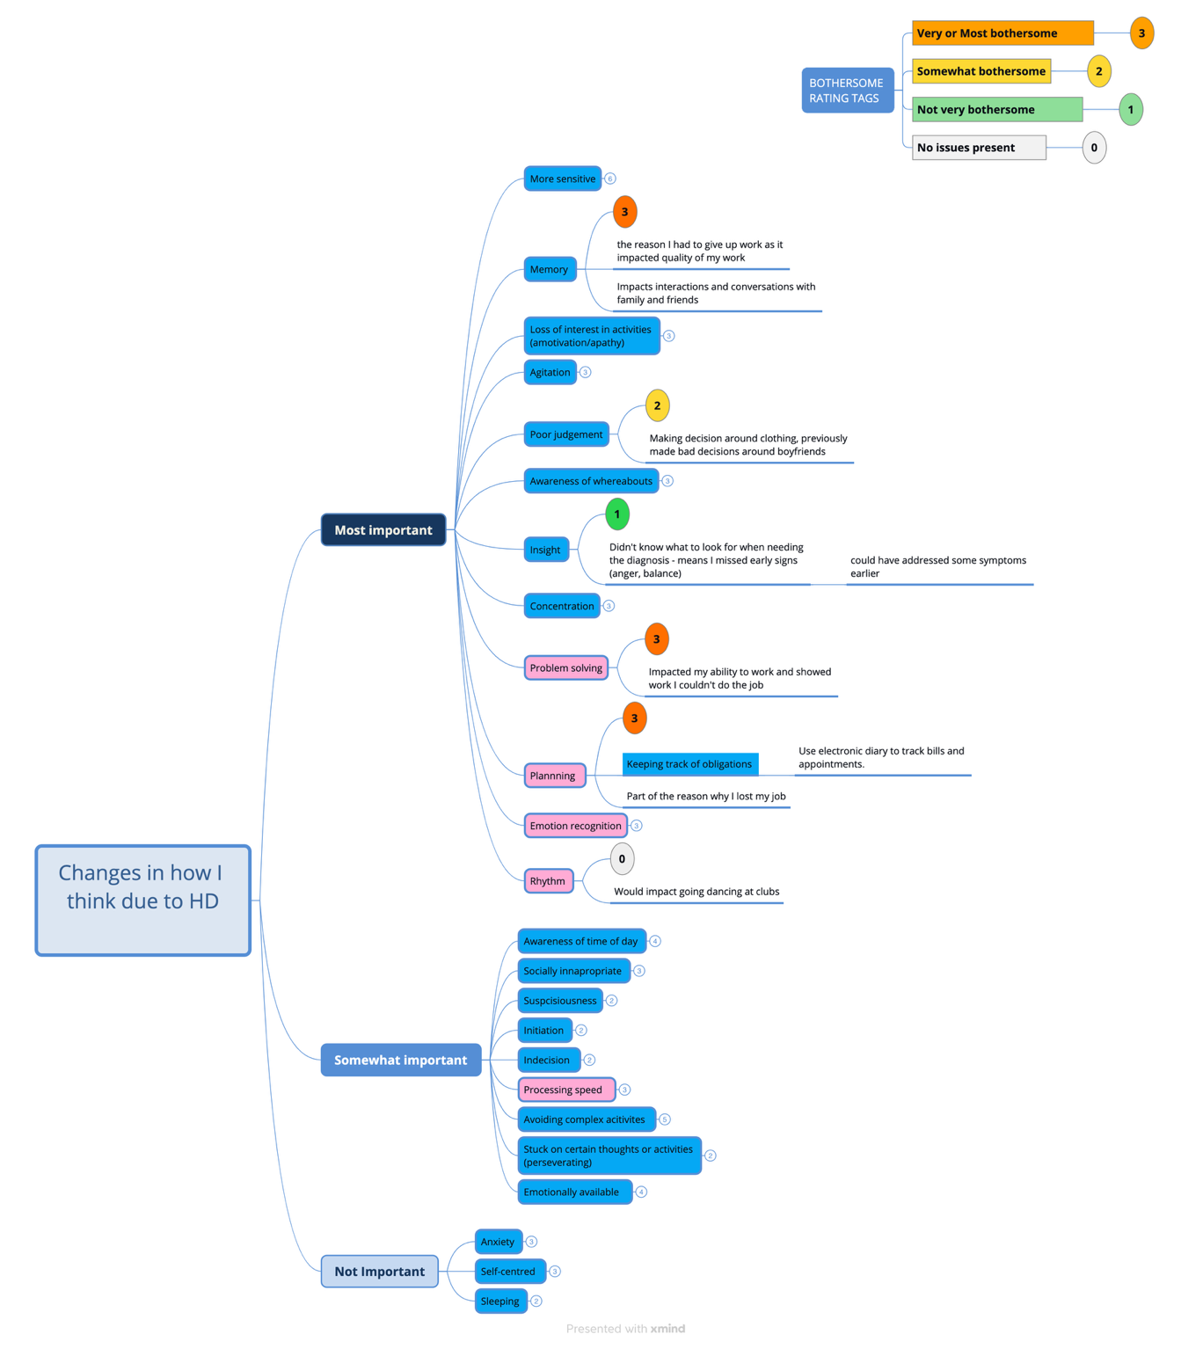
Note: Blue nodes represent symptoms identified by the participant on the UCSD HDBQ; pink nodes represent symptoms prompted by the researcher. In practice, symptoms were collapsed after discussions, however, some are left open here for demonstration. Symptom map was altered slightly to remove any potentially identifying information.
Appendix B
Table 1B. Supplementary quotes from the RTA.
Themes | Subthemes | Quotes
Changes in cognition affect everyday activities. | Changes in cognition affect my ability to work. | “Ok, yeah, so uh…if I can't communicate effectively and um, clearly with, um, others it does make it difficult because part of my volunteering work I drive for the, organization and we pick up various types of clients. To pick them up for, they might be going to their job, for a social appointment, for medical or whatever.” – H1 (communication)  “While I don't work anymore, I was one of the reasons I just stopped working as I was more impulsive and reacting to situations a lot quicker.” - H13 (impulsivity)  “At work, obviously cause I’m at work, I have difficulty concentrating, you know, sitting at my desk…I’m- looking at the screen.” - H11 (concentration)  “I think this has been getting harder in the past five years. But...yeah, but it’s a pretty...um, like it’s always been an open plan environment for me. Which has always been challenging.” - H4 (concentration)  “My brain sort of is working on it in the background. But yeah, I do find if I'm doing a task and I'm in it, and then the boss messages me or something and says “hey, can you do this?” It's like, I've literally got to get away from my desk. Make a cup of coffee pat the dog, do something. That's what I'm working at home, to switch.” - H17 (switching attention)  “Yeah, um, point of sale at the registers. You know, you’re dealing with customers all the time. You can see some oldies having a had time when they get started to get flustered...That sort of thing. So, you know, you might guess that’s the best example of how I deal with that every day.” - H5 (emotion recognition)  “Well, as a tax agent and accountant, we had to plan.” - H14 (planning)  “That was how I sort of knew the onset started, because all of a sudden I couldn't follow things as well as I used to.” - H13 (processing speed)
 | Changes in cognition affect my leisure activities. | “Focusing on reading or golf, or you know.” – H6 (concentration)  “I even gave audio books a go but now, I still have trouble remembering from day to day what happened the day before.” - H13 (memory)  “So, I used to come up with ideas to do, now I’m just finding it a bit, a bit harder.” - H3 (initiation)  “I played chess with my grandson. So that would be a bit of an issue.” – H8 (problem solving)  “Even the last couple of weekends there’s like a few gigs I was going to go to. I'm like, I don't ask people because I just don't know if I'm gonna have the energy on the day and I’m like, oh.” – H4 (fatigue)  “Used to… I think activities… we used to- years ago… I used to, we used to often walk to… just go for, for example, we used to go walk the tan. The tan, that- that's in the city. And we used to do that regularly. But I've lost interest.” - H15 (amotivation/apathy/losing interest)  “You know, when I do get in a sort of like, like the puzzle, and stuff like that, I can't sit still for a long time, but I am also taking longer to do the things I want to do.” – H9 (processing speed)  “So that's not an issue, but like it could affect like, how you can walk with the dog.” – H2 (psychomotor rhythm)  “You know, there’s planning to go ride a bike, plan to go to the football...” - H10 (planning)
 | Changes in cognition affect my driving. | “Again, I had to give up driving, that was the big one.” - H13 (shifting attention)  “I wouldn’t get lost all the time [laughs]. I’d stop doing U turns.” – H9 (understanding whereabouts/navigation)  “There’s not really much that stands out like this one changes. If I’m driving on the Monash freeway and there’s a car crash, just go [another way] [laughs]. Not really in the world…there’s like, ten ways to get everywhere.” - H16 (problem solving)  “So, when I'm driving, I'm fine. But I can't drive at night, because I get- I'm not- it's very unknown.” - H11 (memory)
 | Changes in cognition affect my domestic activities. | “Um…um…It means that like, oh I’ll go shopping and buy a lot of different stuff without necessarily, um… needing them.” - H14 (impulsivity)  “So, it can be order of things to do, if I’m trying to cook. It’s about remembering that sort of stuff.” - H6 (memory)  “Um…Obviously now that…activities at home, or work, I’m changing the hardest bit to- to make it easier for myself.” - H11 (avoiding complex activities)  “My mother, we just helped her renovate her house, which in itself was way too much for me. I was telling [wife], “I can't do this.” I've lost the interest and drive to do that sort of thing.” – H7 (amotivation/apathy/losing interest)  “And I, yeah, so indecisive…aslo when I go shopping, I find that I procrastinate over things, whether to buy them or not.” - H15 (decision making)  “I…uh…can do. Like, I used to build chairs [indicates to chairs being built]. I did all that.” - H12 (problem solving)
 | Changes in cognition affect my finances. | “Okay, one, although there's been, there's been an occasional surprise bill that has gone through the cracks [laughs].” – H4 (planning)  “Even, for me what would be a tax return or uh…so…I put them in the too hard basket.” - H14 (avoiding complex activities)  “Um it's got more to do with wanting things. Like, all look at stuff online and then I left open the wallet and buy stuff. Whereas before I was able to restrain a bit more.” - H5 (impulsivity)  “So, things like finances I've now had to give over to [wife] and stuff. Just to make sure I don't do a properly, pay anything, or pay the wrong thing or do anything like that.” - H13 (impulsivity/judgement)
 | Changes in cognition affect my ability to interact and socialise. | “So, I just- just trying to be planning or planned for conversations, plan for meetings.” – H6 (planning)  “I do think like, for example, five years ago, would have answered that question like that [snap]” - H7 (processing speed)  “So, if I'm focused on something and somebody talks to me from the outside, I don't hear it.” - H13 (shifting attention)  “It means...sometimes I forget what I’m doing with some friends, or.” - H3 (memory)  “Like if someone’s being like, “sorry about this, sorry about that, you know, it’s great to see you” I’m like, I don’t really pick it up great, as in like [unintelligible], like it doesn’t really come across like that. I’d say it’s been like that for like, 2 years.” - H16 (emotion recognition)  “I'll be talking to somebody, and… a word will just not- not be there.” - H17 (word finding difficulties)
Changes in cognition affect my wellbeing. |  | “Aw, I just hate it when people assume you’re drunk. Well, I don't drink alcohol for that reason. I don't take drugs for that- that reason. So. I don’t give them any reason to say, “oh well yeah ok, I am drunk”.” - H18 (stigma)  “No, it doesn't annoy me, but you sort of get frustrated a bit.” - H10 (switching attention)  “I think if I'm pressured I’d probably become frustrated, so if I was if I was pressured to give an answer quickly.” - H17 (processing speed)  “It’s annoying.” - H12 (concentration)  “Cause it just starts to annoy me, it’s just annoying. It just annoys me when that happens.” – H1 (memory)  “Mm-hmm. I just don’t want to face the day. It’s all going to be too hard.” - H7 (planning)  “Cause I think it will affect the quality of my life, if I can’t think clearly.” - H18 (processing speed)  “It could cause my depression and anxiety to get worse because I’m worried about forgetting things.” - H2 (memory)  “I wouldn't actually dance because I felt self-conscious.” – H9 (psychomotor rhythm)  “It’s probably, yeah, number one terrifying thing. I’ll wobble down the street ad you know, hobble all I like, but like losing my memory [grimace]. - H4 (memory)
Changes in cognition affect my relationships. | Changes in cognition have affected my relationship from my loved one’s perspective. | “Oh, cause [wife does everything], it’s [unintelligible].” - H12 (keeping track of commitments)  “And now, other people are doing it [social planning] ... But I'm very open with my friends with what I can and can’t do.” – H11 (planning)  “And I’d be more reliant on the assistance of, you know, my husband to help me out.” - H1 (problem solving)  “I think other people around you would probably go, well, hang on, you're not doing what you used to do, you're not helping solving- the problem that we're having.” – H8 (problem solving)  “You know, I don’t necessarily have the emotional strength for [wife] me to lean on all the time. Like I used to.” - H13 (emotion availability)  “...and then like you also worry about being a burden on other people.” - H2 (memory)  “But it's also like on I worry about how any of these things are going to affect my family.” - H17  “No, I probably bother, bother my family.” - H15 (memory)
 | Changes in cognition have affected my relationships from my perspective. | “When I came up here today, I thought, if that girl walked off, and doesn’t wait for me, I will not be able to find her again.” – H7 (awareness of whereabouts)  “I’m a lot more dependent on [wife] than I used to be.” - H13 (shifting attention)  “I think people were distancing themselves from me because they don't want to see the progression. And there's nothing- nothing anyone can do at the moment to help anyone…” – H9 (emotional lability)  “No- no one wants to decline their ability…yeah I want to live here independently, I don’t want have those sort of issues with where I have to rely on someone has to look after me.” - H18 (memory/brain freezes)
Note: This table does not include all quotes collected during data analyses.

