Supplementary Figure
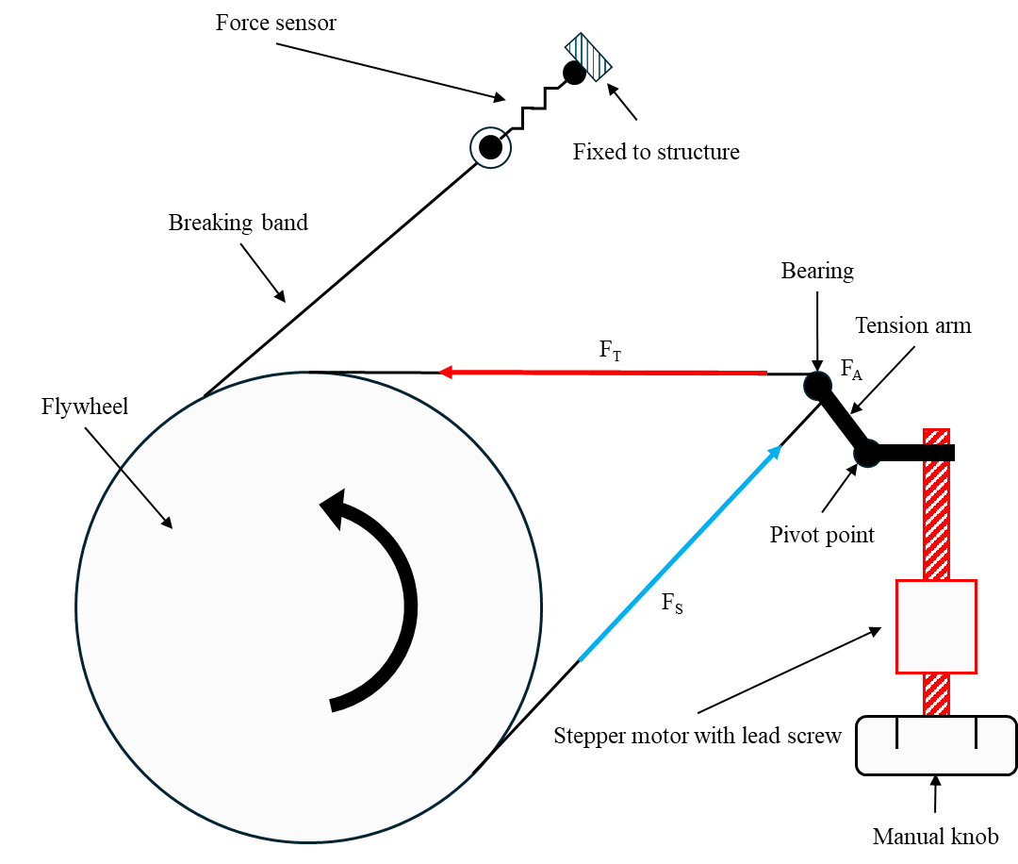
Supplementary figure 1: Visualization of European Enhanced Exploration Exercise Device (E4D) ergometer internal mechanics and forces. Forces acting on the braking band are tension forces for the tight (F_{T}) and slack (F_{S}) ends of the braking band, and an additional friction force (F_{A}).

