Experiment ID | Tracts | Primary injection site | Direction | Source | Target
298718072 | Genu of corpus callosum (ccg) | Secondary motor area | parallel | motor area | motor area (contralateral)
175739085 | Stria teminalis (st) | Bed nuclei of the stria terminalis | parallel | Pallidum | Central and Medial amygdalar nucleui (ipsilateral)
119848249 | Arbor vitae/cerebellar commissure (arb/cbc) | Lobule II | parallel | Central Lobule | Central Lobule (contralateral)
287600392 | Cingulum bundle (cing) | Anterior cingulate area, ventral part | orthogonal | Anterior cingulate area | Retrosplenial area (ipsilateral)
180720175 | Corticospinal tract (cst) | Primary motor area | orthogonal | Motor area | Pons (ipsilateral)
306957248 | Optic tract (opt) | Retina, Dorsal part of the lateral geniculate complex | orthogonal | Dorsal part of the lateral geniculate complex | Superior colliculus (ipsilateral)
543881679 | Cerebellar peduncles/rubrospinal tracts (cbp/rust) | Red nucleus | orthogonal | Red nucleus | Intermediate reticular nucleus (contralateral)
Supplementary Information (SI)

SI, Table S1. Viral tracing experiments used to extract white matter tracts.

SI, Fig S1. dMRI metric changes in sham and mTBI male mice across tract orientation bins. a) shows group differences in MKT and RK across acquisition frequencies. b) shows group differences in MD and RD across acquisition frequencies. The data is shown as change in each cohort post-injury relative to baseline, mean +/- SEM. Abbreviations: MD, mean diffusivity; MKT, mean kurtosis tensor; RD, radial diffusivity; RK, radial kurtosis; SEM, standard error of the mean

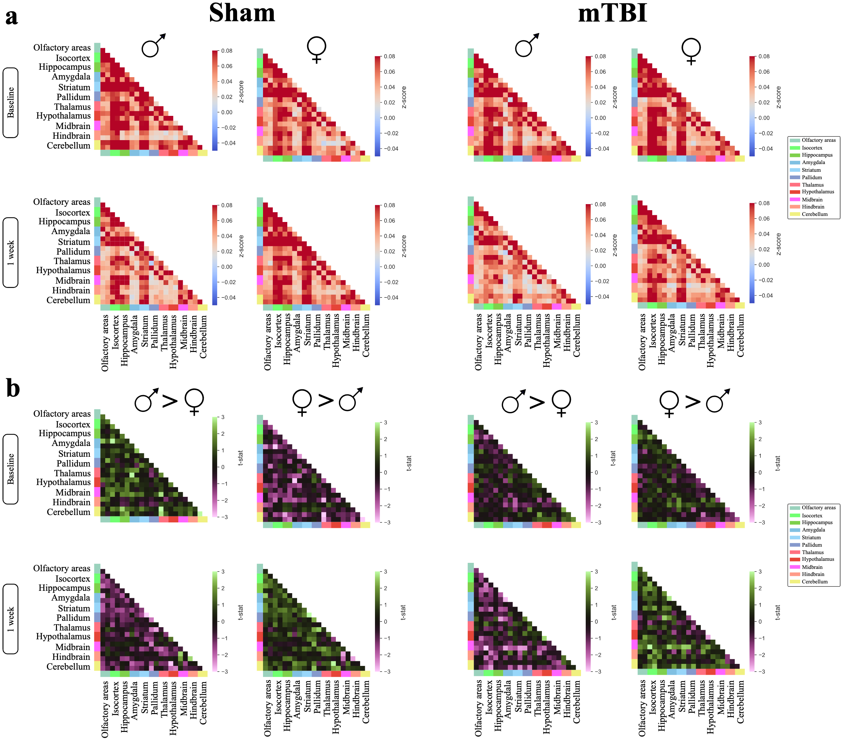
SI, Fig S2: No observable sex change before and 1 week after injury or sham procedure using 22 ROI atlas. A) Average connectivity matrices males and females in the sham on the left and in the mTBI group on the right at baseline (top) and after 1 week (bottom). B) t-statistics of hypothesis testing between males and females within sham (left) and mTBI (right) at baseline (top) and after 1 week (bottom). Connectivity strength was calculated as Pearson’s correlation coefficient and converted to z-score using Fisher’s transformation. Hypothesis testing was done using permutation testing with 10,000 permutations and corrected for multiple comparisons using false-discovery rate. Anatomical structures in each matrix are color-coded and the legends are on the right. Abbreviations: mTBI, mild traumatic brain injury; ROI, region of interest; , female; , male.

SI, Fig S3: No observable sex change before and 1 week after injury or sham procedure using 82 ROI atlas. A) Average connectivity matrices males and females in the sham on the left and in the mTBI group on the right at baseline (top) and after 1 week (bottom). B) t-statistics of hypothesis testing between males and females within sham (left) and mTBI (right) at baseline (top) and after 1 week (bottom). Connectivity strength was calculated as Pearson’s correlation coefficient and converted to z-score using Fisher’s transformation. Hypothesis testing was done using permutation testing with 10,000 permutations and corrected for multiple comparisons using false-discovery rate. Anatomical structures in each matrix are color-coded and the legends are on the right. Abbreviations: mTBI, mild traumatic brain injury; ROI, region of interest; , female; , male.

SI, Fig S4. mTBI induces loss of connectivity one week after injury. Hypothesis testing within each group before and after sham procedure or injury was done using permutation testing with 10,000 permutations and corrected for multiple comparisons using FDR. A) Atlas used to segment the brain. The subregions atlas was adapted from ABA CCFv3 and consists of 41 ROI per hemisphere. Structures on the right hemisphere are color-coded and show boundaries between different regions. The anatomical atlas is shown on the left hemisphere. B) Average connectivity matrix of the sham group (left) and mTBI group (right), at baseline (top) and after 1 week of the sham procedure of head injury (bottom). Correlation strengths were calculated as Pearson’s correlation coefficient between each pair of nodes and converted to z-score using Fisher’s transformation. D&E) Boxplots of regions that showed significant decrease after the sham procedure (C) and after mTBI (D) for comparison. E) Circular plot showing edges with significant decrease from baseline, 1 week after injury. The thickness of the lines reflects the percentage of decrease with the thickest line represent biggest decrease from baseline correlation (127% decrease) and the thinnest line shows smallest decrease from baseline (7%). C) Abbreviations: ABA, Allen Brain Atlas; ACA, anterior cingulate area; AI, agranular insular area; AMY, amygdala; AUD, auditory areas; CA, ammon's horn; CBN, cerebellar nuclei; CCFv3, common coordinate framework version 3; DG, dentate gyrus; DORpm, thalamus, polymodal association cortex related; ECT, ectorhinal area; ENT, entorhinal area; FC, functional connectivity; FDR, false-discovery rat; FRP, frontal pole, cerebral cortex; GU, gustatory areas; HEM, hemispheric regions; HY, hypothalamus; ILA, infralimbic area; L, left; LSX, lateral septal complex; MBsta, midbrain, behavioral state related; MO, somatomotor areas; mTBI, mild traumatic brain injury; OLF, olfactory areas; PAL, pallidum; PAR, parasubiculum; POST, postsubiculum; PRE, presubiculum; ProS, prosubiculum; PTLp, posterior parietal association areas; R, right; SS, somatosensory areas; STRd, striatum dorsal region; SUB, subiculum; TEa, temporal association areas; VERM, vermal regions; VIS, visual areas.

SI, Fig S5. Right hemisphere vs left hemisphere functional connectivity statistical comparisons in each group and in each condition using 22 ROI atlas. Paired hypothesis testing was done between left and right hemisphere functional connectivity using permutation testing with 10,000 permutations and false-discovery rate for multiple comparisons correction. Each matrix represents one contrast, black squares are edges with no significant change and colored ones reflect statistically significant changes (P value < 0.05) between hemispheres in sham group (left) or mTBI group (right) at baseline (top) or 1 week after intervention (bottom). Anatomical structures in each matrix are color-coded and the legends are on the right. Abbreviations: mTBI, mild traumatic brain injury; ROI, region of interest.

SI, Fig S6. Right hemisphere vs left hemisphere functional connectivity statistical comparisons in each group and in each condition using 82 ROI atlas. Paired hypothesis testing was done between left and right hemisphere functional connectivity using permutation testing with 10,000 permutations and false-discovery rate for multiple comparisons correction. Each matrix represents one contrast, black squares are edges with no significant change and colored ones reflect statistically significant changes (P value < 0.05) between hemispheres in sham group (left) or mTBI group (right) at baseline (top) or 1 week after intervention (bottom). Anatomical structures in each matrix are color-coded and the legends are on the right. Abbreviations: mTBI, mild traumatic brain injury; ROI, region of interest.

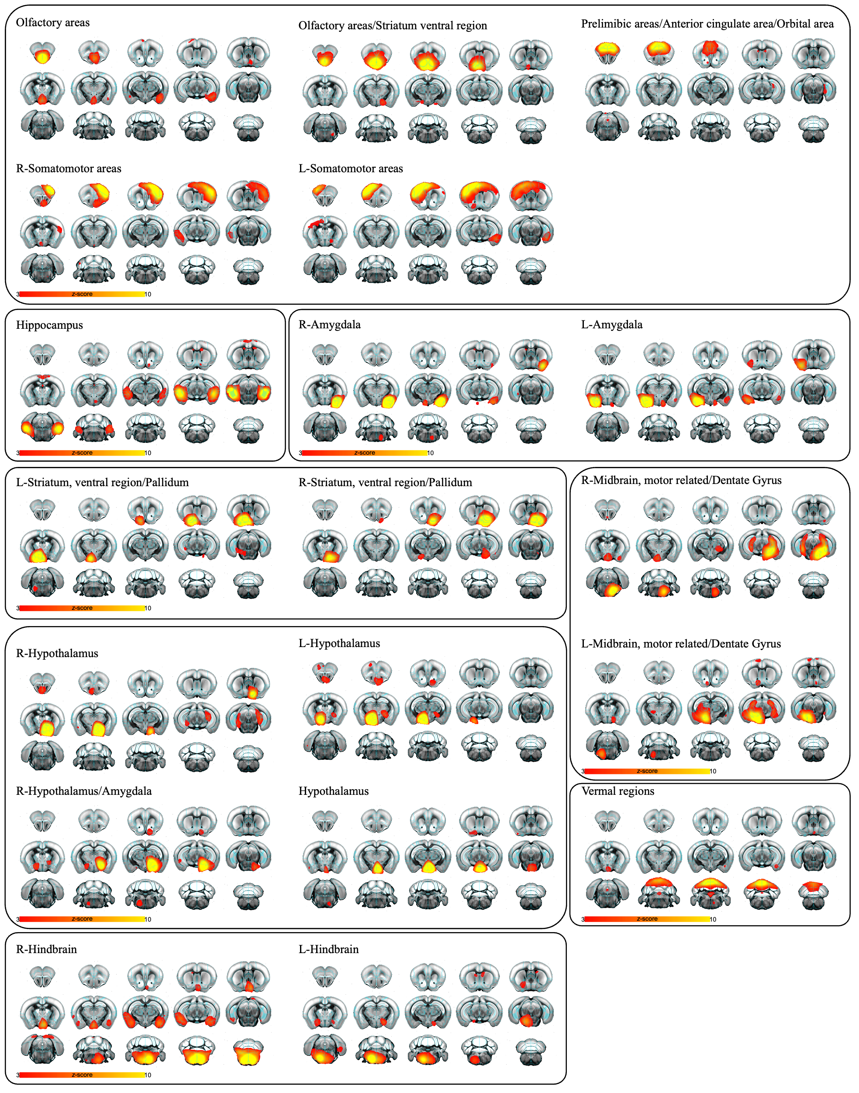
SI, Fig S7. RSNs identified by ICA. We used probabilistic ICA on the concatenated prefiltered group data from all subjects in both sessions (before and after) to identify different RSNs. We identified networks in the cerebral cortex, the thalamus, the hippocampus, the amygdala, the striatum, and the cerebellum. All components showed significant overlap with known anatomical structures and were labeled based on ABA CCFv3. The images are shown in anatomical view overlaid on ABA CCFv3 anatomical atlas and the networks are scaled in pseudo-z-scores. Abbreviations: ABA, Allen Brain Atlas; CCFv3, common coordinate framework version 3; ICA, independent component analysis; RSNs, resting-state networks.

SI, Fig S8. Dual regression analysis shows upregulation of connectivity strength in sham group after sham procedure. voxel-wise analysis shows increase in functional connectivity between a number of ICA networks and various clusters across the brain in the sham group 1 week after the procedure. Permutation testing with 10,000 permutations was used for hypothesis testing. All the results are corrected across voxels, networks, and contrasts using family-wise error. ICA networks are showed overlaid on an ABA CCFv3 anatomical atlas. Abbreviations: ABA, Allen Brain Atlas; CCFv3, common coordinate framework version 3; ICA, independent component analysis.

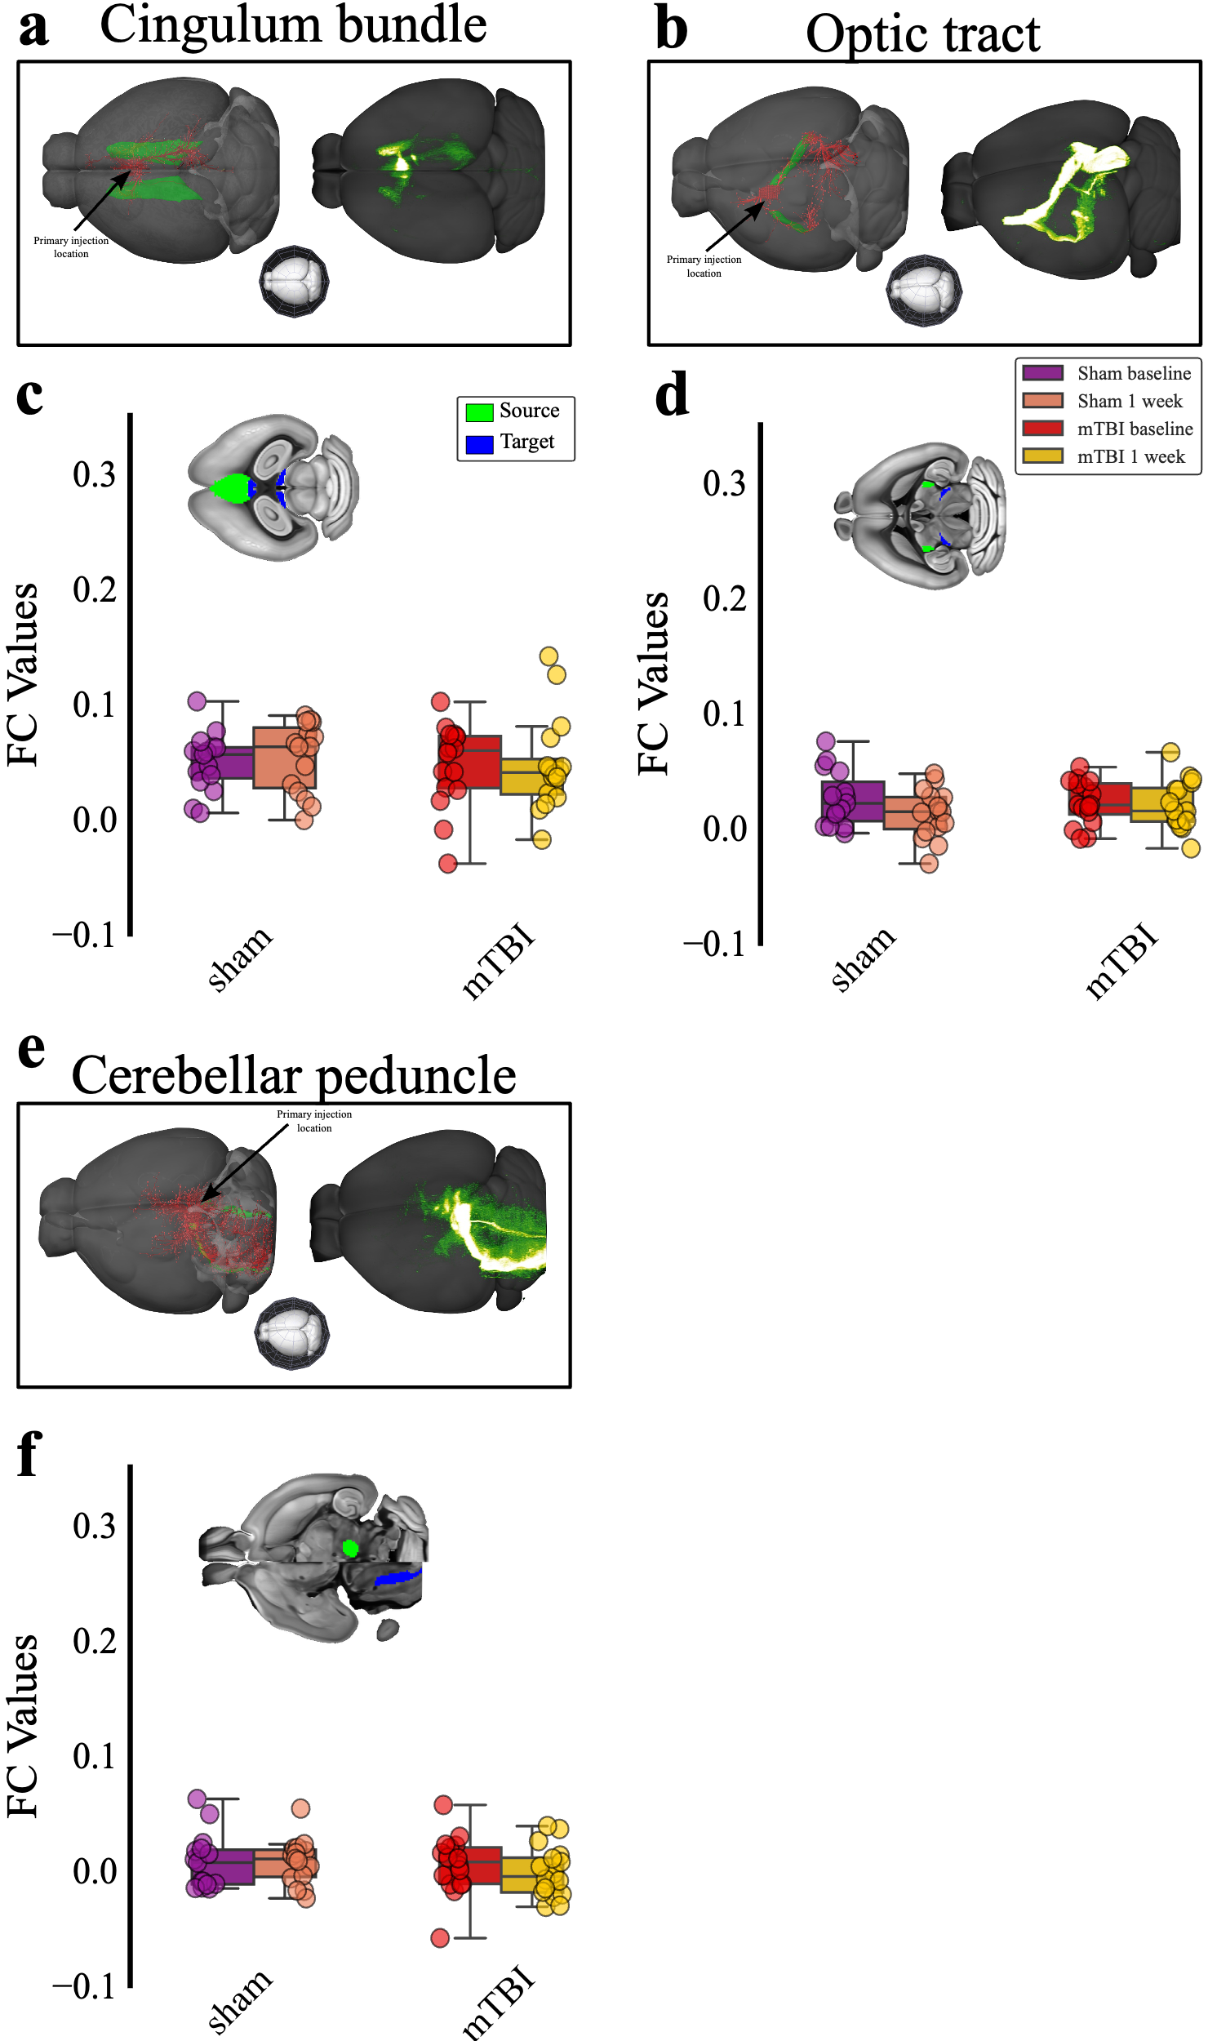

SI, Fig S9. Tractography-based functional connectivity across fibers orthogonal to plane of rotation. Cingulum bundle (A), optic tract (B), and cerebellar peduncle (E) fiber tracts was isolated using viral tracers injected in various location. The left shows primary injection location in red and the fibers 3D rendering based on ABA CCFv3, the right shows signal density, and an orientation compass is in the middle. C, D, &F) Box plots of connectivity strength between regions connected through cingulum bundle (C), optic tract (D), and cerebellar peduncle (F). Paired Student’s t-test was performed within each group. The top view shows masks of the source and the target used to calculate FC overlaid on an ABA CCFv3 anatomical atlas. Abbreviations: ABA, Allen Brain Atlas; CCFv3, common coordinate framework version 3; FC, functional connectivity.

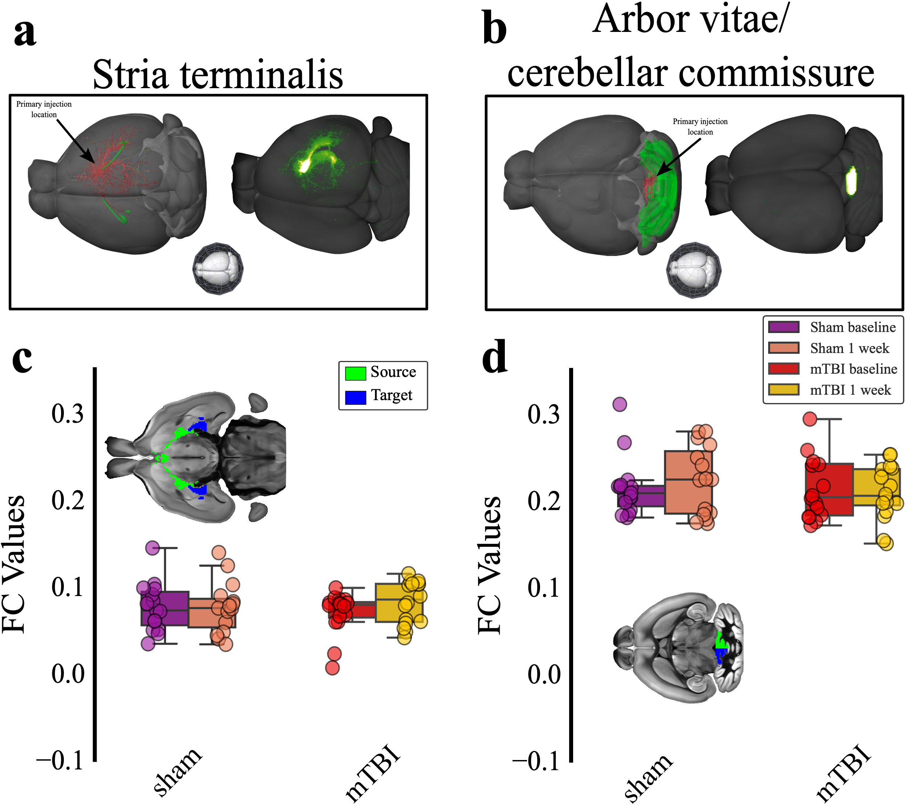

SI, Fig S10. Tractography-based functional connectivity across fibers parallel to plane of rotation. Stria terminalis (A) and arbor vitae (B) fiber tracts was isolated using viral tracers injected in various location. The left shows primary injection location in red and the fibers 3D rendering based on ABA CCFv3, the right shows signal density, and an orientation compass is in the middle. C&D) Box plots of connectivity strength between regions connected through stria terminalis (C) and arbor vitae (D). Paired Student’s t-test was performed within each group. The top view shows masks of the source and the target used to calculate FC overlaid on an ABA CCFv3 anatomical atlas. Abbreviations: ABA, Allen Brain Atlas; CCFv3, common coordinate framework version 3; FC, functional connectivity.

