Supplemental Material

A1. Theory – Mesh Surface Reconstruction from 3D Point Cloud

Marching Cubes
The reconstruction of mesh surfaces from 3D point clouds is a fundamental problem in the field of computer vision. Traditional methods, such as triangulation and voxel-based approaches, often struggle with lack of detail representation of complex geometry, sparse and noisy data, and non-uniform point sampling. The Poisson Surface Reconstruction (PSR) algorithm¹⁶ addresses these challenges by leveraging the concept of implicit surfaces and the mathematical framework of Poisson equations. However, the PSR method is computationally expensive, and it requires point cloud data with already computed normal values. Additionally, the PSR is not suitable for real-time 3D mapping and SLAM implementation. Instead, Open3D implements TSDF fusion and Marching Cubes for real-time 3D mesh surface reconstruction with depth and RGB maps. The Marching Cubes algorithm was first proposed by Lorensen and Cline in 1987¹⁷. Since the integrated TSDF values that represents RGB-D information from a 3D scene are stored inside a voxel block grid, defined as a scalar field:
$$F: R^{3}→R$$
where $F(x,y,z)$ is a signed distance function indicating the distance to the nearest surface.
- $F\left(x,y,z\right)>0:Point is inside the surface.$
- $F\left(x,y,z\right)<0:Point is outside the surface.$
- $F\left(x,y,z\right)=0:Point is exactly on the surface.$
The goal of the Marching Cubes is to extract the isosurface or the zero-level set where $F\left(x,y,z\right)=0$. More precisely, each cube inside of the voxel block grid can by defined by 8 corner points or vertices:
$$v_{i}=\left(x_{i},y_{i},z_{i}\right), i=1,…,8$$
Each vertex $v_{i}$ has a scalar field value: $F\left(v_{i}\right)=F\left(x_{i},y_{i},z_{i}\right)$ and a binary state:
$$b_{i}=\left\{\begin{aligned} 1, if F\left(v_{i}\right)≥0 (outside) \\ 0, if F\left(v_{i}\right)<0 (inside)\end{aligned}\right.$$
Each cube can have 256 possible binary corner configurations. Next, the Marching Cubes lookup table assigns triangle patterns based on the 8-bit binary index:
$$Index= b_{1}+2b_{2}+4b_{3}+ ∙∙∙+128b_{8}$$
The lookup table contains predefined edge to triangle mapping for all 256 corner combinations. For each edge of the voxel grid, two adjacent corners are connected to form each edge. Let $s_{i}=F\left(v_{i}\right)$ and $s_{j}=F\left(v_{j}\right)$ represent the TSDF values at two edge-connected voxel points $v_{i}$ and $v_{j}$, if $s_{i}$ and $s_{j}$ have opposite signs, the surface must be passing through the edge, hence the following conditions are formed:
- $s_{i}<0$ and $s_{j}>0$, the surface crosses the edge between $v_{i}$ and $v_{j}$.
- $s_{i}>0$ and $s_{j}<0$, the same but reversed.
- $s_{i}∙s_{j}>$0, no surface crossing.
To find the final zero crossing point $p$, let $F\left(p\right)$=0, assuming linear interpolation:
$$F\left(p\right)=\left(1-λ\right)F\left(v_{i}\right)+λF\left(v_{j}\right)=0$$
Solving for $λ:$
$$λ=\frac{\left|s_{i}\right|}{\left|s_{i}-s_{j}\right|}$$
Finally, the interpolated position $p$ along the edge is:
$$p=v_{i}+λ(v_{i}-v_{j})$$
Expanding for each coordinate:
$$p_{x}=x_{i}+λ(x_{i}-x_{j})$$
$$p_{y}=y_{i}+λ(y_{i}-y_{j})$$
$$p_{z}=z_{i}+λ(z_{i}-z_{j})$$
These equations provide the exact position of the surface vertex along the edge of a voxel cube. A triangle is formed when three interpolated points are found. Figure S1 illustrates a simplified graphical interpretation of the conversion process from 3D point cloud to a mesh geometry. From left to right, the blue dots represent a set of densely populated point cloud. The Marching Cubes algorithm is used to extract an isosurface from a 3D scalar field defined on a regular grid. For visual simplicity, only a 6x6x6 grid is plotted here, but the density of the voxel grid is defined by the resolution of the input data. For each voxel in the grid, the algorithm evaluates the scalar values at the cube's vertices to determine how the isosurface intersects the cube's edges. Linear interpolation is used to estimate the intersection points. Based on a predefined lookup table, the algorithm generates triangles that approximate the isosurface within each cube. These triangles collectively form a polygonal representation of the spherical isosurface. 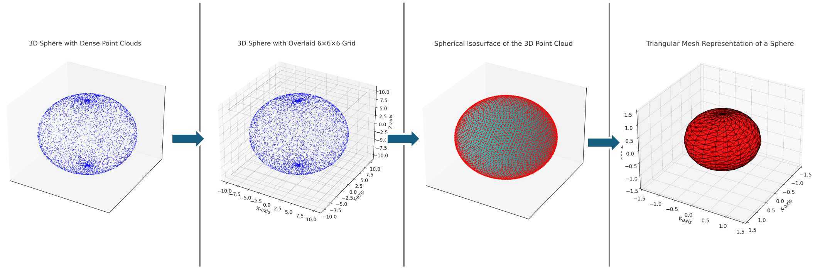
Figure S1: From left to right, graphical interpretation of the VBG-MC conversion process from 3D point cloud to a mesh geometry.

Poisson Surface Reconstruction (PSR)
Originally proposed by Kazhdan et al., PSR formulates surface reconstruction as the solution to a Poisson equation, which minimizes inconsistencies between the point normal and the gradient of the approximated surface’s indicator function. An indicator function $f(X)$ is a scalar field that implicitly encodes a surface. The values of $f(X)$ at any point $X$ in space indicates whether the point is inside, outside, or on the surface:
- $f\left(X\right)>0:Point is inside the surface.$
- $f\left(X\right)<0:Point is outside the surface.$
- $f\left(X\right)=0:Point is exactly on the surface.$
The zero-level set is the subset of the domain where $f\left(X\right)=0$. The solution surface is represented implicitly as the zero-level set of an indicator function $f\left(X\right)$, defined over a 3D space $X$ = (x, y, z). The normal vectors of the point cloud $N$are treated as sample of the gradient field, where $f\left(X\right)$is the indicator function of the surface. The problem is then cast as finding $f\left(X\right)$such that:
$$∇ ∙V= ∇ ∙∇f\left(X\right)= ∆f(X)$$
Where $∆$is the Laplacian operator, $V$ is the gradient field constructed by associating each point $X$ with its normal vector $N$, and finally, $∆f\left(X\right)=∇ ∙V$ is the Poisson equation subjects to boundary conditions. Solving the Poisson equation numerically requires a discretized space as a 3D grid. The indicator function $f\left(X\right)$is represented by an octree structure to allow efficient computation. In practice, point cloud is represented as a set of discrete points; to compute $∇ ∙V$ for each voxel in the 3D grid, the process aggregates the contribution of point normal to estimate the divergence. Hence, the Poisson equation can be formulated as a minimization problem:
$$\min_{f}{\int_{R^{3}}{{\left\|∆f- V\right\|}^{2 }dx,}}$$
Solving this optimization problem yields $f(X)$, which is smooth due to the regularizing properties of the Laplacian. The estimation of the point cloud normal is critical since any error in normal approximation will propagate to the reconstructed surface. PSR can handle open surfaces because it does not require the input point cloud to form a closed manifold. Instead, it reconstructs surfaces by solving a Poisson equation that captures the orientation and density of points locally in space. This approach allows the algorithm to work with sparse and incomplete data, if there is sufficient geometric information to infer surface normal vectors. However, in sparsely distributed point cloud regions, the final reconstructed surface may exhibit artifacts. Finally, to extract the polygonal mesh from the solution, the Marching Cubes algorithm is generally used. As mentioned earlier, this method discretizes the 3D space into a regular voxel grid. For each voxel, the Marching Cubes determines how the surface intersect the cell by checking the signs of solution function $f\left(X\right)$ at its vertices. Wherever the function changes signs across a voxel, the algorithm approximates the surface at the intersection by generating triangular facets. The interconnected triangles are combined to form a polygonal mesh that closely represents the geometry of the original point cloud data.
The key differences between the MC and the PSR mesh surface reconstruction algorithms lie in the types of input data and the quality of the resulting surface. The MC method generally works well for extracting surfaces from structured data, such as a scalar field or implicit functions. It is not directly applicable to unstructured point cloud data without preprocessing the data by voxelization and assigning scalar values. An example of the scalar values is the signed distance functions. Unlike regular 2D color or 3D medical images, point clouds are a collection of discrete points in 3D space without any inherent connectivity. Real world point clouds often contain noise and outliers, further disrupting the unstructured nature of the data. If we forced the MC algorithm onto unstructured sparse point cloud data, the resulting surface may contain holes and be noisy. In contrast, the PSR before a MC reconstruction bridges the gap between unstructured point cloud and structured scalar fields. This duo forms a powerful pipeline for high-quality mesh surface reconstruction from point clouds.

A2. Definition of Root Mean Square Error
The root mean square error (RMSE) in Iterative Closest Point (ICP) registration quantifies how well two point clouds data sets align after applying an estimated transformation. For each point in the source point cloud, the closest corresponding point in the target point cloud is identified. After applying the rotational and translational transformation to the source point cloud, the Euclidean distance between each transformed source point and its corresponding target point is computed. The distance values are summed, squared over all available data points, and then divided by the number of the total data points. A low RMSE value indicate a better alignment between the source and the target point cloud data, and it is being used as a metric to evaluate when the ICP algorithm has converged. The formula can be expressed as:
$$RMSE=\sqrt{\frac{1}{n}\sum_{i=1}^{n}{{\left\|T(P_{i})-Q_{i}\right\|}^{2}}}$$
Where:
$n$ is the total number of point clouds,
$P_{i}$ is the source point cloud,
$Q_{i}$ is the corresponding target point cloud,
$T$ is the estimated transformation matrix by the ICP algorithm.

