VA Million Veteran Program:
Core Acknowledgements for Publications
May 2024

MVP Program Office

- Sumitra Muralidhar, Ph.D., Program Director
US Department of Veterans Affairs, 810 Vermont Avenue NW, Washington, DC 20420
- Jennifer Moser, Ph.D., Associate Director, Scientific Programs
US Department of Veterans Affairs, 810 Vermont Avenue NW, Washington, DC 20420
- Jennifer E. Deen, B.S., Associate Director, Cohort & Public Relations
US Department of Veterans Affairs, 810 Vermont Avenue NW, Washington, DC 20420

MVP Executive Committee

- Co-Chair: Philip S. Tsao, Ph.D.
VA Palo Alto Health Care System, 3801 Miranda Avenue, Palo Alto, CA 94304
- Co-Chair: Sumitra Muralidhar, Ph.D.
US Department of Veterans Affairs, 810 Vermont Avenue NW, Washington, DC 20420
- J. Michael Gaziano, M.D., M.P.H.
VA Boston Healthcare System, 150 S. Huntington Avenue, Boston, MA 02130
- Elizabeth Hauser, Ph.D.
Durham VA Medical Center, 508 Fulton Street, Durham, NC 27705
- Amy Kilbourne, Ph.D., M.P.H.
VA HSR&D, 2215 Fuller Road, Ann Arbor, MI 48105
- Michael Matheny, M.D., M.S., M.P.H.
VA Tennessee Valley Healthcare System, 1310 24th Ave. South, Nashville, TN 37212
- Dave Oslin, M.D.
Philadelphia VA Medical Center, 3900 Woodland Avenue, Philadelphia, PA 19104
- Deepak Voora, MD
Durham VA Medical Center, 508 Fulton Street, Durham, NC 27705

MVP Co-Principal Investigators

- J. Michael Gaziano, M.D., M.P.H.
VA Boston Healthcare System, 150 S. Huntington Avenue, Boston, MA 02130
- Philip S. Tsao, Ph.D.
VA Palo Alto Health Care System, 3801 Miranda Avenue, Palo Alto, CA 94304

MVP Core Operations

- Jessica V. Brewer, M.P.H., Director, MVP Cohort Operations
VA Boston Healthcare System, 150 S. Huntington Avenue, Boston, MA 02130
- Mary T. Brophy M.D., M.P.H., Director, VA Central Biorepository
VA Boston Healthcare System, 150 S. Huntington Avenue, Boston, MA 02130
- Kelly Cho, M.P.H, Ph.D., Director, MVP Phenomics
VA Boston Healthcare System, 150 S. Huntington Avenue, Boston, MA 02130
- Lori Churby, B.S., Director, MVP Regulatory Affairs
VA Palo Alto Health Care System, 3801 Miranda Avenue, Palo Alto, CA 94304
- Scott L. DuVall, Ph.D., Director, VA Informatics and Computing Infrastructure (VINCI)
VA Salt Lake City Health Care System, 500 Foothill Drive, Salt Lake City, UT 84148
- Saiju Pyarajan Ph.D., Director, Data and Computational Sciences
VA Boston Healthcare System, 150 S. Huntington Avenue, Boston, MA 02130
- Robert Ringer, Pharm.D., Director, VA Albuquerque Central Biorepository
New Mexico VA Health Care System, 1501 San Pedro Drive SE, Albuquerque, NM 87108
- Luis E. Selva, Ph.D., Director, MVP Biorepository Coordination
VA Boston Healthcare System, 150 S. Huntington Avenue, Boston, MA 02130
- Shahpoor (Alex) Shayan, M.S., Director, MVP PRE Informatics
VA Boston Healthcare System, 150 S. Huntington Avenue, Boston, MA 02130
- Brady Stephens, M.S., Principal Investigator, MVP Information Center
Canandaigua VA Medical Center, 400 Fort Hill Avenue, Canandaigua, NY 14424
- Stacey B. Whitbourne, Ph.D., Director, MVP Cohort Development and Management
VA Boston Healthcare System, 150 S. Huntington Avenue, Boston, MA 02130

MVP Publications and Presentations Committee

- Co-Chair: Themistocles L. Assimes, M.D., Ph. D
VA Palo Alto Health Care System, 3801 Miranda Avenue, Palo Alto, CA 94304
- Co-Chair: Adriana Hung, M.D.; M.P.H
VA Tennessee Valley Healthcare System, 1310 24th Ave. South, Nashville, TN 37212
- Co-Chair: Henry Kranzler, M.D.
Philadelphia VA Medical Center, 3900 Woodland Avenue, Philadelphia, PA 19104

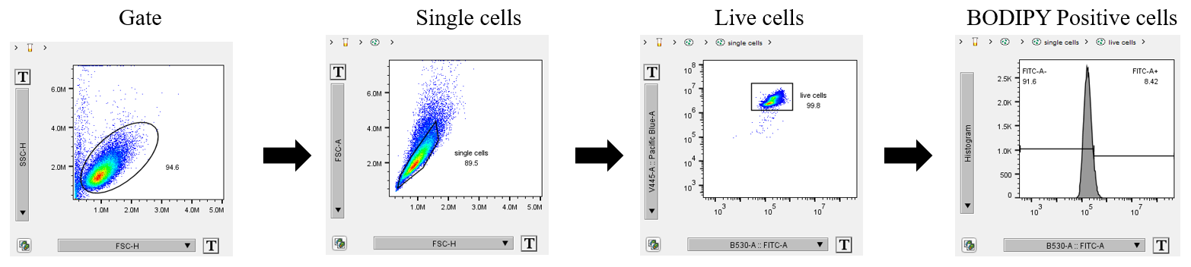

FACS gating strategy for bodipy staining.

