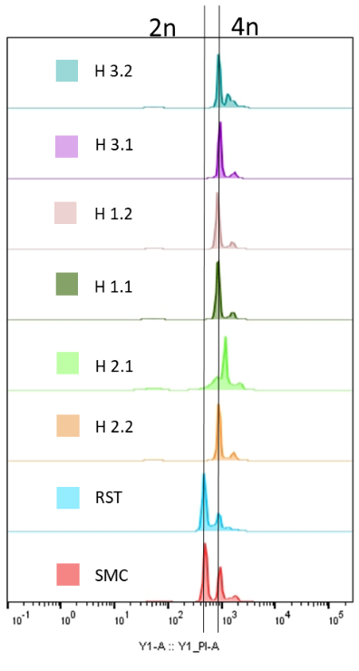
Supplementary Figure 1
B
A
Supplementary Figure 1. Ploidy of hybrid cells. (A) Flow cytometry analysis of DNA content measurement of fluorescent PI intensity. X-axis represent fluorescent intensity and Y-axis number of events detected. (B) Chromosome spreading after colchicine treatment. Ten independent mitoses were counted/cell line. Visualization done by Video microscope (Zeiss) after DAPI staining.

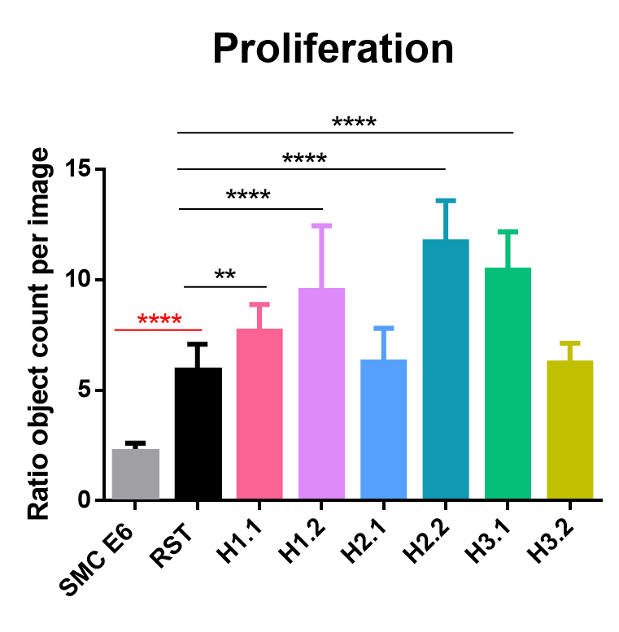
Supplementary Figure 2

Supplementary Figure 2. Proliferation rate of hybrid cells. Proliferation rate measured with IncucyteS3® (Sartorius). Cells were seeded in 96-well plate, one picture was acquired/well/hour during 72h. Data normalized to the number of cells counted in the first image at T0. Statistical test: non-parametric, Mann-Whitney t-test (**p=0.0018, ****p<0.0001, error bars, SD; n=3) each independent experiment done in sextuplets.

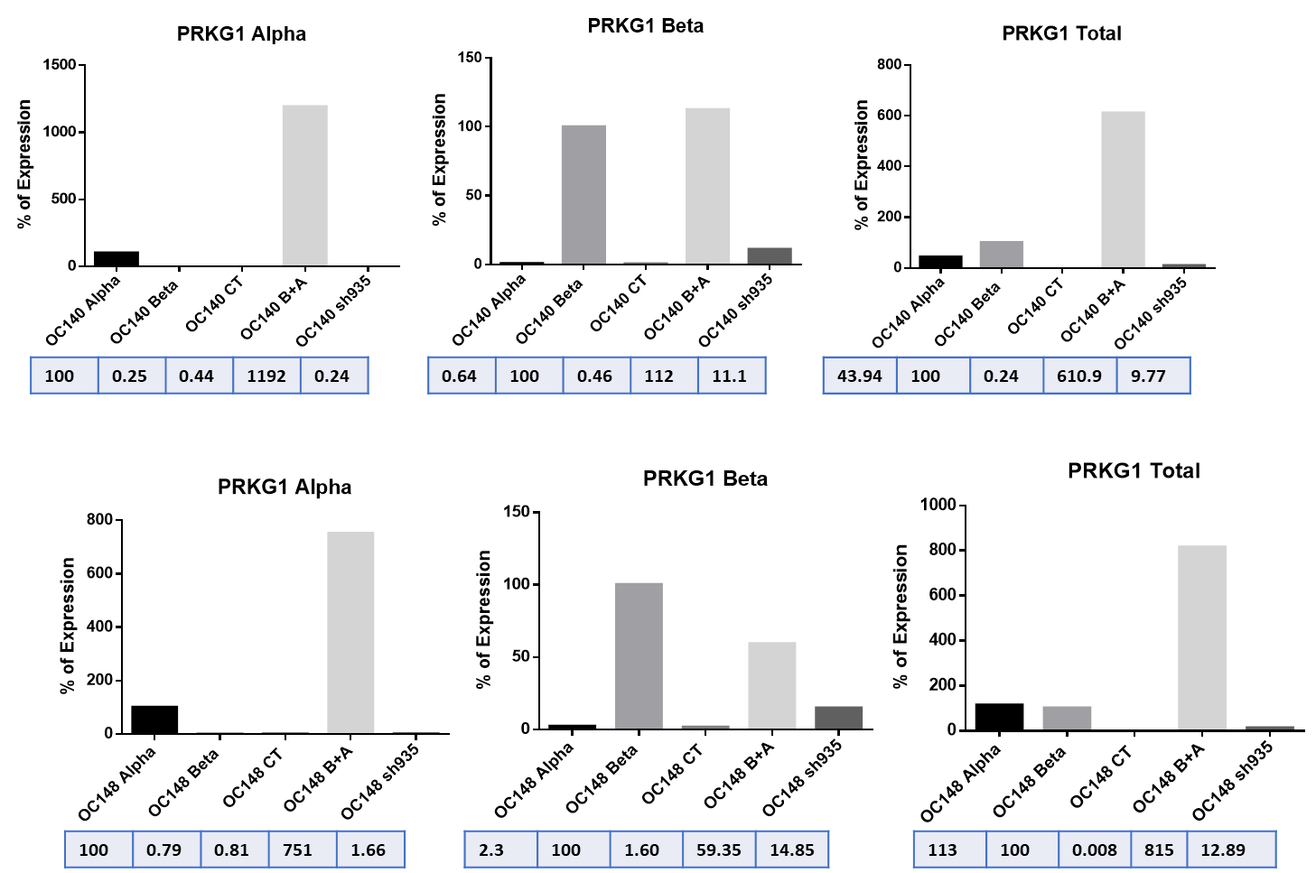
Supplementary Figure 3
A

B

C
D
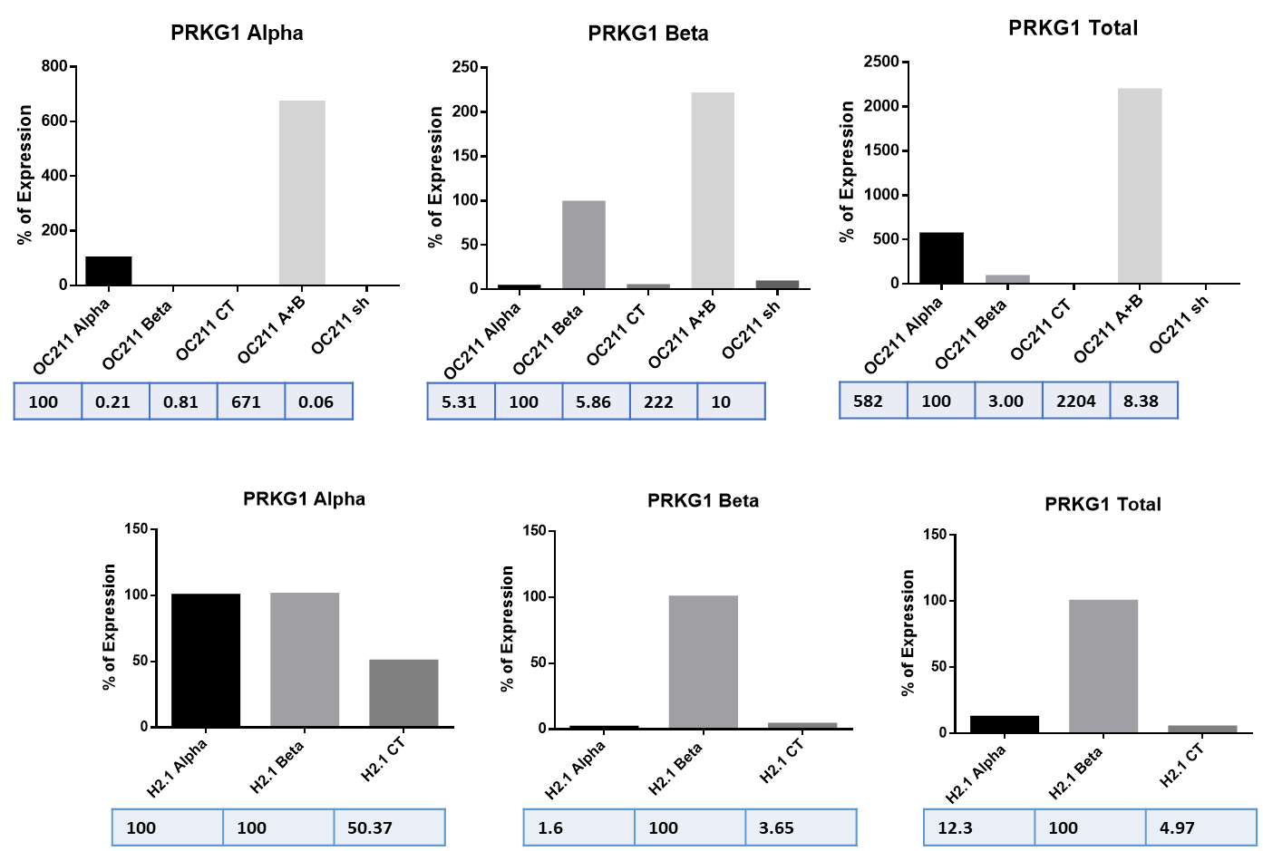
Supplementary Figure 3. Taqman™ validation of PRKG1-alpha, PRKG1-beta and PRKG1Total (englobing both isoforms). The title of the graph indicates the probe used at each time, either PRKG1-alpha, PRKG1-beta or PRKG1 Total. Y-axis different cell lines used, X-axis percentage (%) of expression, n=3. Results for: (A) OC140, (B) OC148, (C) OC211 and (D) H2.1. When measuring PRKG1-alpha expression normalization was done with the corresponding cell line-overexpressing alpha, likewise for beta, and when measuring PRKG1-Total normalization was done with cell line-overexpressing the beta isoform.

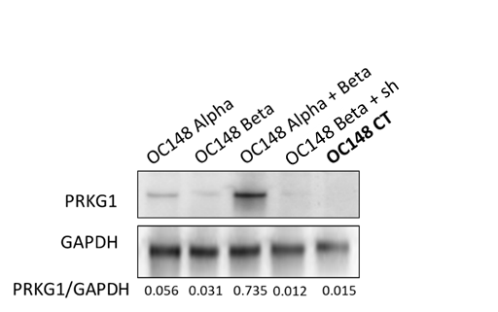
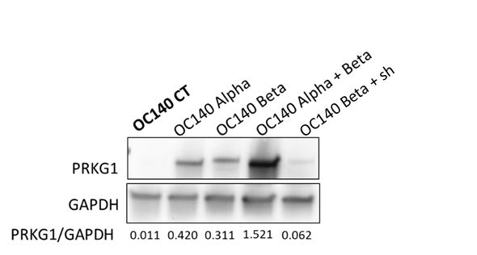
Supplementary Figure 4
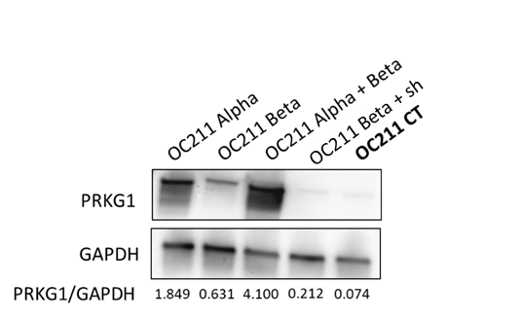
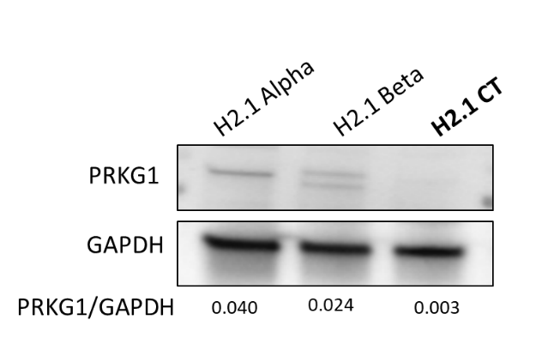

Supplementary Figure 4. Expression of PRKG1 and GAPDH evaluated by western blotting. At the top gel images, at the bottom, quantification of PRKG1 expression normalized by GAPDH expression (loading control). Abbreviations: Sh: shRNA935 directed against PRKG1. CT: control.

Supplementary Figure 5
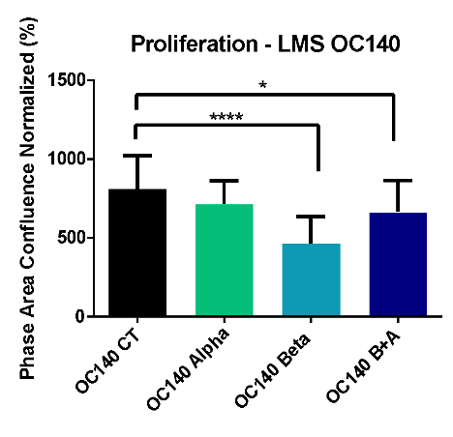

Supplementary Figure 5. Phenotypic analysis on LMS and hybrid cell lines. Proliferation assay of OC140 performed during 5 days taking pictures every 4h (Incucyte®). Data normalized to the number of cells counted in the first image at T0. Statistical test: non-parametric, Mann-Whitney t-test (*p<0.01, ****p<0.0001 error bars, SD) N=3 done in sextuplets.

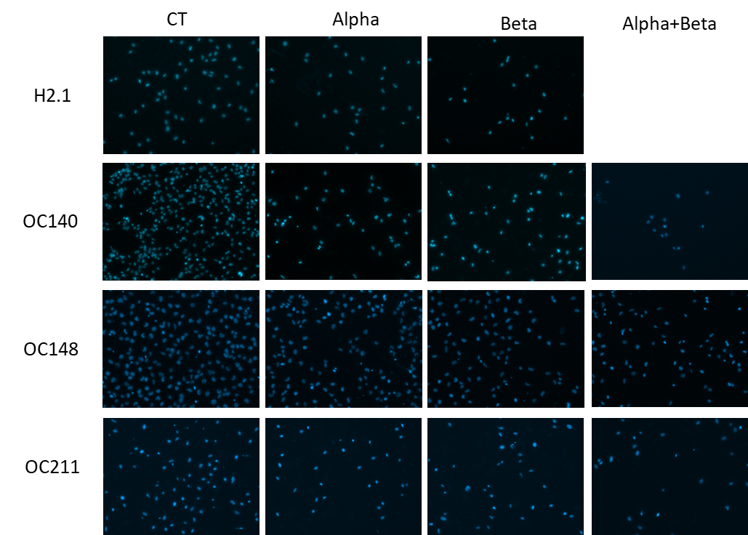
Supplementary Figure 6

Supplementary Figure 6. Transwell images from the migration of H2.1 (t=6h), OC140, OC148, and OC211(t=24h) comparing the different isoforms of PRKG1. Data normalized to the number of cells seeded at T0 determined by flow cytometry. Each chamber was stained with DAPI and imaged with Axio Zeiss microscope. Image processing was done with ZEN Blue software, and the counting of the nuclei was done with ImageJ, n=3 done in quadruplicate in each independent experiment.

Supplementary Figure 7
B
A

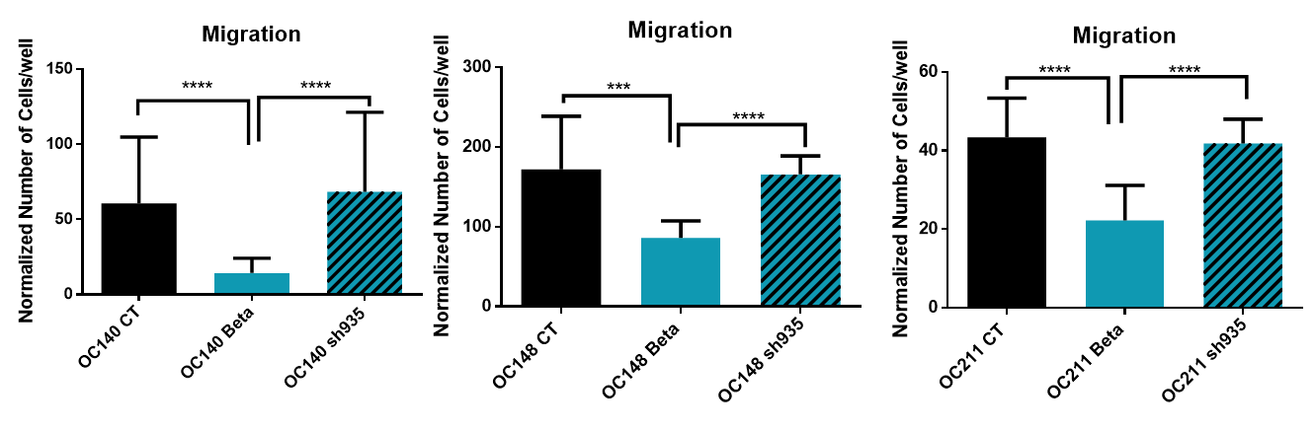
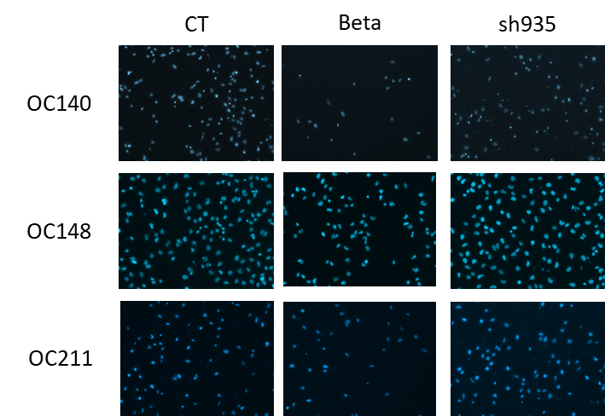
C

Supplementary Figure 7. Phenotypic analysis after reducing PRKG1 expression with sh935. (A) Proliferation assay for OC140 performed over 5 days with Incucyte S3®, taking pictures every 4h. Data normalized to the number of cells counted in the first image at T0. Statistical test t-test (non-parametric) Mann-Whitney (*p<0.01, error bars, SD) n=3 done in sextuplets. (B) Boyden chamber migration assay of OC140, OC148 and OC211 cell lines comparing between CT, cell line transduced with beta isoform and reduction of expression of PRKG1 (shRNA935). Migration was evaluated during 24h, data normalized to the number of cells seeded at T0 determined by flow cytometry. Statistical test t-test (non-parametric) Mann-Whitney (*p<0.01, error bars, SD; n=3 done in quadruplicate in each independent experiment. (C) Transwell images from Boyden chamber migration assay of OC140, OC148 and OC211. Migration was evaluated during 24h, data normalized to the number of cells seeded at T=0 determined by flow cytometry. Each chamber was stained with DAPI and imaged with Axio Zeiss microscope. Image processing was done with ZEN Blue software, and the counting of the nuclei was done with ImageJ, n=3 done in quadruplicate in each independent experiment.

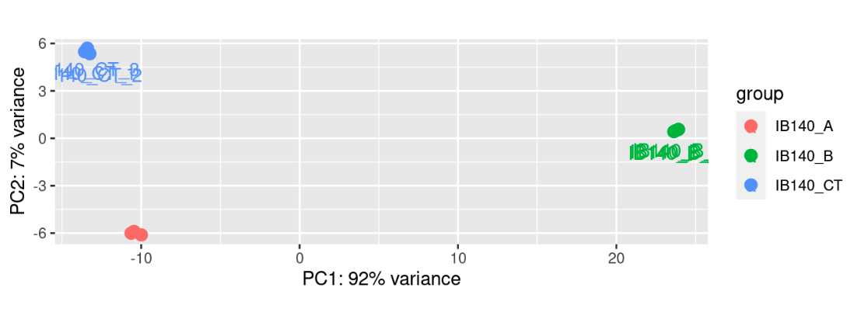
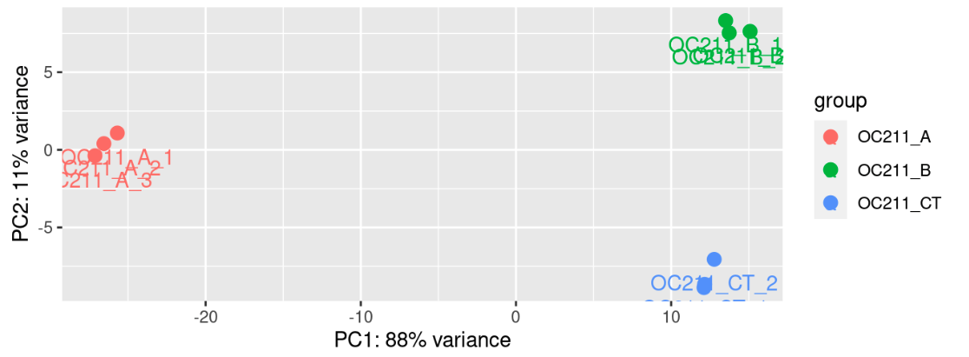
Supplementary Figure 8
Supplementary Figure 8. Principal Component Analysis (PCA) results for transcriptomic differences in different OC140 and OC211 cell lines. The top panel shows that in OC140, the primary variance is driven by the comparison between conditions B and CT. In contrast, the bottom panel indicates that in OC211, the main transcriptomic divergence is observed between conditions A and CT.
OC140_A
OC140_B
OC140_CT

