Supplementary Figures and Legends
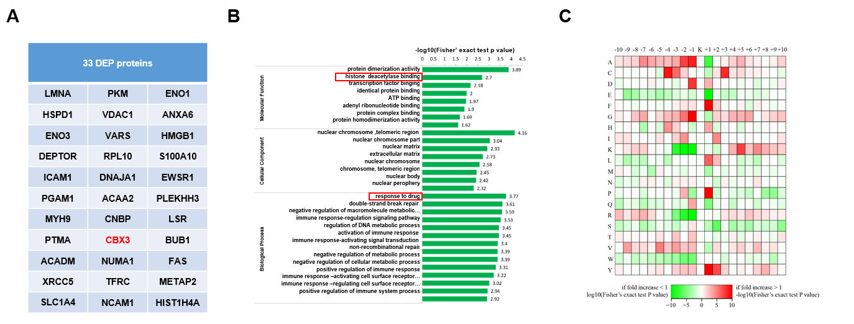
S FIGURE 1 Deferentially expressed proteins in drug-resistant MM cells (A) List of SILAC assay-identified 33 DEP proteins in protemoics and acetylome in BR and WT MM.1S cells. (B) GO enrichment analysis shows the biological processes and cellular functions of DEP proteins in the BR MM.1S cells. (C) Heat map for changed acetylated sites in SILAC assay for the BR MM.1S cells.
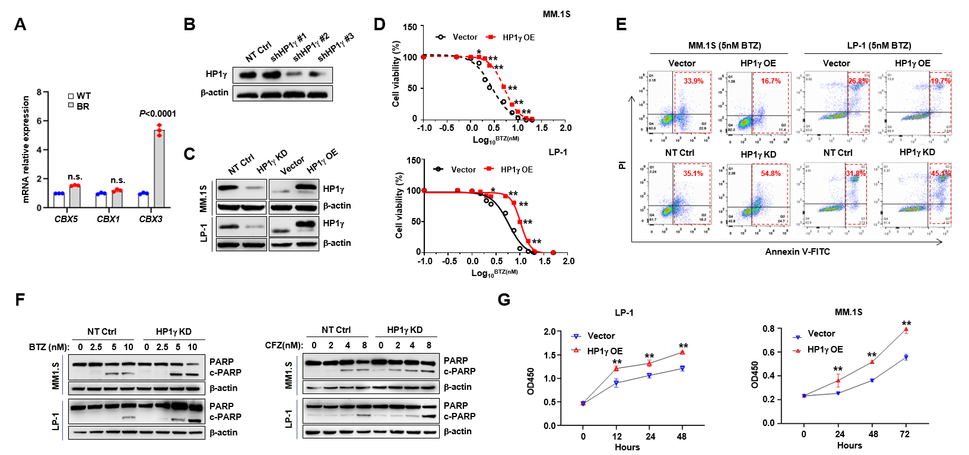
S FIGURE 2 Effects of HP1γ on MM cell apoptosis. (A) qPCR detecting the genes of HP1 family genes in WT and BR MM.1S cells. (B) Western blotting shows the efficacy of three shRNAs targeting HP1γ in HEK293T cells, and (C) validates the knockdown efficacy of shRNA#2 (HP1γ KD) and overexpression efficacy of HP1γ (HP1γ OE) in MM cells. (D) Alteration of IC50 to BTZ treatment in the Vector and HP1γ OE cells (n = 3). (E) Representative flow cytometry assay to detect the percentage of apoptotic cells in the Vector, HP1γ OE, non-target control (NT Ctrl) and HP1γ KD MM cells induced by 5 nM BTZ for 48 hr. (F) Cleavage of PARP as the apoptotic marker in MM.1S and LP-1 cells with HP1γ expression manipulated by shRNA or ectopic expressing vector, treated with increasing dosage of BTZ and carfilzomib (CFZ) for 24 hr. (G) Cell proliferation of LP-1 and MM.1S cells stably expressing vector (Vector) or HP1γ.
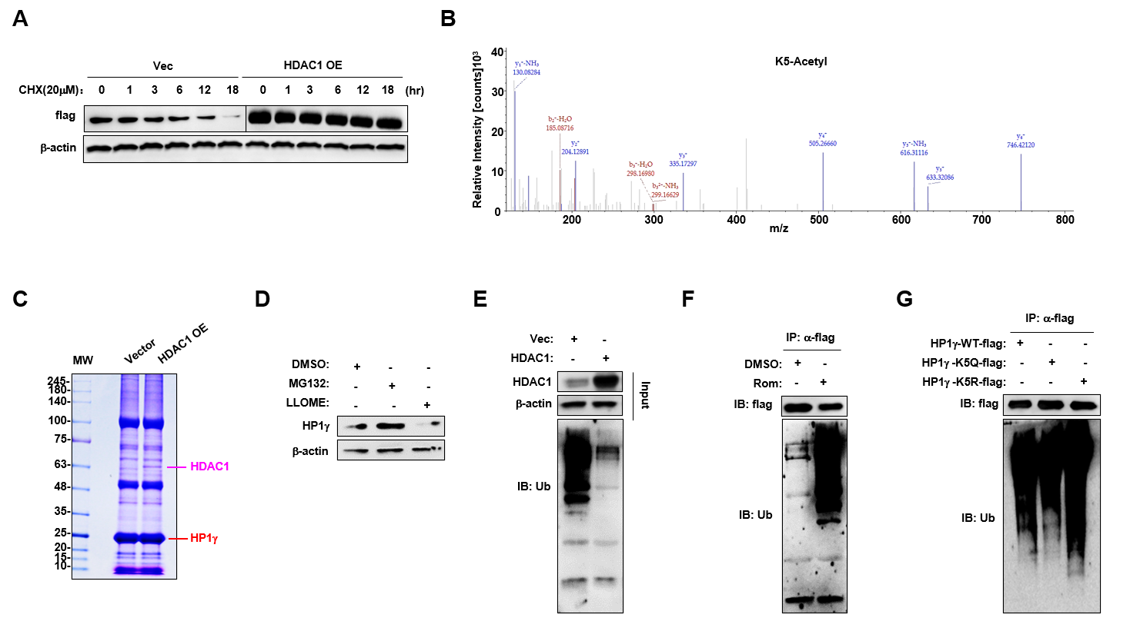
S FIGURE 3 Acetylation modification enhances ubiquitination of HP1γ. (A) Degradation of HP1γ-flag protein in HEK293T transfected with HDAC1 and treated with 20 μM cycloheximide (CHX) for 12hr. (B) Mass spectra of enriched acetylated peptides containing K5 sites in HP1γ-flag proteins. (C) Coomassie blue staining for flag-pulldown in HEK293T cells transfected with vector or flag-HP1γ for 48 hr. (D) Western blotting shows HP1γ levels in LP-1 cell treated with DMSO, MG132(20μM) and LLOME (L-leucyl-L-leucine methyl ester, 20μM) for 24hr. Ubiquitination status of HP1γ in HEK293T cells transfected with (E) P300 or HDAC1 for 48 hr, or (F) C646 (20μM) or Rom (Romidepsin, 100nM) for 24 hr. (G) Ubiquitination status of HP1γ-WT-flag, HP1γ-K5Q-flag or HP1γ-K5R-flag in HEK293T cells.
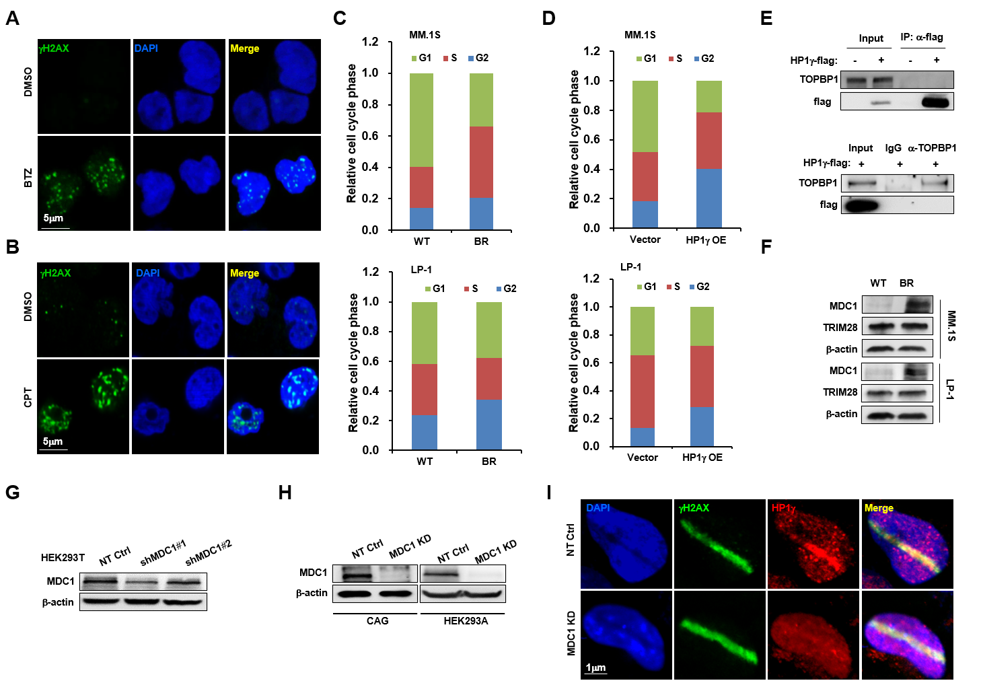
S FIGURE 4 MDC1 recruits HP1γ to enhance DNA damage repair. (A) Confocal immunofluorescence for endogenous HP1γ in MM cells treated with 5 nM BTZ or DMSO (Control), or (B) 2μM CPT for 24 hr. Scale bar, 5 μm. (C) Cell cycle assay of the WT and BR MM.1S and LP-1 cells. (D) Cell cycle assay of MM.1S and LP-1 cells stably expressing vector control or HP1γ overexpressing vector. (E) Co-IP assay shows bilateral interactions between exogenous HP1γ with TOPBP1. (F) Western blotting shows the alteration of MDC1 and TRIM28 levels in the WT and BR MM.1S and LP-1 cells. (G) Western blotting shows the efficacy of three shRNAs targeting MDC1 in HEK293T cells, and (H) validates the knockdown efficacy of shRNA#1 (MDC1 KD) in CAG and HEK293A cells. (I) Immunofluorescence assay demonstrating the HP1γ recruited to DNA damage regions in HEK293A cells. The focused regions of DNA damage were produced by using a scanning laser system. Scale Bar: 1 μm.
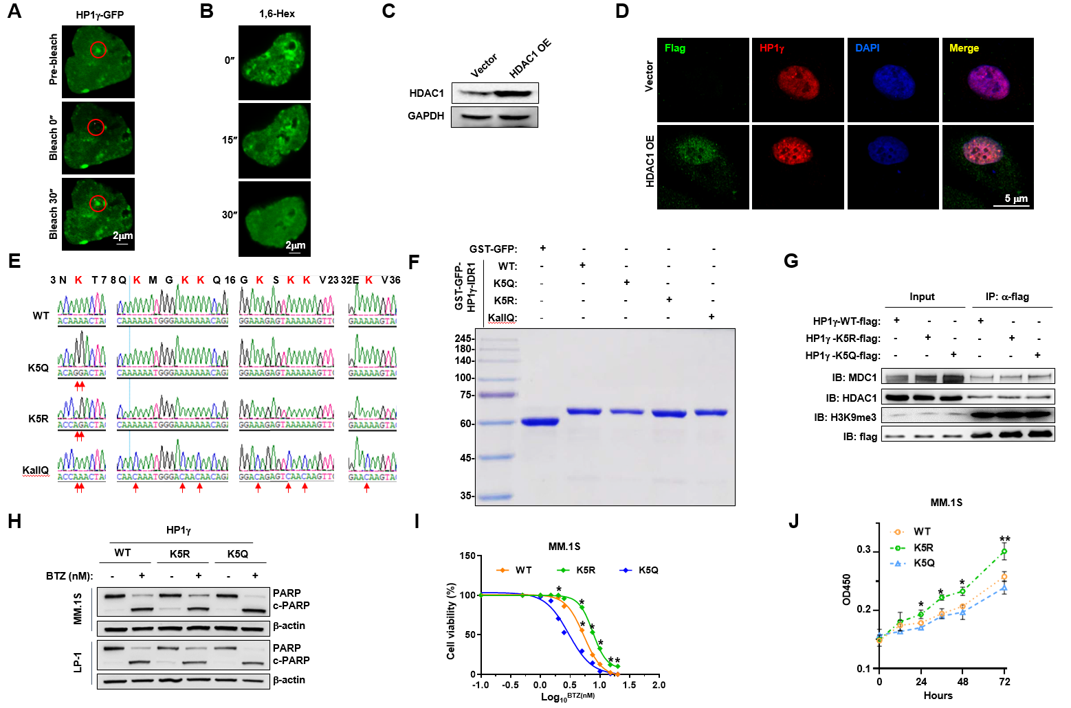
S FIGURE 5 Deacetylation enhances nuclear condensation of HP1γ and drug resistance to BTZ. (A) Fluorescence recovery after photobleaching (FRAP) assay of HP1γ-GFP in HEK293T cells. Scale bar, 2 μm. (B) Fluorescence intensity of full length GFP-HP1γ (FL) in HEK293T cells before and after treatment with 3% 1,6-hexanediol at different time. (C) Western blotting shows the overexpression efficacy of HDAC1 in MM.1S cells. (D) Confocal immunofluorescence for endogenous HP1γ droplet foci in myeloma cells stably expressing HDAC1 for 48 hr. Scale bar, 5 μm. (E) Sequence alignment of CBX3-WT, K5Q, K5R and KallQ. The site of lysine acetylation mutants indicated by red arrows. (F) Coomassie blue staining shows in vitro expression of GST-GFP, GST-GFP-HP1γ-IDR1-WT, -K5Q, -K5R, -KallQ fusion protein. (G) Co-IP assay for HP1γ-WT, -K5Q or -K5R with MDC1, HDAC1 and H3K9me3 in HEK293T cells. Input, 2% whole lysate; IP, M2-flag antibody. (H) Cleavage of PARP as the marker of apoptosis in MM cells stably expressing HP1γ-WT, -K5R and -K5Q for 24 hr. (I) Alteration of IC₅₀ to BTZ treatment in the HP1γ-WT, -K5R and -K5Q in MM.1S cells. (J) Cell proliferation of MM.1S cells stably expressing HP1γ-WT, -K5Q or -K5R for 72 hr.
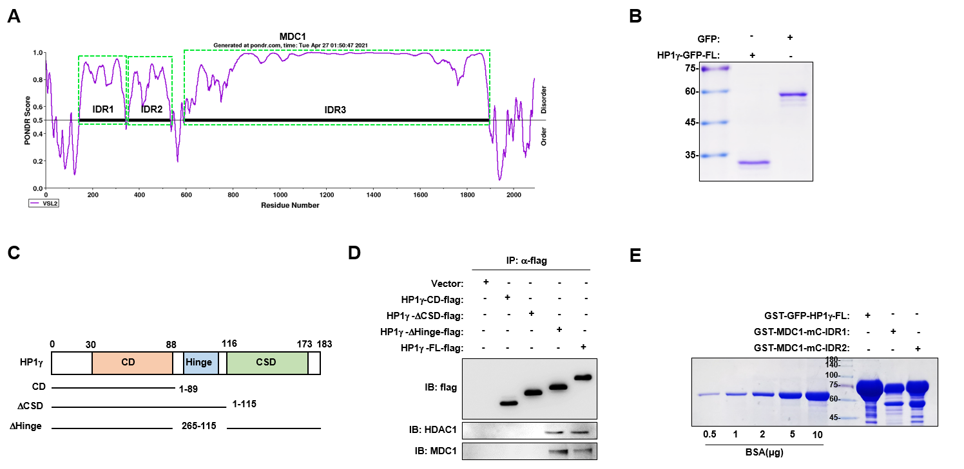
S FIGURE 6 Interaction with MDC1-IDR1 enhances HP1γ droplet formation in vitro. (A) Analysis of the MDC1 protein sequence for intrinsically disordered regions using the program VSL2. (B) Coomassie blue staining to show in vitro expression of GFP and HP1γ-GFP-FL fusion protein. (C) Schematic illustration of strategy to construct HP1γ truncations. (D) Immunoprecipitation assay to show interactions of full length HP1γ (FL) or truncations with HDAC1 or MDC1 in HEK293T cells. (E) Coomassie blue staining to show in vitro expression of GST-GFP-HP1γ-FL, GST-MDC1-mC-IDR1 and GST-MDC1-mC-IDR1 protein.
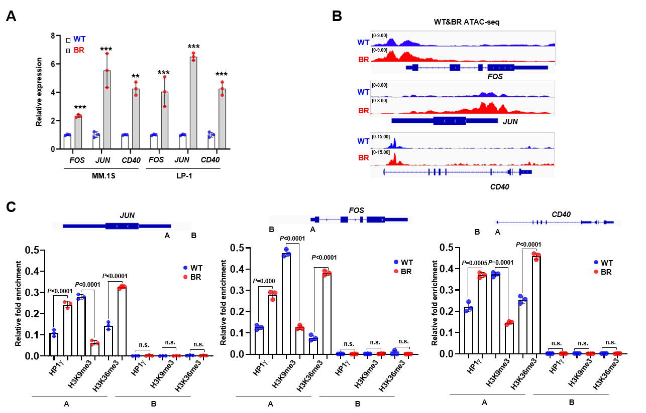
S FIGURE 7 HP1γ facilitates chromatin accessibility of genes governing drug sensitivity. (A) qPCR shows relative expressions of FOS, JUN and CD40 genes in WT and BR MM cells. (B) Gene tracks shows representative ATAC-Seq profiles at FOS, JUN and CD40 gene loci in WT and BR LP-1 cells. (C) ChIP-qPCR assay to show enrichment of HP1γ, H3K9me3 and H3K36me3 at gene loci of FOS, JUN, and CD40 in WT and BR LP-1 cells.

