Supplemental materials
Figure S1. Relationships between other meteorological variables and daily step count in the main models of five Chinese cities Note: BJ = Beijing, SH = Shanghai, CQ = Chongqing, SZ = Shenzhen, HK = Hong Kong. The model for each city was adjusted for relative humidity#, precipitation, windspeed, pressure#, sunshine, AQI/AQHI, month, day of week, public holiday, extra workdays, typhoon, super typhoon, and marathon (#some cities had these variables removed in the stepdown process). Black markings along the x-axis indicate the actual existing meteorological data of each city; Grey shading indicates the 95% confidence interval.

BJ | 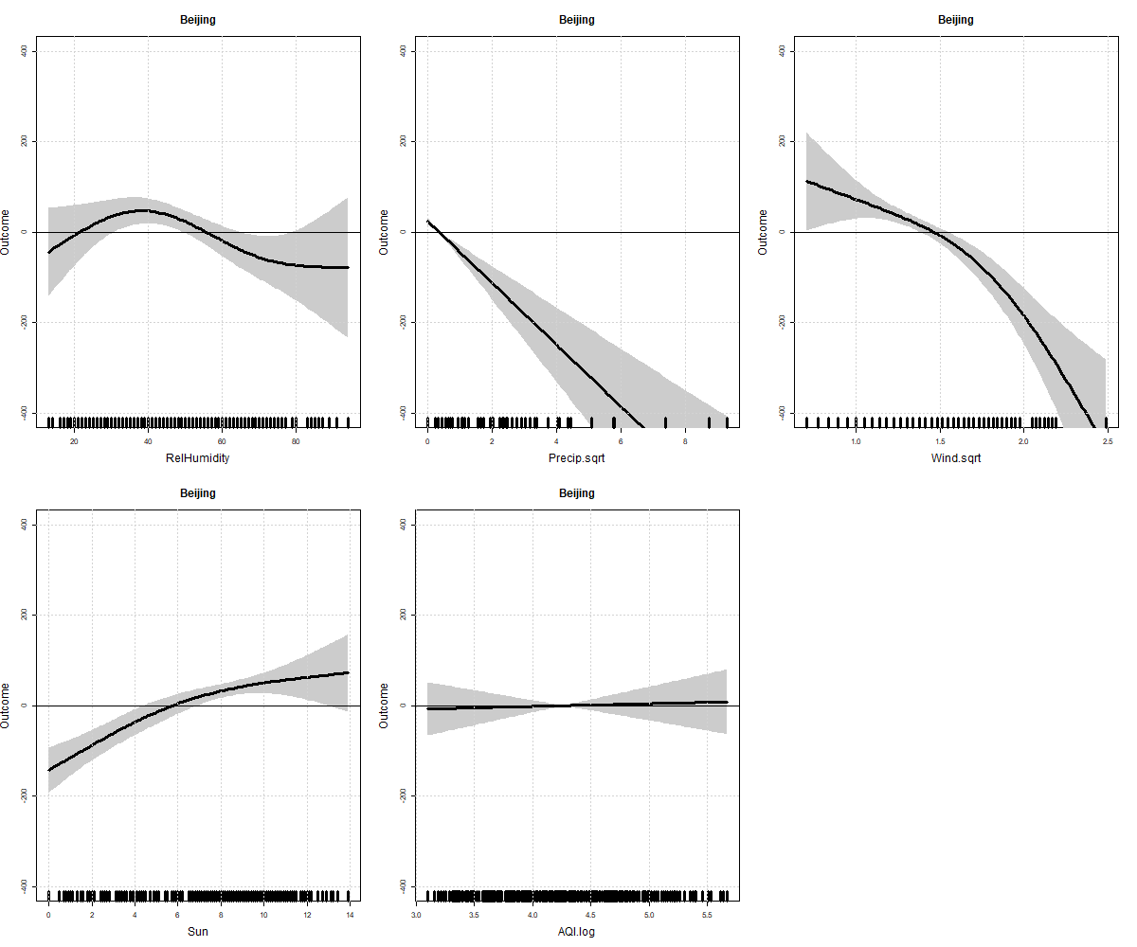
SH | 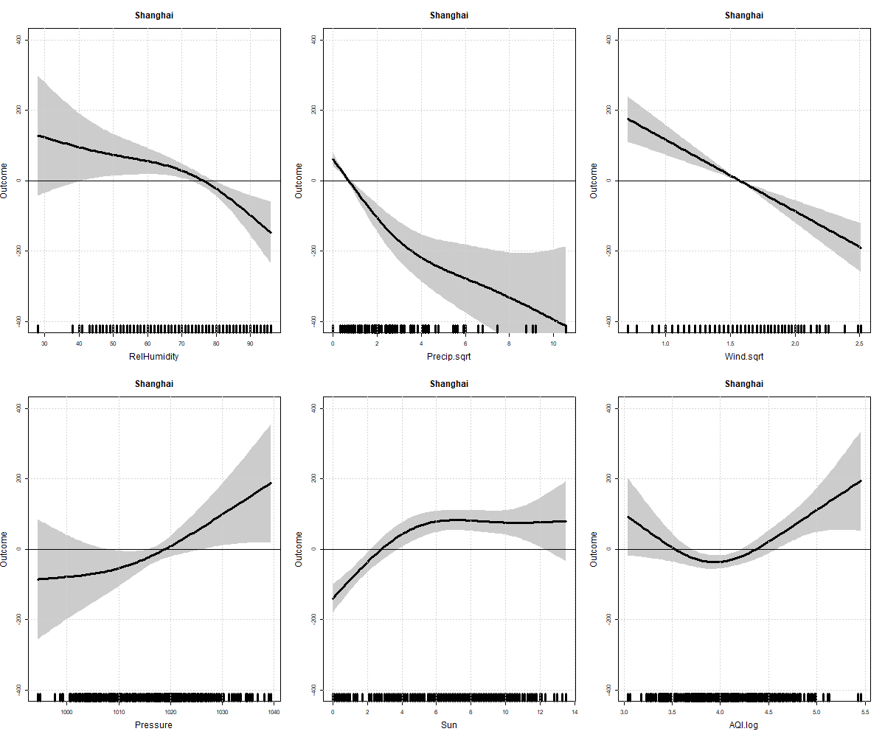
CQ | 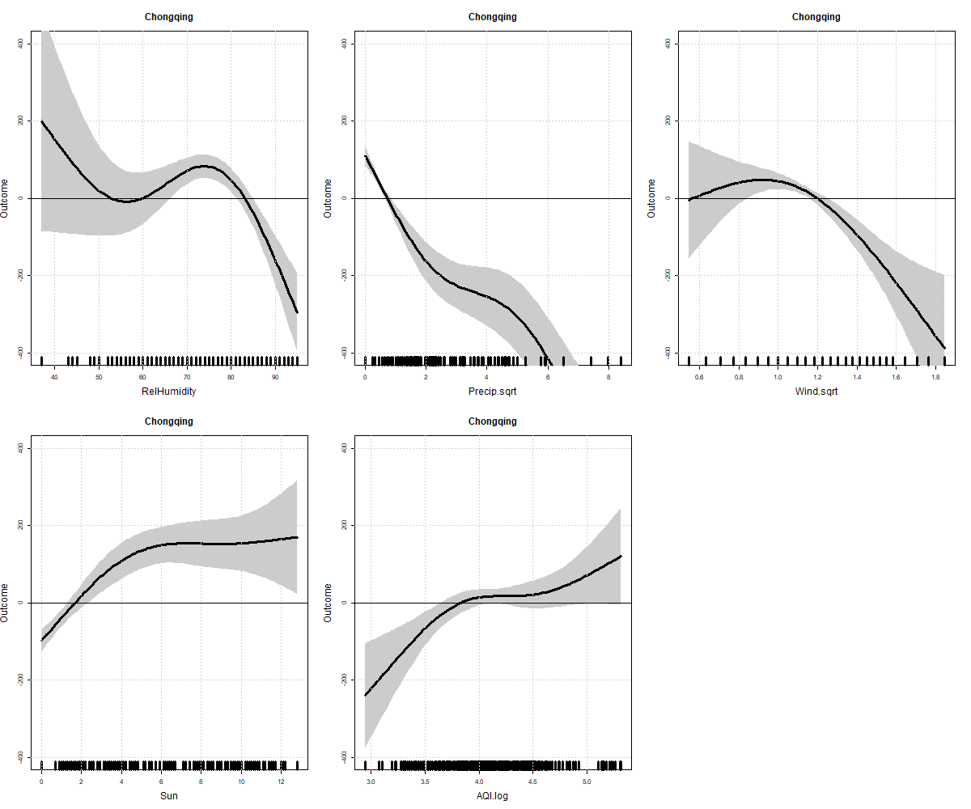
SZ | 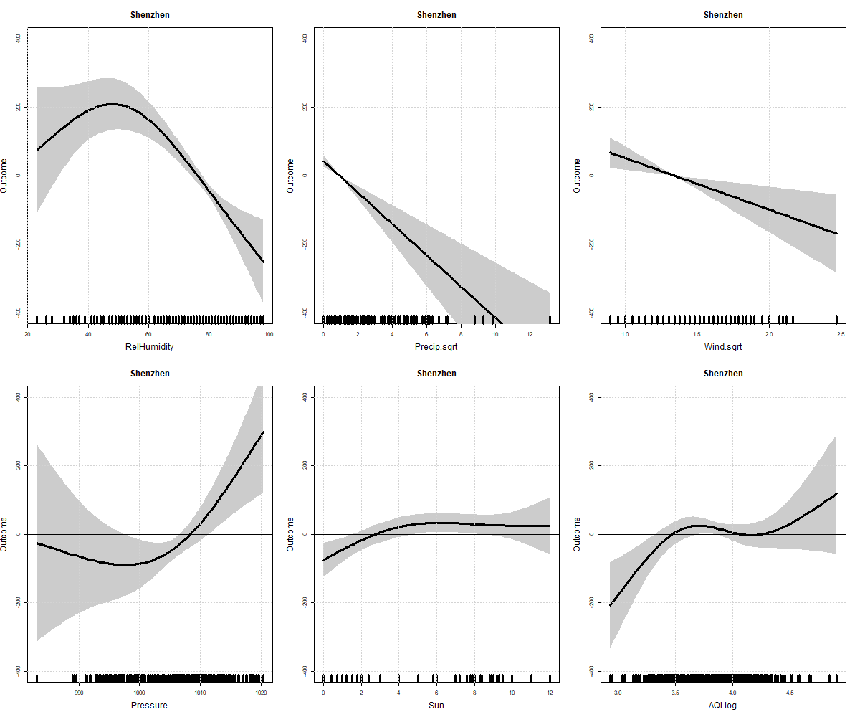
HK | 