Supplementary material

Supplementary figure 1. Partial correlations adjusted by age between biomarkers at baseline
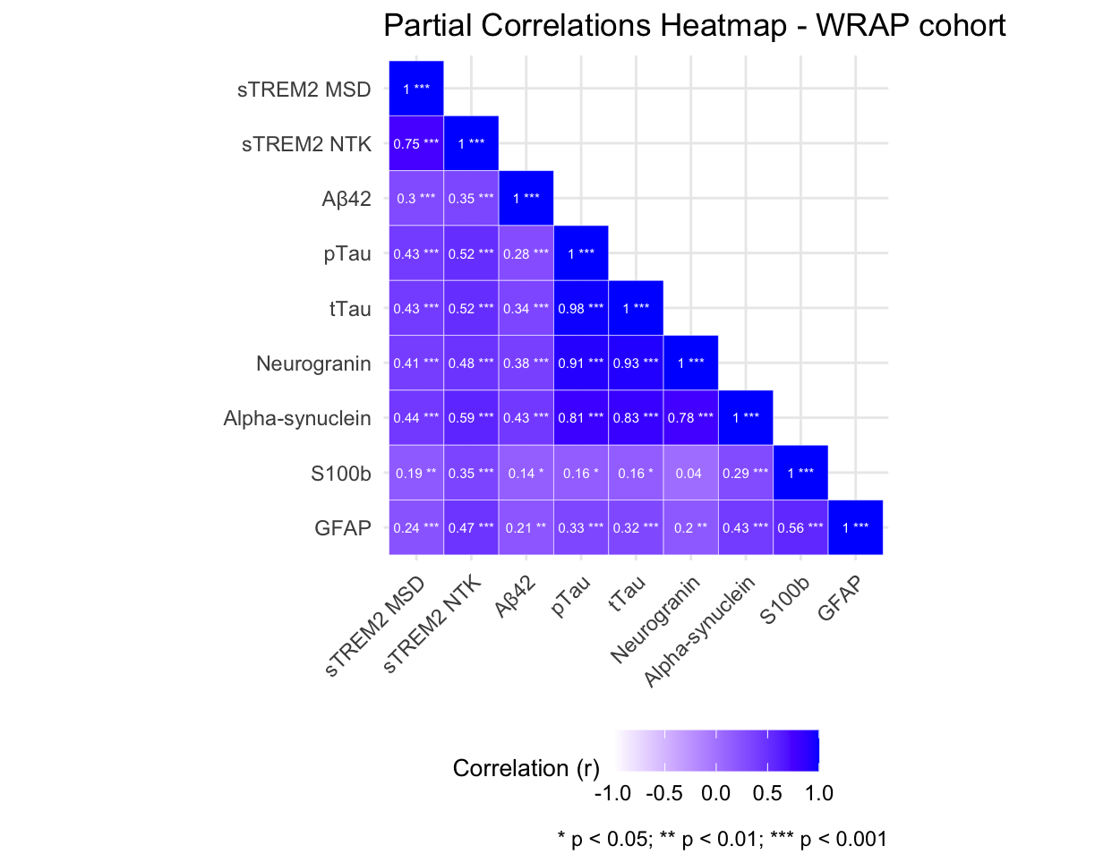

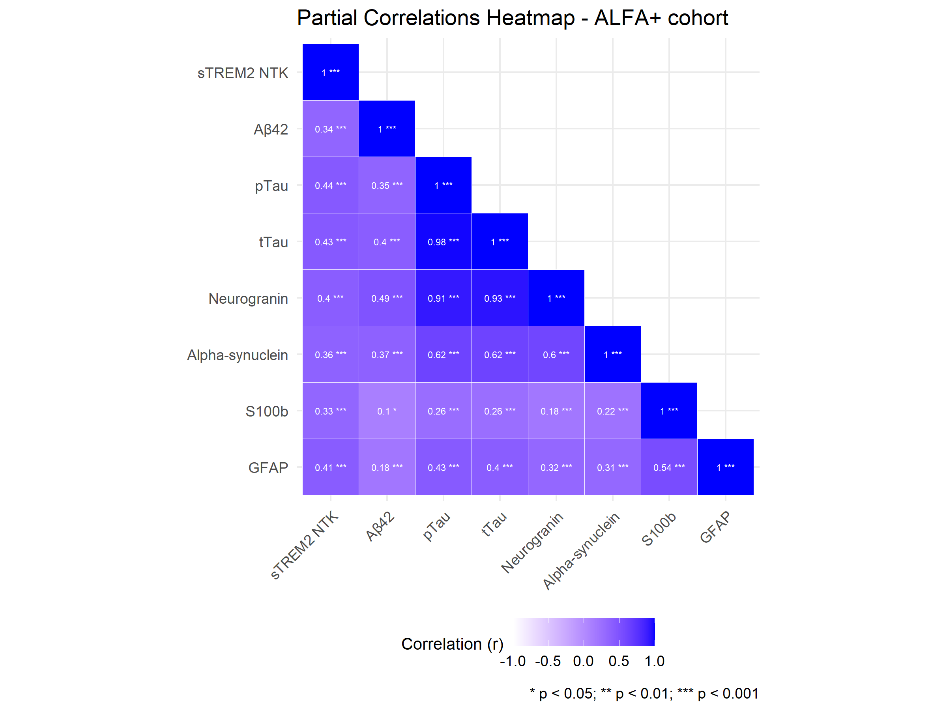
 | Total sample |  | < Aß42/Aß40 median |  | > Aß42/Aß40 median |  | A + |  | A - |  | < P-tau median |  | > P-tau median |  | T- |  | T+ |  | Apoe-e4 carrier |  | Apoe-e4 non-carrier
 | n=239 |  | n= 119 |  | n=120 |  | n= 46 |  | n=193 |  | n= 119 |  | n=120 |  | n=214 |  | n=25 |  | n=88 |  | n=151
 | ß | p-value | ß | p-value | ß | p-value | ß | p-value | ß | p-value | ß | p-value | ß | p-value | ß | p-value | ß | p-value | ß | p-value | ß | p-value
Neurogranin
Model 1 | 0.37 | 0.000 | 0.38 | 0.00 | 0.35 | 0.00 | 0.40 | 0.01 | 0.39 | 0.00 | 0.25 | 0.03 | 0.27 | 0.03 | 0.39 | 0.00 | 0.49 | 0.29 | 0.39 | 0.00 | 0.36 | 0.00
Model 2 | -0.04 | 0.78 | 0.13 | 0.48 | -0.37 | 0.08 | -0.05 | 0.88 | -0.05 | 0.73 | -0.04 | 0.81 | -0.06 | 0.77 | -0.07 | 0.61 | 0.32 | 0.59 | 0.10 | 0.59 | -0.16 | 0.39
Alfa-synuclein
Model 1 | 0.37 | 0.00 | 0.37 | 0.00 | 0.39 | 0.00 | 0.48 | 0.00 | 0.37 | 0.00 | 0.30 | 0.00 | 0.29 | 0.00 | 0.37 | 0.00 | 0.79 | 0.01 | 0.40 | 0.00 | 0.36 | 0.00
Model 2 | 0.16 | 0.09 | 0.15 | 0.25 | 0.20 | 0.14 | 0.37 | 0.08 | 0.12 | 0.26 | 0.11 | 0.42 | 0.19 | 0.141 | 0.11 | 0.25 | 0.83 | 0.02 | 0.20 | 0.19 | 0.14 | 0.24
S100b
Model 1 | 0.28 | 0.002 | 0.41 | 0.001 | 0.15 | 0.26 | 0.29 | 0.21 | 0.28 | 0.00 | 0.11 | 0.33 | 0.32 | 0.01 | 0.22 | 0.02 | 0.74 | 0.03 | 0.28 | 0.03 | 0.24 | 0.06
Model 2 | 0.16 | 0.06 | 0.26 | 0.03 | 0.06 | 0.61 | 0.23 | 0.27 | 0.15 | 0.10 | 0.05 | 0.64 | 0.28 | 0.01 | 0.10 | 0.23 | 0.70 | 0.07 | 0.18 | 0.12 | 0.11 | 0.37
GFAP
Model 1 | 0.26 | 0.0001 | 0.21 | 0.03 | 0.31 | 0.00 | 0.27 | 0.17 | 0.26 | 0.00 | 0.08 | 0.36 | 0.12 | 0.18 | 0.23 | 0.00 | 0.40 | 0.22 | 0.20 | 0.05 | 0.31 | 0.00
Model 2 | 0.09 | 0.15 | 0.04 | 0.67 | 0.16 | 0.07 | 0.14 | 0.47 | 0.10 | 0.16 | 0.11 | 0.28 | 0.08 | 0.36 | 0.09 | 0.18 | 0.32 | 0.42 | 0.07 | 0.46 | 0.13 | 0.14
Supplementary table 1. WRAP cohort. Beta-coefficients and p-values for cross-sectional associations between synaptic biomarkers and soluble cleaved soluble TREM2 (cSTREM2) in linear regression models
Statistically significant (p<0.05)
Model 1=adjusted by age and sex. Model 2=adjusted by age, sex, Aβ42 and PTAU
Aβ42/Aβ40 median = 0.067. The cut-off for amyloid (A) positivity according to the Aβ42/Aβ40 ratio is < 0.046
P-tau median = 15.94 pg/mL. The cut-off for tau (T) positivity according to P-tau is > 24.8 pg/mL
WRAP = Wisconsin Registry for Alzheimer prevention cohort

Supplementary table 2. WRAP cohort: Beta coefficients for the interaction between baseline biomarkers and time. predicting longitudinal change in csTREM2
 | Total sample |  | < Aß42/Aß40 median |  | > Aß42/Aß40 median |  | A + |  | A - |  | < P-tau median |  | > P-tau median |  | T- |  | T+ |  | Apoe-e4 carriers |  | Apoe-e4 non-carriers
 | n=116 |  | n= 61 |  | n=55 |  | n= 28 |  | n=88 |  | n= 53 |  | n=63 |  | n=105 |  | n=11 |  | n=46 |  | n=71
 | ß | p-value | ß | p-value | ß | p-value | ß | p-value | ß | p-value | ß | p-value | ß | p-value | ß | p-value | ß | p-value | ß | p-value | ß | p-value
Neurogranin
Model 1 | -0.041 | 0.000 | -0.039 | 0.002 | -0.045 | 0.010 | -0.057 | 0.004 | -0.038 | 0.003 | -0.052 | 0.011 | -0.052 | 0.011 | -0.040 | 0.001 | -0.092 | 0.078 | -0.038 | 0.005 | -0.044 | 0.005
Model 2 | -0.041 | 0.000 | -0.039 | 0.002 | -0.046 | 0.008 | -0.058 | 0.003 | -0.038 | 0.002 | -0.052 | 0.011 | -0.052 | 0.010 | -0.041 | 0.001 | -0.093 | 0.076 | -0.039 | 0.005 | -0.044 | 0.005
Alfa-synuclein
Model 1 | -0.026 | 0.003 | -0.023 | 0.049 | -0.031 | 0.019 | -0.035 | 0.066 | -0.025 | 0.012 | -0.028 | 0.119 | -0.024 | 0.100 | -0.025 | 0.010 | -0.018 | 0.688 | -0.021 | 0.089 | -0.030 | 0.015
Model 2 | -0.026 | 0.002 | -0.022 | 0.051 | -0.031 | 0.019 | -0.035 | 0.066 | -0.026 | 0.011 | -0.028 | 0.117 | -0.024 | 0.098 | -0.025 | 0.009 | -0.018 | 0.689 | -0.021 | 0.083 | -0.030 | 0.015
S100b
Model 1 | 0.016 | 0.317 | 0.014 | 0.419 | 0.019 | 0.520 | 0.052 | 0.052 | 0.001 | 0.976 | 0.013 | 0.629 | 0.042 | 0.050 | 0.017 | 0.318 | 0.017 | 0.651 | 0.008 | 0.697 | 0.029 | 0.268
Model 2 | 0.015 | 0.338 | 0.014 | 0.422 | 0.016 | 0.580 | 0.052 | 0.050 | -0.001 | 0.958 | 0.012 | 0.638 | 0.042 | 0.049 | 0.015 | 0.366 | 0.017 | 0.637 | 0.007 | 0.704 | 0.028 | 0.286
GFAP
Model 1 | -0.003 | 0.770 | -0.002 | 0.858 | -0.005 | 0.766 | 0.045 | 0.046 | -0.015 | 0.243 | -0.002 | 0.932 | 0.016 | 0.300 | -0.002 | 0.863 | 0.037 | 0.240 | -0.003 | 0.832 | -0.003 | 0.841
Model 2 | -0.004 | 0.731 | -0.002 | 0.871 | -0.007 | 0.682 | 0.046 | 0.044 | -0.015 | 0.220 | -0.002 | 0.904 | 0.016 | 0.302 | -0.003 | 0.802 | 0.037 | 0.232 | -0.004 | 0.802 | -0.003 | 0.831
Statistically significant (p<0.05)
Model 1=adjusted by age and sex. Model 2=adjusted by age, sex, Aβ42 and p-tau
.

Supplementary table 3. ALFA+ Cohort. Beta-coefficients and p-values for cross-sectional associations between synaptic biomarkers and soluble cleaved soluble TREM2 (cSTREM2) in linear regression models

 | Total sample |  | < Aß42/Aß40 median |  | > Aß42/Aß40 median |  | A + |  | A - |  | < P-tau median |  | > P-tau median |  | T- |  | T+ |  | Apoe-e4 carriers |  | Apoe-e4 non-carriers
 | n=239 |  | n= 119 |  | n=120 |  | n= 46 |  | n=193 |  | n= 119 |  | n=120 |  | n=214 |  | n=25 |  | n=46 |  | n=71
 | ß | p-value | ß | p-value | ß | p-value | ß | p-value | ß | p-value | ß | p-value | ß | p-value | ß | p-value | ß | p-value | ß | p-value | ß | p-value
Neurogranin
Model 1 | 0.31 | 0.00 | 0.27 | 0.00 | 0.36 | 0.00 | 0.30 | 0.00 | 0.34 | 0.00 | 0.20 | 0.01 | 0.31 | 0.00 | 0.28 | 0.00 | 0.01 | 0.95 | 0.25 | 0.00 | 0.36 | 0.00
Model 2 | -0.21 | 0.04 | -0.13 | 0.43 | -0.23 | 0.06 | -0.26 | 0.16 | -0.14 | 0.25 | -0.37 | 0.00 | -0.03 | 0.85 | -0.22 | 0.04 | -0.20 | 0.57 | -0.05 | 0.76 | -0.32 | 0.01
Alfa-synuclein
Model 1 | 0.21 | 0.00 | 0.26 | 0.00 | 0.16 | 0.00 | 0.30 | 0.00 | 0.17 | 0.00 | 0.12 | 0.00 | 0.19 | 0.00 | 0.18 | 0.00 | 0.11 | 0.19 | 0.15 | 0.00 | 0.25 | 0.00
Model 2 | 0.07 | 0.06 | 0.15 | 0.02 | 0.02 | 0.53 | 0.20 | 0.01 | 0.03 | 0.45 | 0.04 | 0.28 | 0.10 | 0.11 | 0.06 | 0.15 | 0.15 | 0.15 | 0.06 | 0.34 | 0.08 | 0.05
S100b
Model 1 | 0.44 | 0.00 | 0.42 | 0.00 | 0.49 | 0.00 | 0.59 | 0.00 | 0.34 | 0.00 | 0.33 | 0.00 | 0.33 | 0.00 | 0.39 | 0.00 | 0.27 | 0.15 | 0.35 | 0.00 | 0.63 | 0.00
Model 2 | 0.28 | 0.00 | 0.30 | 0.00 | 0.28 | 0.00 | 0.51 | 0.00 | 0.13 | 0.11 | 0.25 | 0.00 | 0.29 | 0.00 | 0.28 | 0.00 | 0.26 | 0.16 | 0.26 | 0.01 | 0.34 | 0.00
GFAP
Model 1 | 0.40 | 0.00 | 0.34 | 0.00 | 0.44 | 0.00 | 0.44 | 0.00 | 0.27 | 0.01 | 0.30 | 0.00 | 0.30 | 0.00 | 0.36 | 0.00 | 0.11 | 0.51 | 0.37 | 0.00 | 0.26 | 0.00
Model 2 | 0.24 | 0.00 | 0.16 | 0.07 | 0.29 | 0.00 | 0.38 | 0.00 | 0.22 | 0.00 | 0.23 | 0.00 | 0.26 | 0.00 | 0.25 | 0.00 | 0.17 | 0.33 | 0.43 | 0.00 | 0.23 | 0.00
Statistically significant (p<0.05)
Model 1=adjusted by age and sex. Model 2=adjusted by age, sex, Aβ42 and PTAU
Aβ42/Aβ40 median = 0.08057. The cut-off for amyloid (A) positivity according to the Aβ42/Aβ40 ratio is < 0.071.
P-tau median = 14.75 pg/mL. The cut-off for tau (T) positivity according to P-tau is > 24 pg/mL
ALFA = Alzheimer’s and Families cohort

Supplementary table 4. ALFA+ cohort: Beta coefficients for the interaction between baseline biomarkers and time. predicting longitudinal change in csTREM2

 | Total sample |  | < Aß42/Aß40 median |  | > Aß42/Aß40 median |  | A + |  | A - |  | < P-tau median |  | > P-tau median |  | T- |  | T+ |  | Apoe-e4 carriers |  | Apoe-e4 non-carriers
 | n=277 |  | n= 135 |  | n=142 |  | n= 92 |  | n=185 |  | n= 115 |  | n=129 |  | n=212 |  | n=32 |  | n=152 |  | n=125
 | ß | p-value | ß | p-value | ß | p-value | ß | p-value | ß | p-value | ß | p-value | ß | p-value | ß | p-value | ß | p-value | ß | p-value | ß | p-value
Neurogranin
Model 1 | -0.006 | 0.222 | 0.001 | 0.878 | -0.015 | 0.018 | 0.007 | 0.476 | -0.016 | 0.008 | -0.012 | 0.280 | 0.006 | 0.494 | -0.005 | 0.397 | 0.021 | 0.443 | -0.008 | 0.227 | -0.004 | 0.615
Model 2 | -0.002 | 0.744 | 0.007 | 0.339 | -0.011 | 0.105 | -0.001 | 0.875 | -0.005 | 0.363 | -0.012 | 0.287 | 0.007 | 0.491 | -0.005 | 0.398 | 0.022 | 0.436 | -0.005 | 0.466 | 0.003 | 0.656
Alfa-synuclein
Model 1 | -0.007 | 0.091 | -0.004 | 0.596 | -0.011 | 0.053 | 0.002 | 0.776 | -0.013 | 0.010 | -0.004 | 0.466 | 0.001 | 0.865 | -0.007 | 0.182 | 0.011 | 0.313 | -0.013 | 0.042 | -0.003 | 0.619
Model 2 | -0.002 | 0.630 | 0.007 | 0.240 | -0.011 | 0.048 | 0.004 | 0.559 | -0.006 | 0.191 | -0.004 | 0.483 | 0.001 | 0.868 | -0.006 | 0.190 | 0.011 | 0.310 | -0.005 | 0.466 | 0.000 | 0.966
S100b
Model 1 | 0.008 | 0.403 | 0.013 | 0.360 | -0.001 | 0.948 | 0.020 | 0.236 | 0.000 | 0.976 | 0.023 | 0.090 | -0.001 | 0.950 | 0.006 | 0.518 | 0.016 | 0.519 | 0.012 | 0.280 | 0.000 | 0.997
Model 2 | 0.007 | 0.376 | 0.010 | 0.415 | 0.003 | 0.793 | 0.018 | 0.204 | -0.001 | 0.942 | 0.023 | 0.091 | -0.001 | 0.936 | 0.006 | 0.523 | 0.016 | 0.532 | 0.010 | 0.397 | 0.003 | 0.797
GFAP
Model 1 | -0.001 | 0.832 | 0.000 | 0.961 | -0.002 | 0.773 | 0.003 | 0.788 | -0.005 | 0.490 | 0.005 | 0.563 | -0.003 | 0.745 | -0.002 | 0.734 | 0.013 | 0.488 | -0.005 | 0.595 | -0.002 | 0.831
Model 2 | 0.000 | 0.978 | 0.001 | 0.921 | -0.001 | 0.885 | -0.002 | 0.827 | -0.001 | 0.891 | 0.005 | 0.558 | -0.003 | 0.745 | -0.002 | 0.736 | 0.013 | 0.493 | 0.001 | 0.895 | 0.002 | 0.820
Statistically significant (p<0.05)
Model 1=adjusted by age and sex. Model 2=adjusted by age, sex, Aβ42 and p-tau

